TRANSPORTATION POOLED FUND PROGRAM
QUARTERLY PROGRESS REPORT

Lead Agency: Utah Department of Transportation

INSTRUCTIONS:
Project Managers and/or research project investigators should complete a quarterly progress report for each calendar quarter during which the projects are active. Please provide a project schedule status of the research activities tied to each task that is defined in the proposal; a percentage completion of each task; a concise discussion (2 or 3 sentences) of the current status, including accomplishments and problems encountered, if any. List all tasks, even if no work was done during this period.

Transportation Pooled Fund Program Project #  TPF-5(296) |  | Transportation Pooled Fund Program - Report Period:  _ Quarter 1 (January 1 – March 31, 2015)  _ Quarter 2 (April 1 – June 30, 2015)  x Quarter 3 (July 1 – September 30, 2015)  _ Quarter 4 (October 1 – December 31, 2015)
Project Title:
Simplified SPT Performance-Based Assessment of Liquefaction and Effects

Name of Project Manager(s):  David Stevens | Phone Number:  801-589-8340 |  | E-Mail  davidstevens@utah.gov
Lead Agency Project ID:  FINET 42065, ePM PIN 12436  UDOT PIC No. UT13.407 | Other Project ID (i.e., contract #):  UDOT Contract No. 148753 |  | Project Start Date:  March 6, 2014
Original Project End Date:  November 30, 2016 | Current Project End Date:  November 30, 2016 |  | Number of Extensions:  1

Project schedule status:

X On schedule _ On revised schedule _ Ahead of schedule _ Behind schedule

Overall Project Statistics:
Total Project Budget | Total Cost to Date for Project | Percentage of Work  Completed to Date
$149,500.00 (current contract)  $167,500.00 (total commitments) | $71,750 | 60%

Quarterly Project Statistics:
Total Project Expenses  and Percentage This Quarter | Total Amount of Funds  Expended This Quarter | Total Percentage of  Time Used to Date
0% | $0 | 55%

Project Description:

Liquefaction of loose saturated sands results in significant damage to buildings, transportation systems and lifelines in most large earthquake events. Liquefaction and the resulting loss of shear strength can lead to lateral spreading and seismic slope displacements, which often impact bridge abutments and wharfs, damaging these critical transportation links at a time when they are most needed for rescue efforts and post-earthquake recovery.

While most updated seismic provisions now adopt a risk-targeted approach to design ground motions for superstructures, other critical aspects of geotechnical engineering, such as liquefaction and ground deformation evaluation, are still based on the older concept of deterministic hazard evaluation. Recent advances in performance-based earthquake engineering (PBEE) in geotechnical engineering (e.g., Kramer and Mayfield 2007; Rathje and Saygili 2008; Bradley et al. 2011; Franke and Kramer 2013) have introduced probabilistic uniform hazard-based procedures for evaluating seismic ground deformations within a performance-based framework from which the likelihood of exceeding various magnitudes of deformation within a given time frame can be computed. However, the ability to apply these performance-based procedures on everyday projects is generally beyond the capabilities of most practicing engineers.

This study proposes to create and evaluate simplified performance-based design procedures for the a priori prediction of liquefaction triggering, lateral spread displacement, seismic slope displacement, and post-liquefaction free-field settlement using the standard penetration test (SPT).

Objectives for this study include:

1. Derive new simplified performance-based procedure for liquefaction triggering, lateral spread displacement, free-field post-liquefaction settlements, and Newmark seismic slope displacements.
2. Develop liquefaction parameter maps in GIS format associated with each of the hazards included in objective 1 at return periods of 475 years, 1033 years, and 2475 years for each of the states participating in the study.
3. Evaluate the new simplified performance-based liquefaction procedures against conventional (i.e., AASHTO) liquefaction analysis procedures.
4. Develop a simplified design procedure that will allow the designer to envelope the performance-based and conventional results to select which result will govern the design.
Tasks for this study include, regarding the participating states:

1. Derivation and validation of a new simplified liquefaction triggering model (Year 1).
2. Derivation and validation of simplified lateral spread displacement models (Year 1).
3. Derivation and validation of simplified post-liquefaction settlement models (Year 2).
4. Derivation and validation of simplified Newmark seismic slope displacement models (Year 2).
5. Assessment of grid spacing considerations in various seismic environments for map development (Years 1 & 2).
6. Development of liquefaction parameter maps at targeted return periods in GIS file format (Years 1 & 2).
7. Comparison of simplified, conventional, and deterministic analysis approaches (Years 1 & 2).
8. Development of a simplified design procedure and an analysis spreadsheet that incorporates both performance-based and conventional methods (Years 1 & 2).
9. Preparation of the annual and final reports (Years 1 & 2).
10. Dissemination of results in appropriate engineering journals and conferences (Years 1 & 2).
11. Technical Advisory Committee meetings (Years 1 & 2), including a final workshop to train partner states on the new performance-based liquefaction hazard methods.

Dr. Kevin Franke of BYU is the Principal Investigator for this research project. The technical advisory committee (TAC) for the study includes representatives from UT, AK, CT, ID, MT, OR, and SC state DOTs.

Progress this Quarter (includes meetings, work plan status, contract status, significant progress, etc.):

Task 1 – 100% complete.
Task 2 – 100% complete.
Task 3 – 95% complete.
Task 4 – 95% complete. BYU updated the TAC quarterly update report for Tasks 3 and 4 based on TAC feedback.
Task 5 – 80% complete. BYU continued work on this task.
Task 6 – 80% complete. BYU continued work on this task and prepared the TAC quarterly update report and maps for Tasks 5 and 6 (Year 2).
Task 7 – 60% complete. BYU began the Year 2 work on this task.
Task 8 – 60% complete. BYU began the Year 2 work on this task.
Task 9 – 60% complete.
Task 10 – 50% complete.
Task 11 – 50% complete.
Contract – No adjustment this quarter. Oregon DOT posted a funding commitment online to join the pooled fund.

Anticipated work next quarter:

Task 1 – Completed.
Task 2 – Completed.
Task 3 – BYU will complete work on this task.
Task 4 – BYU will finish updating the TAC quarterly update report for Tasks 3 and 4 based on TAC feedback.
Task 5 – BYU will complete work on this task.
Task 6 – BYU will complete work on this task. The TAC quarterly update report for Tasks 5 and 6 (Year 2) will be completed and shared with the TAC for their review, along with the volumetric strain and seismic slope displacement reference parameter maps.
Task 7 – BYU will complete the Year 2 work on this task (comparison of analysis approaches).
Task 8 – BYU will complete the Year 2 work on this task (adding features to the analysis spreadsheet).
Task 9 – TAC quarterly update reports will continue to be combined for final reports.
Task 10 – None.
Task 11 – A TAC web-conference will be held in October or November to review progress and provide feedback.
Contract – A plan will be made with BYU and Oregon DOT to generate maps and other deliverables for Oregon DOT as part of the study. This additional work and budget will be incorporated in a contract amendment.

Significant Results:

The research activities this quarter focused on applying the simplified performance-based volumetric strain (i.e., settlement) and simplified Newmark seismic slope displacement models to the states funding this research project. Specifically, volumetric strain parameter maps are currently being developed for the states, as well as slope displacement reference parameter maps.

The development of the reference maps this quarter required greater understanding of how the grid spacing used to develop the contour maps can bias the simplified results. If the grid spacing is too small, then the map developing will be analytically expensive and time-consuming. If the grid spacing is too large, then the maps will introduce bias in the computed hazards, particularly in areas of higher seismicity. A grid spacing study was performed to correlate the length of the grid spacing required to achieve 5% bias in and and mapped probabilistic peak ground acceleration (PGA) hazard. Multiple cities across the U.S. were evaluated in developing these correlations. These were same cities that were used to evaluate the bias in the development of liquefaction loading parameter maps and lateral spread displacement reference parameter maps in the first year of the study. Because both volumetric strain and Newmark seismic slope displacement were to be simultaneously computed for the grids across the different states, focus was given to the hazard that demonstrated the “tightest” grid spacing. The results for the governing grid spacing relationship to achieve 5% or less bias in the computed reference parameters is shown in Fig. 1 and Table 1. One may note that a few points were located well below our recommended grid spacing line. These points corresponded to cities such as Jackson Hole, WY; and Reno, NV, which are located on the boundaries between various seismic zones, as defined and delineated by the US. Geological Survey. As a result, these cities demonstrated very complex and erratic hazard behavior in our computations, and were therefore considered to be non-representative of the majority of U.S. cities that are located well within the boundaries of the USGS delineated seismic regions. Therefore, they were not considered when developing the boundaries for the grid spacing study. As a result, use of these simplified reference parameter maps in such cities could potentially result in a bias in the interpolated hazard reference parameter that is slightly more than 5%.

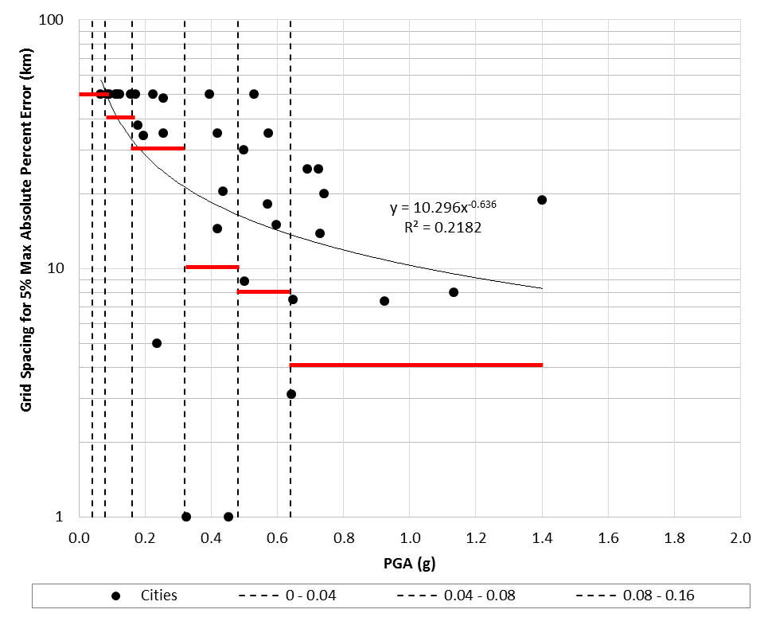

Figure 1. Recommended grid spacing correlation for developing liquefaction parameter/loading maps. These correlations should result in absolute error in mapping hazard reference parameter values for volumetric strain and Newmark seismic slope displacement.

Table 1. Recommended grid spacing correlation for developing liquefaction parameter/loading maps. Interpreted from the hand-drawn correlations presented in Fig. 1.

Mapped PGA (g) | Recommended Spacing (km)
0 - 0.04 | 50
0.04 - 0.08 | 50
0.08 - 0.16 | 40
0.16 - 0.32 | 30
0.32 - 0.48 | 10
0.48 - 0.64 | 8
0.64+ | 4

Circumstance affecting project or budget. (Please describe any challenges encountered or anticipated that
might affect the completion of the project within the time, scope and fiscal constraints set forth in the
agreement, along with recommended solutions to those problems).

Because reference parameter maps for both volumetric strain and seismic slope displacement are being developed simultaneously, they are taking longer to develop than the reference parameter maps developed in the first year of the research. In addition, the grid spacing for areas of moderate seismicity is significantly tighter than it was for the maps in the first year, resulting in more grid points in such areas. This latter observation has had a particularly significant impact on our analysis of the state of Alaska due to its very large size. Finally, we have observed that the USGS probabilistic deaggregation servers, which our hazard tools utilize to compute reference parameter values, have struggled to meet demand during the past 1-2 months, resulting in additional delays. As a result, we are approximately 2 months behind schedule at this point. However, we anticipate that we will be able to make up this lost time in the last quarter of the study because much of the work to be performed in that quarter was already completed during the first year of the study. Therefore, we do not currently anticipate the need for additional time or budget.

Potential Implementation:

Once the reference parameter hazard maps are developed for volumetric strain and seismic slope displacement, engineers will be able to compute probabilistic estimates of post-liquefaction settlement and seismic slope displacement in conjunction with liquefaction triggering and lateral spread displacement. The research activities in the last quarter will focus on implementing the methods into the spreadsheet that was developed for this study so that engineers can easily use these procedures on their engineering projects.

