TRANSPORTATION POOLED FUND PROGRAM
QUARTERLY PROGRESS REPORT

Lead Agency: Utah Department of Transportation

INSTRUCTIONS:
Project Managers and/or research project investigators should complete a quarterly progress report for each calendar quarter during which the projects are active. Please provide a project schedule status of the research activities tied to each task that is defined in the proposal; a percentage completion of each task; a concise discussion (2 or 3 sentences) of the current status, including accomplishments and problems encountered, if any. List all tasks, even if no work was done during this period.

Transportation Pooled Fund Program Project #  TPF-5(244) |  | Transportation Pooled Fund Program - Report Period:  _ Quarter 1 (January 1 – March 31, 2014)  _ Quarter 2 (April 1 – June 30, 2014)  _ Quarter 3 (July 1 – September 30, 2014)  x Quarter 4 (October 1 – December 31, 2014)
Project Title:
Shaking Table Testing to Evaluate Effectiveness of Vertical Drains for Liquefaction Mitigation

Name of Project Manager(s):  David Stevens | Phone Number:  801-589-8340 |  | E-Mail  davidstevens@utah.gov
Lead Agency Project ID:  FINET 42046, ePM PIN 9933  UDOT PIC No. UT07.708 | Other Project ID (i.e., contract #):  UDOT Contract No. 138731 |  | Project Start Date:  May 1, 2013
Original Project End Date:  March 31, 2016 | Current Project End Date:  March 31, 2016 |  | Number of Extensions:

Project schedule status:

_ On schedule X On revised schedule _ Ahead of schedule _ Behind schedule

Overall Project Statistics:
Total Project Budget | Total Cost to Date for Project | Percentage of Work  Completed to Date
$115,000.00 | $6,500.00 | 40%

Quarterly Project Statistics:
Total Project Expenses  and Percentage This Quarter | Total Amount of Funds  Expended This Quarter | Total Percentage of  Time Used to Date
0% | $0 | 60%

Project Description:

The vision for this study is to determine the viability of large diameter (100 mm) prefabricated vertical drains for preventing liquefaction and associated settlements or lateral spreading under full-scale conditions. If viable, drainage alternatives offer substantial advantages in comparison to conventional densification approaches. In production, drains can often be installed at 25% to 40% of the cost of stone columns. In addition, the drains can be installed in about one-third to one-half of the time required for stone columns. Finally, the time and cost associated with post-treatment in-situ testing to evaluate improvement produced by densification may not be required with drains. In an era when construction budgets are becoming increasingly tight and projects are increasingly placed on fast-track schedules, innovative alternative solutions are required to deal with liquefaction hazards.

Although limited blast liquefaction testing (Rollins et al. 2003, Rollins et al. 2004), vibration testing (Chang et al. 2004) and centrifuge testing (Yang et al. 2004 ) suggest that vertical drains can be effective, no full-scale drain installation has been subjected to earthquake induced ground motions. This lack of performance data under full-scale conditions has been a major impediment to expanding the use of this technique. To remedy this problem we will conduct full-scale tests with vertical drains in liquefiable sand using the laminar shear box and high speed actuator system at NEES-Univ. at Buffalo. Tests will involve level ground conditions with two drain spacings and will be integrated with a previously funded NEESR study currently underway so that the control tests without drains will already be available. We will use the same sand installation techniques, as well as the same instrumentation plan and shaking protocols which have already been developed and proven successful. This collaborative approach will significantly reduce the cost of the study in comparison to a completely independent study. In addition, it will provide a comparison between the performance of the soil profile with drains relative to subsequent tests where piles will be involved. If full-scale tests prove the effectiveness of the drainage technique, significant time and costs savings can be achieved for both new construction and for retrofit situations.

Three objectives are outlined for this study:
1. Evaluate the ability of earthquake drains to reduce excess pore pressure and settlement for level ground conditions at progressively higher acceleration levels.
2. Define the influence of drain spacing on the effectiveness of the drains for mitigating liquefaction hazard.
3. Provide well-documented case histories which can be used to calibrate/validate numerical models for predicting the performance of vertical drains.

The scope of work consists of eight specific tasks:
1. Perform a literature review to summarize the state of the art in the area of liquefaction mitigation through drainage.
2. Conduct level ground shaking table tests with drains at 4 ft spacing.
3. Conduct level ground shaking table tests with drains at 3 ft spacing.
4. Reduce the test data, analyze, and compare with previous test on untreated sand.
5. Evaluate predictive methods by comparing measured behavior with behavior computed using computer models and simplified models.
6. Prepare a final report on effectiveness of the drain technique.
7. Disseminate the research results.
8. Hold technical advisory committee meetings.

Dr. Kyle Rollins of BYU is the Principal Investigator for this research project. The TPF-5(244) testing was performed at the SUNY-Buffalo shaking table testing facility in the summer of 2014. BYU was approved for shared-use status on the NEES-Buffalo shake table. Individual task reports will be prepared for Tasks 1 through 5 when these are completed. Up to two in-person meetings with the multi-state technical advisory committee (TAC) are planned to be held in Salt Lake City, Utah during the project. Other TAC meetings will be tele-conference or web meetings.

Progress this Quarter (includes meetings, work plan status, contract status, significant progress, etc.):

Task 1 – 100% complete.
Task 2 – 90% complete. BYU prepared the summary report for the task testing.
Task 3 – 90% complete. BYU prepared the summary report for the task testing.
Task 4 – 50% complete. BYU continued the test data reduction and analysis.
Task 5 – 10% complete. BYU began evaluating predictive methods.
Task 6 – No work yet.
Task 7 – No work yet.
Task 8 – 15% complete. No TAC meetings were held this quarter.

Anticipated work next quarter:

Task 1 – None.
Task 2 – Submit the Test 1 summary report for TAC review.
Task 3 – Submit the Test 2 summary report for TAC review.
Task 4 – Continue with test data reduction and analysis.
Task 5 – Continue with evaluating predictive methods.
Task 6 – None.
Task 7 – None.
Task 8 – Plan to hold another TAC web-conference to review and discuss preliminary results from the testing.

Significant Results:

In the July-September 2015 quarter two test series were performed in the laminar shear box at SUNY-Buffalo. In the first series of tests conducted in late August 2014, the drains were spaced at 4 ft on centers and in the second set of tests, conducted in mid-September, drains were spaced at 3 ft on centers. For each drain spacing, the soil profile was subjected to a total of nine motions. Prior to the first set of motions, a seismic CPT sounding was made, permeability measurements were performed in three intervals, and initial readings from the vertical profilometer were obtained. The profile was then subjected to 15 cycles of sinusoidal motions with peak base accelerations of 0.05g, 0.10g, and 0.20g. At the end of each 15 cycles of shaking, the settlement of the soil profile was measured, permeability was measured, and the volume of water exiting the profile was pumped away and measured. At this point, another seismic CPT sounding was made to account for the increase in density produced by the shaking. Thereafter, the profile was again subjected to base motions with peak accelerations of 0.05g, 0.10g, and 0.20g and the process was repeated a third time.

During the October to December 2014 quarter work has focused on (1) uploading the test data to the NEES archive to satisfy NSF requirements for the funding for the tests, (2) reducing the data from the first test series, and (3) producing summary reports for Tests 1 and 2. These three efforts are on-going although we have nearly met all the NEES requirements for the archived data. A sampling of data obtained from the first set of tests (4 ft drain spacing) with a shaking level of 0.20g is provided in Figs. 1 and 2, respectively. For the first test, the sand was in a looser state after initial placement; however, in the second test the sand had been densified to some extent by repeated shaking events which caused settlement. The plots show excess pore pressure ratio (PPR) time histories and selected acceleration time histories at different depths below the surface of the sand in the laminar box. As shown in Figs. 1 and 2, the soil profile tends to amplify the ground motions from the input acceleration of 0.2g at the base of the box to about 0.25g at the ground surface. The ground motions in the lower half of the profile are somewhat less than near the surface as would be expected. However, there is no significant decrease in the peak ground acceleration with liquefaction as might be expected. For the loosest sand density shown in Fig. 1 the sand in the upper 7 feet of the profile liquefies (PPR=1.0) with a couple cycles of acceleration. The PPR at 10 ft quickly rises to a PPR of about 80% and eventually increases to about 90% suggesting that it is essentially liquefied at the end of the shaking. The PPR at 12 ft, which is in somewhat denser soil, gradually increases to about 80% after 15 cycles. The PPR values shown in Fig. 1 typically remain flat after liquefaction or increase with time toward liquefaction during the 15 cycles of shaking

For the somewhat denser sand shown in Fig. 2 relative to Fig. 1, more stress cycles are required to induce liquefaction and there is a tendency for the PPR to decrease with time at several depths as the drains act to reduce the PPR. In addition, after the shaking ends there is a more rapid decrease in PPR relative to the looser sand. It also appears that the PPR oscillates to a greater degree with tension and compression cycles in the soil for the denser sand. Although the sand is becoming denser with the settlement associated with each test, the borehole permeability tests conducted after each shaking test suggest that the permeability is not decreasing dramatically. In addition, the modulus of compressibility, mv, for the sand is decreasing with each additional shaking test. The overall effect of drainage on pore pressure generation and dissipation is a function of the ratio of permeability to compressibility. It appears that the decrease in compressibility is more than compensating for the decrease in permeability as the sand density increases with additional shaking tests. These results, along with the settlement data, will be very helpful in calibrating/validating computer models in the next phase of this testing program.

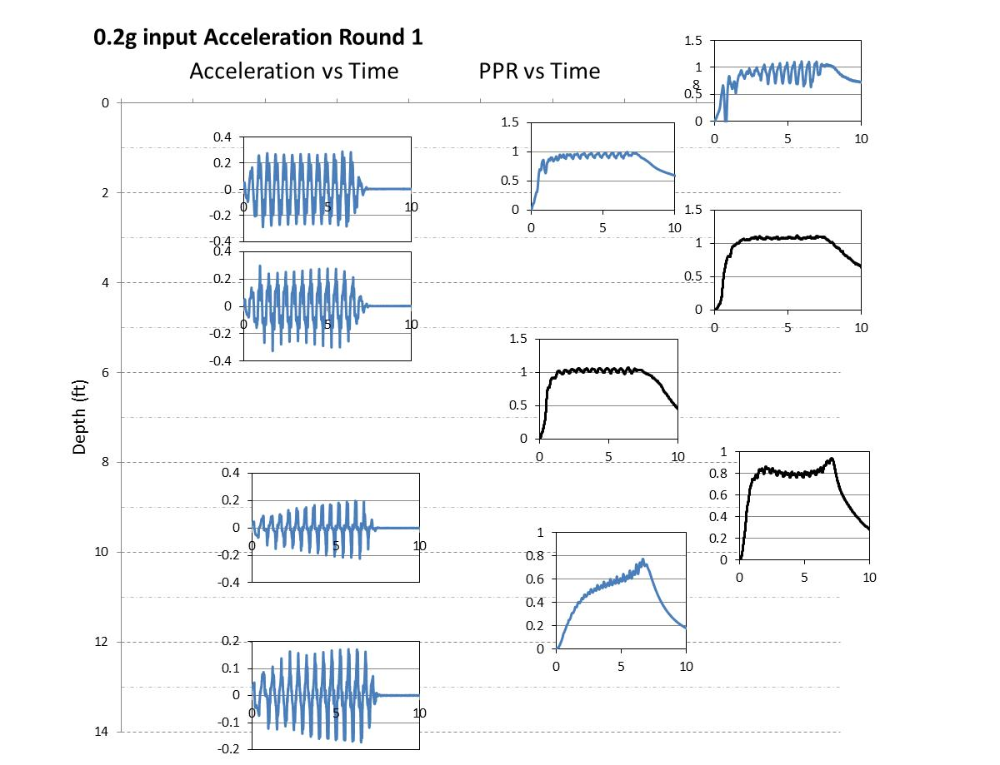

Fig. 1 Measured time histories of excess pore pressure ratio versus depth along with measured time histories of acceleration at selected locations for the first test with peak base acceleration of 0.20g. Sand was at its loosest relative density (about 45%). Depth location is associated with the (0,0) coordinate.

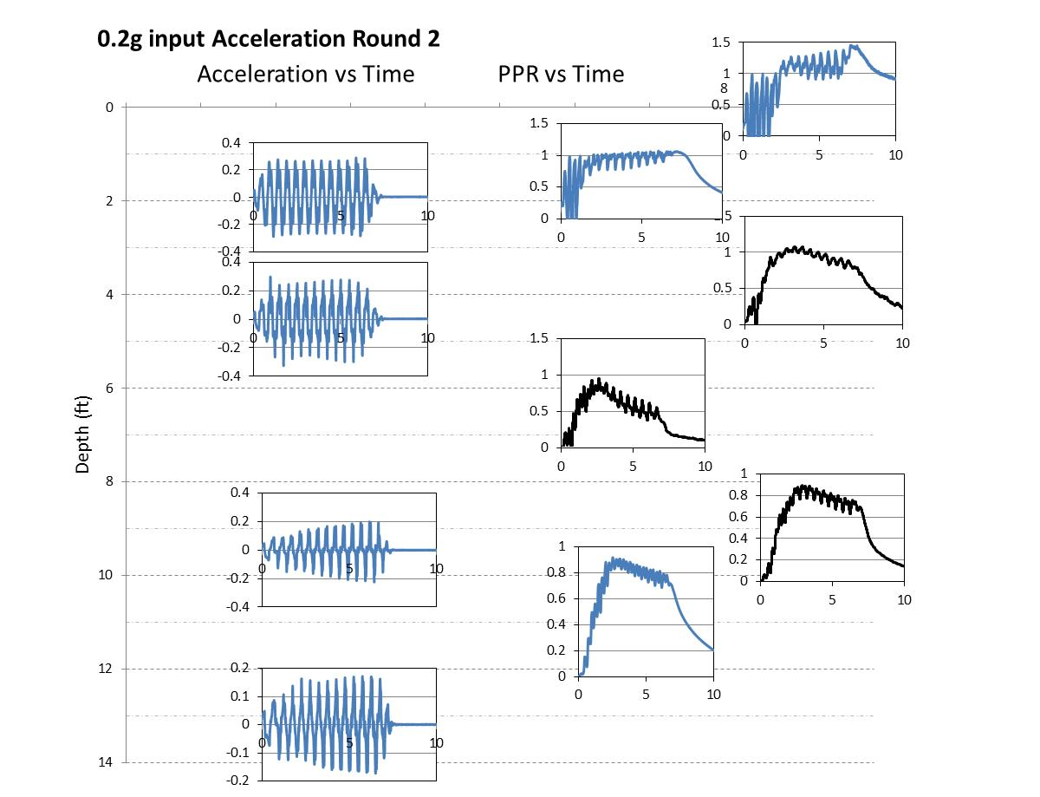

Fig. 2 Measured time histories of excess pore pressure ratio versus depth along with measured time histories of acceleration at selected locations for the second test round with peak base acceleration of 0.20g. Sand was at a somewhat higher relative density after having been subjected to previous round of five shaking tests. Depth location is associated with the (0,0) coordinate.

Circumstance affecting project or budget. (Please describe any challenges encountered or anticipated that
might affect the completion of the project within the time, scope and fiscal constraints set forth in the
agreement, along with recommended solutions to those problems).

Some testing tasks and associated analysis have taken longer to complete than originally planned. However, it is anticipated that the project tasks and deliverables will be completed within the original contract period.

Potential Implementation:

