TRANSPORTATION POOLED FUND PROGRAM
QUARTERLY PROGRESS REPORT

Lead Agency: Utah Department of Transportation

INSTRUCTIONS:
Project Managers and/or research project investigators should complete a quarterly progress report for each calendar quarter during which the projects are active. Please provide a project schedule status of the research activities tied to each task that is defined in the proposal; a percentage completion of each task; a concise discussion (2 or 3 sentences) of the current status, including accomplishments and problems encountered, if any. List all tasks, even if no work was done during this period.

Transportation Pooled Fund Program Project #  TPF-5(381) |  | Transportation Pooled Fund Program - Report Period:  _ Quarter 1 (January 1 – March 31, 2018)  _ Quarter 2 (April 1 – June 30, 2018)  x Quarter 3 (July 1 – September 30, 2018)  _ Quarter 4 (October 1 – December 31, 2018)
Project Title:
Evaluation of Lateral Pile Resistance Near MSE Walls at a Dedicated Wall Site – Phase 2

Name of Project Manager(s):  David Stevens | Phone Number:  801-589-8340 |  | E-Mail  davidstevens@utah.gov
Lead Agency Project ID:  FINET 42085, ePM PIN 16761  UDOT PIC No. UT17.404 | Other Project ID (i.e., contract #):  UDOT Contract No. 19-8182 |  | Project Start Date:  August 20, 2018
Original Project End Date:  September 30, 2020 | Current Project End Date:  September 30, 2020 |  | Number of Extensions:

Project schedule status:

X On schedule _ On revised schedule _ Ahead of schedule _ Behind schedule

Overall Project Statistics:
Total Project Budget | Total Cost to Date for Project | Percentage of Work  Completed to Date
$140,000.00 (current contract)  $220,000.00 (total commitments) | $0.00 | 27%

Quarterly Project Statistics:
Total Project Expenses  and Percentage This Quarter | Total Amount of Funds  Expended This Quarter | Total Percentage of  Time Used to Date
0% | $0.00 | 8%

Project Description:

Bridge abutment piles are frequently surrounded by mechanically stabilized earth (MSE) walls rather than a soil slope. Piles near MSE walls must be designed for lateral loads from earthquakes and thermal expansion/contraction. In the TPF-5(272) Phase 1 study involving several state DOTs, a series of 31 tests on free-head piles provided p-multipliers as a function of pile spacing which can be used to account for reduced lateral soil resistance due to the presence of an MSE wall. Equations were also developed to compute the induced force developed in the reinforcements by the lateral pile loading. However, a number of questions came up when the results of the Phase 1 study were presented to engineers and those responsible for code changes. These issues involve (a) the effect of cyclic loading when previous testing was monotonic, (b) the effect of pile head fixity because previous tests were on free-head piles while most abutment piles are “fixed-head”, (c) the effect of pile group loading when previous tests were for single piles, and (d) the effect of pile diameter on the p-multiplier and induced force equations because previous tests were all for piles about 12 inches in diameter.

Objective: To provide closure relative to the outstanding issues described above, a series of additional tests will be conducted as a Phase 2 follow-up to the original test series.
The Phase 1 study included construction of a dedicated MSE wall site in Utah with instrumented piles behind the 20-ft high wall.

Tasks for this Phase 2 study include:

1. Excavate the top 6 ft of the soil backfill behind the existing MSE wall.
2. Instrument MSE reinforcements and piles with strain gauges.
3. Re-compact the top 6 ft of the soil backfill behind the existing MSE wall.
4. Conduct cyclic lateral pile load testing.
5. Conduct fixed-head lateral pile load testing.
6. Conduct lateral pile load testing of larger-diameter piles (24-inch diameter), to be newly placed between cut-off existing piles.
7. Conduct lateral pile load testing of a pile group.

The following tasks will be added to the research contract once all of the funding commitments are transferred:

8. Develop p-multipliers for Phase 2 lateral pile load testing results, compare these with the Phase 1 results, and update the overall p-multiplier equation as necessary.
9. Develop tensile force equations for Phase 2 lateral pile load testing results, compare these with the Phase 1 results, and update the overall tensile force equations as necessary.
10. Submit a final report that documents the Phase 2 research effort.
11. Report results to TAC committee members in video conferences.
12. Make presentations at AASHTO bridge engineers’ committee meetings and TRB events to aid in national efforts to implement the study results.

Dr. Kyle Rollins of BYU is the Principal Investigator for this research project. The technical advisory committee (TAC) for the study currently includes representatives from UT, FL, KS, MN, NY, and WI state DOTs.

Progress this Quarter (includes meetings, work plan status, contract status, significant progress, etc.):

Task 1 – Started and finished this task.
Task 2 – Started and finished this task.
Task 3 – Started and finished this task, and prepared the basic completion memo for Tasks 1-3.
Task 4 – Completed the cyclic lateral pile load testing.
Task 5 – Completed the fixed-head lateral pile load testing.
Task 6 – Completed the lateral pile load testing of larger-diameter piles (24-inch diameter).
Task 7 – Not started.
Task 8 – Not started.
Task 9 – Not started.
Task 10 – Not started.
Task 11 – Not started.
Task 12 – Not started.

Contract – Dr. Rollins updated the testing plan and cost estimate for this new phase of the study. UDOT coordinated on the contract preparation with Dr. Rollins and BYU. The contract was executed, and the project began.

Anticipated work next quarter:

Task 1 – Completed.
Task 2 – Completed.
Task 3 – Completed.
Task 4 – Prepare the task completion memo, including the test layout, procedure, basic results, and load-deflection curves.
Task 5 – Prepare the task completion memo with layout, procedure, and basic results.
Task 6 – Prepare the task completion memo with layout, procedure, and basic results.
Task 7 – Start and complete the lateral pile load testing of a pile group. Prepare the task completion memo with layout, procedure, and basic results.
Task 8 – Start developing p-multipliers for Phase 2 lateral pile load testing results.
Task 9 – None planned.
Task 10 – None planned.
Task 11 – Consider scheduling a TAC web conference in January 2019 to provide updates and discuss progress.
Task 12 – None planned.

Contract – UDOT will collect the remaining funding commitments from the TPF study partner states, add this additional funding to the research contract, and authorize work on Tasks 8-12.

Significant Results:

Monotonic lateral load tests were conducted on four 12-inch square fixed-head test piles and on four 24-inch diameter free-head test piles. In addition, cyclic lateral load tests were performed on four 12.75-inch diameter test piles. Tests were performed on piles located at nominal distances of 2, 3, 4, and 5 pile diameters/widths (D) from the center of the pile to the back of the MSE wall.

The goal of the fixed-head lateral pile testing was to determine if the pile head fixity would change the basic behavior observed in the Phase 1 testing which only involved laterally loaded free-head test piles. For the free-head test piles, lateral pile resistance was relatively unaffected by the presence of the wall for piles located more than about 4D behind the wall, but decreased significantly as piles were driven closer to the wall. Although it is not practical to produce a completely fixed head condition in which the pile head translates without rotation, the testing geometry provided a reasonable approximation of this condition. For each test pile a reinforced concrete pile cap (typically 2 ft x 4 ft x 4 ft) was poured around the square pile. Rollers were placed between plywood sheets at the base of the pile cap and the top of the underlying soil in an effort to restrain the rotation of the cap. This approach was generally successful in limiting rotations to less than 1 degree at the maximum load. Pre-cast concrete blocks were applied to the area behind the pile cap extending approximately 8 feet on either side of the test pile. The concrete blocks simulate the 600 psf pressure that would be associated by fill material from the approach fill behind the bridge abutment over the top of the reinforcing strips.

A hydraulic jack was used to produce a lateral load against each pile cap as shown in Fig. 1 through a gap in the pre-cast concrete blocks. Load was progressively increased to reach target deflection increments of approximately 0.25 inch until the deflection of the wall panel became excessive (approaching 1 inch). After the target deflection was reached, the fluid volume in the jack was held constant for three minutes while the applied load and pile deflection came to equilibrium.

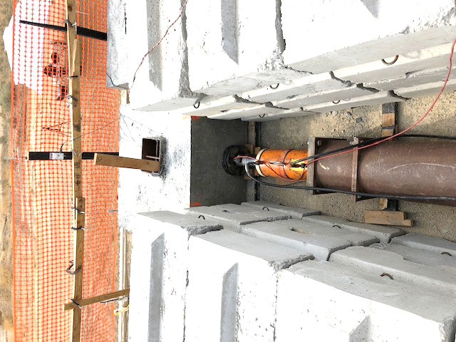

Fig. 1 Photo of a pile cap being loaded laterally with a hydraulic jack. Pre-cast concrete blocks provide surcharge to simulate the weight of the approach fill on the reinforcing strips.

Lateral pile head load versus deflection curves for each of the four fixed-head pile load tests are shown in Fig. 2. There is very little reduction in lateral resistance between the pile at 5D and the pile at 4D as would be expected based on previous lateral pile load testing with the free-head piles. However, there is a significant reduction in lateral pile resistance for piles placed closer than 4D behind the wall as predicted by the previous free-head pile load tests. The reduction in resistance becomes greater as the pile is placed closer to the wall as expected. Therefore, the fixed-head test results are in qualitative agreement with previously conducted free-head test results. Additional LPILE analyses will be required to determine if the p-multipliers necessary to account for the reduced pile resistance due to proximity to the wall will be the same as those determined previously for the free-head pile head condition. This evaluation will take place over the next quarter or more.

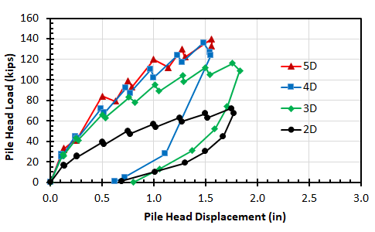
Fig. 2 Measured lateral pile head load versus deflection curves for fixed head test piles located at 2, 3, 4, and 5 pile widths (D) behind the wall. (Results are preliminary based on measurements during field testing.)

Circumstance affecting project or budget. (Please describe any challenges encountered or anticipated that
might affect the completion of the project within the time, scope and fiscal constraints set forth in the
agreement, along with recommended solutions to those problems).

The project expenses are in line with budgeted expenses at the completion of the field testing program.

Potential Implementation:

