TRANSPORTATION POOLED FUND PROGRAM
QUARTERLY PROGRESS REPORT

Lead Agency: Utah Department of Transportation

INSTRUCTIONS:
Project Managers and/or research project investigators should complete a quarterly progress report for each calendar quarter during which the projects are active. Please provide a project schedule status of the research activities tied to each task that is defined in the proposal; a percentage completion of each task; a concise discussion (2 or 3 sentences) of the current status, including accomplishments and problems encountered, if any. List all tasks, even if no work was done during this period.

Transportation Pooled Fund Program Project #  TPF-5(264) |  | Transportation Pooled Fund Program - Report Period:  _ Quarter 1 (January 1 – March 31, 2017)  _ Quarter 2 (April 1 – June 30, 2017)  x Quarter 3 (July 1 – September 30, 2017)  _ Quarter 4 (October 1 – December 31, 2017)
Project Title:
Passive Force-Displacement Relationships for Skewed Abutments

Name of Project Manager(s):  David Stevens | Phone Number:  801-589-8340 |  | E-Mail  davidstevens@utah.gov
Lead Agency Project ID:  FINET 42051, ePM PIN 10903  UDOT PIC No. UT11.406 | Other Project ID (i.e., contract #):  UDOT Contract No. 138123 |  | Project Start Date:  August 13, 2012
Original Project End Date:  September 30, 2014 | Current Project End Date:  December 30, 2018 |  | Number of Extensions:  4

Project schedule status:

_ On schedule X On revised schedule _ Ahead of schedule _ Behind schedule

Overall Project Statistics:
Total Project Budget | Total Cost to Date for Project | Percentage of Work  Completed to Date
$400,000.00 (current contract)  $400,000.00 (total committed) | $236,500.00 | 70%

Quarterly Project Statistics:
Total Project Expenses  and Percentage This Quarter | Total Amount of Funds  Expended This Quarter | Total Percentage of  Time Used to Date
3% | $10,000.00 | 80%

Project Description:

At present, about 40% of the 600,000 bridges in the FHWA database are constructed at a skew angle (Silas Nichols, Personal Communication). There is considerable uncertainty about the passive force on skewed abutments where the passive force develops at an angle relative to the longitudinal axis of the bridge structure. Although current design codes (AASHTO 2011) consider that the ultimate passive force will be the same for a skewed abutment as for a non-skewed abutment, numerical analyses performed by Shamsabadi et al. (2006) indicate that the passive force will decrease substantially as the skew angle increases. Reduced passive force on skewed abutments would be particularly important for bridges subject to seismic forces or integral abutments subject to thermal expansion. Unfortunately, there have not been any physical test results for skewed abutments reported in the literature which could guide engineers in making appropriate adjustments for skewed conditions. Nevertheless, some field evidence has clearly shown poorer performance of skewed abutments during seismic events and distress to skewed abutments due to thermal expansion (Shamsabadi et al. 2006, Steinberg and Sargand 2010).

This study builds on previous pooled fund testing conducted by Rollins and his students at BYU to evaluate passive force-deflection relationships for non-skewed abutments (TPF-5(122), Dynamic Passive Pressure on Abutments and Pile Caps, Rollins et al, 2010). The test facilities can readily be modified to allow for the test program with relatively small additional costs because of the test fixtures (reaction shafts, reaction walls, and pile supported cap) which are already constructed at the site. Results from this study can be compared with previous testing to assess overall performance.

Four objectives are outlined for Phase I of this study:
- Determine static passive force-displacement curves for skewed abutments with and without wingwalls from large scale tests.
- Provide comparisons of behavior of skewed abutments with that of normal abutments.
- Evaluate the effect of wingwalls on skewed abutment response.
- Develop design procedures for calculating passive force-displacement curves for skewed abutments.

Phase II objectives focus on passive force-deflection relationships for Controlled Low-Strength Material (CLSM) (a.k.a. flowable fill, cellular concrete, etc.) backfill and the influence of skew angle and rotation.

Phase I tasks for this study include:
I-1. Literature Review and Collection of Existing Test Data
I-2. Perform Laboratory Passive Force-Deflection Tests on 2 ft High Wall with Skew Angles of 0º, 15º, 30º, and 45º
I-3. Perform Field Passive Force-Deflection Tests on 5.5 ft High Wall with Skew Angles of 0º, 15º, and 30º and Transverse Wingwalls
I-4. Perform Field Passive Force-Deflection Tests on 5.5 ft High Abutment with Skew angles of 0º, 15º, 30º and MSE Wingwalls
I-5. Calibrate Computer Model and Conduct Parametric Studies
I-6. Preparation of Final Report
I-7. Perform Additional Field Passive Force-Deflection Tests on 5.5 ft High Abutment with a Skew Angle of 45º with and without MSE Wingwalls
I-8. Perform Field Passive Force-Deflection Tests on 3.0 ft High Unconfined Backfill with Skew Angles of 0º and 30º
I-9. Perform Field Passive Force-Deflection Tests on 5.5 ft High Pile Cap with Concrete Wingwalls and Skew Angles of 0º and 45º
I-10. Perform Field Passive Force-Deflection Tests on 3.5 ft High Unconfined Gravel Backfill with Skew Angles of 0º and 30º
I-11. Perform Field Passive Force-Deflection Tests on 3.5 ft High GRS Gravel Backfill with Skew Angles of 0º and 30º
I-12. Present the Results of the Study at TRB and AASHTO Meetings

Phase II tasks for this study include:
II-1. Conduct literature review to define typical characteristics of CLSM backfill
II-2. Perform lab-scale passive force test with CLSM
II-3. Conduct large-scale passive force field tests with CLSM
II-4. Perform large-scale passive force tests with rotation and longitudinal displacement
II-5. Validate or calibrate computer models
II-6. Develop simplified design models to simulate observed performance
II-7. Prepare final report with design examples for typical cases
II-8. Disseminate results and work with sponsors and AASHTO to implement findings into future codes

Dr. Kyle Rollins of BYU is the Principal Investigator for this research project. Individual task reports will be prepared for Tasks I-1 through 5 and I-7 through 11, and for Tasks II-1 through 6, when these are completed. Phases I and II will have separate final reports. Two in-person meetings with the multi-state technical advisory committee (TAC) were held in Salt Lake City, Utah during the project. Other TAC meetings will be tele-conference or web meetings.

Progress this Quarter (includes meetings, work plan status, contract status, significant progress, etc.):

Task I-1 – 100% complete.
Task I-2 – 100% complete.
Task I-3 – 100% complete.
Task I-4 – 100% complete.
Task I-5 – 80% complete. Continued work on RC Wingwall case.
Task I-6 – 50% complete. Progress was made on multiple draft final reports to be published. UDOT and the TAC continued reviewing draft final reports. Planned list of final reports is as follows:
- Passive force-deflection behavior of 5.5 ft skewed abutments with transverse wingwalls (45 degree skew tests added)
- Passive force-deflection behavior of 5.5 ft skewed abutments with longitudinal MSE wingwalls (45 degree skew tests added)
- Passive force-deflection behavior of 3 ft skewed abutments with transverse wingwalls (larger width-to-height ratio tests) – draft received
- Passive force-deflection behavior of 5.5 ft abutments with longitudinal reinforced concrete wingwalls – draft received
- Passive force-deflection behavior of 3.5 ft gravel and Geosynthetic Reinforced Soil (GRS) backfill with transverse wingwalls – draft received
- Computer model calibration and parametric studies, Part 1 – Passive force-deflection modeling with no wingwall – draft received
- Computer model calibration and parametric studies, Part 2 – Additional modeling with longitudinal reinforced concrete wingwalls, 45 degree skew, two-lane highway
- Summary report on passive force-deflection behavior of skewed abutments (short report up to 20 pages)
Task I-7 – 80% complete. Continued data analysis and worked on task report.
Task I-8 – 90% complete. Draft final report for this task is complete.
Task I-9 – 90% complete. Draft final report for this task is complete.
Task I-10 – 90% complete.
Task I-11 – 90% complete. Combined draft final report for Tasks 10 and 11 is complete.
Task I-12 – 80% complete.

Task II-1 – 100% complete.
Task II-2 – 90% complete. Draft task report was shared with the TAC for review.
Task II-3 – 90% complete. Draft task report was shared with TAC for review.
Task II-4 – 80% complete. Field tests have been completed. Progress was made on task report.
Task II-5 – Computer models are being incorporated in the other Phase II reports.
Task II-6 – Simplified design models are being incorporated in the other Phase II reports.
Task II-7 – None.
Task II-8 – None.

TAC Meetings – None this quarter.
Contract – No changes this quarter.

Anticipated work next quarter:

Task I-1 – None.
Task I-2 – None.
Task I-3 – None.
Task I-4 – None.
Task I-5 – Continue work on RC Wingwall case.
Task I-6 – Continue work on multiple draft final reports to be published, including UDOT and TAC reviews. Combine portions of other task reports for the Final Summary Report.
Task I-7 – Complete the draft final report for this task.
Task I-8 – Revise the draft final report for this task based on TAC feedback.
Task I-9 – Revise the draft final report for this task based on TAC feedback.
Task I-10 – Revise the draft final report for this task based on TAC feedback.
Task I-11 – Revise the draft final report for this task based on TAC feedback.
Task I-12 – Refine proposed code changes with the TAC in preparation for 2017-2018 interaction with AASHTO SCOBS. Prepare to publish a peer-reviewed paper on the study as a reference that could be noted in the code.

Task II-1 – None.
Task II-2 – Receive TAC review comments on the task report and update the report.
Task II-3 – Receive TAC review comments on the task report and update the report.
Task II-4 – Complete work on the task report and share with TAC for review.
Task II-5 – Continue incorporating computer models in the other Phase II reports.
Task II-6 – Continue incorporating simplified design models in the other Phase II reports.
Task II-7 – None.
Task II-8 – None.

TAC Meetings – Plan to hold a web conference TAC meeting in November or December 2017 to discuss new results, report reviews, and implementation.

Contract – No revision planned.

Significant Results:

During this quarter work has focused on completing all the plots associated with the tests involving 0 and 30º skew with sand backfill where the load was inclined to allow for lateral displacement. The rotation was 0.3 radians which is considered typical from skewed abutment geometries according to studies by Ian Buckle and Univ. of Nevada.

Surface Heave

Before the 0° and 30° skew tests were performed, a 2 ft by 2 ft grid was painted onto the surface of the backfill. Additional gridlines were painted at 1 ft intervals in the first 4 ft behind the pile cap because more movement was expected in that area. Figures 1 and 2 show the grid line layout for the 0° and 30° skew tests. The grid points were surveyed using an auto level before and after the test was conducted. The surface heave at each grid point was calculated by taking the difference of the elevations from before and after the test. These heave values were then entered into ArcMap to create heave contours using the kriging method. The heave contours and surface cracks for the 0° and 30° tests are presented in Figure 3 and 4. The same heave interval was used for both figures so they can be compared against each other.

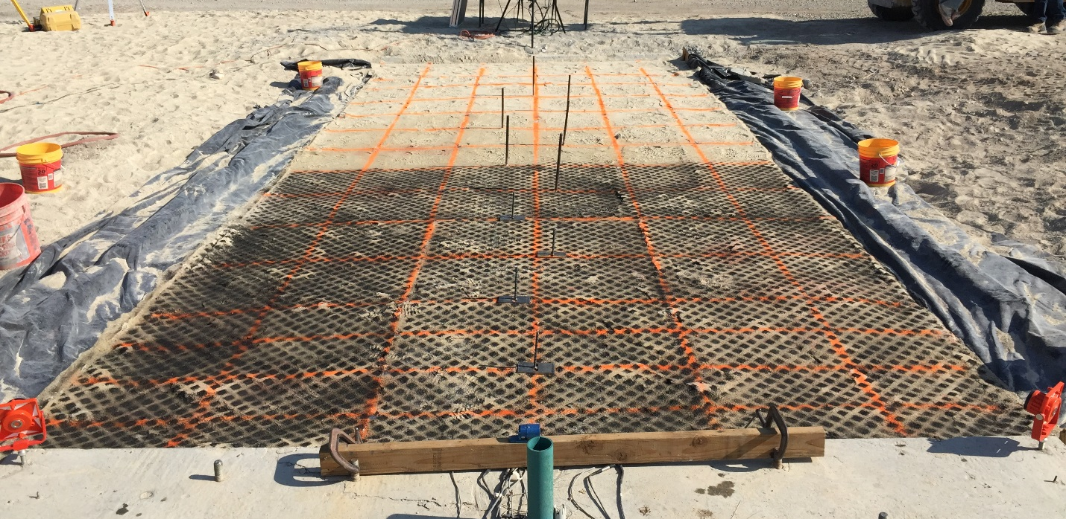
Figure 1: Photo of the grid line layout for the 0° test.

Figure 2: Photo of the grid line layout for the 30° test.

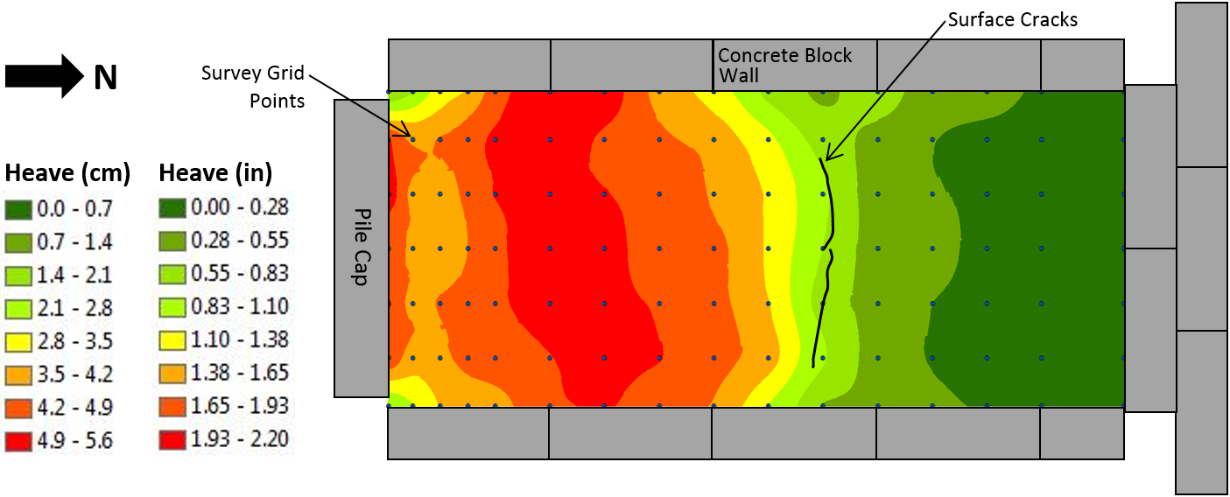
Figure 3: Heave contours and surface cracks for non-skewed abutment.

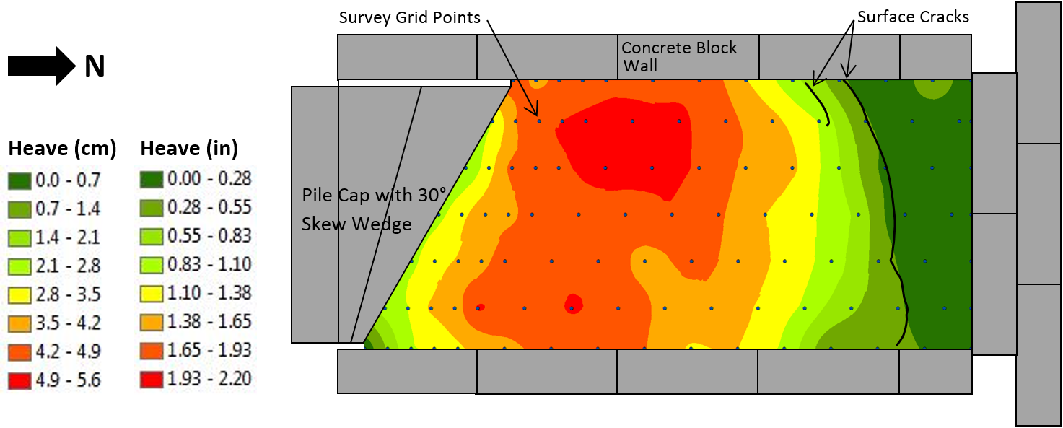
Figure 4: Heave contours and surface cracks for 30° skewed abutment.

For the non-skewed test, Figure 3 shows that the greatest heave (1.93-2.20 inches) occurred in the area between 4 and 8 feet away from the pile cap but significant heave also occurred at the pile cap-soil interface. Heave contours were relatively uniform across the width of the backfill. Surface cracks, which define the location where the failure surface day-lighted, formed almost uniformly across the backfill about 16 feet away from the pile cap. There was somewhat less heave near the corners of the pile cap relative to the rest of the backfill across the face of the cap. For the 30° skew test, Figure 4 shows that the greatest soil heave occurred on the acute side of the skew wedge in the area between 4 and 8 feet from the wedge. This is interesting because there was more force being applied to the pile cap on the obtuse side due to the inclined loading applied in this test. The surface cracks did, however, appear to be affected by the inclined loading. The failure surfaced day-lighted at approximately 22 feet away from the obtuse side of the skew wedge and only 14 feet away from the acute corner of the cap. As was observed for the horizontal displacement contours shown in the previous quarterly report, there is a zone of soil located in the pocket between the wedge and the wingwall where soil heave appears to be restricted as shown in Figure 4. This appears to be the same zone of soil which essentially moved with the pile cap and reduced the effective skew angle of the soil-pile cap interface. This reduction in effective skew angle led to greater passive force that was observed in previous tests without parallel wingwalls. Numerical analyses conducted with the computer model PLAXIS3D suggest that this effect is less important as the width of the pile cap (or abutment) increases so that the pocket of soil represents a much smaller portion of the entire width of soil. We expect to have the numerical analyses completed to document this effect for the next quarterly report.

Circumstance affecting project or budget. (Please describe any challenges encountered or anticipated that
might affect the completion of the project within the time, scope and fiscal constraints set forth in the
agreement, along with recommended solutions to those problems).

Potential Implementation:

UDOT is considering early adoption of the skew reduction factor for passive force based on the laboratory and field test results. In June of 2013, 2014, and 2016, Dr. Rollins presented the results of the research to date to technical committees at the AASHTO Subcommittee on Bridges and Structures Annual Meetings in Oregon, Ohio, and Minnesota on behalf of the project TAC. This interaction is intended by the TAC and Dr. Rollins to prepare the way for design code revisions once the research is completed. Caltrans is also promoting use of the research results in their design methods. Dr. Rollins is proposing changes to the AASHTO code, and we will continue to promote these to the TAC and AASHTO SCOBS.

