August 23, 2022

Kevin Ward
Division Administrator
Federal Highway Administration
3220 West Edgewood Drive, Suite H
Jefferson City, Mo 65109

Dear Mr. Ward:

The Missouri Department of Transportation (MoDOT) would like to request Federal Highway Administration (FHWA) approval to establish a pooled fund study using 100 percent SP&R funding for solicitation # 1583 - Missouri/Kansas 2022 Peer Exchange Pooled Fund.

The establishment of this pooled fund has already been approved for inclusion into the MoDOT work program. This step will establish the pooled fund using 100 percent SPR Funding.

Your approval to establish this pooled fund at 100 percent SPR funding is greatly appreciated. Should you have any questions, please let me know. You may contact me at 573-526-3636 or via e-mail at Jennifer.Harper@modot.mo.gov.

Sincerely,
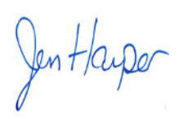
Jen Harper
Research Director

