**Progress Report – 3/31/2022**

**Title:** Assessment and Repair of Prestressed Bridge Girders Subjected to Over-height Truck Impacts Pooled Fund Project

**Project Number:** TR202011

**Principal Investigator (PI):** Mohamed ElGawady PhD (PI)

**Co-PI(s):** William Schonberg PhD, PE (Co-PI)

|  |  |  |  |
| --- | --- | --- | --- |
| **Award date:** | **1/1/2021** | | |
| **Scheduled completion date:** | **12/31/2023** | **% of project completed to date:** | **35%** |
| **Total budget:** | **$**755,000 | **% of budget expended to date:** | **38%** |
| **Draft report due:** | **9/30/2023** | **Final report due:** | **12/1/2023** | |

Provide a short description of the **work currently underway**.

*Use* *additional notes section* *if you need to provide more information.*

While not part of the tasks, it is essential to establish a good team to carry out the research tasks.Interviewing more than 30 potential students were carried out and four graduate students were selected and the hiring process started.

***Task 2. Experimental testing of bridge girders subjected to lateral impacts:*** There is a delay in receiving the small size setup and the wheels for the full-scale cart. The small size test setup will be shipped on April 15th. However, all required pieces for the full-scale test set up arrived to Rolla (Figs. 1-2). The installation of the test setup for the large-scale testing is moving forward. HSS were used as cross ties for the impact rail. The cross ties were drilled and installed in the laboratory strong floor. Steel H-beams and rails were also drilled and fixed on top of the cross ties. Four vertical stubs were fabricated using W-shaped cross sections. Plates were fixed atop of the columns having inclined angles to accommodate the H-shaped beams and the rails. The plates were also drilled to fix the rail. Currently, the cured segment of the rail is being manufactured. The cart is being manufactured awaiting the arrival of the wheels. The instrumentation for the testing will be finalized as well.

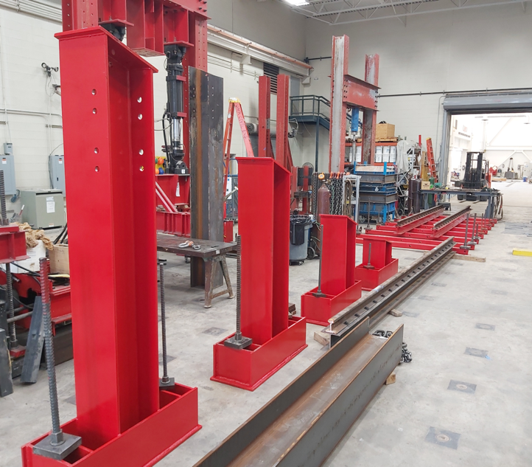

***Task 3. Determine the residual flexural and shear strengths of the damaged bridge girders***

The current investigation primary goal is to address the gap in literature on prestressed girders subjected to impact loads in terms of residual bending capacity for damaged beams. Furthermore, the tested girders after impact will be repaired and will be vertically loaded statically to determine the girder residual capacity and identify the failure modes. The flexural capacity was computed using the ACI 318-19 method. The shape of the test setup and beam flexural capacity calculations are show at the end of this report.

***Task 5: Develop finite element models for the beams.*** Three finite element (FE) models have been developed and validated using previous experimental studies. The main goal is to prepare a calibrated FE model that is capable of capturing the prestressed girder response under both static and impact loading conditions. The model should be able to predict the prestressed girder mode of failures such as flexural, shear, and flexural-shear modes. The first model was validated using the experimental study by Gangi et al. (2018) for a 44 ft long AASHTO girder type III failed mainly in flexural mode of failure. The second model was validated using the experimental study by Chehab et. al. 2018 by testing AASHTO type II girder that failed due to shear. The previous two models were tested under static loading. The third model was validated against the impact loading experimental test by the University of Tennessee – Knoxville by Mitchell et al. (2015) of AASHTO type I girder. All figures are show at the end of this report. Modeling of a full bridge is also continued as shown at the end of this report.

***Task 7: Deliverable.*** A first draft for the literature review chapter I the final report is attached to this report. The write up of the experimental work and finite element chapters are in progress.

Provide a short description of the **noteworthy activities/accomplishments** during this reporting period.

*Use* *additional notes section* *if you need to provide more information.*

***Task 1: Literature review.*** This task was 100% completed.

***Task 2. Experimental testing of bridge girders subjected to lateral impacts:*** Several delays occurred due to the current supply chain issues. However, manufacturing the test setup is moving forward as shown at the end of this report.

To prepare for testing, an experimental database of 140 reinforced concrete beams collected by Zhao et al 2019, was used to predict the peak impact force (PIF) . The database contains RC beams with clear span ranges from 1500 mm to 6000 mm with a mean span value of 2400 mm. Polynomial regression was used to plot the kinetic energy as a function of the PIF as shown at the end of this report. The figure was used to qualitatively determine the PIF for the full-scale and small size prestressed girders. A maximum predicted peak impact force of 1250 KN (281 Kips) is estimated for the test specimens.

Data measurements and acquisition for the impact testing were designed. Two load cells will be used to record the girder positive (push) reactions due to the impact load at both ends and another two load cells for the negative (pull) reaction due to the girder rebound.

### Up to eleven wire strain potentiometers will be installed along the length of each beam spaced at 4 ft to measure the out-of-plane deformation of the girders. In addition, five strain potentiometers will be used to measure the vertical displacements.

### Up to fourteen accelerometers of up to 2000 g with a 0-150 HZ frequency range will be installed on each beam along the girder span to obtain the acceleration profile of the girder due to impact load as shown in the figure at the end of this report. The accelerometers are mounted to the top flange of each girder and closely spaced at every 4 ft. The acceleration profiles will be used for the validation of the finite element models. The inertial forces distribution of reinforced concrete beams is often assumed to be linear.

### Several strain gages will be used to measure the longitudinal strains in the girder's different components. Concrete vibrating strain gages will be used at one-third and mid-span at the upper and lower flanges to measure the extreme concrete fiber strain. Strain gages to monitor the strain distribution in the steel ties will be also used at different locations along the girder span.

A high-speed video camera, with 2000 frames per second will be used to record the impact incident. Also, to accurately acquire the impact cart speed, a radar gun will be used for this purpose.

## 

## *Impactor head design*

During this period, the research team designed also the impactor head. An accurate prediction of the impact demand is one of the most important parameters in this investigation. The impactor head was designed to have a flat head along the front part of the impactor cart to make a more realistic model of a semitrailer head with a uniformly distributed load rather than a concentrated load. A 5-axle semitrailer has a width of about 98” (Report, 2015). The impactor head in this experimental work will be approximately 72 inches representing about 70-75% of the actual semitrailer cargo.

The cart is composed of an impact front beam HP10X42 supported by two side beams W12X53 connected to two standard train wheel axels as shown in the figure at the end of this report. A bracing member HP10X42 is used at its mid-span to decrease the unbraced length and prevent the impact beam global buckling. Another cross beam HP10X42 connects the two side support beams which will be used for the cart releasing mechanism from the elevated track. This system was chosen to accommodate the wheels and axels while providing the highest structural resistance to the impact that can be achieved. The dimensions of the cart are 62 inches by 72 inches. A C-channel impactor head (C10 X 30) will be bolted to the front part of the impact cart. The cart was designed to withstand a lateral load of *600 kips* distributed uniformly along the length of the impact beam. This value corresponds to AASHTO’s vehicular collision force for the design of bridge piers against vehicular impact [1]. This value is chosen as an upper-bound conservative value since its basis stem from the collision of a tractor-trailer with a rigid column at 55 mph [2]. The cart will be loaded with concrete blocks producing a gravity load of 11.5 kips.

Identify **issues or problems** that need to be addressed.

*Use* *additional notes section* *if you need to provide more information.*

We finally received the rails and other parts of the test setup except the wheels for the cart. All precast plants are too busy to cast the beams. However, we should start receiving the girders in two months. Another ongoing issue is to bring in the last graduate student as he is international student and has issues with his visa.

Provides dates for when the **next progress report or presentation** due:

**6/30/2022**

|  |
| --- |
|  |
|  |
|  |
|  |
|  |
| **Fig. 1: Track lower segment** |

|  |
| --- |
|  |
|  |
|  |
|  |
|  |
|  |
|  |
|  |
|  |
|  |
|  |
|  |
| **Fig. 2: Inclined segment of the track with the assembled stub columns** |

|  |
| --- |
|  |
|  |
|  |
|  |
|  |
| **Fig. 3: Back stops and concrete supports of the investigated girders** |

|  |
| --- |
|  |
|  |
|  |
|  |
| **Fig. 4: Manufacturing the impact cart** |

|  |
| --- |
| (a) |
| (b) |

**Fig. 5. PIF prediction (a) Kinetic energy, (b) Impact speed**

**Table 1. Predicted peak impact force**

|  |  |  |  |  |  |  |  |
| --- | --- | --- | --- | --- | --- | --- | --- |
| The test | Maximum impact speed (m/s) | Maximum impact mass (Kg) | Maximum kinetic energy (Joul) | Predicted PIF based on impact speed (KN) | Predicted PIF based on impact kinetic energy (KN) | Mean PIF (KN) | Max. PIF (KN) |
| Small size precast beams | 5. 50 | 300 | 4704 | 1000 | 750 | 875 | 1000 |
| Large size precast girders | 6.70 | 5000 | 112225 | 1250 | 940 | 1095 | 1250 |

**Table 2. Summary of the proposed load cells**

|  |  |  |  |  |
| --- | --- | --- | --- | --- |
| Location | Predicted force (kips) | Load cell capacity | Qty | Measurement |
| Girder vertical support | - | 450 | 2 | Vertical reaction due to uplifting restraint |
| Girder mid-span | 281 | 450 | 1 | Impact force |
| Girder support Backside reaction | 140 | 450 | 2 | Positive support reaction |
| Girder front side | 140 | 450 | 2 | Negative support reaction |

|  |  |
| --- | --- |
|  |  |
|  | |
| **Figure 6. Load cell locations** | |

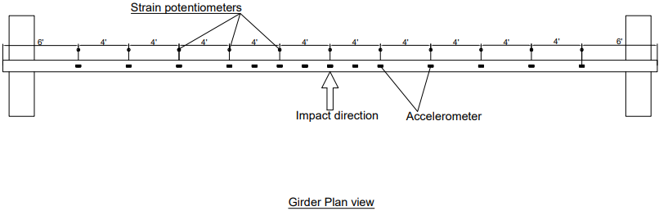

**Figure 7. String potentiometers and accelerometers profile**

|  |
| --- |
| **Figure 8. Strain gage locations** |
| **Figure 8. Strain gages locations** |

**Table 3. Summary of the planned measurements**

|  |  |
| --- | --- |
| Item | Qty/girder |
| Load cells (450 kips) | 8 |
| Wire Potentiometer | 11 |
| Accelerometer | 14 |
| Steel tie strain gage | 84 |
| Strand strain gage | 96 |
| Concrete strain gage | 6 |
| High-speed video camera | 1 |
| Radar gun | 1 |

### Design of the flexural test setup

### The flexural capacity of each beam was determined per ACI 318-11 simplified method as follows:

Number of strands = 50

Aps/strands = 0.08 in2  ( for strand diameter of 0.375 inch )

Aps (total) = 50 * 0.08 = 4 in2

Distance form top compression fiber to strands centroid (dp)

Assume a deck thickness = 8.75 in

dp = 53.75- 6.5= 47.25 in

Top flange width (bf) = 16 in

Prestressing strands ratio, =

Fpy = 0.9 * 250 = 225 Ksi, Fpy / Fpu  = 225/250 = 0.9 , ɣp  = 0.28

Rectangular stress block factor 𝛽1

F’c = 6.65 Ksi

𝛽1  = 0.85 – 0.05(f’c – 4 ksi) ≥ 0.65 for f’c ≥ 4 Ksi

= 0.85- 0.05(6.65-4) = 0.718

Strand stress at ultimate for bonded tendons ( No non- prestressed reinforcement was used)

, 𝛽1  = 0.718 ACI 318-19 (20.3.2.3.1)

From equilibrium in section forces

C = T

0.85 F’c bc a = Aps fps

Compression block depth (a) = < (hflange  = 20.25) in flange

Depth of neutral axis C :

38,879 Kips.in = **3239 Kips.ft**

### 

### Check prestressing strand strain

>

ACI 318-19 ( 21.2.2.2)

All prestressed RFT : (steel yield strain)

Flexural failure and section is Tension-controlled

**Cracking moment**

Mcr =

Modulus of rupture

H= 53.75in

dp = 53.75 -6.5 = 47.25 in

Ag  = bh = 615.5 in2

Centroid location from top fiber (Yct)

Gross moment of inertia (Ig )

e = 26.3-6.5 = 19.8 in

**Prestressing losses by AASHTO LRFD**

**Initial stress in tendons immediately prior to transfer**

fp + 𝞓fpES  = 0.75fpu (S5.9.5.3)

= 0.75 * 250 = 187.5 Ksi

**Elastic shortening losses (SC 5.9.5.2.3a-1)**

Mg = Girder midspan moment due to member self-weight

Girder self weight = 615.5 in2 * (44 ft * 12 ft/in) * 150 Ib/ft3 *(1/12^3) = 28210 Ibs = 28.2 Kips

= 28.2 / 44*12 = 0.053 Kips/in

Mg = 0.053 * (44*12)^2 / 8 = 1861 Kips. in

**Prestressing stress at transfer**

fpt  = stress immediately prior to transfer - 𝞓fpES

= 187.5 – 17.06 =170.48 Ksi

**Prestreeing force at transfer**

Pt = Nstrands Aps fpt = 50 * 0.08 * 170.48 = 681.92 Kips

Initial prestress loss = 1-170.48/184.5 = 7.59 %

**Shrinkage losses (S5.9.5.4.2)**

𝞓fpSR = (117-1.03H) (MPa)

Where H is the average annual ambient relative humidity % = 70%

𝞓fpSR = (117-1.03*70) = 44.9 (MPa) = 6.51 Ksi

**Creep losses (S5.9.4.3-1)**

𝞓fpCR = 12 fcgp - 7.0 𝞓fcdp Mpa≥ 0

Where fcgp is the concrete stress at the c.g of the prestressing strands at transfer. 𝞓fcdp is a change in concrete stress at c.g of prestressing strands due to permanent loads. It depends on the effect of the weight of the deck, diaphragm, haunch and parapet. For simplicity will be assumed as 20% of fcgp

𝞓fpCR = 12*3.08*6.89 Ksi/MPa- 7.0 *0.2*3.08 *6.89 Ksi/MPa = 224.9 Mpa = 32.6 Ksi ≥ 0

**Relaxation losses (S5.9.5.4.4c) for stress-releievd strans**

𝞓fpR2 = 138 – 0.4 𝞓fpES – 0.2 (𝞓fpSR + 𝞓fpCR ) (MPa)

= 138 - 0.4 * 17.06*6.89 – 0.2*( 44.9 +224.9) = 37 Mpa = 5.37 Ksi

**Total loss after transfer**

𝞓fpT  = 𝞓fpES  + 𝞓fpSR + 𝞓fpCR + 𝞓fpR2

= 17.06 + 6.51 + 32.6 + 5.37 = 61.54 Ksi

**Actual effective prestress after all losses**

Max fpe  = 0.8 fpy = 0.8 * 0.9 *250 =180 Ksi

fpe  = 0.75 fpu - 𝞓fpT  = 0.75*250 – 61.54 = 125.9 Ksi < Max fpe (180 Ksi) Ok

> 0.5fpy (112.5 Ksi)Ok

Effective force in prestressing Ppf  = Ap fpe  = 4 * 125.9 = 503.6Kips

Bottom fiber stress ( fcb )

=

**Figure 9. A 3D model for flexural test setup**

**Maximum Internal Forces:**

Mult = 4.5 kip.in Maximum Bending Moment

Vult = 0.5 kip Maximum Shear Force

Section considered based on the available dimensions

Choice of Section: **C10X20**

Required data

tw = 0.375 in

w = 12 in

bf = 3 in

tf = 0.375 in

ry = 3.67

Zx = 19.4

E = 29000 ksi

Fy = 50 ksi

**Design For Flexure:**

**For flanges:**

Bflange/2tflange= 3/2*0.375 = 4

From Table 4.1a, case 10 (i.e flanges of channels)

0.38*sqrt(E/Fy) = 0.38*sqrt(29000/50) = 9.15

2.99 < 9.15

Flange is non-compact

**For web:**

hweb/tweb = 12/0.375 = 32

From Table 4.1b, case 15 (i.e webs of doubly symmetric channels)

hweb/tweb = 32 < 3.76*sqrt(E/Fy) = 90.55

The web is non-compact

Section is non-compact

Chapter **F**, Section **F2** Applies

The nominal flexural strength, Mn, shall be the lower value obtained according to the limit states of *lateral-torsional buckling* and *yielding.*

Design Limit State of Lateral Torsional Buckling:

Lb = 36 in.(req) <Lp = 1.76*ry*E*Fy = 155.55 in. AISC -F2-5

The design limit state of LTB does not apply

Yielding:

Mn ==Fy Zx = 50*(19.4) = 970 kip.in AISC -F2-1

Φ = 0.90 (LRFD)

Φ Mn = 873 kip.in

Given section is adequate and efficient

**Design For Shear:**

From Section G2

Vn = 0.6Fy AwCv = 135 AISC -G2-1

Since hweb/tweb = 32 < 1.1*sqrt(Kv*E/Fy) = 61.2 AISC-G2-3

Cv = 1.0

Kv=5.34 (since web is without stiffeners)

Φ Vn = 0.9*135=121.5 > 0.5

The given section satisfies the required moment and shear stress; thus, a section is adequate.

|  |  |  |
| --- | --- | --- |
|  | |  |
|  | |
|  |  | |

**Figure 10. The Experimental testing by Chehab et. al. 2018 and the FE results**

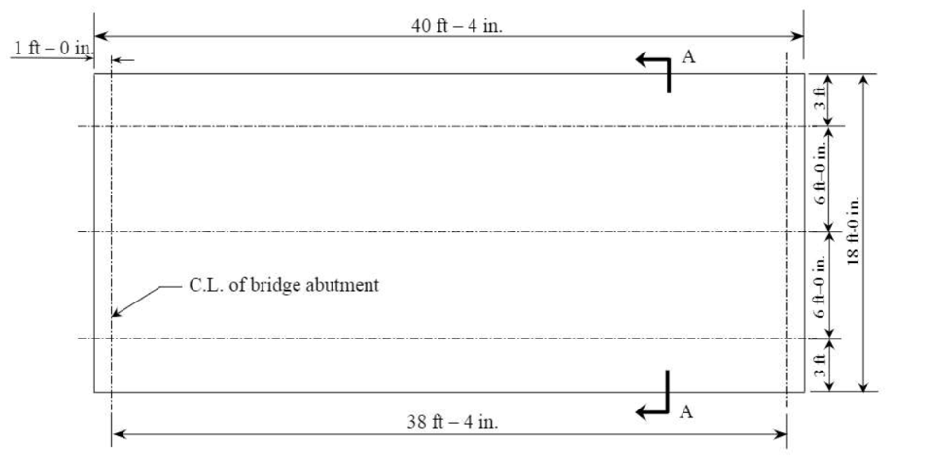

**a)** Bridge layout

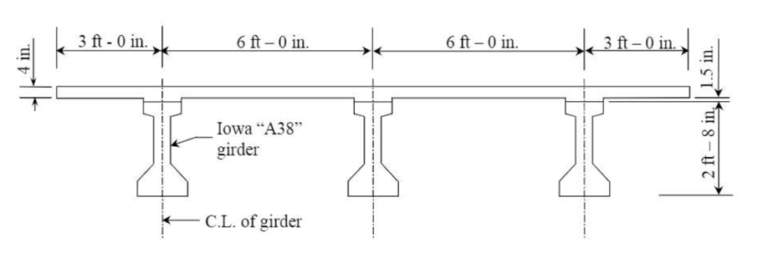

**b)** Cross-section details

**Figure 11. Bridge details; a) layout, b) cross-section**

**Reinforced Concrete Deck:**

Concrete SOLID ELMS + MAT_CSCM

RFT BEAM ELMS + MAT_PLASTIC_KINEMATIC

Coupling **shared nodes** or **CLIS**

**Prestressed Girders:**

Concrete SOLID ELMS + MAT CSCM

Strands BEAM ELMS + MAT_PLASTIC_KINEMATIC

Apply prestressing force using Temperature

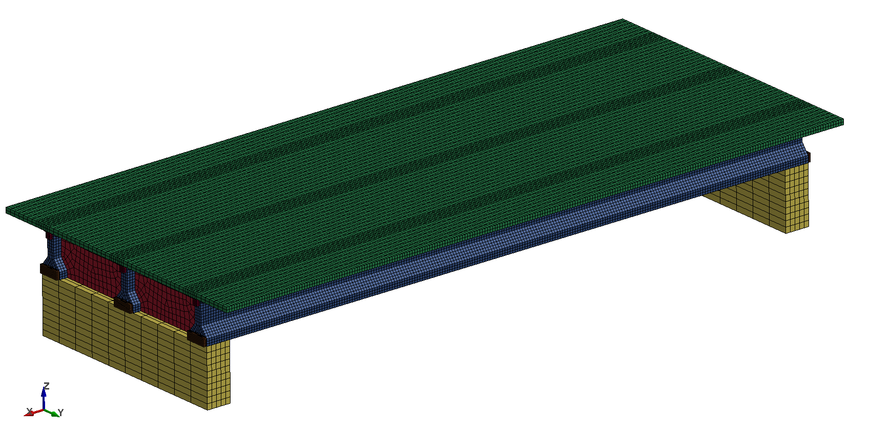

**Figure 12: Full-scale finite element bridge model**

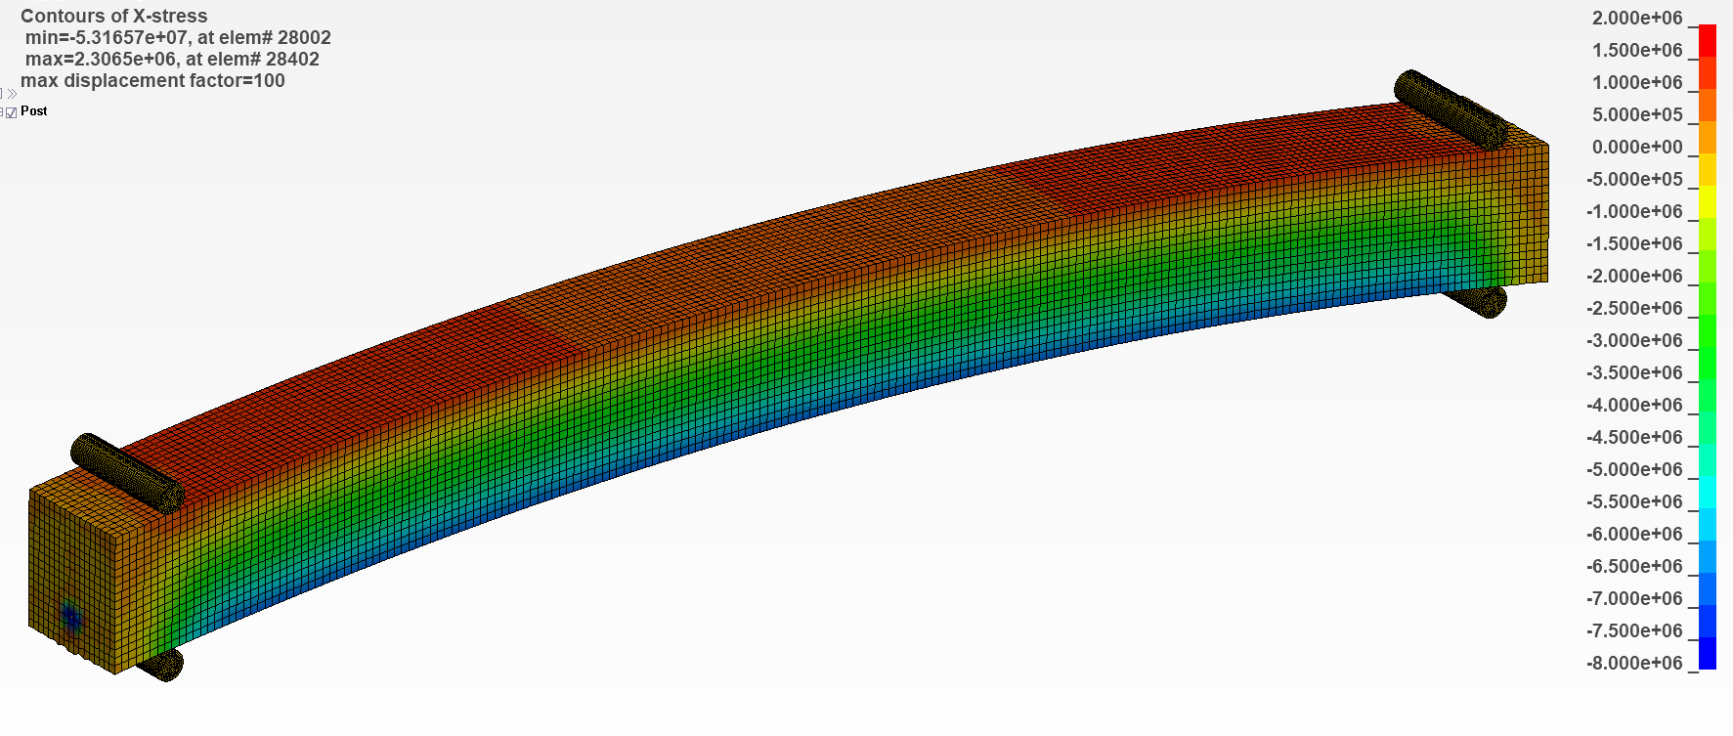

1. Proposed prestressing method

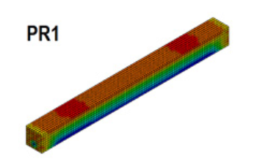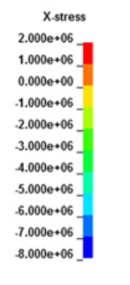

1. Husain’s (2019) model

**Figure 13: Validation of the prestressing force method;  
a) the proposed method, b) Husain’s (2019) model**

1. Compressive stresses at midspan
2. Tensile stresses at midspan

**Figure 14: Mesh Sensitivity analysis**

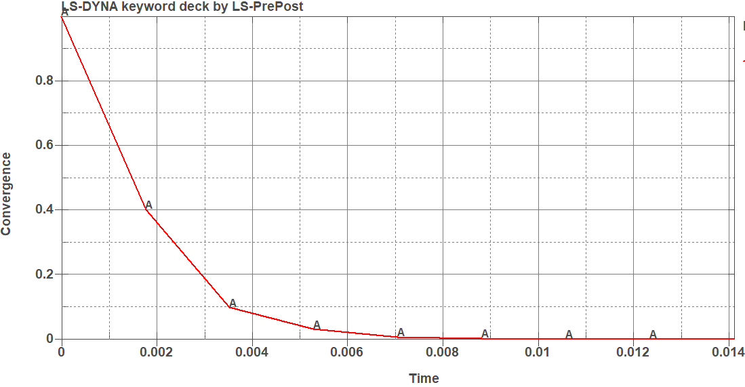

1. Convergence

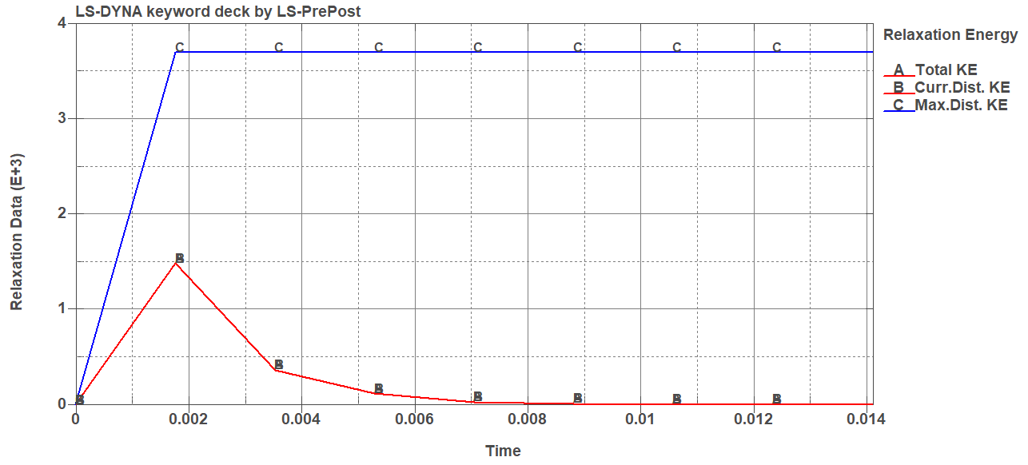

1. Distortion vs total energy

**Figure 15: Dynamic Relaxation results**

1. Load-Deflection results at the midspan of the exterior girder
2. Load-Deflection results at the midspan of the interior girder

**Figure 16: FE model validation**

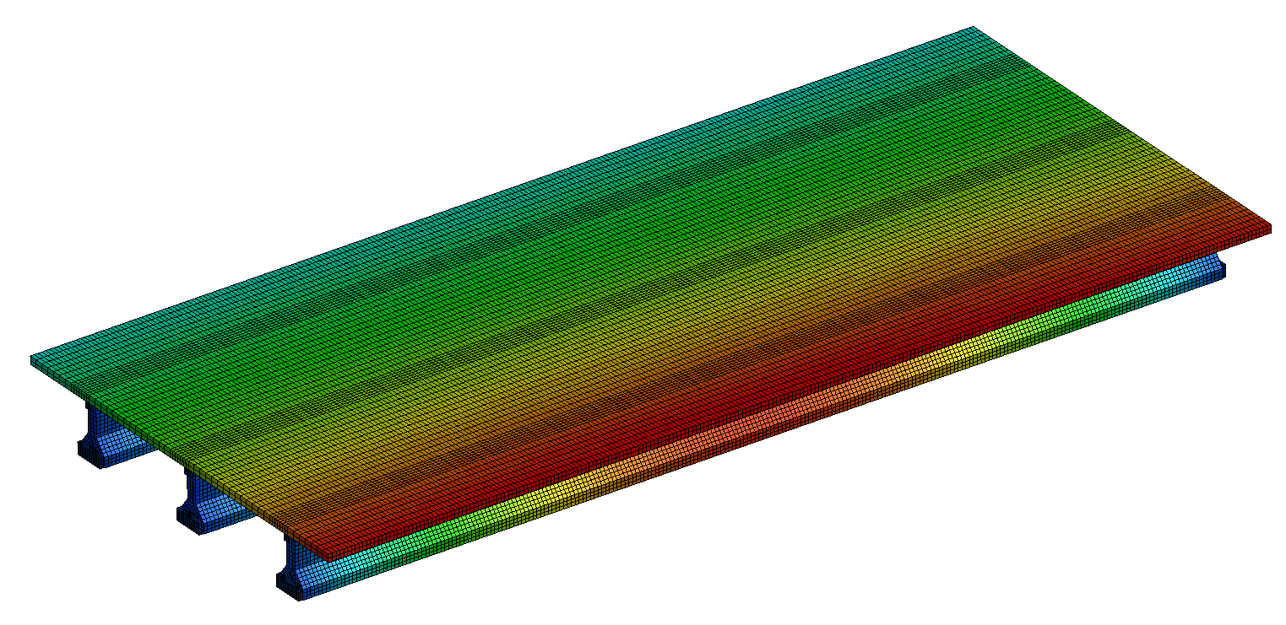

**Figure 17: Deflection of the bridge subjected to a vertical load at the exterior mid-span** girder