**Material Properties**

**1. Backfill Soil**

**1.1 Soil Gradation**

Sieve analysis was performed to characterize the particle size distribution of UCSD sand. The gradation curve is shown in Figure 1. This sand has a coefficient of uniformity  = 6.1 and a coefficient of curvature  = 1.2, and the average grain size  is approximately 0.85 mm. The UCSD sand is classified as a well‑graded sand (SW) according to USCS (Unified Soil Classification System).



Fig. 1 Gradation curve.

**1.2 Compaction Behavior**

The maximum and minimum dry unit weights are  = 17.73 kN/m3 and  = 14.41 kN/m3, and the corresponding minimum and maximum void ratios are  = 0.467 and  = 0.804 using a specific gravity  = 2.65. Standard proctor test was performed to evaluate the compaction behavior. The compaction curve, shown in Figure 2, is relatively flat, as expected for sand. The maximum dry unit weight  is 17.72 kN/m3 at a moisture content of approximately 13.5%.



Fig. 2 Compaction curve.

**1.3 Compressibility**

An oedometer test was conducted to investigate the compressibility behavior of this sand. The one-dimensional compression curve is shown in Figure 3. The compression and recompression indices are  = 0.0061 and  = 0.0012, respectively.



Fig. 3 One-dimensional compression curve.

**1.4 Shear Strength**

A series of consolidated-drained (CD) triaxial tests were performed on the UCSD sand to measure the shear strength and volume change behavior. Conventional triaxial tests were performed at confining stresses of 7 kPa, 34 kPa, 69 kPa, 138 kPa, and 207 kPa, respectively, which encompass the stress range for both reduced-scale and full-scale MSE bridge abutment models.

The specimens were compacted within the latex membrane held by a split-wall compaction mold at a relative density of 90%. After compaction, vacuum was applied to the soil specimen, and the split mold was removed. The sand specimens had a diameter of 71.1 mm and height of 142.2 mm. The soil specimens were saturated using backpressure and the confining stress was applied prior to shearing. The shear force was applied using a constant strain rate of 1.0%/min, and the volume change reading was taken during shearing.

The stress-strain and volume change responses for different confining stresses are shown in Figure 4. The peak shear strength for each test were used to define the Mohr-Coulomb failure envelope. Mohr circles are shown in Figure 5, along with the best-fit failure envelope with a zero cohesion for the UCSD sand. The friction angle is 46.3°, which is consistent with the friction angle calculated using Modified Mohr-Coulomb diagram, shown in Figure 6. The effect of confining stress on dilation angle is shown in Figure 7. A decreasing trend with increasing confining stress is observed, as expected.

 

(a) (b)

Fig. 4 Triaxial test results: (a) deviator stress vs. axial strain; (b) volumetric strain vs. axial strain.



Fig. 5 Mohr circles and failure envelope.



Fig. 6 Modified Mohr-Coulomb diagram.



Fig. 7 Effect of confining stress on dilation angle.

**2. Geogrid Reinforcement**

The geogrid reinforcement used in the reduced-scale shake table tests is a high density polyethylene (HDPE) uniaxial geogrid LH800 from Tensar. This geogrid has a relatively low tensile strength compared to other uniaxial geogrids used in full-scale retaining walls. The aperture size is approximately 120 mm by 27 mm, which is also smaller than typical uniaxial geogrids used in full-scale retaining walls (approximately 470 mm by 22 mm for Tensar UX series).

A series of single rib tensile tests were conducted to evaluate the strength and stiffness of the geogrid. The single rib geogrid specimen used in the tensile test has four junctions (three apertures) and a length of 360 mm. The single rib tensile testing setup is shown in Figure 8.

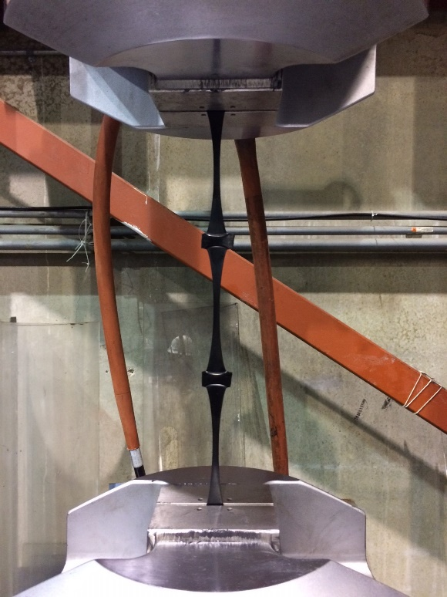

Fig. 8 Single rib tensile test setup.

The tensile tests were performed for three specimens at a strain rate of 10%/min according to ASTM D6637 Method A. The load-strain curves are shown in Figure 9. The results for three tests are consistent and shows the repeatability of the tests. The tensile strength at 5% strain are 531 N, 495 N, and 508 N for the three tests, respectively. There are 37 ribs per unit width, thus the corresponding tensile stiffness values at 5% strain are 393 kN/m, 366 kN/m, and 376 kN/m, with an average stiffness value of 378 kN/m. Considering a scaling factor of 2 for the geometry of the reduced-scale shake table test, the scaling factor for reinforcement stiffness is 4, so the prototype geogrid stiffness would be 1512 kN/m. This is a typical value like for Tensar UX 1700, which is a common geogrid used in full-scale retaining walls. This confirms the choice of the Tensar LH800 as the model geogrid.



Fig. 9 Tensile tests at strain rate 10%/min.

The tensile tests were also conducted at strain rates of 1, 5, 10, 50, and 100%/min to investigate the effect of strain rate. The test results are shown in Figure 10, and indicate that the tensile strength and stiffness both increase with increasing strain rate. Although the geogrid is made of HDPE, which typically does not show a rate effect, the rate effect may be due to the relatively low ultimate tensile strength and softer response compared to other HDPE geogrids used in full-scale retaining walls. The relationship between tensile stiffness at a strain of 2% and the strain rate is presented in Figure 11, and indicates an increase in tensile stiffness with strain rate, ranging from 315 kN/m to 759 kN/m. A similar increase trend in the tensile stiffness at a strain of 5% with strain rate is observed in Figure 12, where the tensile stiffness increases from 243 kN/m for 1%/min to 554 kN/m for 100%/min, which are smaller than the corresponding values at 2% strain. It should be noted that in the small strain range, there are not significant rate effects, so the need to consider rate corrections will likely depend on the magnitude of strains encountered in the shake table tests.



Fig. 10 Tensile tests at different strain rates.



Fig. 11 Effect of strain rate on tensile stiffness at 2% strain.



Fig. 12 Effect of strain rate on tensile stiffness at 5% strain.