Background
MEMBERS
- Connecticut DOT
- Maryland DOT
- Michigan DOT
- Minnesota DOT
- Ohio DOT
- Pennsylvania DOT
- Texas DOT

PARTNERS
- AASHTO
- Federal Highway Administration
Automated Vehicles (AVs) are a disruptive technology that will dramatically change the transportation system, potentially reducing crashes, expanding access, and promoting sustainability, equity and efficiency. With over 41 states actively advancing AV testing, research, policy, and planning, state departments of transportation face challenges understanding what strategies and actions are needed to prepare for this evolution in emerging technology. While many states are advancing strategic plans and roadmaps, strategies vary and ideas of what it means to be implementation ready differ.

Vision

The Automated Vehicle Pooled Fund Study started in 2020 to collaboratively coordinate funding, strategies and research to help state DOTs understand their role in this changing environment, and how to proactively prepare. Ohio DOT is the lead state to help infrastructure owner-operators develop a readiness framework and forum to engage AV industry to advance operations, identify standards, research vehicle-road interactions, support interoperability, understand how to plan for these technologies, and address DOT functional areas in investment, funding, procurement, engagement, partnerships, policy, staffing and other key areas.

Pooled Fund Goals
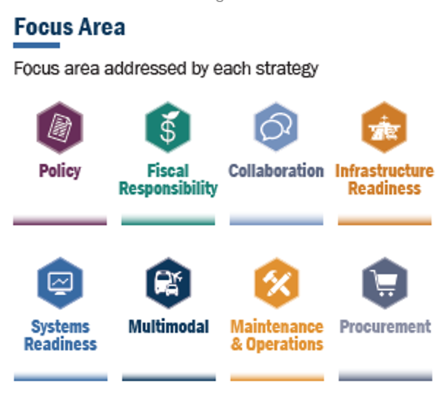
- Infrastructure readiness: What infrastructure investments do DOTs need to be making to plan and prepare for AVs?
- Operations: How does AV impact operations, traffic safety and maintenance?
- Policy frameworks: What laws and policies do states need to enact to develop clear, more uniform policy across regions to avoid a patchwork approach?
- Interstate freight and multi--modal harmonization – How can DOTs advance freight harmonization and interstate networks to support autonomous delivery?
- Workforce development: How do we skill our current and future workforce for new technologies, processes and impacts?
- Communications and engagement: How do we message this work to internal and external stakeholders and engage partners, industry and communities?
- Partnerships: How can infrastructure owner-operators (IOOs) partner with industry, researchers, communities and non-profits to plan for this unknown future?
- Strategic investment: How can IOOs make strategic investments with limited resources that plan for emerging technology and AV innovation?
Early readiness strategies the
Pooled Fund is exploring
- Planning: How should DOTs plan for AV technology in the short and long-term horizons? How can DOTs follow trends and develop shared future scenarios?
- Industry forum: How can we develop a collaborative forum where states together can meet with AV industry to share ideas and learn about industry goals, similar to the CAT Coalition’s IOO-OEM forum.

HOW TO GET INVOlvED
Full pooled fund members pay $50,000 a year to meet monthly, share best practices, develop a DOT readiness strategy and develop an AV industry-DOT forum. All DOTs are welcome to join at any funding level, including opportunities to join at reduced rates. Contact Nick Hegemier at nick.hegemier@dot.ohio.gov to learn more.

