Research Problem Statement

Research Problem Title:
Temporary Traffic Control Advance Warning Sign Placement

Statement of Problem
The MUTCD presents two different methods for determining warning sign spacing, depending on the chapter in the Manual. Guidance in the MUTCD’s warning signs chapter, (Section 2C.05 – Placement of Warning Signs) recommends providing time and distance for Perception-Response Time (PRT) and complex driving situations, stopping distance, or braking distance (1). These distances are based on research and engineering calculations.

MUTCD guidance for Temporary Traffic Control (TTC) warning signs (Section 6C.04 – Advance Warning Area) provides a warning sign spacing table based on classification, facility location, and speed. Further guidance is also provided, but depending on speed, this written spacing guidance sometimes conflicts with the table values. Challenges also arise due to the nature of TTC warning signs. TTC warning signs are typically arranged in a series of three advance warning signs. Warning sign spacing is provided between the work space and closest warning sign and between each warning sign in the series. In urban areas with close intersection or driveway spacing, or in mountainous rural areas, the warning sign spacing is dependent on site conditions rather than calculated distances (1). Compound that with queue lengths and the placement of advance warning signs becomes more complex than the distances shown in the table.

The basis for the recommendations in the MUTCD for TTC warning sign spacing and placement and taper distances is unclear to practitioners and there is a need to determine if the simplified spacing guidance for TTC warning signs is appropriate to provide sufficient warning in TTC zones.

Similarly, the MUTCD presents shifting taper rates that vary significantly for TTC applications as opposed to permanent applications. Shifting taper rates are a distance of L for permanent applications, but only half of L in TTC zones. While it’s likely that the TTC application taper distances are shorter due to space restrictions and limitations in work zones, the basis for the TTC taper length is unclear.

The objective of this research is to consider the differences in spacing guidance and taper length guidance between MUTCD Part 2 (for sign spacing)/Part 3 (for taper lengths) and Part 6 and to better align the Part 6 guidance to the Part 2 and Part 3 guidance as appropriate, based on research findings. The research will involve evaluating methods for calculating shifting tapers and determining distances for road users to react to different temporary traffic control warning messages. The research will also consider whether methods should vary based on the type of TTC warning sign (e.g., whether messages are information or if action is required).

Summary of Existing Literature
State of Practice for Advance Warning Sign Spacing and Placement
The MUTCD NPA provides recommendations and guidance for the placement and spacing of TTC advance warning signs. Section 6B.04 states that “on urban streets, the effective placement of the nearest warning sign to the TTC zone, in feet, should range from 4 to 8 times the speed limit in mph, with the high end of the range being used when speeds are relatively high.” Section 6B.04 also states “Since rural highways are normally characterized by higher speeds, the effective placement of the first warning sign in feet should be substantially longer—from 8 to 12 times the speed limit in mph. Since two or more advance warning signs are normally used for these conditions, the advance warning area should extend 1,500 feet or more for open highway conditions (see Table 6B-1)” (2). Tables 6B-1 and 6P-3 provide recommended minimum spacing in a variety of TTC contexts and can be found below.
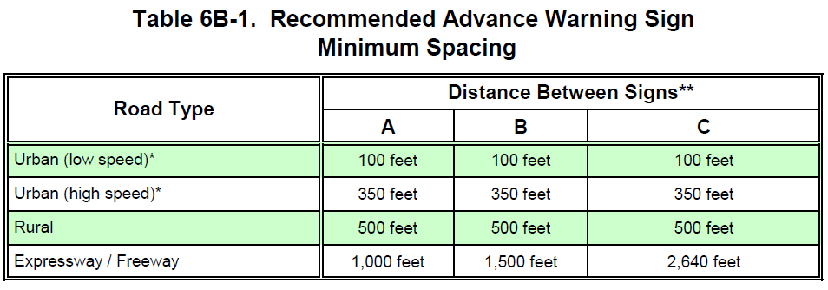
These recommendations and guidance are different than those provided in the MUTCD NPA for warning signs not located in TTC zones. Table 2C-3 below provides guidelines for other warning signs. The values in the “0” column are the AASTHO Stopping sign Distance minimum design guidelines per the NCUTCD Recommendation 12A-RW-02 (10).
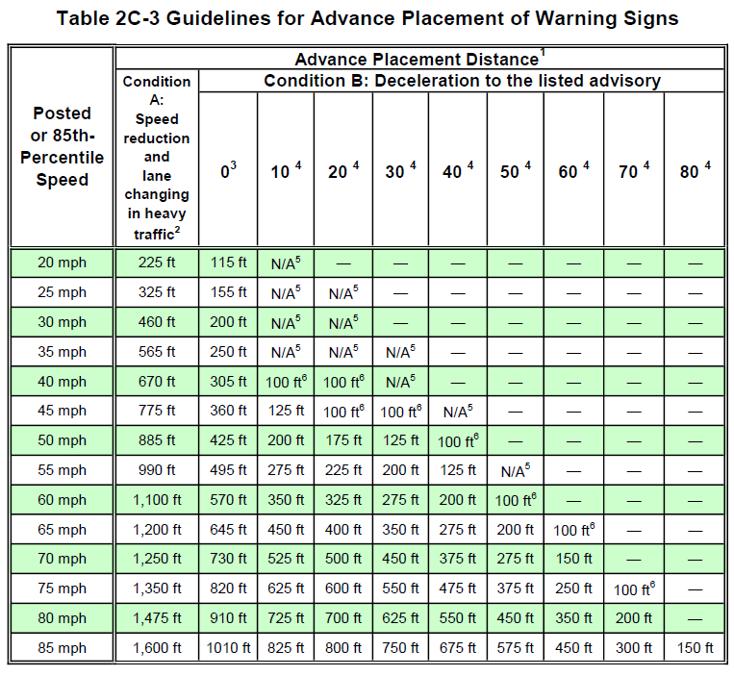
Several states have provided additional information regarding placement and spacing of TTC advance warning signs, to supplement the current MUTCD. For example, Wisconsin DOT provided clarifications to differentiate high speed and low speed urban roads with high speeds being defined of 35-40 mph and low speeds being 25-30 mph (3). Wisconsin also provides approximate distances between the closest sign to the TTC zone and the signs in Table 6C-1.

South Carolina DOT (SCDOT) has also provided specific speeds to differentiate between low speed and high speed urban roads with low speed roads being 35 mph or less and high speed roads being 40-50 mph. SCDOT also revised the recommended distance between signs for low speed roads to 200 ft (4).

Idaho DOT also provides speeds for differentiation with urban low speed roads being 35 mph or lower and urban high-speed roads being 40 mph or greater.

Washington State DOT amends Table 6C-1 of the 2009 MUTCD to provide more categories of roads with specific speed limits associated, as shown below (3).
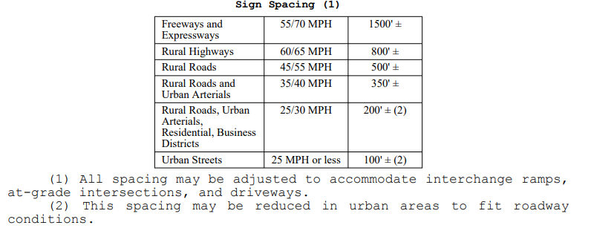
Michigan DOT also modified Table 6C-1 basing it solely on speed limits as shown below (5):
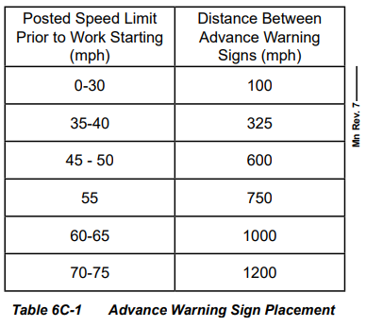
Delaware DOT revised Table 6C-1 to define low speed and high-speed roads as well as to include interstates in the bottom row as shown below (6).
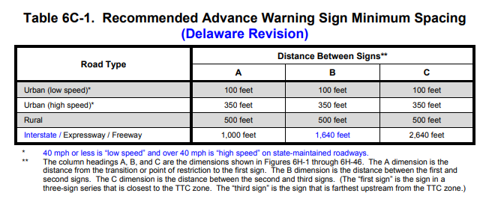
State of Practice for Shifting Taper Lengths
The MUTCD NPA provides guidance about appropriate taper lengths in section 6B08. This section explains that a shifting taper is used when a lateral shift is needed. It also clarifies that a taper distance longer than the minimum required distance may be beneficial when space allows for it (1). Table 6B-3 and 6B-4 displayed below provide the taper length criteria for Temporary Traffic Control Zones and the formulas for determining taper length, respectively (1).
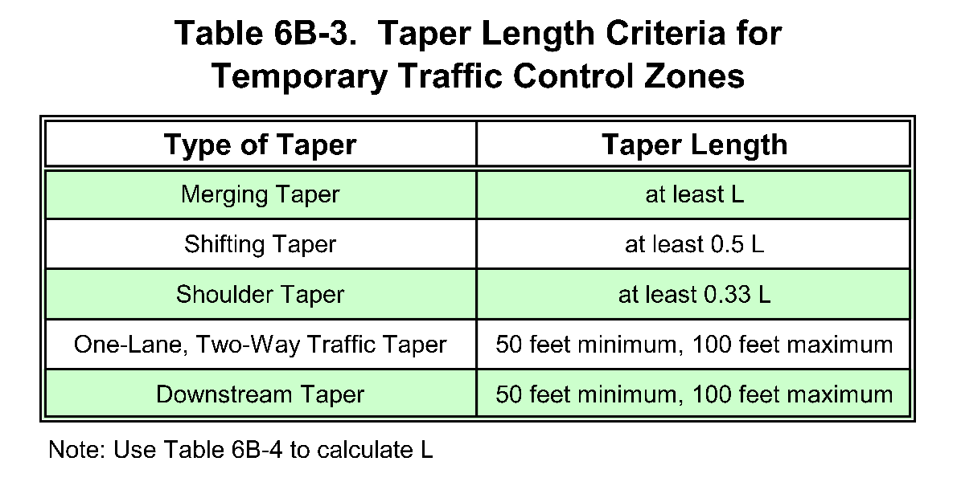
Section 3B.12 of the MUTCD NPA describes taper lengths for permanent applications. This section uses the same formulas indicated in Table 6B-4, but calls for the taper length to be the full length of L rather than half of L (1).

The Wisconsin DOT provides an MUTCD supplement with guidance on device spacing that states the maximum distance in feet between devices in a taper should not exceed 1.0 times the speed limit in mph. This distance in feet may be modified to a maximum of 1.25 times the speed limit in mph to correspond with the pavement marking cycle length (length of one broken line segment plus one gap) (3).

The Ohio DOT provides further guidance that a shifting taper should be approximately L in length, unless speeds are less than 50 mph, in which case the shifting taper may be approximately ½ L. The adjusted table the Ohio DOT provides is shown below (11):
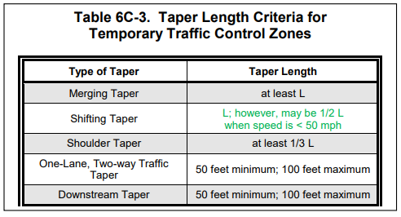

The South Carolina DOT has adopted the following values for taper lengths (4):
- Urban Low Speed ≤ 35 mph Taper Length = 250 Feet
- Primary Routes ≥ 40 mph Taper Length = 700 Feet
- Interstate Routes Taper Length = 800 Feet
The Maryland DOT provides further guidance on taper lengths and an adjusted table 6C-3. The Maryland supplemental information states the minimum taper length for State owned, operated, and maintained expressways/freeways shall be 300 m (1000 ft). This taper shall be located in the transition area. In Maryland, a shifting taper should have a minimum length of 0.5L. Table 6C-3 for the Maryland DOT is provided below (12):
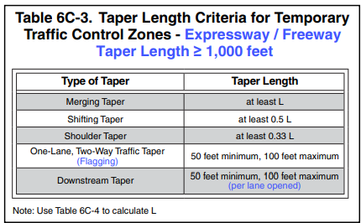
The Texas DOT provides a table for merging taper lengths and spacing of channelizing devices, shown below:
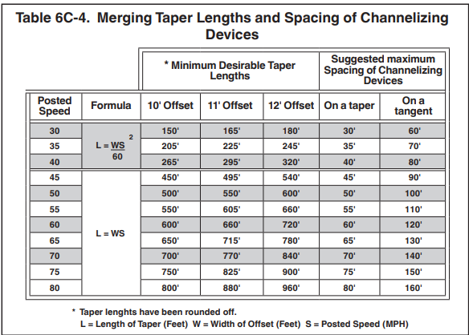

Relevant Research for Advance Warning Sign Spacing and Placement
Little research that focuses on TTC advance warning sign placement is publicly available. A simulator study by Hang et al. sought to understand how placement of Lane End signs and traffic volume impact driving behaviors in TTC zones. They found that the placement of the Lane End sign had a significant impact on perception of drivers approaching work zones. They recommended installing the Lane End signs 500 meters in advance of the merge point (Hang, et al.) (7). This study looked at a specific type of advance warning sign with a focus on lane merges.

Another study by Li and Bai sought to determine optimal placement of portable changeable message signs (PCMS) in work zones to reduce speeds. The study included two field experiments in which PCMS were placed in three different locations and vehicle speeds were evaluated. The first experiment found that 575 ft in front of the first static TTC sign was the ideal location. The second experiment was conducted in an effort to confirm the findings of the first study by placing PCMS 750 ft, 575 ft, and 400 ft in advance of the first static TTC sign. A regression analysis found that the optimal PCMS placement was between 556ft and 575 ft in advance of the first TTC static sign (8).

While few studies have evaluated ideal placement of TTC warning sign placement, studies such as those in Texas A&M Transportation Institute’s (TTI’s) “Studies to Improve Temporary Guide Signs in Work Zones” have acknowledged the importance of sign placement in work zones to provide adequate time for drivers to view and process the sign content (9).
Relevant Research for Shifting Taper Lengths
The Transportation Research Board performed a study that took place in the 1970s and reevaluated the existing taper length formula that at the time suggested longer taper lengths. “As a result of this field evaluation of the operational effects of taper length, the Federal Highway Administration (FHWA) and the National Advisory Committee on Uniform Traffic Control Devices (NAC) have approved the proposed taper formula for inclusion in the MUTCD. The proposed taper formula [L = Ws2/ 157.5 (L=Ws2/ 60, when S is in mph)] should be used to compute taper length on urban, residential, and other streets where the posted speeds are 65 km/h (40 mph) or less. The standard taper length formula is retained for freeways, expressways, and all other roadways having a posted speed of 72 km/ h (45 mph) or greater.” The MUTCD was revised accordingly (15).

Another study, performed by the Univeristy of Illinois at Urbana-Champaign, assessed drivers’ comfort levels with reduction of taper lengths in Pakistani work zone conditions. The taper lengths were reduced by various percentages on motorways and highways and the results indicated that age and driving experience played a significant role in comfort levels. For taper length reductions of up to 20%, most drivers felt either comfortable or neither comfortable nor uncomfortable. However, when the taper length was reduced by 30%, most drivers felt uncomfortable. In conclusion, the study recommends a 25% reduction in taper length for both motorways and highways (16).

A study published by Periodica Polytechnica Transportation Engineering focused on how confusion among motorists about navigating lane closures during congested periods leads to inconsistent flow patterns, forced merges, travel delays, and crashes. This study used simulations, encompassing 192 scenarios with varying truck compositions, transition lengths, and traffic volumes, to determine the optimal transition length for implementing a zipper merge. The study found that none of the six tested taper lengths had a significant advantage over the others, although there were operational differences that became more pronounced with higher traffic volumes and truck percentages (17).

Lastly, a study published in the Transportation Research Record focused on exploring the operational effects of reduced merging taper lengths on lower-speed urban arterials, where driver expectations and traffic dynamics differ from high-speed freeways. Longer tapers relied on channelizing devices to prompt lane changes, leading to some vehicles with obstructed views getting trapped and causing mobility issues. Shorter taper lengths saw drivers reacting primarily to the taper and the work vehicle itself, resulting in fewer trapped vehicles but with the merge point being closer to the work vehicle (18).

Potential Research Approach
The general approach to addressing the research objective is to analyze the sources that have traditionally been used to determine sign placement and calculate taper lengths and validate whether or not the practices are appropriate given past research and knowledge of human capabilities when navigating work zones. The research team would gather information on the current state of practice, how the current MUTCD recommendations were developed, and what other relevant research has been conducted. Utilizing the findings, the research team would develop a method for TTC advance warning sign placement and calculating TTC taper lengths based on research and best practices.
Task 1 – Kick-off Meeting and Project Management
Researchers will attend a kickoff meeting with the TCD PFS panel. The research team will work with the TCD PFS and other stakeholders to confirm that all parties have a shared understanding of the research scope and to obtain input on existing research information available, potential practitioner contacts to provide feedback or who may be able to provide historical context for the current MUTCD guidance.
Task 2 – Literature Review and State of Practice
The research team will review and synthesize literature regarding research that has been performed on sign placement and taper lengths in work zones. Additionally, current practices and MUTCD text will be summarized along with any information that can be gathered on the sources that led to the current MUTCD language. As part of gathering information about current practices, the research team will obtain feedback from practitioners via e-mail and/or casual phone calls about their procedures, challenges they encounter, and any changes they feel should be implemented.

Task 3 – Development of TTC Advance Warning Sign Placement and Taper Length Method
The research team will compare and analyze the current practices and research from Task 2. Based on the findings, the research team will develop and submit a method for determining TTC advance warning sign placement and spacing and taper lengths.

Task 4 – Expert Panel Workshop to Review TTC Advance Warning Sign Placement and Taper Length Method
The research team will assemble an expert panel with members of the TCD PFS who have TTC work experience as well as other TTC practitioners and experts such as members of the ATSSA sign committee and/or ATSSA TTC committee and the NCUTCD TTC Technical Committee (Chapters 6A and 6B Task Force and Typical Applications Task Force). The method from Task 3 will be provided to the expert panel for review and then a virtual workshop will be conducted to obtain feedback on the sign placement and taper length method.

Task 5 – Final Report and Presentation
The research team will revise the TTC advance warning sign placement method per comments received at the expert panel workshop. The research team will then develop a final report that includes the state of practice and literature review, the revised TTC advance warning sign placement method, and a summary of the justification for the methodology.
Chance of Successful Evaluation
Medium to High
An effective field study that incorporates the findings would be extremely difficult to implement given the numerous factors that are present in work zones as well as the difficulty to determine if any effects were from sign placement, taper length, or an external variable. However, the development of recommendations based on the existing body of knowledge would be beneficial to document the basis of taper lengths and the distances used to place warning signs.
References

- FHWA. National Standards for Traffic Control Devices; the Manual on Uniform Traffic Control Devices for Streets and Highways; Revision. https://www.regulations.gov/docket/FHWA-2020-0001/document
- Wisconson DOT. (2009, December). PART 6. TEMPORARY TRAFFIC CONTROL. https://wisconsindot.gov/dtsdManuals/traffic-ops/manuals-and-standards/wmutcd/mutcd-ch06.pdf
- SCDOT. (2011, May). South Carolina Department of Transportation. Traffic Engineering MUTCD Supplement. https://www.scdot.org/business/pdf/accessMgt/trafficEngineering/supplement_mutcd.pdf
- MDOT, Part 6 - Temporary Traffic Control - Manual on Uniform Traffic Control Devices (2009). https://mdotjboss.state.mi.us/TSSD/getTSDocument.htm?docGuid=dbc08581-5f19-4bd5-8d57-69abc3598d6d&fileName=mmutcdpart6_2017.pdf
- DE MUTCD, Chapter 6A. General (2018). https://regulations.delaware.gov/register/may2018/final/MUTCDPart6TemporaryTrafficControl.pdf?cache=1698161203466
- Hang, J. (2018, August 11). Exploring the effects of the location of the Lane-end sign and traffic volume on Multistage Lane-changing behaviors in work zone areas: A driving simulator-based study. Transportation Research Part F: Traffic Psychology and Behaviour. https://www.sciencedirect.com/science/article/abs/pii/S1369847818303954
- Li, Y., & Bai, Y. (2011, November 30). Determining optimal deployment location of portable changeable message sign upstream of work zones. TRID. https://trid.trb.org/View/1128907
- Theiss, L., Higgins, L., & Ullman, G. L. (2021). (rep.). Studies to improve Temporary Guide Signs in Work Zones. College Station, Texas: TEXAS A&M TRANSPORTATION INSTITUTE. https://static.tti.tamu.edu/tti.tamu.edu/documents/0-7046-R1.pdf
- NCUTCD. (2012, June). Advance Traffic Control Signs. RW Signs No. 3.
(11) Ohio DOT. (2012, January). Chapter 6A, Temporary Traffic Control – General. https://www.dot.state.oh.us/roadway/omutcd/Documents/2012%20OMUTCD%20-%20Pt.%206.pdf
(12) MMUTCD. (2011, December). PART 6. TEMPORARY TRAFFIC CONTROL. https://www.roads.maryland.gov/mmutcd/2011_Parts_06_rev2.pdf
(13) Washington DOT. WAC 468-95-301: (2011, November). https://app.leg.wa.gov/wac/default.aspx?cite=468-95-301
(14) Texas DOT: Texas MUTCD. (2011, December). PART 6. TEMPORARY TRAFFIC CONTROL. https://ftp.txdot.gov/pub/txdot-info/trf/tmutcd/2011-rev-2/6.pdf.

(15) Graham, J. L., Harwood, D. W., & Sharp, M. C. (1979). (rep.). Effects of Taper Length on Traffic Operations in Construction Zones. Transportation Research Board. https://onlinepubs.trb.org/Onlinepubs/trr/1979/703/703-004.pdf.
(16) Khan, R. A. (2011). Driver’s Comfort Level in Construction Zones with Reduced Transition Taper Length: Case Study for Pakistani Conditions (thesis). Graduate Dissertations and Theses at Illinois. https://www.ideals.illinois.edu/items/26337

(17) Idewu, W., Chanpiwat, P., Naghawi, H. (2020) “Identifying Optimum Taper Lengths for Zipper Merging Applications using Real Data, Microscopic Simulation”, Periodica Polytechnica Transportation Engineering, 48(3), pp. 210–220. https://doi.org/10.3311/PPtr.13044

(18) Theiss, L., Finley, M. D., & Ullman, G. L. (2011). Merging Taper Lengths for Lane Closures of Short Duration. Transportation Research Record, 2258(1), 64-70.
https://doi.org/10.3141/2258-08

