TRANSPORTATION POOLED FUND PROGRAM
QUARTERLY PROGRESS REPORT

Lead Agency: ---- Utah Department of Transportation ----

INSTRUCTIONS:
Project Managers and/or research project investigators should complete a quarterly progress report for each calendar quarter during which the projects are active. Please provide a project schedule status of the research activities tied to each task that is defined in the proposal; a percentage completion of each task; a concise discussion (2 or 3 sentences) of the current status, including accomplishments and problems encountered, if any. List all tasks, even if no work was done during this period.

Transportation Pooled Fund Program Project #  (TPF-5(257) |  | Transportation Pooled Fund Program - Report Period:  _ Quarter 1 (January 1 – March 31)  _ Quarter 2 (April 1 – June 30)  _ Quarter 3 (July 1 – September 30)  x_ Quarter 4 (October 1 – December 31)

Project Title: Evaluation of Spliced Sleeve Connections for Precast RC Bridge Piers

Name of Project Manager(s):  Russ Scovil | Phone Number:  801-965-4097 |  | E-Mail  Rgscovil@utah.gov
Lead Agency Project ID:  5H06604H, UT11.502 | Other Project ID (i.e., contract #):  12-8775 |  | Project Start Date:  3/23/2012
Original Project End Date:  3/30/2013 | Current Project End Date:  10/30/2013 |  | Number of Extensions:  1

Project schedule status:

_ On schedule X_ On revised schedule _ Ahead of schedule _ Behind schedule

Overall Project Statistics:
Total Project Budget | Total Cost to Date for Project | Percentage of Work  Completed to Date
$175,848 | $63,000 | 40%

Quarterly Project Statistics:
Total Project Expenses  and Percentage This Quarter | Total Amount of Funds  Expended This Quarter | Total Percentage of  Time Used to Date
$43,000 / 24% | $43,000 | 47%

Project Description:

Sleeved connections are being considered as one of the methods for connecting precast concrete bridge elements. The purpose of this project is to perform experiments to evaluate the performance of a sleeved connection between a reinforced concrete square bridge column and a bridge footing (Type I) or a reinforced concrete square bridge column and a bridge bent cap (Type II) in a seismic area. This information is very valuable for construction of bridges using Accelerated Bridge Construction in areas with high seismic activity.

Progress this Quarter (includes meetings, work plan status, contract status, significant progress, etc.):

Project Progress: This quarter the project was focused on testing the precast concrete column to footing joint with the
NMB splice connectors (Type I), as well as the precast concrete column to bent cap joint with the Lenton Interlock
connection (Type II). The final construction drawings and pictures for the Type I sleeved connections are shown in
Figures 1 and 2, respectively.
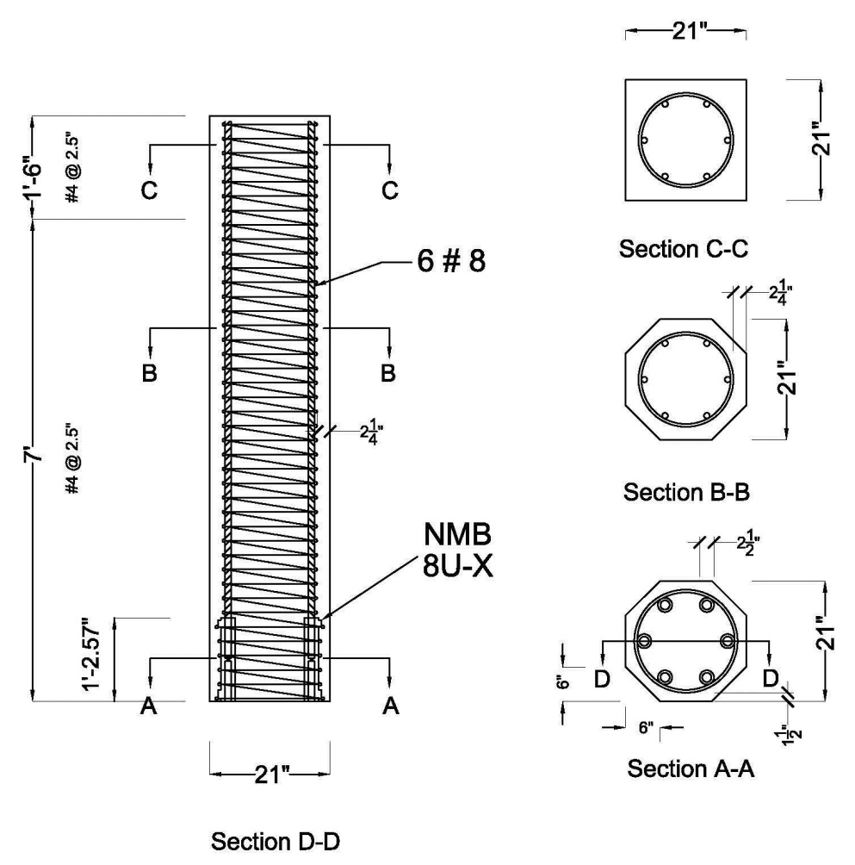

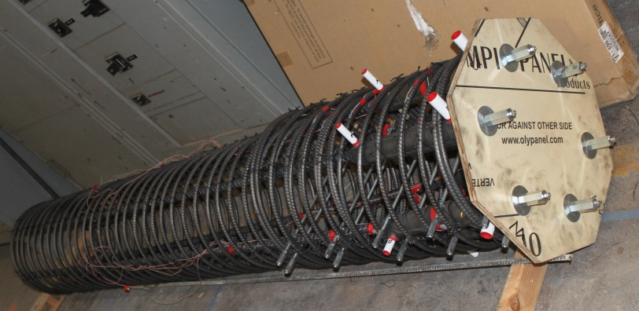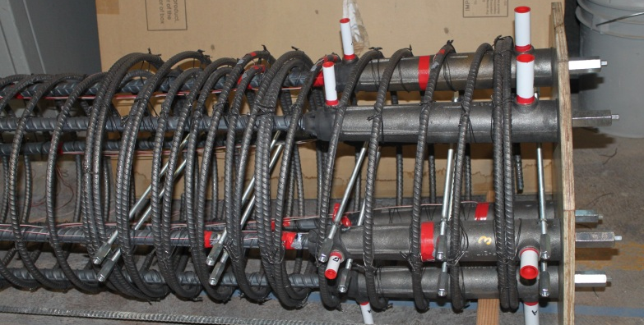

Figure 1. Column details for NMB connection: six mechanical sleeves embedded in the column.

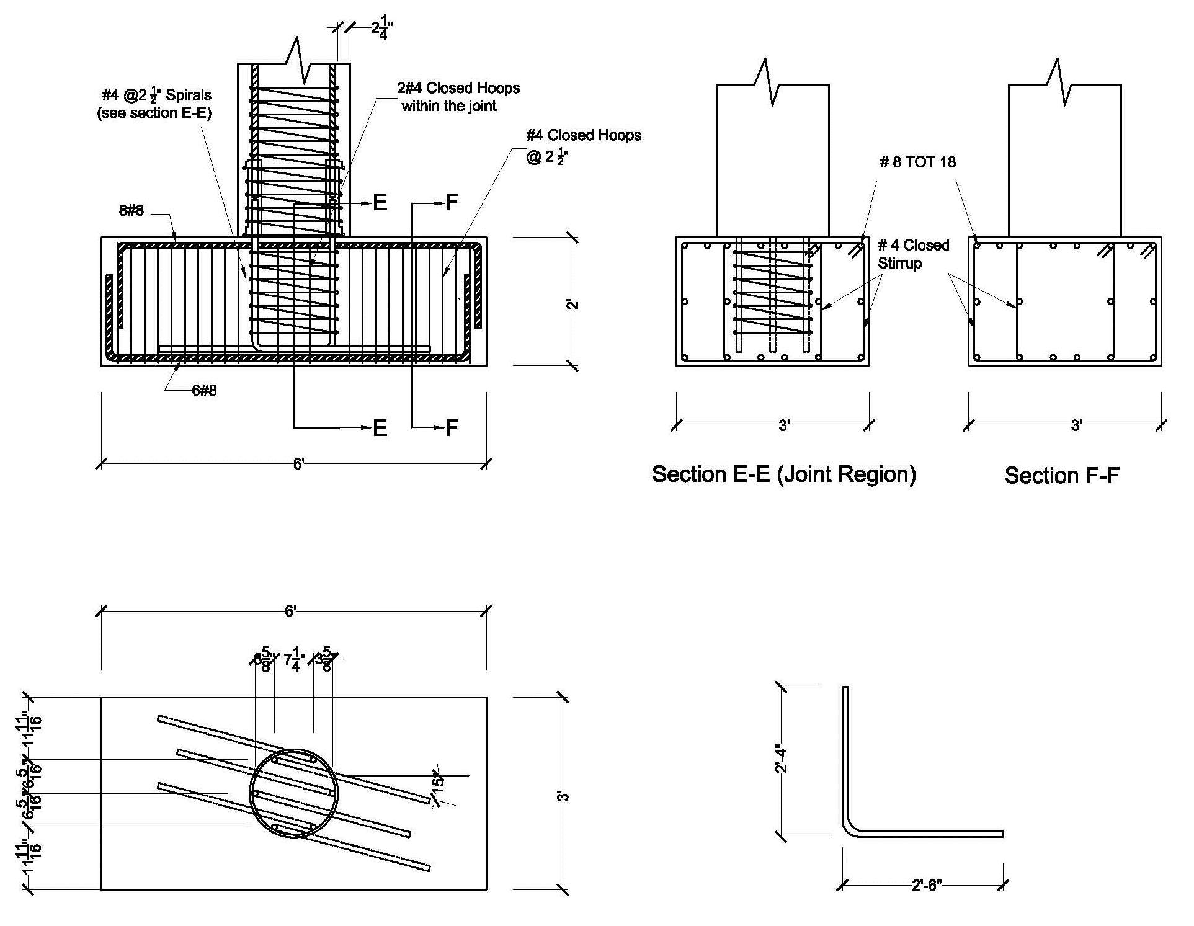

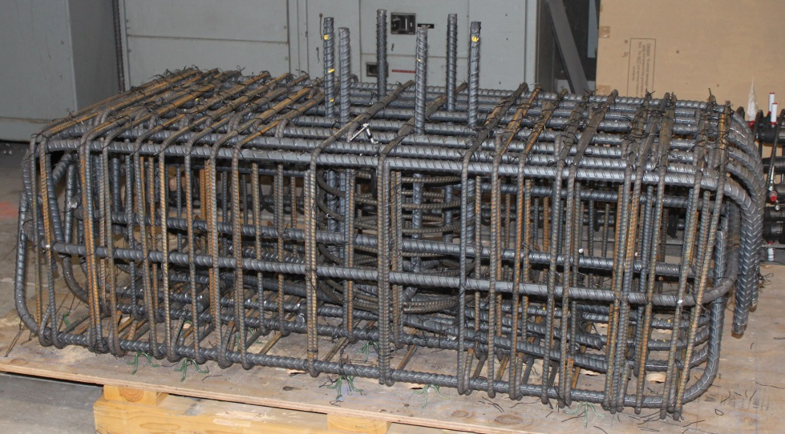

Figure 2. Footing details for NMB connection: six mechanical sleeves embedded in the column.

The final construction drawings and pictures for the Type II sleeved connections are shown in Figures 3 and 4, respectively. It should be noted that both sleeved connections were constructed with the mechanical sleeves in the column.

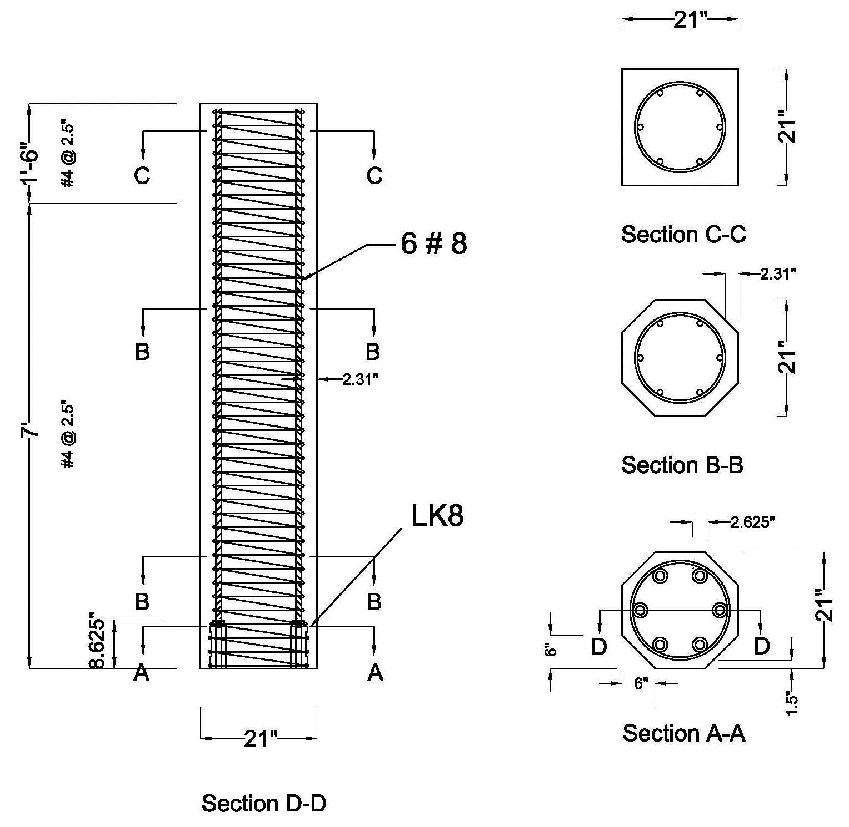

Figure 3. Column details for Lenton Interlock connection: six mechanical sleeves embedded in the column.

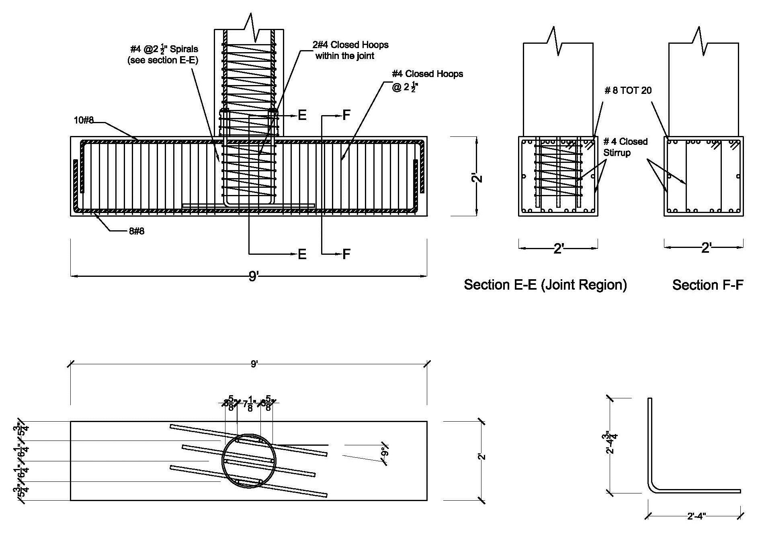

Figure 4. Bent cap details for Lenton Interlock connection: six mechanical sleeves embedded in the column.

The Type I and Type II specimens after the grouting operation are shown assembled in Figure 5. The first (foreground) is the footing to column connection with six NMB splice sleeve connectors (NMB-1) and the second (background) is the column to bent cap connection with six Lenton Interlock connectors (LEN-1).

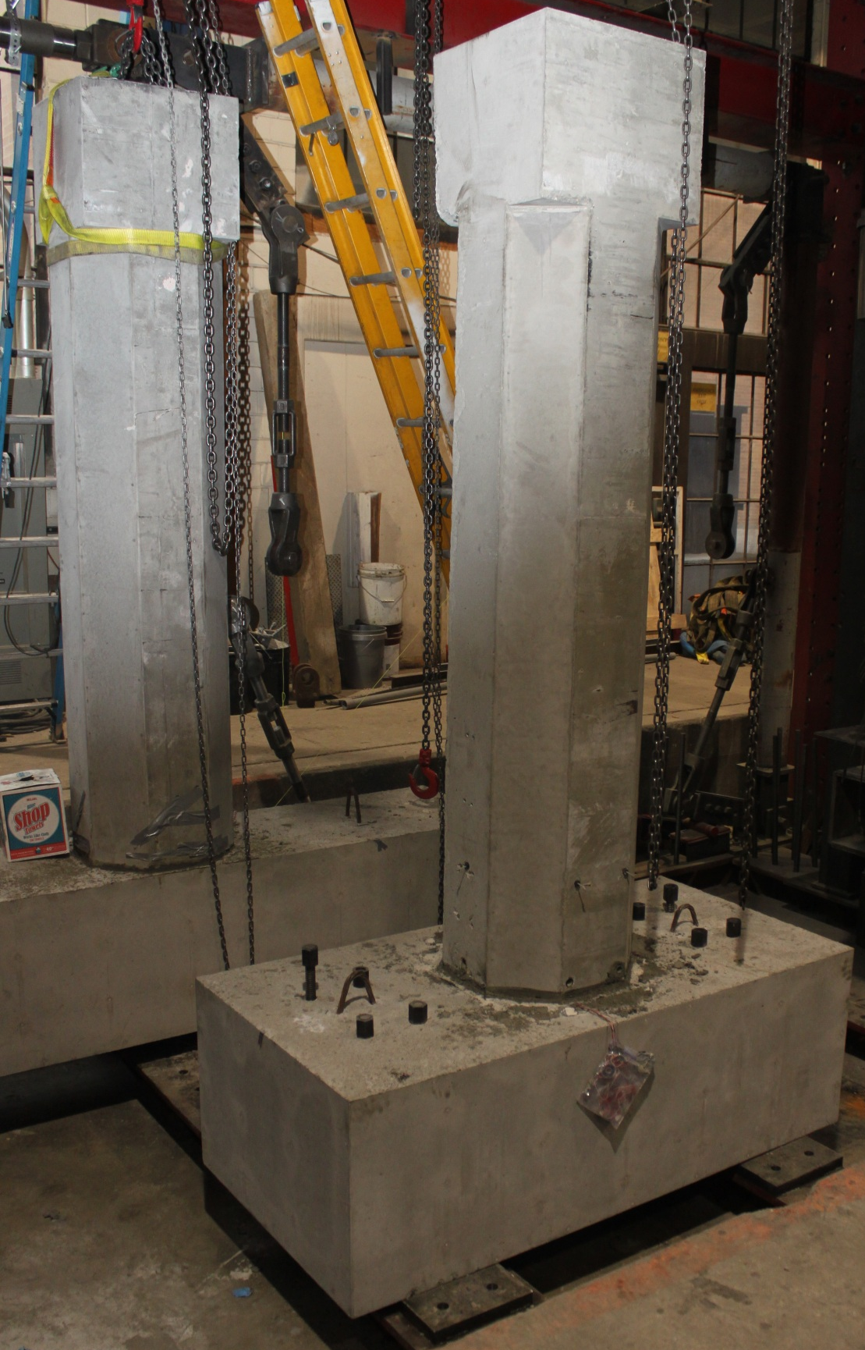

Figure 5. Assembled footing to column (NMB-1) and column to bent cap (LEN-1) specimens.

The two specimens shown in Figure 5 were tested in the University of Utah Structures Laboratory under quasi-static cyclic forces while an axial load was applied to the column. Figure 6 shows specimen NMB-1 at the extreme cycles of 9% drift. Figure 7 shows the hysteresis loops for specimen NMB-1; the performance is shown to be very satisfactory up to 8% drift.
Specimen NMB-1 test results are shown in Figure 8. Figure 8(a) shows the specimen at 3% drift; at this stage cracks had developed at the top of the sleeves and the top of the exterior spiral and there was spalling of concrete at the column corners. Figure 8(b) shows the specimen at 6% drift; at this time the spiral became exposed and there was yielding penetration into the footing. Figure 8(c) shows the specimen at 9% drift; two of the six bars had fractured.

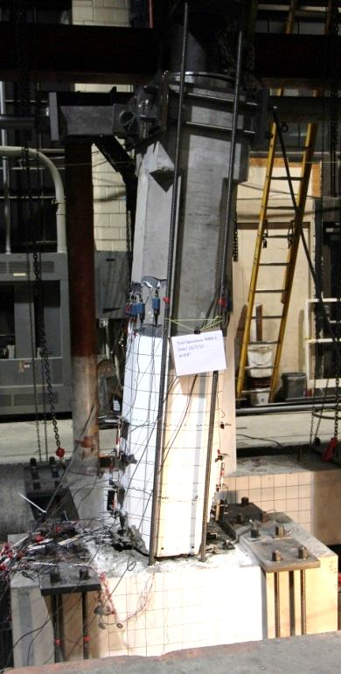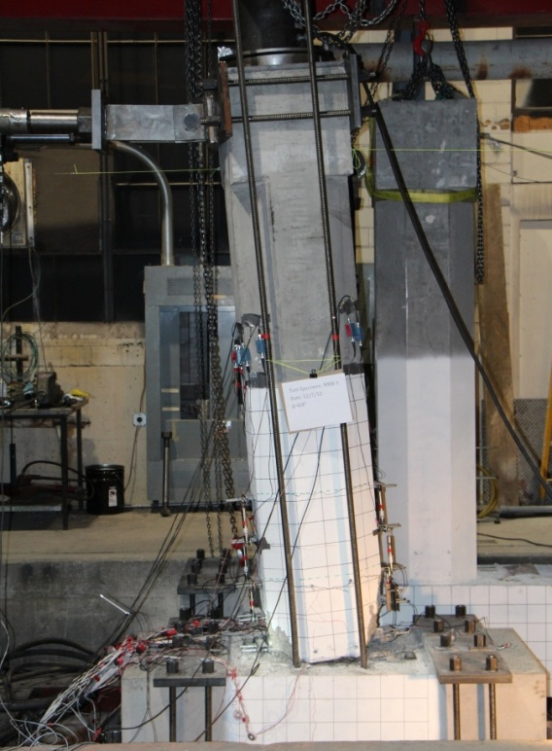

Figure 6. Specimen NMB-1 at the ultimate condition at 9% drift.

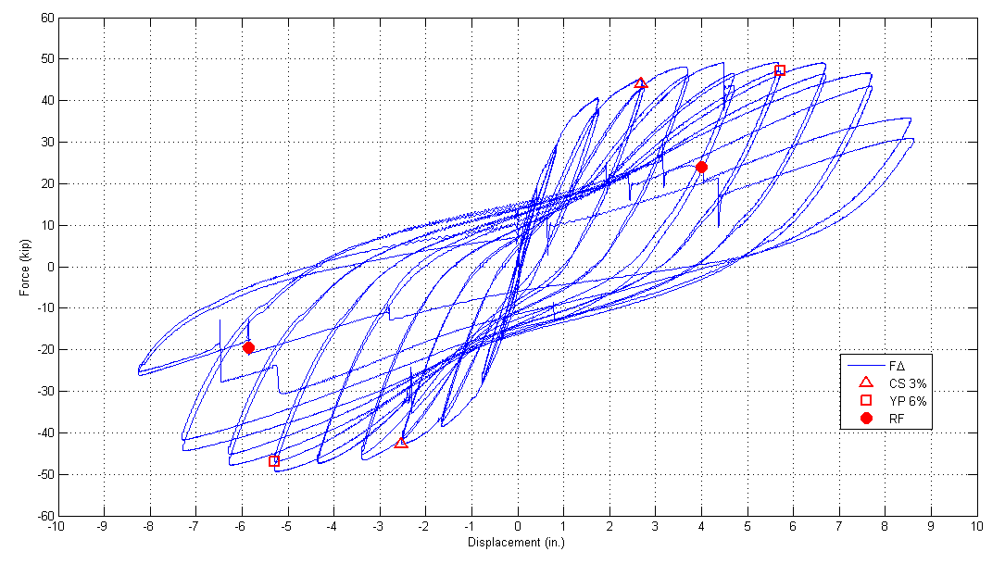

Figure 7. Hysteresis curves for specimen NMB-1.

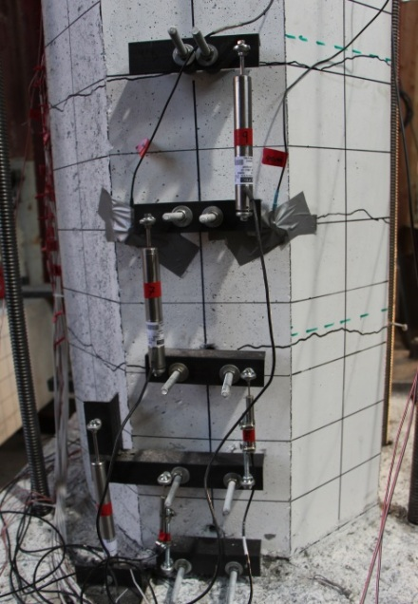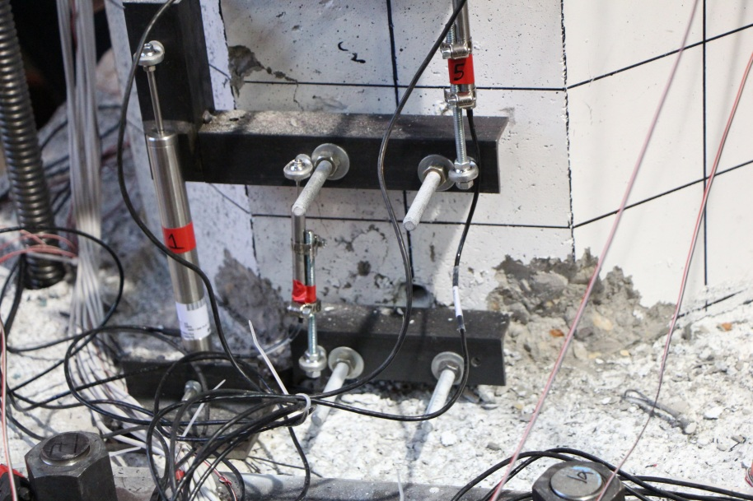
(a)

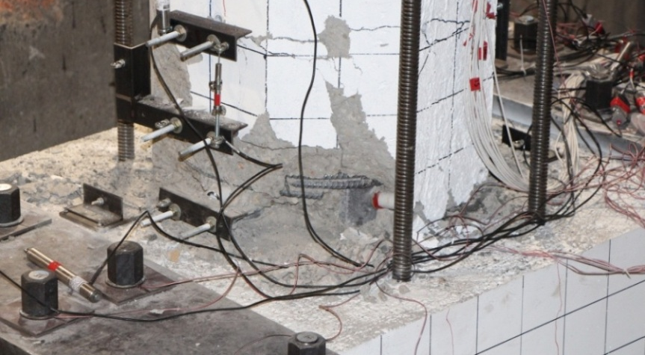
(b)

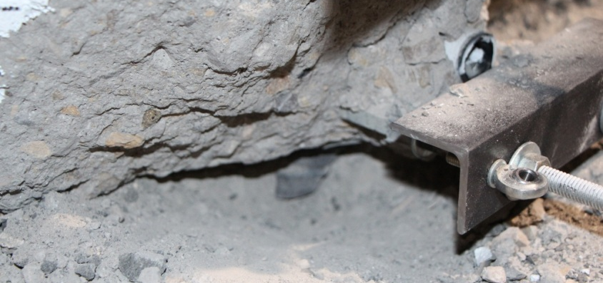
(c)

Figure 8. Test condition of specimen NMB-1: (a) 3% drift, (b) 6% drift, and (c) 9% drift.

Figure 9 shows specimen LEN-1 at the extreme cycles of 6% drift. Figure 10 shows the hysteresis loops for specimen LEN-1; the performance is shown to be very satisfactory up to 4% drift; at 6% drift the lateral force dropped more than 20% due to bars pulling out of the sleeve and the test was terminated. Specimen LEN-1 test results are shown in Figure 11. Figure 11(a) shows the specimen at 3% drift; at this stage cracks had developed at the top of the sleeves and there was spalling of concrete at the column corners. Figure 11(b) shows the specimen at 6% drift; at this time at least four bars started pulling out of the sleeve.
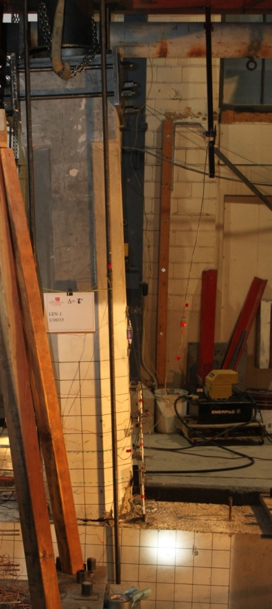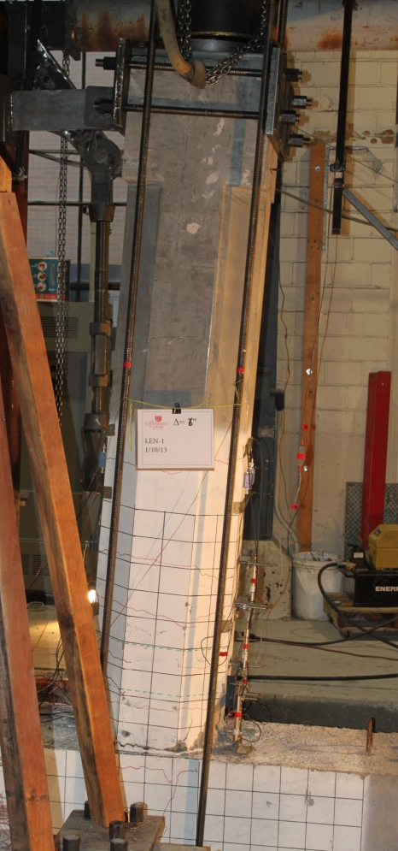

Figure 9. Specimen LEN-1 at the ultimate condition at 6% drift.

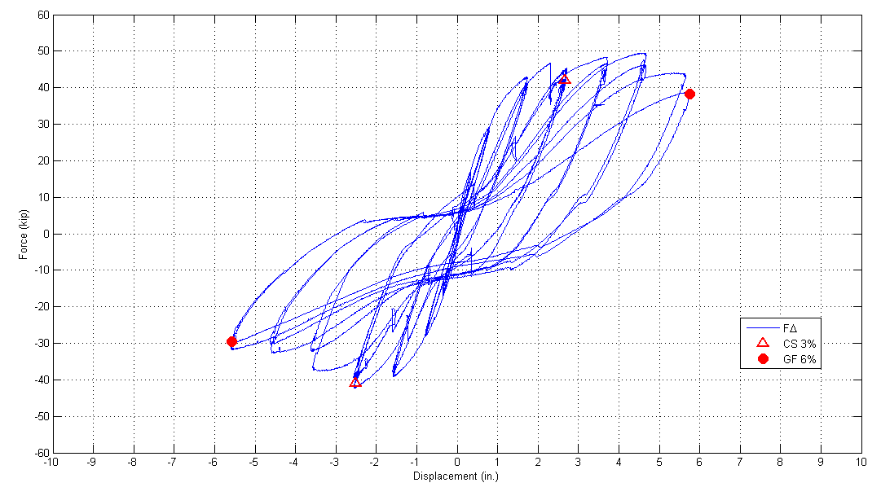

Figure 10. Hysteresis curves for specimen LEN-1.
(a)

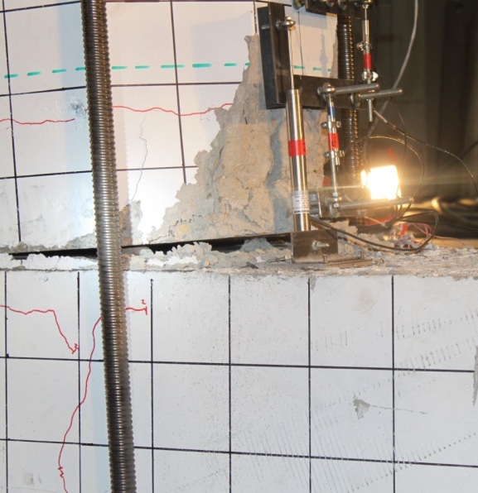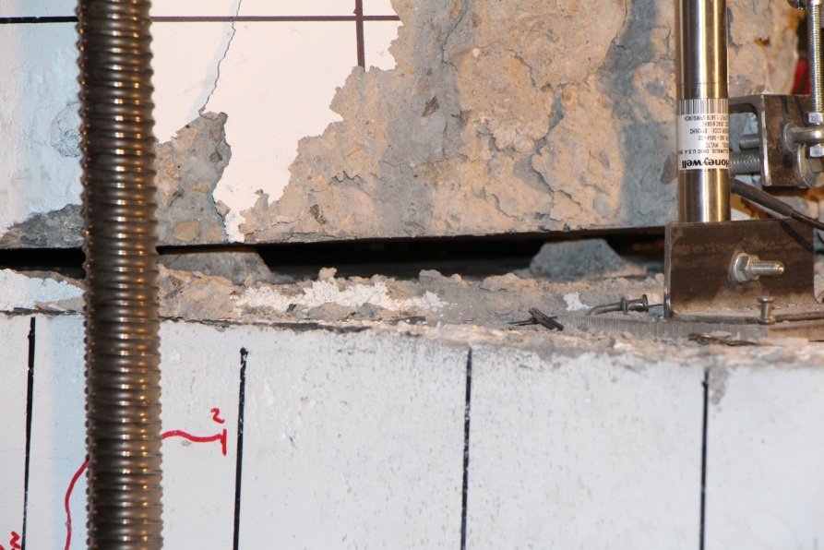

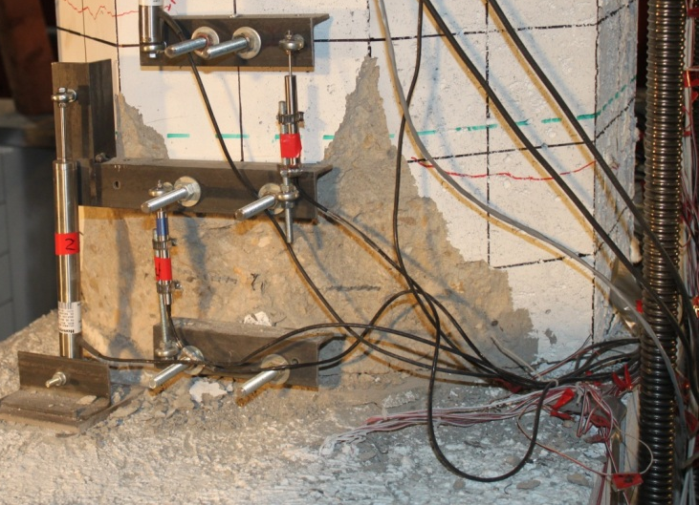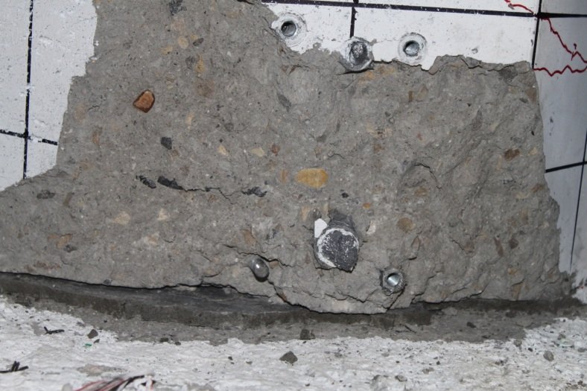
(b)

Figure 11. Test condition of specimen LEN-1: (a) 3% drift, and (b) 6% drift.

Project Status: The project is progressing well and the percentage completion for each task is as follows:

Task 1: Review Existing Experimental Results for Sleeved Connections: 100% Complete
Task 2: Build Precast Columns, Footings and Cap Beams for Tests: 50% Complete
Task 3: Test Column to Footing Connections (Type I): 25% Complete
Task 4: Test Column to Cap Beam Connections (Type II): 25% Complete
Task 5: Test Column to Footing Monolithic Cast-In-Place Connection
and Column to Cap Beam Monolithic Cast-In-Place Connection: 0% Complete

Anticipated work next quarter:

It is anticipated that in Quarter 4, the second set of precast concrete columns, footings, and cap beams will be tested. The sleeves in both of these specimens (NMB-2 and LEN-2) will be located in the footing and cap beam, respectively.

Significant Results:

The column to footing connection with NMB splice sleeves (Type I) performed very well up to a drift of 8%. The column to bent cap connection with Lenton Interlock connectors (Type II) performed very well up to 4% drift.

Circumstance affecting project or budget. (Please describe any challenges encountered or anticipated that
might affect the completion of the project within the time, scope and fiscal constraints set forth in the
agreement, along with recommended solutions to those problems).

None.

Potential Implementation:

It is anticipated the Utah DOT will implement the findings of this research once it is completed in Accelerated
Bridge Construction (ABC). It is likely that the New York State Department of Transportation and the Texas Department of Transportation will be able to implement them too.

