INSTRUCTIONS FOR FHWA TRANSFER REQUEST (FHWA-1575C)
The FHWA Funds Transfer Request form (FHWA-1575C) is to be used for all funds transfer requests that previously utilized forms FHWA-1575 and FHWA-1576. Any previous forms are obsolete and will be rejected after March 31, 2021.
This form is to be used by the State for the transfer of funds between programs, between States, and to FHWA or other agencies. The form is in pdf fillable format. Use of the single form will help to eliminate confusion as to the appropriate form for different types of transfers. Signatures on the transfer request by authorized officials of both the State transportation department and FHWA Division Office approves the movement of contract authority and/or obligation authority.

Completion of General Information Section
Step 1: Select Type of Transfer:
Determine the “type of transfer” request and select from the drop menu. Note that, depending on what type of transfer you select, the transfer form will automatically enable or disable certain fields. For example, if you select “Between Programs - Fund to Fund”, “Between Projects - Demo to Demo Project”, “Between Projects - Special Limitation”, the “Transfer to State” and “Transfer to Other” fields will be disabled because they are not required. See example below.
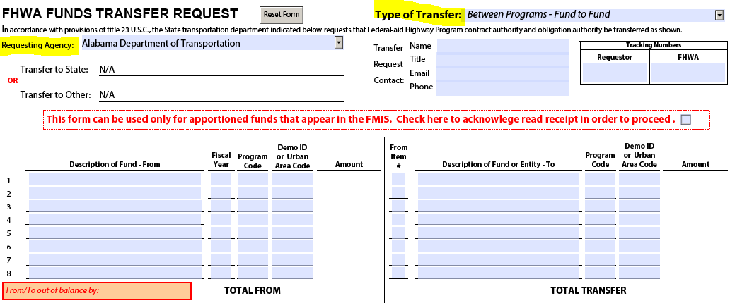
Type of transfer list:
- Between Programs - Fund to Fund
- Between Projects - Demo to Demo Project
- Between Projects - Special Limitation
- State to State - Non-Pooled Funded (including Demos)
- State to State - Pooled Fund Project
- To Federal Lands Highway or FHWA Program Office
- To Other Federal Government Entity
Step 2: Select Requesting Agency:
Select “requesting agency” from the drop menu.
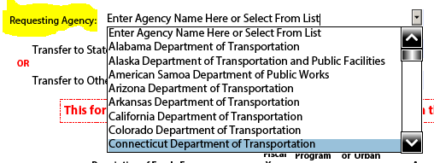
Step 3: If applicable, select Transfer to State or Transfer to Other (if not applicable, proceed to step 4):
Select the appropriate entity in the drop-down menu for either “transfer to state” or “transfer to other”.
Select “Transfer to State” for State-to-State – Non-Pooled Fund or State-to-State – Pooled Fund requests. Reminder: These types of requests require an acceptance letter from the receiving agency.
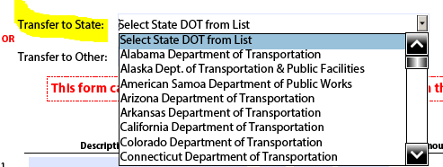
Select “Transfer to Other” for Transfers to Other Federal Government Entity or to Federal Highway Administration (FHWA) request.
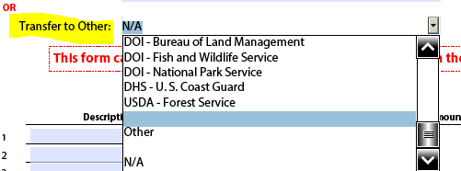
Step 4: Fill in Transfer Request Contact Field:
Each field is REQUIRED. Enter name (first and last), position title, e-mail address, and telephone number (including area code) of the person who should be contacted concerning the transfer request.
Step 5: Fill in Tracking Numbers Field:
Enter the “requestor” tracking number, if applicable. The FHWA field is optional and for use by FHWA. Do not enter data in this field.
Step 6: Complete the Acknowledgement statement:
Read the statement and check the box as shown in the image below. By checking this box, you acknowledge the statement shown. This enables the amount fields and the signature boxes in the transfer form.

Completion of "Description of Fund-From"
Step 7: Fill in “Description of Fund – From” field:
Enter the name of the program fund(s) to be transferred. Refer to FMIS report W10A for the name of the program fund. The report is accessible from Reports - Pre-Published Monthly.
An asterisk (*) beside a program description indicates that more information is required. Complete the additional information field (limited to 1150 characters) and attach supplementary sheets if more room is needed for explanatory notes.
* For Bridge Program, indicate the percentage indicator of the fund. For example, 85% On System.
* For High Priority Projects, enter the description of the project as itemized in the public law.
* For SP&R program funds transferred to another State for administration of a pooled fund project, enter the title of the pooled fund project.
* For STP/STBG program funds, indicate the suballocation. If the funds are apportioned for obligation in a designated urban area, enter the name of the urban area.
* For Transportation Improvement Projects, enter the description of the project as itemized in the public law.
--------------- For each Item #, complete the four items on the row as applicable. ---------------
Fiscal Year
Enter the fiscal year of the fund. Requests may be delayed or rejected if submitted without the fiscal year of the fund to be transferred.
Program Code
Enter the four-character FMIS program code of the program fund to be transferred. Program codes established for obligation through Delphi cannot be transferred through these means.
Demo ID or Urban Area Code
Demo ID or Urban Area Code is required for certain fund transfers. Enter the 5-character Demo ID or the 3 or 5-digit urban area code.
Amount
Enter the dollar amount of funds to be transferred.
An equal amount of limitation, where applicable, will be transferred. For transfer of limitation only of demonstration projects, the Type of Transfer Request selected must be "Between Projects - Special Limitation". Use the Transfer of Funds Worksheet to determine the percentage of total apportionment and determine eligibility for transfer.
Total From:
This field is automatically calculated. It is the total amount of funds to be transferred.

Completion of "Description of Funds or Entity-To"
Step 8: Fill in “Description of Fund or Entity – To” field:
Enter the Item # from left-hand (From) side. The "From" Item # can be used more than once if funds from one fund are to be transferred to more than one fund or entity on the right-hand ("To") side.
Transferring funds Between Programs or Between States
Enter the name of the program fund(s) receiving the transfer. Refer to FMIS report W10A for the name of the program fund. The report is accessible from Reports - Pre-Published Monthly.
An asterisk (*) beside a fund description indicates that more information is required. Complete the additional information field and attach supplementary sheets if more room is needed for explanatory notes.
* For Bridge Program, indicate the percentage indicator of the fund. For example, 85% On System.
* For High Priority Projects, enter the description of the project as itemized in the public law.
* For SP&R program funds transferred to another State for administration of a pooled fund project, enter the title of the pooled fund project.
* For STP/STBG program funds, indicate the suballocation. If the funds are apportioned for obligation in a designated urban area, enter the name of the urban area.
* For Transportation Improvement Projects, enter the description of the project as itemized in the public law.
Transferring funds to a FHWA Program Office
When transferring funds to a FHWA Program Office, the following information must be provided in the “Description of Entity -– To” field:
- the three-digit Budget, Program, Accounting Code (BPAC) that identifies the Program Office; and
- the FHWA routing symbol.
Example: “OFFICE OF TECHNICAL SERVICES, Resource Center OTS-RC-1, BPAC 300”
List of FHWA Headquarters Program Office BPACs:
- Office of Administration (080)
- Office of Chief Counsel (026)
- Office of the Chief Financial Officer (029)
- Office of Planning, Environment, and Realty (060)
- Office of Operations (070)
- Office of Civil Rights (027)
- Office of Chief Counsel (026)
- Office of Infrastructure (050)
- Office of Safety (055)
- Office of Technical Services, Resource Center (300)
- Office of Research and Development (040)
- Office of Policy and Governmental Affairs (030)

If a State is uncertain of the appropriate FHWA Routing Symbol to use, please reach out to the Division Office for assistance.
When transferring funds to another Federal Government Entity, please ensure the receiving entity is identified in the “Description of Entity – To” field.
--------------- For each Item #, complete the three items on the row as applicable. ---------------
Program Code
Enter the four-character FMIS or Delphi program code of the program fund to receive transferred funds.
Demo ID or Urban Area Code
Demo ID or Urban Area Code is required for certain fund transfers. Enter the 5-character Demo ID or the 3 or 5-digit urban area code.
Amount
Enter the dollar amount of funds to be received by the program.
Total Transfer:
This field is automatically calculated from entries in the Amount column.
Step 9: Provide any additional information, if required.
The following information must be provided in the “Enter Item #, Pooled Fund Project Number and Description, or any additional information” section:
- The project description for a Demo ID or urbanized area funds; and
- the number and title for pooled fund study (i.e., TPF-5(468), Structural Behavior of Ultra-High Performance Concrete).
Step 10: Select whether the State has entered into an agreement with the receiving agency.

Approvals and Submission
Step 11: Signature and submission of transfer form.
The transfer request must be signed by authorized representatives of both the State transportation department and the FHWA Division Office. Signatures, titles of approving officials and dates of approval are REQUIRED. Please note that the date and title fields must be completed before the electronic signature is applied. After an electronic signature is entered, these fields are locked.
Completed transfer requests should be sent electronically to the OCFO - Office of Budget (FHWA Transfers FHWA_Transfers@dot.gov). Please copy the FHWA Division or corresponding transfer recipient. This helps for tracking purposes and keeping an accurate record of the transfers on the receiving end. In addition, please ensure that the Adobe version of the transfer form is always submitted. This may be in addition to a scanned, ink-signed version but the Adobe version is typically easier to read and helps eliminate logging discrepancies.

Authority to Collect Information
This collection of information is required to obtain benefits and will be used to process fund transfers to other agencies and among Title 23 programs. This information collection will ensure the States requests are accurately executed and the requests are allowable by law. Public reporting burden is estimated to average 15 minutes per response, including the time for reviewing instructions searching existing data sources, gathering and maintaining the data needed, and completing and reviewing the collection of information.
Please note that an agency may not conduct or sponsor, and a person is not required to respond to, a collection of information unless it displays a currently valid OMB control number. The OMB control number for this collection is 2125-0620. Send comments regarding this burden estimate or any other aspect of this collection of information, including suggestions for reducing this burden to: Information Collection Clearance Officer, Federal Highway Administration, 1200 New Jersey Ave., SE, Washington, DC 20590. Expiration date: 02/29/2024.

