Click here to enter Program or Project Title
Progress Report – Click here to enter a date.

Title: Assessment and Repair of Prestressed Bridge Girders Subjected to Over-height Truck Impacts Pooled Fund Project

Project Number: TR202011

Principal Investigator (PI): Mohamed ElGawady PhD (PI)
Co-PI(s): William Schonberg PhD, PE (Co-PI)

Award date: | 1/1/2021
Scheduled completion date: | 12/31/2023 | % of project completed to date: | 50%
Total budget: | $755,000 | % of budget expended to date: | 47%
Draft report due: | 9/30/2023 | Final report due: | 12/1/2023

Provide a short description of the work currently underway.
Use additional notes section if you need to provide more information.

Task 2. Experimental testing of bridge girders subjected to lateral impacts:
- Working with a local precast supplier (Coreslab) to provide the prestressed girders.
- Finalizing the back-stoppers to accommodate the girders
- Preparing the impact mass
- Finalizing the data acquisition system. The current data acquisition system at S&T needed to be modified to acquire high-speed impact data. The required digital cards were delayed for nine months but finally arrived last week to S&T. Our lab engineer is finalizing the measurement system.
Task 5: Develop finite element models for the beams. Task 5: Develop finite element models for the beams.
- Finite element models are being developed for damaged girders and full-bridge to determine the residual capacity after different damage states.
- Finite element models are being developed to determine the residual capacity of bridge girders and full-bridge after repairing using three different repair options.

Provide a short description of the noteworthy activities/accomplishments during this reporting period.
Use additional notes section if you need to provide more information.

Task 2. Experimental testing of bridge girders subjected to lateral impacts: The test setup is ready for testing as shown in the figures below. The cart empty weight is 2000 Ibs. Reinforced concrete slabs, 6 x 3 ft and 6 inch thick, will be used as cart weights to create different levels of damage. Four slabs will be used during testing. Each slab represents 1350 Ibs.

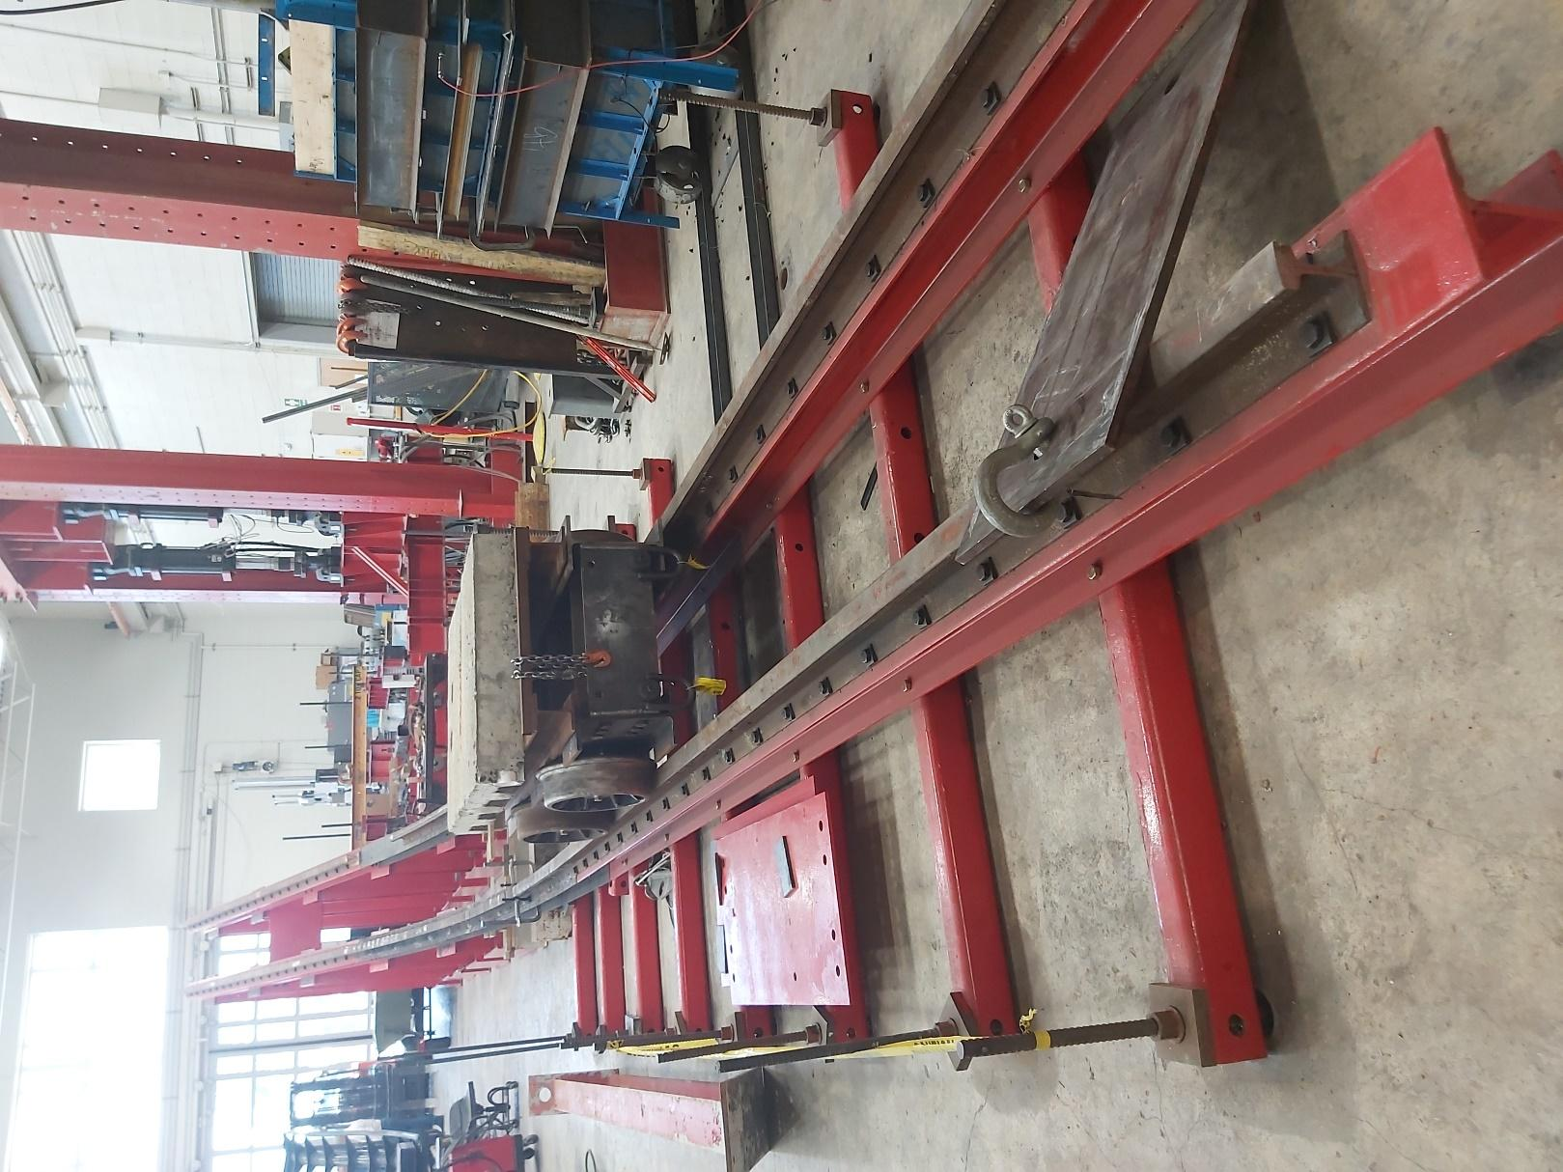
Fig. 1: Test setup ready for testing

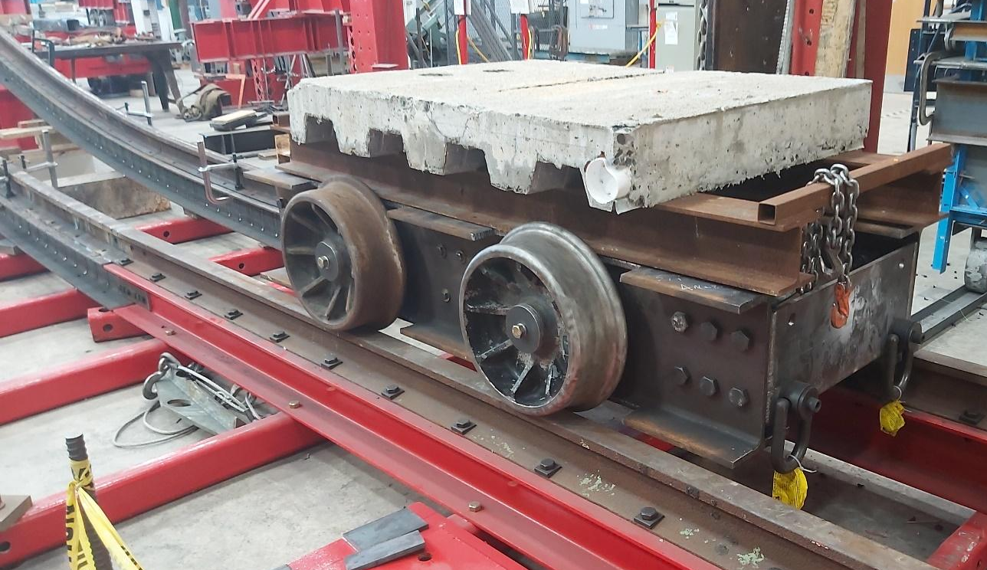
Fig. 2: Cart ready for testing

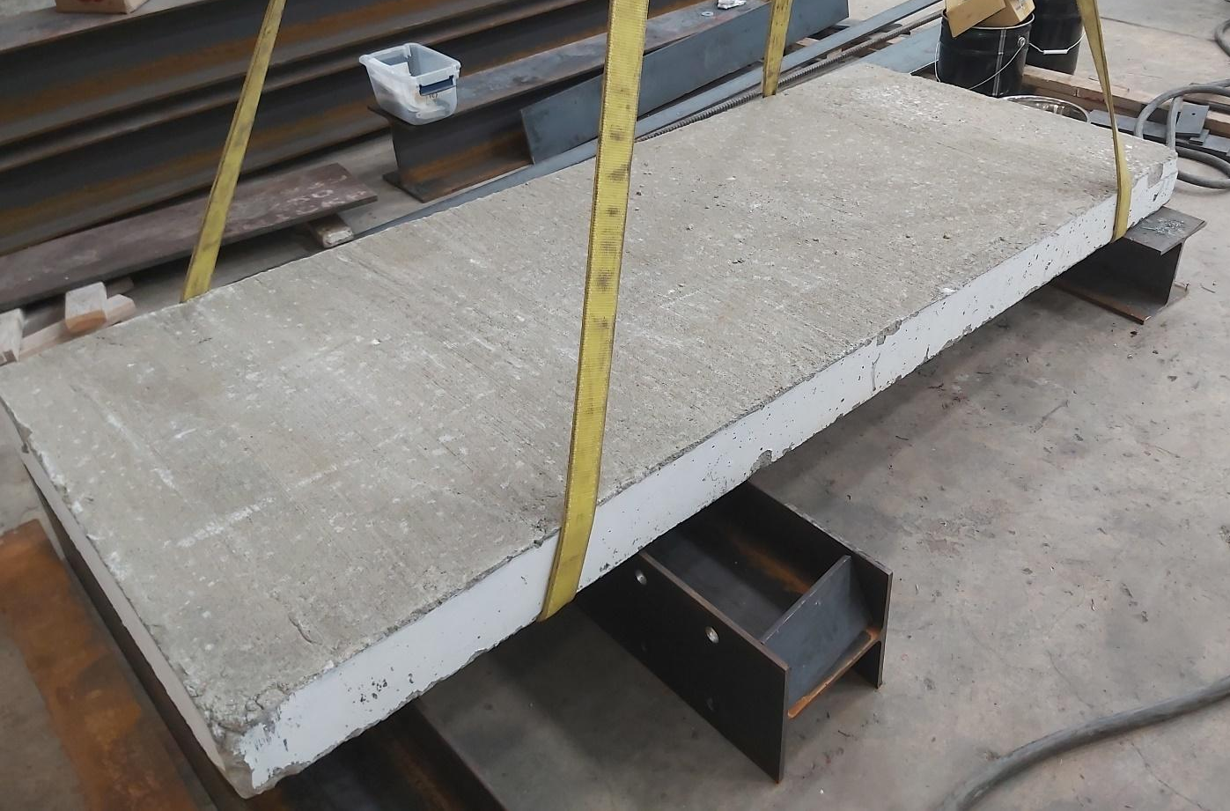
Fig. 3: Reinforced concrete slab used as an additional weight for the impact cart

Task 5: Develop finite element models for the beams.
Finite element models have been developed to simulate different damage scenarios before experimental testing. Examples of the work done is shown below:
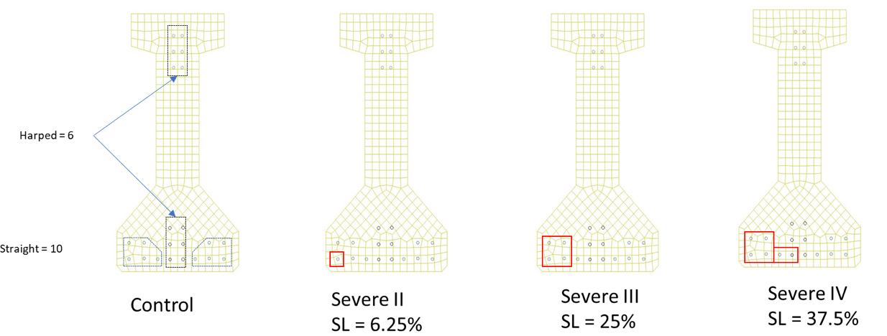
Fig. 4: Different types of damages

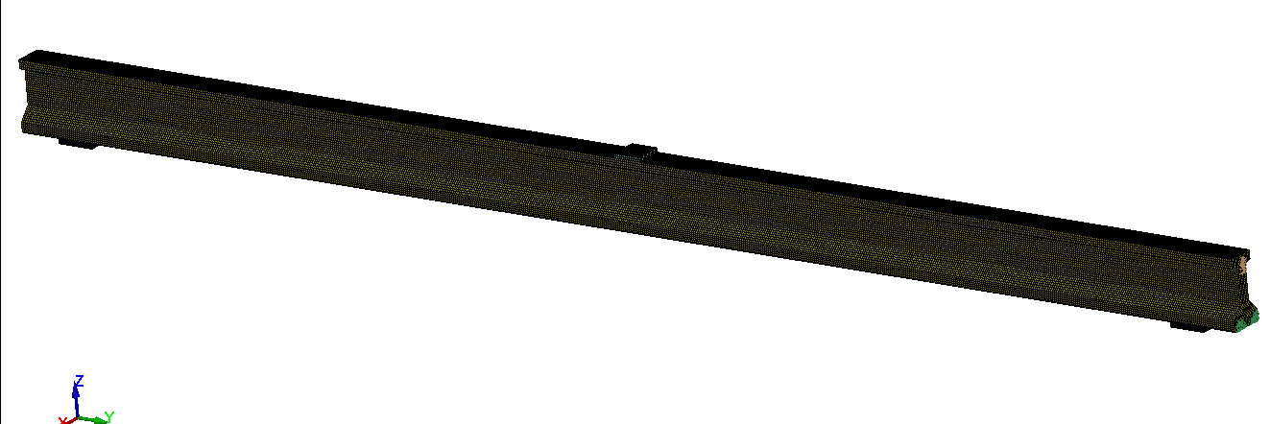
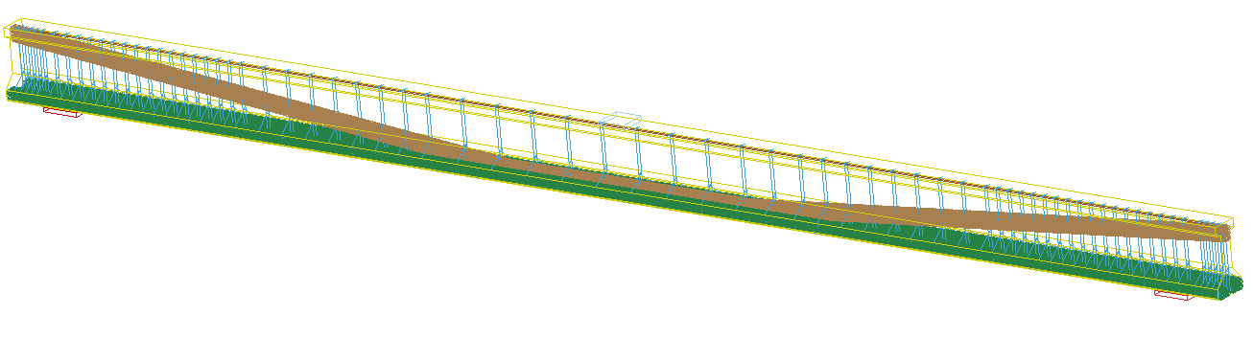
Fig. 5: Control girder
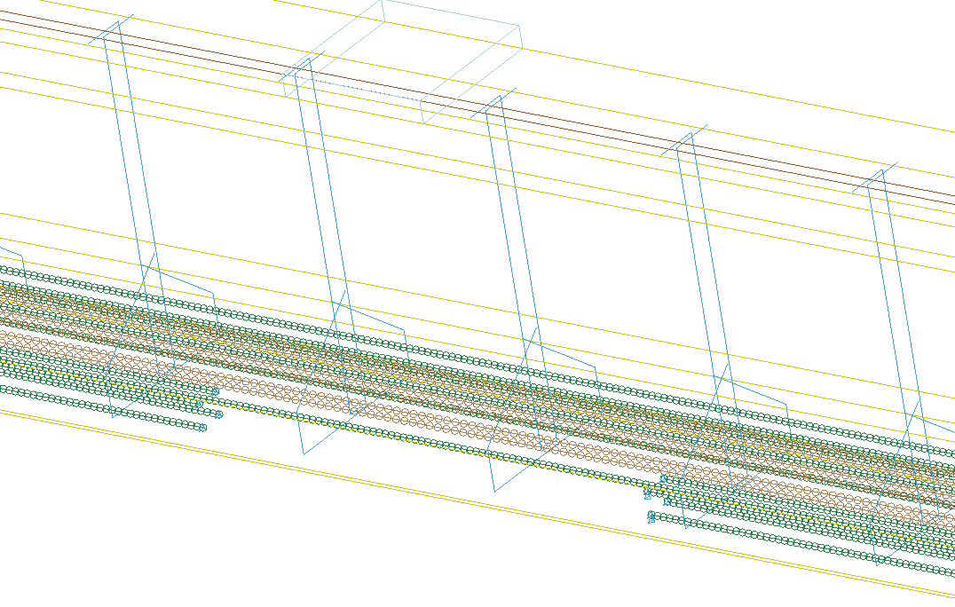
Fig. 6: An example of strand loss
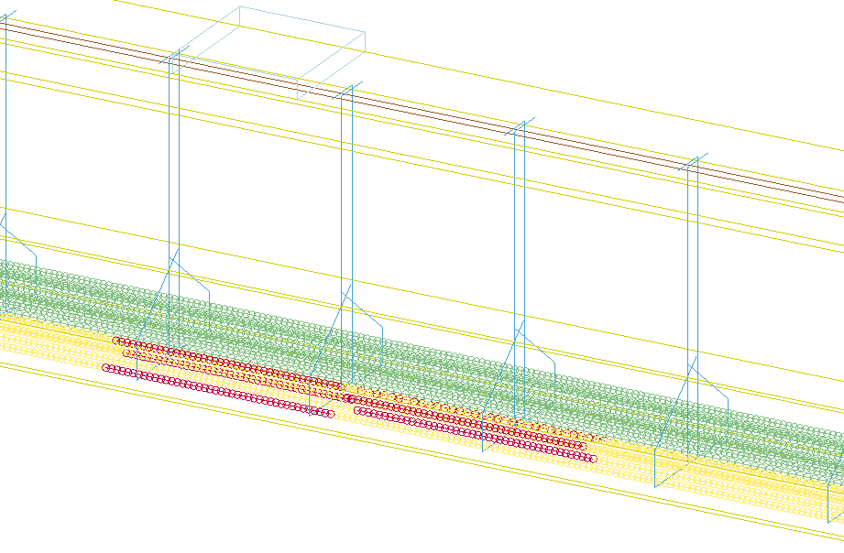
Fig. 7: An example of repair opetions
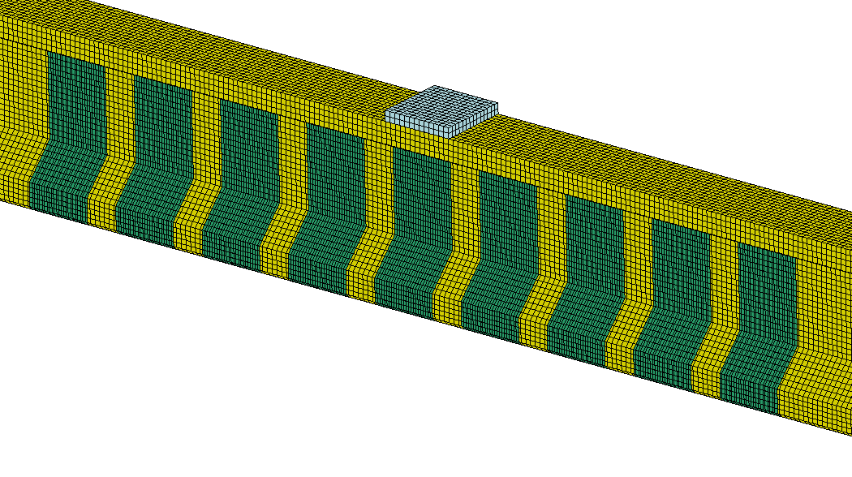
Fig. 8: Another example of repair options

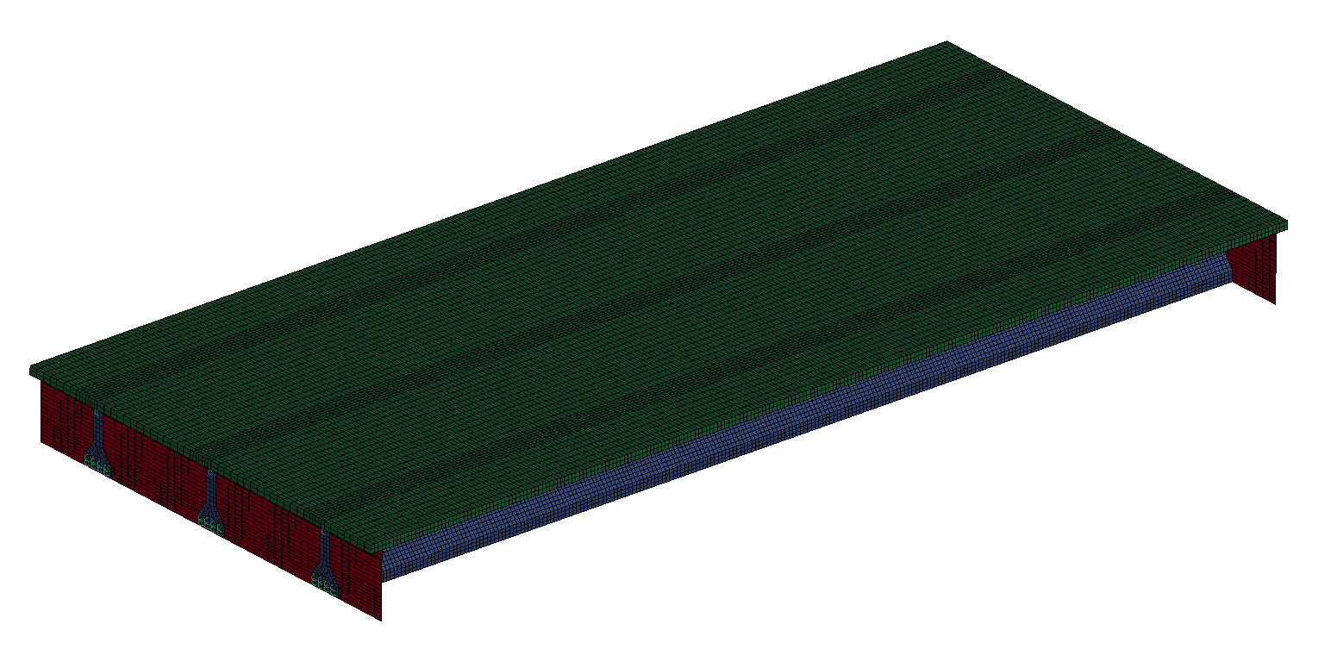
Reinforced Concrete End Diaphragm
Prestressed Girders:
Concrete SOLID ELMS + MAT CSCM
Strands BEAM ELMS + MAT_PLASTIC_KINEMATIC
Apply prestressing force using Temperature
Reinforced Concrete Deck:
Concrete SOLID ELMS + MAT_CSCM
RFT BEAM ELMS + MAT_PLASTIC_KINEMATIC
Coupling shared nodes or CLIS
Fig. 9: Full-scale finite element bridge model
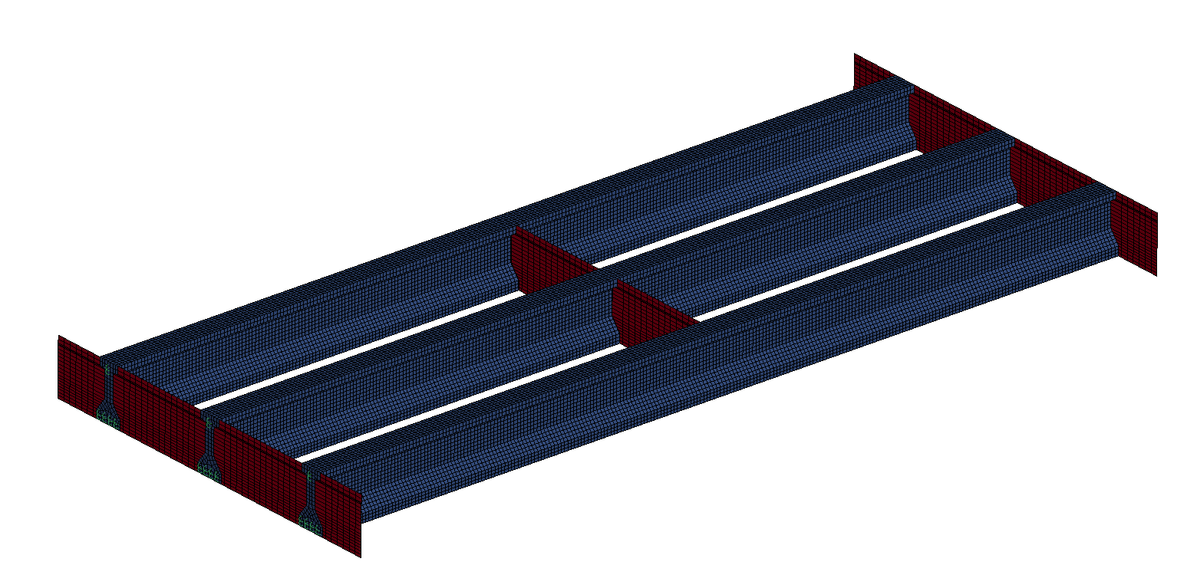
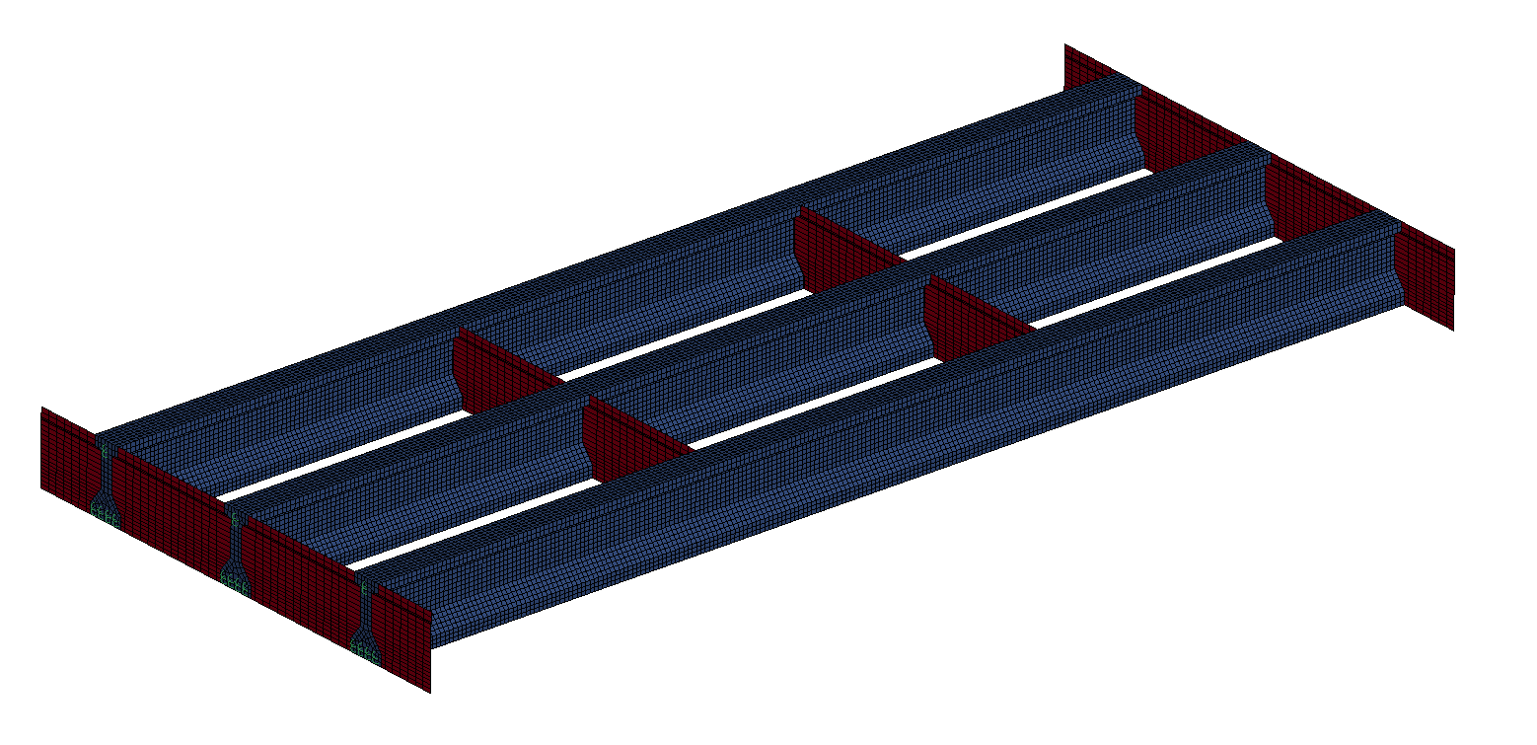
b) RC.3: 6" RC intermediate diaphragm at third points
a) RC.1: 6" RC intermediate diaphragm at the midspan

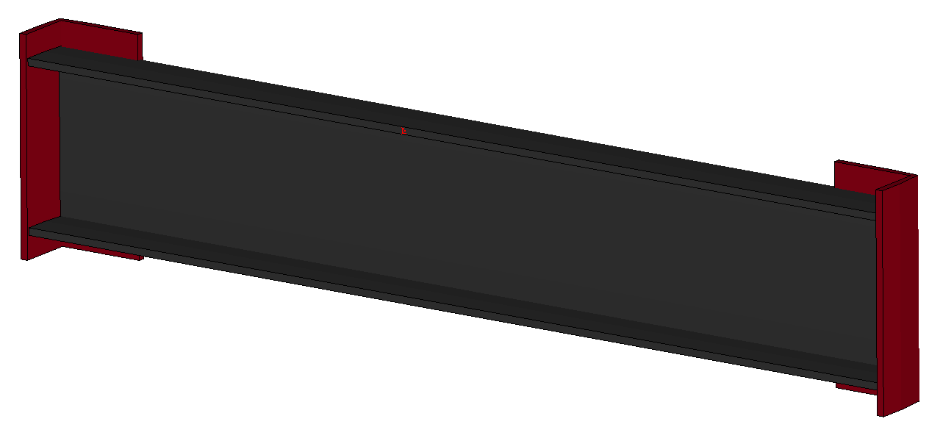
C15x33.9x5’-3’’
L6x4x1/2x1’-4’’
C) C1: Steel intermediate diaphragm typical section

Fig. 10: intermediate diaphragms details
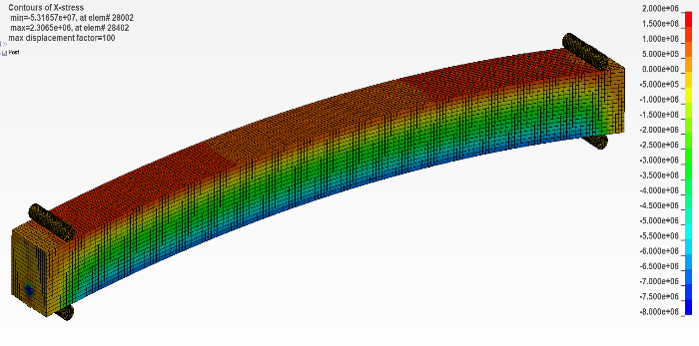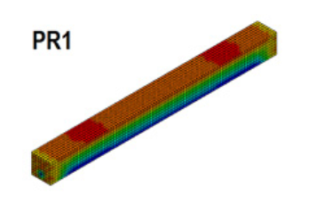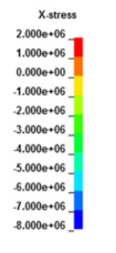
a) Prestressed beam using temperature method
b) Husain’s (2019) model

Fig. 11: Validation of the prestressing force
a) compressive stresses at midspan
b) tensile stresses at midspan

Fig. 12: Mesh sensitivity analysis for prestressing force
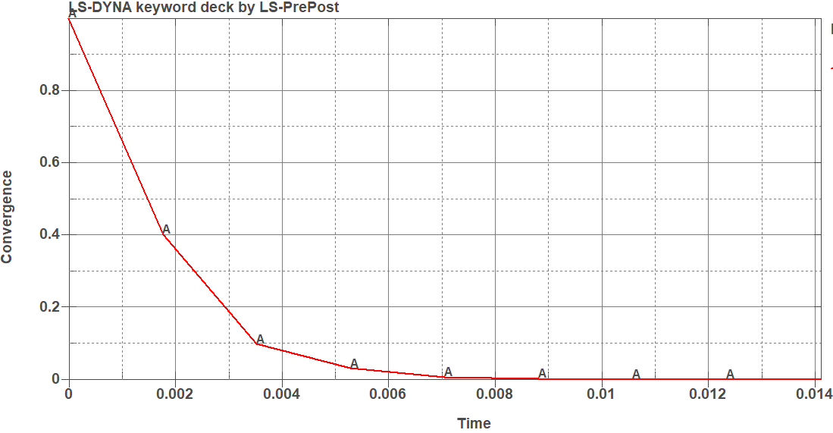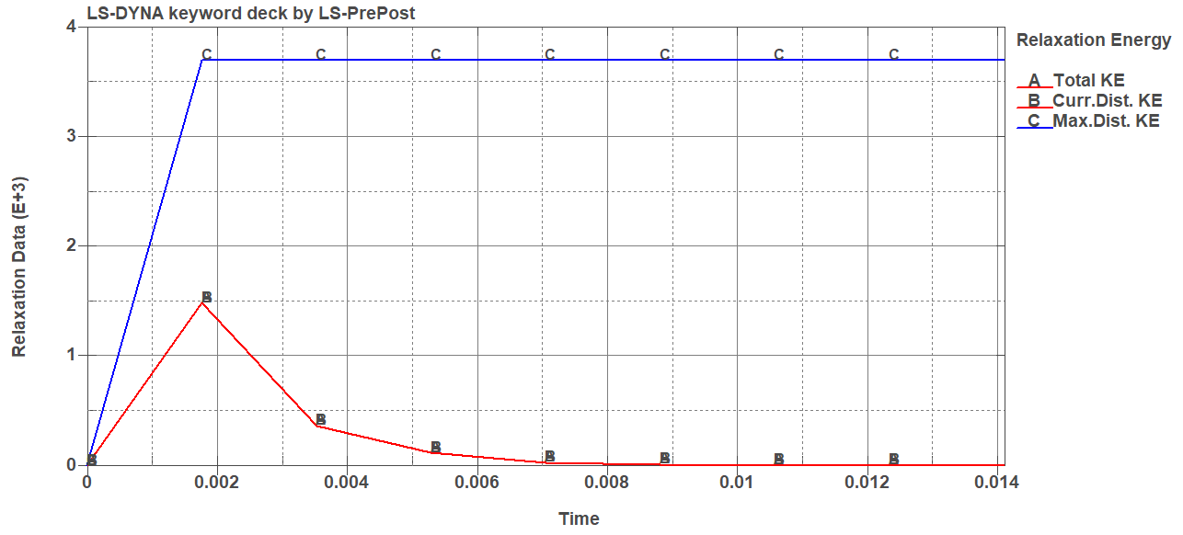
a) convergence
b) distortion vs total energy

Fig. 13: Dynamic relaxation results

RC.3 Intermediate Diaphragm
Load: Point 6
Displacement: Point 5 (vertical)
RC.3 Intermediate Diaphragm
Load: Point 6
Displacement: Point 6 (vertical)
RC.1 Intermediate Diaphragm
Load: Point 6
Displacement: Point 5 (vertical)
RC.1 Intermediate Diaphragm
Load: Point 6
Displacement: Point 6 (vertical)
No Intermediate Diaphragms
Load: Point 6
Displacement: Point 5 (vertical)
No Intermediate Diaphragms
Load: Point 6
Displacement: Point 6 (vertical)
Fig. 14: Load-displacement verification results
Without Intermediate Diaphragm
Load: Point 6
Displacement: Point 6 (horizontal)
C1 Steel Intermediate Diaphragm
Load: Point 6
Displacement: Point 5 (vertical)
C1 Steel Intermediate Diaphragm
Load: Point 6
Displacement: Point 6 (vertical)

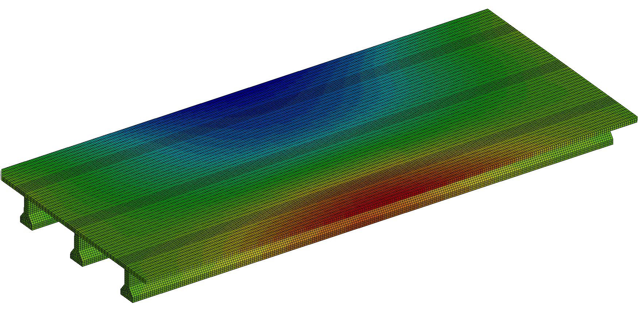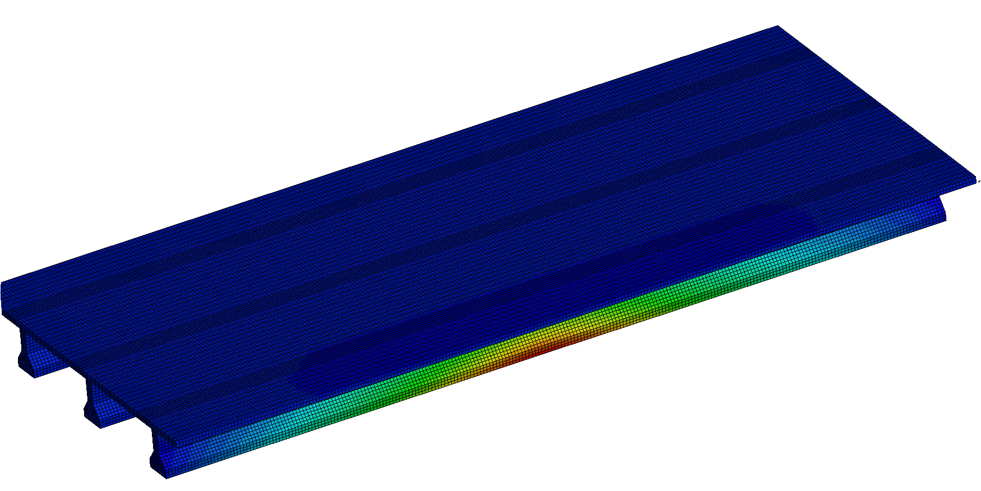
b) Horizontal Displacement
a) Vertical Displacement

Fig. 15: Vertical and horizontal displacement contour plots

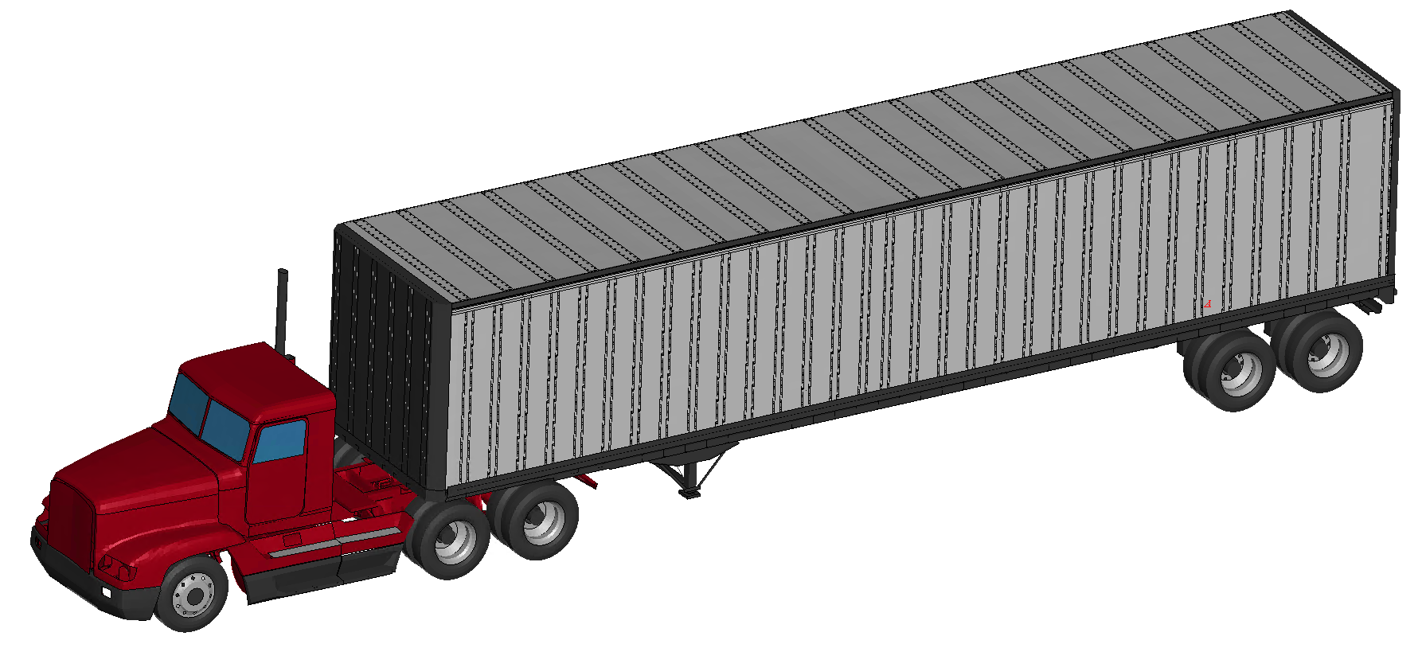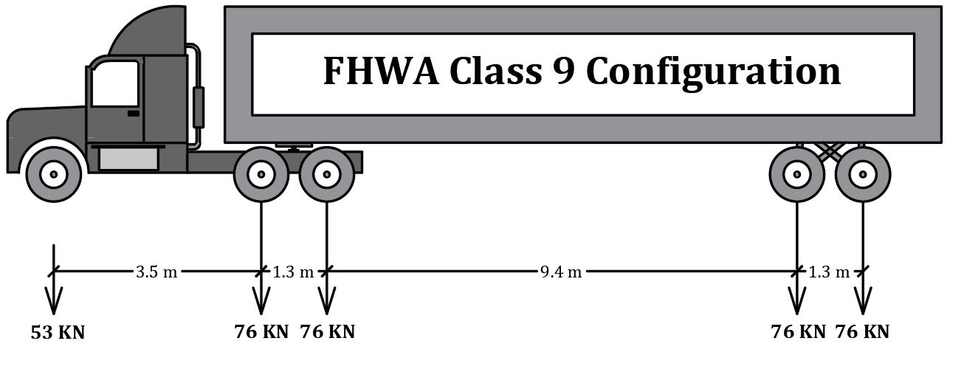
b) Truck Details
a) Truck FE model

Fig. 16: Truck model details

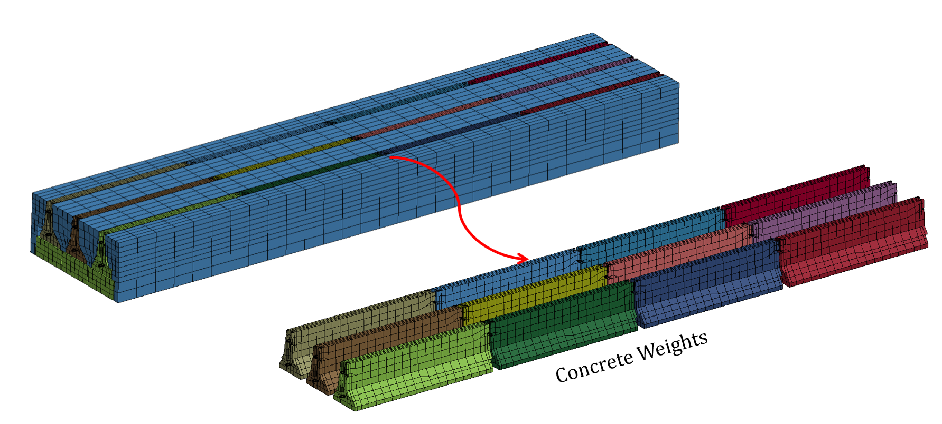

Fig. 17: Ballast weight for the trailer

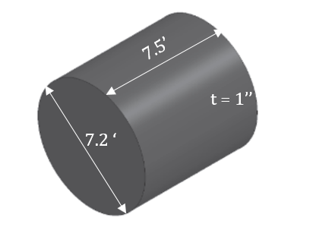
Fig. 18: Steel tank rigid impactor details

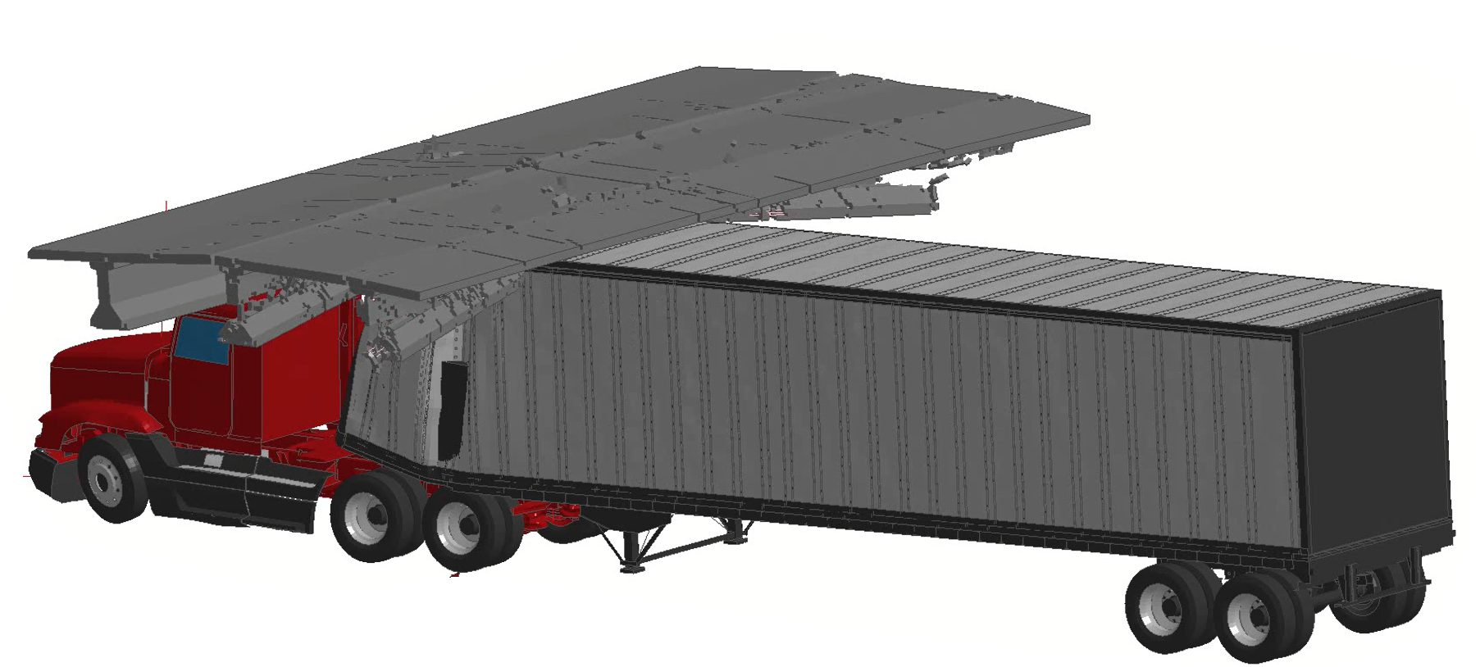
Fig. 19: Bridge failure

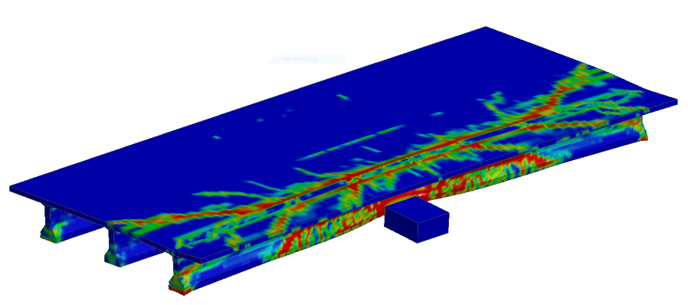
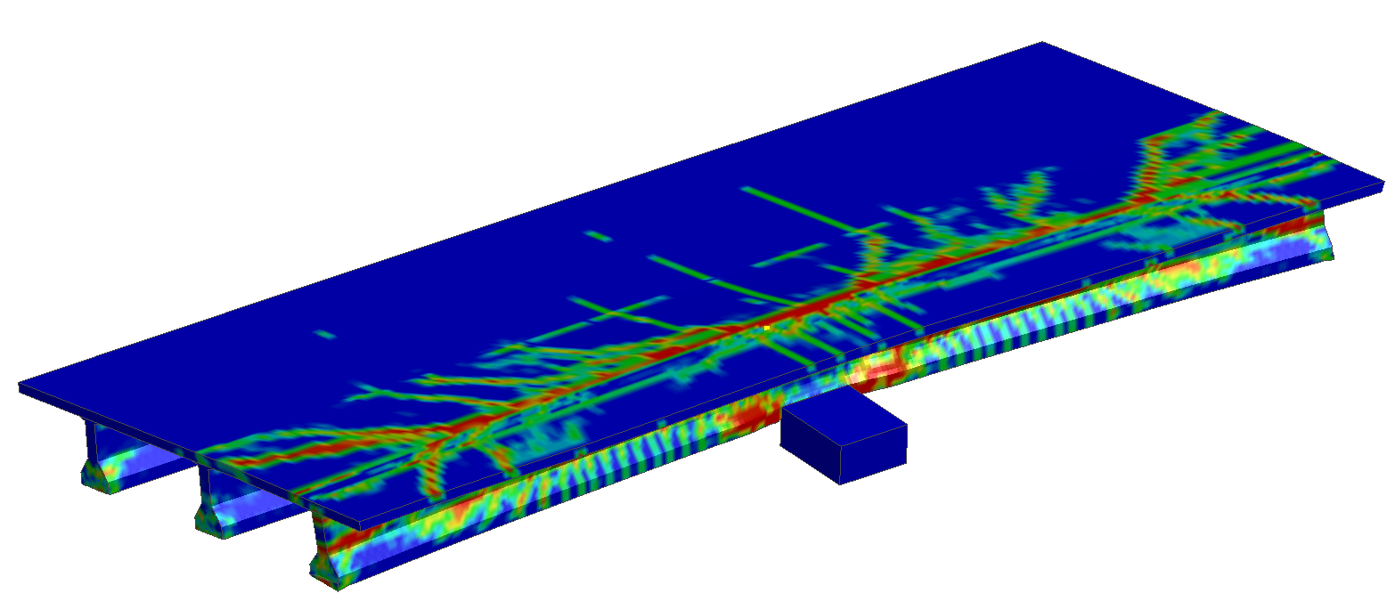

b) Impact at 25 mph speed
a) Impact at 50 mph speed

Fig. 20: Preliminary impact results

