Click here to enter Program or Project Title
Progress Report – July-September 2023.

Title: Assessment and Repair of Prestressed Bridge Girders Subjected to Over-height Truck Impacts Pooled Fund Project

Project Number: TR202011

Principal Investigator (PI): Mohamed ElGawady PhD (PI)
Co-PI(s): William Schonberg PhD, PE (Co-PI)

Award date: | 1/1/2021
Scheduled completion date: | 12/31/2023 | % of project completed to date: | 79%
Total budget: | $805,000 | % of budget expended to date: | 70%
Draft report due: | 9/30/2023 | Final report due: | 12/1/2023

Provide a short description of the work currently underway.
Use additional notes section if you need to provide more information.

Task 2. Experimental testing of bridge girders subjected to lateral impacts:
- 2nd girder is being prepared for testing.

Task 4: Residual Capacity:
- Determine the flexural capacity of damaged prestressed girders considering the bi-axial bending due to loss of strands.

Task 5: Repair Evaluation:
- Preparing the flexural testing of the 1st repaired beam

Provide a short description of the noteworthy activities/accomplishments during this reporting period.
Use additional notes section if you need to provide more information.

Task 2. Experimental testing of bridge girders subjected to lateral impacts:
The 1st bridge girder was tested (Figs. 1 through 8).

Task 5: Repair Evaluation:
- Preparing the flexural testing of the 1st repaired beam. The repair implemented as follows.
GRABB-IT strand splicing of 0.5-inch size were used to splice the damaged strands. High pressure lubricant (Goop fluid) was used to lubricate the strand splicing chucks. This step was crucial to ensure the smooth operation of the prestressing system and maintain its longevity.
Stressed Prestressing strands to 26 kips:
Per the American Association of State Highway and Transportation Officials (AASHTO) guidelines, we successfully stressed the prestressing chucks to 26 kips.
Prepared Formwork for Damaged Area:
Formwork was prepared for the damaged area. This involved the precise measurement and assembly of the formwork to facilitate the subsequent concrete repair work.
Used Non-Shrinkage Grout Concrete for Repairs:
To ensure the integrity of the repaired structure, five and half non-shrinkage grout bags were used as the primary repair material. This type of grout minimizes the risk of cracking and shrinkage, which is essential for the longevity of the repair.
Grout placing:
Following the formwork preparation and material selection, the non-shrinkage grout was placed into the damaged area. Additionally, concrete cubes were made for quality control purposes to monitor the strength and durability of the concrete used for repairs.
Surface preparation and application of CFRP:
Repair any cracks or defects in the concrete using an appropriate repair mortar and grinding the surface of the concrete beam to a desired roughness. dust, dirt, and contaminants were removed, ensuring the surface was dry before proceeding. This step is crucial to ensure a strong bond between the CFRP material and the concrete surface. The CFRP was cut to the required length and applied to the concrete surface.

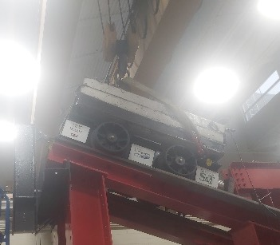
Fig. 1: Lifting the cart with the crane and holding its weight using the releasing mechanism system
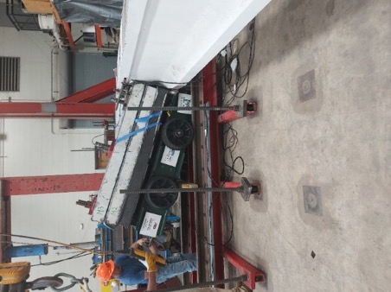
Fig. 2: The cart impacted the girder after release.
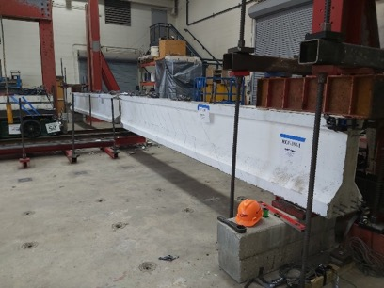
Fig. 3: Cracking mapping and concrete spalling on the girder front.
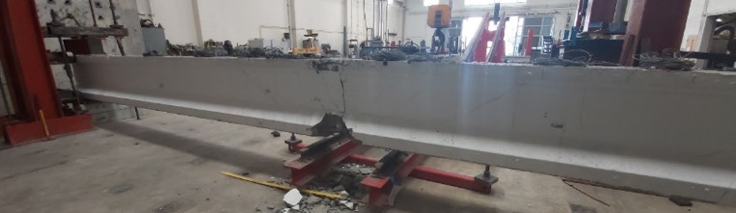
Fig. 4: Concrete cracking and spalling at the girder rear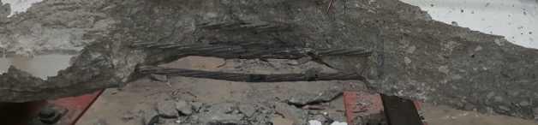
Fig. 5: Prestressing strands yielding at the girder front
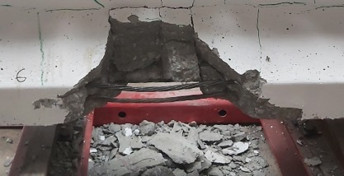
Fig. 6: Prestressing strands yielding at the girder rear
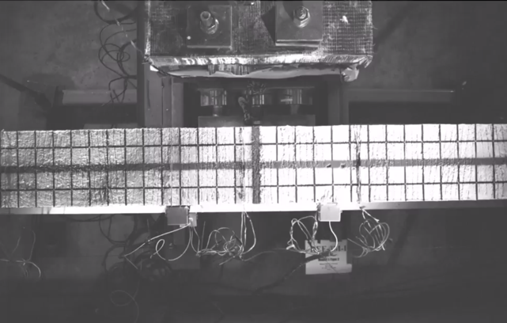
At the impact moment (T = 0)
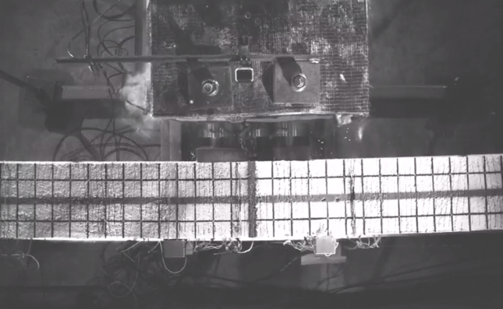
T = 180 msec
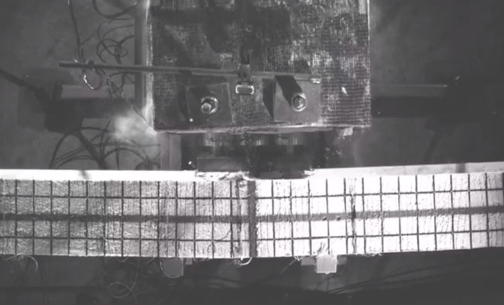
Concrete spalling at bottom flange
Concrete spalling at top flange
T = 260 msec
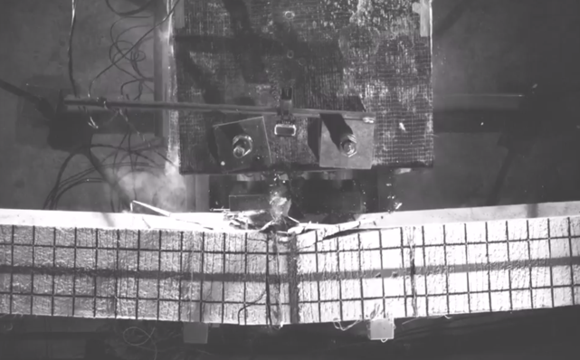
T = 360 msec
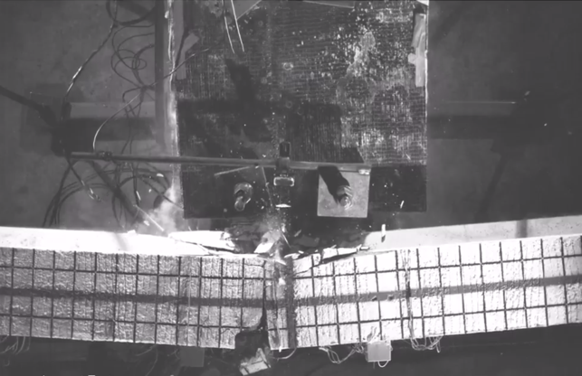
T = 520 msec
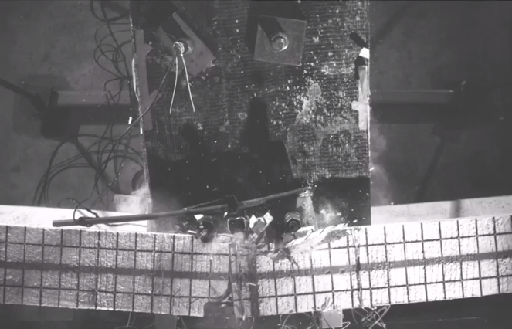
T = 1080 msec (time of maximum deflection)
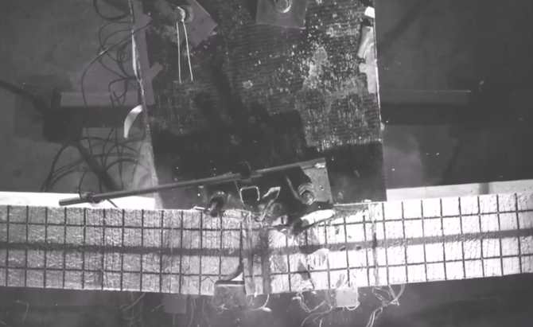
T = 1105 msec
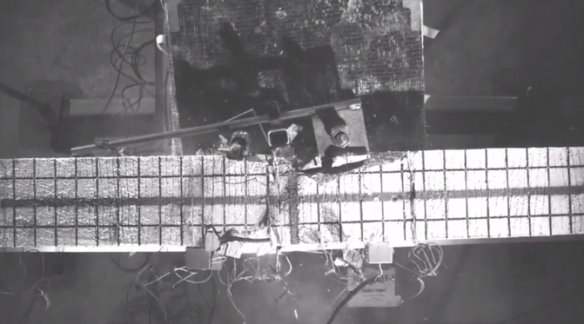
T = 1146 msec (End of girder rebound)
Figure 7. High speed camera footage for the girder lateral displacement and damage propagation
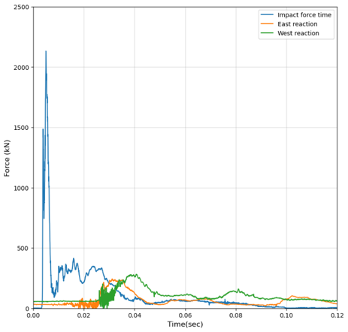
(a)
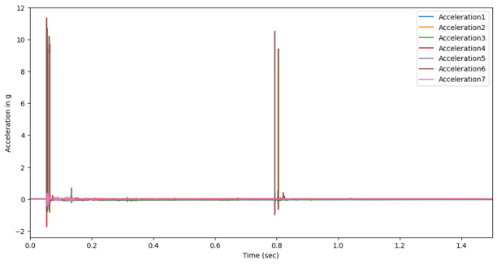
(b)
Figure 8. (a) Impact and reaction force time histories, (b) Girder Acceleration time history

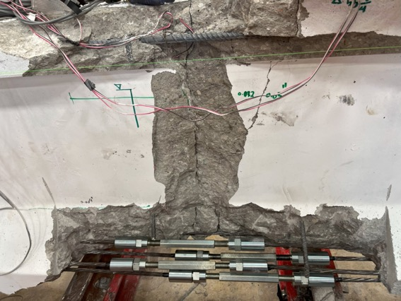
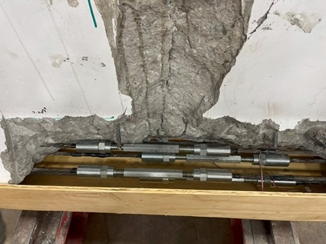
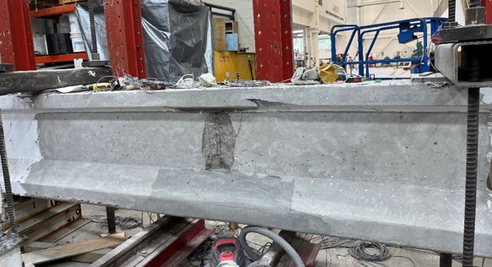
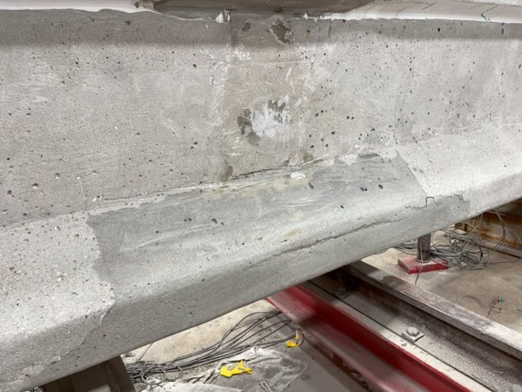
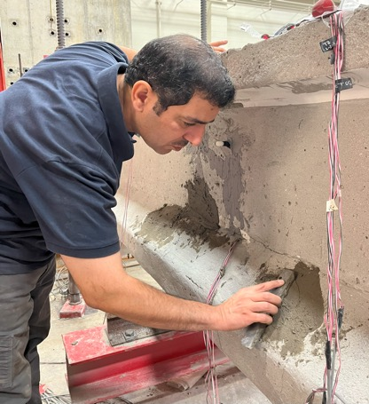
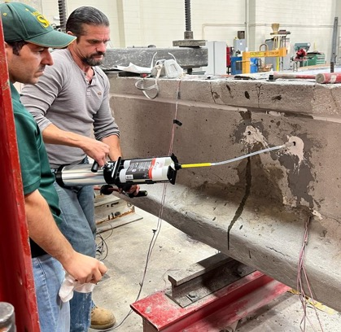
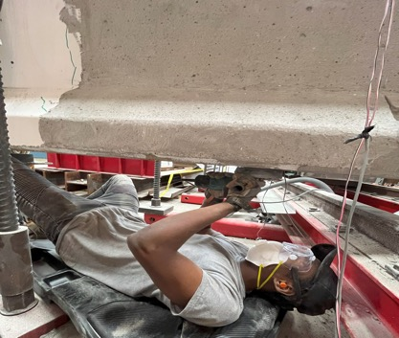

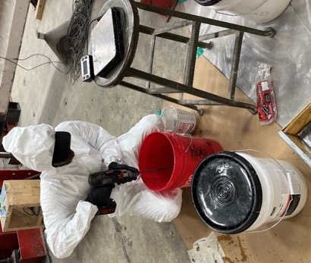
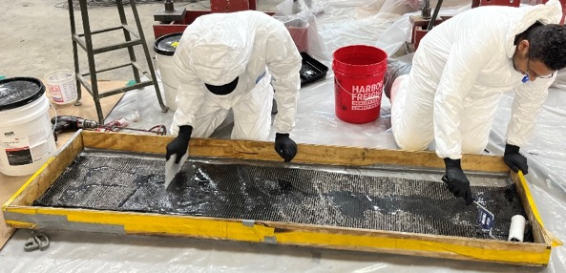
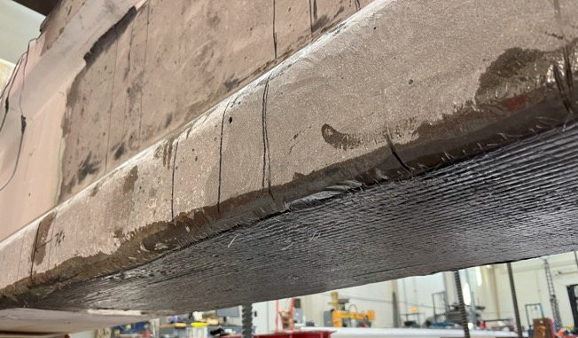
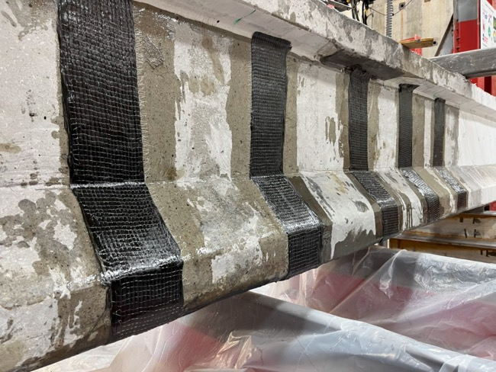
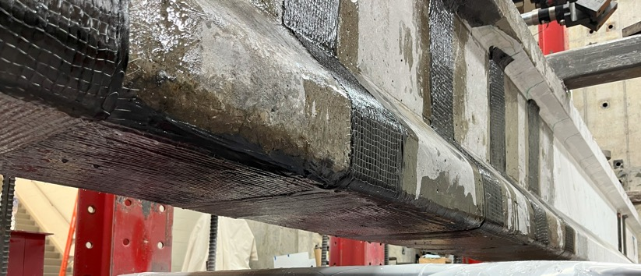
Figure 9. Repair of the 1st girder

