Quarterly Progress Report (QPR)

Applications of Enterprise GIS in Transportation
Progress Report for Quarter 3 [April 1st 2020 – June 30th, 2020]
WSP Program Manager: Jag Mallela (jag.mallela@wsp.com)
WSP Technical Lead: Abhishek Bhargava (abhishek.bhargava@wsp.com)

Background
The Pooled Fund Study (PFS) on Applications of Enterprise GIS in Transportation (AEGIST) was initiated by FHWA in 2018. During Phase 1 of this study a guidebook was developed for transportation agencies in the United States, with the primary objective of documenting guidance on how spatial and linear referenced data should be managed by States. Phase 2 of this PFS was initiated in October 2019. This phase will span over 5 years (October 2019 – September 2024), during which the objectives outlined below would be accomplished.
Objective
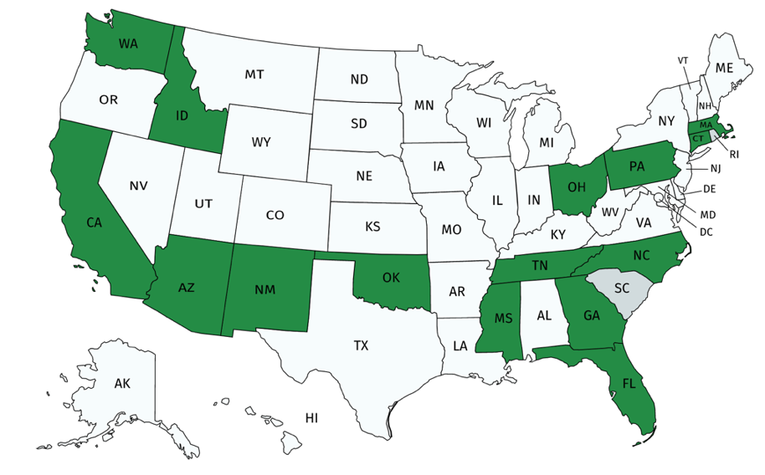
- Establish a standard for sharing and publishing highway infrastructure data between stakeholders at DOTs and their Federal, State and Local partners
- Review existing practices in spatial and linear referencing data management at State transportation agencies
- Assess the extent to which the States participating in the PFS (Figure 1) have implemented standards based spatial data management practices.
- Create/update AEGIST Guidebook based on best practices in spatial data management at State transportation agencies.
- Coordinate with the PFS States to further advance the spatial data management practices at the DOTs by implementing spatial and linear referencing data management solutions and data science platforms.
Completion Status and Summary
Time Frame: October 1, 2019 to September 30, 2024
Total Time, months: 60
Time Expended, months: 9
Percent Calendar Time Expended: 15%

Work Accomplished This Reporting Period
Task 1: Project Management
Task Objective: Perform project management activities, which include conducting monthly status meetings, developing quarterly status reports, creating project work plan, managing project resources, schedule, deliverables and communication with all stakeholders.
Work Accomplished: Following activities were performed in the reporting period:
- Deliverable 1.2.0 – Work Plan v1.0 Submission
  - Meeting with FHWA and PFS States to review content in Work Plan v1.0
  - Finalize and submit work plan v1.0 with cross-agency activities.
- Discussions with PFS States on timing and scope of technical services that need to be provided to the States as part of the AEGIST project.
- Monthly & Quarterly progress reports development.
- Coordination with PFS States (AZ, CT, CA) to get 100 hours approved for conducting the guidebook update and AEGIST specifications evaluation against DOT practices. These two tasks are identified as Task 2.2.1 and 2.2.2 in the Technical Work Plan (in the section on Cross-agency activities). Received approval from Caltrans on 6/12.

Task 2: Technical Services
Task Objective: Provide technical services associated to PFS States by completing various agency-specific and cross-agency activities identified in the work plan.
Work Accomplished: Following activities were performed in the reporting period:
- Task 2.1 – Evaluate AEGIST spatial data modeling implementation practices
Centerlines, Intersections and Routes modeling practices were discussed with the following states:
- Georgia (April 2nd & 13th)
- Connecticut DOT (multiple meetings during the month).
Both DOTs made ALRS datasets available for detailed analysis of existing rules, and these datasets were analyzed for business rules and extraction of specific examples in the network. Focus of the analysis to compare practices with information in the guidebook for:
- Identifying changes needed in Guidebook v1.0 on Centerlines, Intersections and Routes.
- Integrating HPMS, MIRE & AEGIST data models based on preliminary mapping
- Documentation of existing AEGIST model and busines rules in Roads & Highways.
Additionally, conducted discussions and analysis of spatial data governance (specifically, modeling and integration) practices in following States: Arizona, Connecticut, North Carolina, Georgia & New York. Focus of the discussion was on roads data modeling and exchange between DOT and local agencies, for preparation of ARNOLD. On May 29th, delivered presentation to PFS States on Intersection modeling practices & AEGIST specifications, rules. Conducted poll on Intersection modeling practice.

- Task 2.1: Biweekly discussions with NC. ID and CT on routes & intersection modeling rules and AEGIST implementation at their DOTs. Collecting of information from Kansas on routes data conflation practice in the State, especially integration of local agency routes data into DOT LRS.
- Task 2.CA.x: Received approval from Caltrans on AEGIST work plan on 6/25.

- Task 2.2 – Guidebook v2.0
Preparation of content on modeling of Centerlines, Routes and Intersections at DOTs (NC, CT).

- Task 2.CA.x: Caltrans Technical Services
Published Work Plan v1.1 on May 28th with detailed information on the Caltrans Tasks 2.CA.1 – 1Spatial Integration & 2.CA.2 – ArcGIS Hub setup. Received approval from Caltrans on AEGIST work plan on 6/25.

- Task 2.ID.x: Idaho Technical Services
Task 2.ID.1: Idaho work planning weekly sessions held to develop scope and identify deliverables.

- Task 2.GA.x: Georgia Technical Services
Task 2.GA.x: Prepared and shared Technical Services work plan v1.2 to reflect activities identified by Georgia on June 2nd, 2020. Georgia planned for approximately 250 hours of services and requested that work starts in 2021, as the tasks involve conducting on-site workshop & discussions with stakeholders. Remaining tasks will be planned in 2021 based on stakeholder inputs, spatial data governance (modeling, integration priorities), & readiness to implement AEGIST intersection model.

Task 3: Marketing and Communication
Task Objective: Webinars and Workshops will be held, and Articles will be presented in conferences and other industry forums to communicate information about the activities of the project, especially the technical work products developed as part of the project.
Work Accomplished: Following activities were performed in the reporting period:

- Deliverable 3.1.1 – Article 1:
On May 15th, submitted abstract for article on “Utilizing HPMS & MIRE Compliant Safety Dataset for Building Econometric and Machine Learning Models for Safety Performance Analysis”. FHWA comments received on May 18th. Abstract updated. Started review of practices and articles where MIRE attributes have been proved to be statistically significant in terms of their impact on Safety. Prepared a catalog of articles that validate significance of each MIRE element.

- Deliverable 3.2.1 – Workshop 2 (TRB-2021)
Submitted abstract & workshop request on May 24th.

- Deliverable 3.2.2 – Presentations
- Presentation made to NYSDOT on April 29 to inform about AEGIST goals, activities & share project documents.
- Traffic Records Forum presentation abstract submitted on 06/30
- Presentation to Kansas (non-PFS State) on June 19th to inform about AEGIST & share project documents, presentation material and information about activities.
Task 4: Peer Exchange Meetings
Task Objective: Plan, organize and conduct 5 peer exchanges, one each year between 2019 and 2023.
Work Accomplished: Following activities were performed in the reporting period:
- Scheduled weekly planning meetings with FHWA starting May 24th, 2020. Conducted first meeting.
- During June, conducted weekly planning meetings with FHWA. Coordinated with PFS State presenters on content.
Problems Encountered/Recommended Solutions:
- Approval of 100 hours for conducting AEGIST Guidebook updates and specification evaluation.
- Planning of State-specific AEGIST Technical Services due to ongoing projects and internal coordination required at DOTs. Also, some PFS States awaiting updates to Guidebook v1.0

Complete List of Base Period Deliverables
Note: Deliverables on which work is complete (in green) and work is in progress (in orange).

Task | D# | Deliverable Name | Due Date | Status
Task 1 | 1.1.0 | Kick-off Meeting | 10/30/19 | Completed.
Task 1 | 1.2.0 | Work Plan Version 1: Cross-Agency Tasks, Deliverables & Schedule | 4/30/20 | Completed. Submitted to FHWA and PFS States.
Task 1 | 1.3.1 | Quarterly Progress Report - 1 (incl. 3 monthly meetings and reports) | 12/31/19 | Completed. Submitted to FHWA. Email sent to PFS States.
Task 1 | 1.3.2 | Quarterly Progress Report - 2 (incl. 3 monthly meetings and reports) | 3/31/20 | Completed. Submitted to FHWA.  Email sent to PFS States.
Task 1 | 1.3.3 | Quarterly Progress Report - 3 (incl. 3 monthly meetings and reports) | 6/30/20 | MPR for April, May, June published.  QPR-3 (April-June) published.
Task 1 | 1.3.4 | Quarterly Progress Report - 4 (incl. 3 monthly meetings and reports) | 9/30/20 | Prepared MPR for June 2020.  QPR-4 (June-Oct) in progress.
Task 1 | 1.3.5 | Quarterly Progress Report - 5 (incl. 3 monthly meetings and reports) | 12/31/20 | Not Started
Task 1 | 1.3.6 | Quarterly Progress Report - 6 (incl. 3 monthly meetings and reports) | 3/31/21 | Not Started
Task 1 | 1.3.7 | Quarterly Progress Report - 7 (incl. 3 monthly meetings and reports) | 6/30/21 | Not Started
Task 2 | 2.1 | TASK 2 Technical Services (incl. Work Plan v1.1 with State Tasks) - MONTH 8 - MAY 2020 | 5/30/20 | Work Plan v1.1 has Caltrans Tasks.  May 29th PFS States Presentation.
Task 2 | 2.2 | TASK 2 Technical Services (incl. Work Plan v1.2 with State Tasks) - MONTH 9 - JUN 2020 | 6/30/20 | Work Plan v1.2 has CA, GA, ID Tasks.  June 16th PFS States Presentation.
Task 2 | 2.3 | TASK 2 Technical Services (incl. Work Plan v1.3 with State Tasks) - MONTH 10 - JUL 2020 | 7/30/20 | Not Started
Task 2 | 2.4 | TASK 2 Technical Services (incl. Work Plan v1.4 with State Tasks) - MONTH 11 - AUG 2020 | 8/30/20 | Not Started
Task 2 | 2.5 | TASK 2 Technical Services (incl. Work Plan v1.5 with State Tasks) - MONTH 12 - SEP 2020 | 9/30/20 | Not Started
Task 2 | 2.6 | TASK 2 Technical Services (incl. Work Plan v1.6 with State Tasks) - MONTH 13 - OCT 2020 | 10/30/20 | Not Started
Task 2 | 2.7 | TASK 2 Technical Services (incl. Work Plan v1.7 with State Tasks) - MONTH 14 - NOV 2020 | 11/30/20 | Not Started
Task 2 | 2.8 | TASK 2 Technical Services (incl. Work Plan v1.8 with State Tasks) - MONTH 15 - DEC 2020 | 12/30/20 | Not Started
Task 2 | 2.9 | TASK 2 Technical Services (incl. Work Plan v1.9 with State Tasks) - MONTH 16 - JAN 2020 | 1/20/21 | Not Started
Task 2 | 2.10 | TASK 2 Technical Services (incl. Work Plan v1.92 with State Tasks) - MONTH 17 - FEB 2020 | 2/28/21 | Not Started
Task 2 | 2.11 | TASK 2 Technical Services (incl. Work Plan v1.94 with State Tasks) - MONTH 18 - MAR 2020 | 3/20/21 | Not Started
Task 2 | 2.12 | TASK 2 Technical Services (incl. Work Plan v1.98 with State Tasks) - MONTH 19 - APR 2020 | 4/30/21 | Not Started
Task 2 | 2.13 | TASK 2 Technical Services (incl. Work Plan v2.0 with State Tasks) - MONTH 20 - MAY 2021 | 5/30/21 | Not Started
Task 3 | 3.1.1 | Article 1 | 6/30/20 | Started. First draft in progress
Task 3 | 3.2.1 | Workshop 1 – TRB-2021 | 1/30/21 | GIS-T replaced by TRB-2021.
Task 3 | 3.2.2 | Workshop or Presentations | 10/30/20 | NYSDOT (Apr); TRF (Aug); KDOT (Jun)
Task 3 | 3.2.3 | Workshop 3 - GIS-T 2021 | 4/30/21 | Not Started
Task 3 | 3.3.1 | Webinar 1 | 8/30/20 | Not Started
Task 4 | 4.1.0 | Peer-Exchange 1 - 2019 | 12/30/19 | Completed.
Task 4 | 4.2.0 | Peer-Exchange 2 - 2020 | 12/30/20 | Started Planning Meetings

