Click here to enter Program or Project Title
Progress Report – Click here to enter a date.

Title: Assessment and Repair of Prestressed Bridge Girders Subjected to Over-height Truck Impacts Pooled Fund Project

Project Number: TR202011

Principal Investigator (PI): Mohamed ElGawady PhD (PI)
Co-PI(s): William Schonberg PhD, PE (Co-PI)

Award date: | 1/1/2021
Scheduled completion date: | 12/31/2023 | % of project completed to date: | 75%
Total budget: | $805,000 | % of budget expended to date: | 67%
Draft report due: | 9/30/2023 | Final report due: | 12/1/2023

Provide a short description of the work currently underway.
Use additional notes section if you need to provide more information.

Task 2. Experimental testing of bridge girders subjected to lateral impacts:
- Preparing testing the first three girders.
- Finalize the finite element models.

Task 4: Residual Capacity:
- Determine the flexural capacity of damaged prestressed girders considering the bi-axial bending due to loss of strands.
- Preparing a paper that will be submitted to TRB

Task 5: Repair Evaluation:
- Strand splices and CFRP were acquired from different suppliers
- Repair options are finalized.

Provide a short description of the noteworthy activities/accomplishments during this reporting period.
Use additional notes section if you need to provide more information.

Task 2. Experimental testing of bridge girders subjected to lateral impacts:
Three girders were delivered to the structural lab at Missouri University of Science and Technology (Fig. 1). The three girders represent the first patch of testing girders and will be tested for three different repair methods. Severe damages are targeted for the three girders to account for the worst-case scenario of bridge girder subjected to vehicle collisions. Each girder will be impacted and then repaired. The repaired girder will be flexural tested under four-point static loading to determine its capacity.
The impact test setup is ready (Fig. 2), and several dry tests were conducted (Fig. 3) to ensure the stability of the impact cart and the integrity of the track structural system. Lateral supports HP 10x34 steel beams were installed, and two 250 kips load cells were mounted at the bottom and top flanges at both girder ends to record the reaction forces. A release lever with a capcity of 6000 lbs was installed on a 10x34 HP steel section to hold the impact cart and release it from the top of the track (Fig. 4).
Three cylinders were tested after 28 days from casting and the average compressive strength was found to be 8.2 ksi (Fig. 5).
Twenty-eight strain gages were attached to the girder stirrups and strands along the girder length to monitor the strain changes due to the impact loading. Seven Kistler shock piezoelectric accelerometer with a capacity of 5000 g were attached to the girder to record the girder acceleration and the girder dynamic response (Fig. 6). All accelerometers are connected to an eight-channel piezoelectric to analog converter. Three load cells were mounted on the impact cart front to record the impact forces. Four load cells will be mounted on the left and right lateral supports to record the reaction forces. High speed camera (Fig. 7) with one million frame per second (FPS) will record the girder deflection. All measurement devices are connected to a data acquisition system with sampling rate of 50 Khz.

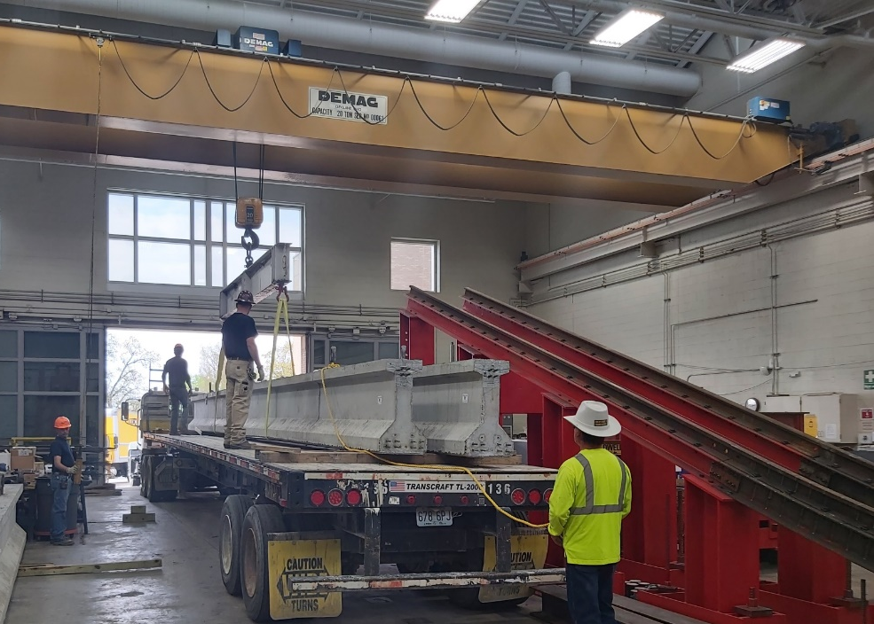
Figure 1. Delivery of the girders to the structural lab.
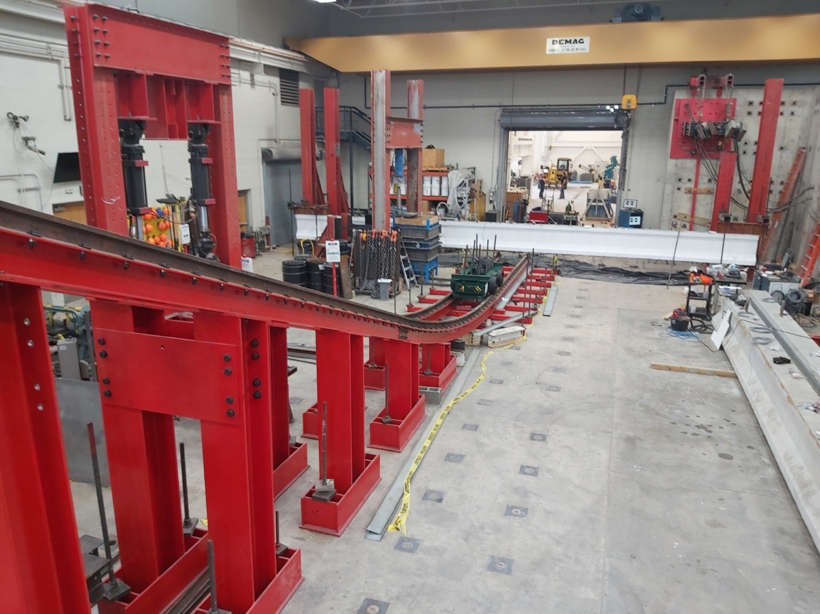
Uplift supports
Lateral supports
Figure 2. Track test setup
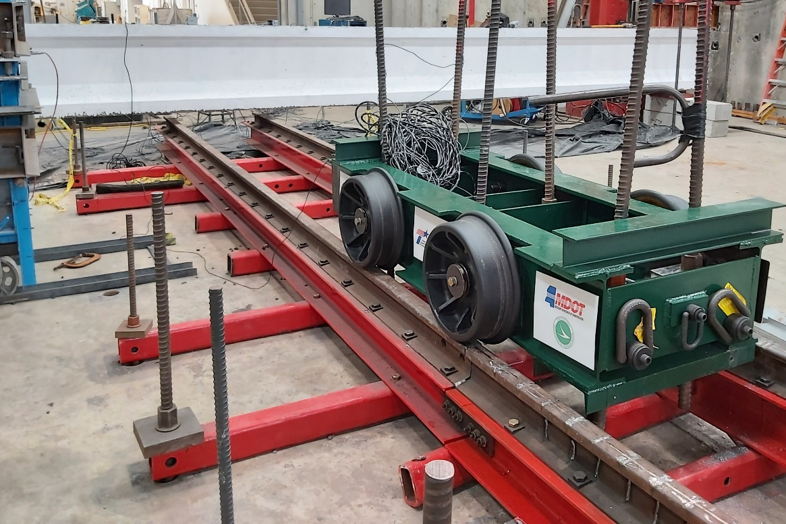
Impact location
Figure 3. Girder-impact trial
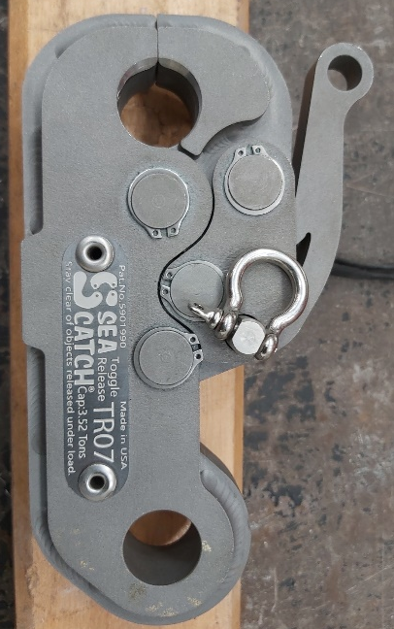
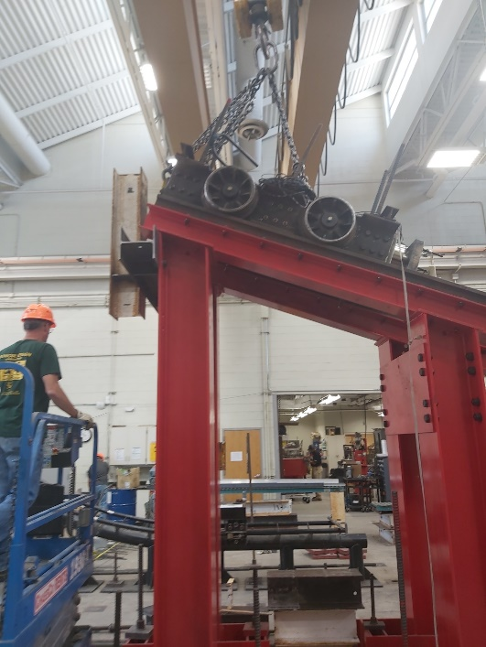
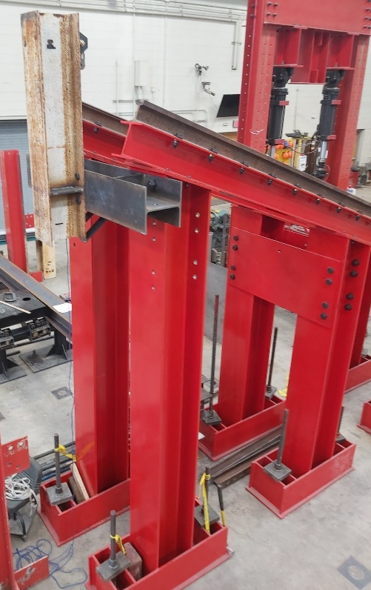
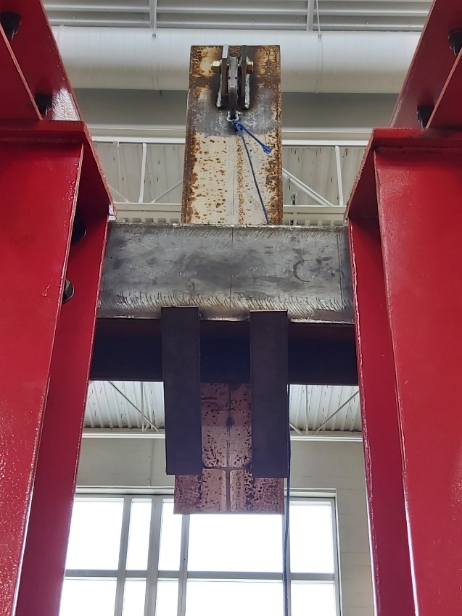
Release lever
Figure 4. Release mechanism for the impact cart

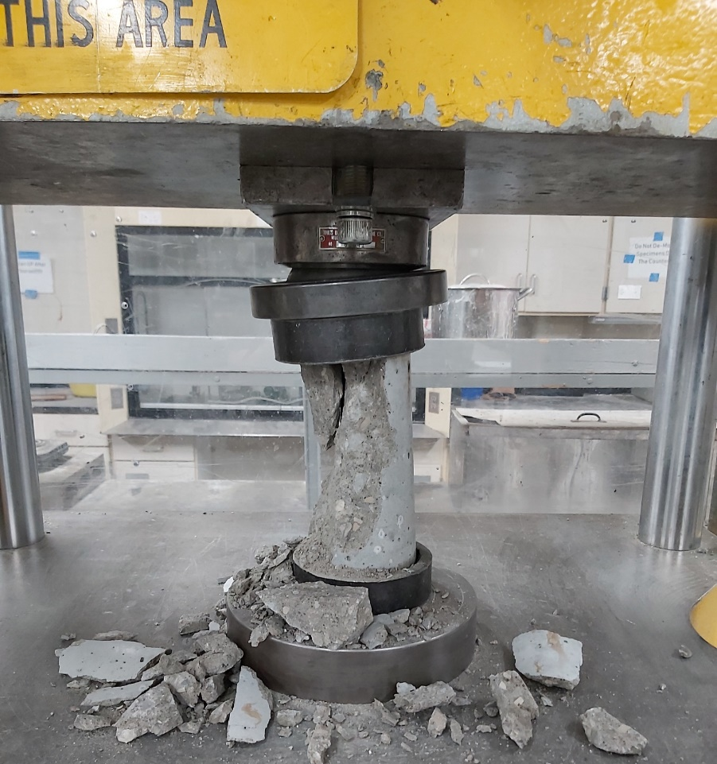
Figure 5. Cylinder testing

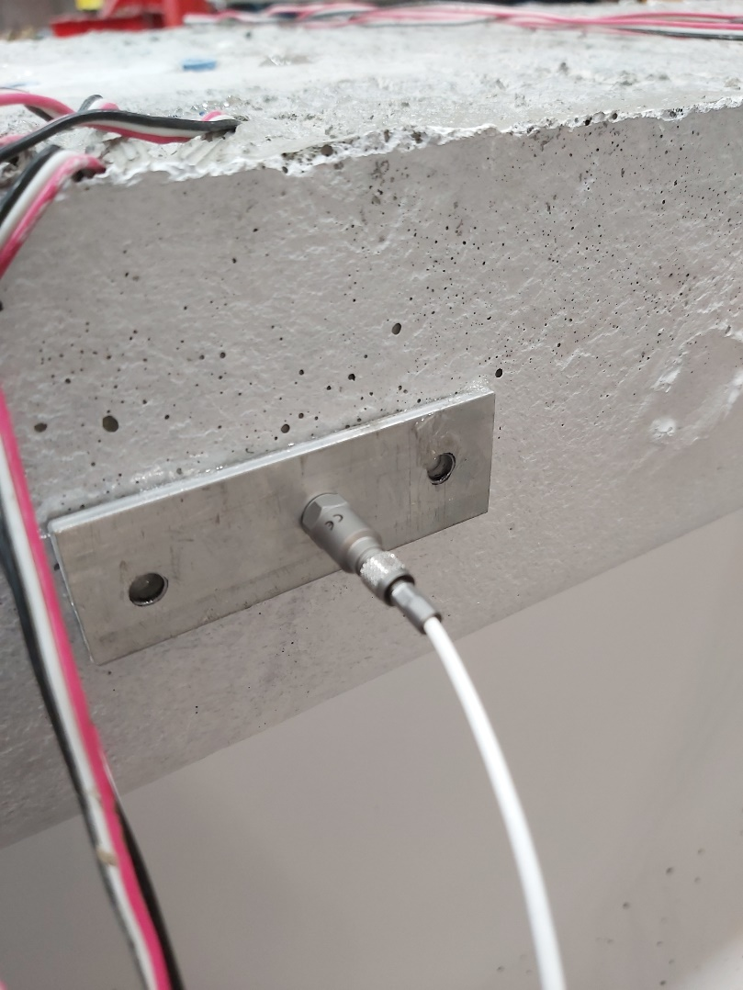
Accelerometer
Mounting plate
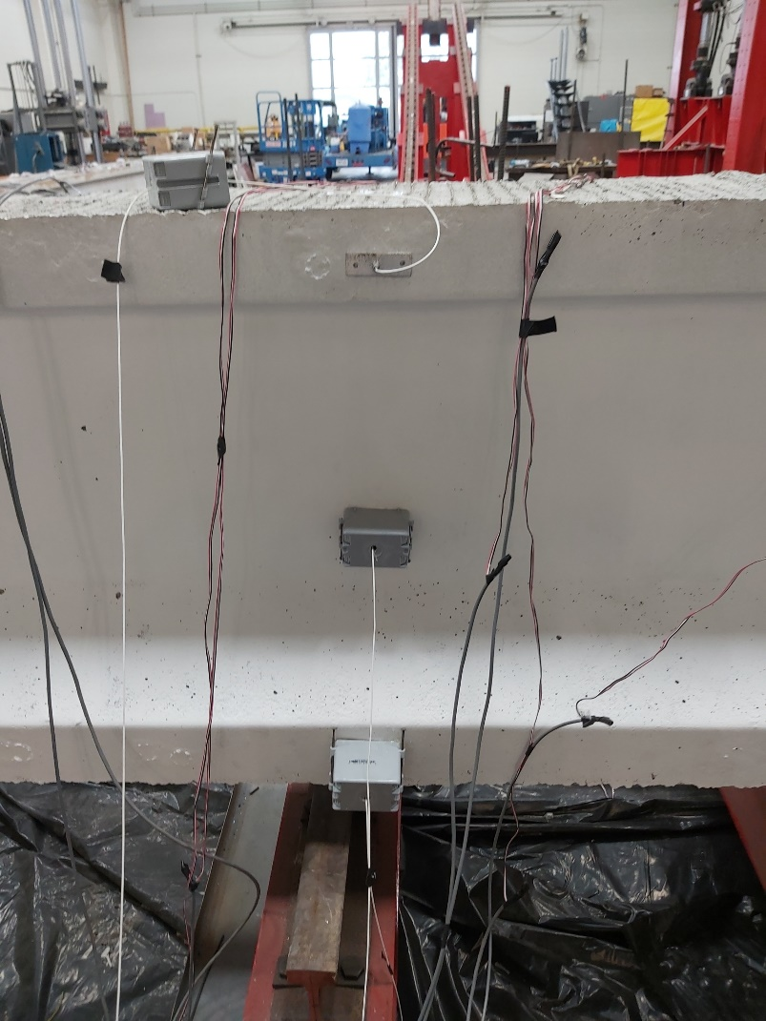
Accelerometer
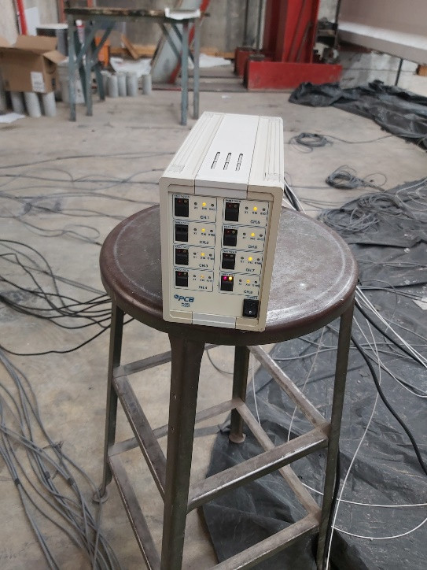
Accelerometer signal converter
Figure 6. Accelerometers installation

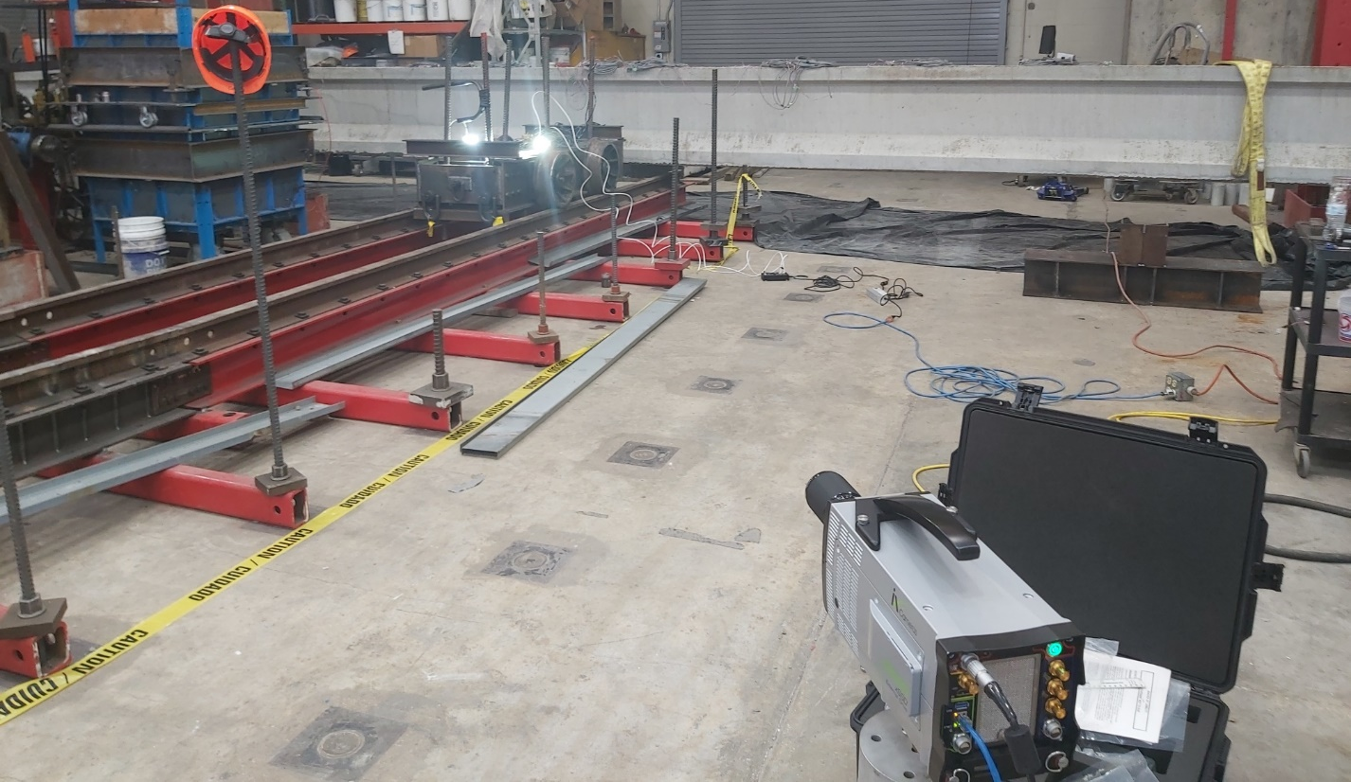
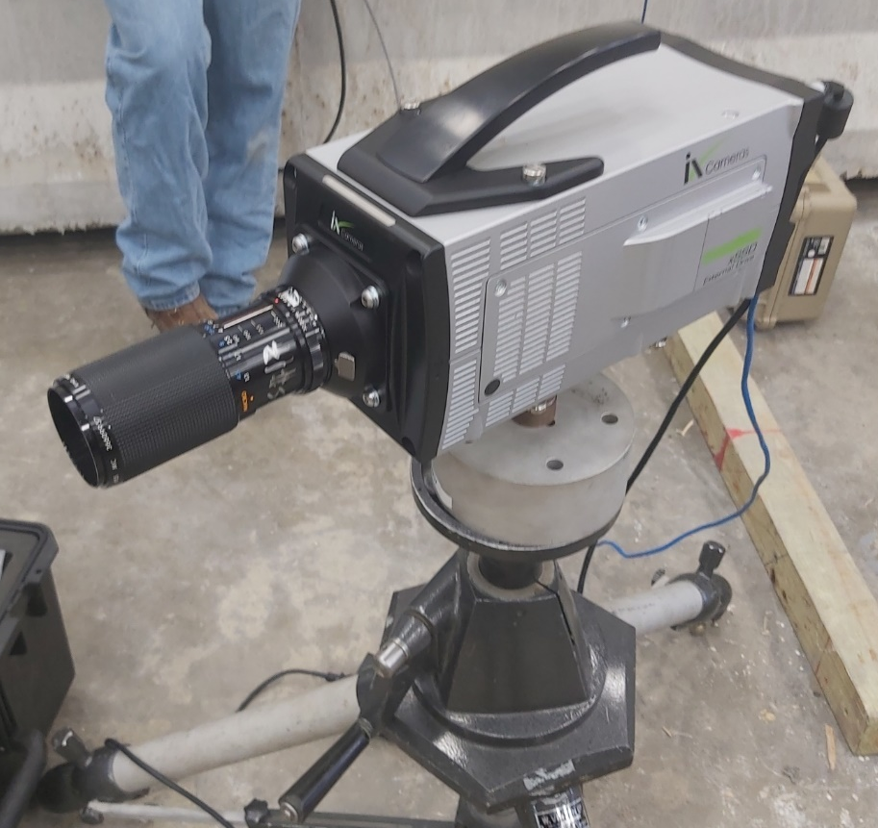
Figure 7. High speed camera

