Click here to enter Program or Project Title
Progress Report – Click here to enter a date.

Title: Assessment and Repair of Prestressed Bridge Girders Subjected to Over-height Truck Impacts Pooled Fund Project

Project Number: TR202011

Principal Investigator (PI): Mohamed ElGawady PhD (PI)
Co-PI(s): William Schonberg PhD, PE (Co-PI)

Award date: | 1/1/2021
Scheduled completion date: | 12/31/2023 | % of project completed to date: | 83%
Total budget: | $805,000 | % of budget expended to date: | 84%
Draft report due: | 9/30/2023 | Final report due: | 12/1/2023

Provide a short description of the work currently underway.
Use additional notes section if you need to provide more information.

Task 2. Experimental testing of bridge girders subjected to lateral impacts:
- The 7th and 8th girders were tested. Both girders were tested with intermediate diaphragms
Task 3. Determine the residual flexural and shear strengths of the damaged bridge girders
- Girders 2 through 4 were tested under four pint bending. The girders are as follows:
G2: Sustained only minor impact damage and served as the baseline for comparison.
G3: Suffered severe mid-span damage, losing 3 of its 12 strands due to the impact.
G4: Experienced even more significant damage, with half of its strands (6 out of 12) severed.
Task 5: Repair Evaluation:
- Girders 5 and 6 are being repaired and prepared for flexural testing. Girder 5 are being repaired using strand splice and 6 using CFRP

Provide a short description of the noteworthy activities/accomplishments during this reporting period.
Use additional notes section if you need to provide more information.

Task 2. Experimental testing of bridge girders subjected to lateral impacts
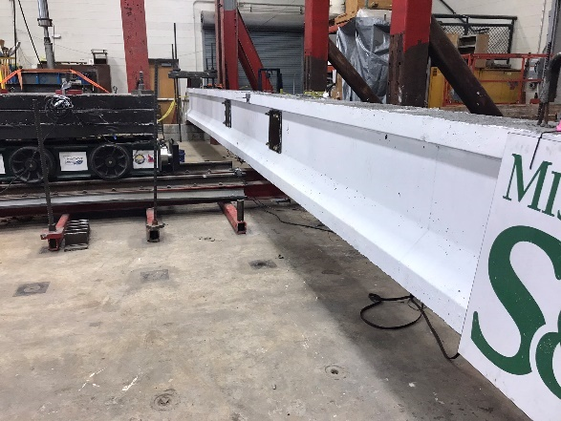 | 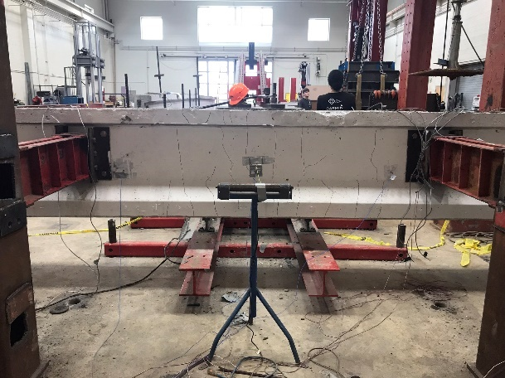
Impact side | Back side
Fig. 1. Testing girders 7 and 8 with intermediate diaphragm
Task 3. Determine the residual flexural and shear strengths of the damaged bridge girders
- The residual capacity of the damaged girders were determined using four point testing.

Table 1. Summary of damaged girders
Girder | Number of severed strands | Level of damage | Damage classification per NCHRP 20-07/Task 307
2 | 0 | 0% | Minor
3 | 3 | 25% | Severe III
4 | 6 | 50% | Severe IV

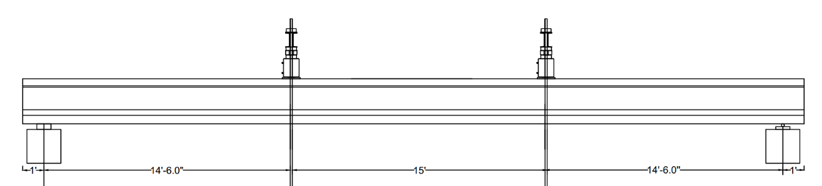
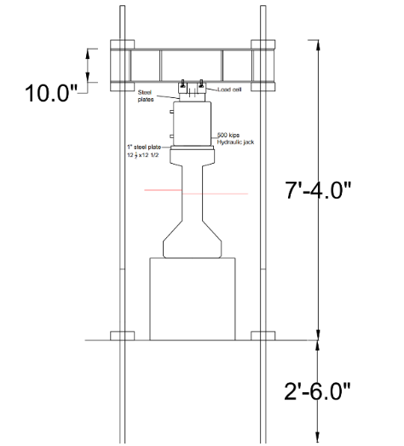
Hydraulic jack
Load cell

Fig. 2. Experimental test setup

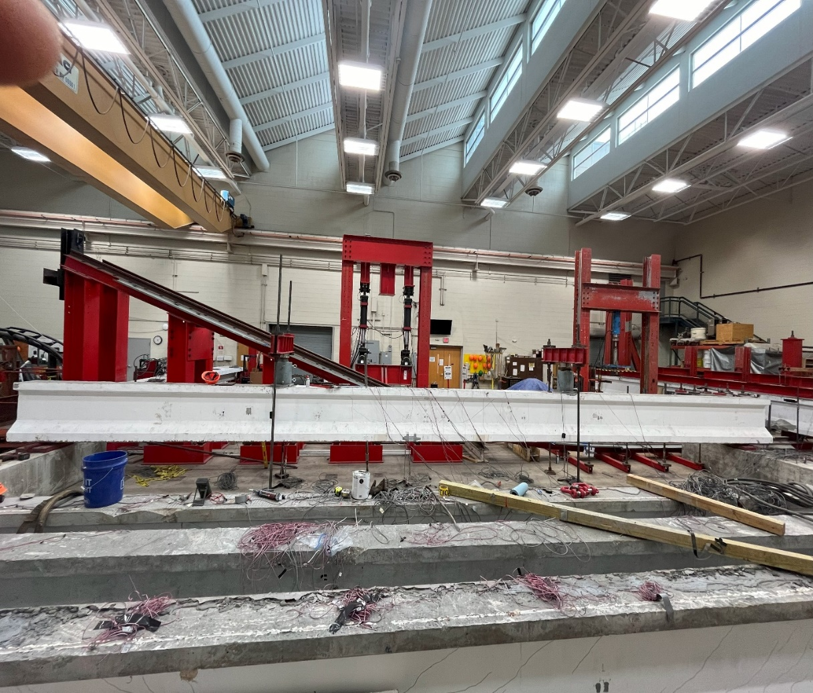
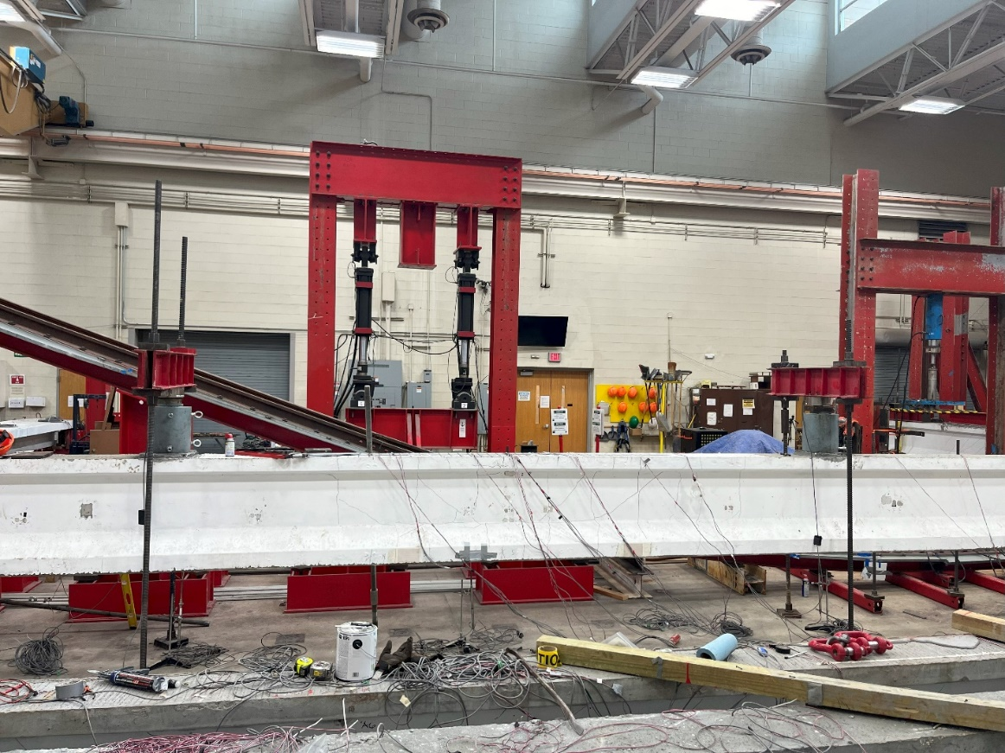
Fig.3 Testing of girder 2

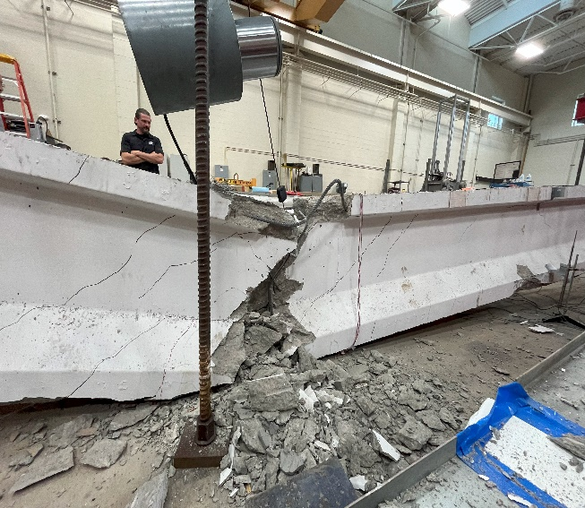
Fig.4. Failure of girder 2

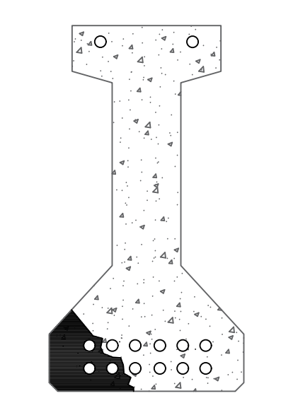 | 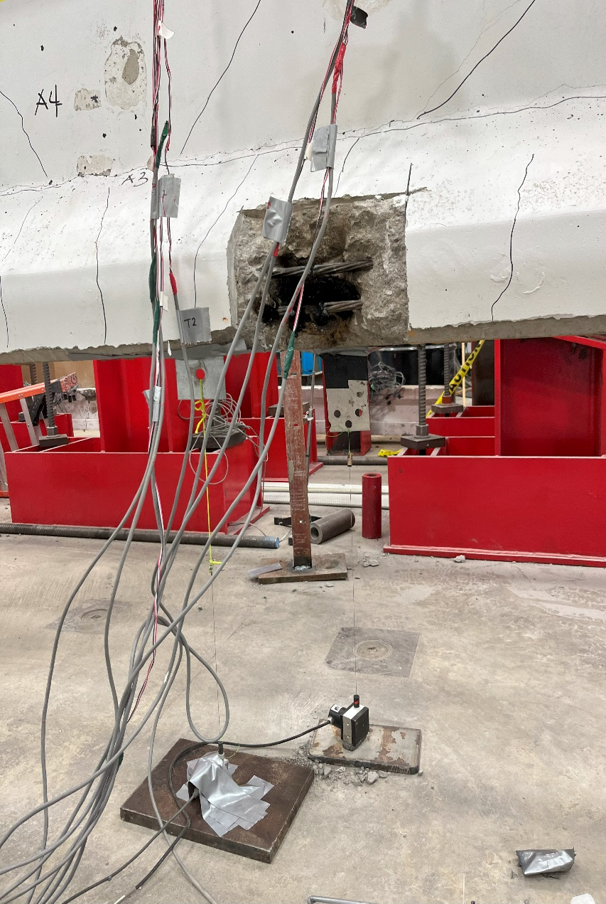
Cross section showing loss of strands | Section along the girder showing strand loss (before flexural test)
Fig.5 Girder 3 with 25% strand loss

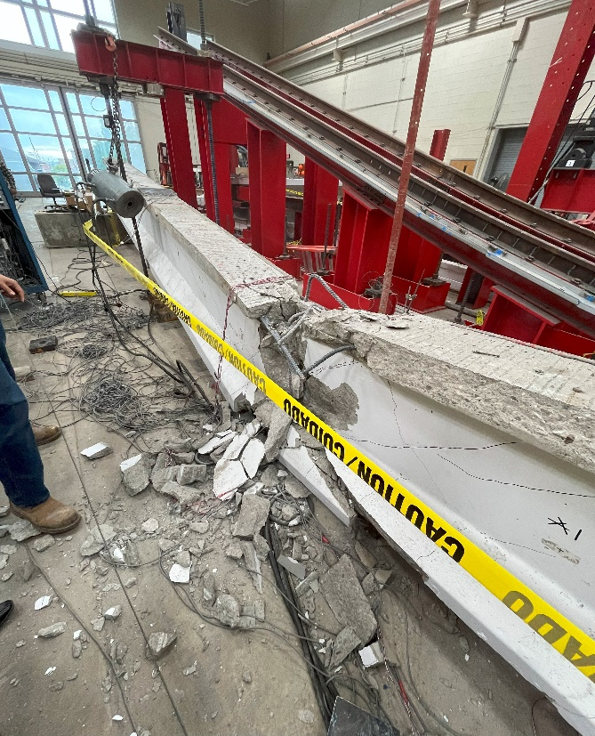 | 
Fig. 6. Failure of girder 3

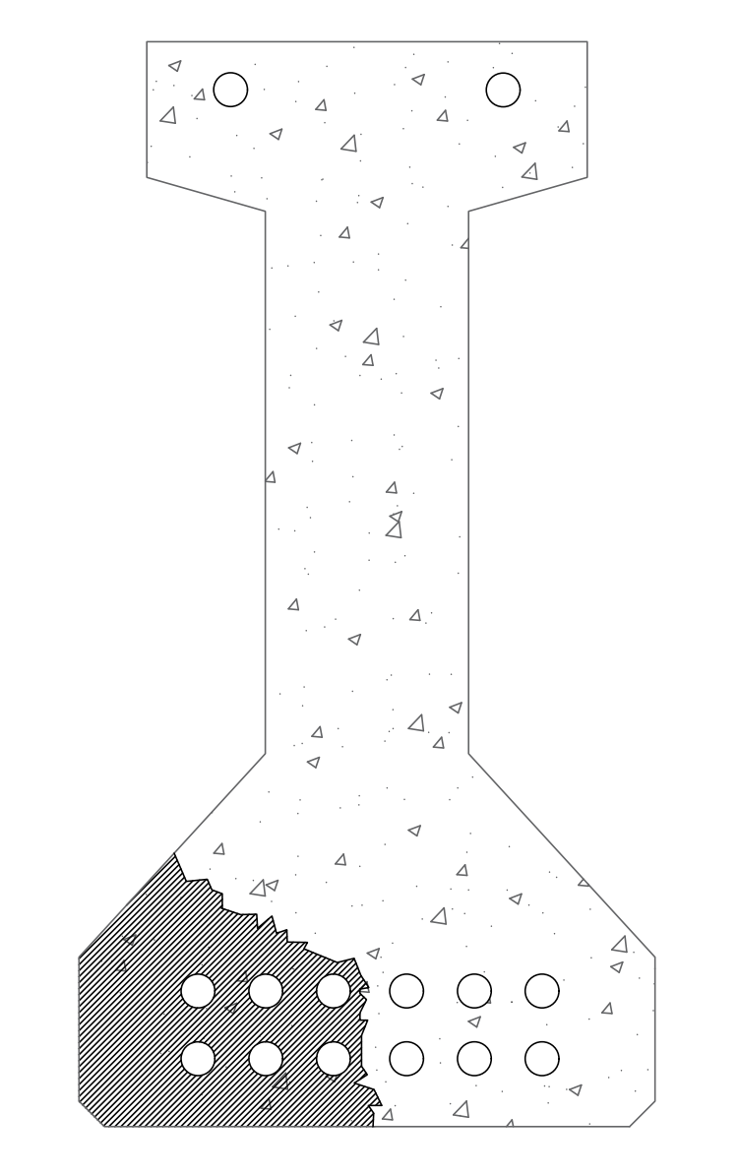 | 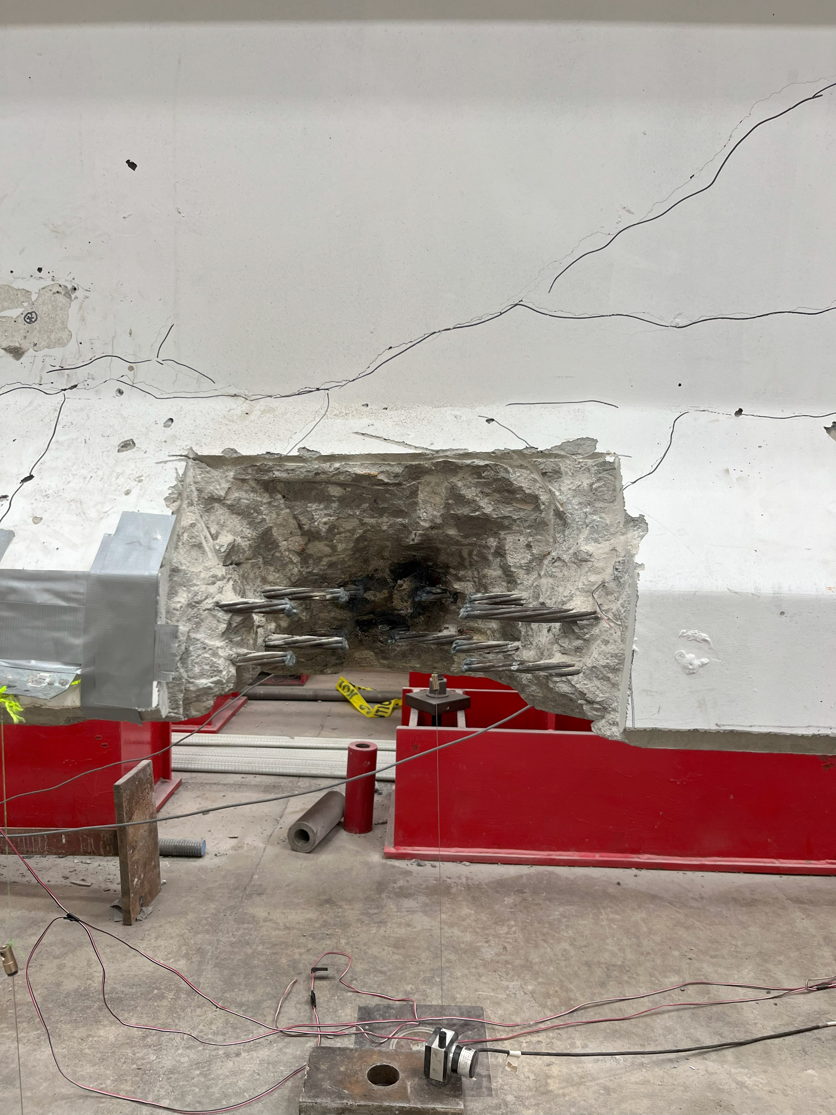
Cross section showing loss of strands | Section along the girder showing strand loss (before flexural test)

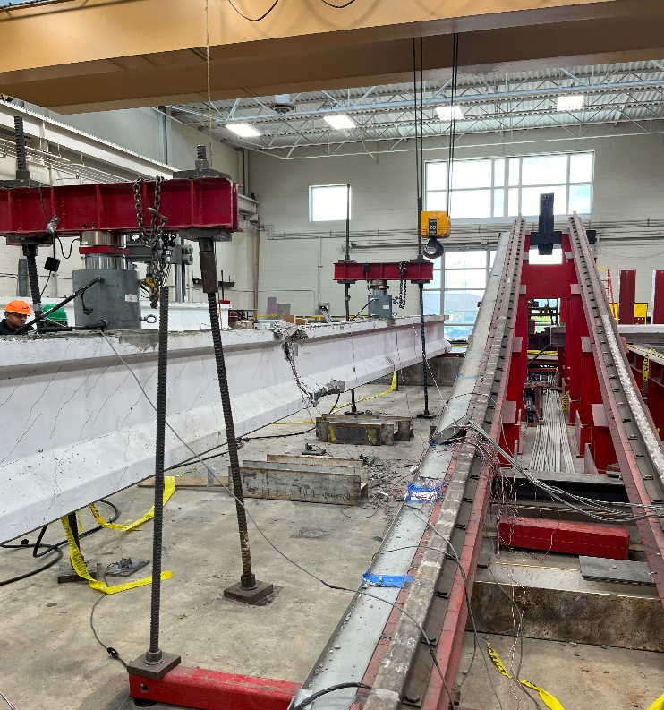 | 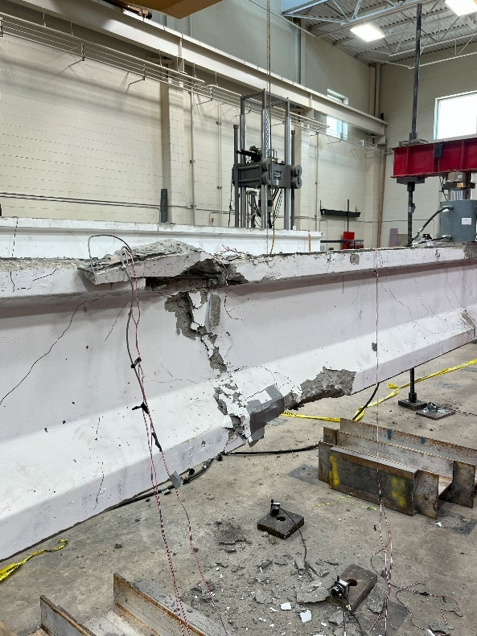
Fig.7. Failure of girder 4 at 72kips

