4th Quarterly Progress Report to the

FEDERAL HIGHWAY ADMINISTRATION

(FHWA)

On the Project:

THE IMPACT OF WIDE-BASE TIRES ON PAVEMENT DAMAGE

DTFH61-11-C-00025

For period

January 1st to March 31st 2012

From

University of Illinois at Urbana-Champaign

Illinois Center for Transportation



**QUARTERLY PROGRESS REPORT**

**QUARTER 4**

**The Impact of Wide-Base Tires on Pavement Damage – A National Study**

1. **Work Performed**

During this quarter, the following tasks have been accomplished:

* The testing sites UC-Davis, Florida DOT, South Africa, and University of Illinois received the two tires (275/80R22.5 and 445/50R22.5) with the corresponding rims from Michelin.
* The measurement of the three-dimensional contact stresses started in South Africa. Completion of this task will occur at the beginning of next quarter.
* Pavement structures to be built during summer 2012 in Florida were finalized. Figure 1and Figure 2 show cross sections of the pavement structures and instrumentation.
* Three sections, to be constructed in Ohio this summer, were included in this project. These sections are perpetual pavement sections (13- and 15-in-thick) and will be fully instrumented. The details of the sections and drawingsa are presented in Appendix A. Part of the research team attended a meeting with Ohio University (OU) and the Ohio Department of Transportation (ODOT) to finalize the details regarding the section instrumentations and sampling of loose HMA and cores. Figure 3 and Figure 4 present the cross section of the sections.
* Smithers Laboratories were contacted to carry out the material characterization of the tire components (rubber and reinforcement). These test results are important input for the tire’s finite element modeling.
* A script using Python was developed and fine-tuned to generate the input file of any pavement structure subjected to any load. These input file is used by Abaqus to run the finite element analysis.
* A pavement structure and material properties were provided to Delft to perform finite element analysis using linear elasticity. This will allow comparison between the results obtained between the two groups.

1. **Work to be accomplished next quarter**

* Finalize the pavement structure and instrumentation of the section at UC-Davis.
* Determine the material characterization of the tire components (rubber and reinforcement)
* Once the three-dimensional tire-pavement contact stresses are measured and become available, they will be put in the adequate format to be used in the finite element model.
* The sections in Ohio will be built during the next quarter. As a consequence, initial set of data will be available.

1. **Problems encountered**

No problems have been encountered in this quarter.

1. **Current and cumulative expenditures**

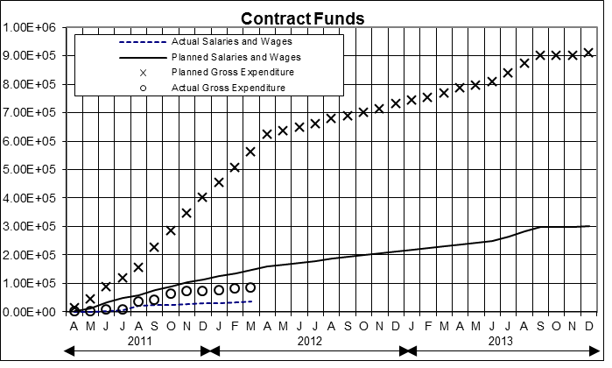



1. **Planned, actual, and cumulative percent of effort**

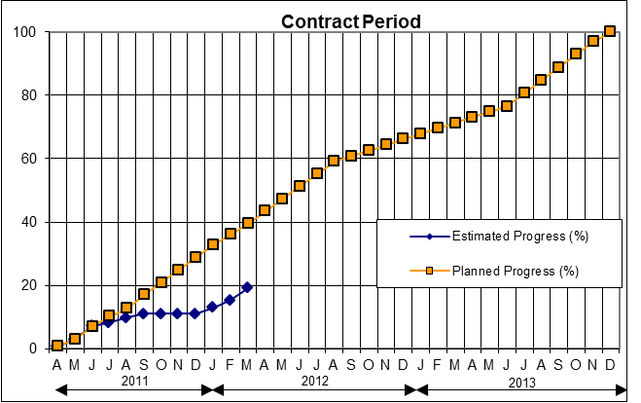



Figure 1. Pavement structure and instrumentation for the test pit section at Florida DOT



Figure 2. Pavement structure and instrumentation for the test track section at Florida DOT

1. **APPENDIX A: PERPETUAL PAVEMENT SECTIONS IN OHIO**

The pavement structure and instrumentation of the three sections to be built in Ohio and used in the WBT project are presented in Figure 3 and Figure 4. The most relevant features of these sections are:

* The total thicknesses of the AC layer for the sections are 13 in for Sections A and B, and 15 in for Section C. For Sections A and B, the thickness of the ATB is 6 in, while for Section C is 8 in.
* H-type strain gauges will be installed at three different depths: the bottom of the fatigue resistant layer (FRL), the bottom of the asphalt treated base (ATB), and the bottom of upper lift of the surface layer
* Six longitudinal sensors will be place at the bottom of the FRL; six at the bottom of the ATB (3 longitudinal and 3 transverse); and four close to the surface (2 longitudinal and 2 transverse).
* The instrumentation of these sections is also composed by LVDTs, pressure cells, and strain gauge rosettes (SGR) as shown in Figure 3 - Figure 6. In addition to the pressure cells on top of the subgrade, another 2 will be installed at the bottom of the FRL.
* A total of 16 SGR will be installed in Section A, two holes total, 8 rosettes in each hole at four different depths. Out of the two holes, one of them will be circular and the other one rectangular. The location of the SGR will be at the middle of each lift, and after the second set of LVDTs. Figure 5 shows the detail of the rosettes instrumentation
* Section B will have the same number of SGR and distribution as Section A.
* In each hole, 2 rosettes will be installed at each depth (4 depths total per hole as shown in Figure 5). One of these two rosettes will be installed in the direction of traffic and the other one in the direction perpendicular to traffic.
* Section C has an 8.0-in-thick ATB instead of 6.0 in. However, the number of rosettes in this section does not change (see Figure 6)
* The load and inflation pressure that will be used during testing is given in Table 1; the speed will be 5, 25, 45, 55 mph.

Table 1. Test Matrix

|  |  |  |  |  |  |  |
| --- | --- | --- | --- | --- | --- | --- |
| **Tire Type** | **Inflation Pressure (psi)** | **Tire Loading (kips)** | | | | |
| NG-WBT and Dual | 80 | 6 | 8 | 10 | 14 | 18 |
| NG-WBT and Dual | 100 |
| NG-WBT and Dual | 110 |
| NG-WBT and Dual | 125 |
| Dual Only | 60/110* |
| Dual Only | 80/110* |

*Indicates pressure differential in dual tires



Figure 3. Pavement structure and instrumentation of Sections A and B (13-in-thick)



Figure 4. Pavement structure and instrumentation of Section C (15-in-thick)



Figure 5. Detail of rosettes instrumentation for Sections A and B



Figure 6. Detail of rosettes instrumentation for Section C



Figure 7. Cross section of pavement structure and instrumentation for Sections A and B



Figure 8. Cross section of pavement structure and instrumentation for Section C