TRANSPORTATION POOLED FUND PROGRAM
QUARTERLY PROGRESS REPORT

Lead Agency: Utah Department of Transportation

INSTRUCTIONS:
Project Managers and/or research project investigators should complete a quarterly progress report for each calendar quarter during which the projects are active. Please provide a project schedule status of the research activities tied to each task that is defined in the proposal; a percentage completion of each task; a concise discussion (2 or 3 sentences) of the current status, including accomplishments and problems encountered, if any. List all tasks, even if no work was done during this period.

Transportation Pooled Fund Program Project #  TPF-5(296) |  | Transportation Pooled Fund Program - Report Period:  _ Quarter 1 (January 1 – March 31, 2014)  x Quarter 2 (April 1 – June 30, 2014)  _ Quarter 3 (July 1 – September 30, 2014)  _ Quarter 4 (October 1 – December 31, 2014)
Project Title:
Simplified SPT Performance-Based Assessment of Liquefaction and Effects

Name of Project Manager(s):  David Stevens | Phone Number:  801-589-8340 |  | E-Mail  davidstevens@utah.gov
Lead Agency Project ID:  FINET 42065, ePM PIN 12436  UDOT PIC No. UT13.407 | Other Project ID (i.e., contract #):  UDOT Contract No. 148753 |  | Project Start Date:  March 6, 2014
Original Project End Date:  November 30, 2016 | Current Project End Date:  November 30, 2016 |  | Number of Extensions:

Project schedule status:

X On schedule _ On revised schedule _ Ahead of schedule _ Behind schedule

Overall Project Statistics:
Total Project Budget | Total Cost to Date for Project | Percentage of Work  Completed to Date
$88,000.00 (current contract)  $148,000.00 (total committed) | $24,000 | 15%

Quarterly Project Statistics:
Total Project Expenses  and Percentage This Quarter | Total Amount of Funds  Expended This Quarter | Total Percentage of  Time Used to Date
15% | $24,000 | 12%

Project Description:

Liquefaction of loose saturated sands results in significant damage to buildings, transportation systems and lifelines in most large earthquake events. Liquefaction and the resulting loss of shear strength can lead to lateral spreading and seismic slope displacements, which often impact bridge abutments and wharfs, damaging these critical transportation links at a time when they are most needed for rescue efforts and post-earthquake recovery.

While most updated seismic provisions now adopt a risk-targeted approach to design ground motions for superstructures, other critical aspects of geotechnical engineering, such as liquefaction and ground deformation evaluation, are still based on the older concept of deterministic hazard evaluation. Recent advances in performance-based earthquake engineering (PBEE) in geotechnical engineering (e.g., Kramer and Mayfield 2007; Rathje and Saygili 2008; Bradley et al. 2011; Franke and Kramer 2013) have introduced probabilistic uniform hazard-based procedures for evaluating seismic ground deformations within a performance-based framework from which the likelihood of exceeding various magnitudes of deformation within a given time frame can be computed. However, the ability to apply these performance-based procedures on everyday projects is generally beyond the capabilities of most practicing engineers.

This study proposes to create and evaluate simplified performance-based design procedures for the a priori prediction of liquefaction triggering, lateral spread displacement, seismic slope displacement, and post-liquefaction free-field settlement using the standard penetration test (SPT).

Objectives for this study include:

1. Derive new simplified performance-based procedure for liquefaction triggering, lateral spread displacement, free-field post-liquefaction settlements, and Newmark seismic slope displacements.
2. Develop liquefaction parameter maps in GIS format associated with each of the hazards included in objective 1 at return periods of 475 years, 1033 years, and 2475 years for each of the states participating in the study.
3. Evaluate the new simplified performance-based liquefaction procedures against conventional (i.e., AASHTO) liquefaction analysis procedures.
4. Develop a simplified design procedure that will allow the designer to envelope the performance-based and conventional results to select which result will govern the design.
Tasks for this study include, regarding the participating states:

1. Derivation and validation of a new simplified liquefaction triggering model (Year 1).
2. Derivation and validation of simplified lateral spread displacement models (Year 1).
3. Derivation and validation of simplified post-liquefaction settlement models (Year 2). (Not funded in original contract.)
4. Derivation and validation of simplified Newmark seismic slope displacement models (Year 2). (Not funded in original contract.)
5. Assessment of grid spacing considerations in various seismic environments for map development (Years 1 & 2). (Partially funded in original contract.)
6. Development of liquefaction parameter maps at targeted return periods in GIS file format (Years 1 & 2). (Partially funded in original contract.)
7. Comparison of simplified, conventional, and deterministic analysis approaches (Years 1 & 2). (Partially funded in original contract.)
8. Development of a simplified design procedure and an analysis spreadsheet that incorporates both performance-based and conventional methods (Years 1 & 2). (Partially funded in original contract.)
9. Preparation of the annual and final reports (Years 1 & 2).
10. Dissemination of results in appropriate engineering journals and conferences (Years 1 & 2).
11. Technical Advisory Committee meetings (Years 1 & 2), including a final workshop to train partner states on the new performance-based liquefaction hazard methods.

Dr. Kevin Franke of BYU is the Principal Investigator for this research project. The technical advisory committee (TAC) for the study includes representatives from UT, AK, CT, ID, MT, and SC DOTs.

Progress this Quarter (includes meetings, work plan status, contract status, significant progress, etc.):

Task 1 – 100% complete.
Task 2 – 100% complete. The TAC quarterly update report for Tasks 1 and 2 was prepared and shared with the TAC.
Task 3 – Not funded currently.
Task 4 – Not funded currently.
Task 5 – 30% complete. BYU began work on this task. A request was made to the TAC members to send BYU information regarding areas in their states where they would like high-resolution grid spacing in map development.
Task 6 – 30% complete. BYU began work on this task. The TAC quarterly update report for initial portions of Tasks 5 and 6 will be prepared and shared with the TAC, along with liquefaction parameter maps.
Task 7 – No work yet.
Task 8 – No work yet.
Task 9 – No work yet.
Task 10 – No work yet.
Task 11 – 10% complete. A web conference was held in June with the TAC, with BYU presenting a summary of completed Tasks 1 and 2 and the associated TAC quarterly update report.
Contract – No changes were made.

Anticipated work next quarter:

Task 1 – Completed.
Task 2 – Completed.
Task 3 – None.
Task 4 – None.
Task 5 – BYU will continue funded work on this task.
Task 6 – BYU will continue funded work on this task.
Task 7 – None.
Task 8 – None.
Task 9 – None.
Task 10 – None.
Task 11 – A web-conference will be held in September with the TAC to review progress on Tasks 5 and 6.
Contract – No changes are planned.

Significant Results:

The research activities this quarter focused on the derivation and validation of simplified performance-based liquefaction triggering and lateral spread displacement models. These models are based on the Boulanger and Idriss (2012, 2014) model for liquefaction triggering, and the Youd et al. (2002) model for lateral spread displacement.

The simplified performance-based approach is inspired by the map-based approach presented by Mayfield, Kramer, and Huang (2010) for liquefaction triggering, which was based on the Cetin et al. (2004) liquefaction triggering model. This approach mimics the same approach used by practicing engineers to develop probabilistic ground motions without having to perform a site-specific seismic hazard analysis. With the simplified seismic hazard approach, researchers assume generalized site conditions (i.e., rock with an average shear wave velocity of 760 meters/sec) to perform probabilistic seismic hazard assessments across a grid of geographic points. After specifying a hazard level or return period (e.g., 7% probability of exceedance in 75 years), ground motion estimates corresponding to that specified hazard level are identified, and contours are developed for map development. Engineers can then apply code-specified site factors based on site response research to the generalized mapped probabilistic ground motion estimates for rock to correct the ground motions for local site conditions (i.e., soil amplification). Similarly, this research assumes a generalized soil layer that is evaluated for probabilistic liquefaction triggering (Kramer and Mayfield 2007; Franke et al. 2014) and for probabilistic lateral spread displacement (Franke and Kramer 2014). By evaluating these liquefaction hazards for the generalized soil profile across a grid of geographic points, liquefaction loading and lateral spread reference maps can be developed that target specific hazard levels or return periods. Mapped values of liquefaction loading (termed , or reference cyclic stress ratio in units of percent) and reference lateral spread displacements (termed , or reference displacement in log-transformed units of meters) can be corrected for site-specific soil properties specified by the engineer using derived correction equations to closely approximate the results of a full performance-based assessment.

The research activities this quarter focused on development and validation of the simplified performance-based liquefaction triggering and lateral spread displacement procedures. The simplified procedures for liquefaction triggering using the Boulanger and Idriss (2012, 2014) model and for lateral spread displacement using the Youd et al. (2002) model were successfully developed, and correction equations for site-specific soil properties were mathematically derived. Validation activities compared the newly-developed simplified performance-based procedures against full performance-based procedures at ten different cities in the US, representing a wide range of seismic environments. Results from these validation and comparison activities are presented below in Figures 1 and 2. Figure 1 presents the comparisons between the calculated standard penetration test (SPT) resistance required to resist liquefaction triggering, for the hypothetical soil layers used in the validation analysis at the ten cities. Results from the simplified performance-based procedure are generally within ±3.4% of the full performance-based procedure, on average. Figure 2 presents that computed displacement (m) comparisons between the simplified performance-based procedure and the full performance-based procedure. Results from the simplified performance-based procedure are generally within ±2.9% of the full performance-based procedure, on average. The results presented in these figures suggest that the new simplified performance-based procedures closely approximate the full performance-based procedures at the three return periods that were evaluated: 475, 1033, and 2475 years.

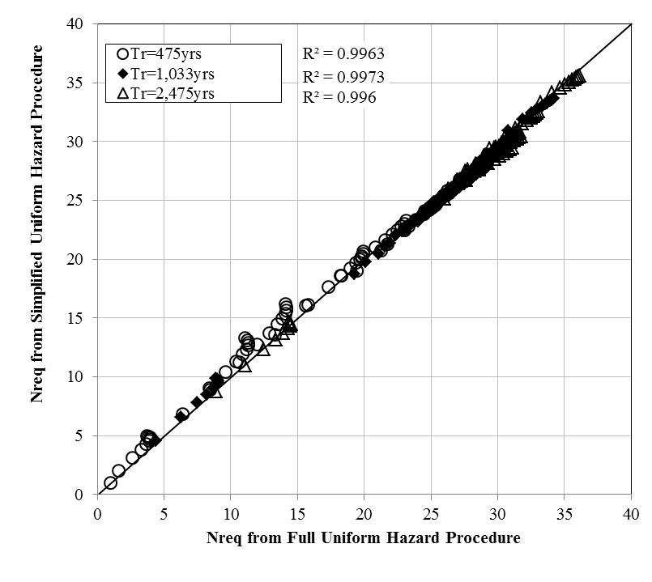
Figure 1. Comparisons of computed SPT resistance required to resist liquefaction triggering for the newly-developed simplified performance-based and the full performance-based liquefaction procedures at return periods of 475, 1033, and 2475 years

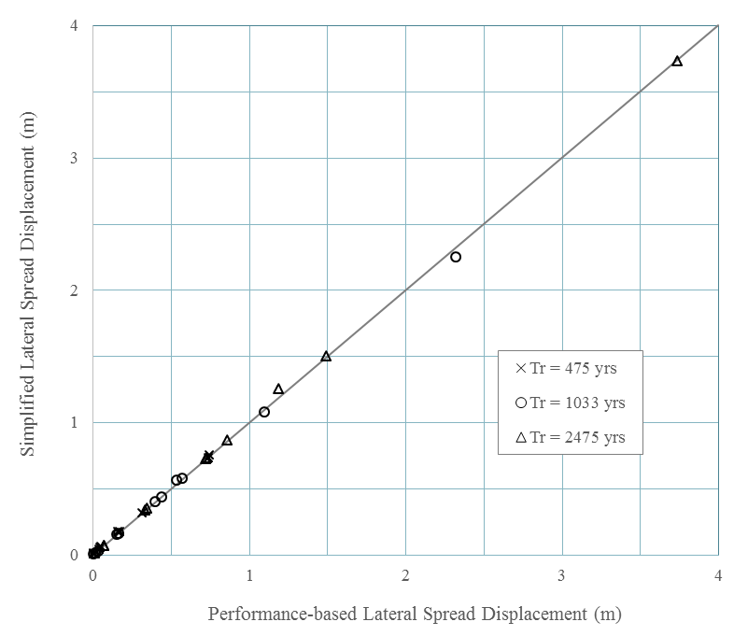
Figure 2. Comparisons of computed lateral spread displacements for the newly-developed simplified performance-based and the full performance-based lateral spread displacement procedures at return periods of 475, 1033, and 2475 years

Circumstance affecting project or budget. (Please describe any challenges encountered or anticipated that
might affect the completion of the project within the time, scope and fiscal constraints set forth in the
agreement, along with recommended solutions to those problems).

Potential Implementation:

With the simplified performance-based liquefaction triggering and lateral spread displacement procedures and the derived correction equations, engineers could immediately implement these procedures into practice with liquefaction loading and lateral spread reference maps for their site(s) of interest. Future tasks in this project will develop such maps for the states of Utah, Idaho, Montana, Alaska, South Carolina, and Connecticut, as well as a spreadsheet to implement the correction equations. Without these maps, it will be impossible to implement the simplified performance-based procedure in engineering practice.

