**Click here to enter Program or Project Title**

**Progress Report – Click here to enter a date.**

**Title:** Assessment and Repair of Prestressed Bridge Girders Subjected to Over-height Truck Impacts Pooled Fund Project

**Project Number:** TR202011

**Principal Investigator (PI):** Mohamed ElGawady PhD (PI)

**Co-PI(s):** William Schonberg PhD, PE (Co-PI)

|  |  |  |  |
| --- | --- | --- | --- |
| **Award date:** | **1/1/2021** | | |
| **Scheduled completion date:** | **12/31/2023** | **% of project completed to date:** | **60%** |
| **Total budget:** | **$**755,000 | **% of budget expended to date:** | **65%** |
| **Draft report due:** | **9/30/2023** | **Final report due:** | **12/1/2023** | |

Provide a short description of the **work currently underway**.

*Use* *additional notes section* *if you need to provide more information.*

***Task 2. Experimental testing of bridge girders subjected to lateral impacts:***

Working with a local precast supplier (Coreslab) to provide the prestressed girders. Coreslab was added a subcontractor to the project and is expected to provide the griders in the next couple of weeks.

***Task 4: Residual Capacity:***

Numerical modeling has been used to develop models that simulate different damage scenarios before experimental testing. The damage induced to the models are categorized as following, in accordance to damage classification by NCHRP 20-07/Task 306 (2012). Models for both single girders and full-bridge were developed.

## 

## Strand damage

The developed models removed the strand in a 4 ft length at the girder mid-span and the remaining strand was left. Also, the cut strand end from the free side was assigned to displacement constrained in the X and Z while Y-direction was left with no constraint to monitor any slippage may occur during the simulation.

***Task 5: Repair Evaluation:***

Different repair methods will be applied. Finite element models are used to optimized the design of the retrofitting. The strands were modeled explicitly using beam element. Plastic_kinematic material was assigned to the splice. The material strength of the spliced segment was given a value 219 ksi of 0.9 of the strand yield strength for a 270 ksi strand. The spliced segments were positioned in a staggering arrangement which is a common practice.

### Finite element modeling of FRP

CFRP sheets of 0.45 mm thickness was modeled as shell element with element formulation (ELFORM = 2), which is the Belytschko-Tsay integration scheme. Enahanced_Compsiste_Damage ( Mat 54) was used to model the constitutive model which is based on Chsng-Chang failure criteria. Contact_tied_nodes_to_surface was used to define the interface between the concrete substrate and the CFRP sheets. CFRP U-wraps of 10 inch width and spaced each 6 inch was used in Model 1. Model 2 consists of continuous CFRP-Uwraps. Model 3 is using CFRP longitudinal strips in the bottom flange, longitudinal web strips, U-wraps and steel channel works as an anchorage system for the FRP configuration.

Table 1: Damage levels

|  |  |  |  |
| --- | --- | --- | --- |
| **Damage Level** | **% Strands loss** | **Targeted No. Strands loss** | **Targeted % Strands loss** |
| Severe I | < 5 % | None |  |
| Severe II | > 5 % | 1 | 6.25 % |
| Severe III | > 20 % | 4 | 25 % |
| Severe IV | > 35 % | 6 | 37.5 % |

Properties of the control girder

|  |  |
| --- | --- |
| MoDOT type II | |
| Length (ft) | 49 |
| Strand | 0.5 “ Low-relaxtion 270 Ksi |
| Number of strands | 16 ( Straight 10 , Harped 6) |

|  |
| --- |
| Figure 1. Strands removal arrangements |

|  |
| --- |
|  |
| Figure 2. Control Girder |

|  |
| --- |
|  |
| A picture containing graphical user interface  Description automatically generated  Figure 3. Strand loss 6.75% |
|  |
| A picture containing diagram  Description automatically generated  Figure 4. Strand loss 25% |

Damaged Girder

Impact Direction

Figure 5. Damaged girder

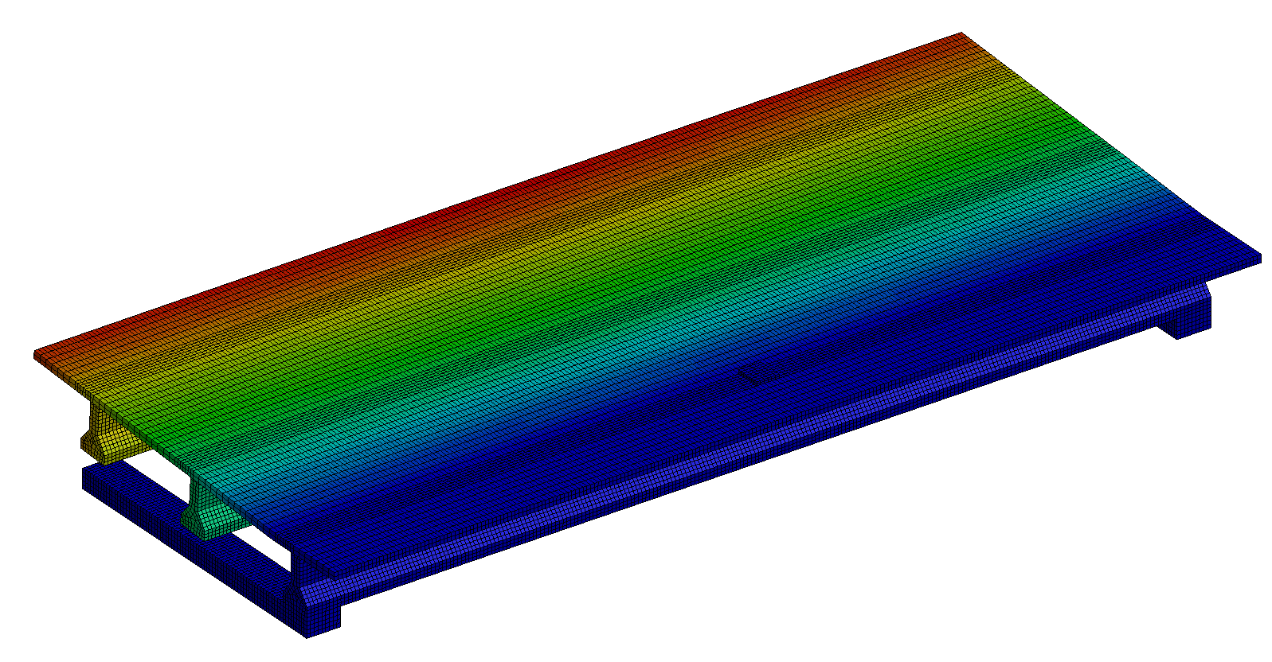

Uplift force resulted in the opposite side.

Static displacement is applied at the midspan of the exterior girder to find its **Residual Capacity**.

Figure 6. Residual capacity preliminary results

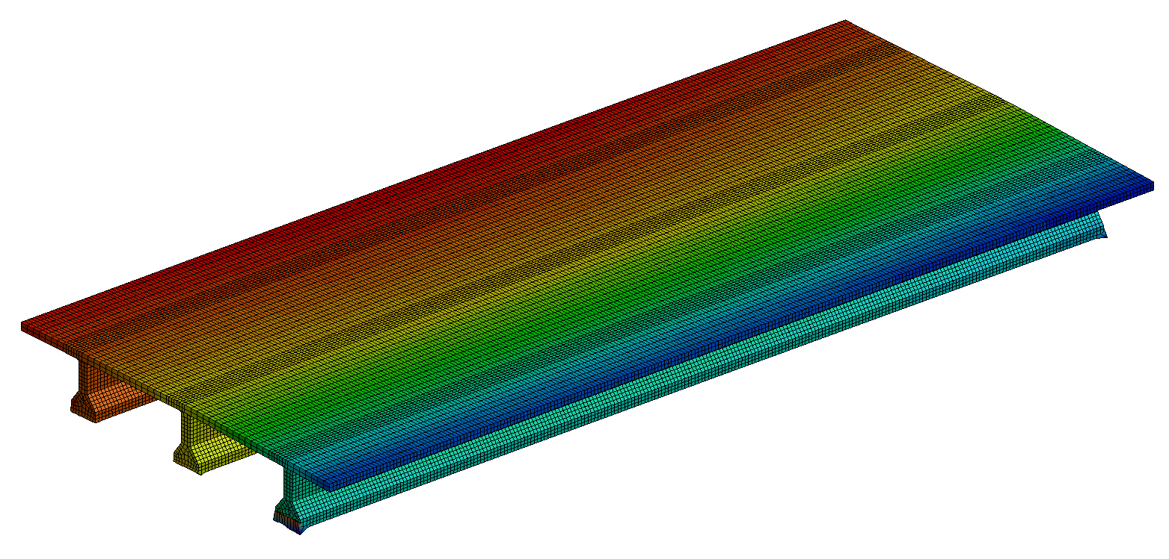

Figure 7. Residual capacity preliminary results

Figure 8. Different repair options

|  |
| --- |
|  |
| Diagram  Description automatically generated  Figure 9. Strand splicing for 1 strand |
|  |
| Diagram  Description automatically generated with medium confidence  Figure 10. Strand splicing for 4 strands |
|  |
| Chart  Description automatically generated  Figure 11. Strand splicing for 6 strands |

|  |
| --- |
|  |
| Figure 12. CFRP Model 1 |

|  |
| --- |
|  |
| A picture containing text, circuit, electronics  Description automatically generated  Figure 13. CFRP Model 2 |

|  |
| --- |
|  |
|  |
| A picture containing circuit  Description automatically generated  Figure 14. CFRP Model 3 |

Provide a short description of the **noteworthy activities/accomplishments** during this reporting period.

*Use* *additional notes section* *if you need to provide more information.*

***Task 2. Experimental testing of bridge girders subjected to lateral impacts:***

The cart was re-designed as some damage was observed after the first few trials. The new cart is now ready for testing. Lateral column bracings were installed.

|  |  |
| --- | --- |
|  |  |
|  | |

Figure 15. New design of the impact cart

Figure 16. The new cart ready for testing

|  |  |
| --- | --- |
|  |  |
| Figure 16. Bracing columns ready for testing | |

|  |
| --- |
| Figure 17. The full test setup with the track, cart, and bracing columns |

***Task 4: Residual Capacity:***

One of the main damage consequences of over height vehicles impact with prestressed concrete girders is the rupture od prestressing strands. Rupture of tendons lead to sudden loss of prestressing force. It was observed from many previous crash incidents with bridge girders that the rupture accompanies the concrete spalling and damage at the impact zone. In many cases, the outer tendons, that face the vehicle or impacting object head, are ruptured while the inner strands remain undamaged. The asymmetric loss of prestressing force causes an out-of-plane prestressing force eccentricity. Both the in-plane eccentricity that the prestressed girders are by default designed for and the sudden out-of-plane eccentricity combined and produce biaxial bending moment to the girder. Limited research was conducted to investigate the biaxial bending moments to prestressed concrete girders. A pioneer study was conducted by Warner to produce a numerical solution to prestressed girders subjected to biaxial bending (Warner, 1969). The study used a discretized sectional analysis and nonlinear material stress-strain relationships to calculate the section strain, stresses and moments. (Mast 1994) investigated the lateral stability of prestressed girder while lifting and hauling. The experimental testing conducted by tilting full scale girder to maximum tilt angle of 32o degrees. The lateral bending of the girder was generated by the girder self-weight. Both studies provided significant insights to understand the behavior of the prestressed concrete girders under biaxial bending moments. However, both studies focused on one axis eccentric girders that are subjected to externally loads that caused the biaxial bending. The AASHTO LRFD does not include any provisions to account for biaxial bending, however it permits the use of strain compatibility approach for refined analyses. The average prestressing force *fps* provided by AASHTO LRFD is formulated based on one axis bending.

The current study primary objective is to investigate the precast concrete girder that undergoes internally and externally sudden biaxial bending due eccentric prestressing force from the girder center of gravity in both the section principle axes and due to moments from lateral impact combined with gravity loads.

First, full precast bridge was designed according to AASHTO LRFD (2017) and checked using PGSuper software to investigate different scenarios of prestress losses and compare it to finite element model results. PGSuper is a widely used software for precast girders which developed by department of transportation of Washington state WSDOT and Texas TXDOT. Second, three finite element models were developed and validated using experimental tests. Finally, an example was provided with simple prestressed beam with rectangle cross-sectio and solved analytically using strain completability approach.

The FE model was calibrated in flexural failure with considering composite deck slab of 63.5 ft long (Olsen 1992) and shear failure of AASHTO type II girder of 36 ft long (Chehab et al. 2018). The FE and test results were compared in terms force deflection and mode of failure. The developed FE models show a good agreement with the test results. The error between the FE and test results are within a reasonable range.

|  |  |
| --- | --- |
|  |  |
| Figure 18 Test apparatus of Olsen 1992 and FE model | |
|  |  |
| Figure 19: Test apparatus (Chehab 2018) anf the FE model | |

|  |  |
| --- | --- |
|  |  |
| Figure 20: Test and FE force-deflection plot for experimental testing by Chehab 2018 | |
|  | |
| Figure 21. Test and FE force-deflection plot for experimental testing by Olsen 1992 | |

1. **Biaxial bending due to Loss of prestressing strands**

The control girder that was used for the bridge design was a MoDOT type II girder. The number of strands required to satisfy the service, strength, and fatigue limit states by AASHTO LRFD were 16 strands. The strands were divided to ten straight and six harped to reduce the tensile stresses at the girders ends at prestress transfer and increase the shear strength. Loss of half of the strands (50%) was considered as an extreme case. Two models were analyzed, one where the loss of strands was symmetric and another case asymmetric for comparison. All cases were non-composite except one was modeled as composite. The analyses show that the non-composite (NC) girder when lost 50% strands, it has the same initial stiffness for control girder for both symmetric and asymmetric cases. The asymmetric NC girder show an increase of 12.5% over the NC girder with symmetric strands. The NC girder out of plane moment resulting from eccentricity ex is 12.6%. No considerable change in the tendon stress distributaion was noticed at ultimate strength. The observed failure mode for both cases with flexural controlled. The Asymmteric girder shows a stress increases in the top fiber due to the combined moments and a reduction in bottom fiber stress.

The composite (C) girder shows that have higher initial stiffness from the non-composite as expected. Also, a higher strength was gained due to the composite action of deck slab contribution. PGSuper software has the ability to define the exact locations of strands at the cross-section, an increase of 21% of PGSuper estimated capacity with asymmetric eight strand model from the FE results. The difference can be explained that PGSuper use 2D sectional analyses using strain compatibility while the FE model considers 3D stress distribution. The used algorithm in PGSuper divides the cross-section into layers and estimate the corresponding stress to an incremental strain. Then, layer force and moments can be computed. The section flexural capacity is the accumulated moments of all layers.

|  |  |
| --- | --- |
|  |  |
| (a) | (b) |

Figure 22. (a) PGSuper, (b) LS Dyna FE model

|  |  |
| --- | --- |
| Figure 23. In plane moment and vertical deflection for noncompoiste section | Figure 24. In plane moment and vertical deflection for noncompoiste & composite sections |
| Figure 24. Out of plane moment and horizontal deflection for noncompoiste section | |

|  |
| --- |
| Figure 25. Average tendon stresses at mid-span with time for the symmetric and Asymmetric cases |
| Figure 26. Top and bottom fiber stress distribution at mid-span |

1. **Biaxial Bending Stresses Due to Biaxial Bending: Rectangle Section**

A rectangular shape example to Estimate the strain and stress of rectangular cross-section before and after strands loss using strain compatibility approach.

f’c= 5000 psi

ε’c = 2.25

Three ½” low-relaxation strands 270 ksi

Ix = 12 * 243 /12 = 13824 in4

Iy = 24*123/12 = 3456 in4

Ag  = 24x12 = 288 in2

Eg = 28500 Ksi

Beam length = 8 ft (simply supported)

**Effective prestress at transfer**

fp + 𝞓fpES  = 0.75fpu (S5.9.5.3)

fps  = 0.75 * 270 = 202.5 Ksi

Mg = Girder midspan moment due to member self-weight

Girder self-weight = 8 ft x 145 Ib/ft3 x 1/1000= 1.16 K/f

Mg = 1.16 * (8)2 / 8 = 9.28 kip.ft = 111.36 Kips. in

ec = average eccentricity of stands at mid-span = 20”

**Prestressing stress at transfer**

fps  = stress immediately prior to transfer - 𝞓fpES

= 202.5 – 18.24 = 184.2 Ksi

Locked in strain differential Δεp is the prestress strain that is in the prestressing strands due to jacking force and short-term losses of elastic shortening at release

Δεp  = fps / Ep = 184.2 /28500 = **6.46 x10-3**

**1-Find the transformed section properties**

Ec = 4030 ksi

Ep = 28500 ksi

Ap = 3 * 0.153 in2 = 0.459 in2

Modular section np = Ep/Ec = 28500/4030 = 7.1

Atr = Ac + npAps = (Ag-Ap) +npAps = Ag + (np-1)Ag

= 288 + (7.1-1) x 0.459 = 290.8 in2

Ytop,tr  = ƩAiyi / ƩAi

= (288 x 12 +(7.1-1)*0.459*20) / 290.8 = 12.1 “

The prestressing strands area pulling the section neutral axis downwards.

Ix,tr = Ʃ [ Ii + Ai ( yt – yi )2] , Assume Istrand = 0

= [13824 + 288 * (12.1-12)2 ] + [ 0 + (7.1-1)0.459 x (12.1-20)2 ] = 14000 in4

**2-Find the decompression force and moment**

The prestressing force will cause initial compression strain to the section and the tendon eccentricity will cause initial curvature. Decompression is the force and moment required to counteract the section curvature and return the section to equilibrium at zero strain and curvature.

No = Ep x Δεp x Ap = 28500 x 6.46x10-3 *0.459 = 84.5 kips

Mo = No x e = 84.5 kip * (20-12.1) in= 667.5 k.in = 55.6 k.ft

**3-Find the strain at centroid and curvature**

Assume there is no additional axial force and only moment due to self-weight

= -0.072x10-3 ( comp. strain)

= - 9.85x10-6 ( negative sign for counter-clockwise curvature form section vertical axis)

**4-Find the strain and stress for concrete and prestressing tendon**

= -0.072x10-3 - (-9.85x10-6) x 12.1” = 0.047x10-3

= -0.072x10-3 + (-9.85x10-6) x (12.1”-24”) = -0.189x10-3

Fc,top  = εc,top x Ec  = 0.047x10-3 *4030 = **0.19 ksi (comp)**

Fc,bot  = εcbot x Ec  = -0.189x10-3 *4030 = **-0.76 ksi (tension)**

Δεp  = -0.072x10-3 + (-9.85x10-6) x (12.1”-24”) + 6.46x10-3 = 6.27x10-3

Fp = εp x Ep = 6.27x10-3 x 28500 ksi = **178.7 ksi** < fy (243 ksi) ( linear elastic range)

The top fiber is under tensile stresses while the bottom fibers are compresses due to prestressing force in tendon s. The self-weight moment could not counteract the top fiber tensile stresses due to camber.

Two strand were damaged which corresponds to 67% loss of the prestressing strands. What would be the effect of the out of plane strand eccentricity.

Aps  = 0.153 in2

**5- Recalculate the transformed section properties after strand loss**

Atr = Ac + npAps = (Ag-Ap) +npAps = Ag + (np-1)Ag

= 288 + (7.1-1) x 0.153 = 288.9 in2

Ytop,tr  = ƩAiyi / Ʃai

= (288 x 12 +(7.1-1)*0.153*20) / 288.9 = 12.02 “

The loss of 67% prestressing strands area pulling the section neutral axis upwards of 0.08”.

Ix,tr = Ʃ [ Ii + Ai ( yt – yi )2] , Assume Ip = 0

= [13824 + 24x12 x (12.02-12)2 ] + [ 0 + (7.1-1) x 0.153x (12.02-20)2 ] = 13883 in4

Xtr  = ƩaiXi / Ʃai

= (24*12*6 + (7.1-1)*0.153*10) / 288.9 = 6.01”

Iy,tr = Ʃ [ Ii + Ai ( xt – xi )2] , Assume Ip = 0

= [3456 + 24x12 x (6-6.01)2 ] + [ 0 + (7.1-1) x 0.153x (6.01-10)2 ] = 3471 in4

The loss of strands caused an eccentricity to the section in X-direction by 0.01 inch.

6-Re-evaluate the decompression force and moment due to prestress force loss

Nox = Noy = Ep x Δεp x Ap = 28500 x 6.46x10-3 *0.153 = 26.1 kips

Mox = Nox x ey = 26.1 kip * (20-12.02) in= 208.3 k.in = 17.3 k.ft

Mox = Noy x ex = 26.1 kip * (10-6.01) in= 104.1 k.in = 8.7 k.ft

**7-Calculate the stress due to the combined in-plane and out of plane bending moments**

The biaxial Mox, Moy will cause nonsymmetrical bending because the resultant moment plane of loads that does not coincide with the principal axis of the section. Using mechanics of materials, the inclined angle plane of loads α measured from the X-axis counter- clockwise (Borzi).

tanϴ = Moy / Mox  = 17.3 / 8.7 = 1.98

ϴ = 70.3o

Ф = 90 + (90-70.3o) = 109.7o

Assume Ixy = 0 due to very small differences in the centroid location

= , α = -35.1o ( clockwise)

Assume Ixy = 0 due to very small differences in the centroid location

The section neutral axis will rotate 35.1 degrees counterclockwise due to the resultant of the two bending moments.

The z stresses on the cross-section due to the nonsymmetrical bending moments can be calculated using the following expression

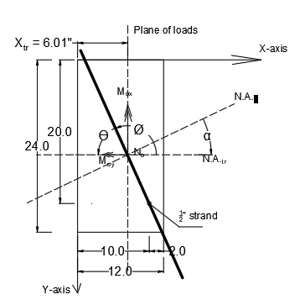

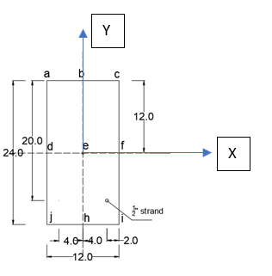

|  |  |  |  |
| --- | --- | --- | --- |
| Point | Xi (in) | Yi(in) | σz (Ksi) |
| A | -6.01 | 12.02 | 0.125 |
| B | 0 | 12.02 | 0.18 |
| C | 5.99 | 12.02 | 0.234 |
| D | -6.01 | 0 | -0.055 |
| E | 0 | 0 | 0 |
| F | 5.99 | 0 | 0.055 |
| J | -6.01 | -11.98 | -0.234 |
| H | 0 | -11.98 | -0.179 |
| I | 5.99 | -11.98 | -0.125 |

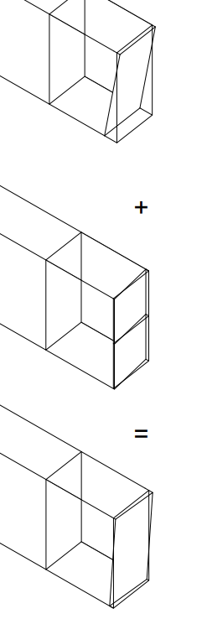

Compression

Tension

Tension

Compression

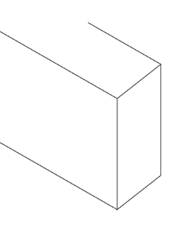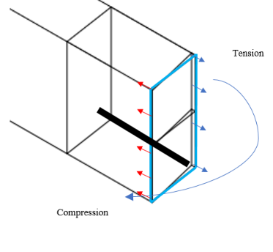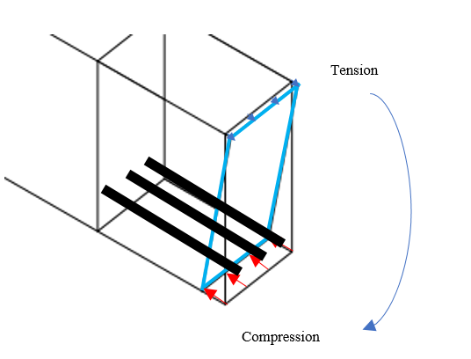

Symmetric prestressing force Pretensioned-beam + Dead loads PT beam + DL + Asymteric loss of tendons

Applied Live loads

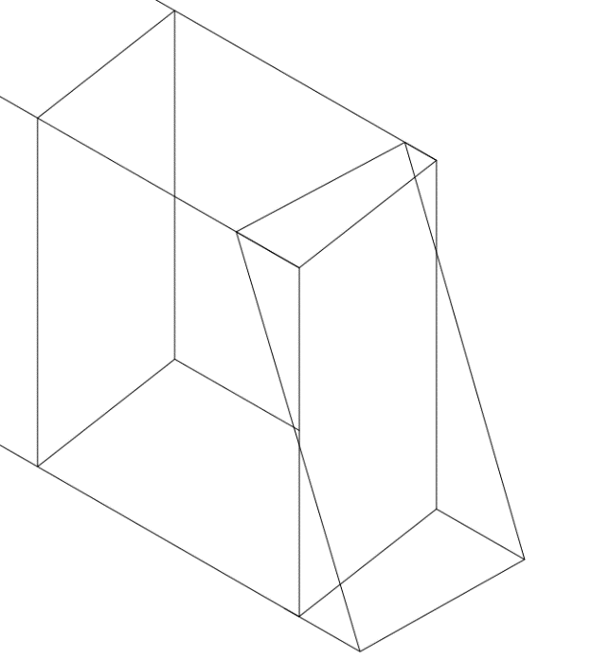

PT beam + DL + LL + Asym. loss of tendons

