PROPOSAL FOR

UPDATING PRECIPITATION FREQUENCY ESTIMATES

FOR LOUISIANA

(NOAA ATLAS 14 VOLUME)

Prepared by:

Office of Water Prediction

National Weather Service

National Oceanic and Atmospheric Administration

December 18, 2020

**Table of Contents**

INTRODUCTION 4

OBJECTIVE 4

WORK PLAN 5

Task 1 - Data collection and quality control 5

A. Background 5

B. Analysis 5

C. Product 6

Task 2 - Regionalization and calculation of regional statistics 6

A. Background 6

B. Analysis 6

C. Product 6

Task 3 - Frequency distribution selection and frequency calculations 6

A. Background 6

B. Analysis 6

C. Product 6

Task 4 - Estimates for 5-minute and 10-minute durations 7

A. Background 7

B. Analysis 7

C. Product 7

Task 5 - Internal consistency at observing locations 7

A. Background 7

B. Analysis 7

C. Product 7

Task 6 - Error estimates for DDF/IDF curves 7

A. Background 7

B. Analysis 8

C. Products 8

Task 7 - Spatial interpolation and consistency 8

A. Background 8

B. Analysis 8

C. Products 8

Task 8 - Temporal distributions 8

A. Background 8

B. Analysis 8

C. Products 8

Task 9 - Peer review 9

A. Background 9

B. Analysis 9

C. Products 9

Task 10 - Documentation 9

A. Background 9

B. Analysis 9

C. Products 9

Task 11 - Final deliverables 10

Task 12 - Status Reporting 12

A. Background 12

B. Analysis 12

C. Products 12

PROGRAM MANAGEMENT 12

BUDGET 13

REFERENCES 14

LIST OF ACRONYMS 16

INTRODUCTION

The National Oceanic and Atmospheric Administration (NOAA) proposes developingupdated precipitation frequency estimates for Louisiana. Estimates will be published in a new Volume of NOAA Atlas 14.

The Hydrometeorological Design Studies Center (HDSC) within the Office of Water Prediction (OWP) of the NOAA’s National Weather Service (NWS) updates precipitation frequency estimates for the United States and affiliated territories on behalf of the Federal Government. They are published in “NOAA Atlas 14: Precipitation-Frequency Atlas of the United States” and are available for download from the Precipitation Frequency Data Server (PFDS) [<https://hdsc.nws.noaa.gov/hdsc/pfds/index.html>].

OBJECTIVE

The purpose of this project is to update precipitation frequency estimates for Louisiana that are published in NOAA Atlas 14 Volume 9. Like previous NOAA Atlas 14 volumes, the estimates and associated bounds of 90% confidence intervals will be provided at 30 arc-sec resolution for durations of 5-minute through 60-day at average recurrence intervals (ARIs) of 1-year through 1,000-year.

The study results will be published as NOAA Atlas 14 Volume 14, a wholly web based publication available at [Precipitation Frequency Data Server (PFDS)](https://hdsc.nws.noaa.gov/hdsc/pfds/). The publication will include the artifacts provided in previous NOAA Atlas 14 Volumes, including access through the PFDS, base grids in standard formats together with error estimates, electronic copies of maps, charts of seasonal distributions and probabilistic temporal distributions of heavy precipitation, and detailed documentation. Updated areal reduction factors (ARF), which are needed to calculate analogous areal precipitation frequency estimates, will not be developed as a part of this project. Instead, the ARF curves from the Technical Paper No. 29 (U.S. Weather Bureau, 1957) will be referenced in the final documentation to be used with this update.

The project will review and process all reasonably available precipitation data. It is recognized that the precipitation data archived by NOAA’s National Centers for Environmental Information - NCEI (formerly NCDC) may not be enough to accomplish the objectives of this project. Therefore, additional data available from other Federal, State and local agencies will be examined and included where appropriate.

Frequency analysis and interpolation techniques and processes developed and applied for previous NOAA Atlas 14 Volumes will be applied to develop the updated precipitation frequency estimates and supplementary information. A variety of probability distribution functions will be examined for each location and duration and the most suitable distribution will be selected. The 5-minute and 10-minute estimates will be computed by applying region-specific scaling factors to corresponding 15-minute estimates. A simulation approach will be used to produce upper and lower limits of the 90% confidence interval for the precipitation frequency estimates. Estimates and confidence limits will be interpolated on a high-resolution grid using a hybrid statistical-geographic approach for mapping climate data. Estimates will be optimized across durations and frequencies to ensure consistency. Both spatially interpolated and point estimates for base durations and ARIs will be distributed for peer review to all interested parties.

WORK PLAN

# Task 1 - Data collection and quality control

A. Background

The increase in the amount of available data from Volume 9 to Volume 14, both in the number of stations and their record lengths, could have a considerable effect on precipitation frequency estimates. For stations used in Volume 9, almost a decade of data have accumulated since the completion of the current estimates. Also, many stations that were not retained for analysis in Volume 9 due to short records will be considered for Volume 14.

While quality control of data is the subject of this task specifically, it is an ongoing byproduct of many later tasks. The specific analyses and products of this task focus only on the initial quality control processes.

B. Analysis

Precipitation data will be obtained from the NCEI, as well as other Federal, State and local agencies. Data will be formatted to a common format at one of three base durations that corresponds to the original reporting period: 15-minute, 1-hour or 1-day. Data recorded at variable time steps will be formatted at all three durations. In addition, other data, such as monthly maxima for various n-minute durations, will be obtained to assist in developing scaling factors used to generate precipitation frequency estimates grids at 5-minute and 10-minute durations.

Stations will first be screened for errors in latitude, longitude and elevation data. Nearby stations with complementary periods of record will be examined as candidates for merging. The data records will also be examined to ensure a minimum number of data years at each station. Stations with an insufficient number of data years will be excluded. The minimum number of data years will be determined as a tradeoff between a sufficient number of data years and a sufficient density of stations included in the analysis.

NOAA Atlas 14 frequency analysis approach that will be used to calculate estimates will be based on analysis of annual maximum series (AMS) across a range of durations. The final delivery will also provide estimates based on the Partial Duration Series (PDS). The PDS-based precipitation frequency estimates will be calculated indirectly from a widely used Langbein (1949) empirical formula.

AMS for each station will be obtained by extracting the highest precipitation amount for a duration in each successive water year. Procedures for developing an AMS from a precipitation dataset will use specific criteria designed to extract only reasonable maxima if a year is incomplete or has accumulated data or if there are insufficient observations during the heavy rainfall months. Seasonality of heavy rainfall will be determined for each climate region that will be delineated based on characteristics of annual maxima.

Data will be reviewed for quality, period of record, completeness and independence. Questionable data will be mapped with concurrent measurements at nearby stations and if they could not be confirmed, will be investigated further using climatological observation forms, monthly storm data reports and other historical weather event publications. Depending on the outcome of each investigation, values will either be kept as is, corrected, or removed from the datasets. In cases where data are changed, the change will be maintained in a log for future reference.

Data from stations at which observations are taken at fixed intervals (“constrained observations”) will be adjusted to capture the true-interval amount (“unconstrained observations”) by applying correction factors. Correction factors will be estimated from regression analysis of concurrent constrained and unconstrained annual maxima.

C. Product

This task will result in a database of observations and extracted AMS data for durations from 15-min to 60-day, as available. Those data will be used in subsequent analyses. Observations found lacking in quality in subsequent analyses will be excluded from the database for that time, and any time series such data contributes to will be re-extracted. Non-NCEI data digitized as part of this activity will be shared with the NCEI for inclusion in the NOAA archive for broader public access.

Task 2 - Regionalization and calculation of regional statistics

A. Background

The statistical approach to be used to calculate regional statistics relies on the development of regions (or sets of observing locations) which are homogeneous according to specific geographic and statistical criteria.

B. Analysis

The regions will be defined using a region-of-influence approach developed in preceding NOAA Atlas 14 Volumes. This approach defines regions such that each station has its own region with a potentially unique combination of nearby stations. Stations are selected based on selected geographic and statistical criteria. One of the advantages of the region-of-influence approach is that it results in a smooth transition in estimates across regional boundaries, which is relevant for the mapping of precipitation frequency estimates.

C. Product

This step will result in estimates of regional statistics across all durations from 15-minute to 60-day at all observing locations.

Task 3 - Frequency distribution selection and frequency calculations

A. Background

The statistical techniques will not rely on pre-selection of a single probability distribution function. Rather, a range of candidate functions will be examined and the function that best represents the distribution of the population represented by the sample data will be selected. Implicit in the selection procedure will also be the process of determining parameters for the distribution so that it best represents the underlying population. Once the probability distribution has been selected and parameterized for each observing location and duration it will be a simple matter to compute the precipitation frequency estimates.

B. Analysis

Several statistical goodness-of-fit tests and visual inspection of probability plots will be used to assess which distribution provides acceptable fit to the data. Once the probability distribution has been selected and parameterized for each observing location and duration, precipitation frequency values for durations between 15-minute and 60-day at average recurrence intervals from 1-year to 1,000-year will be computed.

C. Product

The product from this task will be a set of precipitation frequency values for durations from 15-minute to 60-day for average recurrence intervals from 1-year to 1,000-year at each observing location.

Task 4 - Estimates for 5-minute and 10-minute durations

A. Background

Due to the scarcity of data with duration of less than 15 minutes, precipitation frequency estimates for those durations will be derived by scaling 15-minute precipitation frequency estimates.

B. Analysis

Precipitation frequency estimates for 5-minute and 10-minute durations will be derived by multiplying the 15-minute precipitation frequency grids by scaling factors. Scaling factors will be obtained from n-minute stations and will be calculated as average ratios of 5-minute and 10-minute annual maxima to corresponding 15-minute annual maxima. If at-station scaling factors vary little across the project area, they will be assumed to be uniform for the whole area; otherwise, regional estimates will be derived.

C. Product

The final products of this task will be precipitation frequency estimates at 5-minute and 10-minute durations for average recurrence intervals from 1-year to 1,000-year at each observing location.

Task 5 - Internal consistency at observing locations

A. Background

Since precipitation frequency estimates will be calculated independently for each duration, estimates across frequencies and durations must satisfy a series of internal consistency constraints. For example, a 24-hour estimate of depth must not be higher than a 48-hour estimate of depth at a particular average recurrence interval. Similarly at a particular duration a 50-year estimate cannot be higher than a 100-year estimate.

B. Analysis

Algorithms for testing internal consistency at observing locations and smoothing estimates across frequencies and durations by using constrained cubic spline functions were developed and demonstrated during the production of previous NOAA Atlas 14 Volumes. These same algorithms will be tested, revised if necessary, and applied in this task. The results will be examined to ensure that the adjustment techniques developed earlier are successful.

C. Product

The products from this task will be Depth-Duration-Frequency (DDF) and Intensity-Duration-Frequency (IDF) curves for ARIs between 1-year and 1,000-year and for durations between 5-minute and 60-day at each observing location.

Task 6 - Error estimates for DDF/IDF curves

A. Background

Frequency estimates from Task 5 represent expected estimates of the population frequency estimates, but there is a high probability that the true values actually lie above or below those estimates. Confidence limits are therefore needed to provide a measure of the uncertainty. They represent values between which one would expect the true value to lie with a certain confidence, and they are not necessarily equidistant from the estimates. The width of a confidence interval between the upper and lower confidence limits is affected by a number of factors, such as the degree of confidence, sample size, ARI, and so on.

B. Analysis

A Monte Carlo type of simulation procedure that accounts for inter-station dependence will be used to construct confidence intervals.

C. Products

The products from this task will be 90% confidence intervals (i.e., 5% and 95% confidence limits) on precipitation frequency estimates for ARIs between 1-year and 1,000-year and for durations between 5-minute and 60-day at each observing location.

Task 7 - Spatial interpolation and consistency

A. Background

Precipitation frequency estimates and rainfall frequency estimates with accompanying confidence limits computed at observing locations will be spatially interpolated to 30-arc sec grids. The spatial interpolation process will account for variations in terrain and will produce grids that are consistent from one grid to the next.

B. Analysis

HDSC has worked with the Oregon State University’s PRISM Climate Group to produce a modified version of PRISM system suitable for spatial interpolation of precipitation frequency estimates over varying terrain. The grids of precipitation frequency estimates and confidence limits for all frequencies will then be derived in an iterative process using the inherently strong linear relationship that exists between precipitation frequency estimates at consecutive frequencies for a given duration. The resulting grids will be examined and adjusted in cases where inconsistencies occur between durations and frequencies. This process will be verified and modified as necessary during this task for this specific domain. Other spatial interpolation techniques may be examined and applied if appropriate.

C. Products

The products from this task will be spatially interpolated high resolution grids of precipitation frequency estimates and accompanying upper and lower bounds of 90% confidence intervals for each combination of average recurrence intervals and durations across the project area domain.

Task 8 - Temporal distributions

A. Background

The Natural Resources Conservation Service has developed curves that are commonly used to describe the temporal distribution of rainfall. These curves are single valued distributions designed synthetically to approximate extreme cases. For NOAA Atlas 14, NWS has adopted a technique for describing the many potential temporal distributions of natural rainfall in probabilistic terms.

B. Analysis

Temporal distributions of precipitation amounts exceeding precipitation frequency estimates for the 2-year interval will be provided for 6-hour, 12-hour, 24-hour, and 96-hour durations for climate regions delineated based on characteristics of heavy precipitation. The temporal distributions for the duration will be expressed in probability terms as cumulative percentages of precipitation totals. To provide detailed information on the varying temporal distributions, separate temporal distributions will be derived for four precipitation cases defined by the duration quartile in which the greatest percentage of the total precipitation occurred.

C. Products

Probabilistic temporal distributions for 6-, 12-, 24-, and 96-hour durations will be provided as charts and in tabular format.

Task 9 - Peer review

A. Background

The development of precipitation frequency estimates benefits greatly by incorporating local knowledge. In order to incorporate this knowledge, the initial spatial distribution of 1-hour, 6-hour, 24-hour and 10-day estimates for 2-year and 100-year ARI will be made available for review. The full range of estimates at observing locations will also be included in this review. The invitation to review will be distributed widely to a list developed from suggestions made by funding sources as well as a list maintained by OWP which includes interested parties, recognized academics specializing in the field, and State Climatologists.

B. Analysis

The following information will be prepared and distributed for review:

- Metadata for stations whose data were used in precipitation frequency analysis,

- Metadata for stations whose data were collected, but not used in the analysis,

- At-station Depth-Duration-Frequency (DDF) curves for 60-minute to 10-day durations and for 2-year to 100-year ARIs,

- Maps of spatially interpolated precipitation frequency estimates for 60-minute, 6-hour, 24-hour and 10-day durations and for 2-year and 100-year average recurrence intervals.

After an appropriate period, all comments received will be analyzed to determine what action to take in response to the comments.

C. Products

Documentation of the comments and follow-up actions will be prepared and published.

Task 10 - Documentation

A. Background

Precipitation frequency estimates are published with a target audience of knowledgeable users. These users require documentation in order to understand the basis of the estimates and their scope and applicability. The documentation will not attempt to be an academic text that replaces or reproduces published scientific work; rather it will reference such sources as appropriate. Similarly, the documentation will not attempt to provide basic education and so will not replace or reproduce basic academic texts developed for that purpose.

B. Analysis

All aspects of the development of each artifact will be described in sufficient depth to allow the knowledgeable user to understand the basis of the estimates and their scope and applicability. Documentation for this volume will be similar in layout, coverage and depth to documentation prepared for previous NOAA Atlas 14 Volumes.

C. Products

Documentation of the basis of development of each of the NOAA Atlas 14 artifacts will be prepared and made available for download from <https://www.weather.gov/owp/hdsc>.

Task 11 - Final deliverables

All deliverables will be accessible through the [Precipitation Frequency Data Server (PFDS).](https://www.weather.gov/owp/hdsc) That includes:

* Interactive map of the United States. Via this map, IDF/DDF tables and curves will be available for any location in the project area. The location could be selected by:
  + manually entering latitude and longitude coordinates;
  + selecting a station from a pull-down list;
  + typing geographical searches in a search box
  + dragging the red cursor to a location on the map;
  + double clicking anywhere on the map;
  + clicking on an observing station on the map.
* Precipitation frequency grids in GIS compatible formats. Precipitation frequency estimates with corresponding upper and lower bounds of 90% confidence intervals will be available at 30-arc sec grid for durations of 5, 15, 30, 60, and 120 minutes, 3, 6, 12, 24 hours, and 2, 4, 7, 10, 20, 30, 45, and 60 days, and ARIs of 1, 2, 5, 10, 25, 50, 100, 200, 500, and 1,000 years (one grid for each combination of frequency and duration for the expected value and upper and lower confidence limits).
* Metadata in Federal Geographic Data Transfer Standard format.
* Cartographic maps of precipitation frequency estimates. Cartographic maps will show contour lines created from gridded precipitation frequency estimates for selected durations and average recurrence intervals. Figure 2 shows an example of a cartographic map. Maps will be created to serve as visual aids and are not recommended for interpolating precipitation frequency estimates, as point precipitation frequency values for any location could be accessed directly from the gridded data.

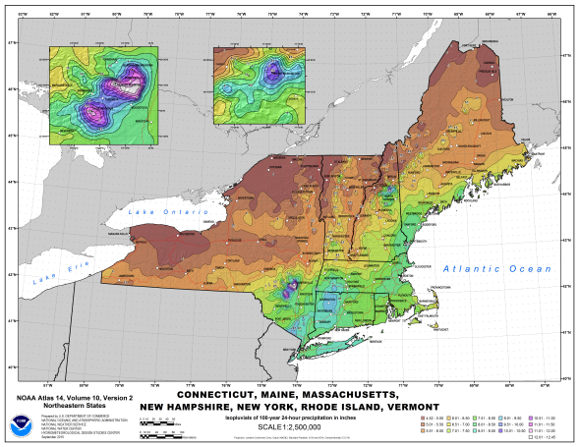

*Figure 2. Cartographic map example.*

* Charts of the seasonal distribution of annual maxima; see an example in Figure 3.

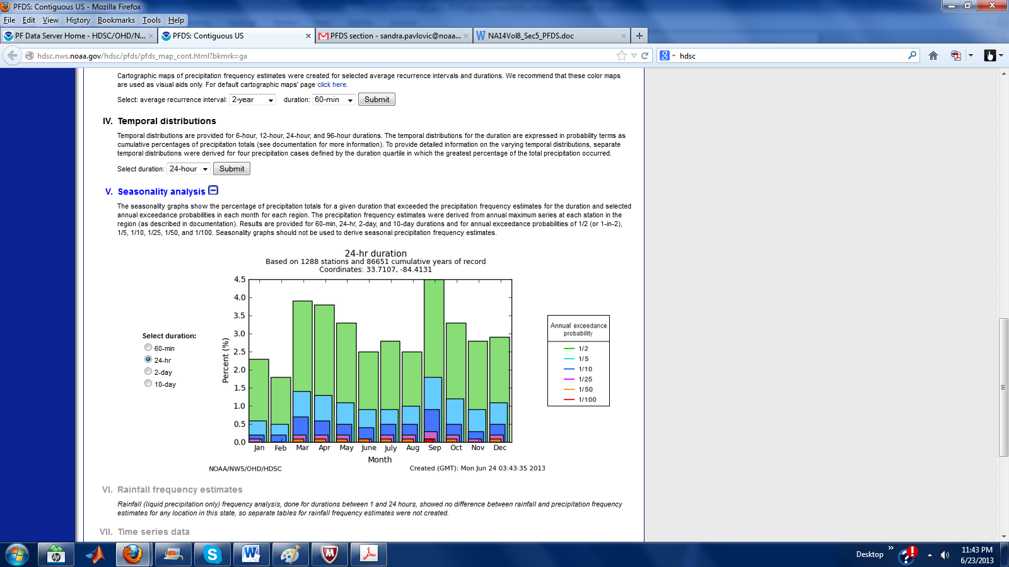

*Figure 3. Sample 24-hour seasonal distribution graph.*

* Probabilistic temporal distributions for 6-hour, 12-hour, 24-hour, and 96-hour durations in both chart and digital form (see an example in Figure 4).

FFoig1

*Figure 4. An example of charts for 6-hour distribution curves.*

* Rainfall frequency estimates with corresponding upper and lower bounds of 90% confidence intervals will be available at 30-arc sec grid for durations of 1, 2, 3, 6, 12 and 24 hours.
* Documentation
* Quarterly Status Reports (see Task 13).

Task 12 - Status Reporting

A. Background

Progress for this volume will be reported each quarter in a Quarterly Status Report.

B. Analysis

Reports will document progress in the preceding quarter, status of the entire project, issues, activities expected in the coming quarter and expected completion schedule.

C. Products

Quarterly Status Reports will be prepared and made available for download from the following web page: <https://www.weather.gov/owp/hdsc_current_projects> within 10 days of the conclusion of each quarter.

PROGRAM MANAGEMENT

Mark Glaudemans, Director of the Office of Water Prediction’s Geo Intelligence Division (GID), will be the primary point of contact and responsible program manager for this project.

Sandra Pavlovic from the GID Hydrometeorological Design Studies Center (HDSC) will serve as project manager and technical lead for the development of the NOAA Atlas 14 Volumes.

BUDGET

The estimated cost for development of estimates for a new NOAA Atlas 14 Volume 14 (Tasks 1 to 13) for Louisiana is $430,000. Table 1 below shows the estimated cost breakdown. The estimates for labor costs are based on the costs incurred for production of preceding NOAA Atlas 14 Volumes. Project costs are based in part on the estimated number of stations and the area of the state. The costs do not include any associated travel nor associated federal labor. The project is expected to be completed in a period between 24 to 30 months (2-2.5 years) in duration.

*Table 1. Estimated costs for development of Louisiana estimates.*

|  |  |
| --- | --- |
| **Cost Description** | **Project Total** |
| Contract Labor | $352,000 |
| PRISM | $62,000 |
| Web Support | $10,000 |
| IT Equipment | $5,000 |
| Office Supply | $1,000 |
| **TOTAL COST:** | **$430,000** |

REFERENCES

Langbein, W. B. (1949). “Annual Floods and the Partial-Duration Flood Series.” Transactions American Geophysical Union 30

U.S. Weather Bureau (1957). Technical Paper No. 29, Rainfall Intensity-Frequency Regime; Part 2 – The Southeastern United States. Weather Bureau, Washington, D.C. Retrieved from https://www.weather.gov/media/owp/oh/hdsc/docs/TP29P2.pdf

**NOAA Atlas 14 Volumes**

Bonnin, G., D. Todd, B. Lin, T. Parzybok, M.Yekta, D. Riley (2003). NOAA Atlas 14 Volume 1, Precipitation-Frequency Atlas of the United States, Semiarid Southwest (Arizona, Southeast California, Nevada, New Mexico, Utah). NOAA, National Weather Service, Silver Spring, Maryland.

Bonnin, G., D. Todd, B. Lin, T. Parzybok, M.Yekta, D. Riley (2004). NOAA Atlas 14 Volume 2, Precipitation-Frequency Atlas of the United States, Delaware, District of Columbia, Illinois, Indiana, Kentucky, Maryland, New Jersey, North Carolina, Ohio, Pennsylvania, South Carolina, Tennessee, Virginia, West Virginia. NOAA, National Weather Service, Silver Spring, Maryland.

Bonnin, G., D. Martin, B. Lin, T. Parzybok, M.Yekta, D. Riley (2006). NOAA Atlas 14, Volume 3, Precipitation-Frequency Atlas of the United States, Puerto Rico and the U.S. Virgin Islands. NOAA, National Weather Service, Silver Spring, Maryland.

Perica, S., D. Martin, B. Lin, T. Parzybok, D. Riley, M. Yekta, L. Hiner, L.-C. Chen, D. Brewer, F. Yan, K. Maitaria, C. Trypaluk, G. M. Bonnin (2009). NOAA Atlas 14 Volume 4, Precipitation-Frequency Atlas of the United States, Hawaiian Islands. NOAA, National Weather Service, Silver Spring, Maryland.

Perica, S., B. Lin, D. Martin, F. Yan, D. Brewer, C. Trypaluk, M. Yekta, L. Hiner, S. Heim, S. Dietz, T. Parzybok, L.-C. Chen, K. Maitaria, R. Chen, I. Roy, D. Unruh, T. Zhao, J. Yarchoan, G. M. Bonnin (2009). NOAA Atlas 14 Volume 5, Precipitation-Frequency Atlas of the United States, Selected Pacific Islands. NOAA, National Weather Service, Silver Spring, Maryland.

Perica, S., S. Dietz, S. Heim, L. Hiner, K. Maitaria, D. Martin, S. Pavlovic, I. Roy, C. Trypaluk, D. Unruh, F. Yan, M. Yekta, T. Zhao, G. Bonnin, D. Brewer, L.-C. Chen, T. Parzybok, J. Yarchoan (2011). NOAA Atlas 14 Volume 6, Precipitation-Frequency Atlas of the United States, California. NOAA, National Weather Service, Silver Spring, MD.

Perica, S., D. Kane, S. Dietz, K. Maitaria, D. Martin, S. Pavlovic, I. Roy, S. Stuefer, A. Tidwell, C. Trypaluk, D. Unruh, M. Yekta, E. Betts, G. Bonnin, S. Heim, L. Hiner, E. Lilly, J. Narayanan, F. Yan, T. Zhao (2012). NOAA Atlas 14 Volume 7, Precipitation-Frequency Atlas of the United States, Alaska. NOAA, National Weather Service, Silver Spring, MD.

Perica, S., D. Martin, S. Pavlovic, I. Roy, M. St. Laurent, C. Trypaluk, D. Unruh, M. Yekta, G. Bonnin (2013). NOAA Atlas 14 Volume 8, Precipitation-Frequency Atlas of the United States, Midwestern States. NOAA, National Weather Service, Silver Spring, MD.

Perica, S., D. Martin, S. Pavlovic, I. Roy, M. St. Laurent, C. Trypaluk, D. Unruh, M. Yekta, G. Bonnin (2013). NOAA Atlas 14 Volume 9, Precipitation-Frequency Atlas of the United States, Southeastern States. NOAA, National Weather Service, Silver Spring, MD.

Perica, S., S. Pavlovic, M. St. Laurent, C. Trypaluk, D. Unruh, D. Martin, O. Wilhire (2015). NOAA Atlas 14 Volume 10, Precipitation-Frequency Atlas of the United States, Northeastern States. NOAA, National Weather Service, Silver Spring, MD.

Perica, S., S. Pavlovic, M. St. Laurent, C. Trypaluk, D. Unruh, O. Wilhire (2018). NOAA Atlas 14 Volume 11, Precipitation-Frequency Atlas of the United States, Texas. NOAA, National Weather Service, Silver Spring, MD.

LIST OF ACRONYMS

AEP Annual Exceedance Probability

AMS Annual Maximum Series

ARI Average Recurrence Interval

DDF Depth-Duration-Frequency

GID Geo-Intelligence Division

GIS Geographic Information System

HDSC Hydrometeorological Design Studies Center

IDF Intensity-Duration-Frequency

NCDC National Climatic Data Center

NCEI National Centers for Environmental Information

NOAA National Oceanic and Atmospheric Administration

NWS National Weather Service

OWP Office of Water Prediction

PDS Partial Duration Series

PFDS Precipitation Frequency Data Server

PRISM Parameter-elevation Regressions on Independent Slopes Model