17th Quarterly Progress Report to the

FEDERAL HIGHWAY ADMINISTRATION

(FHWA)

On the Project

THE IMPACT OF WIDE-BASE TIRES ON PAVEMENT DAMAGE

DTFH61-11-C-00025

For the Period

April 1st to June 30th, 2015

Submitted by

Illinois Center for Transportation

University of Illinois at Urbana-Champaign



**QUARTERLY PROGRESS REPORT**

**QUARTER 17**

**The Impact of Wide-Base Tires on Pavement Damage – A National Study**

1. **Work Performed**

The following tasks were accomplished during this quarter:

* Finite element model (FEM) validation was performed for three sections from Florida, California, and Ohio. The results indicated that the numerical models are able to realistically simulate tire-pavement interaction, given the appropriate material characterization and accurate loading conditions.
* Sensitivity analysis of the Artificial Neural Network (ANN) models was completed to determine the importance of variables. Specifically, the missing data problem and incremental sensitivity (also called one-at-a-time (OAT) analysis) methods were implemented.
* Life cycle assessment (LCA) and life cycle cost analysis (LCCA) were performed to analyze the impact of wide-base tires on the environment and economy.
* First draft of the final report was completed.
* Journal publications are in the process of preparation/submission. The following is the list of papers we are working on:
  + Effect of Wide-Base Tires on Nationwide Flexible Pavement Systems – Numerical Modeling (to be submitted to TRB)
  + Finite-Element Modeling based Surrogate Method for Prediction of New Generation Wide-base Tires Pavement Responses (to be submitted to Neural Computing and Applications)
  + Nationwide Pavement Instrumentation on the Effect of New Generation Wide-Base Tire on Pavement Damage (to be submitted to ASCE Journal of Transportation Engineering)
  + Investigating the Impact of New Generation Wide-Base Tires on Pavement Life Cycle Energy Consumption, Greenhouse Gas Emissions, and Cost Using Life Cycle Assessment and Life Cycle Cost Analysis (to be submitted to TRB)
  + Effect of Wide Base Tire on Pavement Responses (to be submitted)
  + Comparison of Mechanistic part of MEPDG with Finite Element Analysis (to be submitted to TRB)

1. **Work to Be Accomplished in the Next Quarter**

* Submit final report and address any feedback from the technical committee.
* Prepare TRB webinar.
* Conduct TAC meeting/training.

1. **Problems Encountered**

* Only SI units were provided in the draft final report.

1. **Current and Cumulative Expenditures**

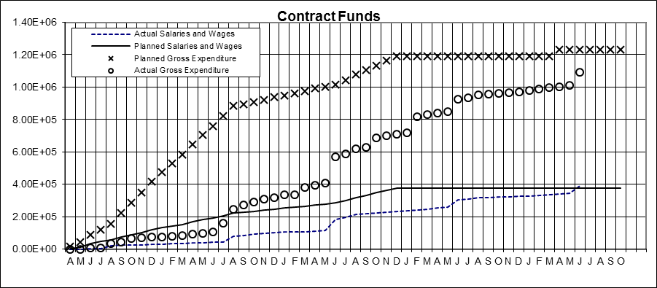

Figure 1. Project’s expenditure (based on current plan including amendments).

1. **Planned, Actual, and Cumulative Percentage of Effort**

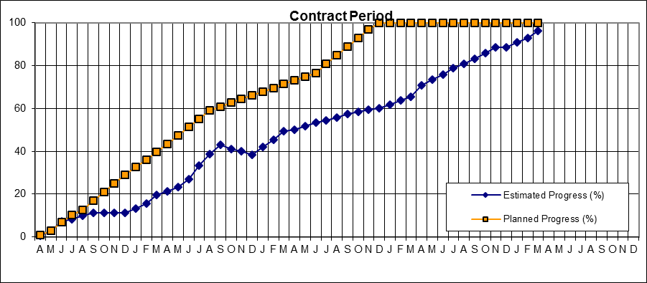

Figure 2. Project’s progress (based on current plan including amendments).

**APPENDIX A  
SENSITIVITY ANALYSIS OF ANN MODELS**

To investigate the importance of the input variables in the ANN modeling scheme, a series of sensitivity analyses were conducted. The missing data problem and incremental sensitivity (or OAT analysis) methods were implemented to analyze the models. In the former, one variable was removed from the model at a time and output error was calculated. The relative importance of the variables is evaluated by comparing the output errors. The higher the error, the more important the variable is. Figure A-1 shows the missing data sensitivity results for thin and thick pavement structures with variables aggregated into four categories: pavement structure, load, tire type, and tire pressure. Aggregation is done due to practical issues and to summarize the results in limited number of categories than reporting the results for all variables. Pavement structure category includes all structure related variables (surface and base thicknesses, and material properties). Also tire inflation pressure variable category includes both tire pressure and differential tire pressure.

Figure A-1. Missing data sensitivity analysis results for thin and thick structures averaged over all responses and Level 1 and Level 2 models.

The vertical axis shows the amount of error incurred as a result of a missing variable. For the thick pavement cases, if information were not available for “pavement structure,” the error would be 21.0%, making “pavement structure” the most important variable. It should be noted that missing a specific variable is conditional on knowing the variable range; otherwise, it would be impossible to know the response without knowing, for example, the layer thicknesses.

On the other hand, for the OAT analysis, each variable gradually increases one step at a time from low to high values in the input range. The change in output is recorded while all other variables are kept at baseline values. Step length may vary for different variables depending on the unit, but the same number of steps should be used for all variables to obtain consistent results. At each step, a normalized sensitivity ratio (SR) is calculated using the following equation:

|  |  |  |
| --- | --- | --- |
|  |  | (1) |

where: = model output in step due to variable

= model output in step *i* due to variable

= value of variable in step

= value of variable in step

The average of over all steps is an indicator of the effect of the input on the output; the higher the , the more important the variable. Figure A-2 shows the variable importance for thick and thin pavements with respect to . In this study, twenty steps were used. Although normalization is required for cross-structure comparison i.e. thin versus thick, the OAT result shows the relative importance of the variables within each pavement structure (thin or thick). Cross-structure comparison between two structures shows that variables have the same relative order of importance regardless of pavement structure type; pavement structure has the highest influence followed by load.

A sample trend of the OAT analysis is provided in Figure A-3 for one of the responses. The illustration shows the change of longitudinal strain at the bottom of the surface layer with change of tire inflation pressure, load, and AC thickness.

Figure A-2. OAT sensitivity analysis results for thin and thick pavement structures averaged over all responses.

(a) (b)

(c)

Figure A-3. Change of longitudinal strain at bottom of surface with change in: (a) tire inflation pressure, (b) load, and (c) AC thickness.

Both sensitivity methods used different scales to determine the importance of variables; therefore, a sensitivity factor in scale from 0 to 1 was defined, and the results were normalized to this scale. Figure A-4(a) shows a comparison of the sensitivity factor of each method in one scale averaged over thin and thick structures, responses, and levels. Figure A-4(b) shows the final averaged sensitivity factor based on two methods. According to the sensitivity factor results, the pavement structure has the highest effect in both cases. Load is a little more emphasized in the missing data problem. It can also be noted that tire type plays an important role in pavement response calculation. According to the missing data problem, the type of the tire can be responsible for up to 10% influence on responses, which is a little more emphasized than the effect of tire pressure. Also the analysis showed that tire pressure effect is more pronounced in near surface responses with the effect of tire pressure reaching 6.6% on near surface compared with 4.7% on in-depth responses.

(a) (b)

Figure A-4. Sensitivity factor results: (a) comparison of two methods, and (b) overall sensitivity factor averaged on two sensitivity methods.

**APPENDIX B**

**VALIDATION**

Thin Section at Florida

Results of the Accelerated Pavement Test (APT) conducted at the Florida Department of Transportation facility (FDOT) were used to validate the numerical pavement model. The “Test Pit” section that has 3 in of AC, 10.5 in of limerock base and 12 in of subbase was selected and the loading condition considered 552 kPa tire inflation pressure with 26 kN axle load for the dual tire assembly (DTA).

There were four pressure cells installed in this section, two of them were placed at the bottom of AC and the other two were at the bottom of base. While the average pressure was measured as 169.33 kPa at the bottom of AC, it was 31.37 kPa at the bottom of base. The corresponding stresses based on FEM simulations were 167.1 and 25.8 kPa, respectively.

There were six strain gauges installed at the bottom of AC: three along the traffic direction and three in the transversal direction. The average tensile strain was calculated as 21.1 and 98.03 με for the transverse and traffic directions, respectively. On the other hand, the FEM predicted these strains as 18.5 and 43 με.

The numerical simulation provided an accurate approximation of the vertical pressure and tensile strain in the transverse direction. However, the approximation for the strain in traffic direction is inaccurate by factor of 2. This could be alluded to the characterization of the base material, which is realistically stress-dependent and non-linear. Moreover, it should be modelled as an anisotropic material, which means that the behavior is observed differently in each principal direction.

However, since the resilient modulus test was only conducted under a vertical load, non-linear material characterization parameters for the three orthogonal directions could not be obtained. Therefore, the assumption of isotropic base material had to be made, which could be the main reason for the underestimation of the tensile strain in traffic direction.

Thin Section at UC Davis

Another section used for FEM validation was built at the University of California Pavement Research Center facility in Davis, California. The section called “671HC” was selected, which has two AC layers, each 60 mm thick. While the top layer was warm mix asphalt (WMA), the bottom later was a conventional hot mix asphalt (HMA). Underneath these two AC layers, there was a recycled base and a subbase layer that have thickness of 250 and 270 mm, respectively. The loading condition considered a DTA with an applied load of 26 kN and tire inflation pressure of 552 kPa.

There were four pressure cells installed in this section, two of them were placed at the top of recycled base and the other two were at the bottom of recycled base. While the average pressure was 85.02 kPa at the top of base, it was 40.08 kPa at the bottom of base. The resulting stresses from the simulation were 58.6 and 30.97 kPa.

In addition, there were eight strain gauges installed in this section, wherein four were placed at the bottom of the WMA (with two strain gauges oriented along the traffic and transverse directions). The other four strain gauges were placed at the bottom of the HMA in a same manner. The transverse strains at the bottom of the WMA and bottom of the HMA were 59.2 and 11.57 με, respectively. On the other hand, FEM predicted the corresponding strains as 4.3 and 16.9 με.

The approximation of the vertical pressure at the top and bottom of the base were much lower than the ones obtained from the field. The reason is that the base material was characterized as linear elastic due to the lack of resilient modulus data. As reported in literature (Kim et al., 2009), linear elastic characterization of base results to stiffer behavior in pavement simulations. This assumption becomes more significant for thin pavement sections, which was utilized for validation.

Furthermore, FEM inaccurately estimated the transverse strain at the bottom of the WMA. Although the field measurement is 59.2 με, FEM approximated it as 4.3 με. However, it was deemed that this field measurement was unrealistically high. This can be deduced by looking at the transverse strain at the bottom of the HMA. Due to the bending effect, higher tensile strain is anticipated as the AC depth increases. Conversely to the anticipated behavior, the field measurement at a lower depth is lower than the one at the bottom of the AC (11.57 < 59.2 με). Therefore, the tensile strain gages near the surface were concluded to produce unrealistically high strain measurements.

Thick Section at Ohio

The last FEM validation was done on a thick pavement structure from Ohio, which was named as the “Mainline Section, Driving.” This section has a total of six layers including the subgrade, with thicknesses of 25 mm of fine graded polymeric asphalt concrete, 50 mm of intermediate course, 200 mm of asphalt treated base (ATB), 100 mm of fatigue resistant layer (FRL), and 150 mm of granular base. The loading condition was selected as DTA with an applied load of 44 kN and tire inflation pressure of 758 kPa.

While the asphalt concrete was characterized by Prony series (derived from the complex modulus test), the information provided for base material characterization was insufficient to obtain the stress-dependent and anisotropic model parameters. The provided one-dimensional - parameters were not enough to characterize base as non-linear anisotropic stress dependent material. Additionally, the elastic modulus provided for the subgrade was considered unrealistically low (0.23 MPa). Therefore, different material assumptions for the base and subgrade layers were considered. The elastic modulus values, obtained from literature, were assumed to be 513 and 769 MPa for the base and subgrade, respectively (Xue et al, 2014).

Four pressure cells were installed to the section in Ohio; while two were placed at the bottom of fatigue resistant base layer, the other two cells were at the bottom of the aggregate base layer. Average vertical pressure measurements for these two locations were 48.2 and 31.2 kPa, respectively. On the other hand, the corresponding FEM approximations were 58.2 and 50.1 kPa.

Additionally, transverse strains were measured at three different locations: bottom of the AC, ATB, and FRL layers. A total of 300 measurements for the transverse strain at the bottom of AC were obtained with high variability. The measurement varied between 50 and 350 με, with the average of 173 με and standard deviation of 76 με. The numerical model predicted the transverse strain as 40.2 με.

On the other hand, good repeatability was observed for other pavement responses. The measured transverse strain at the bottom of the ATB and FRL layers were 46 and 123 με, respectively; whereas FEM approximations were 27 and 15 με. High discrepancy between the measurement and FEM results was alluded to the lack of data for the base and subgrade material characterizations.

Lastly, two rosette shear gauges were used for model validation. One of them was placed 0.88 in above the AC bottom whereas the other one was positioned 1.50 in below the ATB surface. These strain gauges reported strain measurements in three directions (Figure B-1). The formula given in Equation 1 was used to derive the strains in principal directions.

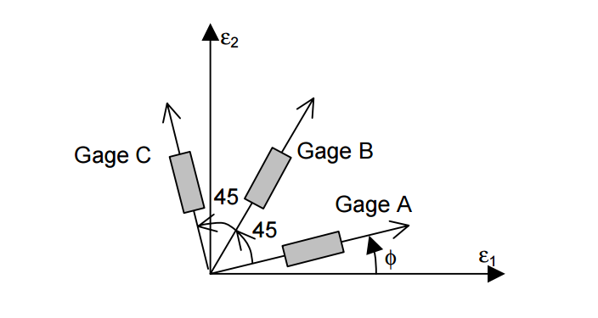

Figure B-1. Rectangular rosette gage orientation (Craig, 2010).

|  |  |
| --- | --- |
|  | 1 |

Field strains and predicted stains are given in Table B-1. As seen, there is discrepancy between the predicted and measured values. Two reasons could explain the observed differences. First, the aforementioned assumptions were not adequate replacements to the missing material characterization data. Secondly, the gauge installation technique. Strain gauges were mounted onto the wall of the hole, drilled through the pavement, which introduced discontinuity to the pavement structure. In contrary to the instrumentation plan, the numerical pavement structure was modeled as a continuum body, thereby unable to capture the change in stiffness due to the field-produced discontinuity.

**Table B-1: Field and Predicted Values for Strains**

|  |  |  |  |
| --- | --- | --- | --- |
| **Location** | **Direction** | **Field** | **Predicted** |
| AC | Vertical | 281.28 | 90.10 |
| AC | Transverse | 66.05 | 51.50 |
| ATB | Vertical | 130.78 | 32.40 |
| ATB | Transverse | 51.80 | 37.00 |

**References:**

Craig J. Strain Transformation and Rosette Gage Theory. (2010). *Retrieved from http://soliton.ae.gatech.edu/people/jcraig/classes/ae3145/Lab2/strain-gage-rosette-theory.pdf*. Accessed July 27, 2015.

Kim, M., Tutumluer, E., & Kwon, J. (2009). *Nonlinear pavement foundation modeling for three-dimensional finite-element analysis of flexible pavements*. International Journal of Geomechanics.

Xue W., Weaver E., Wang L. (2014). *Influence of Tire Inflation Pressure on Measured Pavement Strain Responses and Predicted Distresses*, Transpiration Research Board, Washington, DC.

**APPENDIX C**

**Life Cycle Assessment and Life Cycle Cost Analysis**

A study was originally conducted by UC Davis to analyze and compare the impact of wide-base tires on energy and greenhouse gases (GHGs) with standard dual tires. Because of suspicious rutting responses, UIUC team decided to conduct the LCA again based on the pavement responses obtained through ANN from FEM simulations. The same roughness and texture progression models developed by UC Davis were used to compute energy consumption and GHGs in the use phase, but the UIUC life cycle inventory (LCI) database and pavement LCA tool were used to calculate the environmental impacts during the material and construction phases.

For the LCCA, the cost of pavement materials, equipment operation, and vehicle fuel were considered but cost saving from reduction in vehicle emissions and elimination of penalty on trucks with wide-base tires were not considered in the analysis. Scenario-based case studies were conducted and the resulting conclusion was that the use of wide-base tires can result in higher or lower life cycle energy consumption and cost as well as and GHG emissions, depending on the pavement structure, traffic level, and failure mode for the pavement.

A scenario-based case study was conducted on two different asphalt pavements of varying thicknesses (120 and 60mm) and truck volumes (19 and 2%). It is worth noting that the pavement geometries are referenced from Wu and Jones (2013), wherein the thick and thin pavement sections are coined as Section 671HC and Section 670HC, respectively.

|  |  |
| --- | --- |
| **(a)** | **Figure 10-. Cross-sections of the two studies: (a) 671HC (thick asphalt) and (b) 670HC (thin asphalt).**  **(b)** |
| Figure C-1. Cross-sections of the (a) thick and (b) thin pavement cases. | |

Three scenarios were analyzed separately to determine pavement design life under wide-base tires. The scenarios included the following arrangements: (I) pavement design life was the same between standard dual tires and wide-base tires; (II) pavement design life was determined by fatigue cracking performance but had the same IRI; and (III) pavement design life was limited to rutting using IRI progression.

Different levels of market penetration of wide-base tires were also analyzed within each scenario, with zero percent market penetration treated as the baseline and all the results presented relative to that baseline. Specific performance models (IRI, fatigue cracking, and rutting) and Miner’s Law were applied to estimate the pavement design life under each scenario. Because the scenarios introduced various pavement service lives, the study annualized the energy consumption and GHG emissions to generate a fair comparison.

Results

The values shown in Tables C-1 through C-3 represent the difference between NG-WBT and DTA. Therefore, positive values refer to relative savings from using NG-WBT whereas negative values stand for relative losses from using NG-WBT.

Since Scenario I assumed that NG-WBT and DTA have the same rutting and fatigue performance, the design lives for both tire types are the same. As a result, the environmental impacts (or costs) associated with the material and construction phases are the same for both tires. Therefore, the net saving (from using NG-WBT) in energy, GHG, and cost is zero.

TABLE C-1. Scenario I Results for the Thick and Thin Pavement Cases: Energy and GHG Reductions Compared to the Baseline (DTA)

|  |  |  |  |  |  |
| --- | --- | --- | --- | --- | --- |
| **Thick Pavement** | **Market Penetration of Wide-Base Tires** | **Material Production Phase** | **Construction Phase** | **Use Phase** | **Life Cycle Result** |
| Energy saving compared to baseline  (MJ) | 5% | 0 | 0 | 127,654 | 127,654 |
| 10% | 0 | 0 | 255,308 | 255,308 |
| 50% | 0 | 0 | 1,276,540 | 1,276,540 |
| 100% | 0 | 0 | 2,553,079 | 2,553,079 |
| GHG reduction compared to baseline  (metric ton CO2e) | 5% | 0 | 0 | 9 | 9 |
| 10% | 0 | 0 | 19 | 19 |
| 50% | 0 | 0 | 94 | 94 |
| 100% | 0 | 0 | 187 | 187 |
| Economic saving compared to baseline ($ Present) | 5% | 0 | 0 | 3,108 | 3,108 |
| 10% | 0 | 0 | 6,216 | 6,216 |
| 50% | 0 | 0 | 31,079 | 31,079 |
| 100% | 0 | 0 | 62,158 | 62,158 |
| **Thin Pavement** | **Market Penetration of Wide-Base Tires** | **Material Production Phase** | **Construction Phase** | **Use Phase** | **Life Cycle Result** |
| Energy saving compared to baseline  (MJ) | 5% | 0 | 0 | 8,694 | 8,694 |
| 10% | 0 | 0 | 17,388 | 17,388 |
| 50% | 0 | 0 | 86,941 | 86,941 |
| 100% | 0 | 0 | 173,881 | 173,881 |
| GHG reduction compared to baseline  (metric ton CO2e) | 5% | 0 | 0 | 1 | 1 |
| 10% | 0 | 0 | 1 | 1 |
| 50% | 0 | 0 | 6 | 6 |
| 100% | 0 | 0 | 13 | 13 |
| Economic saving compared to baseline ($ Present) | 5% | 0 | 0 | 225 | 225 |
| 10% | 0 | 0 | 449 | 449 |
| 50% | 0 | 0 | 2,246 | 2,246 |
| 100% | 0 | 0 | 4,493 | 4,493 |

On the other hand, as Scenarios II and III have different fatigue and rutting performance, the net savings change with market penetration of NG-WBT.

TABLE C-2. Scenario II Results for the Thick and Thin Pavement Cases: Energy and GHG Reductions Compared to the Baseline (DTA)

|  |  |  |  |  |  |
| --- | --- | --- | --- | --- | --- |
| **Thick Pavement** | **Market Penetration of Wide-Base Tires** | **Material Production Phase** | **Construction  Phase** | **Use Phase** | **Life Cycle Result** |
| Energy saving compared to baseline  (MJ) | 5% | -317,900 | -112,644 | 127,551 | -302,993 |
| 10% | -317,900 | -112,644 | 255,103 | -175,442 |
| 50% | -635,800 | -225,288 | 1,274,605 | 413,516 |
| 100% | -953,701 | -337,933 | 2,547,635 | 1,256,002 |
| GHG reduction compared to baseline  (metric ton CO2e) | 5% | -18 | -9 | 9 | -18 |
| 10% | -18 | -9 | 19 | -8 |
| 50% | -36 | -18 | 93 | 39 |
| 100% | -55 | -26 | 187 | 106 |
| Economic saving compared to baseline ($ Present) | 5% | -128,642 | -39,408 | 3,108 | -164,942 |
| 10% | -128,642 | -39,408 | 6,216 | -161,834 |
| 50% | -257,283 | -78,817 | 31,079 | -305,021 |
| 100% | -385,925 | -118,225 | 62,158 | -441,993 |
| **Thin Pavement** | **Market Penetration of Wide-Base Tires** | **Material Production Phase** | **Construction  Phase** | **Use Phase** | **Life Cycle Result** |
| Energy saving compared to baseline  (MJ) | 5% | 0 | 0 | 8,694 | 8,694 |
| 10% | 0 | 0 | 17,388 | 17,388 |
| 50% | -370,884 | -131,417 | 86,865 | -415,436 |
| 100% | -370,884 | -131,417 | 173,731 | -328,570 |
| GHG reduction compared to baseline  (metric ton CO2e) | 5% | 0 | 0 | 1 | 1 |
| 10% | 0 | 0 | 1 | 1 |
| 50% | -21 | -10 | 6 | -25 |
| 100% | -21 | -10 | 13 | -19 |
| Economic saving compared to baseline ($ Present) | 5% | 0 | 0 | 217 | 217 |
| 10% | 0 | 0 | 433 | 433 |
| 50% | -194,606 | -59,123 | 2,164 | -251,565 |
| 100% | -194,606 | -59,123 | 4,326 | -249,403 |

TABLE C-3. Scenario III Results for the Thick and Thin Pavement Cases: Energy and GHG Reductions Compared to the Baseline (DTA)

|  |  |  |  |  |  |
| --- | --- | --- | --- | --- | --- |
| **Thick Pavement** | **Market Penetration of Wide-Base Tires** | **Material Production Phase** | **Construction  Phase** | **Use Phase** | **Life Cycle Result** |
| Energy saving compared to baseline  (MJ) | 5% | 0 | 0 | 137,472 | 137,472 |
| 10% | 0 | 0 | 264,933 | 264,933 |
| 50% | 0 | 0 | 1,284,617 | 1,284,617 |
| 100% | 556,325 | 197,127 | 2,575,624 | 3,329,077 |
| GHG reduction compared to baseline  (metric ton CO2e) | 5% | 0 | 0 | 10 | 10 |
| 10% | 0 | 0 | 19 | 19 |
| 50% | 0 | 0 | 94 | 94 |
| 100% | 32 | 15 | 189 | 236 |
| Economic saving compared to baseline ($ Present) | 5% | 0 | 0 | 3,497 | 3,497 |
| 10% | 0 | 0 | 6,740 | 6,740 |
| 50% | 0 | 0 | 32,681 | 32,681 |
| 100% | 180,098 | 55,172 | 64,584 | 299,854 |
| **Thin Pavement** | **Market Penetration of Wide-Base Tires** | **Material Production Phase** | **Construction Phase** | **Use Phase** | **Life Cycle Result** |
| Energy reduction compared to baseline  (MJ) | 5% | 0 | 0 | -300,383 | -300,383 |
| 10% | 0 | 0 | -291,648 | -291,648 |
| 50% | -317,900 | -112,644 | -380,996 | -811,540 |
| 100% | -476,850 | -168,965 | -432,971 | -1,078,787 |
| GHG reduction compared to baseline  (metric ton CO2e) | 5% | 0 | 0 | -22 | -22 |
| 10% | 0 | 0 | -21 | -21 |
| 50% | -18 | -9 | -27 | -54 |
| 100% | -27 | -13 | -31 | -71 |
| Economic saving compared to baseline ($ Present) | 5% | 0 | 0 | -7,319 | -7,319 |
| 10% | 0 | 0 | -7,106 | -7,106 |
| 50% | -166,805 | -50,677 | -9,553 | -227,035 |
| 100% | -250,208 | -76,015 | -11,015 | -337,238 |

The results indicated the following:

* Scenario I: because of the fuel economy improvement resulting from using wide-base tires, there were significant cost and fuel consumption savings and GHG emissions reductions, which were proportional to the truck traffic.
* Scenario II: the 670HC case showed higher annual energy consumption and GHG emissions compared with the baseline. This is caused by the fact that wide-base tires introduced a higher tensile strain at the bottom of the asphalt layer than the standard dual tires, which reduced the pavement fatigue life and therefore increased the energy consumption, cost, and GHG emissions from the material production and construction phases.

Although a reduced fatigue life brought higher energy consumption and GHG emissions, the 671HC case experienced overall savings in energy consumption and GHG emissions because the impact of fuel economy improvement from wide-base tires was greater (at higher market penetrations of 50% and 100%). However, the overall economic saving was negative as the ratio of calorific or energy value and unit cost of fuel is very high compared to that of pavement materials.

* Scenario III: it was found that wide-base tires have lower life cycle energy consumption and cost, and GHG emissions, although the benefits mainly stem from the use phase. For the 671HC case, the compressive strain, often correlated with rutting, was relatively similar between standard dual tires and wide-base tires, and the design life determined by the IRI performance (essentially rutting performance shown in this study) is quite similar to the baseline.

On the other hand, compressive strain is higher with wide-base tires for the 670HC case and therefore the case experienced higher energy consumption and GHG emissions. In addition, the impact of energy loss from a faster IRI progression was greater than that of the fuel economy improvement, thereby leading to a negative overall energy consumption and GHG emissions in the use phase. Thus, the resulting economic savings were also negative.

In summary, the preliminary study concludes that the use of wide-base tires can result in higher or lower life cycle energy consumption and cost, and GHG emissions, depending on the pavement structure, traffic level, and failure mode for the pavement.

**References:**

Wu, R. & Jones, D (2013). *Wide-Base Tire Study: Test Track Construction, Instrumentation, Accelerated Pavement Testing, and Sampling*. Draft Technical Memorandum: UCPRC-TM-2013-06.