**Plan for Additional Funding**

During Pooled Fund TPF-5-297, led by Oklahoma DOT, the research team has been using advanced characterization techniques to learn more about freeze thaw damage. This work has given important insights into how moisture and salt move and react within concrete. This in-turn, has an impact on the damage that occurs in the concrete.

Additional states have joined the project and supplied more money than was in the original budget. This additional funding will specifically examine pore infilling and its role in altering the overall freeze thaw performance. Work will also be done to produce more online video content over the Super Air Meter. The description below outlines additional work that will be performed using x ray tomography and video creation at Oklahoma State and a combination of length change and damage development at Oregon State University.

**Task A1 – Observation of void filling**

One technique that has been very valuable is X-ray CT. This method allows 3D maps of the inside of concrete to be created. These maps allow the concrete changes from freezing cycles to be followed. One important observation during these measurements is that some of the air voids appear to be filling during the freeze thaw cycles. Some examples of this can be seen in Figure 1. This is a paste sample with 15% air content. The air voids seem to be filling with increased freeze thaw cycles. This can be observed because the voids are no longer black but are filled with a light gray material.



Figure 1 – A slice from an X-ray CT scan that shows air voids being filled from freeze thaw cycles. The volume changes are shown in Figure 2.

For example three samples are shown in Fig. 2 with different volumes of air. These samples are ponded on the surface and subjected to 80 freeze thaw cycles. At the end of these cycles it can be observed that approximately 45% of the air voids are filling near the surface of the concrete. This is alarming because the air voids are no longer available to protect the paste during freezing if they are filled. This could be an important contributor to the freeze thaw durability of concrete.



Figure 2 – The volume of air within a sample is lower at the surface than within the depth. This volume change is caused by the filling of air voids caused by freeze thaw cycles.

At this point it is unclear what is causing the filling of the air voids and what material is in these voids. Preliminary work at Oklahoma State suggests that the solid material has a much higher Ca content than the bulk paste and calcium hydroxide is detected in the voids. This likely means that these voids are filling with water during freezing and then solids are precipitating within the voids. Again, this could be detrimental for freeze thaw durability and this should be better understood.

**Task A2 – Observation of damage from freeze thaw**

In addition to void filling, the team has been focused on tracking the damage that occurred during freezing. Figure 3 shows the crack pattern observed with a concrete mortar sample that has nearly 100% degree of saturation. It appears that the damage observed starts at the transition zone between the paste the aggregate. There is also substantial cracking that is occurring within the aggregate. This data was gathered in preliminary studies and more work is needed to better understand what is occurring.

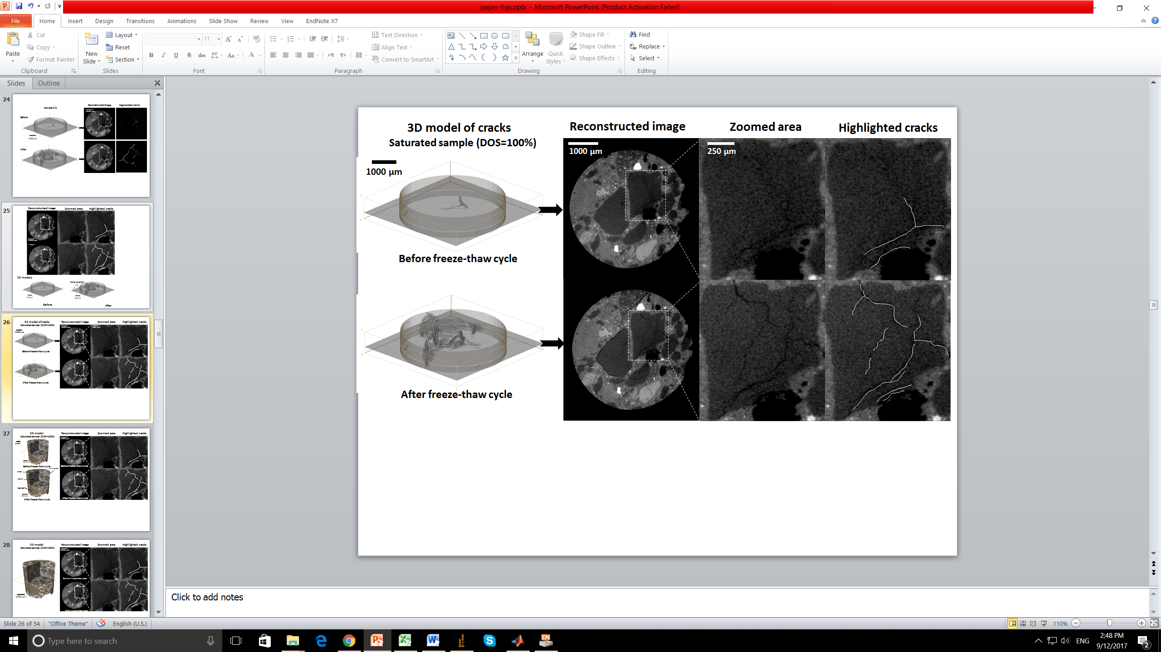

Figure 3 – Cracking is shown within a concrete sample before and after a freeze thaw cycle. The damage seems to be occurring within the aggregate and within the transition zone.

Task A1 and A2 will be investigated by creating air entrained paste and mortar samples and subjecting them to freeze thaw cycles while they are ponded with solution. Scans will be taken before the freeze thaw cycles to find the initial structure and distribution of the air void system. Scans will be taken every 10 cycles to determine the damage and also the void filling that occurs. This will be done at one w/cm but with mixtures with three different SAM numbers.

**Task A3 - Length Change Measurement During Freezing**

Oregon State University is working on the development of a new technique to detect length change and damage associated with freezing. A series of experiments are planned that will focus on solving three main questions.

1. Can the critical degree of saturation be determined from length change?
2. How is pore infilling related to the solution (salt) in which the samples are stored? Specifically this would build on Task A1 where the calcium hydroxide is known to react with certain deicing salts to form calcium oxychloride.
3. How does this infilling alter the degree of saturation or critical degree of saturation for a concrete and how can this be modeled? This would allow insight into how air void filling reduces the resistance to freeze thaw damage.

An experimental program consisting of samples stored at 4 degrees of saturation, in 3 solutions, with 3 air void systems and one water to cement ratio would be anticipated.

To assess the interaction between freeze thaw damage and the filling of air voids a program will be performed using mixtures with varying SAM numbers at one water to cement ratio. These mixtures will be consistent with those used in the previous portion of the project.

**Task A4 – Online video creation**

As part of this task several online training videos for the SAM will be created and made available online. These videos will cover some of the most asked questions during the training for the SAM. It is anticipated that these videos will cover the maintenance of the SAM, troubleshooting the meter, checking for leaks, and use of the shotgun to fill the bottom chamber.

**Budget**

As part of the pooled fund study it appears that there is additional money that has not been committed to the research team of at least $150K. The team would like to propose using that money to better understand how freeze thaw damage occurs at different degrees of hydration and how the voids fill within air entrained systems with continued freeze thaw cycles.

We think this will be an important addition to the current study and will improve the accuracy of the models that are being developed to help predict freeze thaw damage. The money will be split evenly between Oklahoma State and Oregon State University and the existing overhead rates will be used.