13th Quarterly Progress Report to the

FEDERAL HIGHWAY ADMINISTRATION

(FHWA)

On the Project

THE IMPACT OF WIDE-BASE TIRES ON PAVEMENT DAMAGE

DTFH61-11-C-00025

For the Period

April 1st to June 30st, 2014

Submitted by

Illinois Center for Transportation

University of Illinois at Urbana-Champaign



**QUARTERLY PROGRESS REPORT**

**QUARTER 13**

**The Impact of Wide-Base Tires on Pavement Damage – A National Study**

1. **Work Performed**

The following tasks were accomplished during this quarter:

* The Adjustment Factor scheme is being developed to compare DTA and WBT in a computational-efficient fashion. The AASHTOWare Pavement ME Design procedure was implemented using Julea, MatLab, and AutoHotkey in order to improve efficiency and access a wider range of pavement responses; see Appendix A.
* Finite element analysis of thick and thin pavements has been completed.
* Final Draft Online User Interface for pavement response data has been submitted. Figure 1 is a snapshot of the latest version of the tool.
* Wide-Base Tire Artificial Neural Network (WBT-ANN) tool is being developed.

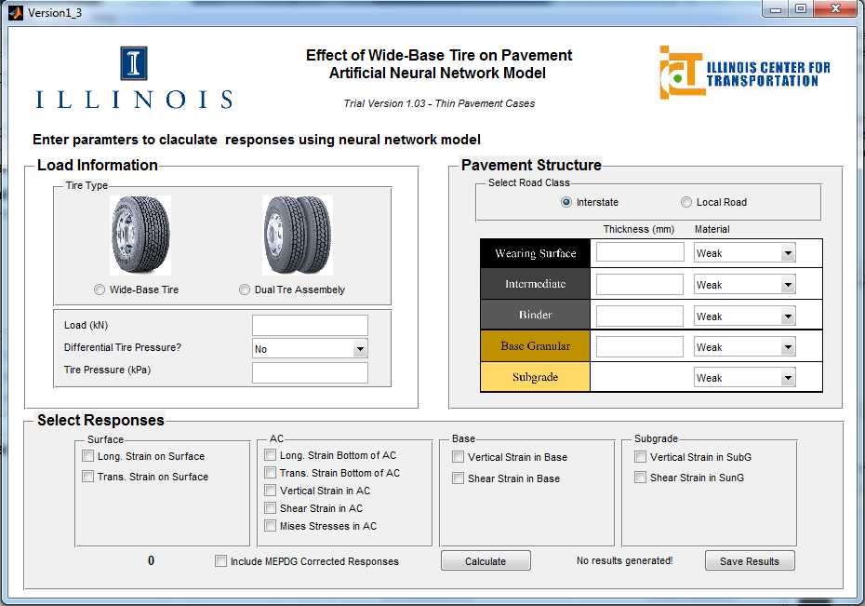

Figure 1 - WBT-ANN Tool Version 1.03

* SCB test data for Ohio sections were analyzed. The specimens include four lifts of the pavement section including surface, intermediate (INT), asphalt treated base (ATB) and fatigue resistance layer (FRL). Specimens were prepared from loose mix at 50-mm thicknesses. Four replicates were prepared from each mix; see Appendix B.
* A meeting with the research panel has been schedule for July 31st, 2014.

1. **Work to Be Accomplished in the Next Quarter**
   * Regression study will be conducted to derive the adjustment factor for pavement responses calculated by AASHTOWare Pavement ME Design procedure.

* Finalizing the WBT-ANN tool.
* Running DCT for Ohio sections and comparing results with those from the SCB tests.

1. **Problems Encountered**

* Due to issues with DCT-machine software, reliability for Florida, UC-Davis, and Ohio test section results was compromised. The machine is fixed and the test will be performed to ensure consistency and reliability of data.

1. **Current and Cumulative Expenditures**

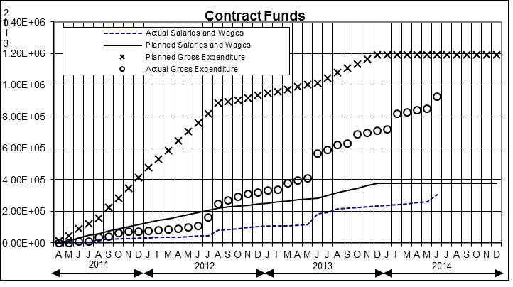

Figure 2. Project’s expenditure

1. **Planned, Actual, and Cumulative Percentage of Effort**

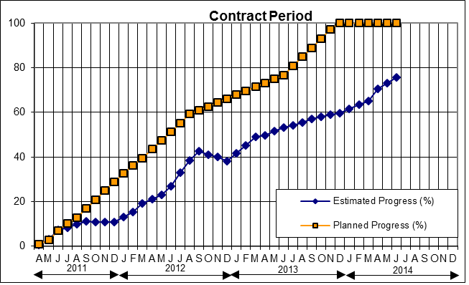

Figure 3. Project’s progress

**APPENDIX A**

**ADJUSTMENT FACTOR FOR MECHANISTIC-EMPIRICAL PAVEMENT DESIGN GUIDE**

The Mechanical-Empirical Design Guide for New and Rehabilitated Pavement Structure, AASHTOWare Pavement ME Design, provides more theoretically sound methodology for the pavement performance prediction compared to the 1993 AASHTO Guide which relies heavily on the results of AASHTO Road Test conducted in Ottowa, Illinois, in 1960s.

In ME Design, the user first assumes a pavement structure as a trial design and provides all other inputs, such as traffic, material properties, and environmental conditions, to the software. Afterward, structural responses (strain, stress, and/or deflections) are calculated within the pavement, which refers to the mechanistic part of the guide. Next, by exploiting empirical models, these responses are linked to predict distress propagations over design period which are consequently used for International Roughness Index (IRI) assessment. Finally, the user checks the design criteria against predicted ones. If design requirements are not satisfied, trial design should be modified and the steps should be repeated until the design requirements are met. Figure 4 illustrates the ME Design procedure.

Accurate prediction of the pavement responses is a key for realistic simulation of distress propagation over time. Although Pavement ME Design has a grounded methodology for pavement analysis, it still has a number of limitations and unrealistic simplifications which may result in inaccurate predictions. On the other hand, Finite Element Analysis (FEA) is capable of simulating pavement responses more realistically in terms of loading conditions and material characterization. Therefore, the goal is developing a correction factor for the structural pavement responses calculated by the Pavement ME Design in accordance with FE results.

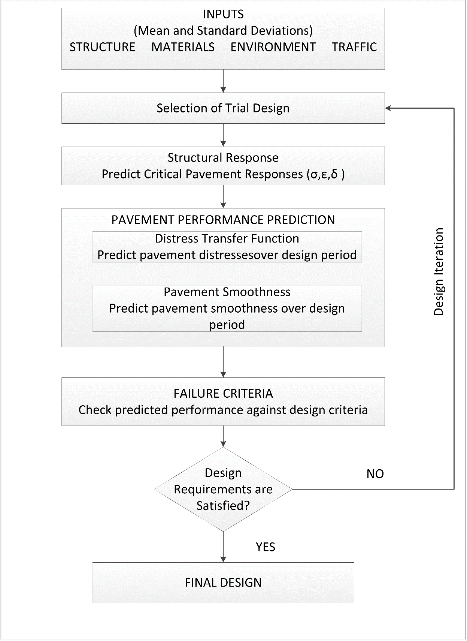

Figure 4. MEPDG Procedure

## **Correction factor**

Pavement ME Design procedure for computing pavement responses have a number of limitations, such as one-dimensional uniform vertical tire pressure with circular contact area, linear elastic analysis of AC layer, steady tire loading, etc. In addition, it does not consider wide base tires at all. Therefore, the idea is to develop two adjustment factors: one when using a wide base tire (adjust to dual tire assembly based on FE results) and the second to consider the adjustment from FE to Pavement ME Design for only dual tire assembly. The proposed method is given in Figure 5.

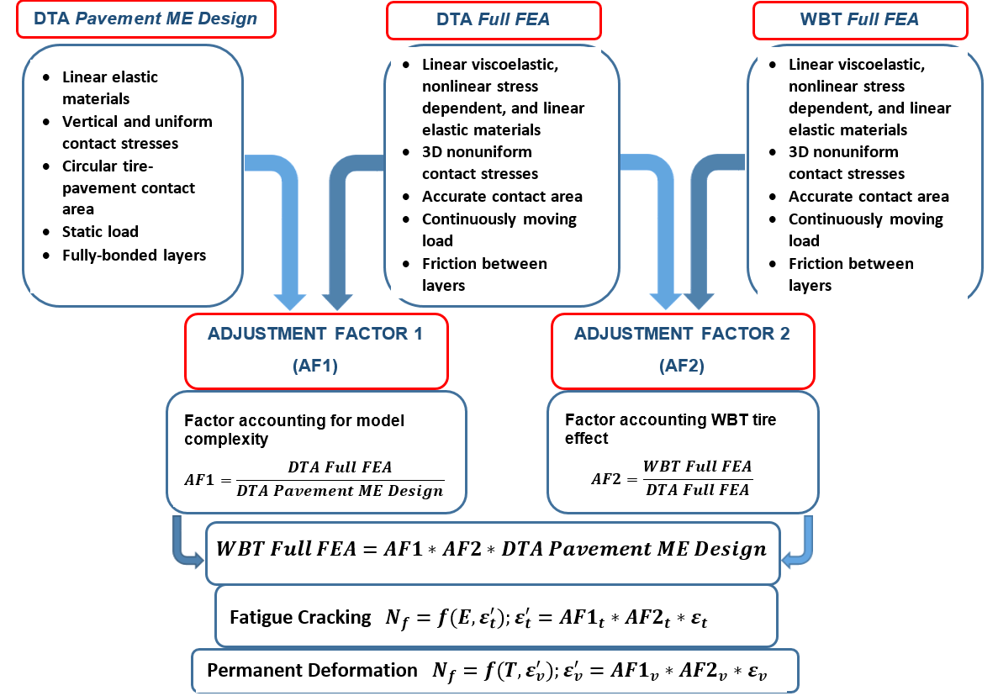

Figure 5. Adjustment Factor Approach

## **Implementation of Pavement ME Design Approach**

A total of 576 cases that capture extreme conditions, i.e., thick and thin pavement structures with strong and weak material properties, have been run in ABAQUS, a commercial FE software. In order to develop the correction factors, these cases should be run in the Pavement ME Design model. The first idea was to use the Pavement ME Design software to obtain responses. However, the implementation of Pavement ME Design as a separate numerical tool is required for two reasons: It is time consuming and cumbersome to run the Pavement ME Design software for 576 cases. In addition, the Pavement ME Design software only gives critical pavement responses (e.g., tensile strain at the bottom asphalt concrete or compressive strain within base layer); however, comparing shear strain within the pavement is of interest in this study. It is believed that shear strain in asphalt concrete is relevant to near surface or top-down cracking.

Therefore, the Pavement ME Design procedure has been implemented by exploiting computer languages of MATLAB and AutoHotkey. The main steps of the Pavement ME Design implementation are listed below:

* Subdivision of pavement layer
* Calculating Dynamic Modulus at mid-depth of each sub-layer
* Creating Input File
* Running JULEA (Linear Elastic Computer Program used in MEPDG)
* Post-processing to get pavement responses

Pavement structures are sub-divided by applying the sub-division algorithm provided in Pavement ME Design. Moreover, dynamic moduli are computed based on the frequency calculation guidance given in APPENDIX CC-3 of Pavement ME Design [1]. Details explaining the simulation of FE cases in Pavement ME Design procedure follow.

### **Simulating FE Cases in Pavement ME Design**

It is critical to convert all inputs used in the FE to the Pavement ME Design procedure to be able to run same cases. Table 1 comprises all inputs of FEA with the Pavement ME Design procedure.

It is necessary to explain in detail how Elastic Stick Model (ESM) is mimicked in Pavement ME Design procedure. The ESM is further improved version of the well-known Coulomb friction model [EQ .1]. ESM allows tangential stress and a certain amount of elastic slip before surfaces defining the interface start to slip (Figure 6). In Romanoschi et al. [2], τmax and *d*max are suggested as 1.415 MPa and 1.6 mm for the pavement modelling based on the direct shear test results.

[1]

where

: friction coefficient,

: maximum shear stress, and

: normal stress at the interface.

On the other hand, JULEA assumes uniformly distributed shear spring to connect the layers to allow relative horizontal movement between two layers. The spring works in radial direction and follow the law given in EQ 2.

[2]

where

= radial shear stress at the interface between layers *i* and *i*+1,

= relative radial displacement across the interface, and

= interface spring stiffness.

Table 1: FEA and MEPDG Input Comparison

|  |  |  |
| --- | --- | --- |
|  | **FEA (Reference)** | **Pavement ME Design Procedure** |
| **Axle Load (P)** | Known | Known |
| **Contact Stress (p)** | Non-uniform 3D stresses (pressure + traction) – measured for each axle load-known | 2D uniform vertical stresses – applied inflation pressure |
| **Contact Area (A)** | True contact area – measured for each axle load | Circular |
| **Motion of Tire (Speed)** | Tire is moved with a given velocity | Implicitly Considered in Dynamic Modulus Calculations |
| **Temperature** | Directly considered in viscoelastic Analysis | Considered in Dynamic Modulus Calculations |
| **Friction between layers** | Elastic Stick Model, defined by τmax and *d*max | Friction Coefficient (user input) |
| **AC Layer Material Properties** | Viscoelastic | Dynamic Modulus obtained from master curve (MEPDG Procedure) |
| **Base Layer** | Thick = Linear Elastic | Linear Elastic |
| Thin = Stress dependent non-linear model |
| **Subgrade** | Linear Elastic | Linear Elastic |

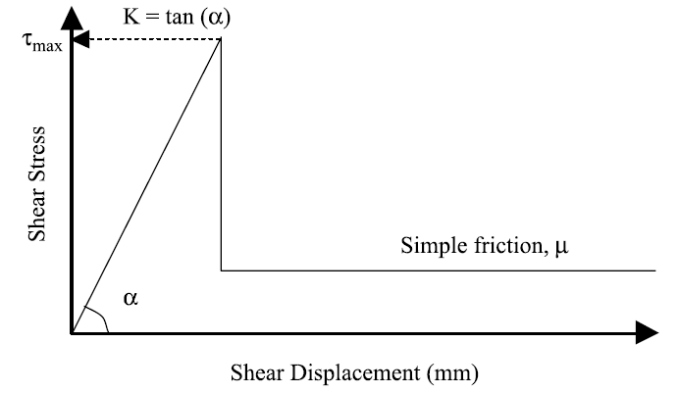

Figure 6. Elastic Stick Model

This law is implemented in any layered elastic computer programs, including JULEA. To reduce numerical complications, JULEA converts EQ. 2 to EQ. 3 by the help of variable *l* given in EQ. 4:

, [3]

[4]

The variable *l* is computed by using user-defined parameter *m*:

[5]

where E2 is modulus layer 2 (below the surface layer).

The spring stiffness is basically the slope of Figure 6, i.e., ratio of and . After computing spring stiffness, the user parameter *m* is calculated by following EQ. 2–5.

**APPENDIX B**

**SEMI-CIRCULAR BEAM TEST RESULTS FOR OHIO**

Figure 7 shows a sample CMOD test result for Surface layer replicate #1.

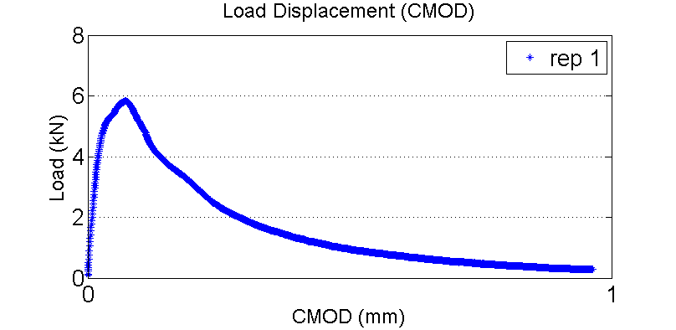

Figure 7. Sample SCB CMOD Curve for Surface Layer, Rep#1

The results are based on the standard CMOD control SCB test and all data are cut in 0.2 kN of the load to calculate the fracture energy. Table 2 shows the summary of the fracture energy results for all lifts based on standard CMOD control SCB test.

Table 2 - SCB Test Results for Ohio Section

|  |  |  |  |  |
| --- | --- | --- | --- | --- |
| **Lift** | **Test Temperature (°C)** | **Average Ligament Length (mm)** | **Average Thickness (mm)** | **Average CMOD Fracture Energy (N/m)** |
| 1 in 4.75 mm Surface (PG 76-22) | -12 | 59.2 | 51.3 | 532.7 |
| 2 in 19 mm INT  (PG 64-28) | -18 | 59.3 | 50.9 | Failed |
| 6 in 37.5 mm ATB  (PG 64-22) | -12 | 59.2 | 51.2 | 256.4  (2 out of 4 failed) |
| 4 in 37.5 mm FRL  (PG 64-22) | -12 | 59.3 | 50.9 | 317.6  (3 out of 4 failed) |

All of the specimens for INT layer and three and two out of four specimens respectively for ATB and FRL layers were failed and fractured during the test. This is because these mixes are stiff in current loading rate of 0.7 mm/min. Inspecting the specimens for ATB and FRL showed that the failure can be due to the large nominal aggregate size (37.5 mm) for these layers. For FRL layer, the test temperature was (-18°C), which is very low compared to other specimens to be tested with the machine at -12°C, and it seems to be very stiff mix. The first recommendation is to decrease loading rate from 0.7 mm/min to a lower rate. The second recommendation is to investigate the results of DCT test for FRL layer and, if a similar trend is obtained in that test, to do a binder extraction to confirm the binder type. Otherwise, SCB test for this layer needs to be rerun.

## **References**

[1] National Cooperative Highway Research Program, “Guide for Mechanistic-Empirical Design of New and Rehabilitated Pavement Structures.” NCHRP, Washington, D.C. (2004)

[2] Romanoschi, Stefan A., and John B. Metcalf. "Errors in pavement layer moduli backcalculation due to improper modeling of the layer interface condition." Proceedings of the 82nd TRB Annual Meeting, Washington, DC. 2003.