Partnership for the Transformation of Traffic Safety Culture
Transportation Pooled Fund (TPF) Program
Objectives:
This program is a cooperative effort of participating state DOTs and other (traditional and non-traditional) organizations with a vested interest in traffic safety. This long-term partnership will support an evolving and integrated project portfolio developed and revised each year by the partners, and complimentary to other related research activities, such as NCHRP 17-69: A Strategic Approach to transforming Traffic Safety Culture to reduce Deaths and Injuries. Together, these projects will accelerate the development and delivery of tools and services to transform the national, state, and community level traffic safety culture. The goal of this transformation is to support the Toward Zero Deaths (TZD) vision with sustainable traffic safety solutions.
Background:
The National Towards Zero Deaths (TZD) Safety Initiative is a cooperative and coordinated effort amongst state highway safety agencies and stakeholders. The transformation of the traffic safety culture is a primary element of the TZD strategy. Only through the growth of a positive safety culture can significant and sustainable reductions in crash fatalities and serious injuries be achieved. Such transformation would not only support traffic safety goals by reducing risky behaviors and increasing protective behaviors, it would also increase public acceptance of other forms of effective traffic safety programs.
As a starting point, the proposed pooled fund program will direct action research to measuring, analyzing, and transforming the cultural factors that influence the most common behavioral risk factors at the national and state level (see Figure 1).
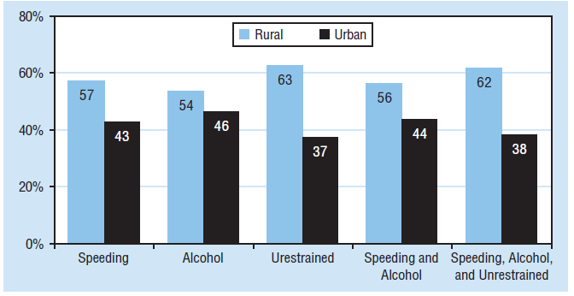
Figure 1. Common behavioral risk factors at national and state level (DOT HS 810 812).
Specific projects related to each risk factor may focus on driver type (e.g., subcultures), contributing factors (e.g., driving experience), and environment context (e.g., rural). These projects will also examine the various origins of cultural influences that may exist from the different levels of society (groups) with which people may identify (see Figure 2).
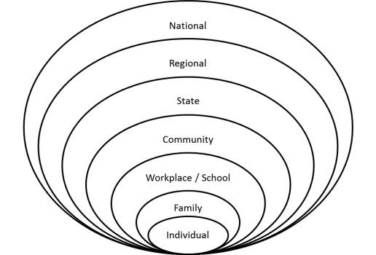
Figure 2. Illustration of multiple levels of cultural influence.
Structure:
In this context, the Montana Department of Transportation is partnering with the Center for Health and Safety Culture (CHSC) within the Western Transportation Institute (WTI) at Montana State University to (1) conduct research to solve specific culture-based traffic safety problems, (2) create training and education materials to enhance workforce understanding and application of traffic safety culture methods, and (3) provide technology transfer of best practices in traffic safety culture methods to all stakeholders. Together, these efforts will support the transformation of traffic safety culture within the families, communities, and organizations of participating states.
This partnership will support an integrated and multiyear program of research in a long-term effort to support the transformation of state and national traffic safety culture. Partners will determine the priority issues in each year. A work plan will then be developed for the selected priority issues. These work plans are expected to have three levels of scope. This funding model is intended to provide a sustainable program of research to support highway safety partners to transform traffic safety culture in order to achieve sustainable traffic safety goals.
First, the partnership may generate ideas for general “services and tools” within the general “action framework” developed by the CHSC to meet the traffic safety goals of most partners. For example, stakeholders participating at the recent National Roadway Safety Culture Summit identified a number of common needs to support the transformation of a positive safety culture for the driving public and traffic safety organizations:
- Develop online courses for workforce development in the understanding and application of traffic safety culture transformation methods.
- Explore, synthesize, and define noteworthy practices both within and outside the transportation industry for developing and sustaining an organizational safety culture.
- Identify strategies, develop transformational leadership training, and develop supporting materials to help leadership promote traffic safety culture.
- Develop standardized survey tools, administration protocols, and analysis methods to access impacts of efforts to transform traffic safety culture.
- Create repository of relevant literature and case studies of best practice relevant to the transformation of traffic safety culture and the formation of safety culture partnerships.
- Create an online forum to which professionals (professional societies and other stakeholder groups) can collaborate to promote safety culture.
Second, this program could conduct research directed to traffic safety problems that have a common cultural component shared by many communities and jurisdictions across the participating partners. For example, Figure 1 includes common behavioral risk factors that are evident both at the national level and identified in many state Strategic Highway Safety Plans (SHSP).
Third, this program can also be used to implement a limited number of demonstration projects of specific traffic safety culture transformation studies within a few selected communities. Examples of possible types of projects are listed in Appendix I. These projects may also be identified from the parallel and complementary NCHRP 17-69 research effort to develop a strategic plan for transforming traffic safety culture. These efforts could then be applied to every state that develops a strategic highway safety plan (SHSP) with an interest in transforming safety culture among the agency and driving population. Depending on the results, these projects can then be modified and expanded for implementation within other partner communities. This could be done either within the current program or as a separate pooled fund project amongst participating partners.
Scope of Work:
The partnership will develop an appropriate method of scoping and managing the scope of work for this pooled fund program. As an example, the following method has been successful in a current program (TPF-5(081)); this is just an example and the process to be followed would be developed by the TPF Technical Advisory Committee (TAC).

- Board of Director (BOD) members solicit and develop problem statements.
- BOD prioritizes problem statements.
- Program administrator prepares Request for Proposals and collects proposals from researchers in partnering states.
- BOD prioritizes proposal topics.
- BOD reviews, discusses, and prioritizes submitted proposals.
- Proposal are scored and ordered based on priorities collected in item 5 and weighted values that are based on state partner commitments that year.
- Annual work plan is prepared by the program administrator who also facilitates contracts between the selected researcher(s) and the Iowa DOT.
- State DOTs form and lead the individual project TACs for projects awarded to a university or entity in their state (other members can request to serve on the TAC).
- Projects are tracked quarterly.
- Draft final reports are reviewed by the home state as well as by the BOD.
- Final reports are posted to the program webpage and sent to national research report repositories.
- Implementation and technical transfer opportunities are discussed by the BOD.

Benefits: The benefits from this pooled fund project include a wide variety of tools and services including completed tools for implementation and deployment, workforce development and training delivery, best practice case studies, and traffic safety culture project development and evaluation. These benefits will be of mutual interest and benefit to pooled fund partners.

Requested Funding:

The proposed funding model is intended to support an evolving partnership to support a long term and integrated program of research. A minimum of 4 contributing partners is desired. The typical commitment amount is $50,000 per state, per year, although a commitment range from $10,000 to $80,000 per year is expected. All participants will have an equal say with regards to project votes. A minimum total of $200,000 per year in commitments is desired.

Appendix I – Individual Project Concepts (examples)

Previous work by the CHSC indicates that bystander engagement (especially in response to strangers) is a powerful predictor of efforts to discourage others from driving while impaired. This study will extend this research to develop media campaigns and supporting knowledge to reduce impaired driving through bystander engagement.
- Can a universal media campaign based on local messaging increase bystander engagement to reduce impaired driving?
- How can local stakeholders support increased bystander engagement?
- How can state agencies support and foster traffic safety improvements at the community level?

Previous work by the CHSC indicates that the culture of the workplace – especially for jobs that include professional driving – can have broad influence on adult driving behavior, even outside the boundaries of the workplace. As such, the safety culture of the workplace can represent an important social influence on the transformation of traffic safety culture across other levels of the social ecology (including the family and community connected to the worker and workplace).

- Which norms are most predictive of increasing bystander engagement in the workplace to increase safe driving behaviors?
- What tools and resources are most important for workplace leaders to implement processes to increase bystander engagement and increase safe driving behaviors?

Traffic crashes are the largest cause of death amongst teenagers. Novice teen drivers have an increased crash risk that can be attributed to decision making affected by the teen culture and social interactions with passengers. As they emerge as new drivers, there is an opportunity to transform their developing traffic safety culture. Indeed, preparations for a positive safety culture could begin earlier as children and be nurtured in family and youth recreation settings.

- What aspects of the teen culture impact traffic safety culture and unsafe driving decisions (e.g., distracted driving) amongst novice teen drivers?
- What phases of the developmental path can be used to instill positive values in children that can prepare them for adopting a positive traffic safety culture as teens?
- What type of program or driver education curriculum can transform the developing traffic safety culture of novice teen drivers?

Focus on family level to gain an understanding of the cultural determinants of seat belt non-compliance and develop interventions based on this understanding to increase usage. Attention within social ecology will focus on rural adults, families, law enforcement, local leaders, and youth.

- Which norms (across the social ecology) are most predictive of improving seat belt usage among rural drivers?
- How are these norms developed, learned, and perpetuated within families?

Conflicts between motorized vehicles and vulnerable road users such as pedestrians and bicyclists are a significant safety issue. Many of these conflicts may reflect different culture between groups in using the road system. This study will examine the culture of each of these user groups in terms of the beliefs, norms and attitudes regarding (a) how to interact with other user groups, and (b) how other user groups are perceived to interact. By examining the separate cultures and the (mis)perceptions each may have of the other groups, it will be possible to better understand and improve interaction scenarios that typically result in conflicts.

CHSC has been a leader in traffic safety culture in terms of co-founding the National Summit for Rural Traffic Safety Culture (http://wtirtsc.coe.montana.edu/index.html), producing a FHWA white paper to discuss the relevance of traffic safety culture to the national highway safety strategy (www.westerntransportationinstitute.org/documents/reports/4W3048_Final_Report.pdf), outlined an action framework to transform traffic safety culture (www.westerntransportationinstitute.org/documents/centers/culture/ACTION_Framework_for_Traffic_Safety_Culture_v5_2012-12-31.pdf), and has presented and published on the paradigm and research supporting the transformation of traffic safety culture (http://mediasite.yorkcast.com/webcast/Viewer/?peid=e7c0cd5aebc040ceba1beda48c6b82321d).
www.westerntransportationinstitute.org/documents/centers/culture/ACTION_Framework_for_Traffic_Safety_Culture_v5_2012-12-31.pdf
http://www.cvent.com/events/roadway-safety-culture-summit/event-summary-39eba6b60c964968ad46ba91a85866d4.aspx

