November 25, 2020

Mr. Todd Jeter
Division Administrator
Federal Highway Administration
John C. Watts Federal Building
330 West Broadway
Frankfort, Kentucky 40601

RE: TPF-5(467) Research Project Tracking System

Dear Mr. Jeter,

The Kentucky Transportation Cabinet is the lead agency for TPF-5(467) “Research Project Tracking System” and agrees to receive, obligate, expend and manage contributions made from participating states.

Participating agencies are requested to submit a copy of this letter with their funding transfer request form for this project to their respective FHWA Division Office for concurrence.

Please contact Jarrod Stanley P.E., Research Coordinator, Kentucky Transportation Cabinet, 200 Mero Street, Frankfort, KY, 40622 or at Jarrod.Stanley@ky.gov, if you have any questions.

Sincerely,
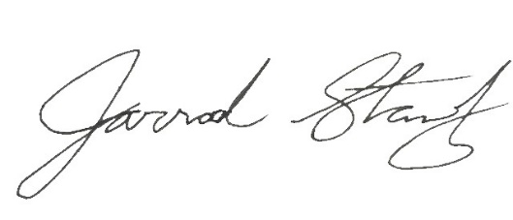 Jarrod Stanley
Research Coordinator

