TRANSPORTATION POOLED FUND PROGRAM
QUARTERLY PROGRESS REPORT

Lead Agency (FHWA or State DOT): ____IOWA DOT _____________________________________

INSTRUCTIONS:
Project Managers and/or research project investigators should complete a quarterly progress report for each calendar quarter during which the projects are active. Please provide a project schedule status of the research activities tied to each task that is defined in the proposal; a percentage completion of each task; a concise discussion (2 or 3 sentences) of the current status, including accomplishments and problems encountered, if any. List all tasks, even if no work was done during this period.

Transportation Pooled Fund Program Project #  TPF-5 (224) |  | Transportation Pooled Fund Program - Report Period:  □Quarter 1 (January 1 – March 31)  □ Quarter 2 (April 1 – June 30)  x Quarter 3 (July 1 – September 30)  □Quarter 4 (October 4 – December 31)
Project Title:
Investigation of Deterioration of Joints in Concrete Pavements
Project Manager: Phone: E-mail:
Peter Taylor 294-9333 ptaylor@iastate.edu

Project Investigator: Phone: E-mail:
Peter Taylor 294-9333 ptaylor@iastate.edu

Lead Agency Project ID:  RF 0323 | Other Project ID (i.e., contract #):  Addendum 361 |  | Project Start Date:  11/01/09
Original Project End Date:  6/30/12 | Current Project End Date:  6/30/12 |  | Number of Extensions:

Project schedule status:
X On schedule □ On revised schedule □ Ahead of schedule □ Behind schedule

Overall Project Statistics:
Total Project Budget | Total Cost to Date for Project | Total Percentage of Work  Completed
165,000 | $48,932 | 50%

Quarterly Project Statistics:
Total Project Expenses  This Quarter | Total Amount of Funds  Expended This Quarter | Percentage of Work Completed  This Quarter
$13,038 |  | 5%

Project Description:

The objective of this project is to identify the failure mechanisms behind early deterioration occurring in the joints of concrete pavements in various northern states, and to develop strategies to prevent the deterioration of new pavements in the future. Tied to this understanding will be the ability to provide effective guidance on what to do about repairing and/or slowing the distress in existing pavements.
Premature deterioration of concrete at the joints in concrete pavements and parking lots has been reported across the northern states. The distress is first observed as shadowing when microcracking near the joints traps water, later exhibiting as significant loss of material. Not all roadways are distressed, but the problem is common enough to cause some local authorities to reconsider the use of concrete in their pavements. Some meetings have been held at which stakeholders have discussed their observations, but to date there is no consensus on what the underlying causes of the distress are, or how to address them. A number of potential causes have been suggested, however it is not clear whether any or all of them is predominant or even applicable.

Progress this Quarter (includes meetings, work plan status, contract status, significant progress, etc.):
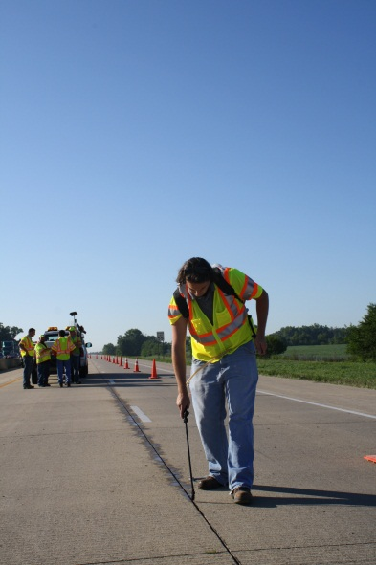
- A paper was developed and submitted for presentation at TRB annual meeting. The paper outlines recent findings that highlight the performance associated with using SME-PS blends.
- A presentation was made and presented via video to the ACPA joint task force outlining the fundamental aspects associated with joint deterioration and the role of salts on fluid transport.
- Guidance document published. Several presentations including PCA and NC
- Abstract submitted to ACPT conference
- Permeability equipment tested on a pavement in Ames
- Visits to look at distress in MN and MI
- Samples sent to MTU for petrography
- Mixtures prepared to assess ITZ effects
- SEM work conducted on previously tested beams for ITZ During this quarter field trials were performed in conjunction with the INDOT on a section of US 231 in Dayton IN. This test section was selected to simulate a pavement that has been in place for several years with some indications of joint deterioration starting. Work included training maintenance personnel on how to remove the existing joint material, to prepare the joint and to place SME-PS as shown in the image to the right. To provide controls for the test section a portion was left untreated and a portion was left with the existing joint material.

Anticipated work next quarter:
- Continue work on all tasks listed above.
- During the coming quarter the team has secured a test site where the longitudinal joint will be treated with SME-PS on a new construction project. This will be located just north of Indianapolis on a section of pavement being placed in October. The local town has received approval from INDOT for this test section. Samples will be prepared for lab tests that accompany the field application. A curb and gutter test is also being examined for a location near Fort Wayne. Interactions between the SME-PS and asphalt, paint and joint materials are currently being tested. Work continues on identifying other sealers as well as developing fundamental scientific understanding and fundamental testing principles.
- Develop tech transfer pieces based on current understanding

Significant Results:
- Findings to date are confirming that lower w/cm decreases risk, and that the ITZ does seem to a significant part of the failure mechanism

Circumstance affecting project or budget (Describe any challenges encountered or anticipated that might affect the completion of the project within the time, scope, and fiscal constraints set forth in the agreement, along with recommended solutions to those problems).
- No technical issues have been encountered. It has been more difficult to obtain field test sections with controls than originally anticipated however this has improved recently.

