Development of an Improved Design Procedure for Unbonded Concrete Overlays

TPF-5(269)

Task 3 Report
Guidelines for Selection of a Suitable Interlayer for an Unbonded Concrete Overlay

Prepared by:

Department of Civil and Environmental Engineering
University of Pittsburgh

September 30, 2019

Introduction

Unbonded concrete overlays have successfully been used in the rehabilitation of concrete pavements for decades and are a viable treatment for concrete pavements with some structural deterioration. Since the overlay is essentially designed as a new concrete pavement, it can restore load-carrying capacity, providing a new riding surface and extending pavement life. The overlay has an effective service life similar to a newly constructed concrete pavement.
Unbonded concrete overlays are typically 4- to 11-in. thick, depending on the anticipated traffic and the condition of the underlying pavement (Harrington and Fick 2014). As the name implies, the overlay is purposely separated from the underlying slab; that is, it is designed independently, considering the existing pavement as a base. Traditionally, the overlay is separated from the underlying pavement through the use of a thin (minimum 1-in.) asphalt layer. Recently nonwoven geotextile fabrics have been successfully used as the separation layer (Rasmussen and Garber 2009). Although the interlayer is a very important element of the unbonded overlay structure, it is often overlooked during the design and construction process.
This document discusses suitability of unbonded overlays as a rehabilitation alternative and provides important considerations related to the interlayer design.

Project Suitability for Unbonded Concrete Overlay
Virtually any type and condition of existing concrete pavement can be overlaid with a well-designed unbonded JPCP overlay, but this treatment is especially attractive for concrete pavements nearing the end of their life yet still providing good, uniform support for the new overlay. Unbonded overlays can be used when existing concrete pavements present any level of material durability issues, such as spalling or pop-outs. However, the evaluations should confirm that future materials related expansion will not result in blow-ups (panel buckling) of the underlying pavement.
The evaluation of the existing pavement is the first step in determining if an unbonded concrete overlay is the correct rehabilitation alternative. The evaluation seeks to identify and characterize the existing pavement in terms of distresses (e.g. cracking and faulting), structural condition (i.e. ability to carry load), functional performance (e.g. roughness and noise), and material-related issues (e.g. D-cracking). Many available resources provide detailed procedures to evaluate a pavement prior to placing an overlay (e.g., Harrington and Fick 2014).
Typically, only severely distressed areas with major loss of structural integrity or areas where voids are present require pre-overlay repair for unbonded concrete overlays. Table 1 provides recommendations for the type of distresses requiring repair and suitable treatments.
Table 1: Pre-overlay Repair Recommendations for Unbonded Concrete Overlays (Harrington and Fick 2014)
Existing Pavement Condition | Possible Repairs to Consider
Faulting (0.25-0.38 in) | None
Faulting (>0.38 in) | Thicker separation layer
Significant tenting | Full-depth repair
Badly shattered slabs | Full-depth repair
Significant pumping | Full-depth spot repair and drainage improvements
Severe joint spalling | Clean
CRCP with punchouts or other severe damage | Full-depth repair

The presence of water at the interface between the overlay and underlying concrete can contribute to many distress mechanisms in UBOL systems. For example, moisture-driven materials-related distresses, such as freeze-thaw damage or alkali-aggregate reactions, often increase in severity and rate of development with increased presence of water. In addition, the build-up of hydraulic pressure under traffic can result in stripping and erosion of asphalt concrete interlayer materials. These pressures can even cause erosion in cement-based materials, as was found on the A5 in 1981 in Germany when pulverized fines and voids were found between the concrete pavement and cementitious base, which were constructed without using an interlayer, resulting in many cracked slabs. To provide drainage at the interface between concrete pavements and cement treated bases, German engineers proposed the use of nonwoven geotextile fabric interlayers (Rasmussen and Garber 2009).
Existing pavement drainage demand and capabilities should be evaluated at the initial stage of the overlay project design to determine the need for any steps required to ensure adequate drainage of the unbonded concrete overlay system (e.g., installation of retrofit edge drains, the need to “daylight” existing subbase materials, etc.). When existing underdrains are present, they should be inspected, cleaned, and repaired (if necessary) prior to construction of the overlay (Harrington and Fick 2014).
Additional aspects of the pavement structure that should be considered in the design of the UBOL drainage system are the pavement geometrics (i.e., profile, cross-slope, and joint layout) and the details of the overlay joint system, which vary widely with state practices. For example, a change in profile and/or cross-slope can be designed in the overlay so that water is more readily shed from the pavement surface with less infiltration of joints. Overlay joints can be designed to resist excessive ingress of water by constructing them with a narrow, single saw cut and/or filling or sealing them appropriately (Harrington and Fick 2014).

Interlayer Considerations
The interlayer (also known as separation layer) is a layer of material that is placed, constructed or allowed to remain between the original pavement and the concrete overlay. The interlayer can serve many purposes, including:
- Reducing (or eliminating) mechanical bond and interlock (due to faulting and other surface irregularities) between the overlay and underlying pavement, thereby reducing restraint stresses in the overlay.
- Isolating the overlay from the underlying pavement so that cracks and other structural defects are less likely to reflect through the overlay.
The interlayer can have a major influence on the performance of unbonded concrete overlays. Insufficient attention is often given to interlayer design and construction. Several unbonded concrete overlays have failed prematurely because of insufficient interlayer thickness, poor interlayer quality or other interlayer-related issues.
The interlayer most commonly consists of HMA (hot-mixed asphalt) or a non-woven geotextile fabric. HMA interlayers consist of a newly placed layer, typically 1 to 2 inches thick. If the existing PCC pavement was previously overlaid with HMA to create a composite pavement, the existing aged HMA layer can serve as the interlayer. Surface defects in the existing HMA can be removed through milling, leaving a minimum of 1 to 2 inches of HMA to serve as the interlayer. In addition to dense-graded HMA, newly laid open-graded HMA layers have been used to improve interlayer drainage characteristics and prevent future stripping of the interlayer.
Non-woven geotextile fabrics have recently become a popular interlayer option for unbonded concrete overlays. The use of fabrics is an adaptation of the German application of using fabrics to separate newly constructed PCC pavements from cement-stabilized bases (Rasmussen and Garber 2009). In the United States, non-woven fabric were first used as an interlayer in UBOLs in 2008.
Each interlayer type offers advantages and disadvantages:
- Dense-graded HMA is relatively resistant to internal breakdown and stripping because water does not flow through the interlayer. However, it is not drainable and trapped water can lead to erosion and stripping at the interfaces. In addition, hydraulic pressure from water trapped at the overlay-interlayer interface can cause joint sealant failure.
- Open-graded HMA allows water to drain, but the material is often more susceptible to degradation due to stripping and raveling. In addition, excessively porous open-graded HMA may have insufficient strength and stability to resist severe deformation or degradation.
- Non-woven geotextile fabric is not erodible and allows drainage through in-plane fabric permittivity. These fabrics are generally highly effective at reducing friction or bond between the overlay and underlying pavement. The use of tie bars or structural concrete fibers is sometimes required to prevent longitudinal joints from opening. There is also the potential for greater curling/warping to occur since the fabric does not bond the overlay to the existing pavement to the same degree as an asphalt interlayer. Therefore, there is less resistance to curling/warping.
Interlayer type and design can affect the rates of development of overlay cracking and faulting, as described below.
Cracking
The interlayer can play a role in the development of both longitudinal and transverse overlay cracks. The development of UBOL longitudinal cracking is discussed below; the development of UBOL transverse cracking follows.
Longitudinal Cracking
Longitudinal cracking in UBOLs typically initiates at transverse joints and may develop in a wheel path or at random locations. These longitudinal cracks appear to be at least partially caused by the breakdown or consolidation of the interlayer (Alland, et al. 2016).
Longitudinal Cracking in Wheel Paths. A common location for the development of longitudinal cracks is the wheel path. Cracking may develop in either the outside and inside wheel path, and can initiate on either the leave or approach side of the transverse joint or crack. Once these cracks initiate, they propagate longitudinally to the adjacent transverse joint, or may turn and propagate toward the adjacent longitudinal joint (lane-shoulder or centerline), appearing as a diagonal crack.

The high stress contributing to the initiation of this crack can be the result of a void or gap in the interlayer beneath the overlay. A void can form beneath the slab in the wheel path in several ways:
- HMA interlayer consolidation may occur in the wheel path at the joint, especially if the interlayer is placed just prior to overlay construction. It is imperative that that sufficient density be achieved during the placement of the interlayer prior to constructing the overlay to reduce the potential for consolidation of the interlayer under traffic.
- HMA interlayers that are susceptible to erosion can be pumped from beneath the joint, thereby resulting in faulting on the approach side of the joint and a void beneath the leave side of the joint.
- HMA with insufficient strength or stability, such as excessively open-graded asphalt or a dense-graded HMA where localized stripping has occurred, can breakdown in the wheel path due to fatigue after repeated loadings.
All of these mechanisms can lead to a loss of support in the wheel path at the transverse joint.

When a wheel load is applied over areas with reduced interlayer support, the overlay panel must bridge across the region with reduced support, resulting in high stress at the bottom of the slab and eventual bottom-up panel cracking. This mechanism is illustrated in Figure 1. Bonded concrete overlays of asphalt (BCOA) with 6 ft x 6 ft panels experience a similar distress mechanism (Li and Vandenbossche 2013).

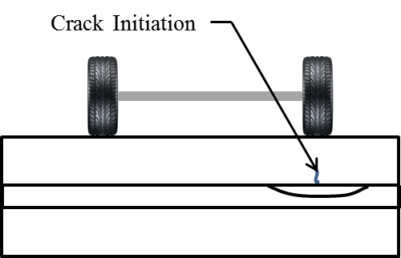
Figure 1: Illustration of condition and mechanism for UBOL longitudinal wheel path cracking.
Longitudinal cracking was the primary distress mechanism observed in the UBOLs included in the LTPP database and the overlays examined in Michigan. It was observed in 11 of the 13 JPCP LTPP sections, and in all of the Michigan sections investigated. The undoweled UBOL sections in the LTPP database experienced significant transverse joint faulting and developed more longitudinal cracks in the wheel path than did the doweled sections (where faulting did not develop). However, it is worth noting that the doweled sections were generally thicker than the undoweled sections, which would provide additional resistance to cracking.

Figure 2 shows some examples of longitudinal cracking in UBOL wheel paths.

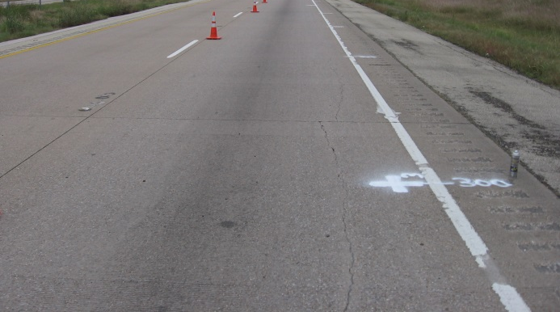
a. | b.
c. | d.
Figure 2. Example photos of longitudinal wheel path and diagonal cracking in UBOLs at: a) inside wheel path of LTPP Section 06-9049, CA (Photo from Infopave.com); b) outside wheel path of LTPP Section 48-9167, TX (Photo from Infopave.com); c) diagonal crack propagating from wheel path to adjacent longitudinal joint in LTPP Section 06-9049, CA (Photo from Infopave.com); and d) inside wheel path of I-96 near Walker, Michigan (Photo Courtesy of Andrew Bennett, Michigan Department of Transportation).

There are several ways to mitigate the mechanisms of longitudinal cracking in UBOLs:
- Increase the thickness of the concrete overlay to decrease the contact stress on the interlayer, thereby decreasing the risk of degradation and/or consolidation.
- Reduce differential deflections and minimize potential for pumping by using load transfer devices.
- Use an interlayer system that is not prone to consolidation, stripping or breakdown due to fatigue.

Random Longitudinal Cracking In traditional JPCPs, longitudinal cracking can develop as a result of loss of support beneath the slab due to erosion of the underlying layer along the roadway. It is often the result of consolidation or transport of base layer materials due to poor drainage. Similar distress is found in UBOLs when a portion of the interlayer becomes eroded. These cracks usually occur on the shoulder side of the pavement, not necessarily occurring in the wheel path. An illustration of this mechanism is presented in Figure 3.

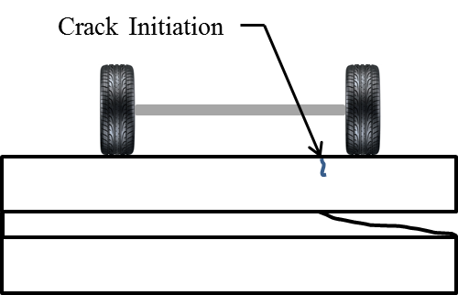

Figure 3: Illustration of condition and mechanism for UBOL longitudinal cracking due to loss of interlayer support along pavement edge.

A survey of Michigan UBOLs found that these cracks often occurred in clusters when proper drainage was not provided. Figure 4 shows a random longitudinal crack on I-75 near West Branch, Michigan. The Michigan DOT has identified proper drainage as being essential for good UBOL performance (Alland, et al 2016). Without a means of escaping, water can become trapped along the interlayer.
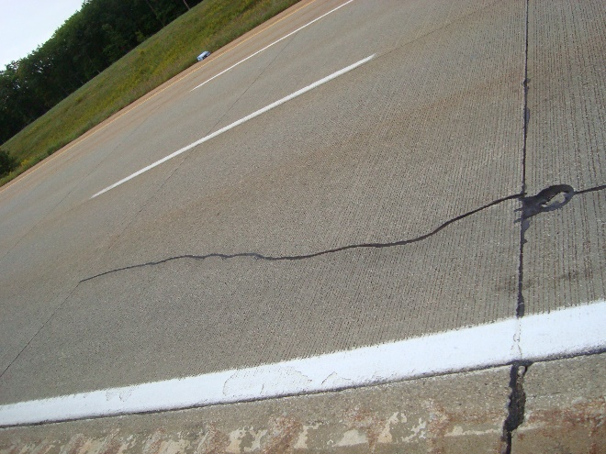
Figure 4: Random longitudinal crack on I-75 near West Branch, Michigan.
Careful attention to pavement drainage details is important for preventing random longitudinal cracking. Any water that infiltrates the pavement joints must have a clear drainage path to exit the pavement structure. Proper maintenance of the drains and outlets is extremely important for these structures as well. The backup of water from a clogged drain can quickly strip and erode HMA interlayers. Drainable interlayers (such as open-graded asphalt or non-woven geotextile fabric) can only improve drainage characteristics if there is a suitable outlet for moving the water away from the pavement structure.
Transverse/Diagonal Cracking
Erosion-related transverse cracking. Transverse cracks in UBOLs caused by interlayer erosion typically form within 1.5 to 5 ft from the transverse joint, and most likely result from interlayer erosion due to the entry of water at the transverse joints. Water entering the transverse joints due to lack of sealant or damaged sealant often drains slowly from the pavement structure, even when an open-graded mixture is used. During periods of upward curling of the overlay, water may even pool in the gap between the interlayer and the existing slab. With the application of heavy axle loads, this water can cause an asphalt interlayer to strip and ravel, leading to a loss of support.
Longitudinal cracks often form between the transverse crack and the adjacent joint, producing a distress that appears similar a punchout in CRCP pavements. If water only enters on a portion of the lane, a corner break can develop. Images of this type of distress are shown in Figure 5.

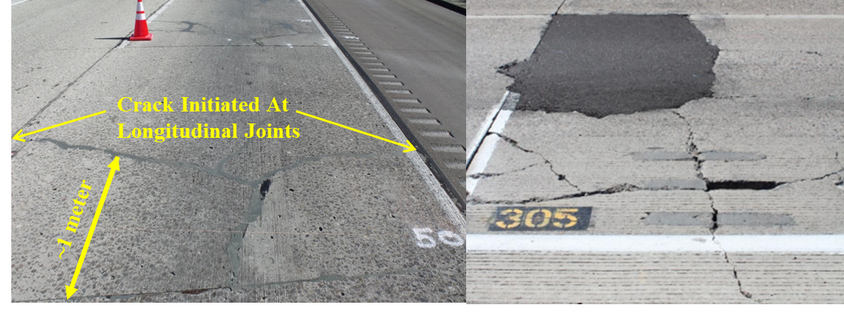
a. | b.
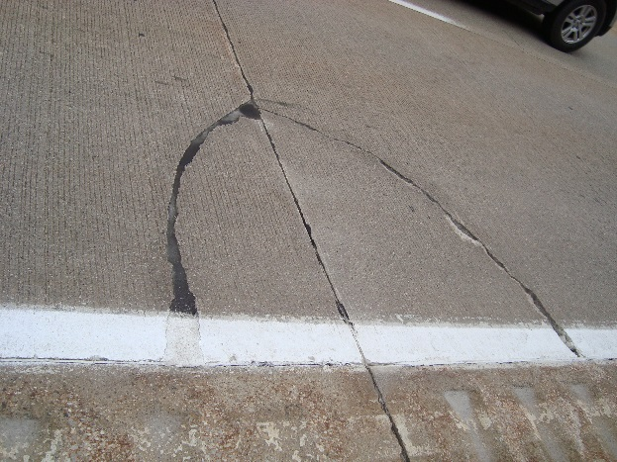
c.
Figure 5: Transverse cracking due to erosion at: a) LTPP Section 06-9048, California [www.datapave.com]; b) MnROAD Cell 305; and c) a corner break on a UBOL in Michigan.
To prevent cracks from forming on the leave side of the joint, it appears to be important to keep joints properly sealed. Using an interlayer which is less susceptible to erosion, such as a more stripping-resistant HMA mixture or a non-woven geotextile fabric, will also help in preventing the development of this distress.
Transverse Reflective Cracking Based on a review of the performance of in-service overlays and an extensive laboratory study, the reflection of joints and cracks up into the overlay (reflective cracking) can be prevented using the following approach:
- The original (underlying) pavement must be fully supported. Slab stabilization and/or panel replacements should be performed prior to overlay construction if voids are present below the existing pavement.
- The interlayer must allow the overlay and underlying pavement to move independently of each other. Faulting and other surface irregularities can cause interlocking between the overlay and the distressed pavement.
- The use of a sufficiently thick interlayer (typically a minimum of about 1 inch of HMA or an appropriate geotextile) and leveling or filling of depressions in distressed regions prior to overlay placement will facilitate free, independent movements between the overlay and underlying pavement.
Faulting
Asphalt interlayers can break down through erosion caused by pumping. Pumping occurs as a result of poor drainage and poor load transfer across the joint. In this scenario, the interlayer is broken down, and fine materials are pumped from beneath the leave side of the transverse joint under the overlay to the approach side and/or are ejected out through the joints. This results in the development of faulting and the formation of a void beneath the overlay (on the leave side of the joint). Asphalt interlayers that are susceptible to stripping are more vulnerable to the development of a void due to erosion.

Optimizing Interlayer Performance

The following should be considered to optimize the performance of the interlayer:

- Use erosion resistant materials.
The same characteristics that make conventional paving asphalt resistant to stripping and erosion are applicable to asphalt interlayers as well. Therefore, the same principles used in making asphalt more resistant to stripping should be applied to the asphalt mixture used as the interlayer (Roberts, et al. 1996; Lu and Harvey 2005; Tran, et al. 2016). The following additional factors should also be considered when selecting an asphalt interlayer mixture design:

- Permeability. A dense-graded asphalt interlayer can result in additional pressure buildup as the water beneath the overlay does not have sufficient voids in the interlayer system through which it can escape and thereby dissipate energy. An overly open-graded asphalt interlayer can also be more susceptible to erosion since these types of interlayers are more susceptible to stripping.
- Strength. The interlayer matrix can break down in the wheel path adjacent to the transverse joint. Extremely open-graded asphalt interlayers are vulnerable to this due to the lower strength/stiffness associated with these mixtures.

Due to the limitations of mixtures with high air void contents, many DOTs specify asphalt mixtures with air void contents of 2 - 4 percent, with a maximum void content of 8 percent (VDOT 2011). The Pennsylvania DOT recommends 3 - 5 percent air voids, and the Arizona DOT recommends 3 - 6 percent, with anything exceeding 8 percent calling for removal (PennDOT 2016, AZMAG 2018). In general, every 1 percent of in-place air voids in excess of 8 percent generally results in a 10 percent or greater reduction in asphalt pavement life (Cornelison 2013, Linden et al. 1989). It should be noted that the performance characteristics of these mixtures might be different when the HMA is serving as an interlayer but it can still serve to provide guidance in what mixtures will optimize the performance of the interlayer.

The Michigan DOT developed the asphalt interlayer aggregate gradation shown in Table 2 to produce asphalt interlayer materials that balance permeability with strength/stability and resistance to erosion. This specification requires an effective binder content of 5 percent by volume with 3 percent air void content and the aggregate gradation specified in Table 2.

Table 2: Aggregate gradation for the Michigan DOT asphalt interlayer mix.
Sieve Size | Percent Passing
½ in | 100
3/8 in | 85-100
No. 4 | 22-38
No. 8 | 19-32
No. 16 | 15-24
No. 30 | 11-18
No. 50 | 8-14
No 100 | 5-10
No. 200 | 4-7

- Ensure density of asphalt interlayer is achieved.
It is easy to become complacent when compacting the interlayer knowing that a PCC overlay will be constructed above it. It is imperative that the target density is achieved when constructing the asphalt interlayer to avoid consolidation under traffic loadings. The resulting void at the intersection of the wheel path and transverse joint will often result in the development of a longitudinal crack in the wheel path.

- Keep moisture out by keeping joints sealed/filled and providing a drainage path for water.
The potential for erosion of the interlayer can be reduced by preventing water from entering the system and providing a drainage path and outlet for water that does contact or enter the interlayer, as shown in Figure 6. In Figure 6a, the interlayer is not connected to a pathway for the water to exist from beneath the pavement. Figure 6b shows that by connecting the interlayer into a drainage system, the water is able to escape from beneath the pavement without developing hydraulic pressures that contribute to interlayer erosion and loss of overlay support.

Erosion of
Interlayer

a. No drainage path is provided to remove water from the system, resulting in erosion.

b. Interlayer is connected to a drainage system to prevent erosion.
Figure 6: Illustrations of interlayer drainage and trapped water on potential for erosion.

- Provide adequate interlayer thickness.
An asphalt interlayer thickness of 1 inch is typically sufficiently thick to prevent reflective cracking. Guidance on selecting an appropriate thickness of a non-woven fabric can be found in Harrington and Fick (2014).

References
AASHTO (2004). Guide for Mechanistic-Empirical Design of New and Rehabilitated Pavement Structures. American Association of State Highway and Transportation Officials. Washington, DC.
Alland, K.D., J.M. Vandenbossche, S. Sachs, J. W. DeSantis, L. Khazanovich, T. Burnham, “Failure Modes in Unbonded Concrete Overlays on Asphalt,” 11th International Conference for Concrete Pavements Conference Proceedings. San Antonio, TX, August 2016.
Arizona Maricopa Association of Governments (AZMAG). 2018. Uniform Standard Specifications and Details for Public Works Construction – Arizona. Cornelison, Don. 2013. “Road Building Fundamentals: Volumetric Properties of Asphalt Mixes.” Arizona Pavements and Materials Conference. Nov. 14, 2013.
Asbahan, R. and J.M. Vandenbossche (2011). “Effects of Temperature and Moisture Gradients on Slab Deformation for Jointed Plain Concrete Pavements.” Journal of Transportation Engineering, 137(8), 563-570. American Society of Civil Engineers. New York, New York.
ERES Consultants (1999). Evaluation of Unbonded Portland Cement Concrete Overlays: NCHRP Report No. 415. Transportation Research Board. Washington, D.C.
Federal, H.A. (2013). “Long-Term Pavement Performance (LTPP) Database.” <Infopave.org>.
Harrington, D. S., D. Degraaf, R. Riley, R. O. Rasmussen, J. Grove and J. Mack (2007). Guide to Concrete Overlay Solutions. National Concrete Pavement Technology Center at Iowa State University. Ames, IA.
Harrington, D. and G. Fick (2014). Guide to Concrete Overlays: Sustainable Solutions for Resurfacing and Rehabilitating Existing Pavements (3rd edition). National Concrete Pavement Technology Center at Iowa State University. Ames, IA

Li. Z. and J.M. Vandenbossche (2013). “Redefining the Failure Mode for Thin and Ultra-thin Whitetopping with a 1.8- x 1.8-m (6- x 6ft) Joint Spacing.” Transportation Research Record: Journal of the Transportation Research Board, 2368 (July 2012), pp 133-144. Transportation Research Board. Washington, D.C.
Linden, R.N., J.P. Mahoney and N.C. Jackson (1989). The Effect of Compaction on Asphalt Concrete Performance. 1989 Annual Meeting of the Transportation Research Board. Washington, DC.

PennDOT (2016). Specifications. Publication 408/2016. Pennsylvania Department of Transportation. Harrisburg, PA.
Rasmussen, R.O. and S. I. Garber (2009). Nonwoven Geotextile Interlayers for Separating Cementitious Pavement Layers: German Practice and US Field Trials. Federal Highway Administration. McLean, VA.
Roberts, F.L., P.S. Kandhal, E.R. Brown, D.Y. Lee and T.W. Kennedy, T.W. (1996). Hot Mix Asphalt Materials, Mixture Design, and Construction. National Asphalt Paving Association Education Foundation. Lanham, MD.
Sachs, S., J.M. Vandenbossche, K.D. Alland, J.W. DeSantis and L. Khazanovich (2016). “Effect of Different Interlayer Systems on Reflective Cracking in Unbonded Concrete Overlays of Existing Concrete Pavements (UBOLs)." Transportation Research Record: Journal of the Transportation Research Board 2591 Vol. 3. Transportation Research Board, National Research Council. Washington, D.C., pp 33-41.
Taylor, P.C., S.H. Kosmatka, G.F. Voigt, M. E. Ayers, A. Davis, G. J. Fick, J. Gajda, J. Grove, D. Harrington and B. Kerkhoff (2007). Integrated Materials and Construction Practices for Concrete Pavement. Federal Highway Administration. McLean, VA
Tran, N., L. Ga, P. Turner and J. Shambley (2016). Enhanced Compaction to Improve Durability and Extend Pavement Service Life: A Literature Review. NCAT Report 16-02R. Federal Highway Administration. Washington, D.C.
Vandenbossche, J.M. (2003). Interpreting Falling Weight Deflectometer Results for Curled and Warped Portland Cement Concrete Pavements. Ph.D. Dissertation. University of Minnesota. Minneapolis, MN.
VDOT (2011). Testing of Asphalt Concrete Mixtures: Chapter 7. Asphalt Testing. Virginia Department of Transportation. Charlottesville, VA.
Watson, M. and T. Burnham (2010). Construction Report for MnROAD Thin Unbonded Concrete overlay Test Cell 5 (Sub-Cells 105-405). Minnesota Department of Transportation. St. Paul, MN.

