Uncrewed Aircraft Systems (UAS) Standardization – FHWA Pooled Funds Project Proposition

Problem
Uncrewed Aircraft Systems (UAS) have been widely accepted by State Departments of Transportation (DOTs) over the last decade. Although UAS have been integrated into workflows and are being leveraged as a supplemental tool across a large variety of use cases there is yet to be defined standards developed. State DOTs need UAS data collection standards, specifically for leading use cases such as, surveying, construction inspection and bridge inspections.

Solution
Through the Federal Highway Administration (FHWA) Transportation Pooled Fund Program State DOTs can pool their funds together to support a project to create UAS standards.

Commitment Needed
In order to fund this project enough States must commit annual funding towards the project for 5 years. The project cannot be initiated until enough States have committed funds that cover the project costs. The minimum commitment needed is $25,000 annually from 15 States for the duration of the 5-year project. This can be adjusted to higher funding commitments from fewer States or lower funding commitments with the participation of more States.

Project Scope
This project will create a comprehensive UAS Standards and Specifications guidebook that provides State DOTs with the needed UAS data collection standards and best practices. A standalone standards guidebook will be developed and validated for the following use cases:
- Survey
- Construction
- Bridge Inspections
- As-builts
- Incident Management
- Earth Movement
The pooled-fund project will span across 5 years but will be structured in a way that a set of deliverables is provided to State DOTs annually. Roughly one use case per year will be accomplished with some overlap between efforts. The set of deliverables provided with each use case will provide utility and benefit to operators at State DOTs and elsewhere throughout the industry. In the final year of the project the first three use cases and their associated standards will be updated as needed based on technology advancements and other factors. The following timeline graphic provides an overview of the project phases that will be used to meet the scope of the project.
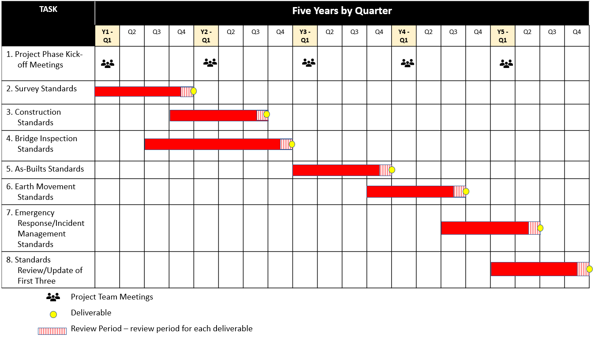

Research Approach
Below is an established methodology or research approach that can be leveraged to meet the project goals in establishing UAS standards across the identified use cases. The last section in the research approach provides what final deliverables could be provided for each project phase.

Literature Review
The first step in the research approach will be to conduct a thorough literature review to provide a comprehensive understanding of existing knowledge and any existing standards or standard development efforts. The process begins with clearly defined research objectives and questions, which will guide the search for relevant industry and academic sources. Utilizing reputable databases, libraries, online journals, and standards organizations resources is crucial in accessing a diverse range of information relevant to UAS standards development. Strategically using keywords and specific search terms will assist to refine and narrow the search, ensuring relevance to the research topic.
Once potential sources are identified, it is imperative to assess their credibility, relevance, and methodological rigor. Evaluating the quality of research design, sample size, data analysis methods, and the publication venue helps establish the reliability of the information. In the context of this project, if standards or standardized processes are identified across the UAS use cases then understanding the quality of the development, the repeatability, and overall integrity will also be done. A well-organized synthesis of the literature findings involves categorizing and summarizing key findings, concepts, and gaps in the existing knowledge. By approaching the literature review with a systematic and rigorous methodology, researchers can ensure that their work is grounded in a comprehensive understanding of the current state of knowledge in their field.

Focus Groups
The next critical piece beyond understanding the literature is engaging with industry to understand the real-world pain points, problems, and needs. The research team will work directly with industry informally and formally throughout the project, one of the formal channels will be through focus groups. Participants for the focus group will be primarily selected from the project participating State DOTs. Other non-project State DOT participants and representatives from various private industry organizations from UAS contracting services to service providers to data processing software developers will also be considered for the focus groups. All participants will possess relevant skills and experience directly related to the use case being studied and for which standards are to be developed.
Adequate diverse representation from various potential stakeholder groups will be a founding goal for the establishment of robust focus groups. When using focus groups as a research methodology, it is best practice to invite more participants than the established goal because participants may need to withdraw for various reasons. The research team will invite more people per stakeholder group and will contact potential participants individually to explain the scope and goals of the focus group and larger project to secure commitments.
The focus group once created will likely meet a few times throughout the project phase relevant to a specific use case and be used in a variety of ways. Initially the group will assist in identifying the gaps regarding standards. The group will also be used to assist with identifying the needs for standards and what meets those needs. Examples of potential questions to fully understand using the focus groups include, how are State DOTs using the data? Where is the breakdown on data? How will standards assist in meeting the data accuracy and quality needs? Members of the focus group may also test various standards in the field across different operations or simulated operations to develop and validate the standards. These meetings with the focus group can be done in-person or virtually. There are advantages and disadvantages to both options which will be fully considered through the lens of the project and associated budget.
A key to the success of the focus group meetings will be the development of the semi-structured questions to be used in the discussions of the research topics. Semi-structured questions are written in an open-ended format and designed to encourage participants to freely share their thoughts. Semi-structured questions allow for focused questioning, while still giving the focus group moderator the flexibility to dive deeper on relevant topics that emerge during the discussion (Adeoye‐Olatunde and Olenik, 2021). The semi-structured method is ideal for exploring participants’ thoughts on complex open-ended topics and yields a rich data set.
The research team will design the focus group questions in an unbiased way, avoiding the use of leading questions. The neutral questions will be developed to target the identified research gaps and extract data from the focus group participants to address these gaps. Focus group best practice is to use engagement, exploration, and exit questions to maximize the participation throughout the course of the focus group meeting (Then et al., 2014). Engagement questions are used to establish the baseline topic and warm up the participants. Exploration questions are designed to be the core questions for the focus groups and areas expected to take the most time. Exit questions are used to check if anything was missed and to provide an opportunity for participants to share last-minute thoughts. The research team will design the flow of questions for each research topic to follow this sequence.
The focus group meetings will be recorded to help with notetaking and to provide recorded transcripts for analysis. The focus group moderators will take notes throughout the course of the meetings, but the recordings will serve as the primary data capture tool for later in-depth analysis.

Gap Analysis
After completing a literature review and conducting focus groups within the industry, the next step in the research approach is to undertake a thorough gap analysis to identify areas where existing knowledge falls short or where industry practices diverge from a lack of industry standards. The gap analysis involves scrutinizing the literature and focus group findings to pinpoint specific gaps or shortcomings in understanding or application. This process allows for a nuanced understanding of the existing knowledge landscape and current operations and provides a foundation for proposing targeted and meaningful standards for development. Once gaps are identified, the research team will prioritize them based on their significance and relevance to the research goals. These prioritized gaps can then guide the research activities that will develop the needed standards through subsequent phases of the study.

Test Flights
This phase of the research approach will likely overlap with the following to phases: Standards Development and Standards Validation. Actual flight tests will be done by the research team and by participating State DOTs to assist with the development and validation of use case standards. These flight tests can and should be done on real-world projects as well as on simulated projects. These tests will be designed in a way to start addressing the gaps from the previous research phases. The tests will help find where the acceptable standard is for the given use case.

Standards Development
This phase of the project will use the findings from the previous tasks and in conjunction with flight testing determine the various components needed to provide acceptable data. Flight testing will experiment with what is needed for various use cases, for example, Ground Control Points, how many are needed and what are the ideal placements? Understanding what is acceptable and creating standards that ensure acceptable data collection is achieved each time. Defining the minimum quality required and the best achievable quality. Determining at what point is the data accurate enough to be equivalent to or better than traditional inspection methods. Depending on the use case tests will be done for photogrammetry and LiDAR, what standards are needed for different sensors or different data analysis tools will be assessed. Understanding how the standards or procedures to achieve the quality data relate back to workflows and project lifecycles will also be considered.

Standards Validation

This stage involves returning the initial standards draft to the Focus Group to gather essential feedback and validate the proposed standards. Our approach combines formal written feedback with in-depth oral discussions during meetings, ensuring a comprehensive validation process.

Final Deliverables
The final deliverables that will be provided at the end of each project phase for each use case will be:
- Technical Memorandum – Summary of Research Activities
A technical memorandum summarizing research activities will serve as a comprehensive document encapsulating the key aspects of that phase of the research project. It will include a concise overview of the research objectives, methodology employed, and the primary findings obtained. The document will summarize the specific techniques, tools, or experimental approaches utilized during the research, providing technical details and insights for the benefit of both technical and non-technical stakeholders. The memorandum may also discuss challenges encountered during the research process and how they were addressed, fostering transparency. Ultimately, this summary acts as a valuable tool for disseminating research outcomes and next steps to all project stakeholders, especially funding members of the project.
- UAS Standards and Specifications Guidebook
The main deliverable will be the set of standalone standards that will have been developed for the use case in each project phase.
- Field Reference Guide
In addition to the full set of standards a quick field reference guide will be provided that will provide utility out in the field on project. It will provide a quick glance resource to assist UAS crews collect data according to the set standards. The guide will be developed in a way to be used concurrently with workflows and operational checklists to assist in ensuring the data deliverables meet or exceed the acceptable standard.

