TRANSPORTATION POOLED FUND PROGRAM
QUARTERLY PROGRESS REPORT

Lead Agency: Utah Department of Transportation

INSTRUCTIONS:
Project Managers and/or research project investigators should complete a quarterly progress report for each calendar quarter during which the projects are active. Please provide a project schedule status of the research activities tied to each task that is defined in the proposal; a percentage completion of each task; a concise discussion (2 or 3 sentences) of the current status, including accomplishments and problems encountered, if any. List all tasks, even if no work was done during this period.

Transportation Pooled Fund Program Project #  TPF-5(272) |  | Transportation Pooled Fund Program - Report Period:  X Quarter 1 (January 1 – March 31, 2015)  _ Quarter 2 (April 1 – June 30, 2015)  _ Quarter 3 (July 1 – September 30, 2015)  _ Quarter 4 (October 1 – December 31, 2015)
Project Title:
Evaluation of Lateral Pile Resistance Near MSE Walls at a Dedicated Wall Site

Name of Project Manager(s):  Jason Richins | Phone Number:  801-360-4985 |  | E-Mail  jtrichins@utah.gov
Lead Agency Project ID:  Finet 42053, ePM PIN 11075  UDOT PIC No. UT11.404 | Other Project ID (i.e., contract #):  UDOT Contract No. 148434 |  | Project Start Date:  December 2, 2013
Original Project End Date:  September 30, 2016 | Current Project End Date:  September 30, 2016 |  | Number of Extensions:

Project schedule status:

X On schedule _ On revised schedule _ Ahead of schedule _ Behind schedule

Overall Project Statistics:
Total Project Budget | Total Cost to Date for Project | Percentage of Work  Completed to Date
$204,500.00 (current contract)  $292,000.00 (total committed) | $48,800.00 | 24%

Quarterly Project Statistics:
Total Project Expenses  and Percentage This Quarter | Total Amount of Funds  Expended This Quarter | Total Percentage of  Time Used to Date
$0, 0% | $0 | 49%

Project Description:

Pile foundations for bridges with integral abutments must resist lateral loads produced by earthquakes and thermal expansion or contraction. Increasingly, right-of-way constraints are also leading to vertical mechanically stabilized earth (MSE) walls at abutment faces. Currently, there is relatively little guidance for engineers in assessing the lateral resistance of piles located close to these MSE walls. As a result, some designers assume that the soil provides no resistance whatsoever which leads to larger pile diameters and increased foundation cost. Other designers locate the abutment piles six to eight pile diameters behind a wall face to minimize the interaction and use conventional design approaches. However, this approach increases the bridge span and the cost of the bridge structure. Still other designers position the pile close to the wall face and reduce the lateral pile resistance using engineering judgment. However, the appropriate reduction factor to use as a function of pile spacing is not well defined.

Recent testing conducted by Rollins et al (2013) and Pierson et al (2008) indicate that lateral resistance decreases substantially as pile spacing from the wall decreases; however, reinforcing can reduce this effect. Rollins et al also found that p-multipliers defined as a function normalized spacing and reinforcement length seemed to provide reasonable agreement with measured pile response. Furthermore, Rollins et al found that the tensile force in the reinforcements owing to the lateral load on the pile could be estimated for design purposes using a correlation with pile load, spacing behind the wall, and distance transverse from the pile load.

Although the tests to date provide a framework for understanding the mechanisms involved and likely design approaches, the available data is too limited to make firm design recommendations. To improve our understanding of pile-MSE wall interaction, this project will involve construction of a test embankment approximately 80 ft long and 20 ft tall where it will be possible to conduct a number of lateral pile load tests on different pile types behind an MSE wall with both strip and grid type steel reinforcements. Additional contributions to the project will consist of in-kind donations from various contractors and material suppliers.

Objectives for this study include:

1. Measure reduced lateral pile resistance vs. displacement curves for circular, square, and H piles behind an MSE wall with steel strips and grid reinforcement.
2. Measure the increase and distribution of tensile force in the MSE reinforcement induced by lateral pile loading.
3. Measure effect of special pile head geometry (e.g. corrugated pipe sleeves, double plastic sheeting) on lateral pile resistance.
4. Develop design rules (e.g. p-multipliers) to account for reduced pile resistance as a function of spacing and reinforcement.
5. Develop equation to predict reinforcement force induced by pile loading.
6. Develop design equations to account for pile shape and pile head geometry.

Tasks for this study include:

1. Instrument test piles and reinforcements.
2. Drive test piles and construct MSE wall to height of 15 ft.
3. Perform lateral load tests on piles with 15 ft high MSE wall.
4. Reduce data and develop report on the testing for the 15 ft high wall.
5. Determine p-multipliers and reinforcement force equations for 15 ft high wall test results.
6. Perform lateral load tests on piles with 20 ft high MSE wall.
7. Reduce data and develop report on the testing for the 20 ft high wall. (Not funded in original contract.)
8. Determine p-multipliers and reinforcement force equations for 20 ft high wall test results. (Not funded in original contract.)
9. Develop design recommendations to account for pile sleeves and plastic sheeting effects. (Not funded in original contract.)
10. Prepare final report with recommendations based on all tests. (Not funded in original contract.)
11. Hold Technical Advisory Committee (TAC) meetings.
12. Present results of the study at AASHTO, TRB, and ASCE meetings. (Not funded in original contract.)

Dr. Kyle Rollins of BYU is the Principal Investigator for this research project. The technical advisory committee (TAC) includes representatives from UT, FL, IA, KS, MA, MN, MT, NY, OR, TX, and WI DOTs.

Progress this Quarter (includes meetings, work plan status, contract status, significant progress, etc.):

Task 1 – 100% complete.
Task 2 – 100% complete.
Task 3 – Completed testing for the piles at the 15-ft wall height.
Task 4 – Work has started.
Task 5 – Work has started.
Task 6 – Completed testing for the piles at the 20-ft wall height.
Task 7 – Funding is available. Working on Amendment to the contract.
Task 8 – Funding is available. Working on Amendment to the contract.
Task 9 – Funding is available. Working on Amendment to the contract.
Task 10 – Funding is available. Working on Amendment to the contract.
Task 11 – 10% complete. Follow-up teleconferences were held with suppliers of the MSE wall panels and reinforcements, UDOT staff, and Dr. Rollins to discuss options for including surcharge at the top of the wall, behind the piles.
Task 12 – Funding is available. Working on Amendment to the contract.
Contract – Additional funding transfers from state partners were received, including our new partner Massachusetts DOT. Working on amendment to the contract.

Anticipated work next quarter:

Task 1 – Completed.
Task 2 – Completed.
Task 3 – Completed.
Task 4 – Data reduction will continue for the 15-ft pile testing.
Task 5 – p-multipliers will be back-calculated based on the results of the test.
Task 6 – Completed.
Task 7 – Data reduction will continue for the 20-ft pile testing.
Task 8 – p-multipliers will be back-calculated based on the results of the test.
Task 9 – Work will begin.
Task 10 – Work will begin.
Task 11 – Plan a date for a TAC meeting to review test results.
Task 12 – None planned.
Contract – The contract will be amended to include funding recently transferred from partner states, for Tasks 7 through 10 and 12, and to address MSE wall design and construction changes.

Significant Results:

A review of the tensile forces induced in the reinforcements by the lateral pile loading indicated that several variables influenced the measured force and that no simple correlation could be developed. Therefore a multi-variable regression analysis was performed under the direction of Dr. Dennis Eggett of the BYU statistics department. Data for this investigation included pipe piles lateral load tests in this study with ribbed strip reinforcements at the 15-ft and 20-ft wall levels along with previous test data at a bridge site collected by Nelson (2013). Using an F-test, the following variables were evaluated to determine if they were statistically significant: the displacement of the wall at the location where the reinforcement attaches to the wall, the transverse distance of the reinforcement to the center of the pile, the depth of the reinforcement below the ground surface, whether the reinforcement was attached near the center or edge of a panel, the pile head load, the pile head displacement, whether the pile being loaded was near a joint or the center of a panel, the normalized pile spacing (distance of the pile behind the wall), the size of the panel the reinforcement is connected to, the type of panel the reinforcement is connected to, the applied surcharge, and the L/H ratio of the wall at the time of testing. Of these parameters, the transverse distance of the reinforcement to the center of the pile being loaded, the pile head load, the normalized pile spacing, and the depth of reinforcement were all statistically significant. Additionally, a two way interaction analysis of each of the variables was performed and multiple interactions of these variables were found to be statistically significant.

Because the tensile force data was not normally distributed, a base 10 log transformation of the data was applied before running the model. The results of the multiple regression analysis are summarized in Table 1. It is important to note that these values are based on the log transformation of the data. A plot of the predicted values versus measured values is provided in Figure 1. The R² value of the model is 0.70, indicating that about 70% of the variation in the reinforcement tensile force is accounted for by the equation. A plot of the residuals for each of the four main variables used in the equation is provided in Figure 2. The residuals for each of the variables seem to be scattered evenly around 0 and do not indicate any serious violation of the model assumptions.

Table 1: Multiple regression model results
Parameter | Coefficient Estimate | Standard Error | t Value | Pr>|t|
Intercept | 0.081718036 | 0.049777 | 1.64 | 0.1011
Transverse spacing, T | -0.002550851 | 0.000878 | -2.91 | 0.0038
Depth, Z | 0.009498420 | 0.001069 | 8.89 | <.0001
Pile load, P | 0.023386595 | 0.001609 | 14.54 | <.0001
Normalized spacing, S/D | -0.060416415 | 0.025866 | -2.34 | 0.0198
T*Z | 0.000047533 | 0.000014 | 3.44 | 0.0006
T*P | -0.000185330 | 0.000025 | -7.47 | <.0001
Z² | -0.000068720 | 0.000007 | -9.88 | <.0001
Z*D | -0.000785430 | 0.000222 | -3.54 | 0.0004
P² | -0.000117049 | 0.000025 | -4.67 | <.0001
D² | 0.006264353 | 0.002742 | 2.28 | 0.0226

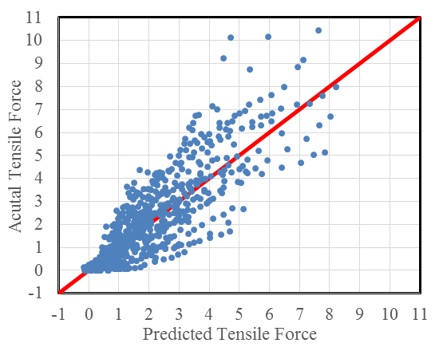
Figure 1: Predicted versus measured tensile force in the reinforcement.
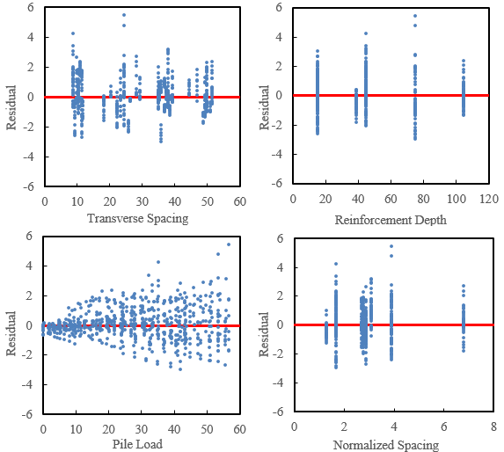

Figure 2: Residuals for the variables used in the multiple regression model.

Using the coefficients found in Table 1, the tensile force in the reinforcement, F, in kips can be predicted using the equation

(1)

Where

T is the transverse spacing of the reinforcement from the center of the pile in inches,
Z is the depth of the reinforcement below the ground surface in inches,
P is the pile head load in kips, and
S/D is the normalized pile spacing with S being the distance from the center of the pile to the back face of the MSE wall D being the pile diameter.

This equation can be simplified somewhat into the following form which predicts loads close to equation (1),

(2)

Another important variable which could not be explored in the analysis is the pile diameter. In all of the various research studies the piles were 12.75 in. diameter pipe piles. It is likely that the diameter of the pile could affect the transverse spacing and the load part of the equation. More field testing or numerical modeling will likely be necessary to determine the effect of pile diameter in the future. Similar analyses will be conducted for the welded wire reinforcements in the future.

Circumstance affecting project or budget. (Please describe any challenges encountered or anticipated that
might affect the completion of the project within the time, scope and fiscal constraints set forth in the
agreement, along with recommended solutions to those problems).

None to report.

Potential Implementation:

