TRANSPORTATION POOLED FUND PROGRAM
QUARTERLY PROGRESS REPORT

Lead Agency: Utah Department of Transportation

INSTRUCTIONS:
Project Managers and/or research project investigators should complete a quarterly progress report for each calendar quarter during which the projects are active. Please provide a project schedule status of the research activities tied to each task that is defined in the proposal; a percentage completion of each task; a concise discussion (2 or 3 sentences) of the current status, including accomplishments and problems encountered, if any. List all tasks, even if no work was done during this period.

Transportation Pooled Fund Program Project #  TPF-5(296) |  | Transportation Pooled Fund Program - Report Period:  _ Quarter 1 (January 1 – March 31, 2015)  x Quarter 2 (April 1 – June 30, 2015)  _ Quarter 3 (July 1 – September 30, 2015)  _ Quarter 4 (October 1 – December 31, 2015)
Project Title:
Simplified SPT Performance-Based Assessment of Liquefaction and Effects

Name of Project Manager(s):  David Stevens | Phone Number:  801-589-8340 |  | E-Mail  davidstevens@utah.gov
Lead Agency Project ID:  FINET 42065, ePM PIN 12436  UDOT PIC No. UT13.407 | Other Project ID (i.e., contract #):  UDOT Contract No. 148753 |  | Project Start Date:  March 6, 2014
Original Project End Date:  November 30, 2016 | Current Project End Date:  November 30, 2016 |  | Number of Extensions:  1

Project schedule status:

X On schedule _ On revised schedule _ Ahead of schedule _ Behind schedule

Overall Project Statistics:
Total Project Budget | Total Cost to Date for Project | Percentage of Work  Completed to Date
$149,500.00 | $71,750 | 50%

Quarterly Project Statistics:
Total Project Expenses  and Percentage This Quarter | Total Amount of Funds  Expended This Quarter | Total Percentage of  Time Used to Date
16% | $23,750 | 45%

Project Description:

Liquefaction of loose saturated sands results in significant damage to buildings, transportation systems and lifelines in most large earthquake events. Liquefaction and the resulting loss of shear strength can lead to lateral spreading and seismic slope displacements, which often impact bridge abutments and wharfs, damaging these critical transportation links at a time when they are most needed for rescue efforts and post-earthquake recovery.

While most updated seismic provisions now adopt a risk-targeted approach to design ground motions for superstructures, other critical aspects of geotechnical engineering, such as liquefaction and ground deformation evaluation, are still based on the older concept of deterministic hazard evaluation. Recent advances in performance-based earthquake engineering (PBEE) in geotechnical engineering (e.g., Kramer and Mayfield 2007; Rathje and Saygili 2008; Bradley et al. 2011; Franke and Kramer 2013) have introduced probabilistic uniform hazard-based procedures for evaluating seismic ground deformations within a performance-based framework from which the likelihood of exceeding various magnitudes of deformation within a given time frame can be computed. However, the ability to apply these performance-based procedures on everyday projects is generally beyond the capabilities of most practicing engineers.

This study proposes to create and evaluate simplified performance-based design procedures for the a priori prediction of liquefaction triggering, lateral spread displacement, seismic slope displacement, and post-liquefaction free-field settlement using the standard penetration test (SPT).

Objectives for this study include:

1. Derive new simplified performance-based procedure for liquefaction triggering, lateral spread displacement, free-field post-liquefaction settlements, and Newmark seismic slope displacements.
2. Develop liquefaction parameter maps in GIS format associated with each of the hazards included in objective 1 at return periods of 475 years, 1033 years, and 2475 years for each of the states participating in the study.
3. Evaluate the new simplified performance-based liquefaction procedures against conventional (i.e., AASHTO) liquefaction analysis procedures.
4. Develop a simplified design procedure that will allow the designer to envelope the performance-based and conventional results to select which result will govern the design.
Tasks for this study include, regarding the participating states:

1. Derivation and validation of a new simplified liquefaction triggering model (Year 1).
2. Derivation and validation of simplified lateral spread displacement models (Year 1).
3. Derivation and validation of simplified post-liquefaction settlement models (Year 2).
4. Derivation and validation of simplified Newmark seismic slope displacement models (Year 2).
5. Assessment of grid spacing considerations in various seismic environments for map development (Years 1 & 2).
6. Development of liquefaction parameter maps at targeted return periods in GIS file format (Years 1 & 2).
7. Comparison of simplified, conventional, and deterministic analysis approaches (Years 1 & 2).
8. Development of a simplified design procedure and an analysis spreadsheet that incorporates both performance-based and conventional methods (Years 1 & 2).
9. Preparation of the annual and final reports (Years 1 & 2).
10. Dissemination of results in appropriate engineering journals and conferences (Years 1 & 2).
11. Technical Advisory Committee meetings (Years 1 & 2), including a final workshop to train partner states on the new performance-based liquefaction hazard methods.

Dr. Kevin Franke of BYU is the Principal Investigator for this research project. The technical advisory committee (TAC) for the study includes representatives from UT, AK, CT, ID, MT, and SC state DOTs.

Progress this Quarter (includes meetings, work plan status, contract status, significant progress, etc.):

Task 1 – 100% complete.
Task 2 – 100% complete.
Task 3 – 90% complete. BYU continued work on this task.
Task 4 – 90% complete. BYU continued work on this task and prepared the TAC quarterly update report for Tasks 3 and 4.
Task 5 – 60% complete. BYU began the Year 2 work on this task.
Task 6 – 60% complete. BYU began the Year 2 work on this task.
Task 7 – 50% complete.
Task 8 – 50% complete.
Task 9 – 50% complete. The annual (Year 1 update) report was revised based on TAC feedback and again shared with the TAC.
Task 10 – 50% complete.
Task 11 – 50% complete.
Contract – No adjustment this quarter.

Anticipated work next quarter:

Task 1 – Completed.
Task 2 – Completed.
Task 3 – BYU will complete work on this task.
Task 4 – BYU will complete work on this task. The TAC quarterly update report for Tasks 3 and 4 will be shared with the TAC.
Task 5 – BYU will continue the Year 2 work on this task. Map grid spacing will be evaluated based on simplified post-liquefaction settlement and Newmark seismic slope displacement models from Tasks 3 and 4.
Task 6 – BYU will continue the Year 2 work on this task. Liquefaction parameter maps will be developed based on simplified post-liquefaction settlement and Newmark seismic slope displacement models from Tasks 3 and 4. The TAC quarterly update report for Tasks 5 and 6 (Year 2) will be prepared and shared with the TAC, along with the volumetric strain and seismic slope displacement reference parameter maps.
Task 7 – BYU will begin the Year 2 work on this task (comparison of analysis approaches).
Task 8 – BYU will begin the Year 2 work on this task (adding features to the analysis spreadsheet).
Task 9 – None.
Task 10 – None.
Task 11 – A TAC web-conference will be held in September to review progress and provide feedback.
Contract – None.

Significant Results:

Research into the development of simplified performance-based procedures for estimating post-liquefaction free-field settlements and Newmark seismic slope displacements was initiated with a new set of graduate students. While liquefaction triggering is an important consideration in geotechnical earthquake engineering, the evaluation of post-liquefaction effects such as settlement is typically considered more crucial for design. Research this quarter used the same PEER performance-based earthquake engineering framework that was used in other tasks in this research to develop probabilistic procedures for computing performance-based post-liquefaction settlement predictions using the standard penetration test (SPT), as well as computing simplified Newmark seismic slope displacement predictions. The post-liquefaction settlement procedure that was developed also incorporates the probability of liquefaction triggering to account for the conditional likelihood that liquefaction would even occur in the soil.

Results of a validation study between the new simplified performance-based post-liquefaction settlement procedure and a full performance-based post-liquefaction settlement procedure demonstrated that the simplified procedure approximated the results from the full procedure reasonably well. The validation study evaluated five different soil profiles in 10 U.S. cities at three different return periods to assess a wide range of performance for the proposed procedures. Figure 1 below shows the computed settlement validation results for the simplified procedure incorporating the Cetin et al. (2009) empirical strain procedure at three return periods, and Figure 2 below shows the computed settlement validation results for the simplified procedure incorporating the Ishihara and Yoshimine (1992) empirical strain procedure, per the approximations recommended by Idriss and Boulanger (2008). The simplified procedure using the Cetin et al. (2009) model shows considerably less scatter than the simplified procedure results using the Ishihara and Yoshimine (1992) results, likely because the Cetin et al. (2009) uses a single, continuous function to predict volumetric strain. Nevertheless, both simplified procedures showed that predicted ground-surface settlements of about 40 cm or less usually approximated the predicted results from the full performance-based procedure quite well. Settlement predictions greater than about 40 cm demonstrated quite a bit more scatter for both models.

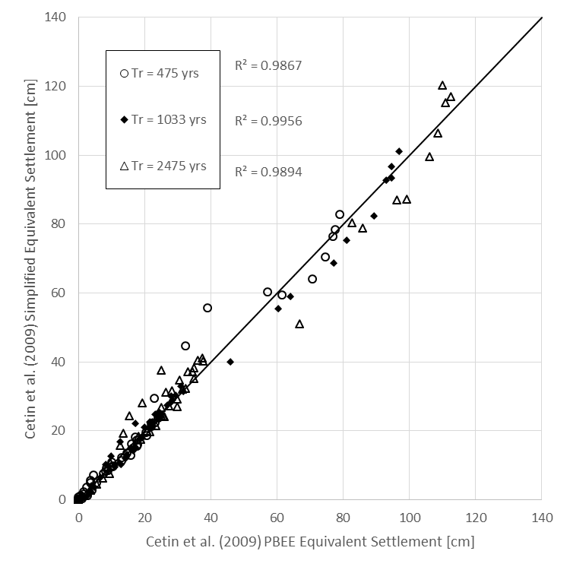
Fig. 1. Comparison of the computed ground surface settlements between the simplified performance-based post-liquefaction settlement procedure using the Cetin et al. (2009) model and the full performance-based post-liquefaction settlement procedure

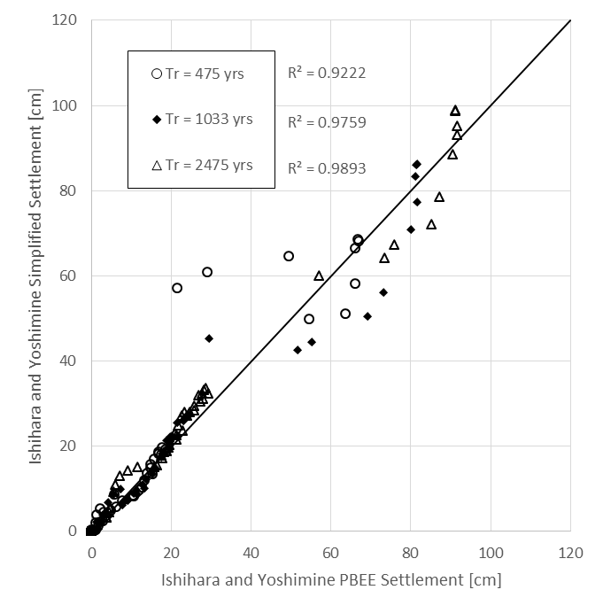
Fig. 2. Comparison of the computed ground surface settlements between the simplified performance-based post-liquefaction settlement procedure using the Ishihara and Yoshimine (1992) model and the full performance-based post-liquefaction settlement procedure

A similar validation study was performed for the simplified performance-based Newmark sliding block procedures using the Rathje and Saygili (2009) model and the Bray and Travasarou (2007) model. The validation study assessed the performance of the simplified performance-based procedure against the full performance-based procedure (Rathje and Saygili 2008) for the 10 selected U.S. cities at three different return periods, and for yield accelerations ranging from 0.1 to 0.5 g. Scatterplots showing the validation study results are presented for the Rathje and Saygili (2009) model in Figure 3, and for the Bray and Travasarou (2007) model in Figure 4. Results from this validation study suggest that the simplified performance-based procedures for both models reasonably approximate the results from the full performance-based procedure, though the procedure incorporating the Bray and Travasarou (2007) showed much better approximations than the procedure incorporating the Rathje and Saygili (2009) procedure. However, the simplified performance-based procedures for both models appeared to approximate the results from the full performance-based procedure very well up to predicted displacements of about 50 cm. At displacements greater than about 50 cm, more inconsistencies in the predictions were observed, particularly with the procedure incorporating the Rathje and Saygili (2009) model.

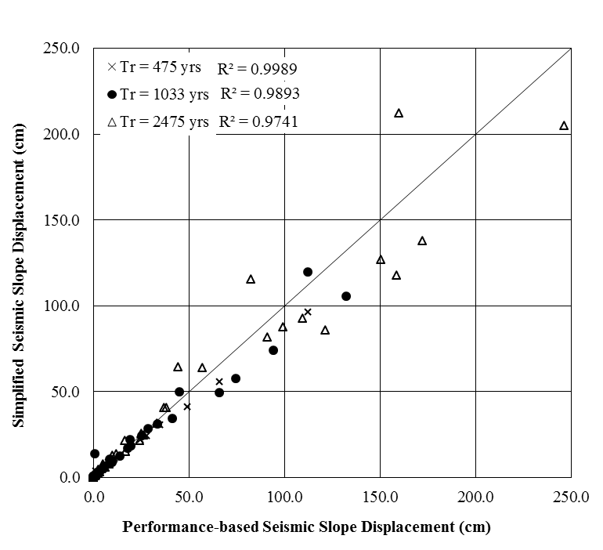
Fig. 3. Comparison of the computed Newmark seismic slope displacements between the simplified performance-based Newmark procedure using the Rathje and Saygili (2009) model and the full performance-based Newmark procedure (Rathje and Saygili 2008)

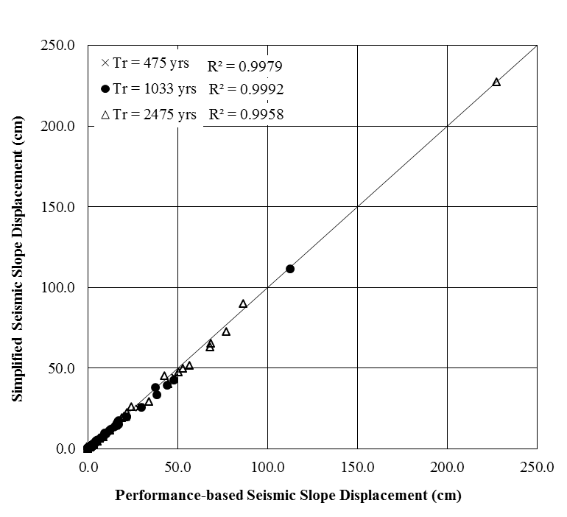
Fig. 4. Comparison of the computed Newmark seismic slope displacements between the simplified performance-based Newmark procedure using the Bray and Travasarou (2007) model and the full performance-based Newmark procedure

Circumstance affecting project or budget. (Please describe any challenges encountered or anticipated that
might affect the completion of the project within the time, scope and fiscal constraints set forth in the
agreement, along with recommended solutions to those problems).

More scatter was observed in the simplified performance-based results for post-liquefaction settlement and Newmark-based seismic slope displacements than was observed with liquefaction triggering and lateral spread displacement. This increase in scatter caused us to evaluate more conditions in the validations studies to satisfy ourselves that the simplified performance-based procedures would be adequately robust for a wide range of conditions that would be encountered by engineering practitioners. These additional evaluations delayed our anticipated schedule by about one month, but we anticipate that we will be able to get back on schedule during the second and third quarters of the research project this year. No additional costs are anticipated due to these delays.

Potential Implementation:

The new simplified performance-based procedures for post-liquefaction settlement and Newmark seismic slope displacement are now developed, and will be able to be used by engineering practitioners once the reference parameter maps are developed (anticipated in the following quarter), and the procedures are added to the analysis spreadsheet (anticipated in the third and fourth quarters this year). Until those other resources are ready, these new procedures will not likely be able to be implemented by engineering practitioners.

