TRANSPORTATION POOLED FUND PROGRAM
QUARTERLY PROGRESS REPORT

Lead Agency (FHWA or State DOT): Oklahoma Department of Transportation

INSTRUCTIONS:
Project Managers and/or research project investigators should complete a quarterly progress report for each calendar quarter during which the projects are active. Please provide a project schedule status of the research activities tied to each task that is defined in the proposal; a percentage completion of each task; a concise discussion (2 or 3 sentences) of the current status, including accomplishments and problems encountered, if any. List all tasks, even if no work was done during this period.

Transportation Pooled Fund Program Project #  TPF-5(448) |  | Transportation Pooled Fund Program - Report Period:  O Quarter 1 (January 1 – March 31)  O Quarter 2 (April 1 – June 30)  O Quarter 3 (July 1 – September 30)  X Quarter 4 (October 1 – December 31)
Project Title:

Integrating Construction Practices and Weather Into Freeze Thaw Specifications

Name of Project Manager(s):  Tyler Ley | Phone Number:  405-744-5257 |  | E-Mail  Tyler.ley@okstate.edu
Lead Agency Project ID:  TPF-TPF5(448) | Other Project ID (i.e., contract #):  AA-1-501021 |  | Project Start Date:  August 30, 2020
Original Project End Date:  August 30, 2023 | Current Project End Date:  August 30,2023 |  | Number of Extensions:  0

Project schedule status:
X On schedule On revised schedule □ Ahead of schedule □ Behind schedule

Overall Project Statistics:
Total Project Budget | Total Cost to Date for Project | Percentage of Work  Completed to Date
$660,000 | $2,500 | 8%

Quarterly Project Statistics:
Total Project Expenses  and Percentage This Quarter | Total Amount of Funds  Expended This Quarter | Total Percentage of  Time Used to Date
$40,500 | $40,500 | 10%

Project Description:

Concrete can be damaged when it is 1) sufficiently wet (has reached a critical degree of saturation) and 2) is exposed to temperature cycles that enable freezing and thawing. The damage that occurs due to freezing and thawing can lead to premature deterioration, costly repairs, and premature replacement of concrete infrastructure elements. Current specifications for frost durability are largely based on work completed in the 1950s, and while this work included many landmark discoveries (Kleiger 1952, 1954). This work from the 1950s may not be representative of materials used in modern concrete mixtures.

The ultimate goal of this work is to build on previous research efforts to produce improved specifications and advance existing test methods; while, improve the underlying understanding of freeze thaw damage. This work will specifically focus on construction practices and the impact of weather.

The objectives are:
- Quantify how different weather conditions impact the freeze thaw performance of concrete with low-cost data loggers. This work has been started under this existing project but these samples should be distributed in the field and used to quantify the combination of saturation and freeze thaw cycles in different states.
- Investigate the freeze thaw performance of existing structures in different climates with different air void qualities. In combination with quantifying the weather in different environments, structures should be found in these structures with different quality of air void systems to determine how they perform. This will provide true case studies of field performance in a quantified exposure.
- Expand the freeze thaw model to a larger range of mixtures to see if the trends still hold.
- Further evaluation of the accuracy of the modeling predictions for determining the matrix saturation and the relationship between the secondary sorption and formation factor.
- Better understand the damage propagation after critical saturation is reached.
- Extension of this work to include salts such as those that result in calcium oxychloride to further improve the computational modeling predictions.
- Determine how air void filling impacts the durability of concrete from freeze thaw cycles.
- Develop freeze thaw specifications based on concrete quality, air void system, and local weather conditions.
- Determine how construction methods such as pumping, mixing time, paving vibration, and hand held vibrators impact the air void spacing within concrete
- Improve the SAM by making the measurement more consistent through developing a semi-automated testing procedure and improving reliability prediction.
- Further refine a rapid test method that measures the uptake and fluid and resistivity of the concrete to determine the freeze thaw durability of concrete

Progress this Quarter (includes meetings, work plan status, contract status, significant progress, etc.):

- Quantify how different weather conditions impact the freeze thaw performance of concrete with low-cost data loggers. This work has been started under this existing project but these samples should be distributed in the field and used to quantify the combination of saturation and freeze thaw cycles in different states.
Sending wather boxes to Missouri. Data is continuing to be collected and analyzed.

- Investigate the freeze thaw performance of existing structures in different climates with different air void qualities. In combination with quantifying the weather in different environments, structures should be found in these structures with different quality of air void systems to determine how they perform. This will provide true case studies of field performance in a quantified exposure.
Samples have been provided from Iowa for this. This will start later in the project.

- Expand the freeze thaw model to a larger range of mixtures to see if the trends still hold.
In part 1 of the project, researchers had developed a correlation between the probability of failure due to freeze-thaw cycles with respect to the degree of saturation of the mortar samples tested (Figure 1).
The probability of failure increases with an increase of DOS in the sample. For example, all the samples with DOS higher than 88% develop FT damage. The failure region starts at DOS of ≈77.5% for the samples with a SAM number ≤0.20 compared to the DOS of ≈72.5% for the samples with a SAM number between 0.20 and 0.60. In addition, when the DOS of the sample is around the critical level of saturation (72.5% <DOS<88%), the probability of failure tends to be higher for samples with high SAM number (SAM > 0.20) compared to samples with a low SAM number (≤0.20). Ley et al. [1] showed that a SAM Number of 0.20 best correlates with the recommended spacing factor of 200 μm for FT durability (ACI 201.2R limit). The reduced quality of air void distribution explains the higher probability of failure in samples with a SAM number > 0.20. This is in accordance with the data collected in [2], where it was concluded that higher quality air-void systems, quantified by lower SAM numbers, may resist freeze-thaw damage at higher levels of saturation than those with poorly distributed air void systems.
This correlation in Figure 1 was collected on 134 mortar samples prepared with cement type I/II and with different air void content and air void quality. Only 9 different mixtures were tested to obtain Figure 1.
Figure 1. Probability of failure with respect to the degree of saturation [3]
This research will expand the measurements of FT damage to a larger numbers of mixtures and calculate the probability of failure for samples conditioned around the critical DOS (72.5-88%).
Several samples with varying mixtures proportions were prepared. 22 different mixtures with different air void content, air void quality and fly ash content were prepared. Cores from each mixtures were prepared and start being preconditioned for the FT damage measurements.
From now until the end of March 2021, the researchers will be testing the freeze thaw damage of these mortar samples preconditioned and different DOS and will calculate the probability of failure and complete Figure 1 with additional data points. The bin size for the statistical analysis in Figure 1 is 5%. These additional measurements will allow decreasing the bin size to 2% which will give more confidence in the correlation and conclusion drawn out of this graph.

- Further evaluation of the accuracy of the modeling predictions for determining the matrix saturation and the relationship between the secondary sorption and formation factor.
In the previous part of the project, a correlation has been established between the apparent formation factor and the initial and secondary sorptivity coefficient of plain concrete samples [4, 5]. The correlation is not established yet for concrete samples with supplementary cementitious materials. The apparent formation factor as well as the initial and secondary sorptivity of concrete samples with varying fly ash content will be tested in the second part or the project [6]. The correlation will be determined for samples with fly ash and compared with the correlation obtained on plain concrete samples. This relationship provides a powerful tool in quality control to obtain FAP that relates to absorption properties by using a simple immersion test. The fluid absorption properties are key parameters in service life prediction of concrete structures subjected to freezing-and-thawing cycles. These measurements will be finalized by the end of March 2021.

- Better understand the damage propagation after critical saturation is reached.
X-ray computed tomography will be used to measure the FT damage in mortar samples with varying degrees of saturation. These results will be correlated with the probability of failure obtained on mortar samples with different DOS (Figure 1).

- Extension of this work to include salts such as those that result in calcium oxychloride to further improve the computational modeling predictions.
In the first part of the project, researchers have studied the salt damage that developed in mortar samples due to the formation of calcium oxychloride. Mortar samples with varying air content, varying air void quality and varying fly ash content were saturated in 20% calcium chloride (CaCl₂) solution. Micro X-ray fluorescent spectroscopy was used to determine that the chloride ions were uniformly distributed throughout the sample.
Saturated samples were exposed to temperature cycles varying from 50°C to 5°C while being immersed in 20% CaCL₂ solution. During the cooling period, calcium oxychloride (CaOXY) develops in the pores of the mortar samples. During the heating period, CaOXY melts. CaOXY is a product of the reaction between CaCl₂ and calcium hydroxide. The volume of CaOXY is smaller than the reactants. Consequently, during the cooling period, due to the volume shrinkage induced by CaOXY formation, 20% CaCl2 solution can diffuse and refill the pores of the cementitious materials. During the heating process, CaOXY melts and expand in volume leading thus to internal pressure and salt damage.
The length of the sample was measured at the beginning and end of each temperature cycle using a high precision micrometer. When a sample is damaged, an increase in its length will be measured. The residual strain was used as an indicator for damage and was calculated according to equation 1.
 | $$Residual strain= \frac{l_{i}-l_{0}}{l_{0}}$$ | (1)

Where, l₀ is the initial length of the sample, l_{i} is the length of the sample after each temperature cycle.
Figure 2 shows the preliminary data obtained. It can be seen that the samples with 40% fly ash content did not develop salt damage while samples without fly ash and with 20% fly ash did exhibit salt damage (i.e. positive residual strain). Samples with 0% fly ash and a higher air content resisted the temperature cycles (i.e. salt damage) for longer duration than samples with a lower air content. Samples containing fly ash contain lower amounts of calcium hydroxide. They will thus develop lower amounts of CaOXY [7-9]. This explains the reduction in salt damage with the increase in fly ash content

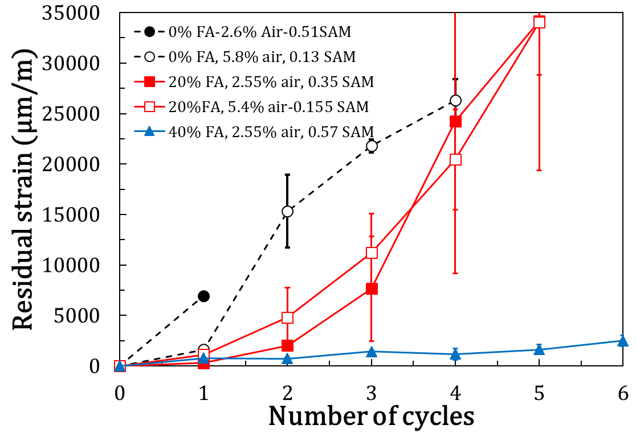
Figure 2. Salt damage evolution in mortar samples with varying fly ash content and varying air content.
Researchers are interested in completing Figure 2 with samples containing intermediate fly ash content: 25%, 30% and 35%. They did prepare the samples and start preconditioning them for this purpose. The experiments will be finished by the end of April 2021.

- Determine how air void filling impacts the durability of concrete from salt damage.
Differential scanning calorimetry (DSC) is an experimental technique in which the difference in the amount of heat required to increase the temperature of a sample compared to a reference is measured as a function of the temperature. This technique can be used to determine the phase change in the sample as well as quantity of material undergoing the phase change. A powder will be prepared from each mix design tested in task 6 (salt damage) and will be mixed with 20% CaCl₂ solution at a ratio of 4:1 [10]. The CaOXY that develops will be quantified. The volume of calcium oxychloride will then be concluded.
X-ray CT scans will be conducted to measure the filling of voids due to CaOXY (formation and melting). The measurements obtained from X-ray CT will be compared with the volume of calcium oxychloride measurements using the LT-DSC

- Develop freeze thaw specifications based on concrete quality, air void system, and local weather conditions.’
This will be done at the end of the project.

- Determine how construction methods such as pumping, mixing time, paving vibration, and hand held vibrators impact the air void spacing within concrete
OK state is looking at vibration and how it impacts the air void system in concrete. Some of this is to improve the SAM and the accuracy with low slump concrete. Some of this is with field concrete and with different vibration. We are also going to do some field mixing time measurements.

- Improve the SAM by making the measurement more consistent through developing a semi-automated testing procedure and improving reliability prediction.
There is a new gauge that will be released as part of the project. We are also working on the error algorithm to improve it. We have done some work to automate different parts of the SAM test but more work is needed. The states should be provided new gauges soon.

- Further refine a rapid test method that measures the uptake and fluid and resistivity of the concrete to determine the freeze thaw durability of concrete
In this research study, the authors have been determining the critical degree of saturation for different mixtures. In addition for some of these mixtures they will be measuring the formation factor and correlating it with the sorptivity coefficient. Consequently, they will work on finding a correlation between the second sorptivity coefficient value and the critical degree of saturation
References:
1. Ley, M.T., et al., Determining the air-void distribution in fresh concrete with the Sequential Air Method. Construction and Building Materials, 2017. 150: p. 723-737.
2. Todak, H.N., Durability assessments of concrete using electrical properties and acoustic emission testing, in School of Civil Engineering. 2015, Purdue University: West Lafayette. p. 143.
3. Ghantous, R.M., et al., Determining the freeze-thaw performance of mortar samples using length change measurements during freezing. accepted in cement and concrete composite 2020.
4. Khanzadeh Moradllo, M., et al., Quantifying fluid filling of the air voids in air entrained concrete using neutron radiography. Cement and Concrete Composites, 2019. 104.
5. Moradllo, M.K., et al., Relating the formation factor of concrete to water absorption. ACI Mater. J., 2018. Submitted.
6. ASTM C1585-13 Standard Test Method for Measurement of Rate of Absorption of Water by Hydraulic-Cement Concretes. 2013, ASTM International: West Conshohocken, PA.
7. Suraneni, P., et al., Use of fly ash to minimize deicing salt damage in concrete pavements. Journal of the Transportation Research Board, 2017. 2629: p. 24-32.
8. Suraneni, P., et al., Role of supplementary cementitious material type in the mitigation of calcium oxychloride formation in cementitious pastes. Journal of Materials in Civil Engineering, 2018. 30: p. 1-10.
9. Suraneni, P., et al., Calcium oxychloride formation potential in cementitious pastes exposed to blends of deicing salt. ACI Materials Journal, 2017. 114(4): p. 631-641.
10. Suraneni, P. and J. Weiss, Extending Low-Temperature Differential Scanning Calorimetry from Paste to Mortar and Concrete to Quantify the Potential for Calcium Oxychloride Formation. Advances in Civil Engineering Materials, 2018. 7(1): p. 1-16.

Anticipated work next quarter:

Continue to work on each task and hold biweekly meetings.

Significant Results:

Circumstance affecting project or budget. (Please describe any challenges encountered or anticipated that
might affect the completion of the project within the time, scope and fiscal constraints set forth in the agreement, along with recommended solutions to those problems).

Potential Implementation:

