TRANSPORTATION POOLED FUND PROGRAM
QUARTERLY PROGRESS REPORT

Lead Agency: Utah Department of Transportation

INSTRUCTIONS:
Project Managers and/or research project investigators should complete a quarterly progress report for each calendar quarter during which the projects are active. Please provide a project schedule status of the research activities tied to each task that is defined in the proposal; a percentage completion of each task; a concise discussion (2 or 3 sentences) of the current status, including accomplishments and problems encountered, if any. List all tasks, even if no work was done during this period.

Transportation Pooled Fund Program Project #  TPF-5(381) |  | Transportation Pooled Fund Program - Report Period:  _ Quarter 1 (January 1 – March 31, 2020)  _ Quarter 2 (April 1 – June 30, 2020)  x Quarter 3 (July 1 – September 30, 2020)  _ Quarter 4 (October 1 – December 31, 2020)
Project Title:
Evaluation of Lateral Pile Resistance Near MSE Walls at a Dedicated Wall Site – Phase 2

Name of Project Manager(s):  David Stevens | Phone Number:  801-589-8340 |  | E-Mail  davidstevens@utah.gov
Lead Agency Project ID:  FINET 42085, ePM PIN 16761  UDOT PIC No. UT17.404 | Other Project ID (i.e., contract #):  UDOT Contract No. 19-8182 |  | Project Start Date:  August 20, 2018
Original Project End Date:  September 30, 2020 | Current Project End Date:  June 15, 2021 |  | Number of Extensions:  2

Project schedule status:

_ On schedule X On revised schedule _ Ahead of schedule _ Behind schedule

Overall Project Statistics:
Total Project Budget | Total Cost to Date for Project | Percentage of Work  Completed to Date
$240,000.00 (current contract)  $240,000.00 (total commitments)  $240,000.00 (obligated on PIN) | $140,000.00 | 60%

Quarterly Project Statistics:
Total Project Expenses  and Percentage This Quarter | Total Amount of Funds  Expended This Quarter | Total Percentage of  Time Used to Date
0% | $0.00 | 76%

Project Description:

Bridge abutment piles are frequently surrounded by mechanically stabilized earth (MSE) walls rather than a soil slope. Piles near MSE walls must be designed for lateral loads from earthquakes and thermal expansion/contraction. In the TPF-5(272) Phase 1 study involving several state DOTs, a series of 31 tests on free-head piles provided p-multipliers as a function of pile spacing which can be used to account for reduced lateral soil resistance due to the presence of an MSE wall. Equations were also developed to compute the induced force developed in the reinforcements by the lateral pile loading. However, a number of questions came up when the results of the Phase 1 study were presented to engineers and those responsible for code changes. These issues involve (a) the effect of cyclic loading when previous testing was monotonic, (b) the effect of pile head fixity because previous tests were on free-head piles while most abutment piles are “fixed-head”, (c) the effect of pile group loading when previous tests were for single piles, and (d) the effect of pile diameter on the p-multiplier and induced force equations because previous tests were all for piles about 12 inches in diameter.

Objective: To provide closure relative to the outstanding issues described above, a series of additional tests will be conducted as a Phase 2 follow-up to the original test series.
The Phase 1 study included construction of a dedicated MSE wall site in Utah with instrumented piles behind the 20-ft high wall.

Tasks for this Phase 2 study include:

1. Excavate the top 6 ft of the soil backfill behind the existing MSE wall.
2. Instrument MSE reinforcements and piles with strain gauges.
3. Re-compact the top 6 ft of the soil backfill behind the existing MSE wall.
4. Conduct cyclic lateral pile load testing.
5. Conduct fixed-head lateral pile load testing.
6. Conduct lateral pile load testing of larger-diameter piles (24-inch diameter), to be newly placed between cut-off existing piles.
7. Conduct lateral pile load testing of a pile group.
8. Develop p-multipliers for Phase 2 lateral pile load testing results, compare these with the Phase 1 results, and update the overall p-multiplier equation as necessary.
9. Develop tensile force equations for Phase 2 lateral pile load testing results, compare these with the Phase 1 results, and update the overall tensile force equations as necessary.
10. Submit a final report that documents the Phase 2 research effort.
11. Report results to TAC committee members in video conferences.
12. Make presentations at AASHTO bridge engineers’ committee meetings and TRB events to aid in national efforts to implement the study results.

Dr. Kyle Rollins of BYU is the Principal Investigator for this research project. The technical advisory committee (TAC) for the study currently includes representatives from UT, CA, FL, KS, MN, NY, and WI state DOTs.

Progress this Quarter (includes meetings, work plan status, contract status, significant progress, etc.):

Task 1 – Completed.
Task 2 – Completed.
Task 3 – Completed.
Task 4 – Completed.
Task 5 – Completed.
Task 6 – Completed.
Task 7 – Completed.
Task 8 – Continued this task.
Task 9 – Continued this task.
Task 10 – Submitted the draft final report on the pile group test for TAC review. Continued drafting 2 other reports from the 4 pile test groupings in Phase 2.
Task 11 – We held a TAC update meeting via web conference in August. Dr. Rollins presented data and analysis results based on the completed Phase 2 field testing. There was some good discussion among the TAC members about the study results so far.
Task 12 – Some presentations were given already.

Contract – UDOT and BYU worked together to amend the contract to include additional work (and pooled funding) on Task 9 and extend the contract end date to June 2021. For the additional work on Task 9, BYU will perform a multi-variable regression analysis using all of the MSE reinforcement tensile force data from Phase 1 and Phase 2 testing. The goal of the additional analysis will be to develop improved design equations for predicting the maximum tensile force in reinforcements developed during lateral pile loading near an MSE wall.

Anticipated work next quarter:

Task 1 – Completed.
Task 2 – Completed.
Task 3 – Completed.
Task 4 – Completed.
Task 5 – Completed.
Task 6 – Completed.
Task 7 – Completed.
Task 8 – Completed
Task 9 – Develop reinforcement tensile force equations, and submit the first of two task completion memos for Task 9; this one will report on the original Task 9 scope results. The second Task 9 memo would be submitted in a few more months to report on the activity and completion of the additional Task 9 statistical analysis.
Task 10 – Complete 2 more draft reports on the 4 pile test groupings, and submit these for TAC review. Begin preparing the shorter summary report addressing all of the key results from the Phase 2 study.
Task 11 – None planned.
Task 12 – None planned.

Contract – No changes are planned.

Significant Results:

This quarter the research team has been evaluating the ability of the equation for predicting tensile force in the welded wire grid reinforcements, developed for free-head test piles in Phase 1, to reliably predict tensile force for tests on fixed-head test piles in Phase 2. The regression equation developed previously to predict maximum tensile force (ΔF) in a welded wire grid is given by:

$ΔF=10^(-0.04+0.027P-2.7x{10}^{-4}P^{2}+5.7x{10}^{-4}σ_{v}-2.6x{10}^{-7}{{σ'}_{v}}^{2}-0.08\frac{T}{D})–1$ (1)

Where:
ΔF is the maximum tensile force induced in the reinforcement (kips)
P is the lateral pile head load (kips)
σ'_{v} is the vertical stress on the reinforcement (psf)
T is the transverse distance from the pile,
D is the pile diameter.
The pile head boundary condition has a significant effect on the lateral pile load carried by a laterally loaded pile. Typically, a fixed-head boundary condition produces much higher lateral loads in comparison to a free-head boundary condition. This was also true in the case of the test pile loaded laterally in the direction of the MSE wall in this study. Fig. 1 provides a plot of the measured pile head load-displacement curves for the square fixed-head test piles spaced at 5.8, 4.3, 3.2 and 2.3 pile diameters from the MSE wall. The load-displacement curves for the 5.8D and 4.3D spacings are relatively similar, but for the 3.2D and 2.3D piles there is much more significant reduction in the lateral resistance for a given deflection. At a pile head deflection of 1.5 inches, the piles developed lateral loads of 60 to 140 kips.

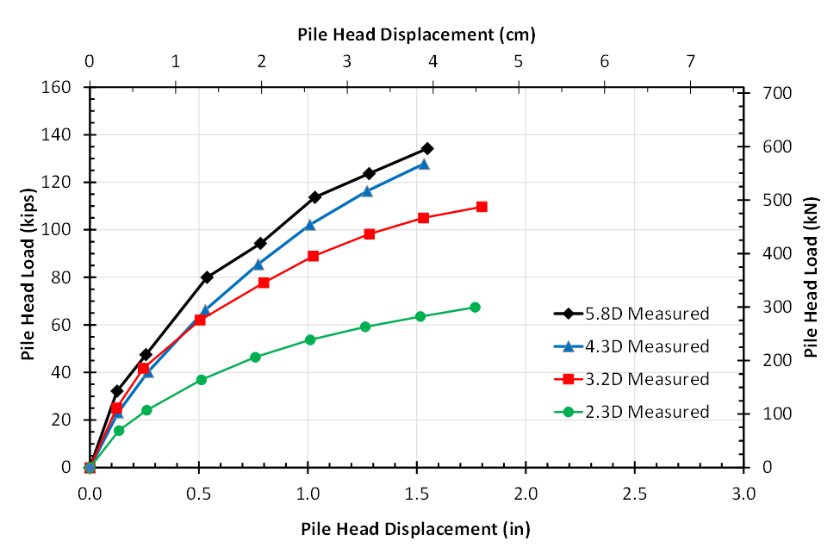
Fig. 1 Measured pile head load vs displacement curves for square fixed-head test piles spaced at 5.8, 4.3, 3.2 and 2.3 pile widths (D) from the MSE wall.

Fig. 2 provides a plot of the measured pile head load-deflection curves for the square free-head test piles spaced at 5.8, 4.3, 3.2 and 2.3 pile diameters from the MSE wall. A comparison with the same plot for the fixed-head piles shown previously in Fig. 2 indicates that the fixed-head test piles provide considerably more lateral resistance for a given pile head deflection than the free-head test piles. In fact, in this case the average increase in lateral resistance for pile head deflection from 0.5 to 1.5 inch was between about 150% and 300%. The lowest increase was for the pile closest to the wall. Part of this increased lateral resistance can be attributed to the higher relative compaction for the fixed-head tests (95% of standard Proctor) relative to the free-head tests (88% to 94% of standard Proctor). Nevertheless, the pile head loads for the fixed-head tests are much higher than those for the free-head tests.

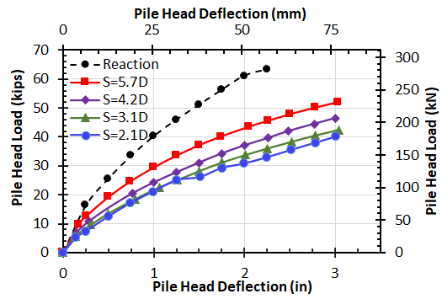

Fig. 2 Measured pile head load vs displacement curves for square free-head test piles spaced at 5.8, 4.3, 3.2 and 2.3 pile widths (D) from the MSE wall.
The higher loads for the fixed-head tests also led to higher deflections of the MSE wall relative to those for the free-head tests. Fig. 3 provides a plot of the maximum MSE wall displacement vs. normalized distance from the wall for fixed-head pile tests in this study relative to free-head pile tests performed previously for a pile head displacement of one inch. Mean and mean plus two standard deviation boundaries from the free-head tests are also shown in Fig. 3. Although the pile head deflection of one inch is the same in both cases, the pile head load is significantly greater for the fixed-head load tests relative to the free-head load tests because of the change in the pile head boundary condition. Because of the higher pile head loads, the measured MSE wall deflections for the fixed-head tests are higher than the mean plus two standard deviation boundary for the free-head tests. The fixed-head tests show a clear trend for the MSE wall deflection to increase as the test pile is located closer to the MSE wall as shown in Fig. 3. Wall deflection more than doubles for the pile test at 5.8D (0.25 inch) to the pile test at 2.3D (0.62 inch).

Fig. 3 Maximum MSE wall displacement vs. normalized distance from the wall for fixed-head pile tests in this study relative to free-head pile tests performed previously.

Fig. 4 provides a plot comparing the maximum measured tensile forces from the fixed-head tests with the predicted tensile forces using Eq. 1 developed from free-head test results. As shown in Fig 4, the Eq. 1 did not provide accurate estimates of the measured maximum tensile force for the fixed-head piles. This is likely a result of the fact that the applied loads are 150 to 300% greater than those applied to the free-head piles. For the higher pile loads (P) associated with a fixed-head pile test, the negative coefficient on the P² term in Eq. 1 significantly reduces the computed tensile force, leading to poor agreement with the measured tensile force. Therefore, additional statistical analyses are necessary to account for the pile head boundary condition effects. This effort is currently underway.

We are exploring the effects of both pile head boundary condition and relative compaction on the maximum tensile force. We are also trying to determine if one overall regression equation can be developed which is acceptable for all the field tests or if it will be necessary to have separate equations considering fixed-head, different relative compaction cases, etc.

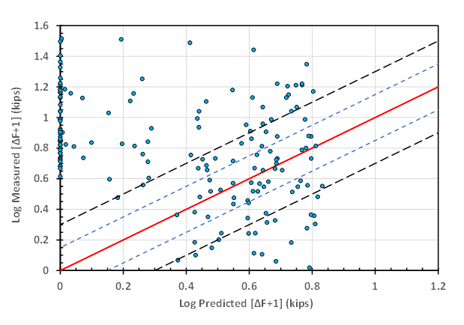
Fig. 4 Log of measured tensile force in reinforcements from fixed-head tests vs. log of tensile force predicted using Eq. 1 developed for free-head tests.

Circumstance affecting project or budget. (Please describe any challenges encountered or anticipated that
might affect the completion of the project within the time, scope and fiscal constraints set forth in the
agreement, along with recommended solutions to those problems).

Because the field testing is completed, students can complete their analysis work on-line. Therefore the project has not been impeded by COVID 19 restrictions to this point.

Potential Implementation:

