TRANSPORTATION POOLED FUND PROGRAM
QUARTERLY PROGRESS REPORT

Lead Agency: Utah Department of Transportation

INSTRUCTIONS:
Project Managers and/or research project investigators should complete a quarterly progress report for each calendar quarter during which the projects are active. Please provide a project schedule status of the research activities tied to each task that is defined in the proposal; a percentage completion of each task; a concise discussion (2 or 3 sentences) of the current status, including accomplishments and problems encountered, if any. List all tasks, even if no work was done during this period.

Transportation Pooled Fund Program Project #  TPF-5(433) |  | Transportation Pooled Fund Program - Report Period:  _ Quarter 1 (January 1 – March 31, 2020)  _ Quarter 2 (April 1 – June 30, 2020)  x Quarter 3 (July 1 – September 30, 2020)  _ Quarter 4 (October 1 – December 31, 2020)
Project Title:
Behavior of Reinforced and Unreinforced Lightweight Cellular Concrete for Retaining Walls

Name of Project Manager(s):  David Stevens | Phone Number:  801-589-8340 |  | E-Mail  davidstevens@utah.gov
Lead Agency Project ID:  FINET 42096, ePM PIN 17824  UDOT PIC No. UT18.404 | Other Project ID (i.e., contract #):  UDOT Contract No. 20-9367 |  | Project Start Date:  May 21, 2020 (contract)
Original Project End Date:  September 30, 2022 | Current Project End Date:  September 30, 2022 |  | Number of Extensions:

Project schedule status:

X On schedule _ On revised schedule _ Ahead of schedule _ Behind schedule

Overall Project Statistics:
Total Project Budget | Total Cost to Date for Project | Percentage of Work  Completed to Date
Total commitments = $322,500.00  Obligated to date = $322,500.00  (including some state match)  Contract amount = $290,003.00  Remaining on contract = $250,878.00 | Total spent = $39,195.41  Contract spent = $39,125.00  Contract support = $70.41 | 15%

Quarterly Project Statistics (on this contract):
Total Project Expenses  and Percentage This Quarter | Total Amount of Funds  Expended This Quarter | Total Percentage of  Time Used to Date
0% | $0.00 | 17%

Project Description:

Roadway widening over existing walls and embankments, conflicts with settlement-sensitive utilities, and accelerated schedule delivery have increased demands for alternative lightweight fill materials. Engineers and contractors are increasingly considering Lightweight Cellular Concrete (LCC) backfills for abutments, embankments, and Mechanically Stabilized Earth (MSE) retaining walls; however, the absence of a consistent design methodology has led to a wide range of design approaches with no consensus standard. The most common class of LCC used in previous highway projects does not strictly behave like a soil or like concrete and must be investigated as a new material for engineering applications. Controversy exists within the industry regarding whether LCC should be modeled as a frictional or a cementitious (cohesive) material. In addition, earth pressures for retaining wall design and potential failure mechanisms of LCC are poorly understood for retaining wall applications, including uncertainty in LCC interaction with internal wall reinforcement in MSE wall applications.

Objective: Measure engineering design parameters and failure mechanisms for unreinforced and reinforced LCC backfills based on large-scale laboratory tests.

Funded tasks for this study include the following:
1. Literature review and survey
2. Basic material properties lab testing
3. Unreinforced LCC large-scale testing
4. Reinforced LCC large-scale testing:
- Reinforced LCC Test 1 – MSE wall with LCC backfill,
- Reinforced LCC Test 2 – MSE wall with LCC backfill against soil slope,
- Reinforced LCC Test 3 – MSE walls on both sides of LCC and overlapping reinforcements, and
- Reinforced LCC Test 4 – Pull-out tests on MSE wall.
5. Compare results with design methods
6. Final Reports for (a) the unreinforced LCC test and (b) the reinforced LCC tests
7. Meetings and dissemination of results

The Principal Investigators for this study are Dr. Kyle Rollins of Brigham Young University and Ryan Maw, a principal engineer at Gerhart-Cole, Inc. The technical advisory committee (TAC) for the study currently includes representatives from UT, CA, KS, LA, MI, NY, OR, and WA state DOTs and FHWA. TAC meetings will be held periodically during the study and are currently planned to be web conferences.

Progress this Quarter (includes meetings, work plan status, contract status, significant progress, etc.):

Task 1 – 20% complete. Started the literature review and prepared a survey.
Task 2 – 60% complete. Completed LCC material properties lab testing for both Reinforced LCC Tests 1 and 2.
Task 3 – 100% complete.
Task 4 – 50% complete. Completed the large-scale testing for both Reinforced LCC Tests 1 and 2. BYU prepared and submitted an interim report with preliminary results from the Reinforced LCC Test 1.
Task 5 – Not started.
Task 6 – Not started.
Task 7 – We held two TAC update meetings via web conference, one in July and one in August. In these meetings Dr. Rollins shared test results collected to date and gathered input from TAC members on upcoming testing configurations.

Contract – No changes were made.

Anticipated work next quarter:

Task 1 – Continue the literature review and survey.
Task 2 – Pause testing to attempt to improve quality control and the consistency of unconfined compressive strength test results of LCC for the study. Complete LCC material properties lab testing for Reinforced LCC Test 3.
Task 3 – Completed.
Task 4 – Prepare and submit an interim report with preliminary results from the Reinforced LCC Test 2. Complete Reinforced LCC Test 3, and prepare an interim report on this test.
Task 5 – None.
Task 6 – None.
Task 7 – Hold a TAC web conference before performing Reinforced LCC Test 3, for Dr. Rollins to present preliminary results of the Reinforced LCC Test 2 and to request TAC input on the upcoming testing.

Contract – Consider modifying the contract to include additional scope and funding for additional large-scale testing, with input from the TAC members. Funding would come from a portion of the committed and transferred pooled funding that is not yet on contract.

Significant Results:

In the 3rd quarter of 2020, we conducted the second large-scale test as part of the TPF-5(433) study. The first unreinforced LCC test with a reinforced concrete cantilever (RCC) wall was performed previously. An interim report with the preliminary results of the reinforced LCC test with MSE wall panels has been posted on the TPF website. Below are some highlights from that report.

The MSE wall panels were nominally 5 ft tall by 10 ft wide and 0.5 ft thick. Reinforcements consisted of ribbed-strip reinforcements that were 60 mm wide and 10 mm thick, provided by Reinforced Earth Company (RECo). The cellular concrete had a unit weight of 27 lbs/ft³ and an unconfined compressive strength (UCS) of about 100 psi at the time of the load test. The cellular concrete was placed in 2.5-foot thick lifts to a height of 10 feet behind the MSE wall panels over a four-day period (one pour per day). The three steel braced walls (show in red) were stiff enough to constrain lateral movements to less than 0.15 inch at the maximum expected surcharge load of about 64 psi (7200 psf) based on SAP2000 analyses of the steel frame. The test box was designed so that we could apply load independently to six stiff concrete beams (2 ft wide by 10 ft long) using independently activated hydraulic jacks with load cells.

Six Geokon pressure cells were placed at approximately 1.5 ft vertical intervals on the back face of the MSE wall panels to monitor interface pressure on the wall during the backfill placement, curing, and surcharge loading. In addition, two hybrid pressure sensors, developed by Prof. Mark Talesnick (Technion, Haifa, Israel) were installed at depths of 2.5 ft. from the top and bottom of the cantilever wall. Two of these pressure sensors were located approximately 1.5 foot inside the LCC block, while two were located at the LCC-wall interface. Finally, 8 thin-film pressure cells developed by Sensor Products were placed at the center of the four LCC lifts at the LCC-MSE wall interface.

Deformation of the retaining wall, the LCC backfill and the test box was monitored using a series of string potentiometers from fill placement to failure that were connected to a data acquisition system. A digital image correlation (DIC) system was also used to monitor the deflection of the retaining wall face to create a color contour map of wall displacements. Thin electrical cables were installed at eight depths within the LCC backfill and monitored with a time-domain reflectometer (TDR) to identify potential failure plane development during surcharge loading. Finally, at the conclusion of the test, the sides of the box and the surcharge panels were removed to identify shear plane and crack patterns in the LCC.

Photographs of the test box just prior to testing the reinforced LCC testing are provided in Fig. 2. For each test, we applied the surcharge load incrementally at 25,000 lbs to 50,000 lbs load increments or 2.75 to 5.5 psi pressure increments. For the test on the MSE wall, load was applied to the first three surcharge blocks (6 ft) adjacent to the MSE wall. For the test against the free face, with no retaining wall, load was applied to the first three surcharge blocks (6 ft) adjacent to the free face. The load was quite uniformly distributed over the three blocks in each case and settlement of each block was also reasonably consistent. Displacement of each block was monitored with three string potentiometers attached to an independent reference frame.
Fig. 1. Schematic plan and profile drawings of the test with reinforced LCC behind two 5’x 10’ MSE wall panels

(a) (b)
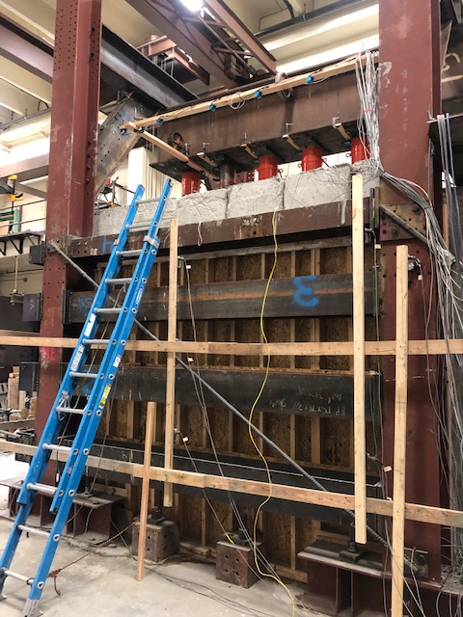
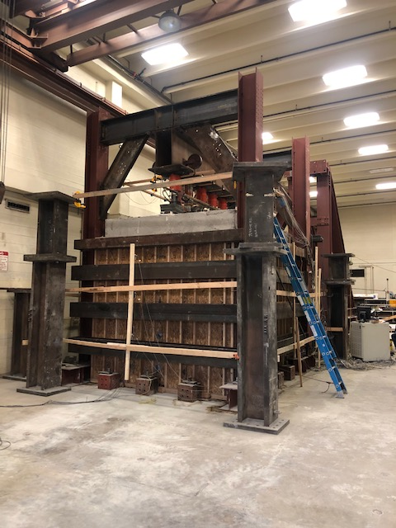

Fig. 2 Photographs showing: (a) the test box from the short side opposite from the retaining wall and (b) the test box from the long side with the concrete surcharge blocks and hydraulic jacks reacting against a longitudinal T-beam.

A plot of the applied surcharge pressure versus axial displacement is provided in Fig. 3. The stiffness of the curve near the MSE wall is somewhat lower than that for the free face, but the difference is small. However, at a surcharge pressure of about 44 psi, the axial settlement near the wall increases rapidly and the surcharge pressure decreases as the LCC loses strength after reaching its peak strength. In contrast, the test near the MSE wall continues to carry higher surcharge pressures up to a value of about 67 psi, where settlement increases to over 3 inches with a small decrease in surcharge pressure. Failure of the MSE wall exhibits relatively ductile behavior, while failure at the free face does not.
Fig. 3. Applied surcharge pressure versus axial displacement in the LCC for tests with and without MSE wall.

A plot of applied surcharge pressure vs. lateral wall displacement is provided in Fig. 4 for the surcharge load tests near the MSE wall and near the Free face (no wall). The pressure vs. displacement curves are very similar until a pressure of 44 psi suggesting that the strength of the LCC provided most of the resistance to this point. At higher pressures, the curve for the free face experiences significant lateral displacement as surcharge pressure decreases. In contrast, the pressure vs. lateral displacement curve near the MSE wall continues to show an increase in resistance that must come primarily from the strength of the wall system. There is a significant reduction in stiffness at a surcharge pressure of about 60 psi and failure of the retaining wall occurs at a surcharge pressure of about 67 psi when the wall begins to deform without an increase in applied pressure.
Fig. 4. Applied surcharge pressure vs. lateral wall displacement in the LCC for tests with and without MSE wall.

Circumstance affecting project or budget. (Please describe any challenges encountered or anticipated that
might affect the completion of the project within the time, scope and fiscal constraints set forth in the
agreement, along with recommended solutions to those problems).

No delays at this time. Testing for this research has been allowed to continue at BYU with additional health precautions related to COVID-19.

Potential Implementation:

None yet.

