TRANSPORTATION POOLED FUND PROGRAM
QUARTERLY PROGRESS REPORT

Lead Agency: Utah Department of Transportation

INSTRUCTIONS:
Project Managers and/or research project investigators should complete a quarterly progress report for each calendar quarter during which the projects are active. Please provide a project schedule status of the research activities tied to each task that is defined in the proposal; a percentage completion of each task; a concise discussion (2 or 3 sentences) of the current status, including accomplishments and problems encountered, if any. List all tasks, even if no work was done during this period.

Transportation Pooled Fund Program Project #  TPF-5(433) |  | Transportation Pooled Fund Program - Report Period:  _ Quarter 1 (January 1 – March 31, 2020)  x Quarter 2 (April 1 – June 30, 2020)  _ Quarter 3 (July 1 – September 30, 2020)  _ Quarter 4 (October 1 – December 31, 2020)
Project Title:
Behavior of Reinforced and Unreinforced Lightweight Cellular Concrete for Retaining Walls

Name of Project Manager(s):  David Stevens | Phone Number:  801-589-8340 |  | E-Mail  davidstevens@utah.gov
Lead Agency Project ID:  FINET 42096, ePM PIN 17824  UDOT PIC No. UT18.404 | Other Project ID (i.e., contract #):  UDOT Contract No. 20-9367 |  | Project Start Date:  May 21, 2020 (contract)
Original Project End Date:  September 30, 2022 | Current Project End Date:  September 30, 2022 |  | Number of Extensions:

Project schedule status:

X On schedule _ On revised schedule _ Ahead of schedule _ Behind schedule

Overall Project Statistics:
Total Project Budget | Total Cost to Date for Project | Percentage of Work  Completed to Date
Total commitments = $315,000.00  Obligated to date = $292,500.00  (including some state match)  Contract amount = $290,003.00  Remaining on contract = $250,878.00 | Total spent = $39,195.41  Contract spent = $39,125.00  Contract support = $70.41 | 13%

Quarterly Project Statistics (on this contract):
Total Project Expenses  and Percentage This Quarter | Total Amount of Funds  Expended This Quarter | Total Percentage of  Time Used to Date
13% | $39,125.00 | 5%

Project Description:

Roadway widening over existing walls and embankments, conflicts with settlement-sensitive utilities, and accelerated schedule delivery have increased demands for alternative lightweight fill materials. Engineers and contractors are increasingly considering Lightweight Cellular Concrete (LCC) backfills for abutments, embankments, and Mechanically Stabilized Earth (MSE) retaining walls; however, the absence of a consistent design methodology has led to a wide range of design approaches with no consensus standard. The most common class of LCC used in previous highway projects does not strictly behave like a soil or like concrete and must be investigated as a new material for engineering applications. Controversy exists within the industry regarding whether LCC should be modeled as a frictional or a cementitious (cohesive) material. In addition, earth pressures for retaining wall design and potential failure mechanisms of LCC are poorly understood for retaining wall applications, including uncertainty in LCC interaction with internal wall reinforcement in MSE wall applications.

Objective: Measure engineering design parameters and failure mechanisms for unreinforced and reinforced LCC backfills based on large-scale laboratory tests.

Funded tasks for this study include the following:
1. Literature review and survey
2. Basic material properties lab testing
3. Unreinforced LCC large-scale testing
4. Reinforced LCC large-scale testing:
- Reinforced LCC Test 1 – MSE wall with LCC backfill,
- Reinforced LCC Test 2 – MSE wall with LCC backfill against soil slope,
- Reinforced LCC Test 3 – MSE walls on both sides of LCC and overlapping reinforcements, and
- Reinforced LCC Test 4 – Pull-out tests on MSE wall.
5. Compare results with design methods
6. Final Reports for (a) the unreinforced LCC test and (b) the reinforced LCC tests
7. Meetings and dissemination of results

The Principal Investigators for this study are Dr. Kyle Rollins of Brigham Young University and Ryan Maw, a principal engineer at Gerhart-Cole, Inc. The technical advisory committee (TAC) for the study currently includes representatives from UT, CA, KS, LA, MI, NY, OR, and WA state DOTs and FHWA. TAC meetings will be held periodically during the study and are currently planned to be web conferences.

Progress this Quarter (includes meetings, work plan status, contract status, significant progress, etc.):

Task 1 – 20% complete. Started the literature review and prepared a survey.
Task 2 – 20% complete. Completed LCC material properties lab testing for the unreinforced LCC large-scale test.
Task 3 – 100% complete. Completed the unreinforced LCC large-scale testing. BYU prepared and submitted an interim report with preliminary test results.
Task 4 – 10% complete. Prepared for the Reinforced LCC Test 1.
Task 5 – Not started.
Task 6 – Not started.
Task 7 – Not started.

Contract – The UDOT research contract was executed with Brigham Young University, and work began on the project.

Anticipated work next quarter:

Task 1 – Continue the literature review and survey.
Task 2 – Complete LCC material properties lab testing for both Reinforced LCC Tests 1 and 2.
Task 3 – Completed.
Task 4 – Complete both Reinforced LCC Tests 1 and 2, and prepare and submit interim reports on these two.
Task 5 – None.
Task 6 – None.
Task 7 – Hold TAC web conferences before Reinforced LCC Test 1, and again before Reinforced LCC Test 2, for Dr. Rollins to present preliminary results of the testing completed thus far and to request TAC input on the upcoming testing.

Contract – No changes expected.

Significant Results:

In the 2nd quarter of 2020, we conducted the first large-scale test as part of the TPF-5(433) study, but the second unreinforced lightweight cellular concrete (LCC) test performed with the BYU test box. The first unreinforced LCC test was performed under a separate contract with UDOT to the University of Utah through a sub-contract to BYU. An interim report with the preliminary results of the unreinforced LCC tests has been posted on the TPF website. Below are some highlights from that report.

Schematic plan and profile drawings for the unreinforced LCC test are shown in Fig. 1. The test box is 10 ft tall x 12 ft long x 10 ft wide. The reinforced concrete (RC) cantilever wall had a 1-foot thick slab that was six feet long and a 1-foot thick stem wall extending to a height of 10 ft. The cellular concrete had a unit weight of 27 lbs/ft³ and an unconfined compressive strength (UCS) of about 100 psi at the time of the load test (for the second unreinforced LCC test). The cellular concrete was placed in 2.5-foot thick lifts to a height of 10 feet behind the RC cantilever retaining wall over a four-day period (one pour per day). The three steel braced walls (shown in red) were stiff enough to constrain lateral movements to less than 0.1 inch at the maximum expected surcharge load of about 64 psi (7200 psf) based on SAP2000 analyses of the steel frame. The test box was designed so that we could apply load independently to six stiff concrete beams (2 ft wide by 10 ft long) using independently activated hydraulic jacks with load cells.

Pressure cells were placed on the back face of the retaining wall and within the LCC block to monitor interface pressure on the wall during the backfill placement, curing, and surcharge loading. Deformation of the retaining wall, the LCC backfill and the test box was monitored using a series of string potentiometers from fill placement to failure that were connected to a data acquisition system. A digital image correlation (DIC) system was also used to monitor the deflection of the retaining wall face to create a color contour map of wall displacements. Thin electrical cables were installed at eight depths within the LCC backfill and monitored with a time-domain reflectometer (TDR) to identify potential failure plane development during surcharge loading. Finally, at the conclusion of the test, the sides of the box and the surcharge panels were removed to identify shear plane and crack patterns in the LCC.

Photographs of the test box just prior to testing the RC retaining wall are provided in Fig. 2. For each test, we applied the surcharge load incrementally at 25,000 lbs to 50,000 lbs load increments or 2.75 to 5.5 psi pressure increments. For the test on the RC retaining wall, load was applied to the first three surcharge blocks (6 ft) adjacent to the retaining wall. For the test against the free face, with no retaining wall, load was applied to the first three surcharge blocks (6 ft) adjacent to the free face. The load was quite uniformly distributed over the three blocks in each case, but settlement under the load could be different. Displacement of each block was monitored with three string potentiometers attached to an independent reference frame.
Fig. 1. Schematic plan and profile drawings of the test with unreinforced LCC behind reinforced concrete cantilever retaining wall.

(a) (b)
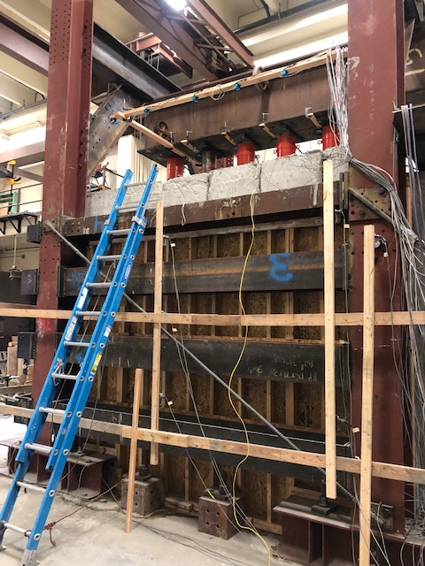
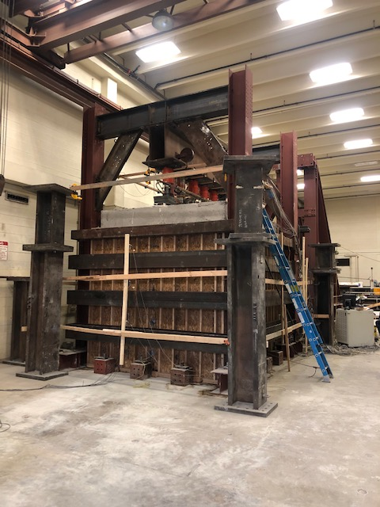

Fig. 2 Photographs showing: (a) the test box from the short side opposite from the retaining wall and (b) the test box from the long side with the concrete surcharge blocks and hydraulic jacks reacting against a longitudinal T-beam.

A plot of the applied surcharge pressure versus axial displacement is provided in Fig. 3. The stiffness of the curve near the RC wall is somewhat higher than that for the free face, but the difference is not large. However, at a surcharge pressure of about 44 psi, the axial settlement near the wall increases rapidly and the surcharge pressure decreases as the LCC loses strength after reaching its peak strength. In contrast, the test near the RC wall continues to carry higher surcharge pressures up to a value of about 63 psi, where settlement increases to over 3 inches at constant pressure. Failure of the RC cantilever wall exhibits ductile behavior, while the free face does not.
Fig. 3. Applied surcharge pressure versus axial displacement in the LCC for tests with and without RC cantilever wall.

Fig. 4 shows plots of surcharge pressure vs. axial strain for both wall tests. The curves show that failure occurred at axial strains of 0.6% and 1.2% for the free face and RC wall tests, respectively.

Fig. 4 Applied surcharge pressure versus axial strain in the LCC for tests with and without RC cantilever wall.

A plot of applied surcharge pressure vs. lateral wall displacement is provided in Fig. 5 for both walls. The pressure vs. displacement curves are very similar until a pressure of 44 psi suggesting that the strength of the LCC provided most of the resistance to this point. At higher pressures, the curve for the free face experiences significant lateral displacement as surcharge pressure decreases. In contrast, the pressure vs. lateral displacement curve near the RC wall continues to show an increase in resistance that must come primarily from the strength of the retaining wall. There is a significant reduction in stiffness at a surcharge pressure of about 50 psi and failure of the retaining wall occurs at a surcharge pressure of about 63 psi when the wall begins to deform without an increase in applied pressure.
Fig. 5. Applied surcharge pressure vs. lateral wall displacement in the LCC for tests with and without RC cantilever retaining wall for unreinforced LLC test 2.

Circumstance affecting project or budget. (Please describe any challenges encountered or anticipated that
might affect the completion of the project within the time, scope and fiscal constraints set forth in the
agreement, along with recommended solutions to those problems).

No delays at this time. Testing for this research has been allowed to continue at BYU with additional health precautions related to COVID-19.

Potential Implementation:

None yet.

