Practitioner’s Guide: Part 2—Determining Properties of Resource Responsible Asphalt Mixtures for Use in the Mechanistic Empirical Pavement Design

May 2020
FOREWORD

Notice
This document is disseminated under the sponsorship of the U.S. Department of Transportation in the interest of information exchange. The U.S. Government assumes no liability for the use of the information contained in this document.
The U.S. Government does not endorse products or manufacturers. Trademarks or manufacturers’ names appear in this report only because they are considered essential to the objective of the document.
Quality Assurance Statement
The Federal Highway Administration (FHWA) provides high-quality information to serve Government, industry, and the public in a manner that promotes public understanding. Standards and policies are used to ensure and maximize the quality, objectivity, utility, and integrity of its information. FHWA periodically reviews quality issues and adjusts its programs and processes to ensure continuous quality improvement.
Technical Report Documentation Page
1. Report No. | 2. Government Accession No. |  |  | 3. Recipient’s Catalog No.
4. Title and Subtitle  Practitioner’s Guide: Part 2—Determining Properties of Resource Responsible Asphalt Mixtures for Use in the Mechanistic Empirical Pavement Design Guide |  |  |  | 5. Report Date  May 24, 2020
 |  |  |  | 6. Performing Organization Code:
7. Author(s)  Harold Von Quintus, Hyung Lee, and Ramon Bonaquist |  |  |  | 8. Performing Organization Report No.
9. Performing Organization Name and Address  Advanced Asphalt Technologies, LLC  40 Commerce Circle  Kearneysville, WV 25430 |  |  |  | 10. Work Unit No.
 |  |  |  | 11. Contract or Grant No.
 |  |  |  | 13. Type of Report and Period Covered
 |  |  |  | 14. Sponsoring Agency Code
15. Supplementary Notes

16. Abstract
Many agencies in North America have plans to implement the AASHTOWare Pavement ME Design® software to design asphalt pavements. Specific engineering properties of asphalt mixtures are required to use the software, which can be measured from standard test procedures or estimated from regression equations. The engineering property regression equations or correlations to estimate the mixture properties included in the software were developed from laboratory studies of dense-graded asphalt mixtures produced with virgin materials. The accuracy or whether the regression equations are even appropriate for estimating the properties of Resource Responsible Asphalt Mixtures (R²AMs) is unknown.
R²AMs represent a significant and growing portion of the total asphalt mixture production in the United States. Only limited guidance, however, is available for engineers designing pavements with these materials. The purpose of this guide is to provide guidance to practicing pavement and materials engineers on the testing of asphalt mixtures and structural design of pavements incorporating R²AMs. This Guide is part two of a two-part series intended to provide guidance to practicing pavement engineers on the structural design of pavements incorporating R²AMs. Part 1 of the Guide provides guidance on measuring the properties in the laboratory, while Part 2 (this document) addresses interpretation of the laboratory test results for deriving the engineering properties of R²AMs when using the Mechanistic Empirical Pavement Design Guide (MEPDG) and associated AASHTOWare software (Pavement ME Design).
17. Key Words  Creep compliance, dynamic modulus, fatigue life, fatigue strength coefficients, MEPDG, plastic strain coefficients, Pavement ME Design, Resource Responsible Asphalt Mixtures |  |  | 18. Distribution Statement  No restrictions. This document is available through the National Technical Information Service, Springfield, VA 22161.
19. Security Classif. (of this report)  Unclassified |  | 20. Security Classif. (of this page)  Unclassified |  |  | 21. No. of Pages  141 | 22. Price  N/A
Form DOT F 1700.7 (8-72) |  | Reproduction of completed page authorized

Table of Contents

Table of Contents i
List of Tables iv
List of Figures vi
Abbreviations, Acronyms, and Symbols xiii
Chapter 1. Introduction 1
1.1 Background 1
1.2 Purpose of the Guide 3
1.3 Organization of the Guide 3
Chapter 2. Laboratory-Derived Mixture Properties 5
2.1 Dynamic Modulus 5
2.1.1 Overview of Input Parameter 5
2.1.2 Laboratory Test Data Interpretation 5
2.2 Plastic Strain Coefficients 6
2.2.1 Overview of Input Parameter 6
2.2.2 Laboratory Test Data Analysis and Interpretation 8
2.3 Indirect Tensile Creep Compliance and Strength 14
2.3.1 Overview of Input Parameters 14
2.3.2 Laboratory Test Data Analysis and Interpretation 15
2.4 Fatigue Strength Coefficients 18
2.4.1 Overview of Input Parameter 18
2.4.2 Laboratory Test Data Analysis and Interpretation 18
Chapter 3. Predicted Distresses for R²AMs 27
3.1 R²AMs Material Property Data 27
3.2 Inputs for Simulations 30
3.3 Dynamic Modulus 31
3.3.1 Comparison of Calculated Dynamic Modulus: Input Level 3 to Input Level 1 31
3.3.2 Comparison of Predicted Distress Using Input Level 3 and Input Level 1 Dynamic Moduli 35
3.3.3 Summary of Comparisons 37
3.4 Asphalt Layer Total Rut Depth 38
3.4.1 Determine Slope and Intercept of Secondary Zone 39
3.4.2 Determine Slope Coefficient or N-Term Exponent 45
3.4.3 Determine Laboratory-Derived Intercept and Temperature Exponent Plastic Strain Coefficients 46
3.4.4 Comparison of Plastic Strain Coefficients: Global and Laboratory-Derived Values 46
3.4.5 Volumetric Property Effects on the Plastic Strain Coefficients 49
3.4.6 Comparison of Predicted Asphalt Layer Rut Depth: Global Plastic Strain Coefficients and Laboratory-Derived Coefficients 49
3.4.7 Summary of Comparisons 50
3.5 Transverse Cracks 52
3.5.1 IDT Strength 53
3.5.2 IDT Creep Compliance 53
3.5.3 Comparison of Predicted Transverse Cracks: Input Level 1 and Input Level 3 54
3.5.4 Summary of Comparisons 55
3.6 Fatigue Cracking, Bottom-Up Alligator Cracking 59
3.6.1 R²AMs Fatigue Strength Coefficients 60
3.6.2 Impact of Volumetric Properties on the Fatigue Coefficients 71
3.6.3 Comparison of Fatigue Cracking: Input Level 1 and Input Level 3 74
3.6.4 Summary of Comparisons 77
Chapter 4. R²AMs Properties 79
4.1 Dynamic Modulus 79
4.2 Plastic Strain Coefficients 81
4.3 IDT Strength and Creep Compliance 85
4.4 Fatigue Strength Coefficients 88
4.5 Summary of Findings and Results 92
Appendix A: Dynamic Modulus 96
Appendix B. Plastic Strain Coefficients 100
WI High RAP Surface Mixture 100
WI High RAP Base Layer Mixture 102
NC High RAP Surface Mixture 104
NC High RAP Intermediate Layer Mixture 106
NC High RAP Base Layer Mixture 108
FL RAP Plus GTR Modified Binder Surface Mixture 110
MA ARGG GTR Modified Binder Surface Mixture 112
PA GTR Modified Binder Surface Mixture 114
Appendix C. IDT Creep Compliance and Strength 116
WI High RAP Surface Layer Mixture 117
WI High RAP Base Layer Mixture 117
NC High RAP Surface Layer Mixture 118
NC High RAP Intermediate Layer Mixture 118
NC High RAP Base Layer Mixture 119
FL GTR Modified Surface Layer Mixture 119
MA AGGR GTR Modified Surface Layer Mixture 120
PA GTR Plus PMA Surface Mixture 120
Appendix D. Fatigue Strength Coefficients 121
WI High RAP Surface Layer Mixture 121
WI High RAP Base Layer Mixture 124
NC High RAP Surface Layer Mixture 126
NC High RAP Intermediate Layer Mixture 128
NC High RAP Base Layer Mixture 130
FL GTR Modified Surface Layer Mixture 132
MA AGGR Modified Surface Layer Mixture 134
PA GTR Plus PMA Surface Mixture 136
PA PMA Surface Mixture 138
References 140

List of Tables
Table 1. Dynamic Modulus Values Measured for the NC High Recycle Intermediate Layer Mixture. 6
Table 2. Summary of Laboratory Plastic Strain Coefficients for the PA GTR Modified Surface Course Mixture 10
Table 3. Creep Compliance Values Measured for the WI High Recycle Surface Course Mixture 15
Table 4. Tensile Strength at -10 ⁰C for the WI High Recycle Surface Mix. 17
Table 5. Fatigue Lives for the NC High Recycle Surface Mixture at 20 ºC. 21
Table 6. Fatigue Strength Coefficients and the Endurance Limit Estimated for the NC High Recycle Surface Mixture at 20 ºC Using the Two Definitions of Fatigue Life. 22
Table 7. Properties of RAP Mixtures. 28
Table 8. Properties of GTR and PMA Mixtures. 29
Table 9. Summary of Temperatures. 30
Table 10. Longitude, Latitude, and Elevation of the Climate Station Used in the Simulation for each Mixture. 31
Table 11. Volumetric and PG Properties for Mixtures with High Recycled Binder Content. 32
Table 12. Volumetric and PG Properties for Mixtures with GTR Modified Binder. 32
Table 13. Dynamic Moduli Measured on the WI High RAP+RAS Base Mixture. 33
Table 14. Dynamic Moduli Measured on the WI High RAP+RAS Surface Mixture. 33
Table 15. Dynamic Moduli Measured on the NC High RAP Base Mixture. 33
Table 16. Dynamic Moduli Measured on the NC High RAP+RAS Intermediate Mixture. 33
Table 17. Dynamic Moduli Measured on the NC High RAP+RAS Surface Mixture. 34
Table 18. Dynamic Moduli Measured on the MA RAP+GTR AGGR Surface Mixture. 34
Table 19. Dynamic Moduli Measured on the FL RAP+GTR Surface Mixture. 34
Table 20. Dynamic Moduli Measured on the PA GTR+PMA Surface Mixture. 34
Table 21. Bias and Standard Deviation of the Residual Errors for Comparing the Measured and Calculated Dynamic Moduli. 37
Table 22. Average Volumetric and PG Properties for Mixtures Used in Repeated Load Permanent Deformation Test. 38
Table 23. Summary of Repeated Load Plastic Strain Coefficients for Each Test Temperature. 44
Table 24. Summary of Mixture Specific Plastic Strain Coefficients Derived from Laboratory Tests using Input Level 1. 47
Table 25. Average Plastic Strain Coefficients for the R²AMs and the Global Default Values for Neat, Virgin Asphalt Mixtures. 52
Table 26. AASHTO T 322 Tensile Strength, Volumetric Properties, and Low Temperature Performance Grade Properties for R²AMs. 53
Table 27. AASHTO T 322 Creep Compliance Values for R²AMs. 55
Table 28. Fatigue Life of R²AMs Based on 50 Percent Stiffness Reduction. 61
Table 29. Fitted Coefficients and Endurance Limits using the Current Fatigue Failure Definition (S-N Relationship). 62
Table 30. Summary R²AMs Fatigue Data using the Traditional Definition for Fatigue Failure. 66
Table 31. Fitted Coefficients and Endurance Limits using the Traditional Definition of Fatigue Failure (50 Percent Stiffness Reduction). 67
Table 32. Fitting Coefficients for the AASHTOWare Pavement ME Design Fatigue Relationship for R²AMs. 70
Table 33. Endurance Limits at the Representative Temperature using the Traditional Definition of Fatigue Life. 71
Table 34. Fatigue Cracks Predicted for Input Level 1 and Input Level 3 for the R²AMs. 75
Table 35. Average Fatigue Strength Coefficients for Different Mixtures. 77
Table 36. Average Dynamic Moduli for the High RAP/RAS R²AMs, psi. 81
Table 37. Average IDT Creep Compliance for the R²AMs. 87
Table 38. Average IDT Strengths for the R²AMs. 88
Table 39. Applicability of Pavement ME Design, Version 2.5.5 Default Values Derived from Dense-Graded Virgin, Neat Asphalt Mixtures to R²AMs. 94

List of Figures
Figure 1. Illustration. Screen Shot for Entering Dynamic Modulus Values in the Pavement ME Design Software, NC High Recycle Intermediate Layer Mixture. 6
Figure 2. Graph. Typical Plastic Strain Curve for an Asphalt Mixture for a Single Test Temperature in Logarithmic Scale. 7
Figure 3. Equation. Calculation of the Test Temperature for Option B or the Equivalent Annual Temperature for Rutting. 8
Figure 4. Equation. Calculation of the Accumulated Plastic Axial Strain for a Specific Test Temperature. 8
Figure 5. Graph. Plastic Strain Curves for the PA GTR Modified Surface Course Mixture in Logarithmic Scale. 10
Figure 6. Equation. Calculation of Accumulated Axial Plastic Strain for Predicting Rut Depth from the Laboratory Repeated load Plastic Deformation Test. 11
Figure 7. Equation. Calculation of the Intercept Term used in the Transfer Function for the MEPDG. 12
Figure 8. Equation. Calculation of the Resilient or Elastic Axial Strain for a Specific Test Temperature. 13
Figure 9. Illustration. Screen Shot for Entering the Laboratory-Derived Plastic Strain Coefficients in the Pavement ME Design Software. 14
Figure 10. Illustration. Screen Shot for Entering the Laboratory-Measured IDT Creep Compliance in the Pavement ME Design Software. 16
Figure 11. Illustration. Screen Shot for Entering the Laboratory-Measured IDT Strength in the Pavement ME Design Software. 17
Figure 12. Graph. Polynomial Fitting of the S-N Relationship to Determine the Fatigue Life of a Beam Test Specimen in Accordance with AASHTO T 321 using the Current Fatigue Life Definition. 20
Figure 13. Equation. Polynomial Relationship Used to Determine the Fatigue Life of a Beam Test Specimen in Accordance with AASHTO T 321 using the Current Fatigue Life Definition. 20
Figure 14. Graph. Example Illustrating the Fatigue Life of Multiple Beam Specimens and Estimating the Endurance Limit for an Asphalt Mixture. 21
Figure 15. Equation. Basic Fatigue Relationship for an Asphalt Mixture for one Test Temperature. 22
Figure 16. Graph. Fatigue Strength for the NC High Recycle Surface Mixture at 20 ºC Using Two Definitions of Fatigue Life 23
Figure 17. Equation. Calculation of the Allowable Number of Load Cycles or Fatigue Strength. 24
Figure 18. Equation. Calculation of the Mixture Volumetric Adjustment Factor, C. 24
Figure 19. Illustration. Screen Shot for Entering the Laboratory-Derived Fatigue Strength Coefficients in the Pavement ME Design Software. 25
Figure 20. Illustration. Screen Shot for Entering the Laboratory-Derived Endurance Limit in the Pavement ME Design Software. 26
Figure 21. Graph. Input Level 1 Measured Dynamic Moduli Compared to Input Level 3 Calculated Dynamic Moduli using the Closest PG of the Recovered Asphalt. 35
Figure 22. Graph. Comparison of Predicted Rut Depth in the Asphalt Layers using Input Level 1 Measured Dynamic Moduli and Input Level 3 Calculated Dynamic Moduli. 36
Figure 23. Graph. Comparison of Predicted Bottom-Up Alligator Cracking using Input Level 1 Measured Dynamic Moduli and Input Level 3 Calculated Dynamic Moduli. 36
Figure 24. Graph. Input Level 1 Measured Dynamic Moduli Compared to Input Level 3 Calculated Dynamic Moduli using the PG of the Virgin Asphalt Added to the R²AMs. 37
Figure 25. Graph. Results from the Repeated Load Plastic Deformation Test for the WI High Recycle Base Mixture. 40
Figure 26. Graph. Results from the Repeated Load Plastic Deformation Test for the WI High Recycle Surface Mixture. 40
Figure 27. Graph. Results from the Repeated Load Plastic Deformation Test for the NC High Recycle Base Mixture. 41
Figure 28. Graph. Results from the Repeated Load Plastic Deformation Test for the NC High Recycle Intermediate Layer Mixture. 41
Figure 29. Graph. Results from the Repeated Load Plastic Deformation Test for the NC High Recycle Surface Mixture. 42
Figure 30. Graph. Results from the Repeated Load Plastic Deformation Test for the FL GTR Modified Binder Surface Mixture. 42
Figure 31. Graph. Results from the Repeated Load Plastic Deformation Test for the MA ARGG GTR Modified Binder Surface Mixture. 43
Figure 32. Graph. Results from the Repeated Load Plastic Deformation Test for the PA GTR Modified Binder Surface Mixture. 43
Figure 33. Graph. Graphical Comparison of the Intercept and Slope from each Test Temperature and Mixture Type. 45
Figure 34. Graph. Comparison of Relationship between the Intercept and Slope for the R²AM and Global Default Coefficients for Virgin, Neat Asphalt Mixtures for Predicting Rut Depths. 48
Figure 35. Graph. Comparison of Relationship between the Intercept and Slope for the R²AM and Virgin, Neat Asphalt Mixtures for Predicting Rut Depths. 48
Figure 36. Graph. Comparison of Load Cycle Exponent and the Amount of RAP/RAS/Rubber added to the R²AM Mixture. 49
Figure 37. Graph. Comparison of Slope Coefficient, k_{r2}, and MEPDG Slope Coefficient or N-Term Exponent 50
Figure 38. Graph. Predicted Rut Depth in the Asphalt Layers for the MA-ARGG GTR Modified and Virgin, Neat Asphalt Mixtures. 51
Figure 39. Graph. Predicted Rut Depth in the Asphalt Layers for the WI High RAP Base and Virgin, Neat Asphalt Mixtures. 51
Figure 40. Graph. Comparison of Total Predicted Rut Depth at the End of the Design Period between the R²AM and Virgin Asphalt Mixtures. 52
Figure 41. Bar Chart. Comparison of AASHTO T 322 Tensile Strength at -10 ºC for R²AMs. 54
Figure 42. Bar Chart. Comparison of AASHTO T 322 Creep Compliance for R²AMs. 56
Figure 43. Bar Chart. Comparison of Input Level 1 and Input Level 3 Creep Compliance Values for R²AMs (-10 ºC and 100 seconds loading time). 56
Figure 44. Graph. Comparison of Predicted Length of Transverse Cracks at the End of the Design Period between the R²AM Using Input Level 1 and Virgin Asphalt Mixtures Using Input Level 3. 57
Figure 45. Graph. Predicted Length of Transverse Cracks for the NC High RAP Surface R²AM using Measured Properties and Virgin Asphalt Mixture using Default Input Level 3. 57
Figure 46. Graph. Predicted Length of Transverse Cracks for the WI High RAP Surface R²AM using Measured Properties and Virgin Asphalt Mixture using Default Input Level 3. 58
Figure 47. Graph. Predicted Length of Transverse Cracks for the FL GTR-Modified Surface R²AM using Measured Properties and Virgin Asphalt Mixture using Default Input Level 3. 58
Figure 48. Graph. Predicted Length of Transverse Cracks for the PA PMA, GTR-Modified Surface R²AM using Measured Properties and Virgin Asphalt Mixture using Default Input Level 3. 59
Figure 49. Bar Chart. Comparison of Strain Exponents from Fatigue Testing of R²AMs. 63
Figure 50. Bar Chart. Comparison of the Intercepts from Fatigue Testing of R²AMs. 63
Figure 51. Bar Chart. Comparison of the Endurance Limits from Fatigue Testing of R²AMs. 64
Figure 52. Graph. Endurance Limits for R²AMs as a Function of Effective Asphalt Content by Volume. 64
Figure 53. Graph. Comparison of the Strain Exponent and Intercept for the R²AMs. 68
Figure 54. Graph. Comparison of the Strain Exponent and Intercept for the R²AMs and Neat, Virgin Asphalt Mixtures. 68
Figure 55. Graph. Endurance Limits for 20 ºC (68 ºF) based on the Traditional Definition of Fatigue Failure for R²AMs as a Function of Effective Asphalt Content by Volume. 69
Figure 56. Graph. Relationship between the Intercept Coefficient, k_{f1}, and Modulus Exponent, k_{f3}, for the R²AM Mixtures Grouped by Effective Asphalt Content by Volume. 72
Figure 57. Graph. Relationship between the Intercept Coefficient, k_{f1}, and Modulus Exponent, k_{f3}, for all R²AM Mixtures. 72
Figure 58. Graph. Relationship between V_{be} and the Tensile Strain Exponent, k_{f2}, for the R²AM Mixtures. 73
Figure 59. Graph. Predicted Area of Alligator Cracking for Different Modulus Exponents. 74
Figure 60. Graph. Predicted Area of Alligator Cracking for Different Tensile Strain Exponents. 74
Figure 61. Graph. Comparison of Predicted Bottom-Up Alligator Cracking at the End of the Design Period between the R²AM and Virgin, Neat Asphalt Mixtures. 76
Figure 62. Graph. FL Location; Predicted Asphalt Layer Rut Depth for R²AMs and Neat, Virgin Asphalt Mixtures. 84
Figure 63. Graph. NC Location; Predicted Asphalt Layer Rut Depth for R²AMs and Neat, Virgin Asphalt Mixtures. 84
Figure 64. Graph. WI Location; Predicted Asphalt Layer Rut Depth for R²AMs and Neat, Virgin Asphalt Mixtures. 85
Figure 65. Graph. Predicted Area of Fatigue Cracking for R²AMs and Neat, Virgin Asphalt Mixtures, WI High RAP Base Mixture. 90
Figure 66. Graph. Predicted Area of Fatigue Cracking for R²AMs and Neat, Virgin Asphalt Mixtures; NC High RAP Base Mixture. 91
Figure 67. Graph. Predicted Area of Fatigue Cracking for R²AMs and Neat, Virgin Asphalt Mixtures; NC High RAP Intermediate Layer Mixture. 91
Figure 68. Graph. Predicted Area of Fatigue Cracking for R²AMs and Neat, Virgin Asphalt Mixtures; FL GTR Modified Surface Mixture. 92
Figure 69. Graph. Predicted Area of Fatigue Cracking for R²AMs and Neat, Virgin Asphalt Mixtures; MA GTR Modified Surface Mixture. 92
Figure 70. Illustration. Screen Shot for Entering Dynamic Modulus Values in the Pavement ME Design Software, WI High RAP+RAS Surface Layer Mixture. 96
Figure 71. Illustration. Screen Shot for Entering Dynamic Modulus Values in the Pavement ME Design Software, WI High RAP+RAS Base Layer Mixture. 96
Figure 72. Illustration. Screen Shot for Entering Dynamic Modulus Values in the Pavement ME Design Software, NC High RAP+RAS Surface Layer Mixture. 97
Figure 73. Illustration. Screen Shot for Entering Dynamic Modulus Values in the Pavement ME Design Software, NC High RAP+RAS Intermediate Layer Mixture. 97
Figure 74. Illustration. Screen Shot for Entering Dynamic Modulus Values in the Pavement ME Design Software, NC High RAP Base Layer Mixture. 98
Figure 75. Illustration. Screen Shot for Entering Dynamic Modulus Values in the Pavement ME Design Software, FL RAP+GTR Modified Surface Layer Mixture. 98
Figure 76. Illustration. Screen Shot for Entering Dynamic Modulus Values in the Pavement ME Design Software, MA RAP+GTR AGGR Surface Layer Mixture. 99
Figure 77. Illustration. Screen Shot for Entering Dynamic Modulus Values in the Pavement ME Design Software, PA GTR Plus PMA Surface Layer Mixture. 99
Figure 78. Graph. Results from the Repeated Load Plastic Deformation Test for the WI High RAP Surface Mixture. 100
Figure 79. Illustration. Screen Shot for Deriving the Laboratory-Measured Plastic Strain Coefficients in the Pavement ME Design Software for the WI High RAP Surface Course Mixture. 101
Figure 80. Graph. Results from the Repeated Load Plastic Deformation Test for the WI High RAP Base Mixture. 102
Figure 81. Illustration. Screen Shot for Deriving the Laboratory-Measured Plastic Strain Coefficients in the Pavement ME Design Software for the WI High RAP Base Course Mixture. 103
Figure 82. Graph. Results from the Repeated Load Plastic Deformation Test for the NC High RAP Surface Mixture. 104
Figure 83. Illustration. Screen Shot for Deriving the Laboratory-Measured Plastic Strain Coefficients in the Pavement ME Design Software for the NC High RAP Surface Course Mixture. 105
Figure 84. Graph. Results from the Repeated Load Plastic Deformation Test for the NC High RAP Intermediate Layer Mixture. 106
Figure 85. Illustration. Screen Shot for Deriving the Laboratory-Measured Plastic Strain Coefficients in the Pavement ME Design Software for the NC High RAP Intermediate Course Mixture. 107
Figure 86. Graph. Results from the Repeated Load Plastic Deformation Test for the NC High RAP Base Mixture. 108
Figure 87. Illustration. Screen Shot for Deriving the Laboratory-Measured Plastic Strain Coefficients in the Pavement ME Design Software for the NC High RAP Base Course Mixture. 109
Figure 88. Graph. Results from the Repeated Load Plastic Deformation Test for the FL RAP plus GTR Modified Binder Surface Mixture. 110
Figure 89. Illustration. Screen Shot for Deriving the Laboratory-Measured Plastic Strain Coefficients in the Pavement ME Design Software for the FL GTR Modified Surface Course Mixture. 111
Figure 90. Graph. Results from the Repeated Load Plastic Deformation Test for the MA ARGG GTR Modified Binder Surface Mixture. 112
Figure 91. Illustration. Screen Shot for Deriving the Laboratory-Measured Plastic Strain Coefficients in the Pavement ME Design Software for the MA AGGR GTR Modified Surface Course Mixture. 113
Figure 92. Graph. Results from the Repeated Load Plastic Deformation Test for the PA GTR Modified Binder Surface Mixture. 114
Figure 93. Illustration. Screen Shot for Deriving the Laboratory-Measured Plastic Strain Coefficients in the Pavement ME Design Software for the PA GTR Modified Surface Course Mixture. 115
Figure 94. Illustration. Screen Shot for Entering the Laboratory-Measured IDT Creep Compliance and Strength in the Pavement ME Design Software for the WI High RAP Surface Course Mixture. 117
Figure 95. Illustration. Screen Shot for Entering the Laboratory-Measured IDT Creep Compliance and Strength in the Pavement ME Design Software for the WI High RAP Base Course Mixture. 117
Figure 96. Illustration. Screen Shot for Entering the Laboratory-Measured IDT Creep Compliance and Strength in the Pavement ME Design Software for the NC High RAP Surface Course Mixture. 118
Figure 97. Illustration. Screen Shot for Entering the Laboratory-Measured IDT Creep Compliance and Strength in the Pavement ME Design Software for the NC High RAP Intermediate Course Mixture. 118
Figure 98. Illustration. Screen Shot for Entering the Laboratory-Measured IDT Creep Compliance and Strength in the Pavement ME Design Software for the NC High RAP Base Course Mixture. 119
Figure 99. Illustration. Screen Shot for Entering the Laboratory-Measured IDT Creep Compliance and Strength in the Pavement ME Design Software for the FL GTR Modified Surface Course Mixture. 119
Figure 100. Illustration. Screen Shot for Entering the Laboratory-Measured IDT Creep Compliance and Strength in the Pavement ME Design Software for the MA AGGR GTR Modified Surface Course Mixture. 120
Figure 101. Illustration. Screen Shot for Entering the Laboratory-Measured IDT Creep Compliance and Strength in the Pavement ME Design Software for the PA GTR+PMA Surface Course Mixture. 120
Figure 102. Graph. Fatigue Life Measured for the WI High RAP Surface Mixture. 121
Figure 103. Illustration. Screen Shot for Deriving the Laboratory-Measured Fatigue Strength Coefficients in the Pavement ME Design Software for the WI High RAP Surface Mixture. 123
Figure 104. Graph. Fatigue Life Measured for the WI High RAP Base Mixture. 124
Figure 105. Illustration. Screen Shot for Deriving the Laboratory-Measured Fatigue Strength Coefficients in the Pavement ME Design Software for the WI High RAP Base Mixture. 125
Figure 106. Graph. Fatigue Life Measured for the NC High RAP Surface Mixture. 126
Figure 107. Illustration. Screen Shot for Deriving the Laboratory-Measured Fatigue Strength Coefficients in the Pavement ME Design Software for the NC High RAP Surface Mixture. 127
Figure 108. Graph. Fatigue Life Measured for the NC High RAP Intermediate Mixture. 128
Figure 109. Illustration. Screen Shot for Deriving the Laboratory-Measured Fatigue Strength Coefficients in the Pavement ME Design Software for the NC High RAP Intermediate Layer Mixture. 129
Figure 110. Graph. Fatigue Life Measured for the NC High RAP Base Mixture. 130
Figure 111. Illustration. Screen Shot for Deriving the Laboratory-Measured Fatigue Strength Coefficients in the Pavement ME Design Software for the NC High RAP Base Layer Mixture. 131
Figure 112. Graph. Fatigue Life Measured for the FL GTR Modified Surface Mixture. 132
Figure 113. Illustration. Screen Shot for Deriving the Laboratory-Measured Fatigue Strength Coefficients in the Pavement ME Design Software for the FL GTR Modified Surface Mixture. 133
Figure 114. Graph. Fatigue Life Measured for the MA AGGR Modified Surface Base Mixture. 134
Figure 115. Illustration. Screen Shot for Deriving the Laboratory-Measured Fatigue Strength Coefficients in the Pavement ME Design Software for the MA AGGR Modified Surface Mixture. 135
Figure 116. Graph. Fatigue Life Measured for the PA GTR Plus PMA Surface Mixture. 136
Figure 117. Illustration. Screen Shot for Deriving the Laboratory-Measured Fatigue Strength Coefficients in the Pavement ME Design Software for the PA GTR+PMA Surface Mixture. 137
Figure 118. Graph. Fatigue Life Measured for the PA PMA Surface Mixture. 138
Figure 119. Illustration. Screen Shot for Deriving the Laboratory-Measured Fatigue Strength Coefficients in the Pavement ME Design Software for the PA PMA Surface Mixture. 139

Abbreviations, Acronyms, and Symbols
AADTT | Average Annual Daily Truck Traffic
AASHTO | American Association of State Highway and Transportation Officials
AMPT | Asphalt Mixture Performance Tester
API | Application Programming Interface
ARB | Asphalt Rubber Binders
ARGG | Asphalt Rubber Gap Graded
ASTM | ASTM International
FL | Florida
GTR | Ground Tire Rubber
HMA | Hot Mix Asphalt
IDT | Indirect Tensile
LTPP | Long-Term Pavement Performance
MA | Massachusetts
MAAT | Mean Annual Air Temperature
MAPT | Mean Annual Pavement Temperature
ME | Mechanistic-Empirical
MEPDG | Mechanistic-Empirical Pavement Design Guide: A Manual of Practice
NAPA | National Asphalt Pavement Association
NC | North Carolina
NCHRP | National Cooperative Highway Research Program
PA | Pennsylvania
PG | Performance Grade
PMA | Polymer Modified Asphalt
QC | Quality Control
RAP | Reclaimed Asphalt Pavement
RAS | Recycled Asphalt Shingles
R²AM | Resource Responsible Asphalt Mixture
SBS | Styrene Butadiene Styrene
SHRP | Strategic Highway Research Program
TTC | Truck Traffic Classification
VMA | Voids in Mineral Aggregate
V_{be} | Effective Volume of Binder
VFA | Voids Filled with Asphalt
WI | Wisconsin
WMA | Warm Mix Asphalt

Chapter 1. Introduction

This Guide is part two of a two-part series intended to provide guidance to practicing pavement engineers on the structural design of flexible pavements incorporating resource responsible asphalt mixtures (R²AMs). Part 1 of the Guide provides guidance on measuring the properties in the laboratory, while Part 2 (this document) addresses interpretation of the laboratory test results.⁽¹⁾ The laboratory test results are used to determine the engineering properties of R²AMs as inputs to the Mechanistic Empirical Pavement Design Guide (MEPDG) and associated AASHTOWare Pavement ME Design® software.

1.1 Background
Interest in using mechanistic-empirical (ME) pavement design as standard practice has increased sharply since the American Association of State Highway and Transportation Officials (AASHTO) published the Mechanistic-Empirical Pavement Design Guide: A Manual of Practice, and later released the accompanying production software, AASHTOWare Pavement ME Design® in 2011.⁽²⁾ The MEPDG procedure, input parameters, and distress prediction methodologies are presented in the National Cooperative Highway Research Program (NCHRP) project 1-37A final report.⁽³⁾
In a recent survey of the United States and Canadian highway agencies, 13 agencies responded they have implemented the MEPDG, and 35 responded they had plans to implement the MEPDG within five years.⁽⁴⁾ Only 7 agencies replied they have no plans to implement the MEPDG for which most of these are Canadian provinces.
One of the advantages of using ME-based pavement design procedures is the ability to consider a variety of materials. This flexibility is important because, in addition to conventional dense-graded virgin asphalt mixtures, several R²AMs are used extensively in the construction of flexible pavements and rehabilitation of existing flexible and rigid pavements. The R²AMs that are being used include: (1) mixtures with high amounts of reclaimed asphalt pavement (RAP), (2) mixtures with reclaimed asphalt shingles (RAS), (3) mixtures containing asphalt binder modified with ground tire rubber (GTR), (4) mixtures produced as warm mix asphalt (WMA), and (5) mixtures produced using various combinations of RAP, RAS, GTR, and/or WMA.
A 2017 survey of United States asphalt producers conducted by the National Asphalt Pavement Association (NAPA) documented the following usage levels for various R²AMs:⁽⁵⁾
- WMA. An estimated 79 million tons of asphalt mixture were produced as WMA or 39 percent of all asphalt mixture produced. This tonnage decreased from the value reported in the 2014 survey, but the percent of total asphalt mixture produced remained high.⁽⁶⁾ In some states the amount of WMA produced exceeded the amount of asphalt mixtures produced at standard temperatures for hot mix asphalt (HMA) production, while some states now require the use of WMA for all asphalt mixture production.
- RAP. An estimated total of 76.2 million tons of RAP were used in asphalt mixtures. This represents a nationwide average RAP content of about 20.4 percent. At this level, however, many producers still report the availability of excess RAP.
- RAS. An estimated 0.95 million tons of RAS were used in asphalt mixtures.
- GTR. An estimated 7.5 million tons of asphalt containing GTR were produced, using almost 1.5 million tons of GTR and other related materials.
A comparison of data from the 2017 survey to previous years shows a sustained to continued trend of increased usage of all the above categories of R²AMs. As more R²AMs are being used in greater extents in North America, the use of historical correlations between volumetric, component material, and engineering properties may or may not apply to today’s asphalt mixtures. So, measuring the asphalt mixture engineering properties and deriving representative inputs to the Pavement ME Design® software is important for R²AMs.
Asphalt mixture properties required for using the AASHTOWare Pavement ME Design® software are determined using one of three hierarchical levels, as defined below:
- Measure the mixture property using a laboratory test, defined as input level 1.
- Calculate the mixture property using regression equations relating the mixture component and volumetric properties to the property needed as an input parameter to the software, defined as input level 2.
- Estimate the mixture property using regression equations relating “default” mixture component and volumetric properties included in the software; in other words, “best-guessed” values, defined as input level 3.
Test procedures for measuring engineering properties of dense-graded asphalt mixtures (input level 1) within the MEPDG were developed for mixtures produced with dense-graded virgin materials. Additionally, the engineering property correlations or regression equations used for input level 2 and the default or best-guessed values for input level 3 are based on historical data generated from laboratory studies of dense-graded asphalt mixtures produced with virgin materials. The accuracy or whether the regression equations are even appropriate for estimating the properties of R²AMs is unknown.
Thus, this Guide is to provide guidance on running the laboratory tests and interpretation of the laboratory test data for deriving the mixture properties to be used in the Pavement ME Design software. Part 1 of the Guide includes guidance for test specimen preparation and testing of R²AMs, while Part 2 (this document) includes guidance for interpreting the laboratory test results to determine the mixture properties needed as input parameters to the Pavement ME Design software.

1.2 Purpose of the Guide
R²AMs represent a significant and growing portion of the total asphalt mixtures produced in the United States, but limited guidance is available for designing flexible pavements and asphalt overlays with these materials. The purpose of this Guide is to provide guidance to practicing pavement and material engineers on the testing of asphalt mixtures and structural design of flexible pavements incorporating R²AMs in accordance with the MEPDG. Part 1 of the Guide provides guidance on test specimen preparation and testing for measuring the properties in the laboratory, while Part 2 (this document) addresses interpretation of the laboratory test results for deriving the engineering properties or input parameters of R²AMs for the MEPDG and associated software.⁽¹⁾ Part 2 includes:
- Background information on the mixture property and how it is used in the Pavement ME Design software to predict distress.
- Interpretation of laboratory test data to derive the required properties of selected R²AMs for use in pavement design.
- Use of the R²AM input level 1 properties to predict distress using the Pavement ME Design software and comparing those predicted distresses to the predictions using virgin asphalt mixture input level 3 properties under the same loading conditions and site factors.
- A listing of typical properties of the R²AMs that were included in the test program in support of this Guide, and an explanation of how those properties differ from the input level 3 properties for virgin, neat asphalt mixtures.
[Note 1: There is some duplication between Parts 1 and 2 regarding the tests for measuring the properties, as well as in deriving the properties for use in the Pavement ME Design® software.]

1.3 Organization of the Guide
This Guide consists of two parts: Part 1 describes the procedures for preparing the test specimens and testing those specimens for measuring the mixture properties, while Part 2 describes interpreting the outcome from the mixture tests to determine the input parameters to the Pavement ME Design software.⁽¹⁾ Part 1 is organized by test procedure, while Part 2 is organized by application and use of the laboratory test data.
This document is Part 2 of the Guide and includes four chapters, including this Introduction. Chapter 2 covers the materials properties needed to predict the distress and performance of dense-graded asphalt mixtures, which are:
- Dynamic modulus, as a function of temperature and loading frequency, for predicting rut depth and area alligator cracking,
- Repeated load plastic strain coefficients for predicting rut depth in the asphalt layers,
- Low temperature indirect tensile (IDT) creep compliance and strength for predicting the length of transverse cracks, and
- Flexural fatigue strength coefficients for predicting bottom-up area alligator cracks.

Chapter 2 consists of two sections: (1) an overview of the input parameter for predicting specific pavement distresses, and (2) an analysis of the measured data obtained from the test to derive the property or input parameter needed for structural design in accordance with the Pavement ME Design software. The first section also includes the background information describing the input parameter, how it is measured, and how it’s applied in the Pavement ME Design software.

Chapter 3 uses the derived mixture properties to predict the distress and performance of typical flexible pavement structures using version 2.5.3 of the Pavement ME Design software. This chapter is more of a demonstration using the measured properties of the R²AMs (input level 1) in the software to predict distress and performance and comparing the results to the predictions using input level 3 global default properties determined for dense-graded virgin asphalt mixtures for the same pavement structure and site factors.

The final chapter or Chapter 4 provides an overall summary on the appropriateness of using input level 3 “best-guessed” calculated properties derived for virgin asphalt mixtures to simulate R²AMs. It also includes a summary of the test methods and analyses for deriving the input level 1 mechanical properties from laboratory tests, and a listing of the properties or coefficients derived for the R²AMs included in this test program.

Four appendices are included in the report. The appendices include the results and laboratory-derived properties as inputs to the Pavement ME Design software (input level 1). Appendix A includes the screen shots for the dynamic modulus inputs, appendix B includes determination of the plastic strain coefficients and screen shots for those inputs, appendix C includes screen shots for the indirect tensile creep compliance and strength, and appendix D includes screen shots for determination of the fatigue strength coefficients for those inputs.

Chapter 2. Laboratory-Derived Mixture Properties

2.1 Dynamic Modulus

2.1.1 Overview of Input Parameter
Dynamic modulus is the material property used in the MEPDG to characterize the stiffness of all asphalt layers throughout different seasons and under different truck loading configurations. The dynamic modulus is measured in accordance with AASHTO T 342, Standard Method of Test for Determining Dynamic Modulus of Hot-Mix Asphalt Concrete Mixtures. Chapter 2 in Part 1 of the Guide provides a detailed explanation of and guidance on the dynamic modulus test specimen preparation and test procedure for R²AMs.
The result or outcome from the test procedure is a listing of dynamic modulus values for different temperatures and load frequencies. The temperature-time-dependent dynamic modulus is used to predict bottom-up alligator cracking, top-down longitudinal cracking, and rut depth in the asphalt layers. The higher the dynamic modulus values, the greater the resistance to load-related cracking and rutting. The MEPDG assumes the dynamic modulus equation included in the software to calculate dynamic modulus (input level 3) is applicable to all asphalt mixtures.

2.1.2 Laboratory Test Data Interpretation
Dynamic modulus data interpretation for R²AMs is the same as for virgin asphalt mixtures. For pavement structural design in accordance with the MEPDG, constructing a dynamic modulus master curve is the primary analysis performed on the dynamic modulus data, which is completed within the Pavement ME Design software. The analysis is the same for all asphalt mixtures.
Constructing the master curve outside of the Pavement ME Design software is not required, other than to review the dynamic modulus data for quality control (QC) purposes. The dynamic modulus master curve can be used to generate dynamic modulus values at temperatures required by the software but excluded from the test, which is discussed in Chapter 2 of Part 1 of the Guide.
The dynamic modulus values from AASHTO T 342 are entered directly into the Pavement ME Design® software for specific temperatures and loading frequencies that are generated from the laboratory test data explained in Chapter 2 of Part 1 of the Guide. Table 1 shows an example of the laboratory-derived, measured dynamic moduli for a North Carolina (NC) high recycle mixture for an intermediate layer in the pavement structure. The NC high RAP and RAS intermediate layer mixture was sampled at the plant and included 40 percent reclaimed material.
The dynamic moduli and the corresponding test temperatures and loading frequencies are entered into the Pavement ME Design software under Mechanical Properties, Dynamic Modulus input screen for that asphalt layer. A screen shot of this input parameter entry is shown in figure 1 for the NC high recycle mixture. Appendix A includes input level 1 dynamic moduli for the R²AMs included in the test program.
Table 1. Dynamic Modulus Values Measured for the NC High Recycle Intermediate Layer Mixture.
Test Temperature, ºF | Loading Frequency, Hz
Test Temperature, ºF | 0.1 | 0.5 | 1.0 | 5.0 | 10.0 | 25.0
14 | 1,942,960 | 2,196,433 | 2,292,044 | 2,482,398 | 2,551,398 | 2,631,628
40 | 1,003,455 | 1,318,369 | 1,455,981 | 1,765,035 | 1,889,648 | 2,043,688
70 | 290,472 | 457,354 | 548,111 | 800,553 | 924,512 | 1,098,291
100 | 79,150 | 127,284 | 157,131 | 255,926 | 313,917 | 407,105
130 | 31,876 | 45,907 | 54,718 | 85,300 | 104,542 | 137,746

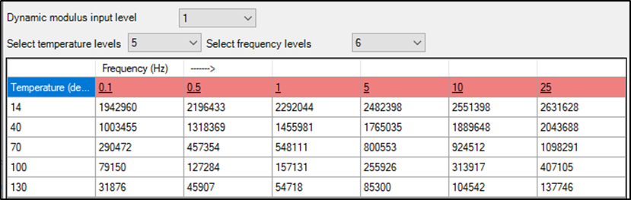
Figure 1. Illustration. Screen Shot for Entering Dynamic Modulus Values in the Pavement ME Design Software, NC High Recycle Intermediate Layer Mixture.

2.2 Plastic Strain Coefficients

2.2.1 Overview of Input Parameter
NCHRP 9-30A, Calibration of Rutting Models for HMA Structural and Mix Design, recommended revisions to the original MEPDG rutting model.⁽⁷⁾ These revisions are incorporated in the current version of AASHTOWare Pavement ME Design, to allow pavement designers to enter asphalt mixture specific plastic strain coefficients (k_{1r}, k_{2r}, k_{3r}) for the asphalt layers. The plastic strain coefficients for R²AMs are derived from a laboratory repeated load permanent deformation test in the same manner as for virgin asphalt mixtures, and are used to predict rutting in the asphalt layers. Chapter 3 in Part 1 of the Guide provides a detailed explanation of and guidance on the repeated load permanent deformation test specimen preparation and test procedure.
Figure 2 shows a typical log-log plot from a repeated load permanent deformation test and identifies the slope and intercept used in AASHTOWare Pavement ME Design software. The repeated load plastic strain curve can exhibit three zones, as defined below.
Figure 2. Graph. Typical Plastic Strain Curve for an Asphalt Mixture for a Single Test Temperature in Logarithmic Scale.

- The first part of the curve is termed the “primary” zone. The primary zone is where the slope of the plastic strain curve decreases with increasing load cycles.
- The second part of the curve is termed the “secondary” zone or steady state portion, and is where the slope of the plastic strain curve is nearly constant. The Pavement ME Design rut depth transfer function uses the slope and intercept from the secondary zone of the plastic strain curve, as shown in figure 2.
- The third part of the curve is termed the “tertiary” zone, and is where the slope of the plastic strain curve increases with increasing load cycles. Asphalt mixtures resistant to plastic strain do not exhibit the tertiary zone. In fact, mixtures that exhibit the tertiary response under confined testing conditions can be susceptible to excessive rutting.
The MEPDG uses the secondary zone to predict the rut depth throughout the pavement design period. As such, the primary and tertiary zones of the plastic strain curve are excluded from the analyses to derive the plastic strain coefficients. The lower the intercept and slope, the more resistant the asphalt mixture is to rutting.

2.2.2 Laboratory Test Data Analysis and Interpretation
The NCHRP 9-30A procedure has two options for testing the asphalt mixtures (refer to Chapter 3 of Part 1 of the Guide): option A includes three test temperatures, while option B uses one test temperature.
- The test temperatures for option A are: (1) 20 ºC (68 ºF), (2) 5 ºC (9 ºF) below the 50 percent reliability high pavement temperature from the LTPPBind® software tool/program, and (3) midway between these two temperatures. For example, the LTPPBind 50 percent high pavement temperature for a Florida (FL) project location was 63 ºC (145 ºF). Specimens for this project were tested at: 20, 58, and 39 ºC (68, 136, and 102 ºF). Option A represents input level 1 for deriving the plastic strain coefficients.
- The test temperature for option B is the equivalent rut depth temperature, which is estimated by the equation included in figure 3. Option B is considered input level 2 and is only mentioned in this Guide for information purposes.
$$T_{RD Equiv}=0.6651\left(T_{LTPPBind}\right)-3.4427$$
where:
T_{RD Equiv} = Equivalent annual temperature for the rut depth predictions, ⁰C
T_{LTPPBind} = LTPPBind temperature at the 50 percent reliability level, ⁰C

Figure 3. Equation. Calculation of the Test Temperature for Option B or the Equivalent Annual Temperature for Rutting.

2.2.2.1 Analysis of Generalized Slope and Intercept Parameters
The primary analysis of repeated load plastic deformation test data for pavement design is the determination of the log-log slope and intercept of the secondary zone of the plastic strain curve. Figure 2 illustrated the slope and intercept used to determine the plastic strain characteristics or coefficients of asphalt mixtures in the AASHTOWare Pavement ME Design software. The intercept and slope coefficients are obtained by fitting the data within the secondary zone of the plastic strain curve to the simplified equation included in figure 4 using linear regression techniques.
$$log\left(ε_{p}\right)=log\left(a\right)+b*\log\left(N\right)$$
where:
ε_{p} = Plastic axial strain
N = Number of load cycles
a = Intercept from the secondary or steady state zone
b = Slope for the secondary or steady state zone

Figure 4. Equation. Calculation of the Accumulated Plastic Axial Strain for a Specific Test Temperature.
The recommended method for determining the slope and intercept of the secondary zone of the plastic strain curve for each test specimen is as follows:
- Check to determine if tertiary flow occurred during the test. This can be done using the flow number algorithm from AASHTO T 378.
- For tests that exhibit tertiary flow, eliminate or discard the data within the tertiary flow zone. In addition, inspect the testing equipment to ensure that the membrane is sealing properly, there are no leaks in the membrane, and the specimen is properly vented. The following are some options to consider in interpreting the test data.
  - If tertiary flow was exhibited on specimens within each test temperature, simply exclude the plastic strains measured within the tertiary flow zone and derive the intercept and slope in accordance with #3 below, except the upper number of load cycles is the point where tertiary flow occurs. However, tertiary flow occurring within each test temperature is an indication that the mixture is susceptible to lateral distortions and excessive rut depths.
  - If tertiary flow was exhibited at one or both of the lower test temperatures, eliminate that portion of the plastic strain curve and derive the slope and intercept in accordance with #3 below, except that the upper number of load cycles is the point at which tertiary flow occurred.
  - If tertiary flow occurs only on the specimens tested at the high test temperature and continues to occur on additional specimens after ensuring there are no membrane leaks and the specimen is properly vented, then decrease the testing temperature by 5 ºC (9 ºF). If tertiary flow continues to be observed at the revised high test temperature, eliminate that portion of the plastic strain curve and derive the slope and intercept in accordance with #3 below, except the upper number of load cycles is the point at which tertiary flow occurs.
- For tests that do not exhibit tertiary flow, fit the data from 1,000 to 10,000 load cycles to the equation shown in figure 4 using linear regression. First take the base 10 logarithm of the number of load cycles and the base 10 logarithm of the plastic strain. Then use linear regression to determine the slope and intercept of the secondary zone of plastic strain curve. Eliminating the first 1,000 load cycles is to exclude the primary zone from the regression analysis.
- Determine the average slope and intercept for the specimens tested at each temperature.
The Pennsylvania (PA) GTR modified surface mixture was used as an example to interpret the results from the repeated load permanent deformation test to derive the plastic strain coefficients. The PA GTR modified mixture was sampled at the asphalt plant and was produced using a GTR modified binder meeting the requirements for Performance Grade (PG) 76-22. The equation included in figure 4 is used to fit each of the repeated load plastic strain curves shown in figure 5 over the range of 1,000 to 10,000 load cycles. The resulting slopes, intercepts and explained variances are summarized in table 2 for the PA GTR-modified surface course mixture.
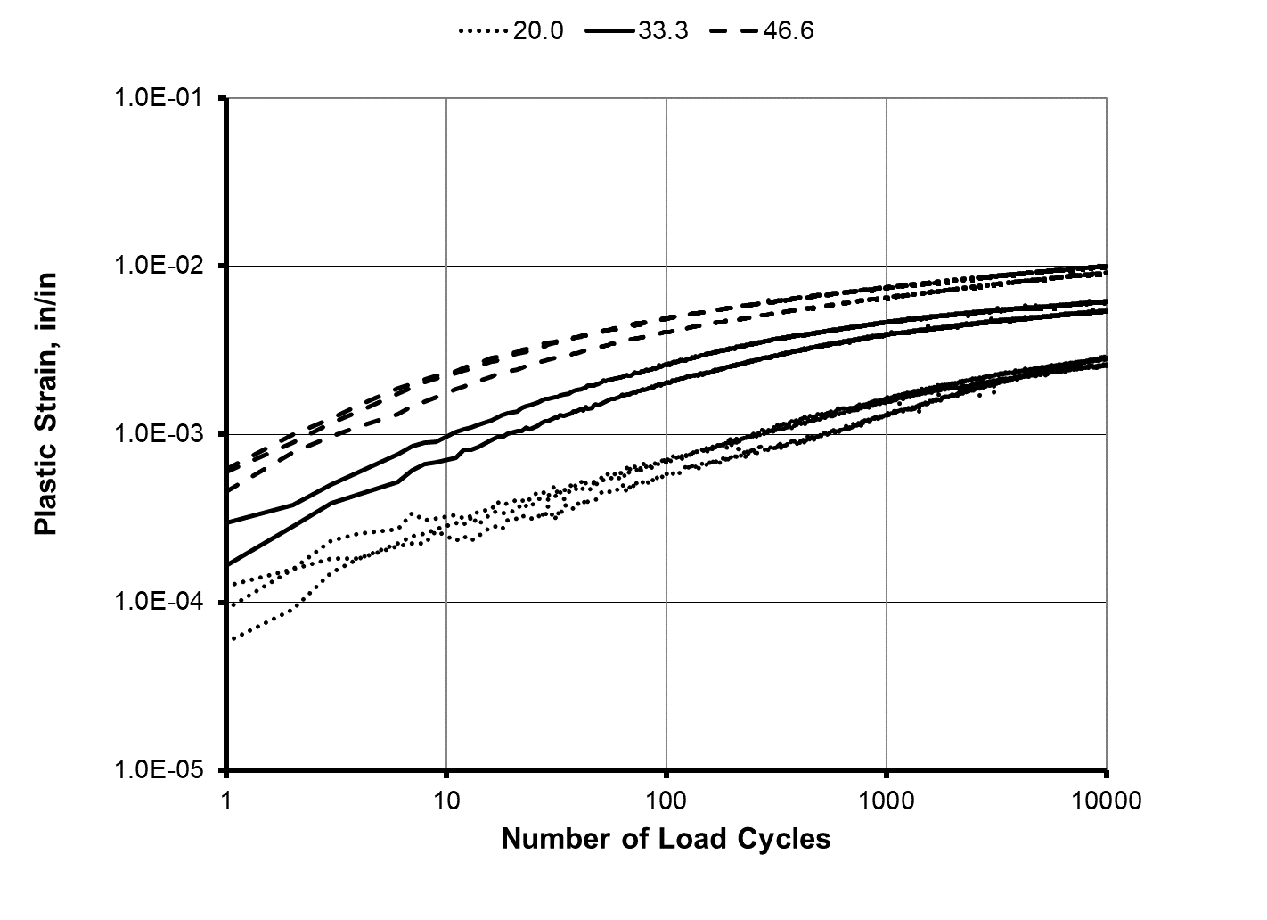
Figure 5. Graph. Plastic Strain Curves for the PA GTR Modified Surface Course Mixture in Logarithmic Scale.

Table 2. Summary of Laboratory Plastic Strain Coefficients for the PA GTR Modified Surface Course Mixture
Specimen | Temperature, ºC | b | a, % | Explained Variance
5 | 20.0 | 0.3337 | 0.0135 | 0.994
9 | 20.0 | 0.2235 | 0.0365 | 0.987
12 | 20.0 | 0.2061 | 0.0393 | 0.990
Average | 20.0 | 0.2544 | 0.0298 | NA
3 | 33.3 | 0.1349 | 0.1572 | 0.993
7 | 33.3 | 0.1152 | 0.2137 | 0.993
10 | 33.3 | 0.1244 | 0.1886 | 0.994
Average | 33.3 | 0.1249 | 0.1865 | NA
2 | 46.6 | 0.1276 | 0.3098 | 0.996
8 | 46.6 | 0.1442 | 0.2429 | 0.997
11 | 46.6 | 0.1224 | 0.3252 | 0.997
Average | 46.6 | 0.1314 | 0.2927 | NA

The coefficients of the MEPDG generalized rut depth transfer function used to represent the laboratory repeated load permanent deformation test and included in the Pavement ME Design software are shown in figure 6.
$$ε_{p}=ε_{r}{10}^{k_{1r}β_{1r}}N^{k_{3r}β_{3r}}T^{k_{2r}β_{2r}}$$
where:
ε_{p} = Accumulated axial plastic strain in the test specimen, in/in.
ε_{r} = Resilient or elastic strain in the test specimen, in/in.
N = Number of load cycles.
T = Test temperature, °F.
k_{1r,} k _{2r,} k _{3r} = Laboratory-derived, plastic strain coefficients using linear regression techniques.
β_{1r},β_{2r},β_{3r} = Calibration coefficients; the β-values are not a part of the measured or laboratory-derived analyses. They are the parameters to remove any bias between the measured and predicted rut depths.

Figure 6. Equation. Calculation of Accumulated Axial Plastic Strain for Predicting Rut Depth from the Laboratory Repeated load Plastic Deformation Test.
The three k-coefficients shown in figure 6 are derived from the laboratory tests for option A:
- k_{1r} is the intercept. The lower the intercept, the lower the predicted rut depth.
- k_{3r} is the number of load cycles exponent or slope within the secondary zone, and assumed to be independent of temperature. The lower the slope, the lower the growth rate of the predicted rut depth and the lower the predicted rut depth.
- k_{2r} is the temperature exponent and assumed to be independent of time. The lower the temperature exponent, the less sensitive plastic strains are to temperature and the lower the predicted rut depth.
For the equations shown in figures 4 and 6, k_{3r} is equal to b and k_{1r} is defined by the intercept and resilient strain for a specific test temperature, as shown by the equation included in figure 7.

2.2.2.2 Derive the MEPDG Laboratory Plastic Strain Coefficients
The MEPDG assumes the number of load cycles exponent, b or k_{3r}, is independent of temperature. This assumption, however, is not applicable to all asphalt mixtures over the entire temperature range between the winter and summer months. The assumption was evaluated within NCHRP project 9-30A by comparing the results between input levels 1, 2, and 3 for plastic strain coefficients.⁽⁷⁾ The results suggested the error from this assumption was nil compared to the errors associated with other parameters, especially the rut depth measurement error in comparing the predicted and measured rut depths.
$$k_{1r}=Log\left(a_{\left(T\right)}\right)-Log\left(ε_{r}\right)-k_{2r}Log\left(T\right)$$
where:
a_{(T)} = Intercept from the secondary zone of the plastic strain versus load cycles relationship on a logarithmic scale for a specific test temperature.

Figure 7. Equation. Calculation of the Intercept Term used in the Transfer Function for the MEPDG.
The following summarizes the combination of test results to determine the three rut depth coefficients that are included in the AASHTOWare Pavement ME Design software.
- Determine the average slope or number of load cycles exponent from the secondary zone, k_{3r}, in accordance with the following rules.
  - If the slope does not consistently change with temperature (consistently and statistically increase or decrease with test temperature), average the slopes or b values from all tests (see table 2).
  - If the slope consistently increases or decreases with temperature but the increase or decrease is statistically indifferent, average the slopes or b values from all tests.
  - If the slope is statistically indifferent between the two higher test temperatures but these two are different from the slope measured at the low test temperature, average the slopes or b values from the two higher test temperatures and ignore the results from the low test temperature.
  - If the slope consistently increases or decreases with test temperature and there is a statistical difference between all three test temperatures, determine the representative slope at the equivalent annual temperature for rut depth (see the equation included in figure 3) by interpolating between the three test temperatures.
- If the average slope, k_{3r}, or b value is less than 0.16, simply set the slope to 0.16. The reason for not using b values less than 0.16 is that the slope derived from the field rut depth time history data collected within NCHRP project 9-30A was always greater than an average value of 0.22.⁽⁷⁾ As such 0.16 times the field adjustment or calibration factor of 1.36 equals 0.22. The field adjustment factor is assumed to be mixture independent.
- Determine the temperature exponent, k_{2r}, or the slope of the linear relationship between logarithmic of temperature (T) and logarithmic a_{(T)}.
- Determine the average intercept term k_{1r} for all test temperatures in accordance with the equation included in figure 7.
The resilient or elastic axial strain for each test temperature for the repeated load permanent deformation test is required to derive the intercept and temperature exponent. The Asphalt Mixture Performance Tester (AMPT), however, does not report the elastic axial deformation. For the test equipment when the elastic axial deformation is not recorded, the elastic axial strain needs to be calculated using the equation shown in figure 8.
$$ε_{r\left(T\right)}=\frac{σ_{p}}{E_{\left(T\right)}}$$
where:
ε_{r(T)} = Resilient or elastic strain in the test specimen for test temperature T, in/in.
T = Test temperature, °F.
σ_{p} = Applied repeated deviator stress in the repeated load plastic deformation test.
E_{(T)} = Dynamic modulus at test temperature T for a 0.1 second load duration or 10 Hz load frequency.
Figure 8. Equation. Calculation of the Resilient or Elastic Axial Strain for a Specific Test Temperature.
It should be noted that the dynamic modulus is measured using an unconfined test condition, while the repeated load plastic deformation test is confined. The difference in testing condition will result in an error in calculating the true resilient strain in the test specimen during confined repeated load testing. This error, however, is believed to be small and is accounted for within the calibration process for the rut depth transfer function.⁽⁸⁾
For the repeated load plastic strain data or curves shown in figure 5, the plastic strain coefficients derived for the PA GTR modified wearing surface mixture are: k_{1r} = -1.774, k_{3r} = 0.128, and k_{2r} = 1.491. The slope coefficient, k_{3r}, however, is less than 0.16, so the value entered into the Pavement ME Design software is 0.16, as noted in the above paragraph. These plastic strain coefficients are entered directly into the Pavement ME Design software under the “Flexible Pavement Calibration Settings” tab. A screen shot for these laboratory-derived input parameters is shown in figure 9 for the PA GTR modified wearing surface. Appendix B shows the determination of input level 1 plastic strain coefficients for the R²AMs included in the test program.
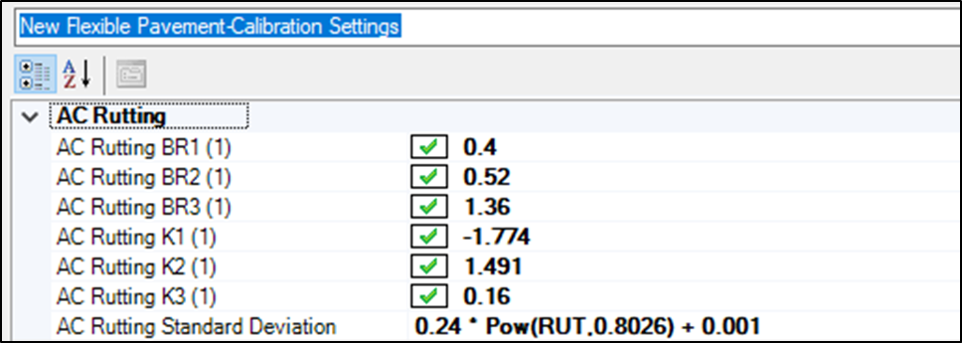
Laboratory-Derived Plastic Strain Coefficients.
Figure 9. Illustration. Screen Shot for Entering the Laboratory-Derived Plastic Strain Coefficients in the Pavement ME Design Software.

2.3 Indirect Tensile Creep Compliance and Strength

2.3.1 Overview of Input Parameters
The transverse cracking model in the AASHTOWare Pavement ME Design software is an enhanced version of the model originally developed during the Strategic Highway Research Program (SHRP).⁽⁹⁾ This model performs a thermo-viscoelastic analysis of a constrained layer to estimate tensile stresses as a function of depth that are caused by contraction forces as the pavement cools. These stresses are used to estimate the depth that a crack has propagated into the asphalt layer. The extent of cracking in the pavement is related to how far the crack has propagated through an idealized asphalt layer.
The asphalt properties needed for the transverse cracking model are: (1) the coefficient of thermal contraction, (2) a creep compliance master curve, (3) the tensile strength measured at -10 ºC (14 ºF), and (4) Poisson’s ratio. The coefficient of thermal contraction is estimated from the volumetric composition of the asphalt mixture and not measured in the laboratory. For input level 1, the IDT creep compliance master curve, tensile strength, and Poisson’s ratio are measured in accordance with AASHTO T 322, Standard Method of Test for Determining the Creep Compliance and Strength of Hot Mix Asphalt (HMA) Using the Indirect Tensile Test Device.
The IDT strength and creep compliance for R²AMs are determined the same as for virgin asphalt mixtures. Chapter 4 of Part 1 of the Guide provides a detailed explanation of and guidance on the IDT creep compliance and strength test procedure; AASHTO T 322. This section of Part 2 of the Guide provides guidance for interpreting the test results of asphalt mixtures in accordance with AASHTO T 322, which is straight forward. In other words, no additional manipulation of the measured data is required for use in the Pavement ME Design software.

2.3.2 Laboratory Test Data Analysis and Interpretation
As noted above, creep compliance and tensile strength are used directly by the Pavement ME Design software to predict the length of transverse cracks. Poisson’s ratio can be entered as a constant value for all temperatures or calculated by the software as a function of temperature.

2.3.2.1 Creep Compliance
The AASHTOWare Pavement ME Design software predicts the length of transverse cracks using the IDT creep compliance values measured for 21 combinations of temperature and loading time (input level 1). The temperatures are 0, -10, and -20 ºC (32, 14, and -4 ºF). Creep compliance values are required for loading times of 1, 2, 5, 10, 20, 50, and 100 seconds. The creep compliance values are entered directly into the software for combinations of temperature and loading time.
For pavement structural design in accordance with the MEPDG, constructing a creep compliance master curve is the primary analysis performed on the creep compliance data. The creep compliance master curve, however, is completed within the Pavement ME Design software. Constructing a creep compliance master curve outside of the Pavement ME Design software is not required, other than to review the creep compliance data for QC purposes. The analysis is the same for all asphalt mixtures.
The creep compliance values from the test procedure are entered directly into the Pavement ME Design software for specific temperatures and loading times from the laboratory test data explained in Chapter 4 of Part 1 of the Guide. Table 3 lists the creep compliance values that are the outcome from the laboratory test for the Wisconsin (WI) high RAP wearing surface mixture. The times in table 3 are the times that creep compliance data are recommended by the AASHTOWare Pavement ME Design software for input level 1.
Table 3. Creep Compliance Values Measured for the WI High Recycle Surface Course Mixture
Loading Time, sec. | Test Temperature, ºF
Loading Time, sec. | -4 | 14 | 32
1 | 3.04E-07 | 4.40E-07 | 8.90E-07
2 | 3.19E-07 | 5.1E-07 | 1.08E-06
5 | 3.51E-07 | 6.06E-07 | 1.44E-06
10 | 3.74E-07 | 7.03E-07 | 1.70E-06
20 | 4.01E-07 | 7.93E-07 | 2.04E-06
50 | 4.46E-07 | 9.72E-07 | 2.62E-06
100 | 4.96E-07 | 1.11E-06 | 3.21E-06

The WI high recycle content surface mixture was a mixture sampled at the asphalt plant and was produced using PG 52-34 binder, 5 percent RAS by weight of aggregate, and 32 percent RAP by weight of aggregate. The recycled binder ratio for this mixture was 0.50. The continuous grade of binder recovered from the mixture was PG 75.9-21.8. The low temperature grade normally specified in the location the mixture was placed is -28.
The creep compliance values and the corresponding test temperatures and loading times are entered into the Pavement ME Design software under Mechanical Properties, Creep Compliance for that asphalt surface layer. A screen shot of this input parameter entry is shown in figure 10 for the WI high recycle surface mixture. Appendix C includes input level 1 creep compliance for the R²AMs included in the test program.
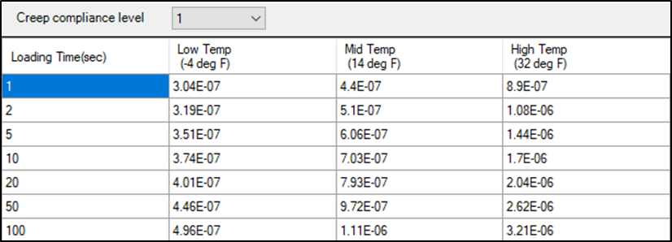
Figure 10. Illustration. Screen Shot for Entering the Laboratory-Measured IDT Creep Compliance in the Pavement ME Design Software.

2.3.2.2 Tensile Strength
The AASHTOWare Pavement ME Design software predicts the length of transverse cracks using the average IDT tensile strength of the mixture measured at -10 ºC (14 ºF) for input level 2. The software interface and definition of the input levels were revised in 2017. Input level 1 includes measuring the IDT strength at three or more test temperatures, while input level 2 includes measuring the IDT strength at -10 ºC (14 ºF) and the software calculates the IDT strengths at higher temperatures. Input level 3 is the same as in previous versions of the software, the strength at -10 ºC (14 ºF) is calculated from regression equations derived from data measured on virgin, neat asphalt mixtures.
Analysis of the AASHTO T 322 strength test data is straightforward; the average of the tensile strengths measured on three test specimens is reported as the asphalt mixture’s IDT strength. Table 4 summarizes the IDT strength for the same WI high recycle surface mixture included above for creep compliance. The average IDT strength is entered directly into the Pavement ME Design software under the “Layer 1 Flexible” tab for Mechanical Properties, Indirect Tensile Strength. A screen shot of this input parameter is shown in figure 11 for the WI high recycle surface mixture. Appendix C includes input level 2 IDT strength for the R²AMs included in the test program.
Table 4. Tensile Strength at -10 ⁰C for the WI High Recycle Surface Mix.
Item | Test Specimen Number
Item | 1 | 2 | 3
Maximum Load, lbs. | 8.68 | 9.53 | 9.31
Diameter, inches | 5.9 | 5.9 | 5.9
Thickness, inches | 1.97 | 1.97 | 1.97
Tensile Strength, psi | 475 | 522 | 510
Average IDT Strength, psi | 502

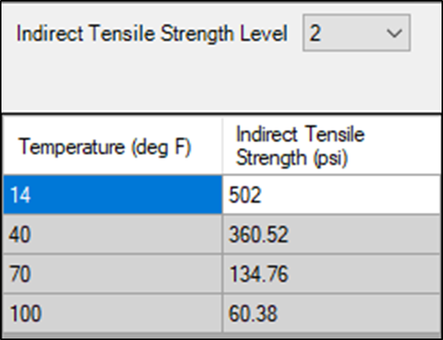
Figure 11. Illustration. Screen Shot for Entering the Laboratory-Measured IDT Strength in the Pavement ME Design Software.

2.3.2.3 Poisson’s Ratio
Poisson’s ratio is calculated as a function of time for test temperatures of 32, 14, and -4 ºF (0, -10, and -20 ºC) at each sampling interval from average data for three test specimens. The global calibration coefficients for all distresses (fatigue cracking, transverse cracking, and rutting) were derived using the temperature dependent Poisson’s ratio relationship included in the Pavement ME Design software. As such, the temperature-dependent Poisson’s ratio relationship included in the software is recommended for use in structural design.
The range of Poisson’s ratio from properly conducted tests is between 0.05 and 0.50. As noted above, time dependent Poisson’s ratio is not a required input to the Pavement ME Design software. The computations external from the software, however, can be used to evaluate the reasonableness of the creep compliance values and/or identify anomalies in the test data.

2.4 Fatigue Strength Coefficients

2.4.1 Overview of Input Parameter
The AASHTOWare Pavement ME Design software predicts two types of load related cracks: (1) alligator (area) cracks which are assumed to initiate at the bottom of the asphalt layer; and (2) longitudinal cracks which are assumed to initiate at the surface. The MEPDGD Manual of Practice recommends that the longitudinal cracks predicted by the Pavement ME Design software be excluded as a design criterion, because that model is being replaced by the methodology and transfer functions from NCHRP project 1-52.⁽¹⁰⁾ The version of the software with the NCHRP 1-52 model should be released at the end of 2019.
The fatigue cracking model embedded in the Pavement ME Design software, version 2.5.3 predicts the area of cracks using the tensile strain at the bottom of the lower asphalt layer and the average dynamic moduli calculated for the truck loading condition and layer temperatures. Three asphalt mixture properties are needed to predict bottom-up (alligator) fatigue cracks: (1) the dynamic modulus as a function of temperature and frequency (see section 2.2 of this chapter); (2) the fatigue strength coefficients (k_{1f}, k_{2f}, and k_{3f}); and (3) the endurance limit. The asphalt content (effective by volume) and air voids also have a significant impact on the predicted area of bottom-up fatigue cracks, as explained in section 2.4.2.3 that follows in this chapter.
The dynamic modulus is measured in accordance with AASHTO T 342, as discussed earlier in this chapter. The fatigue strength coefficients and endurance limit are determined from AASHTO T 321, Standard Method of Test for Determining the Fatigue Life of Compacted Asphalt Mixtures Subjected to Repeated Flexural Bending, in the same manner as for virgin asphalt mixtures. Chapter 5 of Part 1 of the Guide provides a detailed explanation of and guidance for the flexural fatigue test procedure.⁽¹⁾
The fatigue cracking coefficients determine the damage caused by the application of tensile strains at the bottom of the lower asphalt layer. The endurance limit is defined as the tensile strain at which no fatigue damage occurs within the asphalt layer. Thus, all tensile strains below the endurance limit are excluded from the damage computation.

2.4.2 Laboratory Test Data Analysis and Interpretation

2.4.2.1 Definition of Fatigue Strength or Life
The analysis of flexural or bending beam fatigue data includes determining the fatigue life of multiple test specimens. Beam test specimens are tested at different tensile strains for different temperatures. The traditional definition of the fatigue life for a strain or stress controlled flexural fatigue test is the number of cycles required to decrease the flexural stiffness to 50 percent of the initial stiffness value.
In recent changes to AASHTO T 321, the current definition of fatigue life is the number of cycles where the product of the specimen stiffness and load cycles is a maximum. The fatigue life using the current definition is determined by fitting a 6th order polynomial to the curve of flexural stiffness times load cycles versus load cycles and finding the number of cycles where the derivative of the fitted equation is zero, explained in the following subsection of this chapter.

2.4.2.2 Determining the Fatigue Life of Individual Beam Specimens
Analysis of the flexural fatigue data collected in accordance with AASHTO T 321 to determine the fatigue life of the beam test specimen is straightforward and summarized below as explained in Chapter 5 of Part 1 of the Guide.⁽¹⁾
- The traditional definition or version of the test method to determine the fatigue life of an individual beam specimen is the number of cycles required to reduce the flexural stiffness of the specimen to 50 percent of the initial flexural stiffness. The initial flexural stiffness is defined as the flexural stiffness at 50 cycles. This procedure or the traditional definition to determine the fatigue life of an individual beam specimen was used in estimating the fatigue strength coefficients derived for the current and earlier versions of the Pavement ME Design software.
- The current version of the test method defines the fatigue life of an individual beam specimen as the maximum number of load cycles where the peak occurs in the stiffness (S) times the number of load cycles (N) versus number of load cycles. That relationship is defined as an S-N relationship, which is illustrated in figure 12.
The S-N relationship is determined by regressing the base 10 logarithm of the fatigue life of several specimens tested at different tensile strains against the base 10 logarithm of the tensile strain. The peak is determined by fitting a 6th order polynomial of the data collected from cycle 50 where the initial stiffness is determined to the point where the curve has decreased to 90 percent of the “apparent peak” value. The apparent peak value is the maximum value obtained from the raw data.
The polynomial is then differentiated and the derivative is set to zero to determine the peak, as shown by the equation included in figure 13. The fitting is easily accomplished using the trend-line commands in Excel, and the equation in figure 13 is easily solved using the goal seek command in Excel. Figure 12 showed the polynomial fit and the fatigue strength coefficients for the data in figure 14. Substituting the coefficients into the equation included in figure 13 and solving with the goal command in Excel yields a fatigue life of 1,005,763 for the data shown in figure 12.
As an example, table 5 summarizes the test results from AASHTO T 321 for a NC high recycle surface mixture using the two definitions of fatigue life. This NC high recycle surface mixture was sampled at the asphalt plant. The mixture was produced using a PG 58-28 binder with 5 percent manufacturer RAS and 20 percent RAP. Approximately 33 percent of the binder in this mixture was recycled binder with about equal amounts coming from the RAP and RAS. The outcome from each test was analyzed to determine the fatigue life of each beam specimen.
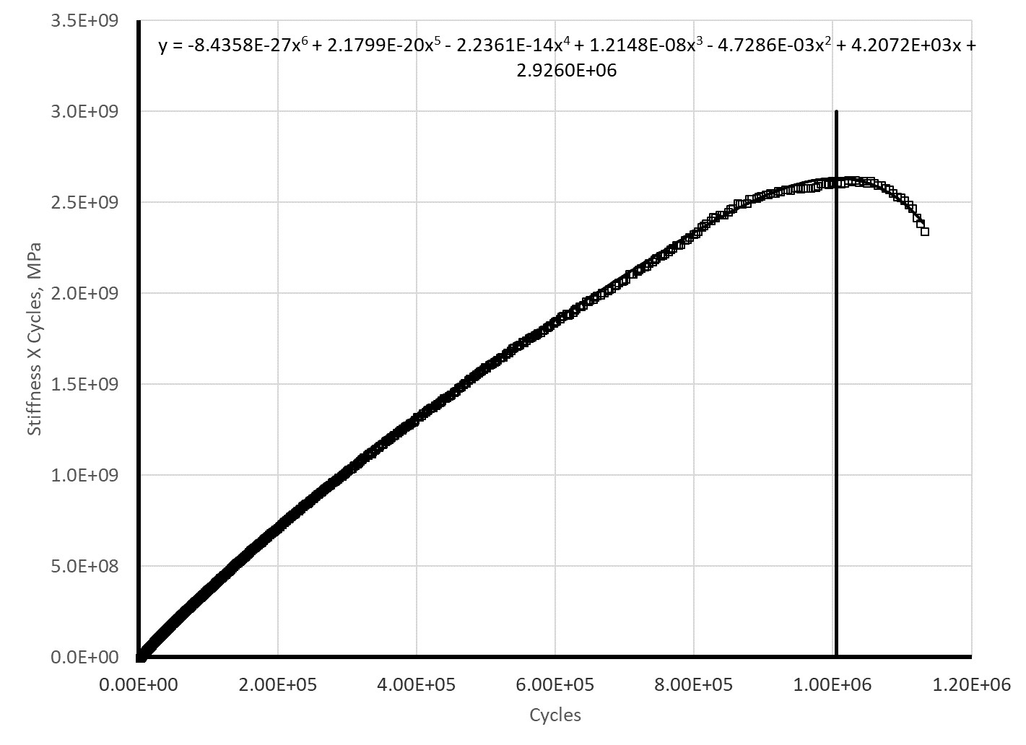
Figure 12. Graph. Polynomial Fitting of the S-N Relationship to Determine the Fatigue Life of a Beam Test Specimen in Accordance with AASHTO T 321 using the Current Fatigue Life Definition.

$$0=a_{1}+2a_{2}x+3a_{3}x^{2}+4a_{4}x^{3}+5a_{5}x^{4}+6a_{6}x^{5}$$
where:
a₁, a₂, a₃, a₄, a₅, a₆ = polynomial coefficients for x, x², x³, x⁴, x⁵, x⁶
Figure 13. Equation. Polynomial Relationship Used to Determine the Fatigue Life of a Beam Test Specimen in Accordance with AASHTO T 321 using the Current Fatigue Life Definition.
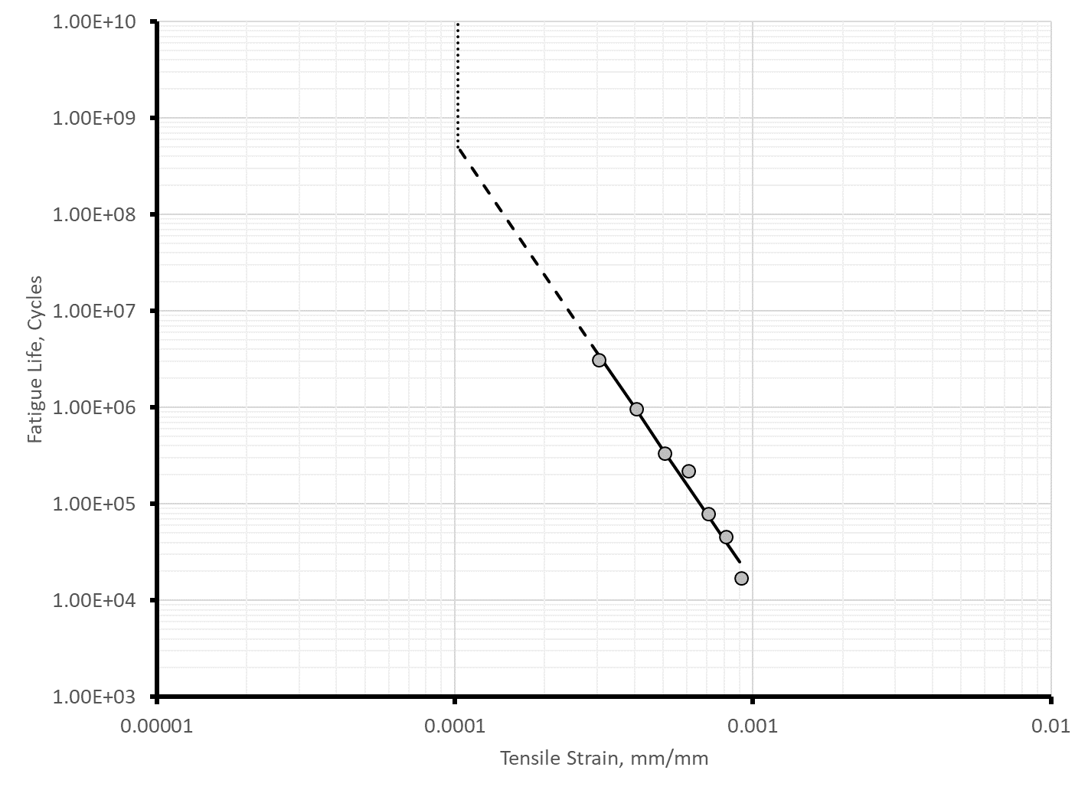
Figure 14. Graph. Example Illustrating the Fatigue Life of Multiple Beam Specimens and Estimating the Endurance Limit for an Asphalt Mixture.

Table 5. Fatigue Lives for the NC High Recycle Surface Mixture at 20 ºC.
Item | 900 μstrain | 700 μstrain | 500 μstrain | 400 μstrain
Coefficient a₆ | -3.6882E-18 | -1.9844E-21 | -1.9381E-24 | -9.3524E-27
Coefficient a₅ | 2.0397E-13 | 5.2871E-16 | 2.2066E-18 | 2.4443E-20
Coefficient a₄ | -4.6890E-09 | -5.6761E-11 | -1.0078E-12 | -2.5153E-14
Coefficient a₃ | 5.7467E-05 | 2.9911E-06 | 2.1989E-07 | 1.3461E-08
Coefficient a₂ | -4.4892E-01 | -8.8240E-02 | -2.4118E-02 | -4.9936E-03
Coefficient a₁ | 4.2332E+03 | 3.9425E+03 | 4.2653E+03 | 4.2249E+03
Fatigue Life (Peak of stiffness times cycles), cycles | 17,699 | 82,009 | 346,723 | 1,004,762
Fatigue Life (50 percent stiffness reduction, cycles | 9,850 | 58,730 | 317,440 | 926,679

2.4.2.3 Determining Fatigue Strength Coefficients
Multiple beam specimens are tested in accordance with AASHTO T 321 at different tensile strains for two or three test temperatures, as discussed in Chapter 5 of Part 1 of the Guide.⁽¹⁾ The outcome from the flexural beam tests is a tabulation of tensile strain, temperature, and fatigue life or number of load cycles to the specific definition of failure (traditional or the current definition of failure).
The analysis of flexural fatigue data from multiple beam specimens is to develop a relationship by performing a regression of the logarithm of the fatigue life versus the logarithm of the flexural strain. The fitting is easily performed using the regression function in Excel. For each beam tested, first take the base 10 logarithm of the average tensile strain during the test, and the base 10 logarithm of the fatigue life. Then use the linear regression function in Excel to determine the slope, k₂, and the intercept, k₁, of the basic relationship between the applied tensile strain and number of load cycles to failure (see equation included in figure 15), as defined by multiple beams tested to failure using the traditional or current definition of fatigue life.
$$N_{f}=k_{1}{\left(\frac{1}{ε_{t}}\right)}^{k_{2}}$$
where:
N_{f} = Number of cycles to failure
ε_{t} = Tensile strain, μstrain
k₁, k₂ = Regression fitting coefficients

Figure 15. Equation. Basic Fatigue Relationship for an Asphalt Mixture for one Test Temperature.
Table 6 lists the resulting basic k₁ and k₂ fatigue strength coefficients at 20 ºC (68 ºF) for the NC high recycle surface mixture data listed in table 5, while figure 16 graphically compares the two definitions of fatigue life for the NC high recycle surface mixture. The fatigue life using the current definition is longer than determined using the traditional definition. At higher strains, the fatigue life using the current definition is about 1.8 times that from the traditional definition, while at low strains the current definition produces about 10 percent longer fatigue lives.
Table 6. Fatigue Strength Coefficients and the Endurance Limit Estimated for the NC High Recycle Surface Mixture at 20 ºC Using the Two Definitions of Fatigue Life.
Definition of Fatigue Life | k₁ | k₂ | Estimated Endurance Limit, μstrain
Current Definition; Peak of Stiffness Times Cycles | 2.65E-11 | -4.88454 | 0.000113
Traditional Definition; 50 percent Stiffness Reduction | 1.71E-13 | -5.52733 | 0.000131

The important point relative to the definition of fatigue life for individual beam specimens is the definition has an effect on the calibration coefficients because the allowable number of load cycles is different between the two definitions (see figure 16). The traditional definition for determining fatigue life was used in the latter chapters of Part 2 of the Guide because the traditional definition was used in estimating the laboratory-derived default fatigue strength coefficients for dense-graded virgin asphalt mixtures.
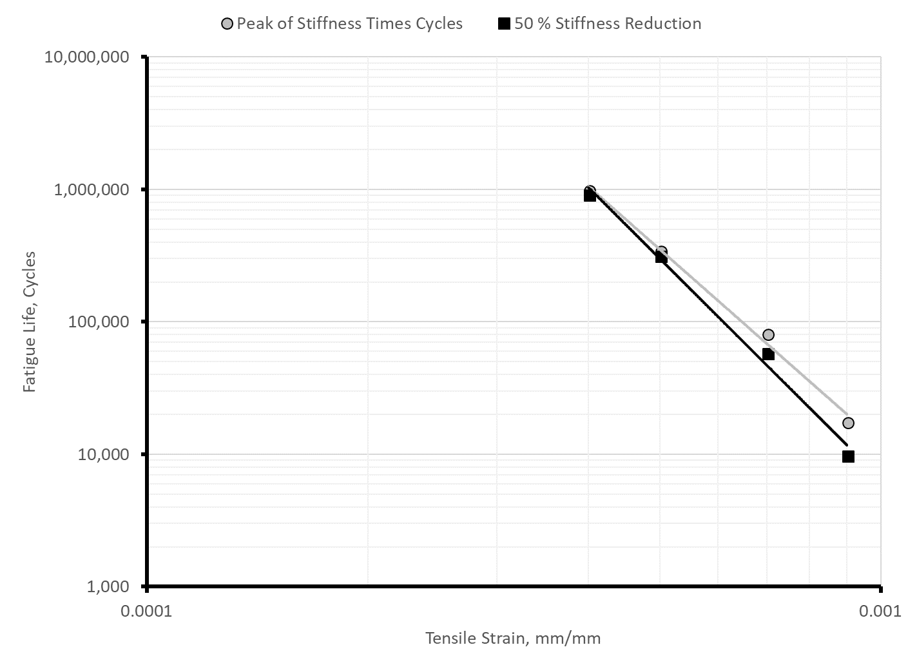
Figure 16. Graph. Fatigue Strength for the NC High Recycle Surface Mixture at 20 ºC Using Two Definitions of Fatigue Life
The fatigue life or allowable number of load cycles equation included in the Pavement ME Design software is included in figure 17. The allowable number of load cycles is used in the incremental damage analysis. The equation included in figure 17 includes an adjustment factor, C, between the volumetric difference between test specimens, as well as combining the results using different test temperatures or flexural stiffness. The equation for the C adjustment factor is included in figure 18.
The intercept, k_{1f}, and strain exponent, k_{2f}, are determined using a linear regression analysis as for the equation included in figure 15. An important point to recognize is flexural fatigue (bending beam) testing between specimens can be highly variable, even taking into consideration the difference in volumetric properties between specimens (the C adjustment factor in the equation included in figure 17).
$$N_{f}=k_{1f}C{\left(\frac{1}{ε_{t}}\right)}^{k_{2f}}{\left(\frac{1}{E}\right)}^{k_{3f}}$$
where:
N_{f} = Allowable number of load cycles.
ε_{t} = Tensile strain, in/in.
E = Asphalt dynamic modulus, psi.
C = Mixture volumetric property factor; defined by the equation included in figure 18.
k_{1f}, k_{2f}, k_{3f} = Laboratory-derived fatigue strength coefficients.
Figure 17. Equation. Calculation of the Allowable Number of Load Cycles or Fatigue Strength.
$$C= {10}^{\left(VFA-0.69\right)}$$
where:
VFA = Voids filled with asphalt expressed as a decimal.
Figure 18. Equation. Calculation of the Mixture Volumetric Adjustment Factor, C.
The resulting fatigue strength coefficients (see figure 17) for the NC high RAP surface mixture are listed below for the traditional definition of fatigue life:
- Intercept, k_{1f} = 0.0604 in./in. (60.4 mils/in.)
- Strain Exponent, k_{2f} = 5.644
- Modulus Exponent, k_{3f} = 2.012
These fatigue coefficients are entered into the Pavement ME Design software under the “New Flexible Pavement Calibration Settings” tab for AC Fatigue. A screen shot for the laboratory-derived input parameters is shown in figure 19 for the NC high RAP surface mixture. Appendix D shows the determination of input level 1 fatigue strength coefficients for the R²AMs included in the test program. (NOTE: AC is used in the software screens and represents Asphalt Concrete. That term, however, is being abandoned or replaced with asphalt.)

2.4.2.4 Determining the Endurance Limit
The endurance limit is a parameter that can be considered by the AASHTOWare Pavement ME Design software. Only one value is entered or assigned to the lower asphalt layer. In other words, the endurance limit is assumed to be temperature and modulus independent.
Multiple projects have been completed to confirm the endurance limit concept for structural flexible pavement design.^{(11,12,13)} Some of the earlier studies suggested one value was appropriate for all asphalt mixtures and temperatures, while latter studies suggest the endurance limit is temperature dependent.
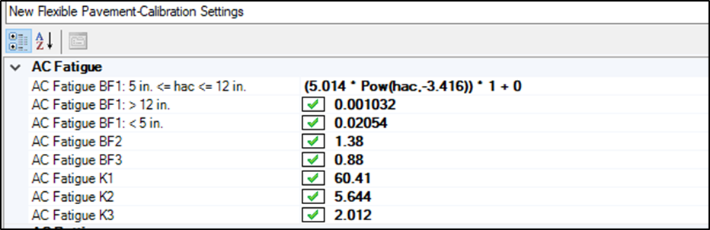
Laboratory-Derived Fatigue Strength Coefficients.
Figure 19. Illustration. Screen Shot for Entering the Laboratory-Derived Fatigue Strength Coefficients in the Pavement ME Design Software.
The fatigue cracking calibration for Pavement ME Design software version 2.5.3 was completed without using the endurance limit. As such, the MEPDG Manual of Practice recommends the endurance limit be excluded in designing flexible pavements or asphalt overlays with the Pavement ME Design software using the global fatigue cracking model coefficients. The fatigue cracking calibration coefficients would need to be derived for the condition of using the endurance limit feature.
The endurance limit for virgin asphalt mixtures and R²AMs is estimated by extrapolating the fatigue life relationship to 500,000,000 load cycles. The results for the NC high recycle surface mixture are summarized in table 6 for the two fatigue life definitions, as shown graphically in figure 14. As illustrated in figure 16 and in table 6, the endurance limit is dependent on the definition of fatigue life. If the test procedure and/or definition of fatigue life changes, the change will have an impact of the laboratory-derived endurance limit.
The endurance limit is entered directly into the Pavement ME Design software under the “AC Layer Properties” tab. A screen shot for the laboratory-derived endurance limit is shown in figure 20 for the NC high RAP surface mixture.
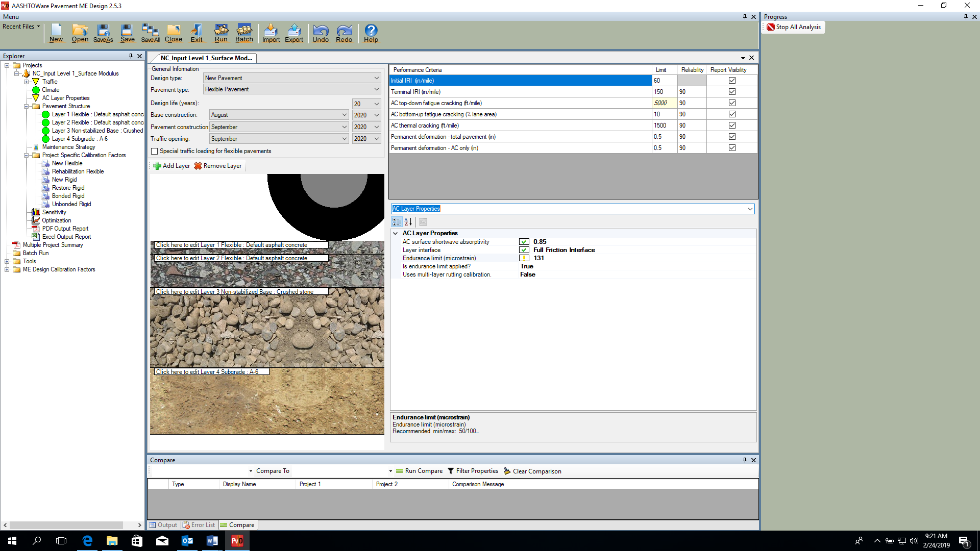
Figure 20. Illustration. Screen Shot for Entering the Laboratory-Derived Endurance Limit in the Pavement ME Design Software.

Chapter 3. Predicted Distresses for R²AMs

This chapter of Part 2 of the Guide uses the measured input level 1 mixture properties discussed in Chapter 2 to predict total rut depth, fatigue cracking, and transverse cracking of R²AM mixtures. The predicted distresses for the R²AM mixtures using input level 1 properties are compared to the predicted distresses using input level 3 default properties and coefficients for virgin, neat asphalt mixtures using the same volumetric and component properties.

3.1 R²AMs Material Property Data
Material from 9 mixtures produced between 2014 and 2016 were sampled and tested using the procedures presented in this Guide. Five of the mixtures included high recycle binder content, three mixtures contained a binder modified with GTR, and one mixture contained a binder modified with styrene butadiene styrene (SBS) polymer. Properties of the high RAP mixtures are summarized in table 7. Similar data for the mixtures containing binder modified with GTR and SBS are summarized in table 8.
As noted in the earlier chapters, input level 1 properties of the R²AM mixtures were measured for 8 of the 9 mixtures for dynamic modulus, plastic strain coefficients, and IDT creep compliance and strength. The one mixture not included in the test program was the PA polymer modified asphalt (PMA) mixture. The fatigue strength properties, however, were measured for all 9 R²AM mixtures. The PA Department of Transportation measured all of the input level 1 properties on many of their typical virgin asphalt mixtures, with the exception for fatigue strength. As such, the measured properties for a typical PMA wearing surface mixture was extracted from the PA library of materials and used in these comparisons for the PA location.
The high recycle binder content mixtures were sampled from projects in WI and NC. Except for the NC base mixture, the mixtures were produced with a combination of RAP and RAS and used a virgin binder that was one grade softer than normally required. The NC base mixture was produced with RAP and PG 64-22 binder, the binder normally specified for that environment.
The mixtures with GTR and PMA binders were sampled from projects in Massachusetts (MA), FL, and PA. The MA GTR mixture was an asphalt rubber gap graded (ARGG) mixture produced with asphalt rubber binder meeting ASTM D 6114 (Type II). The FL and PA GTR mixtures were dense graded surface mixtures produced using proprietary rubber modification processes. The PA surface mixture produced with an SBS modified PG 76-22 binder was also sampled. The FL GTR binder met specification requirements for FL designation PG 76-22 asphalt rubber binder (ARB), requiring a minimum of 7 percent rubber. The PA GTR modified binder met the physical properties for PG 76-22. The MA and FL mixtures also contained RAP. One of the PA surface mixtures sampled consisted of only virgin material components; no GTR, RAP, or RAS.
Table 7. Properties of RAP Mixtures.
Property |  | WI RAP+RAS  Base | WI RAP+RAS Surface | NC RAP Base | NC RAP+RAS  Binder | NC RAP+RAS Surface
Gradation, percent passing sieve size, mm | 37.5 | 100 | 100 | 100 | 100 | 100
Gradation, percent passing sieve size, mm | 25 | 100 | 100 | 94 | 100 | 100
Gradation, percent passing sieve size, mm | 19 | 99 | 100 | 92 | 100 | 100
Gradation, percent passing sieve size, mm | 12.5 | 90 | 98 | 88 | 91 | 100
Gradation, percent passing sieve size, mm | 9.5 | 77 | 86 | 83 | 82 | 96
Gradation, percent passing sieve size, mm | 4.75 | 57 | 70 | 59 | 55 | 72
Gradation, percent passing sieve size, mm | 2.36 | 46 | 54 | 45 | 43 | 58
Gradation, percent passing sieve size, mm | 1.18 | 35 | 41 | 36 | 35 | 47
Gradation, percent passing sieve size, mm | 0.6 | 25 | 30 | 27 | 25 | 33
Gradation, percent passing sieve size, mm | 0.3 | 13 | 15 | 16 | 15 | 19
Gradation, percent passing sieve size, mm | 0.15 | 7 | 8 | 10 | 9 | 11
Gradation, percent passing sieve size, mm | 0.075 | 4.9 | 5.7 | 6.8 | 6.4 | 7.2
Percent Recycled Binder |  | 50 | 50 | 33 | 40 | 33
Recycle Type |  | RAP+RAS | RAP+RAS | RAP | RAP+RAS | RAP+RAS
Virgin Binder, PG |  | 52-34 | 52-34 | 64-22 | 58-28 | 58-28
Asphalt Content, percent |  | 4.53 | 4.51 | 4.38 | 4.20 | 5.72
Voids in Mineral Aggregate (VMA) at 7 % Air Voids, % |  | 15.6 | 15.6 | 17.3 | 16.7 | 20.3
Effective Volume of Binder (V_{be}), percent |  | 8.6 | 8.6 | 10.3 | 9.7 | 13.3
VFA at 7% Air voids, percent |  | 56.6 | 55.2 | 59.1 | 57.8 | 64.6
Recovered Binder Properties | High | 76.9 | 75.9 | 78.0 | 80.5 | 80.9
Recovered Binder Properties | Intermediate | 21.5 | 19.6 | 24.8 | 23.0 | 24.8
Recovered Binder Properties | Low S – Value | -29.2 | -30.1 | -24.9 | -27.8 | -26.2
Recovered Binder Properties | Low m – Value | -20.2 | -21.8 | -25.5 | -25.0 | -23.7
Recovered Binder Properties | Low Overall | -20.2 | -21.8 | -24.9 | -25.0 | -23.7
Recovered Binder Properties | Nearest PG | 76-22 | 76-22 | 76-22 | 82-22 | 82-22

The mixtures were produced for a range of environmental conditions. Table 9 presents a summary of temperatures near the mixture production locations, and includes: (1) the mean annual air temperature (MAAT), (2) the 50 percent reliability high pavement temperature at a depth of 20 mm from LTPPBind version 3.1, and (3) the 50 percent reliability low pavement temperature at the surface from LTPPBind version 3.1. The MAATs were used to compare the fatigue properties of the mixtures at a temperature representative of the environment that the mixture is subjected to. The 50 percent reliability high pavement temperature from LTPPBind was used to select test temperatures for characterizing the plastic strain coefficients of the mixtures. The 50 percent low pavement temperatures characterize the winter environment near where the mixtures were produced and used.
Table 8. Properties of GTR and PMA Mixtures.
Property |  | MA RAP+GTR  ARGG | FL RAP+GTR Surface | PA GTR+PMA Surface | PA PMA Surface
Gradation, percent passing sieve size, mm | 37.5 | 100 | 100 | 100 | 100
Gradation, percent passing sieve size, mm | 25 | 100 | 100 | 100 | 100
Gradation, percent passing sieve size, mm | 19 | 100 | 100 | 100 | 100
Gradation, percent passing sieve size, mm | 12.5 | 93 | 99 | 100 | 100
Gradation, percent passing sieve size, mm | 9.5 | 78 | 95 | 99 | 98
Gradation, percent passing sieve size, mm | 4.75 | 33 | 68 | 66 | 56
Gradation, percent passing sieve size, mm | 2.36 | 18 | 48 | 46 | 39
Gradation, percent passing sieve size, mm | 1.18 | 14 | 35 | 33 | 29
Gradation, percent passing sieve size, mm | 0.6 | 11 | 27 | 24 | 22
Gradation, percent passing sieve size, mm | 0.3 | 8 | 17 | 15 | 14
Gradation, percent passing sieve size, mm | 0.15 | 7 | 8 | 7 | 7
Gradation, percent passing sieve size, mm | 0.075 | 5.2 | 4.4 | 3.1 | 3.5
Percent Recycled Binder |  | <10 | 24 | 0 | 0
Recycle Type |  | RAP | RAP | NA | NA
Virgin Binder PG |  | 58-28 | 76-22 ARB | 76-22 | 76-22
GTR Content |  | ≥ 15 % | ≥ 7 % + polymer | rubber + polymer | None
Asphalt Content, percent |  | 6.54 | 4.68 | 5.90 | 5.90
VMA at 7 % Air Voids, percent |  | 20.9 | 18.4 | 18.4 | 18.4
V_{be}, percent |  | 13.9 | 11.4 | 11.4 | 11.4
VFA at 7% Air voids, percent |  | 66.7 | 61.9 | 61.0 | 61.0
Recovered Binder Properties | High | 85.2 | 78.6 | 78.7 | 78.3
Recovered Binder Properties | Intermediate | 9.6 | 17.2 | 21.9 | 19.8
Recovered Binder Properties | Low S – Value | -36.6 | -30.7 | -26.1 | -27.8
Recovered Binder Properties | Low m – Value | -33.2 | -27.5 | -27.8 | -28.4
Recovered Binder Properties | Low Overall | -33.2 | -27.5 | -26.1 | -27.8
Recovered Binder Properties | Nearest PG | 82-34 | 76-28 | 76-28 | 76-28

Table 9. Summary of Temperatures.
Characteristic  Temperature | WI | NC | MA | FL | PA
MAAT, °C | 8.6 | 16.7 | 9.4 | 20.3 | 9.7
LTPPBind 50 % High Pavement, °C | 52.6 | 60.8 | 48.0 | 65.3 | 51.6
LTPPBind 50 %  Low Pavement, °C | -20.7 | -6.4 | -16.6 | -1.6 | -14.7

3.2 Inputs for Simulations
A common set of inputs was used for all of the runs made with the AASHTOWare Pavement ME Design for comparing the predicted distresses between the R²AM using input level 1 laboratory-derived properties and input level 3 default properties determined for virgin asphalt mixtures. The following summarizes the assumptions for all runs.
- General Design Information:
  - Design Life – a 20-year design period was assumed for all simulations.
  - A reliability level of 90 percent was assumed for all simulations.
- Climate: the climate grid point from the Pavement ME Design climate dataset (MERRA2) was selected for each agency that provided the R²AM mixtures. The grid point selected was simply nearest a ground-based weather station. The longitude and latitude for each grid point used in the simulations are listed in table 10.
- Structural Inputs:
  - A total asphalt layer thickness of 7 inches was assumed for all simulations, which consisted of two layers. The wearing surface was assumed to be 2 inches and the lower asphalt layer was assumed to be a 5-inch asphalt base layer. A total asphalt thickness of 7 inches was selected to result in higher predicted distresses in comparing the different simulations.
  - A 12-inch crushed stone base was assumed for all pavement simulations. The resilient modulus of this layer did vary by the type of crushed stone or granular base included within the Long Term Pavement Performance (LTPP) program database between the different locations.
- Subgrade Inputs: the subgrade soil for the pavement simulations was defined by the soils commonly exhibited near the grid point or ground-based weather station selected for the example. Input level 3 default properties for each soil type were used in all simulations. The subgrade soil for each location is defined below:
  - FL – an A-3 soil.
  - MA – an A-2-4 soil
  - NC – an A-6 soil.
  - PA – an A-6 soil
  - WI – an A-4 soil.
- Traffic Inputs: all traffic inputs were assumed to be the same between all simulations, regardless of location. The following summarizes some of the more important truck traffic inputs:
  - Average Annual Daily Truck Traffic (AADTT) = 2,000. In addition, only one lane was simulated with 100 percent trucks in the design lane and direction.
  - A 3 percent linear growth rate was assumed, which results in about 20 million trucks along the design lane over the design period.
  - A truck traffic classification (TTC) group of 2 was assumed.
  - Unity was assumed for the monthly adjustment factors and the global default values for the number of axles per axle type and truck classification was assumed.
  - The total number of trucks for the 20-year design period was 18.8 million.
Table 10. Longitude, Latitude, and Elevation of the Climate Station Used in the Simulation for each Mixture.
State | Climate Station Number | Latitude | Longitude | Elevation, ft.
FL | Jacksonville; | 30.0 | -81.87 | 98
MA | Boston; | 42.5 | -71.23 | 135
NC | Charlotte; | 35.0 | -80.62 | 653
PA | Harrisburg; | 40.5 | -76.87 | 535
WI | Madison; | 43.0 | -89.37 | 882

3.3 Dynamic Modulus
Dynamic moduli were measured in accordance with AASHTO T 342 and determined in accordance with AASHTO R 84 for eight of the nine mixtures sampled. The one asphalt mixture excluded from the dynamic modulus test program was the PA PMA virgin mixture. The laboratory-measured dynamic moduli represent input level 1 and are needed for predicting rut depth in the asphalt layers and the area of alligator or bottom-up fatigue cracks. Table 11 summarizes the volumetric and continuous AASHTO M 320 PG properties for binder recovered from the R²AMs, while table 12 includes similar data but for the R²AMs containing binder modified with GTR.

3.3.1 Comparison of Calculated Dynamic Modulus: Input Level 3 to Input Level 1
Table 13 through table 20 summarize the dynamic moduli measured on each of the R²AMs. Screen shots for input level 1 dynamic moduli values are included in appendix A. Figure 21 includes a graphical comparison of the input level 1 laboratory-measured dynamic moduli and the input level 3 calculated dynamic moduli from the regression equation embedded in the Pavement ME Design software. The nearest PG from the recovered binders was used in the comparison (refer to table 7 and table 8). As shown, there are differences between the laboratory-derived and calculated values for an individual R²AM. The following summarizes those differences.
- The dynamic moduli measured for the high RAP mixtures (input level 1) are consistently lower than for the calculated values using the regression equations included in the Pavement ME Design software (input level 3) across the range of temperatures and frequencies used in the test program.
- The dynamic moduli measured for the GTR-modified mixtures are lower than for the calculated values using the regression equations included in the Pavement ME Design software in the high temperature, low frequency range and low temperature, high frequency range, but are higher in the intermediate temperature and frequency range.
- The high RAP mixtures exhibit a much greater range in measured dynamic modulus than for the GTR-modified mixtures. Within the high temperature, low frequency range the dynamic moduli for both R²AMs are similar, but the high RAP mixtures exhibit much higher dynamic moduli in the low temperature, high frequency range.
Table 11. Volumetric and PG Properties for Mixtures with High Recycled Binder Content.
Property | WI RAP+RAS  Base | WI RAP+RAS  Surface | NC RAP  Base | NC RAP+RAS  Binder | NC RAP+RAS  Surface
Asphalt Content, total by weight, percent | 4.53 | 4.51 | 4.38 | 4.20 | 5.72
VMA at 7% Air Voids, percent | 15.6 | 15.6 | 17.3 | 16.7 | 20.3
V_{be}, percent | 8.6 | 8.6 | 10.3 | 9.7 | 13.3
VFA at 7% Air Voids, percent | 56.6 | 55.2 | 59.1 | 57.8 | 64.6
Continuous High Temperature Grade, ⁰C | 76.9 | 75.9 | 78.0 | 80.5 | 80.9
Continuous Intermediate Temperature Grade, ⁰C | 21.5 | 19.6 | 24.8 | 23.0 | 24.8
Continuous Low Temperature Grade, ⁰C | -20.2 | -21.8 | -24.9 | -25.0 | -23.7

Table 12. Volumetric and PG Properties for Mixtures with GTR Modified Binder.
Property | MA RAP+GTR ARGG | FL RAP+GTR Surface | PA GTR+PMA Surface
Asphalt Content, total by weight, percent | 6.54 | 4.68 | 5.90
VMA at 7% Air Voids, percent | 20.9 | 18.4 | 18.4
V_{be}, percent | 13.9 | 11.4 | 11.4
VFA at 7% Air Voids, percent | 66.7 | 61.9 | 61
Continuous High Temperature Grade, ⁰C | 85.2 | 78.6 | 78.7
Continuous Intermediate Temperature Grade, ⁰C | 9.6 | 17.2 | 21.9
Continuous Low Temperature Grade, ⁰C | -33.2 | -27.5 | -26.1

Table 13. Dynamic Moduli Measured on the WI High RAP+RAS Base Mixture.
Test Temperature, ºF | Loading Frequency, Hz
Test Temperature, ºF | 0.1 | 0.5 | 1.0 | 5.0 | 10.0 | 25.0
14 | 1,737,918 | 2,012,713 | 2,122,806 | 2,355,163 | 2,444,563 | 2,552,736
40 | 790,066 | 1,055,206 | 1,177,831 | 1,471,465 | 1,598,151 | 1,762,510
70 | 231,303 | 351,498 | 417,307 | 605,063 | 700,706 | 839,520
100 | 76,816 | 117,294 | 141,400 | 218,380 | 262,524 | 332,857
130 | 37,492 | 53,811 | 63,652 | 96,134 | 115,610 | 148,028

Table 14. Dynamic Moduli Measured on the WI High RAP+RAS Surface Mixture.
Test Temperature, ºF | Loading Frequency, Hz
Test Temperature, ºF | 0.1 | 0.5 | 1.0 | 5.0 | 10.0 | 25.0
14 | 2,072,501 | 2,416,819 | 2,557,524 | 2,860,660 | 2,979,845 | 3,126,250
40 | 996,458 | 1,316,403 | 1,464,110 | 1,818,802 | 1,972,761 | 2,173,788
70 | 304,197 | 457,342 | 539,790 | 771,436 | 888,045 | 1,056,269
100 | 89,575 | 138,361 | 167,195 | 258,415 | 310,285 | 392,480
130 | 34,834 | 50,504 | 59,929 | 90,974 | 109,579 | 140,579

Table 15. Dynamic Moduli Measured on the NC High RAP Base Mixture.
Test Temperature, ºF | Loading Frequency, Hz
Test Temperature, ºF | 0.1 | 0.5 | 1.0 | 5.0 | 10.0 | 25.0
14 | 2,079,645 | 2,349,731 | 2,452,345 | 2,658,432 | 2,733,900 | 2,822,316
40 | 1,033,626 | 1,365,909 | 1,511,807 | 1,841,807 | 1,976,048 | 2,143,188
70 | 273,116 | 443,022 | 536,068 | 796,556 | 925,300 | 1,106,750
100 | 64,741 | 111,666 | 141,374 | 241,236 | 300,469 | 396,146
130 | 22,584 | 35,932 | 44,616 | 75,782 | 95,878 | 131,025

Table 16. Dynamic Moduli Measured on the NC High RAP+RAS Intermediate Mixture.
Test Temperature, ºF | Loading Frequency, Hz
Test Temperature, ºF | 0.1 | 0.5 | 1.0 | 5.0 | 10.0 | 25.0
14 | 1,942,960 | 2,196,433 | 2,292,044 | 2,482,398 | 2,551,398 | 2,631,628
40 | 1,003,455 | 1,318,369 | 1,455,981 | 1,765,035 | 1,889,648 | 2,043,688
70 | 290,472 | 457,354 | 548,111 | 800,553 | 924,512 | 1,098,291
100 | 79,150 | 127,284 | 157,131 | 255,926 | 313,917 | 407,105
130 | 31,876 | 45,907 | 54,718 | 85,300 | 104,542 | 137,746

Table 17. Dynamic Moduli Measured on the NC High RAP+RAS Surface Mixture.
Test Temperature, ºF | Loading Frequency, Hz
Test Temperature, ºF | 0.1 | 0.5 | 1.0 | 5.0 | 10.0 | 25.0
14 | 2,041,634 | 2,311,976 | 2,415,785 | 2,626,455 | 2,704,437 | 2,796,462
40 | 1,000,834 | 1,320,100 | 1,461,588 | 1,785,165 | 1,918,380 | 2,085,684
70 | 269,937 | 429,380 | 516,455 | 760,809 | 882,267 | 1,054,517
100 | 68,699 | 114,437 | 142,877 | 23,7051 | 292,368 | 381,378
130 | 25,810 | 39,777 | 48,662 | 79,775 | 99,424 | 133,323

Table 18. Dynamic Moduli Measured on the MA RAP+GTR AGGR Surface Mixture.
Test Temperature, ºF | Loading Frequency, Hz
Test Temperature, ºF | 0.1 | 0.5 | 1.0 | 5.0 | 10.0 | 25.0
14 | 1,308,049 | 1,498,004 | 1,570,917 | 1,718,156 | 1,772,219 | 1,835,553
40 | 608,874 | 819,108 | 914,542 | 1,136,613 | 1,229,148 | 1,345,895
70 | 169,802 | 263,184 | 315,400 | 466,360 | 543,595 | 655,288
100 | 55,593 | 83,287 | 100,212 | 156,010 | 188,965 | 242,538
130 | 28,490 | 38,396 | 44,433 | 64,749 | 77,220 | 98,429

Table 19. Dynamic Moduli Measured on the FL RAP+GTR Surface Mixture.
Test Temperature, ºF | Loading Frequency, Hz
Test Temperature, ºF | 0.1 | 0.5 | 1.0 | 5.0 | 10.0 | 25.0
14 | 2,264,714 | 2,517,293 | 2,615,063 | 2,815,914 | 2,891,414 | 2,981,593
40 | 1,068,500 | 1,371,630 | 1,506,605 | 1,819,135 | 1,950,024 | 2,116,833
70 | 287,138 | 430,691 | 507,812 | 723,420 | 831,209 | 985,685
100 | 86,523 | 132,275 | 159,353 | 245,140 | 293,953 | 371,269
130 | 41,753 | 60,433 | 71,669 | 108,581 | 130,594 | 167,055

Table 20. Dynamic Moduli Measured on the PA GTR+PMA Surface Mixture.
Test Temperature, ºF | Loading Frequency, Hz
Test Temperature, ºF | 0.1 | 0.5, | 1.0 | 5.0 | 10.0 | 25.0
14 | 1,715,547 | 1,931,512 | 2,008,777 | 2,154,493 | 2,204,311 | 2,259,962
40 | 782,268 | 1,083,489 | 1,216,079 | 1,510,234 | 1,625,932 | 1,765,493
70 | 173,819 | 296,311 | 368,844 | 586,605 | 699,836 | 863,055
100 | 48,660 | 76,915 | 95,558 | 162,558 | 205,161 | 277,792
130 | 25,068 | 33,831 | 39,486 | 59,972 | 73,491 | 97,830

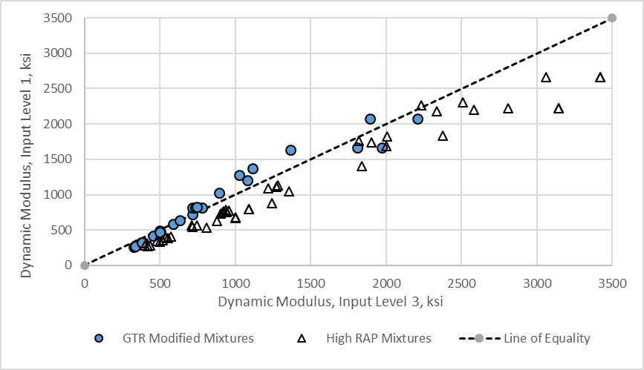
Figure 21. Graph. Input Level 1 Measured Dynamic Moduli Compared to Input Level 3 Calculated Dynamic Moduli using the Closest PG of the Recovered Asphalt.

3.3.2 Comparison of Predicted Distress Using Input Level 3 and Input Level 1 Dynamic Moduli
The Pavement ME Design software was used to predict rutting in the asphalt layers and bottom-up fatigue cracking using input level 1 and input level 3 dynamic moduli to quantify the difference in moduli. The global default laboratory-derived properties for rut depth and bottom-up fatigue crack predictions (determined for virgin, neat asphalt mixtures) were used for the comparison. Figure 22 includes a comparison of rut depths, while figure 23 includes the comparison of bottom-up fatigue cracking. As shown, higher rut depths in the asphalt layers were calculated using input level 1 measured dynamic moduli for the GTR-modified asphalt and high RAP mixtures. Similarly, higher bottom-up fatigue cracks were calculated for the GTR-modified and high RAP mixtures using input level 1 dynamic moduli relative to using input level 3 dynamic moduli.
The PG of the virgin asphalt added to the R²AMs (refer to table 7 and table 8) was used to calculate dynamic moduli (input level 3) to determine if the bias shown in figure 21 would be reduced. Figure 24 includes a comparison of the input level 1 laboratory-measured dynamic moduli and the calculated input level 3 dynamic moduli using the PG of the virgin asphalt added to the R²AMs. Table 21 summarizes the bias and standard deviation of the residual error (calculated minus measured dynamic moduli) using both PGs. As shown, the bias was reduced for some of the high RAP mixtures when using the PG of the virgin asphalt but increased for the GTR-modified asphalt mixtures. Conversely, the standard deviation of the residual errors consistently increased for all of the high RAP mixtures and decreased for the GTR-modified mixtures, except for the MA-surface mixture.
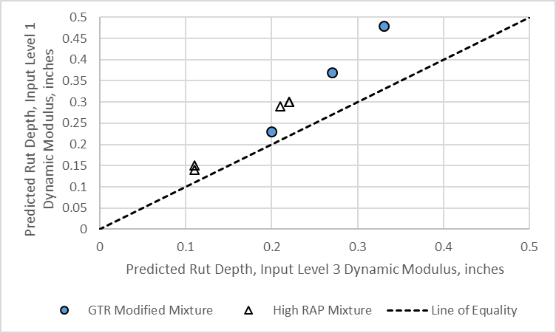
Figure 22. Graph. Comparison of Predicted Rut Depth in the Asphalt Layers using Input Level 1 Measured Dynamic Moduli and Input Level 3 Calculated Dynamic Moduli.
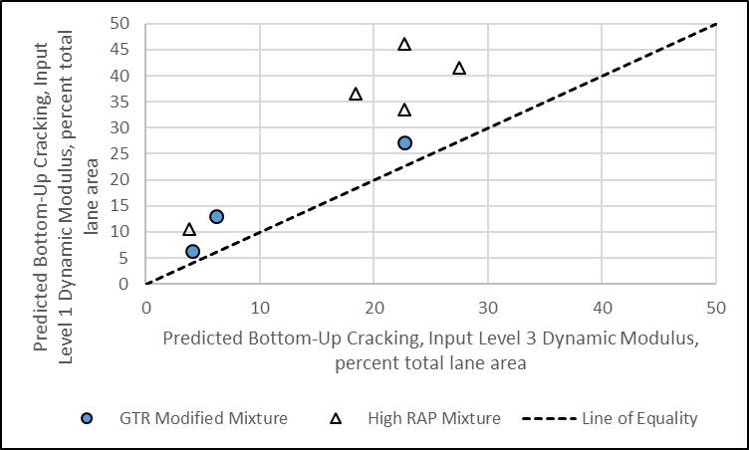
Figure 23. Graph. Comparison of Predicted Bottom-Up Alligator Cracking using Input Level 1 Measured Dynamic Moduli and Input Level 3 Calculated Dynamic Moduli.
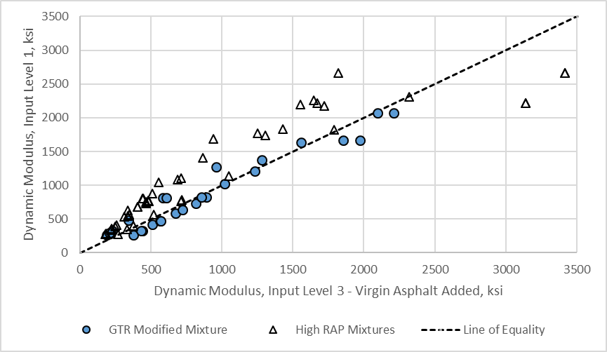
Figure 24. Graph. Input Level 1 Measured Dynamic Moduli Compared to Input Level 3 Calculated Dynamic Moduli using the PG of the Virgin Asphalt Added to the R²AMs.

Table 21. Bias and Standard Deviation of the Residual Errors for Comparing the Measured and Calculated Dynamic Moduli.
Mix Identification | Bias (Calculated Minus Measured Dynamic Modulus, ksi |  | Standard Deviation of the Residual Errors
Mix Identification | PG Recovered Asphalt | PG Virgin Asphalt | PG Recovered Asphalt | PG Virgin Asphalt
WI-Surface | 416.8 | -247.0 | 194.4 | 598.4
WI-Base | 523.9 | -86.2 | 249.0 | 583.8
NC-Surface | 127.2 | -294.1 | 69.0 | 180.8
NC-Intermediate | 167.4 | -273.2 | 11.4 | 132.4
NC-Base | 152.9 | -37.3 | 24.5 | 30.7
FL-Surface | -46.1 | 58.5 | 102.4 | 57.2
MA-Surface | 22.2 | -73.2 | 156.0 | 198.8
PA-Surface | -32.8 | -57.8 | 135.6 | 74.0

3.3.3 Summary of Comparisons
In summary, the use of input level 1 laboratory-measured dynamic moduli for R²AMs results in significantly higher predicted amounts of cracking and rut depths, because the dynamic moduli during the summer months are consistently lower than the dynamic moduli calculated using input level 3. The GTR-modified asphalt mixtures included in the test program exhibit a different or higher temperature susceptibility for dynamic modulus in comparison to the neat dense-graded asphalt mixtures. The measured dynamic modulus for the high RAP mixtures exhibit generally lower dynamic modulus in comparison to neat dense-graded mixtures. The use of input level 3 dynamic moduli regression equation included in the Pavement ME Design software for the closest PG designated asphalt will result in a bias and is inappropriate for use for R²AMs. Agencies that use R²AMs should create a library of measured dynamic moduli and other laboratory-derived properties for these mixtures and use those values for pavement structural design.

3.4 Asphalt Layer Total Rut Depth
Repeated load permanent deformation tests were conducted on 8 of the R²AMs in accordance with Chapter 3 of Part 1 of the Guide. Repeated load permanent deformation tests were not performed on the virgin PA PMA wearing surface mixture. Instead, the plastic strain coefficients and dynamic moduli for a typical PA PMA surface mixture were extracted from the PA materials library for a dense-graded PG 76-22, 9.5 mm wearing surface mixture. The plastic strain coefficients for the PA PMA mixture were: k_{1r} = -2.736, k_{3r} = 0.173, and k_{2r} = 2.360.
Average volumetric properties of the test specimens prepared in accordance with Chapter 3 of Part 1 of the Guide for the 8 mixtures are included in table 22. The continuous AASHTO M 320 performance grade properties for binder recovered from the mixtures is also included in table 22.
Table 22. Average Volumetric and PG Properties for Mixtures Used in Repeated Load Permanent Deformation Test.
Property | WI  Base | WI  Surface | NC  Base | NC  Binder | NC  Surface | FL Surface | MA ARGG | PA Surface
Asphalt Content, total by weight, % | 4.53 | 4.51 | 4.38 | 4.20 | 5.72 | 4.68 | 6.54 | 5.90
VMA at 7% Air Voids, % | 15.6 | 15.6 | 17.3 | 16.7 | 20.3 | 18.4 | 20.9 | 18.4
VBE, % | 8.6 | 8.6 | 10.3 | 9.7 | 13.3 | 11.4 | 13.9 | 11.4
VFA at 7% Air Voids, % | 56.6 | 55.2 | 59.1 | 57.8 | 64.6 | 61.9 | 66.7 | 61
Continuous High Temperature Grade, ⁰C | 76.9 | 75.9 | 78.0 | 80.5 | 80.9 | 78.6 | 85.2 | 78.7
Continuous Intermediate Temperature Grade, ⁰C | 21.5 | 19.6 | 24.8 | 23.0 | 24.8 | 17.2 | 9.6 | 21.9
Continuous Low Temperature Grade, ⁰C | -20.2 | -21.8 | -24.9 | -25.0 | -23.7 | -27.5 | -33.2 | -26.1

3.4.1 Determine Slope and Intercept of Secondary Zone
The plastic strain coefficients were determined in accordance with Chapter 2 of this document. The first step is to determine the intercept and slope from the secondary zone of the accumulated plastic strain curve for each test temperature. The accumulated plastic strain curves for each mixture is included in figure 25 through figure 32. The following summarizes the test specimens exhibiting tertiary flow for deriving the plastic strain coefficients (refer to section 2.2 in Chapter 2), while Appendix B also shows the derivation of the plastic strain coefficients for each R²AM.
- WI high RAP mixtures:
  - High recycle base layer mixture—none of the test specimens exhibited tertiary flow.
  - High recycle surface layer mixture—None of the test specimens exhibited tertiary flow.
- NC high RAP mixtures:
  - High recycle base layer mixture—only one test specimen at the high test temperature exhibited tertiary flow, all other test specimens did not exhibit tertiary flow.
  - High recycle intermediate layer mixture—none of the test specimens at the low and high test temperatures exhibited tertiary flow. The test specimens at the intermediate test temperature exhibited tertiary flow.
  - High recycle surface layer mixture—none of the test specimens for the high and low test temperature exhibited tertiary flow, while only one test specimen at the intermediate test temperature exhibited tertiary flow around load cycle 7,000.
- FL GTR-modified asphalt surface mixture—only one test specimen at the low and high test temperatures exhibited tertiary flow. All other test specimens did not exhibit tertiary flow.
- MA GTR-modified asphalt surface mixture—only one test specimen at the high test temperature exhibited tertiary flow. The other test specimens did not exhibit tertiary flow.
- PA PMA-GTR modified asphalt surface mixture— only one test specimen at the low test temperature exhibited tertiary flow. The other test specimens did not exhibit tertiary flow.
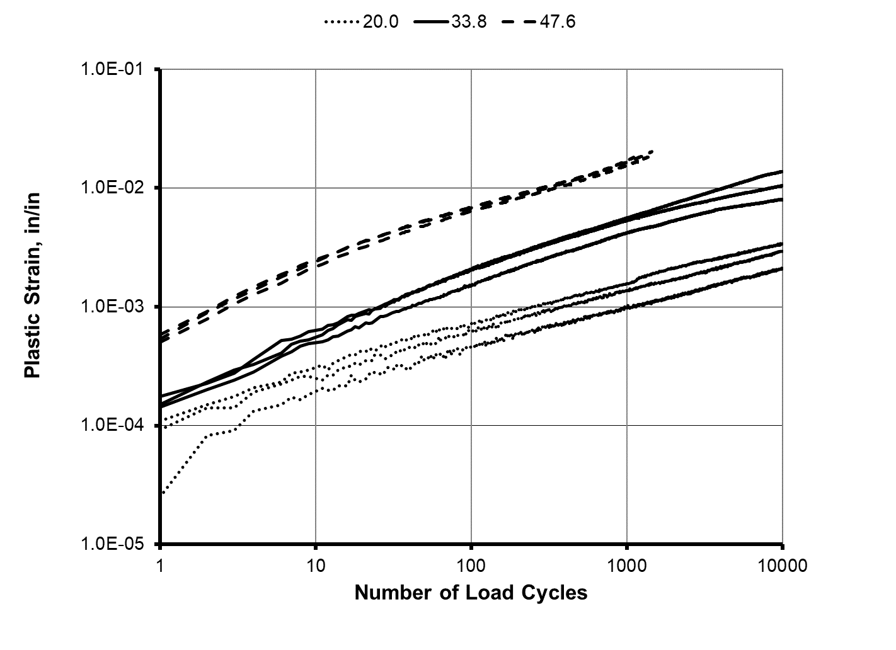
Figure 25. Graph. Results from the Repeated Load Plastic Deformation Test for the WI High Recycle Base Mixture.

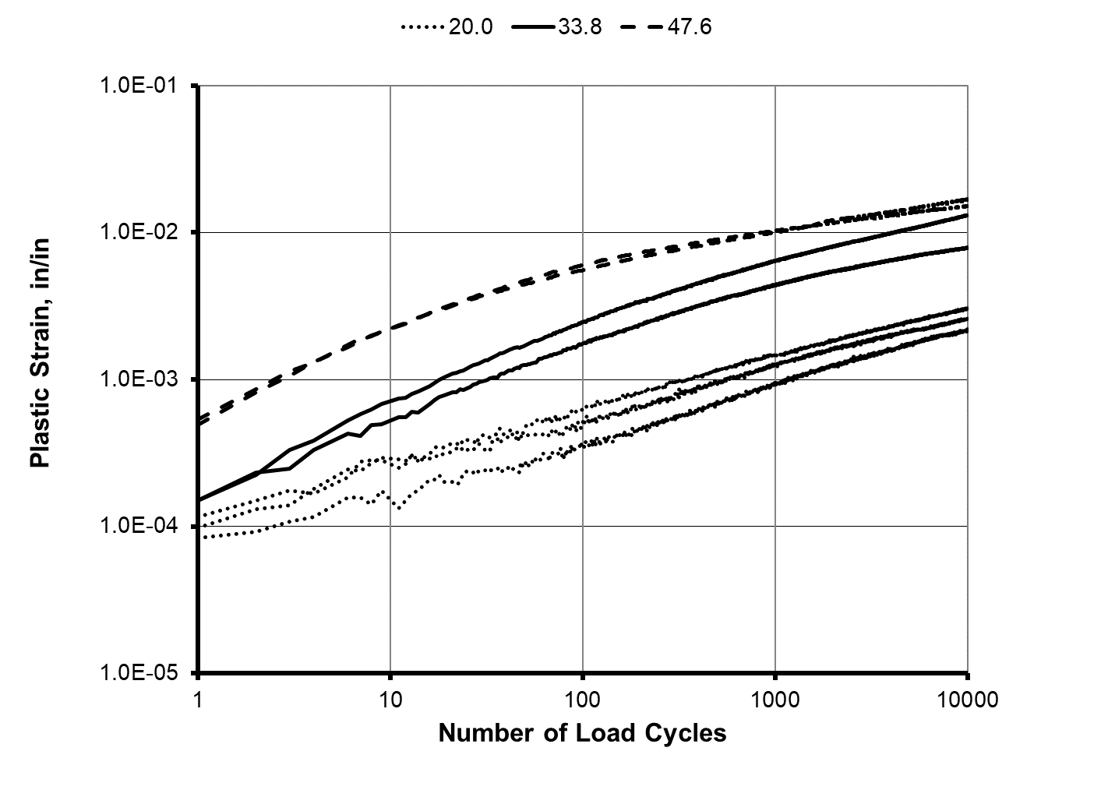
Figure 26. Graph. Results from the Repeated Load Plastic Deformation Test for the WI High Recycle Surface Mixture.
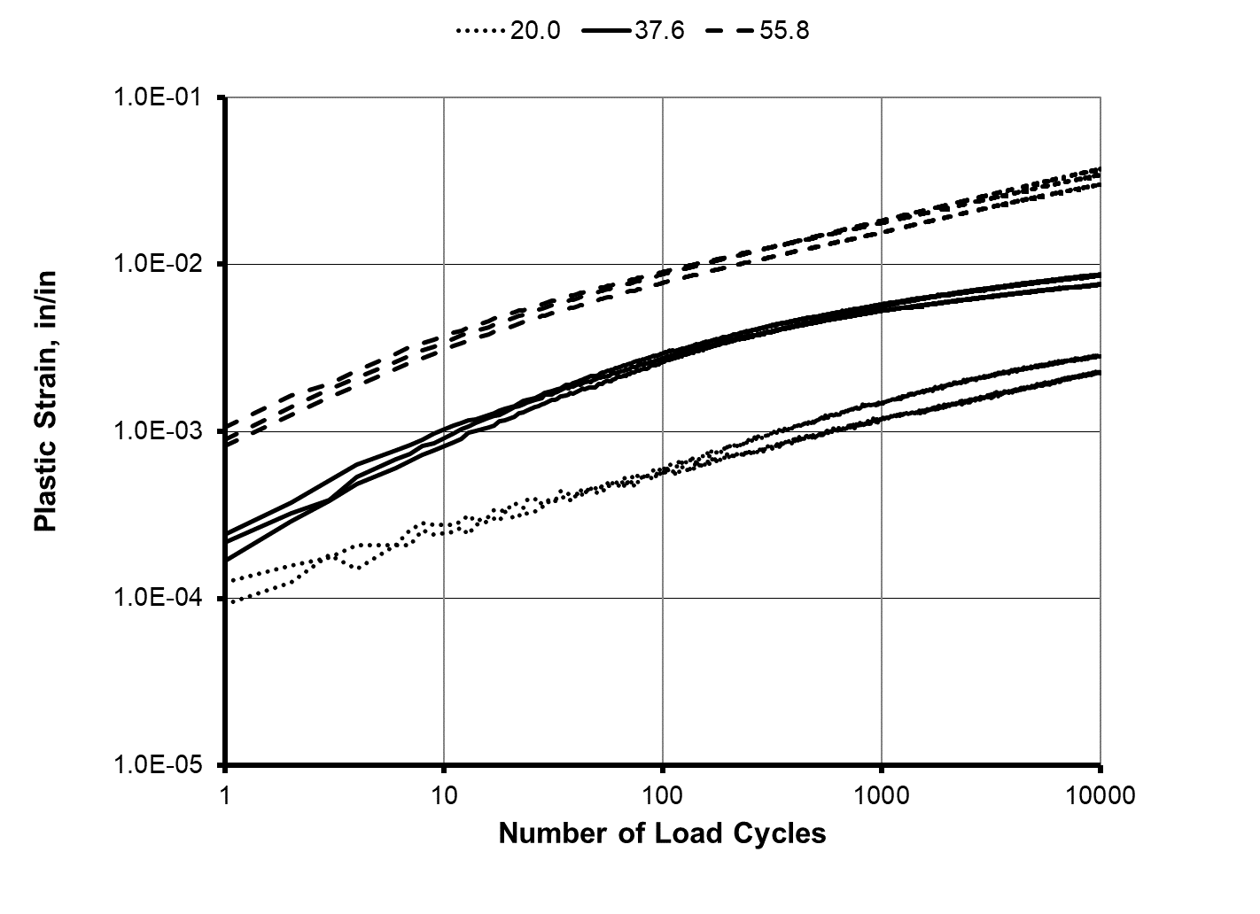
Figure 27. Graph. Results from the Repeated Load Plastic Deformation Test for the NC High Recycle Base Mixture.

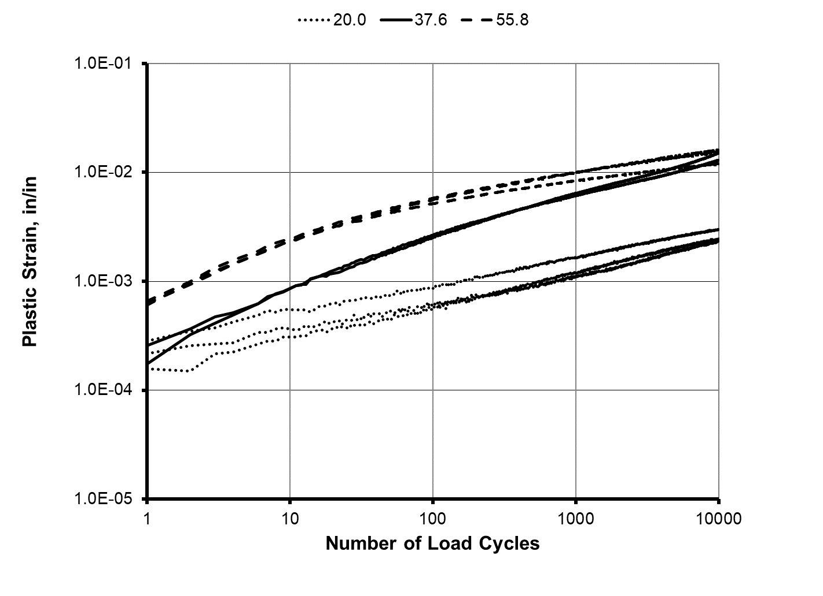
Figure 28. Graph. Results from the Repeated Load Plastic Deformation Test for the NC High Recycle Intermediate Layer Mixture.
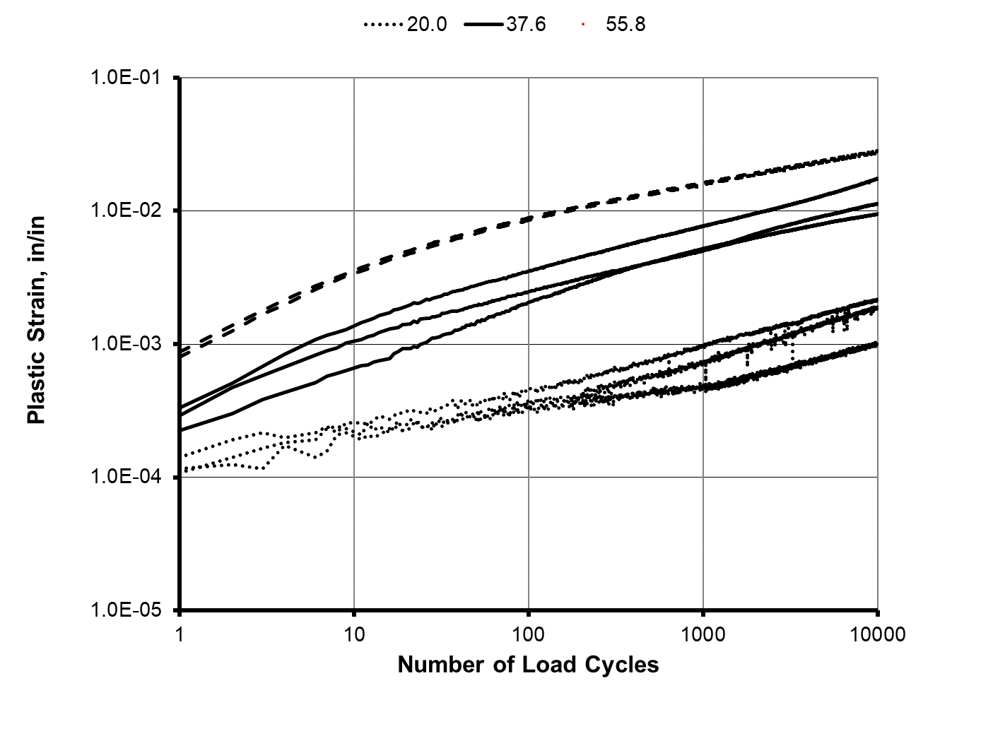
Figure 29. Graph. Results from the Repeated Load Plastic Deformation Test for the NC High Recycle Surface Mixture.

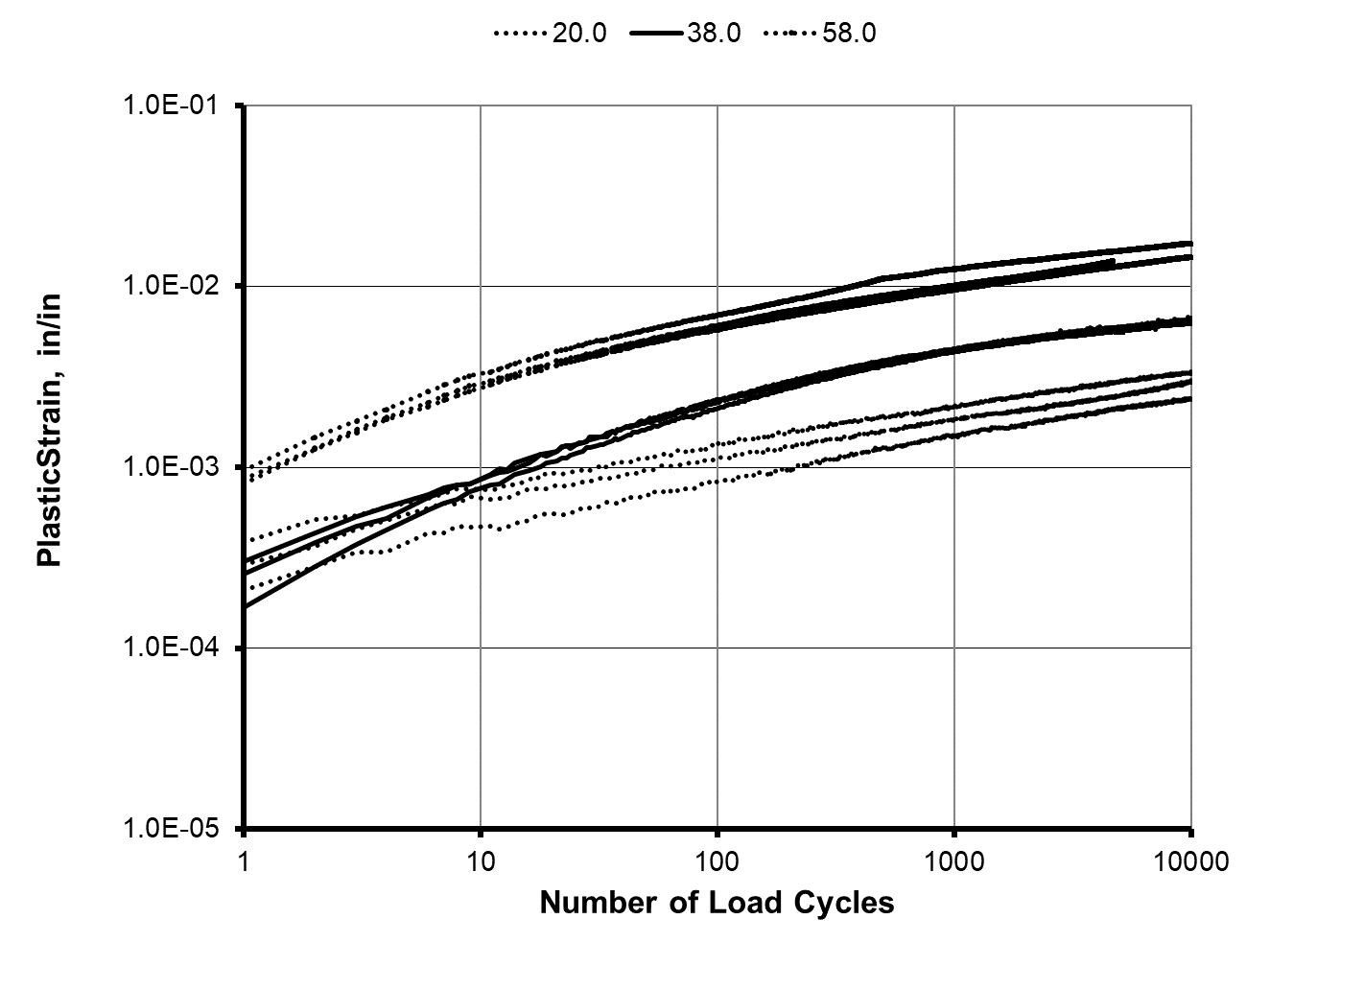
Figure 30. Graph. Results from the Repeated Load Plastic Deformation Test for the FL GTR Modified Binder Surface Mixture.
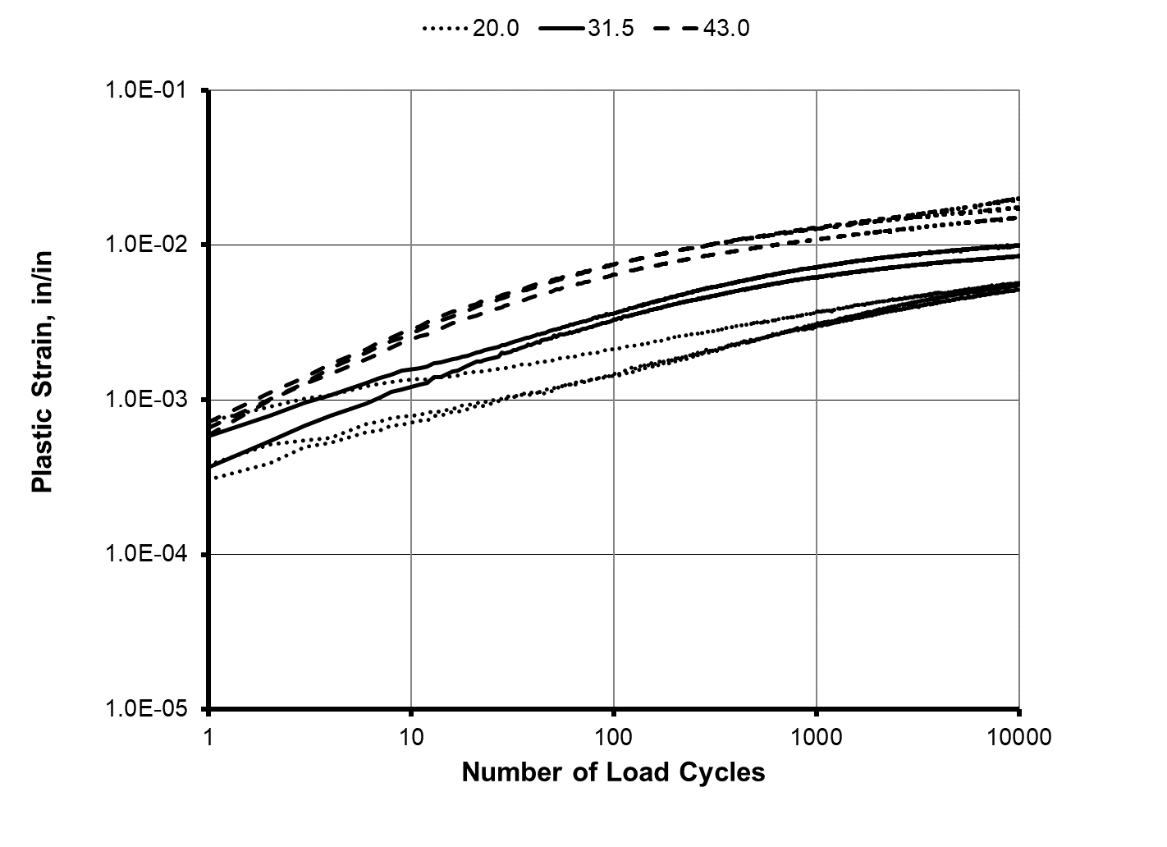
Figure 31. Graph. Results from the Repeated Load Plastic Deformation Test for the MA ARGG GTR Modified Binder Surface Mixture.

Figure 32. Graph. Results from the Repeated Load Plastic Deformation Test for the PA GTR Modified Binder Surface Mixture.
Table 23 summarizes the intercept, a, and slope, b, for each mixture and test temperature (refer to figure 4), and figure 33 includes a comparison between the intercept and slope for the high recycle and GTR modified binder mixtures. As shown, the higher the slope, the lower the intercept. The FL, MA, and PA GTR modified binder mixtures have a lower slope parameter. The average slope for all GTR binder modified mixtures is 0.174, while the average slope for the high recycled mixtures is 0.280.
On the other hand, the average intercept for the GTR modified binder mixtures is higher than for the high recycled mixtures. The average high temperature intercept for the GTR modified mixtures is 0.356 percent, while the average high temperature intercept for the high recycled mixtures is 0.274 percent. The higher intercept implies more rutting will be predicted early in the life of the pavement. However, the rut depth will increase at a slower rate with the number of loading cycles or truck traffic for the GTR mixtures because the average b-value or slope at the high test temperature (0.149) is significantly lower than for the high RAP mixtures (0.245).
Table 23. Summary of Repeated Load Plastic Strain Coefficients for Each Test Temperature.
Mix | Mix Type | Temperature, ºC | a (intercept), % | b (slope)
WI Base | High Recycle | 20.0 | 0.0128 | 0.334
WI Base | High Recycle | 33.8 | 0.0831 | 0.275
WI Base | High Recycle | 47.6 | 0.129 | 0.369
WI Surface | High Recycle | 20.0 | 0.0125 | 0.329
WI Surface | High Recycle | 33.8 | 0.0867 | 0.268
WI Surface | High Recycle | 47.6 | 0.433 | 0.143
NC Base | High Recycle | 20.0 | 0.0200 | 0.277
NC Base | High Recycle | 37.6 | 0.179 | 0.167
NC Base | High Recycle | 55.8 | 0.227 | 0.294
NC Intermediate | High Recycle | 20.0 | 0.0166 | 0.298
NC Intermediate | High Recycle | 37.6 | 0.0572 | 0.344
NC Intermediate | High Recycle | 55.8 | 0.273 | 0.181
NC Surface | High Recycle | 20.0 | 0.0059 | 0.357
NC Surface | High Recycle | 37.6 | 0.0627 | 0.325
NC Surface | High Recycle | 55.8 | 0.309 | 0.238
FL Surface | GTR Modified | 20.0 | 0.0455 | 0.200
FL Surface | GTR Modified | 39.0 | 0.120 | 0.191
FL Surface | GTR Modified | 58.0 | 0.339 | 0.166
MA ARGG | GTR Modified | 20.0 | 0.0733 | 0.219
MA ARGG | GTR Modified | 31.5 | 0.307 | 0.128
MA ARGG | GTR Modified | 43.0 | 0.438 | 0.149
PA Surface | GTR Modified | 20.0 | 0.0269 | 0.254
PA Surface | GTR Modified | 33.3 | 0.183 | 0.125
PA Surface | GTR Modified | 46.6 | 0.290 | 0.131

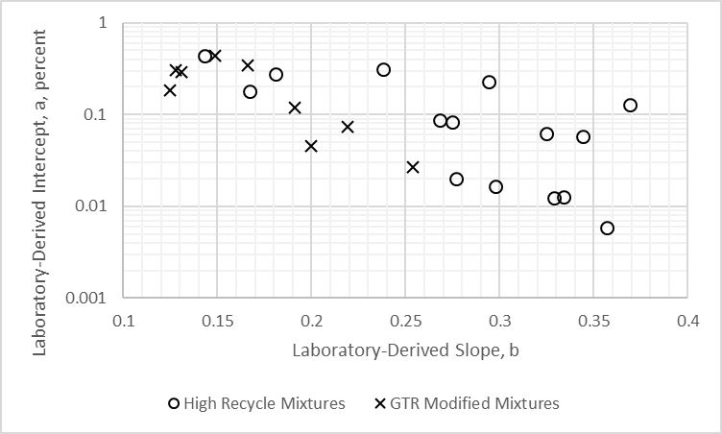
Figure 33. Graph. Graphical Comparison of the Intercept and Slope from each Test Temperature and Mixture Type.

3.4.2 Determine Slope Coefficient or N-Term Exponent
The intercept and slope for each test temperature were used to determine the plastic strain coefficients of the MEPDG generalized transfer function (refer to figure 6). The following summarizes the temperature dependency on the slope parameter of the different R²AMs and if the slopes are indifferent between the test temperatures at a 95 percent confidence level.
- WI high RAP mixtures:
  - High recycle base layer mixture—the slope did not consistently increase or decrease with temperature and is indifferent for all test temperatures. Thus, average the slopes for all test temperatures; b = 0.326.
  - High recycle surface layer mixture—the slope consistently decreases with test temperature. The slopes were different between all test temperatures. Thus, the slope was determined at the equivalent rut depth temperature; b = 0.261.
- NC high RAP mixtures:
  - High recycle base layer mixture—the slope did not consistently increase or decrease with temperature and is indifferent for all test temperatures. Thus, average the slopes for all test temperatures; b = 0.242.
  - High recycle intermediate layer mixture—the slope did not consistently increase or decrease with test temperature. Thus, average the slopes for all test temperatures; b = 0.266.
  - High recycle surface layer mixture—the slope consistently decreases with test temperature. The average slope at the higher test temperature was different from the slope at the lower test temperatures. Thus, the slope was determined at the equivalent rut depth temperatures; b = 0.316.
- FL GTR-modified asphalt surface mixture—the slope for test specimen #4 was significantly higher than any other specimen, so it was removed. Eliminating specimen #4, the slope is independent of test temperature. Thus, average the slopes for all test temperatures, excluding specimen #4; b = 0.175.
- MA GTR-modified asphalt surface mixture—the slope did not consistently increase or decrease with temperature. The slopes at the higher test temperatures are indifferent, while the slope at the low test temperature was slightly higher than for the higher test temperatures. Thus, average the slopes for all test temperatures; b = 0.170.
- PA PMA-GTR modified asphalt surface mixture—the slope did not consistently increase or decrease with temperature. The slopes at the higher test temperatures are indifferent, while the slope at the low test temperature is different from the higher test temperatures. Thus, average the slopes at the higher test temperatures; b = 0.129 which is less than 0.160, so set it at 0.160.

3.4.3 Determine Laboratory-Derived Intercept and Temperature Exponent Plastic Strain Coefficients
The temperature exponent, k_{2r}, and intercept for all test temperatures, k_{1r}, were determined using linear regression analyses using the equation included in figure 7. The resilient or elastic axial strain for each test temperature of the repeated load permanent deformation test was estimated using the dynamic modulus measured at 10 Hz, in accordance with figure 8. Table 24 includes a comparison of the AASHTOWare Pavement ME Design mixture specific plastic strain coefficients derived from the laboratory tests for input level 1.

3.4.4 Comparison of Plastic Strain Coefficients: Global and Laboratory-Derived Values
The global default coefficients included in version 2.5.3 for virgin, neat asphalt mixtures are also included in Table 24. The following provides an overall summary of the R²AM properties in comparison to virgin neat asphalt mixtures.
- The high RAP mixtures exhibited a lower k_{1r} value but higher k_{3r} value in comparison to the default values for virgin, neat asphalt mixtures. This suggests that the initial rut depths predicted by the Pavement ME Design software will be lower, but the rut depths will increase over time at a higher rate than for the virgin, neat asphalt mixtures. More importantly, the k_{2r} value for the high RAP mixtures is lower than for the virgin, neat asphalt mixtures, suggesting a smaller influence or sensitivity to temperature with the exception of the NC and WI high RAP surface mixtures.
- The GTR modified mixtures also exhibited a lower k_{1r} value in comparison to the default values for virgin, neat asphalt mixtures. The k_{3r} value for the GTR modified mixtures, however, is significantly lower than for the high RAP mixtures and default value for virgin, neat asphalt mixtures. This implies rut depths will increase over time or with truck traffic at a much lower rate than for the other mixtures. The k_{2r} value for the GTR modified mixtures is also lower than for the virgin, neat asphalt mixtures, suggesting a smaller influence or sensitivity to temperature.
Table 24. Summary of Mixture Specific Plastic Strain Coefficients Derived from Laboratory Tests using Input Level 1.
Mix Designation | Mix Type | Equivalent Rut Depth Temperature, ºC | Plastic Strain Coefficients
Mix Designation | Mix Type | Equivalent Rut Depth Temperature, ºC | Log k_{1r}, Intercept | k_{3r}, N Exponent | k_{2r}, T Exponent
Global Default Values | Virgin, Dense-Graded Neat | NA | -2.450 | 0.220 | 3.010
WI Base | High Recycle | 31.5 | -3.807 | 0.326 | 2.791
WI Surface | High Recycle | 31.5 | -2.567 | 0.261 | 2.172
NC Base | High Recycle | 37.0 | -3.555 | 0.242 | 2.510
NC Intermediate Layer | High Recycle | 37.0 | -2.960 | 0.266 | 2.142
NC Surface | High Recycle | 37.0 | -4.044 | 0.316 | 2.873
FL Surface | GTR Modified | 39.7 | -1.743 | 0.175 | 1.571
MA ARGG Surface | GTR Modified | 28.5 | -1.483 | 0.160 | 1.480
PA Surface | GTR Modified | 31.0 | -1.658 | 0.160 | 1.496
NA – Not applicable
Figure 34 includes a comparison of the measured log of the intercept (k_{1r}) and slope (k_{3r}) for the mixtures included in the test program in comparison to the global default values for virgin asphalt mixtures. As shown, the GTR modified mixtures have lower slopes but larger intercepts than the global default coefficients derived for dense-graded virgin asphalt mixtures, while the high RAP mixtures have smaller intercepts but higher slopes. The global default plastic strain coefficients (refer to figure 34) were derived from many repeated load permanent deformation tests.^{(3,7)}
Figure 35 shows a comparison of the measured or laboratory-derived intercept for many virgin, neat asphalt mixtures and the R²AM mixtures included in the test program. The plastic strain coefficients for the R²AMs are within the same range for the virgin, neat asphalt mixtures. As more R²AMs are tested, however, the observed difference between virgin mixtures and those with recycled materials may decrease.
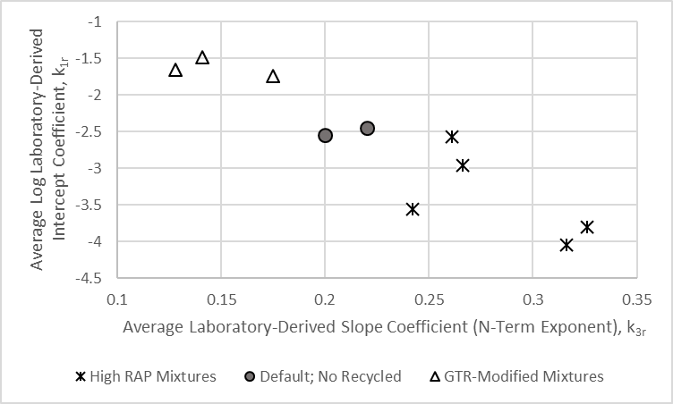
Figure 34. Graph. Comparison of Relationship between the Intercept and Slope for the R²AM and Global Default Coefficients for Virgin, Neat Asphalt Mixtures for Predicting Rut Depths.

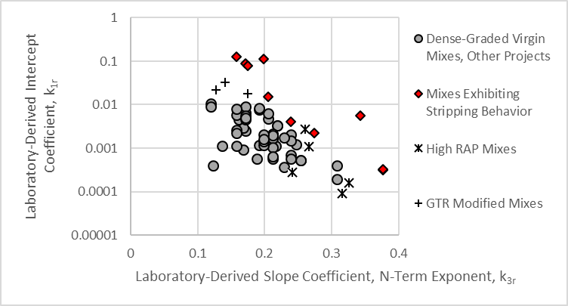
Figure 35. Graph. Comparison of Relationship between the Intercept and Slope for the R²AM and Virgin, Neat Asphalt Mixtures for Predicting Rut Depths.

3.4.5 Volumetric Property Effects on the Plastic Strain Coefficients
Figure 36 shows a comparison of the percentage of RAP and/or GTR added to the R²AM mixture and the exponent of the load cycle term, k_{3r}. Although the number of R²AMs included in this test program is low for making conclusive observations, the k_{3r} exponent increases as the percentage of RAP and/or GTR increases. This observation, however, needs to be confirmed by testing more R²AMs.
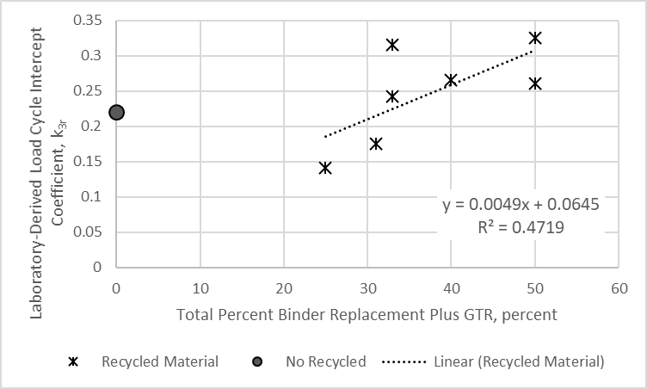
Figure 36. Graph. Comparison of Load Cycle Exponent and the Amount of RAP/RAS/Rubber added to the R²AM Mixture.
Another interesting observation is included in figure 37. The slope coefficient derived from the plastic strain curve appears to be dependent on the VFA of the mixture. As the VFA increases, the slope coefficient decreases, with the exception of the NC high RAP surface mixture which appears to be an outlier. It is expected that as the VFA continues to increase, the slope coefficient will level off and may even start to increase based on previous test results. The average VFA and slope coefficient for virgin asphalt mixtures (no recycled materials) is shown in figure 37, and is within the expected range of values derived for the R²AMs.

3.4.6 Comparison of Predicted Asphalt Layer Rut Depth: Global Plastic Strain Coefficients and Laboratory-Derived Coefficients
The plastic strain coefficients included in Table 24 were used to predict the rut depth in the asphalt layers for each project location and pavement simulation. A comparison of the predicted rut depths between the input level 3 and input level 1 for the R²AMs is summarized below.
- Figure 38 and figure 39 include examples comparing the predicted rut depth in the asphalt layers over the design period between the R²AM mixtures for laboratory-derived plastic strain coefficients and the global default coefficients derived for virgin, neat asphalt mixtures. As shown, the predicted rut depth in the R²AM asphalt layers are significantly less than the predicted rut depth in the virgin, neat asphalt mixtures. All of the R²AMs exhibited similar reduced rut depths in the asphalt layers (50 to 90 percent lower) in comparison to using the default global plastic strain coefficients for virgin, neat asphalt mixtures.
- Figure 40 includes a comparison of the predicted rut depth in the asphalt layers at the end of the design period (20 years). In summary, the predicted rut depth in the asphalt layers for the R²AM GTR modified and high RAP mixtures were significantly lower than for the global plastic strain coefficients derived for virgin asphalt mixtures.
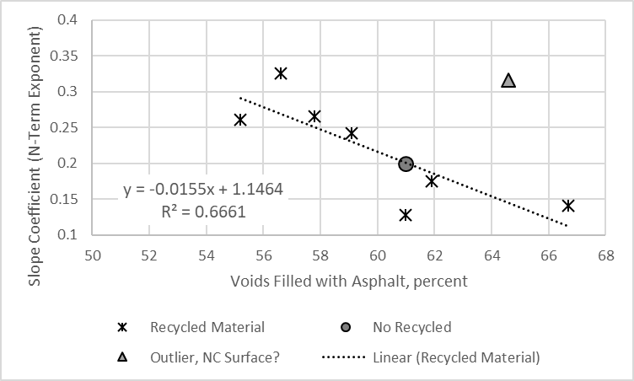
NC High RAP Surface Mix
Figure 37. Graph. Comparison of Slope Coefficient, k_{r2}, and MEPDG Slope Coefficient or N-Term Exponent

3.4.7 Summary of Comparisons
In summary, use of the global plastic strain coefficients derived from virgin, neat asphalt mixtures are not appropriate for use in predicting the rut depth for R²AMs, because higher rut depths will be predicted for the R²AM layers. Table 25 includes the average plastic strain coefficients for the different R²AMs and the global default coefficients derived for neat, virgin asphalt mixtures. The average plastic strain coefficients derived for the R²AMs (summarized in table 25) should be used for design. Agencies should also consider deriving their own R²AMs plastic strain coefficients.
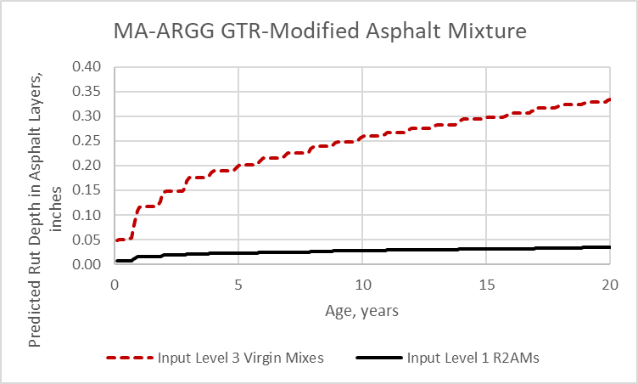
Figure 38. Graph. Predicted Rut Depth in the Asphalt Layers for the MA-ARGG GTR Modified and Virgin, Neat Asphalt Mixtures.

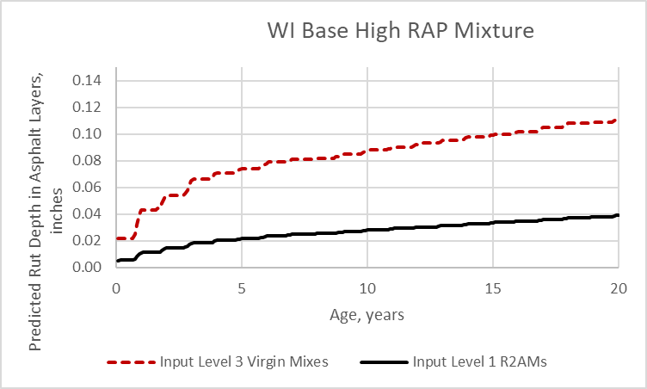
Figure 39. Graph. Predicted Rut Depth in the Asphalt Layers for the WI High RAP Base and Virgin, Neat Asphalt Mixtures.
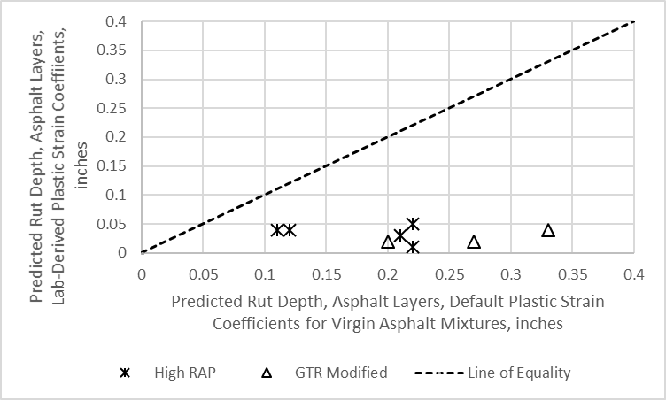
Figure 40. Graph. Comparison of Total Predicted Rut Depth at the End of the Design Period between the R²AM and Virgin Asphalt Mixtures.

Table 25. Average Plastic Strain Coefficients for the R²AMs and the Global Default Values for Neat, Virgin Asphalt Mixtures.
Mixture Type | Plastic Strain Coefficients
Mixture Type | Log k_{1r}, Intercept | k_{3r}, N Exponent | k_{2r}, T Exponent
Global Default Values: Neat, Virgin Asphalt Mixtures | -2.450 | 0.220 | 3.010
High Recycle (RAP and/or RAS) | -3.387 | 0.282 | 2.498
GTR Modified | -1.628 | 0.165 | 1.526

3.5 Transverse Cracks
The predicted length of transverse cracks is only dependent on the asphalt layer properties for the wearing surface. IDT creep compliance and strength, however, were measured on all but one of the R²AM mixtures (see Chapter 2). As such, the asphalt intermediate and base layers were simulated as a wearing surface to compare the predicted length of transverse cracks for which the IDT creep compliance and strengths were measured.
Low temperature creep compliance and strength data were collected in accordance with AASHTO T 322 for eight of the nine mixtures sampled during this project. IDT strength and creep compliance tests were not performed on the PA PMA wearing surface mixture.

3.5.1 IDT Strength
Table 26 presents the average measured IDT strengths at -10 ºC (14 ºF), pertinent volumetric properties, and the low temperature continuous grade of binder recovered from the mixtures. The R²AM IDT strength data are compared graphically in figure 41. The MA ARGG GTR-modified mixture has the lower tensile strength compared to the other R²AMs, and higher V_{be} (see table 8). Figure 41 also includes a comparison between the measured IDT strengths (input level 2) and the strengths calculated using input level 3. The measured IDT strengths for the R²AM mixtures are higher than the input level 3 values calculated by the Pavement ME Design software, except for three mixtures: the WI high RAP surface and base and the MA GTR modified asphalt mixtures.
Table 26. AASHTO T 322 Tensile Strength, Volumetric Properties, and Low Temperature Performance Grade Properties for R²AMs.
Property | WI  Base | WI  Surface | NC  Base | NC  Binder | NC  Surface | FL Surface | MA ARGG | PA Surface
Tensile Strength at -10 ºC, psi | 547 | 502 | 572 | 632 | 652 | 642 | 384 | 619
Asphalt Content, total by weight, % | 4.53 | 4.51 | 4.38 | 4.20 | 5.72 | 4.68 | 6.54 | 5.90
VMA at 7% Air Voids, % | 15.6 | 15.6 | 17.3 | 16.7 | 20.3 | 18.4 | 20.9 | 18.4
Continuous Low Temperature Grade Based on Stiffness, ⁰C | -29.2 | -30.1 | -24.9 | -27.8 | -26.2 | -30.7 | -36.6 | -26.1
Continuous Low Temperature Grade Based on m-value, ⁰C | -20.2 | -21.8 | -25.5 | -25.0 | -23.7 | -27.5 | -33.2 | -27.8

3.5.2 IDT Creep Compliance
Table 27 summarizes the creep compliances for the eight mixtures at the conditions required for input level 1. Figure 42 compares the compliance data for 3 test conditions: (1) -20 ºC, 1 second loading, (2) -10 ºC, 10 seconds loading, and (3) 0 ºC, 100 seconds loading. This figure shows that the three NC high RAP content and FL GTR-modified mixtures have the lowest compliance, while the MA ARGG, PA GTR, and the two WI high RAP mixtures have the higher compliance values.
Figure 43 includes a more important comparison between the measured IDT creep compliance values and the creep compliance values calculated using input level 3 for -10 ºC and a loading time of 100 seconds. The IDT creep compliance for the R²AM mixtures are much lower than the input level 3 values calculated by the Pavement ME Design software. The only two R²AMs creep compliance values that are close to the calculated input level 3 values are for the WI high RAP base and surface mixtures.
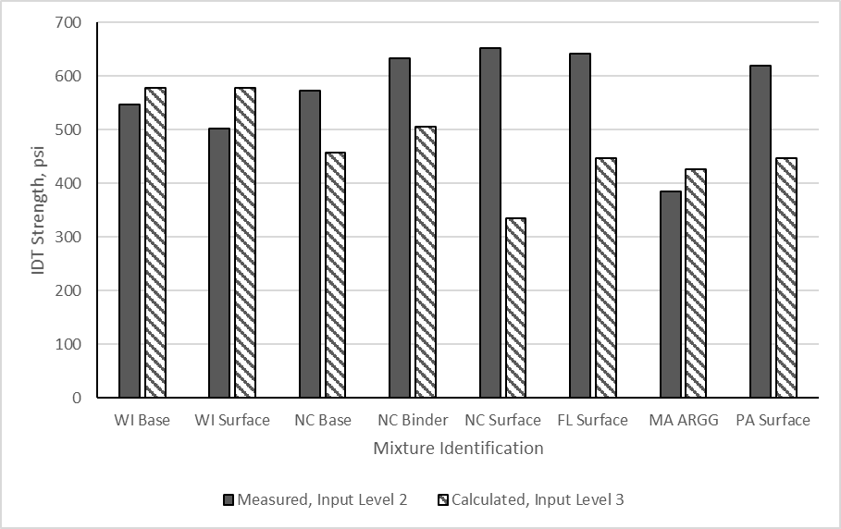
Figure 41. Bar Chart. Comparison of AASHTO T 322 Tensile Strength at -10 ºC for R²AMs.

3.5.3 Comparison of Predicted Transverse Cracks: Input Level 1 and Input Level 3
The measured IDT strength and creep compliance values were used in predicting the length of transverse cracks for each project location and pavement simulation. A comparison of the predicted transverse cracking lengths between the virgin asphalt mixtures using input level 3 defaults and measured input level 1 properties of the R²AM mixtures is shown in figure 44. As shown, higher lengths of transverse cracks were predicted for the R²AMs, except for the WI high RAP base and surface mixtures. The WI high RAP base and surface mixtures were found to be slightly less compliant and exhibit lower IDT strengths (refer to figure 41 and figure 43).
The other R²AMs are significantly less compliant than the virgin asphalt mixtures (refer to figure 43). Less compliant mixtures imply higher lengths of transverse cracks will be predicted, even though these mixtures exhibit higher IDT strengths (refer to figure 41). Figure 45 and figure 46 are examples comparing the predicted length of transverse cracks over time between two of the high RAP R²AMs (NC and WI high RAP surface mixtures) for input level 1 and virgin asphalt mixtures using input level 3. Similar examples are included in figure 47 and figure 48 for two of the GTR-modified asphalt mixtures (FL GTR-modified and PA GTR-modified mixtures).

Table 27. AASHTO T 322 Creep Compliance Values for R²AMs.
Temp., C | Time, second | WI  Base,  1/psi | WI  Surface,  1/psi | NC  Base, 1/psi | NC  Binder, 1/psi | NC  Surface, 1/psi | FL Surface, 1/psi | MA ARGG, 1/psi | PA Surface, 1/psi
-20 | 1 | 2.92E-07 | 3.04E-07 | 2.32E-07 | 2.35E-07 | 2.71E-07 | 2.64E-07 | 3.13E-07 | 3.62E-07
-20 | 2 | 3.05E-07 | 3.19E-07 | 2.43E-07 | 2.41E-07 | 2.83E-07 | 2.78E-07 | 3.40E-07 | 3.73E-07
-20 | 5 | 3.27E-07 | 3.51E-07 | 2.61E-07 | 2.49E-07 | 3.03E-07 | 3.01E-07 | 3.83E-07 | 3.92E-07
-20 | 10 | 3.49E-07 | 3.74E-07 | 2.79E-07 | 2.57E-07 | 3.21E-07 | 3.22E-07 | 4.24E-07 | 4.12E-07
-20 | 20 | 3.77E-07 | 4.01E-07 | 3.00E-07 | 2.68E-07 | 3.41E-07 | 3.48E-07 | 4.73E-07 | 4.37E-07
-20 | 50 | 4.26E-07 | 4.46E-07 | 3.36E-07 | 2.86E-07 | 3.74E-07 | 3.91E-07 | 5.52E-07 | 4.81E-07
-20 | 100 | 4.74E-07 | 4.96E-07 | 3.70E-07 | 3.03E-07 | 4.03E-07 | 4.32E-07 | 6.27E-07 | 5.26E-07
-10 | 1 | 3.96E-07 | 4.40E-07 | 3.10E-07 | 2.83E-07 | 3.57E-07 | 3.57E-07 | 5.12E-07 | 4.53E-07
-10 | 2 | 4.37E-07 | 5.10E-07 | 3.39E-07 | 2.99E-07 | 3.83E-07 | 3.91E-07 | 5.78E-07 | 4.90E-07
-10 | 5 | 5.06E-07 | 6.06E-07 | 3.86E-07 | 3.28E-07 | 4.26E-07 | 4.46E-07 | 6.86E-07 | 5.55E-07
-10 | 10 | 5.74E-07 | 7.03E-07 | 4.31E-07 | 3.54E-07 | 4.64E-07 | 4.99E-07 | 7.86E-07 | 6.21E-07
-10 | 20 | 6.61E-07 | 7.93E-07 | 4.86E-07 | 3.88E-07 | 5.09E-07 | 5.63E-07 | 9.03E-07 | 7.03E-07
-10 | 50 | 8.14E-07 | 9.72E-07 | 5.78E-07 | 4.46E-07 | 5.79E-07 | 6.69E-07 | 1.10E-06 | 8.55E-07
-10 | 100 | 9.59E-07 | 1.11E-06 | 6.66E-07 | 5.02E-07 | 6.43E-07 | 7.72E-07 | 1.28E-06 | 1.01E-06
0 | 1 | 7.17E-07 | 8.90E-07 | 5.12E-07 | 4.38E-07 | 5.43E-07 | 5.86E-07 | 1.00E-06 | 7.59E-07
0 | 2 | 8.41E-07 | 1.08E-06 | 5.85E-07 | 4.92E-07 | 6.01E-07 | 6.69E-07 | 1.17E-06 | 8.83E-07
0 | 5 | 1.06E-06 | 1.44E-06 | 7.03E-07 | 5.83E-07 | 6.90E-07 | 8.07E-07 | 1.43E-06 | 1.10E-06
0 | 10 | 1.28E-06 | 1.70E-06 | 8.21E-07 | 6.72E-07 | 7.72E-07 | 9.38E-07 | 1.68E-06 | 1.33E-06
0 | 20 | 1.54E-06 | 2.04E-06 | 9.66E-07 | 7.79E-07 | 8.69E-07 | 1.09E-06 | 1.97E-06 | 1.61E-06
0 | 50 | 2.01E-06 | 2.62E-06 | 1.20E-06 | 9.72E-07 | 1.02E-06 | 1.35E-06 | 2.46E-06 | 2.12E-06
0 | 100 | 2.47E-06 | 3.21E-06 | 1.43E-06 | 1.15E-06 | 1.16E-06 | 1.60E-06 | 2.91E-06 | 2.63E-06

As noted above, the WI high RAP/RAS base and surface mixture exhibited similar IDT creep compliance and strengths in comparison to the calculated values using the regression in equation in the Pavement ME Design software and similar lengths of transverse cracks were predicted using the calculated and measured properties (see figure 44). The IDT creep compliance measured on the PA and MA GTR modified mixtures were similar (see table 27), but the predicted lengths of transverse cracks were different (2,336 ft./mi. predicted for the MA GTR modified mix and 623 ft./mi. for the PA GTR modified mix). The reason for the large difference in the predicted length of transverse cracks is the IDT strengths: 384 psi for the MA mix and 619 psi for the PA mix (see figure 41).

3.5.4 Summary of Comparisons
An important observation from the comparison of transverse cracking predictions is the regression equations embedded in the Pavement ME Design software to estimate the transverse cracking properties of the R²AM mixtures (input level 3) is inappropriate. The IDT strength and creep compliance of R²AM mixtures should be measured in the laboratory and included in an agency’s materials library. In the interim, the creep compliance and strength properties for the R²AMs measured in this test program can be used as inputs to the Pavement ME Design software for colder and warmer climates (refer to Appendix C, because the creep compliance and strength are material component dependent).
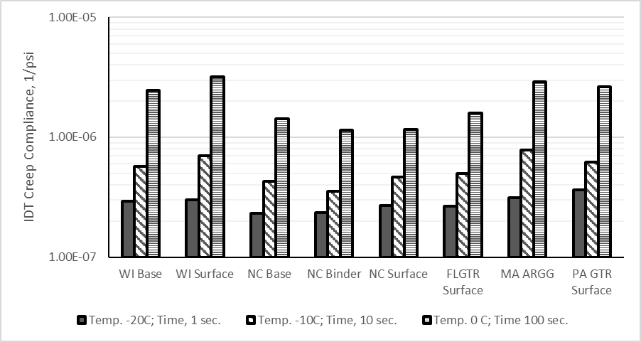
Figure 42. Bar Chart. Comparison of AASHTO T 322 Creep Compliance for R²AMs.
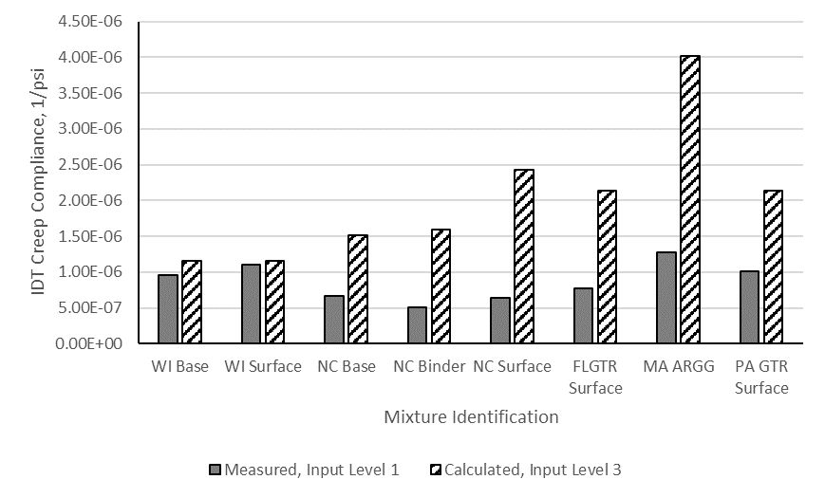
Figure 43. Bar Chart. Comparison of Input Level 1 and Input Level 3 Creep Compliance Values for R²AMs (-10 ºC and 100 seconds loading time).
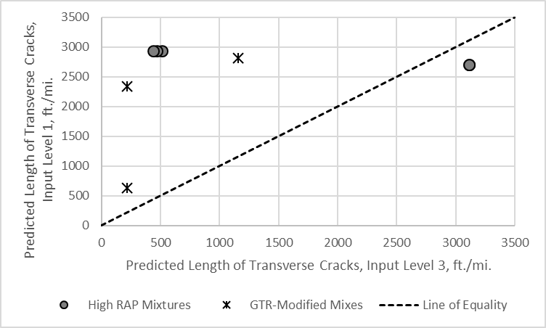
WI high RAP base and surface.
Figure 44. Graph. Comparison of Predicted Length of Transverse Cracks at the End of the Design Period between the R²AM Using Input Level 1 and Virgin Asphalt Mixtures Using Input Level 3.

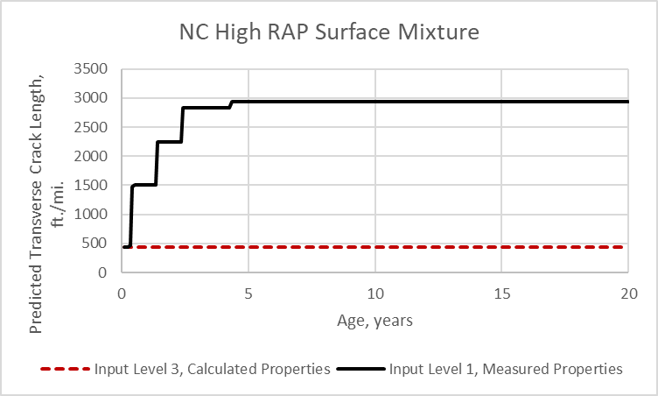
Figure 45. Graph. Predicted Length of Transverse Cracks for the NC High RAP Surface R²AM using Measured Properties and Virgin Asphalt Mixture using Default Input Level 3.
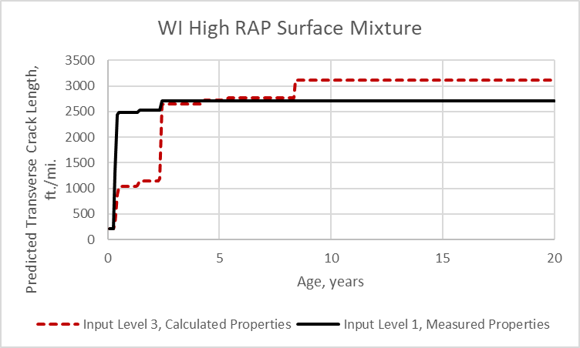
Figure 46. Graph. Predicted Length of Transverse Cracks for the WI High RAP Surface R²AM using Measured Properties and Virgin Asphalt Mixture using Default Input Level 3.

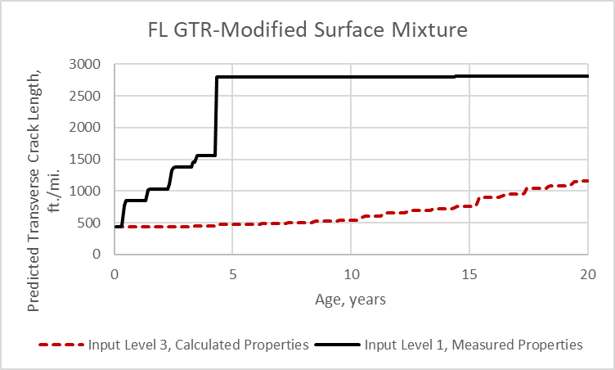
Figure 47. Graph. Predicted Length of Transverse Cracks for the FL GTR-Modified Surface R²AM using Measured Properties and Virgin Asphalt Mixture using Default Input Level 3.
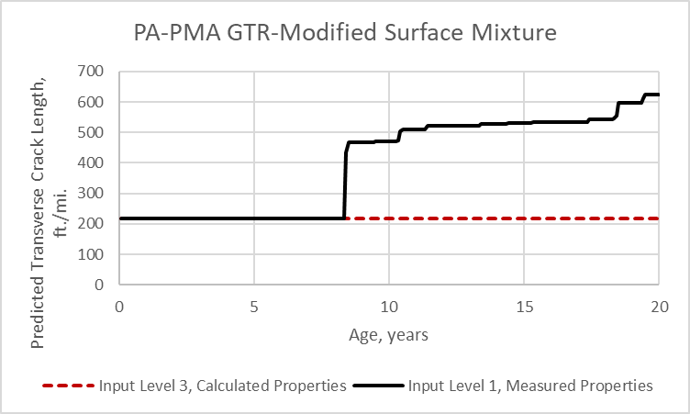
Figure 48. Graph. Predicted Length of Transverse Cracks for the PA PMA, GTR-Modified Surface R²AM using Measured Properties and Virgin Asphalt Mixture using Default Input Level 3.

3.6 Fatigue Cracking, Bottom-Up Alligator Cracking
As noted in Chapter 2, the AASHTOWare Pavement ME Design software predicts two types of load related cracks: (1) alligator cracks which are assumed to initiate at the bottom of the asphalt layer and (2) longitudinal cracks which are assumed to initiate and the surface. Bottom-up alligator cracks are predicted based on the properties of the lower asphalt layer, while top-down longitudinal cracks are predicted based on the properties of the wearing surface.
For both types of cracking, the allowable number of load applications used in the incremental damage analysis is given by the equation in figure 17. Only one set of fatigue strength coefficients are entered in the software, because Pavement ME Design assumes the coefficients are applicable to all asphalt layers. Designing flexible pavement structures with asphalt layers exhibiting different fatigue strength properties must be completed using two separate runs of the software when considering bottom-up alligator and top-down longitudinal cracks. The laboratory-derived fatigue coefficients for the wearing surface should be used for predicting top-down longitudinal fatigue cracks, while the laboratory-derived fatigue coefficients for the asphalt base layer should be used for predicting bottom-up alligator fatigue cracks. As such, two runs of AASHTOWare Pavement ME Design, version 2.5.5 are needed for predicting top-down and bottom-up fatigue cracks when typical dense-graded neat asphalt mixtures and R²AMs are used at the surface and/or asphalt base.
As a reminder from Chapter 2, however, the MEPDG Manual of Practice suggests that top-down longitudinal cracking be excluded as a design criterion in judging the acceptability of a flexible pavement design.⁽¹⁴⁾ More importantly, the top-down longitudinal cracking model in the AASHTOWare Pavement ME Design software is planning to be replaced. As such, the top-down longitudinal cracking model was excluded from this Guide. This section of the Guide only discusses the results and comparison between the R²AM properties and the global default properties derived from testing virgin asphalt mixtures for bottom-up alligator fatigue cracking.

3.6.1 R²AMs Fatigue Strength Coefficients
Flexural fatigue data were measured in accordance with AASHTO T 321 for the nine mixtures sampled during this project (refer to table 7 and table 8). Fatigue tests were conducted on each mixture at multiple strain levels at 10, 20, and 30 ºC using a 10 Hz loading frequency. Table 28 summarizes the fatigue life for the nine mixtures tested at different temperatures and strain levels. The testing was conducted before the recent change to the failure definition in AASHTO T 321. The global fatigue cracking calibration coefficients in the Pavement ME Design software version 2.5.3 were completed using the 50 percent stiffness reduction to define failure—the traditional definition of failure.

3.6.1.1 Fatigue Coefficients Derived Based on the Current Definition of Fatigue Failure
The fatigue data collected in accordance with AASHTO T 321 were used to develop S-N relationships for each mixture at each temperature using log-log regression to determine the constant, k₁, and the exponent, k₂, in the equation in figure 15. Table 29 summarizes the derived coefficients, while figure 49 and figure 50 compare the exponents and intercepts from the S-N curves, respectively. The exponent and intercept decrease with increasing temperature for most of the R²AMs, except for the NC high RAP mixtures. A lower exponent suggests the fatigue life is less sensitive to changes in the strain level, and a lower intercept is the result of a lower exponent.
The S-N relationships were extrapolated to 500,000,000 load cycles to estimate the endurance limit for each mixture at each temperature. Table 29 summarizes the endurance limits, while figure 51 compares the endurance limits between the R²AMs. The endurance limits range from 25 to 195 μstrains and are highly variable, but within the same range of values reported in the literature.⁽¹¹⁾ There does not appear to be a consistent temperature effect on the endurance limits. The endurance limits, however, increase with increasing effective asphalt content by volume, as shown in figure 52.

Table 28. Fatigue Life of R²AMs Based on 50 Percent Stiffness Reduction.
Temp,  ºC | Strain,  μm/m | WI High RAP Base | WI High RAP Surface | NC High RAP Base | NC High RAP Binder | NC High RAP Surface | MA  ARGG | FL GTR Surface | PA GTR Surface | PA PMA Surface
10 | 700 | 2070 | 8760 | 1560 | 2050 | 9940 | 14520 | 7540 | 13080 | 11020
10 | 500 | 15840 | 47010 | 11420 | 9110 | 40630 | 175790 | 149040 | 56230 | 47250
10 | 400 |  |  |  |  | 217930 | 1513560 | 404260 | 123490 | 349400
10 | 300 | 215440 | 1047120 | 52340 | 220460 | 1544850 |  | 1693900 | 1728930 | 2670950
10 | 200 |  |  | 973490
20 | 900 | 3820 | 9160 |  | 2950 | 9850
20 | 800 |  |  |  |  |  |  |  | 36680 | 21980
20 | 700 | 15250 | 19540 | 1570 | 7760 | 58730 | 49600 | 39910 | 47610 | 132330
20 | 600 |  |  |  |  |  | 164680 | 82750
20 | 500 | 81690 | 49860 | 26910 | 21650 | 317440 | 189810 | 248310 | 272260 | 555900
20 | 400 |  |  |  | 100380 | 926679 | 1782830 | 867620 | 1764680 | 2279170
20 | 300 | 838170 | 2089290 | 193490
20 | 200 |  |  | 2915610
30 | 1100 | 3240 | 9430 |  |  |  |  |  |  | 201060
30 | 900 | 6840 | 8780 |  |  | 24480 | 53830 |  | 116140 | 306660
30 | 800
30 | 700 | 24230 | 16800 | 8700 | 11330 | 64890 | 139100 | 27190 | 214610 | 635810
30 | 600 |  |  |  |  | 185490 | 317440 | 66230 | 446680
30 | 500 | 73370 | 52610 | 28470 | 100380 | 908510 |  | 210530 | 1617660 | 2550740
30 | 400 |  |  |  | 319880 |  |  | 439870
30 | 300 |  |  | 300830

Table 29. Fitted Coefficients and Endurance Limits using the Current Fatigue Failure Definition (S-N Relationship).
Temp,  ºC | Parameter | WI High RAP Base | WI High RAP Surface | NC High RAP Base | NC High RAP Binder | NC High RAP Surface | MA  ARGG | FL GTR Surface | PA GTR Surface | PA PMA Surface
10 | Exponent, k₂ | -5.452 | -5.681 | -4.841 | -5.579 | -6.031 | -8.232 | -6.305 | -5.573 | -6.613
10 | Constant, k₁ | -13.851 | -14.017 | -12.065 | -14.354 | -15.134 | -21.843 | -15.865 | -13.588 | -16.942
10 | Estimated Endurance Limit, μstrain | 73 | 100 | 51 | 74 | 112 | 195 | 127 | 100 | 133
20 | Exponent, k₂ | -4.882 | -4.924 | -5.692 | -4.146 | -5.527 | -5.924 | -5.566 | -5.594 | -6.162
20 | Constant, k₁ | -11.247 | -11.217 | -13.233 | -9.196 | -12.767 | -14.005 | -12.983 | -12.882 | -14.559
20 | Estimated Endurance Limit, μstrain | 82 | 90 | 140 | 48 | 131 | 147 | 127 | 139 | 168
30 | Exponent, k₂ | -3.996 | -3.065 | -4.217 | -6.010 | -6.095 | -4.318 | -5.056 | -4.407 | -3.245
30 | Constant, k₁ | -8.294 | -5.411 | -9.403 | -14.888 | -14.279 | -8.437 | -11.471 | -8.456 | -4.358
30 | Estimated Endurance Limit, μstrain | 56 | 25 | 51 | 119 | 170 | 108 | 102 | 128 | 95

Figure 49. Bar Chart. Comparison of Strain Exponents from Fatigue Testing of R²AMs.
Figure 50. Bar Chart. Comparison of the Intercepts from Fatigue Testing of R²AMs.
Figure 51. Bar Chart. Comparison of the Endurance Limits from Fatigue Testing of R²AMs.
Figure 52. Graph. Endurance Limits for R²AMs as a Function of Effective Asphalt Content by Volume.
As noted in the previous chapter, the fatigue coefficients and endurance limit determined using the current definition of fatigue failure are provided for information purposes. The global fatigue cracking calibration coefficients for virgin, neat asphalt mixtures were derived using the traditional definition of fatigue failure. Thus, the next subsection of this chapter of Part 2 of the Guide is the focus of the comparison to the default virgin, neat fatigue coefficients. Appendix D shows examples on the derivation of the fatigue strength coefficients for each R²AM.

3.6.1.2 Fatigue Coefficients Derived Based on the Traditional Definition of Fatigue Failure
Table 30 includes a summary of the fatigue life or cycles to failure based on the traditional definition, dynamic moduli, and strain level for the R²AMs. The fatigue coefficients for the equation included in figure 15 were derived using the fatigue data in table 30. Table 31 summarizes the intercept and strain exponent for all of the R²AMs and test temperatures.
Figure 53 includes a graphical comparison of the strain exponent and the intercept in logarithmic scale for the R²AMs. As shown, the two coefficients are related for all of the different R²AMs. Figure 54 includes the same type of comparison but between the laboratory-derived fatigue coefficients for the R²AMs and values extracted from the literature. As shown, the slope of the relationship between the strain exponent and the intercept in logarithmic scale between the R²AMs and values extracted from the literature for virgin, neat asphalt mixtures are indifferent. In other words, the values reported in the literature have a lower intercept coefficient for the same strain exponent, suggesting the R²AMs are more resistant to fatigue cracking.
The fatigue relationships based on the traditional definition of failure were extrapolated to 500,000,000 load cycles to estimate the endurance limit for each mixture at each temperature. Table 31 summarizes the endurance limits. The estimated endurance limits range from 51 to 195 μstrains, which are within the range of values reported in the literature.⁽¹¹⁾ More importantly, there does not appear to be a consistent temperature effect on the extrapolated endurance limits. The endurance limits derived at 20 ºC (68 ºF) increase with increasing effective asphalt content by volume for the R²AMs, as shown in figure 55. The correlation between the two properties is considered fair.
A more interesting observation from figure 55 is the endurance limit above and below 11 percent V_{be}: below 11 percent the average endurance limit is 84 in./in. and above 11 percent it is 148 in./in. It appears a V_{be} of around 11 percent is the transition between more brittle and strain tolerant mixtures; at least for these 9 mixtures.

Table 30. Summary R²AMs Fatigue Data using the Traditional Definition for Fatigue Failure.
Mixture and Property | 10 ºC | 10 ºC | 10 ºC | 10 ºC | 20 ºC | 20 ºC | 20 ºC | 20 ºC | 30 ºC | 30 ºC | 30 ºC | 30 ºC
WI High RAP Base Strain, μstrain | 300 | 500 | 700 |  | 300 | 500 | 700 | 900 | 500 | 700 | 900 | 1100
WI High RAP Base Modulus, psi | 1287000 | 1287000 | 1287000 |  | 784000 | 784000 | 784000 | 784000 | 434000 | 434000 | 434000 | 434000
WI High RAP Base Cycles to Failure | 215440 | 15840 | 2070 |  | 838170 | 81690 | 15250 | 3820 | 73370 | 24230 | 6840 | 3240
WI High RAP Surface Strain, μstrain | 300 | 500 | 700 |  | 300 | 500 | 700 | 900 | 500 | 700 | 900 | 1100
WI High RAP Surface Modulus, psi | 1580000 | 1580000 | 1580000 |  | 979000 | 979000 | 979000 | 979000 | 530000 | 530000 | 530000 | 530000
WI High RAP Surface Cycles to Failure | 1047120 | 47010 | 8760 |  | 2089290 | 49860 | 19540 | 9160 | 52610 | 16800 | 8780 | 9430
NC High RAP Base Strain, μstrain | 200 | 300 | 500 | 700 | 200 | 300 | 500 | 700 | 300 | 500 | 700
NC High RAP Base Modulus, psi | 1658000 | 1658000 | 1658000 | 1658000 | 1025000 | 1025000 | 1025000 | 1025000 | 534000 | 534000 | 534000
NC High RAP Base Cycles to Failure | 973490 | 52340 | 11420 | 1560 | 2915610 | 193490 | 26910 | 1570 | 300830 | 28470 | 8700
NC High RAP Binder Strain, μstrain | 300 | 500 | 700 |  | 400 | 500 | 700 | 900 | 400 | 500 | 700
NC High RAP Binder Modulus, psi | 1595000 | 1595000 | 1595000 |  | 990000 | 990000 | 990000 | 990000 | 530000 | 530000 | 530000
NC High RAP Binder Cycles to Failure | 220460 | 9110 | 2050 |  | 100380 | 21650 | 7760 | 2950 | 319880 | 100380 | 11330
NC High RAP Surface Strain, μstrain | 300 | 400 | 500 | 700 | 400 | 500 | 700 | 900 | 500 | 600 | 700 | 900
NC High RAP Surface Modulus, psi | 1580000 | 1580000 | 1580000 | 1580000 | 984000 | 984000 | 984000 | 984000 | 521000 | 521000 | 521000 | 521000
NC High RAP Base Cycles to Failure | 1544850 | 217930 | 40630 | 9940 | 926679 | 317440 | 58730 | 9850 | 908510 | 185490 | 64890 | 24480
MA ARGG Strain, μstrain | 400 | 500 | 700 |  | 400 | 500 | 600 | 700 | 600 | 700 | 900
MA ARGG Modulus, psi | 1003800 | 1003800 | 1003800 |  | 577200 | 577200 | 577200 | 577200 | 305000 | 305000 | 305000
MA ARGG Cycles to Failure | 1513560 | 175790 | 14520 |  | 1782830 | 189810 | 164680 | 49600 | 317440 | 139100 | 53830
FL GTR Surface Strain, μstrain | 300 | 400 | 500 | 700 | 400 | 500 | 600 | 700 | 400 | 500 | 600 | 700
FL GTR Surface Modulus, psi | 1570000 | 1570000 | 1570000 | 1570000 | 970000 | 970000 | 970000 | 970000 | 521000 | 520000 | 520000 | 520000
FL GTR Surface Cycles to Failure | 1693900 | 404260 | 149040 | 7540 | 867620 | 248310 | 82750 | 39910 | 439870 | 210530 | 66230 | 27190
PA GTR Surface Strain, μstrain | 300 | 400 | 500 | 700 | 400 | 500 | 700 | 800 | 500 | 600 | 700 | 900
PA GTR Surface Modulus, psi | 1351400 | 1351400 | 1351400 | 1351400 | 764000 | 764000 | 764000 | 764000 | 372400 | 372400 | 372400 | 372400
PA GTR Surface Cycles to Failure | 1728930 | 123490 | 56230 | 13080 | 1764680 | 272260 | 47610 | 36680 | 1617660 | 446680 | 214610 | 116140
PA PMA Surface Strain, μstrain | 300 | 400 | 500 | 700 | 400 | 500 | 700 | 900 | 500 | 700 | 900 | 1100
PA PMA Surface Modulus, psi | 1843000 | 1843000 | 1843000 | 1843000 | 1194000 | 1194000 | 1194000 | 1194000 | 663000 | 663000 | 663000 | 663000
PA PMA Surface Cycles to Failure | 2670950 | 349400 | 47250 | 11020 | 2279170 | 555900 | 132330 | 21980 | 2550740 | 635810 | 306660 | 201060

Table 31. Fitted Coefficients and Endurance Limits using the Traditional Definition of Fatigue Failure (50 Percent Stiffness Reduction).
Temp,  ºC | Parameter | WI High RAP Base | WI High RAP Surface | NC High RAP Base | NC High RAP Binder | NC High RAP Surface | MA  ARGG | FL GTR Surface | PA GTR Surface | PA PMA Surface
10 | Exponent, k₂ | 5.4519 | 5.6808 | 4.8413 | 5.5794 | 6.0306 | 8.2319 | 6.3055 | 5.5730 | 6.6126
10 | Constant, k₁ | -13.7270 | -13.8790 | -11.9660 | -14.2420 | -15.0900 | -21.8200 | -15.7940 | -13.5080 | -16.8620
10 | Estimated Endurance Limit, μstrain | 74 | 100 | 54 | 74 | 115 | 195 | 133 | 110 | 134
20 | Exponent, k₂ | 4.8230 | 4.9243 | 5.6923 | 4.1461 | 5.5273 | 5.9242 | 5.4663 | 5.5944 | 5.5136
20 | Constant, k₁ | -11.1230 | -11.0790 | -14.5210 | -9.0845 | -12.7230 | -13.9820 | -12.9120 | -12.8020 | -12.3090
20 | Estimated Endurance Limit, μstrain | 84 | 98 | 83 | 53 | 133 | 165 | 128 | 144 | 149
30 | Exponent, k₂ | 4.0376 | 2.3065 | 4.0376 | 6.0104 | 6.0946 | 4.3182 | 5.0555 | 4.4075 | 3.2448
30 | Constant, k₁ | -8.3046 | -2.8308 | -8.3046 | -14.7760 | -14.2350 | -8.4143 | -11.4000 | -8.3758 | -4.2777
30 | Estimated Endurance Limit, μstrain | 58 | 14⁽¹⁾ | 51 | 119 | 177 | 110 | 105 | 142 | 99
- Considered an outlier.

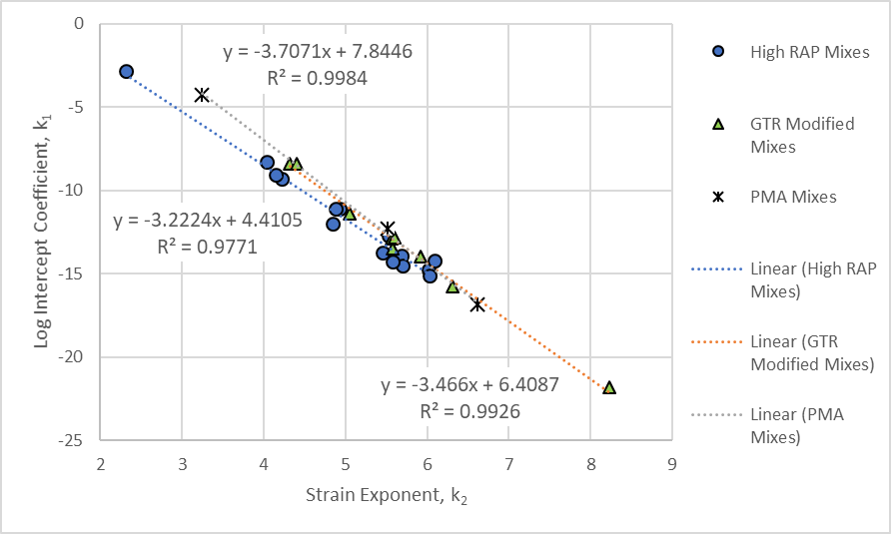
Figure 53. Graph. Comparison of the Strain Exponent and Intercept for the R²AMs.

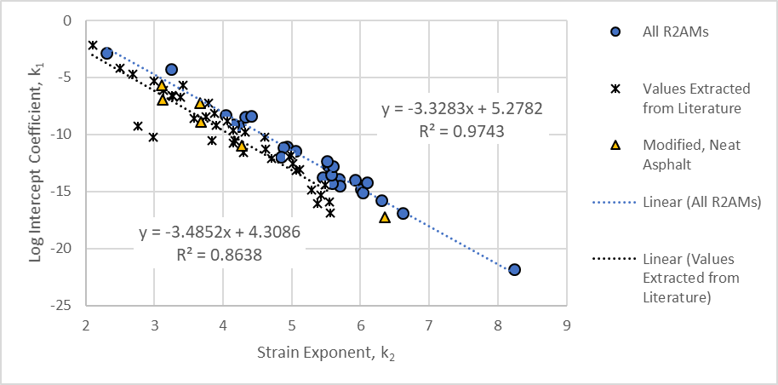
Figure 54. Graph. Comparison of the Strain Exponent and Intercept for the R²AMs and Neat, Virgin Asphalt Mixtures.

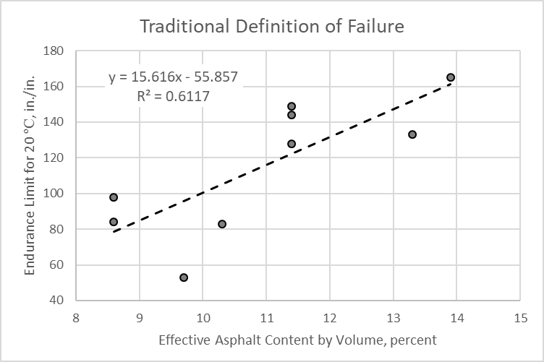
Figure 55. Graph. Endurance Limits for 20 ºC (68 ºF) based on the Traditional Definition of Fatigue Failure for R²AMs as a Function of Effective Asphalt Content by Volume.
The fatigue life data from the three temperatures were combined with 10 Hz dynamic modulus values from the master curves presented in section 3.3 of this Guide. The equation in figure 17 is the laboratory form of the general fatigue relationship used in AASHTOWare Pavement ME Design software. The coefficients or k_{f} values in figure 17 were derived using the data summarized in table 30. Appendix D includes an explanation on the derivation of the fatigue strength coefficients for each mixture.
Table 32 summarizes the fitting coefficients for all R²AM mixtures and the explained variance derived from the laboratory tests using input level 1. The general form of the fatigue relationship reasonably fits the measured data with explained variance ranging from 87 to 96 percent, suggesting a good fit to the measured data. Some general observations from the fatigue life data are listed below:
- The k_{1f} intercept term varies significantly between the different R²AMs. The intercept coefficient for the R²AMs are generally lower than the intercept coefficient for virgin, neat asphalt mixtures (see figure 54).
- The k_{2f} strain exponent for the R²AMs is more stable, but generally higher than for virgin, neat asphalt mixtures (see figure 53). In addition, the strain exponent for the GTR-modified R²AMs is larger than for the high RAP mixtures, except for the NC high RAP wearing surface mixture, which has a V_{be} exceeding 11 percent.
- The modulus exponent for the R²AMs is also highly variable. The default modulus exponent for virgin, neat asphalt mixtures is within the range of the modulus exponent values derived for the R²AMs.
- The intercept coefficient and modulus exponent were significantly higher for the two PA PMA mixtures, than for the other R²AMs and PMA mixtures reported in the literature (see table 32 and figure 54).
Table 32. Fitting Coefficients for the AASHTOWare Pavement ME Design Fatigue Relationship for R²AMs.
Mix Designation | Mix Type | Fatigue Strength Coefficients |  |  | Statistical Parameter, R²
Mix Designation | Mix Type | Intercept, k_{1f} | Response Exponent, k_{2f} | Modulus Exponent, k_{3f} | Statistical Parameter, R²
Default Values; All Mixes | Neat, Virgin | 3.75E-03 | 2.87 | 1.46 | NA
WI Base Layer | High Recycle | 1.810E-01 | 4.895 | 1.801 | 0.94
WI Surface Layer | High Recycle | 4.715E-03 | 5.281 | 1.656 | 0.87
NC Base Layer | High Recycle | 1.448E-04 | 5.070 | 1.425 | 0.96
NC Intermediate Layer | High Recycle | 4.316E-03 | 5.400 | 1.816 | 0.96
NC Surface | High Recycle | 6.041E-02 | 5.644 | 2.012 | 0.94
FL Surface | GTR Modified | 4.611E-11 | 5.592 | 0.477 | 0.88
MA ARGG Surface | GTR Modified | 1.846E-06 | 6.295 | 1.629 | 0.90
PA Surface | GTR Modified | 3.415E+02 | 5.259 | 2.437 | 0.93
PA Surface | PMA, Virgin | 3.422E+07 | 5.175 | 3.162 | 0.91
Note: The intercept or k_{1f} values listed above are in in./in. The global intercept coefficient included in the Pavement ME Design software is mils/in.
The fatigue strength data and coefficients listed in table 32 were used to estimate the endurance limit at the representative fatigue temperature for each mixture and location. The representative fatigue temperature and resulting endurance limits are summarized in table 33 for the mean annual pavement temperature (MAPT) and representative fatigue temperature. In summary, the endurance limit for asphalt mixtures with V_{be} values greater than 11 percent are significantly greater than for mixtures with V_{be} values less than 11 percent (refer to figure 55 and table 33).

Table 33. Endurance Limits at the Representative Temperature using the Traditional Definition of Fatigue Life.
Mixture Type | 50 mm MAPT, ⁰C | Fatigue Temperature, ⁰C | 10 Hz Modulus at Fatigue Temperature ksi | Estimated Endurance Limit at Fatigue Temperature, µstrain | V_{be}, percent
WI High RAP Base | 26.6 | 18.6 | 847.2 | 85 | 8.6
WI High RAP Surface | 26.6 | 18.6 | 1057.6 | 99 | 8.6
NC High RAP Base | 35.6 | 25.7 | 720.1 | 73 | 10.3
NC High RAP Intermediate | 35.6 | 25.7 | 703.9 | 80 | 9.7
NC High RAP Surface | 35.6 | 25.7 | 696.7 | 152 | 13.3
MA ARGG | 21.1 | 14.2 | 806.7 | 185 | 13.9
FL GTR Surface | 39.6 | 29.0 | 556.7 | 108 | 11.4
PA GTR Surface | 28.0 | 19.7 | 779.1 | 145 | 11.4
PA PMA Surface | 28.0 | 19.7 | 121.75 | 149 | 11.4

3.6.2 Impact of Volumetric Properties on the Fatigue Coefficients
Table 31 summarized the mixture specific fatigue strength coefficients for the 9 R²AMs. Table 4 and table 6 summarized the dynamic moduli for 8 of the R²AMs. The dynamic moduli for the PA PMA mixture excluded from the test program were calculated using input level 3. Some observations are listed below, even though only 9 R²AMs were tested in the laboratory.
- Figure 56 shows the modulus exponent, k_{f3}, is dependent on the intercept coefficient, k_{1f}, for the R²AMs. The data are grouped by mixtures with a V_{be} less than and greater than 11 percent, because the range in the endurance limit values appeared to be dependent on this grouping of the data by V_{be} (see figure 55). The default values for the intercept and modulus exponent included in the Pavement ME Design software for neat, virgin asphalt mixtures is also included in figure 56 and is similar to the relationship between the modulus exponent and intercept for the R²AMs in logarithmic scale with a V_{be} less than 11 percent.
- The mixture with the highest intercept and highest modulus exponent was the PA PMA mixture, which was considered an outlier. The mixture with the lowest intercept and lowest modulus exponent was the FL GTR modified mixture, and is also considered an outlier. Considering the variability in the measured data, however, the difference in the relationships between the intercept and modulus exponent is insignificant. Figure 57 shows the relationship between the intercept and modulus exponent for all of the R²AMs combined into one group.
- Figure 58 shows the relationship between V_{be} and tensile strain exponent, k_{2f}. As the V_{be} increases there is a corresponding increase in the tensile strain exponent of the fatigue strength equation (see figure 17), which appears to be independent of mixture type. The correlation between V_{be} and the strain exponent is considered good for the 9 mixtures tested.
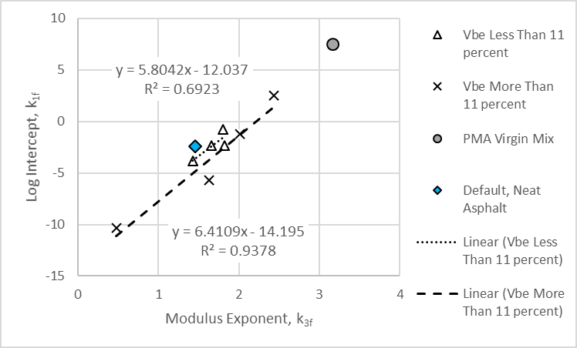
Figure 56. Graph. Relationship between the Intercept Coefficient, k_{f1}, and Modulus Exponent, k_{f3}, for the R²AM Mixtures Grouped by Effective Asphalt Content by Volume.
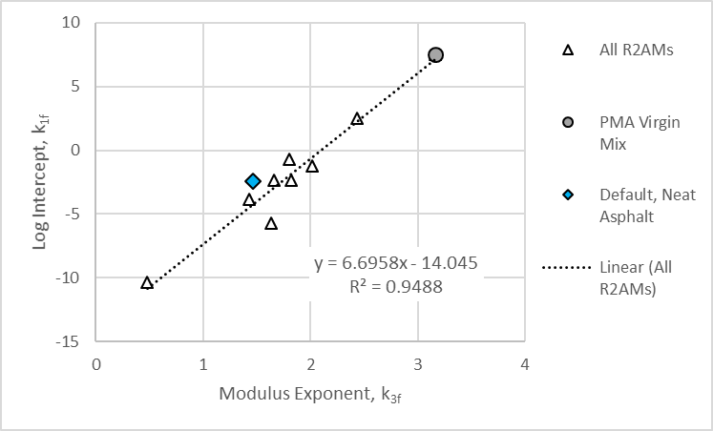
Figure 57. Graph. Relationship between the Intercept Coefficient, k_{f1}, and Modulus Exponent, k_{f3}, for all R²AM Mixtures.
Two important fatigue properties are the modulus and tensile strain exponents (refer to figure 17). To illustrate the impact on the predicted area of alligator cracking, small variations from a measured value were used to demonstrate their sensitivity on the predicted bottom-up fatigue cracking, which is summarized below.
- The modulus exponent for the R²AM mixtures varied from 0.477 to 3.162 (see table 32). Figure 59 shows the sensitivity of predicted alligator cracking to a small variation of the modulus exponent, 1.25 to 1.75. As shown, small variations in the modulus exponent can result in large differences in the predicted area of alligator cracking; going from basically 0 to 100 percent over the 20-year design period.
- The tensile strain exponent for the R²AM mixtures varied from 4.895 to 6.295 (see table 32). Figure 60 shows the sensitivity of predicted alligator cracking to a small variation of the tensile strain exponent; 4.85 to 5.15. As shown, small variations in the tensile strain exponent can result in large differences in the predicted area of alligator cracking; going from less than 2 to over 80 percent over the 20-year design period.
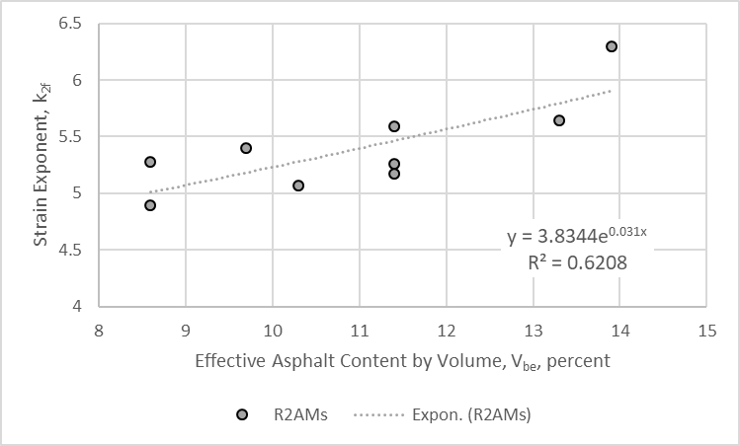
Figure 58. Graph. Relationship between V_{be} and the Tensile Strain Exponent, k_{f2}, for the R²AM Mixtures.
In summary, the larger range of values measured in the laboratory for the modulus and strain exponents will result in an extremely high or low number of allowable load applications, N_{f}, for the fatigue strength. The fatigue strength, however, is dependent on the volumetric properties and the relationship or interaction between the fatigue strength coefficients. The strain exponent increases with an increase in the effective asphalt content by volume (see figure 58) resulting in higher fatigue strengths (see figure 60). However, the higher the strain exponent, the lower the intercept (see figure 54). A lower intercept reduces the fatigue strength. Conversely, lower intercepts result in lower modulus exponents (see figure 57). A lower modulus exponent increases the fatigue strength (see figure 59). Thus, the resulting net effect on the fatigue strength of a specific mixture depends on the relative difference or interrelationship between the fatigue strength coefficients, as well as the volumetric properties.

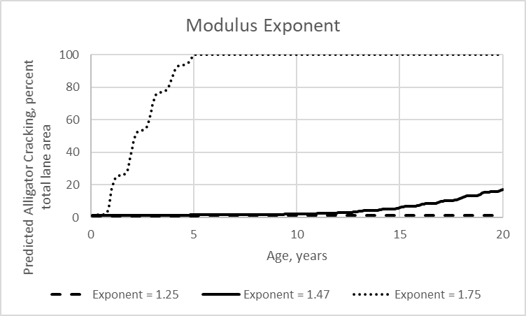
Figure 59. Graph. Predicted Area of Alligator Cracking for Different Modulus Exponents.
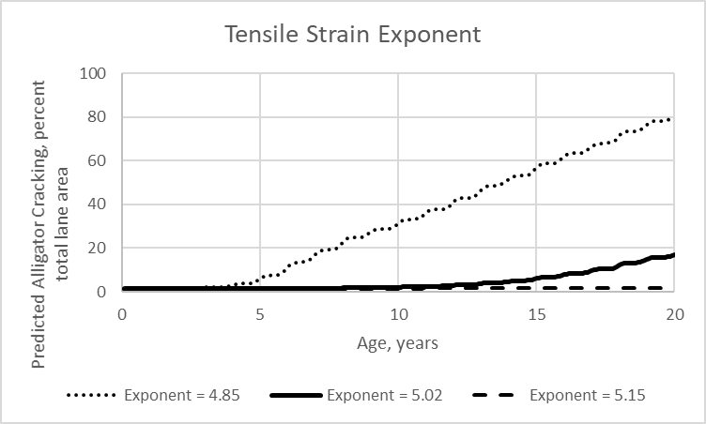
Figure 60. Graph. Predicted Area of Alligator Cracking for Different Tensile Strain Exponents.

3.6.3 Comparison of Fatigue Cracking: Input Level 1 and Input Level 3
The area of bottom-up alligator cracking was predicted using the Pavement ME Design software and the measured properties listed in table 32 in comparison to the default properties and fatigue strength coefficients for virgin, neat asphalt mixtures. The field shift factors or β-values in the AASHTOWare Pavement ME Design software were assumed to be equal between all dense-graded mixtures. Using the same global field shift or adjustment factors, no bottom-up fatigue cracking was predicted for any of the R²AM mixtures over a period of 20 years. The predicted area of fatigue cracking using the global default fatigue strength coefficients based on dense-graded neat, virgin asphalt mixtures (input level 3) are summarized in table 34. The predicted fatigue cracking for the different locations and mixtures varied from 1.89 percent (the FL location for the GTR modified surface mixture) to 28.2 percent (the WI location for the high RAP base mixture). As such, the default or global fatigue strength coefficients determined for dense-graded virgin, neat asphalt mixtures are not representative of the laboratory-derived fatigue strength coefficients for R²AMs.
Table 34. Fatigue Cracks Predicted for Input Level 1 and Input Level 3 for the R²AMs.
Mix Designation | Mix Type | Fatigue Strength Coefficients |  |  | Predicted Fatigue Cracks at 20 years, %
Mix Designation | Mix Type | Intercept, in./in., k_{1f} | Response Exponent, k_{2f} | Modulus Exponent, k_{3f} | Input Level 3 | Input Level 1
WI Base Layer | High Recycle | 1.810E-01 | 4.895 | 1.801 | 28.2 | 1.28
WI Surface Layer | High Recycle | 4.715E-03 | 5.281 | 1.656 | 18.6 | 0.03
NC Base Layer | High Recycle | 1.448E-04 | 5.070 | 1.425 | 15.8 | 21.1
NC Intermediate Layer | High Recycle | 4.316E-03 | 5.400 | 1.816 | 23.6 | 1.04
NC Surface | High Recycle | 6.041E-02 | 5.644 | 2.012 | 2.86 | 0
FL Surface | GTR Modified | 4.611E-11 | 5.592 | 0.477 | 1.89 | 0
MA ARGG Surface | GTR Modified | 1.846E-06 | 6.295 | 1.629 | 3.48 | 0.01
PA Surface | GTR Modified | 3.415E+02 | 5.259 | 2.437 | 10.2 | 0
PA Surface | PMA, Virgin | 3.422E+07 | 5.175 | 3.162 | 7.17 | 0

Field adjustment factors or β-values were derived for a few PMA and other non-typical asphalt mixture test sections for which the fatigue strength coefficients were estimated from other research studies (see figure 54). The β_{1f} intercept coefficient was found to be the same as for the neat, virgin asphalt mixtures. A difference, however, was found for the tensile strain and modulus exponents. The β_{2f}-value for the tensile strain exponent varied from 0.8 to 0.9, as compared to a β_{2f-virgin}-value of 1.38 for virgin, neat asphalt mixtures. The β_{3f}-value for the modulus exponent varied from 0.8 to 1.0, as compared to a β_{3f-virgin}-value of 0.88 for virgin, neat asphalt mixtures. The reasons for the difference is believed to be related to crack propagation through different mixtures in combination with the fatigue test procedure and/or other measured volumetric properties used to calculate the number of allowable load applications in accordance with the equation in figure 17.
A β_{2f}-value (tensile strain exponent) of 0.85 and a β_{3f}-value (modulus exponent) of 0.90 was applied to all R²AM mixtures to determine if the difference in predicted cracking was caused by different field-shift factors. Table 34 summarizes the predicted area of fatigue cracks at 20-years using input level 1 (laboratory-derived fatigue strength coefficients) in comparison to using input level 3 at a 50 percent reliability level. As summarized, large differences were found between input level 1 (mixture specific fatigue strength coefficients) and input level 3 (global default values derived for neat, virgin asphalt mixtures).
Figure 61 includes a comparison of the predicted alligator cracking at the end of the design period for the R²AM and virgin, neat asphalt mixtures. No bottom-up fatigue cracking was predicted for the laboratory-derived fatigue strength coefficients when using the global field-shift factors based on neat, virgin asphalt mixtures. Using the PMA modulus and strain exponent field-shift factors (β_{2f} of 0.85 and β_{3f} of 0.90) based on limited data for all R²AMs, the predicted area of fatigue cracking is higher but is still significantly less than the predicted cracking for the default fatigue strength coefficients, except for the NC high RAP base mixture (see table 34).
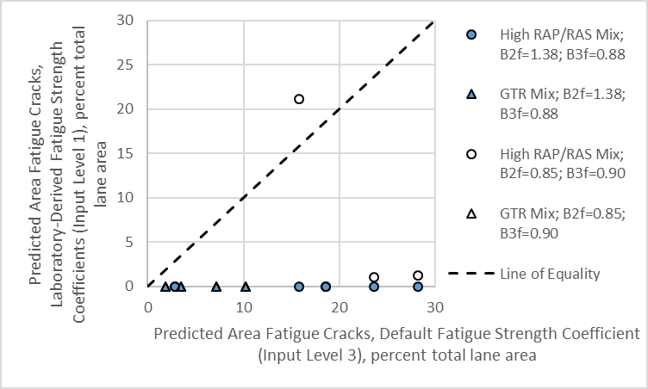
Figure 61. Graph. Comparison of Predicted Bottom-Up Alligator Cracking at the End of the Design Period between the R²AM and Virgin, Neat Asphalt Mixtures.
The reason for the large differences between input level 1 and input level 3 in table 34 is a result of the sensitivity of the predicted cracks to small variations in the tensile strain response and modulus exponents (see figure 59 and figure 60). Small errors within the testing procedure and/or analysis of the test results can result in large differences in the predicted area of fatigue cracking. Thus, the average fatigue coefficients were determined for different types of mixtures based on the observations from the laboratory fatigue tests using the traditional definition of failure.
The following describes the grouping of mixtures based on the results from the fatigue tests which are summarized in table 35, in comparison to the global default values for neat, virgin asphalt mixtures.
- The high RAP mixtures were separated from the GTR modified mixtures because higher areas of fatigue cracking were predicted for the high RAP mixtures in comparison to the GTR modified mixtures (see table 34).
- Only three GTR modified mixtures were included in the test program and all resulted in significantly different k_{1f} intercepts. The values listed in table 35 only include the FL and MA GTR modified mixtures.
- The intercept coefficient, k_{1f}, and modulus exponent, k_{3f}, are related; a decrease in k_{3f} results in a decrease in k_{1f} (see figure 57).
- The tensile strain response exponent, k_{2f}, is related to the effective asphalt content by volume, V_{be} (see figure 58); an increase in V_{be} results in an increase in k_{2f}.
Table 35. Average Fatigue Strength Coefficients for Different Mixtures.
Type of Asphalt Mixture | Fatigue Strength Coefficient, see Figure 17
Type of Asphalt Mixture | Intercept, mils/in., k_{1f} | Response Exponent, k_{2f} | Modulus Exponent, k_{3f}
Default Values; Neat Asphalt Mixtures | 3.75 | 2.870 | 1.460
High RAP (5 Mixes) | 50.1 | 5.258 | 1.742
GTR Modified (2 Mixes) | 9.23E-04 | 5.944 | 1.053
Notes to Table 35:
- The units for the intercept, k_{1f}, in the Pavement ME Design software is mils/inch, while the units for the intercept parameter in table 35 are in./in.
- As noted in a previous paragraph, the virgin PMA and GTR plus PMA mixtures sampled from PA are significantly different from the other mixtures. As such, both were excluded from determining the average coefficients for a material classification.
Both the tensile strain and modulus exponents have significant impact on the predicted area of fatigue cracking. Much more field performance data, however, is needed to confirm the calibration coefficients of the R²AMs. The field-shift or calibration coefficients (the β-values) derived for the dense-graded virgin, neat mixtures are suggested for use at this time.

3.6.4 Summary of Comparisons
In summary, use of the global fatigue strength coefficients derived from virgin asphalt mixtures are inappropriate for use in predicting the area of fatigue cracks for R²AMs (see table 34). As noted in the previous section, the larger range of values measured in the laboratory for the modulus and strain exponents will result in an extremely high or low number of allowable load applications, N_{f}, or fatigue strength (see figure 59 and figure 60). The average fatigue coefficients were determined for the different R²AMs. Table 35 included the average fatigue coefficients for the different R²AMs and the global default values derived for neat, virgin asphalt mixtures. The average fatigue coefficients derived for the R²AMs (summarized in table 35) should be used for pavement structural design, but it is recommended that more R²AMs be used to confirm the calibration coefficients for these mixtures, especially for the GTR modified asphalt mixtures.

Chapter 4. R²AMs Properties

This chapter of the Guide provides a summary of the methods and analyses for determining the input level 1 mechanical properties from laboratory tests, which were discussed in Chapters 2 and 3 of Part 2 of the Guide as well as in Part 1. It also summarizes the range of expected input values to identify asphalt mixtures that are susceptible to rutting and cracking.
As noted earlier, Part 1 of the Guide provided a detailed description of the sample preparation, testing, data collection, and interpretation procedures. Part 2 of the Guide focuses on the interpretation of the test data for developing input level 1 properties for use in the AASHTOWare Pavement ME Design software. The mechanical properties derived from the procedures described in Chapter 2 and summarized below include: dynamic modulus, plastic deformation coefficients, IDT strength and creep compliance, and fatigue strength coefficients.

4.1 Dynamic Modulus
Dynamic moduli are required over a range of temperatures and loading frequencies to predict rutting and fatigue cracking. The dynamic moduli are measured in the laboratory (input level 1) or calculated by the software (input level 3). The Pavement ME Design software uses a regression equation to calculate the dynamic modulus from the volumetric and component properties of the asphalt mixture. The regression equations was derived using data measured on a wide range of neat and some modified dense-graded mixtures. As noted in Chapter 2, the MEPDG assumes the dynamic modulus regression equation for input level 3 is applicable to all asphalt mixtures. The accuracy or appropriateness of the regression equation to R²AM mixtures was evaluated for 8 R²AMs.
Figure 21 in Chapter 3 included a comparison between the calculated and measured dynamic modulus values for the GTR modified and high RAP/RAS mixtures. A negative bias was found, which was greater for the high RAP+RAS mixtures and at the higher temperatures or slower loading frequencies (lower dynamic modulus values). The use of input level 1 laboratory-measured dynamic moduli for R²AMs results in significantly higher predicted amounts of asphalt layer rutting (see figure 22) and fatigue cracking (see figure 23) because the dynamic moduli during the summer months are consistently lower than the dynamic moduli calculated using input level 3. The bias between input level 1 and input level 3 dynamic moduli is about the same for rut depth between high recycle and GTR modified mixtures. The bias for fatigue cracking, however, is greater for the GTR modified mixtures (see figure 23).
In summary, the use of input level 3 dynamic moduli regression equation included in the Pavement ME Design software for the closest PG designated asphalt will result in a bias for fatigue cracking and rutting. Thus, input level 3 calculated dynamic moduli from the regression equation embedded in the Pavement ME Design software are inappropriate for use for R²AMs.
The methods and analyses to determine input level 1 dynamic moduli is straightforward and listed below.
- Measure dynamic modulus of the asphalt mixture in accordance with AASHTO T 342, Standard Method of Test for Determining Dynamic Modulus of Hot-Mix Asphalt Concrete Mixtures. Chapter 2 of Part 1 includes additional information on test specimen preparation and testing.
- The measured dynamic modulus at specific temperatures and frequencies are entered directly into the Pavement ME software. No other data manipulation of the laboratory-measured moduli is required, assuming the dynamic moduli were measured at each temperature and loading frequency required by the software. Figure 1 in Chapter 2 included a screen shot for the Dynamic Modulus Input Level 1.
  - If there are missing temperatures, however, Chapter 2 in Part 1 discusses the spreadsheets that are publicly available which can be used to derive the missing data from the dynamic modulus master curve that was generated from the measured dynamic modulus values.
  - AASHTOWare also provides an Application Programming Interface (API) that can be used to derive dynamic modulus for missing temperatures from the measured data.
- Measure the shear modulus, G*, and phase angle, ϕ, of the asphalt in accordance with AASHTO T 315. G* and ϕ are entered into the Pavement ME Design software as required inputs for input level 1 dynamic moduli.
  - The asphalt properties are only used to estimate the increase in dynamic moduli over time because of aging and are not used to generate the dynamic modulus master curve.
  - The shear modulus and phase angle should be measured at two temperatures, as a minimum; one at the PG temperature and one 10 degrees below the PG temperature.
- The measured dynamic moduli should be compared to the data within a materials library.
  - If the dynamic moduli are statistically indifferent from other similar type mixtures, the dynamic moduli can be averaged to establish the dynamic moduli to be used in design for similar types of mixtures.
  - If the dynamic moduli are statistically different, a separate set of dynamic moduli needs to be included in the materials library.
- Table 36 summarize the average dynamic moduli for the high RAP/RAS R²AM included within the test program (WI base and surface mixes, see table 13 and table 14; NC intermediate layer mix, see table 16). The other R²AMs tested had different volumetric and/or component properties, as designated below, so they were not combined into an average. Table 13 through table 20 in Chapter 3 summarize the dynamic moduli for the 8 R²AMs.
  - No RAS was included in the NC high recycle base mixture.
  - More asphalt was included in the NC high recycle wearing surface having a V_{be} of 11.4 percent which other similar mixtures had a V_{be} less than 11 percent.
  - The FL and MA GTR modified mixtures both included RAP, but the dynamic moduli are different between these two mixtures.
  - The PA GTR modified PMA mixture excluded RAP, but the dynamic moduli are similar to the MA GTR modified mixture with RAP. The dynamic moduli were not averaged for these two mixtures because the component properties are different.
Table 36. Average Dynamic Moduli for the High RAP/RAS R²AMs, psi.
Test Temperature, ºF | Loading Frequency, Hz
Test Temperature, ºF | 0.1 | 0.5 | 1.0 | 5.0 | 10.0 | 25.0
14 | 1,917,790 | 2,208,660 | 2,324,120 | 2,566,070 | 2,658,600 | 2,770,200
40 | 929,990 | 1,229,990 | 1,365,970 | 1,685,100 | 1,820,190 | 1,993,330
70 | 275,320 | 422,060 | 501,740 | 725,680 | 837,750 | 998,030
100 | 81,850 | 127,650 | 155,240 | 244,240 | 295,580 | 377,480
130 | 34,730 | 50,070 | 59,430 | 90,800 | 109,910 | 142,120

4.2 Plastic Strain Coefficients
Plastic strain coefficients are used to predict rutting in the asphalt layers. Default plastic strain coefficients are included in the Pavement ME Design software, and were derived from testing neat, virgin dense-graded asphalt mixtures. The appropriateness of the global default coefficients to R²AM mixtures were evaluated for 8 R²AMs.
Figure 38 in Chapter 3 included a comparison of the predicted rut depth in the asphalt layers using the global default coefficients for neat, virgin asphalt mixtures and laboratory-derived coefficients for the R²AMs. As shown, there is a significant bias between the global default and laboratory-derived coefficients. In summary, use of the global default plastic strain coefficients based on neat, virgin asphalt mixtures will result in higher predicted rut depths for the R²AMs. Thus, the plastic strain coefficients determined for neat, virgin asphalt mixtures are inappropriate for use for R²AMs.
The asphalt plastic strain coefficients are derived from repeated load plastic deformation tests. Chapter 3 of Part 1 includes additional information on test specimen preparation and testing for measuring the plastic deformation coefficients. The methods and analyses to determine input level 1 plastic strain coefficients were discussed in chapter 2 and chapter 3 and are listed below.
- Perform the repeated load plastic deformation tests in accordance with Chapter 3 of Part 1 of the Guide.
- Use AASHTO T 378, Standard Method of Test for Determining the Dynamic Modulus and Flow Number for Hot Mix Asphalt (HMA) Using the Asphalt Mixture Performance Tester (AMPT), to determine if tertiary flow occurred.
  - If tertiary flow did not occur, fit the data from 1,000 to 10,000 load cycles to the equation included in figure 4 using linear regression.
    - Determine the slope, b, and intercept, a, for each test specimen and test temperature.
  - If tertiary flow occurred, determine the slope and intercept for each test specimen up to the number of load cycles when tertiary flow was identified.
    - The slope is determined between the flow number or beginning of the tertiary zone and the load cycle at the end of the primary zone (see figure 2).
    - The intercept, a, is defined from the slope in the secondary zone (see figure 2).
    - The slope and intercept for the mixture is determined as noted above.
- Prepare a summary or listing of the slope, b, and intercept, a, for each test temperature to be used in the regression analyses (see table 23).
  - The slope is assumed to be temperature independent. Two conditions are possible in determining the slope coefficient, b, as listed below:
    - If the slope does not consistently and statistically change with temperature, average the slopes (b-values) from all test specimens and temperatures.
    - If the slope has a consistent and statistical increase or decrease with temperature, determine the representative slope at the equivalent annual temperature for rutting (see the equation in figure 3).
  - The intercept (a-values) from the secondary zone of the plastic strain curve is dependent on the slope and determined for each temperature. The a-value is the plastic strain intercept and usually recorded as inches per inch.
- Derive the plastic strain coefficients or k_{r}-values of the equation in figure 6 using linear regression techniques.
  - The average slope, b, is the k_{3r} coefficient entered into the Pavement ME Design software.
  - The temperature exponent, k_{2r}, and intercept, k_{1r}, are determined from regression analyses of the individual intercepts at each test temperature using linear regression of the equation in figure 7.
  - If the elastic strain is excluded from the test results, it should be determined or calculated using the dynamic modulus test results at the test temperature for a load frequency of 10 Hz (see figure 8).
  - The three plastic strain coefficients are entered into the Pavement ME Design software. Figure 9 in Chapter 2 included a screen shot for the laboratory-derived k_{r}-values. The k_{2r} and k_{3r} exponents are dimensionless, but the k_{1r} intercept value is entered into the software as inches per inch.
- The field adjustment factors or β_{r} values in the equation included in figure 6 are assumed to be independent of mixture type. Thus, a common set of calibration coefficients are assumed to be applicable for all asphalt mixtures. This assumption is believed to be correct based on the test results, predicted rut depths, and field rut depth measurements from limited studies of PMA mixtures. The global calibration coefficients included in the software are recommended for use until more R²AMs are included in the calibration process to compare the measured and predicted rut depths.
- As for dynamic modulus, determine if the laboratory-derived plastic strain coefficients are statistically indifferent to the default values included in the material library. If the values are indifferent, average the results of similar mixtures. If the values are different, establish a different set of coefficients for the R²AM mixture type. For the eight R²AM mixtures tested, the plastic strain coefficients are different from the global default coefficients (see table 24). In addition, the GTR modified mixtures are different from the high-recycled mixtures.
The following provides an overview in judging a mixture’s resistance to rutting based on the measured plastic deformation coefficients.
- Slope or the number of load cycles, N, exponent, k_{3r}:
  - Mixtures with values greater than 0.30 are more susceptible to rutting.
  - Mixtures with values less than 0.20 are more resistant to rutting.
- Temperature, T, exponent, k_{2r}:
  - Mixtures with values greater than 3.5 are more susceptible to rutting.
  - Mixtures with values less than 3.0 are more resistant to rutting.
Figure 62, figure 63, and figure 64 show the predicted rut depth in the asphalt layers for locations in FL, NC, and WI, respectively. Each figure compares the predicted rut depth in the asphalt layers for three sets of plastic strain coefficients: (1) the global default coefficients determined from neat, virgin asphalt mixtures; (2) the average laboratory-derived coefficients for high RAP mixtures; and (3) the average laboratory-derived coefficients for GTR modified asphalt mixtures. The plastic strain or rut depth coefficients for each mixture was included in table 25. As shown, the predicted rut depth in the asphalt layers are significantly lower for the R²AMs in comparison to using the global default values derived for neat, virgin asphalt mixtures. The other important observation is the magnitude of the rut depth in the asphalt layers is low, suggesting all of the R²AMs are resistant to rutting or plastic deformations.
The high RAP mixtures exhibited a lower k_{1r} value but higher k_{3r} value in comparison to the default values for virgin, neat asphalt mixtures. This suggests that the initial rut depths predicted by the Pavement ME Design software will be lower, but the rut depths will increase over time at a higher rate than for the virgin, neat asphalt mixtures. More importantly, the k_{2r} value for the high RAP mixtures is lower than for the virgin, neat asphalt mixtures, suggesting a smaller influence or sensitivity to temperature with the exception of the NC and WI high RAP surface mixtures.
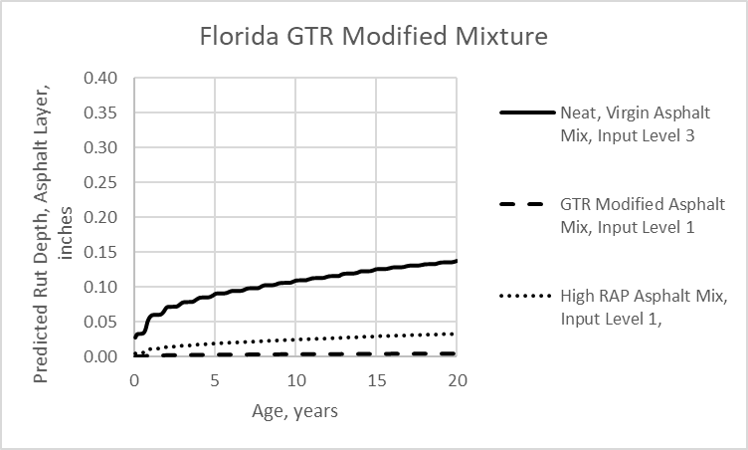
Figure 62. Graph. FL Location; Predicted Asphalt Layer Rut Depth for R²AMs and Neat, Virgin Asphalt Mixtures.

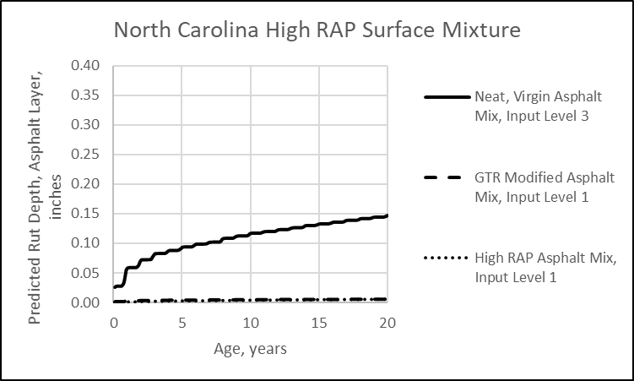
Figure 63. Graph. NC Location; Predicted Asphalt Layer Rut Depth for R²AMs and Neat, Virgin Asphalt Mixtures.
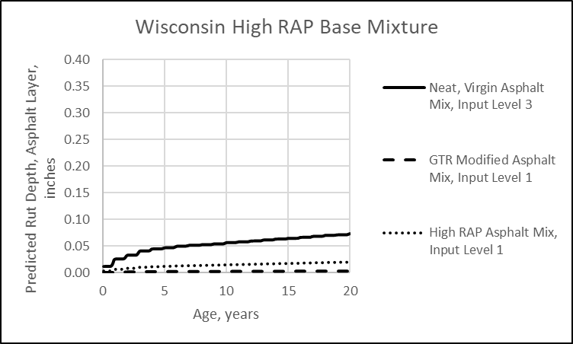
Figure 64. Graph. WI Location; Predicted Asphalt Layer Rut Depth for R²AMs and Neat, Virgin Asphalt Mixtures.
The GTR modified mixtures also exhibited a lower k_{r1} value in comparison to the default values for virgin, neat asphalt mixtures. The k_{3r} value for the GTR modified mixtures, however, is significantly lower than for the high RAP mixtures and default value for virgin, neat asphalt mixtures. This implies rut depths will increase over time or with truck traffic at a much lower rate than for the other mixtures. The k_{2r} value for the GTR modified mixtures is also lower than for the virgin, neat asphalt mixtures, suggesting a smaller influence or sensitivity to temperature.
In summary, use of the global plastic strain coefficients derived from neat, virgin asphalt mixtures are inappropriate for use in predicting the rut depth for R²AMs. Table 25 listed the global plastic strain coefficients that can be used for R²AMs. These coefficients should be used until more of these mixtures can be tested.

4.3 IDT Strength and Creep Compliance
IDT strength and creep compliance are needed over a range of temperatures and loading times to predict the length of transverse cracks in the wearing surface. IDT creep compliance is not required for the other asphalt layers below the wearing surface. The IDT strength and creep compliance are measured in the laboratory (input level 1) or calculated by the software (input level 3).
The Pavement ME Design software uses regression equations to calculate the IDT strength and creep compliance from the volumetric and component properties of the asphalt wearing surface mixture. The regression equations were derived using data measured on a wide range of neat and some modified dense-graded mixtures. The accuracy or appropriateness of the regression equations to R²AM mixtures were evaluated for 8 R²AMs.
The following summarizes the comparison of the global input level 3 values and measured input level 1 values.
- Figure 41 in Chapter 3 included a comparison between the calculated and measured IDT strengths for the GTR modified and high RAP/RAS mixtures. The measured IDT strengths are significantly higher for all R²AMs, except for the MA GTR modified surface mixture and the WI high recycle base and surface mixtures. Thus, a bias exists between the measured and calculated IDT strengths.
- Figure 42 in Chapter 3 included a comparison of the IDT creep compliance measured at -10 ºC (14 ºF) for 100 second loading time. The measured IDT creep compliance values are significantly lower (less compliant) for all R²AMs, except for the WI high recycle base and surface mixtures. Thus, a significant bias exists between the measured and calculated IDT creep compliance values.
- Figure 44 in Chapter 3 included a comparison of the predicted length of transverse cracks between using input level 3 and input level 1 asphalt properties. The use of input level 1 laboratory-measured IDT creep compliance and strength resulted in significantly higher lengths of predicted transverse cracks, except for the WI high recycle base and surface mixtures. The WI base and surface mixture (see figure 23) exhibited about the same creep compliance and strengths, so the predicted length of transverse cracks was also about the same (see figure 44).
In summary, the use of input level 3 IDT creep compliance and strength calculated from the regression equation included in the Pavement ME Design software for the closest PG designated asphalt will result in a bias for transverse cracking. Thus, input level 3 calculated creep compliance and strength from the regression equations embedded in the Pavement ME Design software are inappropriate for use for R²AMs.
The process to determine input level 1 IDT strength and creep compliance is straightforward and listed below.
- Measure the IDT strength and creep compliance of the asphalt mixture in accordance with AASHTO T 322, Standard Method of Test for Determining the Creep Compliance and Strength of Hot Mix Asphalt (HMA) Using the Indirect Tensile Test Device. Chapter 4 of Part 1 includes additional information on test specimen preparation and testing.
- The measured IDT strength at 14 ⁰F is entered directly in the Pavement ME Design software. No other data manipulation of the laboratory-measured IDT strength is required. Figure 11 in Chapter 2 included a screen shot for the Indirect Tensile Strength at 14 ºF.
- The measured IDT creep compliance at specific temperatures (0, -10, and -20 ⁰C) and load durations (1, 2, 5, 10, 20, 50, and 100 seconds) are entered directly into the Pavement ME software. No other data manipulation of the laboratory-measured IDT creep compliance is required. Figure 10 in Chapter 2 included a screen shot for the IDT creep compliance at the temperatures and loading times required by the software.
- The measured IDT strengths and creep compliance should be compared to the data within a materials library.
  - Table 37 summarizes the average creep compliance for the WI high RAP/RAS base and surface mixes, the NC high RAP base layer mix, the NC high RAP/RAS intermediate and surface mixes, the FL GTR modified mix, and the MA and PA GTR modified mixes.
  - Table 38 summarizes the average IDT strengths for similar mixtures. Although the IDT strengths are variable, creep compliance has a more significant effect on the predicted length of transverse cracks.
Table 37. Average IDT Creep Compliance for the R²AMs.
Temp., ºC | Time, second | WI High RAP/RAS, 1/psi | NC High RAP  Base, 1/psi | NC High RAP/RAS, 1/psi | FL GTR Modified, 1/psi | MA & PA GTR Modified, 1/psi
-20 | 1 | 2.98E-07 | 2.32E-07 | 2.53E-07 | 2.64E-07 | 3.38E-07
-20 | 2 | 3.12E-07 | 2.43E-07 | 2.62E-07 | 2.78E-07 | 3.57E-07
-20 | 5 | 3.39E-07 | 2.61E-07 | 2.76E-07 | 3.01E-07 | 3.88E-07
-20 | 10 | 3.62E-07 | 2.79E-07 | 2.89E-07 | 3.22E-07 | 4.18E-07
-20 | 20 | 3.89E-07 | 3.00E-07 | 3.05E-07 | 3.48E-07 | 4.55E-07
-20 | 50 | 4.36E-07 | 3.36E-07 | 3.30E-07 | 3.91E-07 | 5.17E-07
-20 | 100 | 4.85E-07 | 3.70E-07 | 3.53E-07 | 4.32E-07 | 5.77E-07
-10 | 1 | 4.18E-07 | 3.10E-07 | 3.20E-07 | 3.57E-07 | 4.83E-07
-10 | 2 | 4.74E-07 | 3.39E-07 | 3.41E-07 | 3.91E-07 | 5.34E-07
-10 | 5 | 5.56E-07 | 3.86E-07 | 3.77E-07 | 4.46E-07 | 6.21E-07
-10 | 10 | 6.39E-07 | 4.31E-07 | 4.09E-07 | 4.99E-07 | 7.04E-07
-10 | 20 | 7.27E-07 | 4.86E-07 | 4.49E-07 | 5.63E-07 | 8.03E-07
-10 | 50 | 8.93E-07 | 5.78E-07 | 5.13E-07 | 6.69E-07 | 9.78E-07
-10 | 100 | 1.03E-06 | 6.66E-07 | 5.73E-07 | 7.72E-07 | 1.15E-06
0 | 1 | 8.04E-07 | 5.12E-07 | 4.91E-07 | 5.86E-07 | 8.80E-07
0 | 2 | 9.61E-07 | 5.85E-07 | 5.47E-07 | 6.69E-07 | 1.03E-06
0 | 5 | 1.25E-06 | 7.03E-07 | 6.37E-07 | 8.07E-07 | 1.27E-06
0 | 10 | 1.49E-06 | 8.21E-07 | 7.22E-07 | 9.38E-07 | 1.51E-06
0 | 20 | 1.79E-06 | 9.66E-07 | 8.24E-07 | 1.09E-06 | 1.79E-06
0 | 50 | 2.32E-06 | 1.20E-06 | 9.96E-07 | 1.35E-06 | 2.29E-06
0 | 100 | 2.84E-06 | 1.43E-06 | 1.16E-06 | 1.60E-06 | 2.77E-06

Table 38. Average IDT Strengths for the R²AMs.
R²AMs Identification | Average IDT Strength, psi
WI High RAP/RAS Base and Surface Mix | 525
NC High RAP Base | 572
NC High RAP/RAS Intermediate and Surface Mix | 642
FL and PA GTR Modified Mix | 631
MA GTR+RAP Modified Mix | 384

If the IDT creep compliance and strengths are statistically indifferent from other similar type mixtures, the creep compliance values and strengths can be combined or averaged for the mixtures to establish the inputs to be used in design for similar types of mixtures. If the creep compliance and strengths are statistically different, a separate set of IDT properties needs to be included in the materials library.

4.4 Fatigue Strength Coefficients
Fatigue strength coefficients are used to predict the area of bottom-up fatigue cracking in the lower asphalt layer. Default fatigue strength coefficients are included in the Pavement ME Design software, and were derived from testing neat, virgin dense-graded asphalt mixtures. As noted in Chapter 3, the MEPDG assumes the set of fatigue strength coefficients entered in the software is applicable to all asphalt mixtures. The appropriateness of the global default coefficients to R²AM mixtures were evaluated for 8 R²AMs. As discussed in Chapter 3, the PA PMA virgin mixture and GTR plus PMA mixture were excluded from the evaluation because both were considered anomalous compared to the other R²AMs.
Figure 61 in Chapter 3 included a comparison of the predicted area of fatigue cracks using the global default coefficients for neat, virgin asphalt mixtures and laboratory-derived coefficients for the R²AMs. As shown, there is a bias between the global default and laboratory-derived coefficients. In summary, use of the global default fatigue strength coefficients based on neat, virgin asphalt mixtures will result in higher predicted areas of fatigue cracks for the R²AMs. Thus, the fatigue strength coefficients determined for neat, virgin asphalt mixtures are inappropriate for use for R²AMs.
The fatigue strength coefficients are derived from flexural, bending beam tests. Chapter 5 of Part 1 includes additional information on test specimen preparation and testing for measuring the fatigue strength coefficients. The methods and analyses to determine input level 1 fatigue strength coefficients was discussed in Chapter 2 and is summarized below.
- Perform beam flexural fatigue tests in accordance with AASHTO T 321, see Chapter 5 of Part 1 of the Guide. Beam test specimens are tested at different tensile strains and temperatures.
- The analysis of flexural bending beam fatigue data includes determining the fatigue life of multiple test specimens.
  - The traditional definition of the fatigue life for a flexural fatigue test is the number of cycles required to decrease the flexural stiffness to 50 percent of the initial stiffness value. The initial flexural stiffness is defined as the flexural stiffness at 50 cycles.
  - This procedure or the traditional definition to determine the fatigue life of an individual beam specimen was used in estimating the fatigue strength coefficients derived for the current and earlier versions of the Pavement ME Design software.
- Derive the fitting coefficients in the equation in figure 15; k₁ and k₂ for each test temperature (see table 31).
  - For each beam tested, first take the base 10 logarithm of the average tensile strain during the test, and the base 10 logarithm of the fatigue life. Use the linear regression function in Excel to determine the slope, k₂, and the intercept, k₁, of the basic relationship between the applied tensile strain and number of load cycles to failure (see equation included in figure 15), as defined by multiple beams tested to failure using the traditional definition of fatigue life.
  - The intercept, k₁, and strain exponent, k₂, are determined using a linear regression analysis of the equation included in figure 15. An important point to recognize is flexural fatigue (bending beam) testing between specimens can be highly variable, even taking into consideration the difference in volumetric properties between specimens (the C adjustment factor in the equation included in figure 17).
- The strain exponent, k₂, is equal to the k_{2f} exponent in the equation in figure 17. The k_{1f} intercept term and k_{3f} modulus exponent are derived using regression techniques. However, the predicted bottom-up alligator cracking is highly sensitive to the tensile strain exponent, k_{2f} (see figure 51), and modulus exponent, k_{3f} (see figure 50). The analysis of flexural fatigue data from multiple beam specimens is to develop a relationship by performing a regression of the logarithm of the fatigue life versus the logarithm of the flexural strain. As such, the results from multiple fatigue tests and mixtures should be performed and averaged to reduce the impact of testing errors and variability.
- The β_{2f} value (field-shift or adjustment factor for the strain exponent) for R²AMs is 0.85 as compared to the global default value of 1.38 for neat, virgin asphalt mixtures. The β_{3f} value (field-shift or adjustment factor for the modulus exponent) for R²AMs is 0.90, as compared to the global default values of 0.88 for neat, virgin asphalt mixtures. The β_{1f} value (field-shift or adjustment factor for the intercept term) is independent of mixture type. Figure 19 in chapter 2 included a screen shot that showed the fatigue strength k_{f}-coefficients and the field–shift β-values. The β-values for PMA and other non-typical mixtures, however, were based on limited data, and should be used with caution.
- The endurance limit can be determined for each set of flexural fatigue strength tests in accordance with the procedure included in Chapter 5 of Part 2. The endurance limit, however, should not be used with the global fatigue strength coefficients included in version 2.5 of the Pavement ME Design software.
The following provides an overview on judging a mixture’s resistance to bottom-up alligator cracking.
- Tensile Strain Exponent, k_{2f}:
  - Mixtures with values greater than 5.1 are more resistant to fatigue cracking.
  - Mixtures with values less than 4.9 are more susceptible to fatigue cracking.
- Modulus Exponent, k_{3f}:
  - Mixtures with values greater than 1.65 are more susceptible to fatigue cracking.
  - Mixtures with values less than 1.35 are more resistant to fatigue cracking.
Figure 65, figure 66, figure 67, figure 68, and figure 69 show examples of the predicted area of bottom-up fatigue cracks for different mixtures located in WI, NC, FL, and MA, respectively. Each figure compares the predicted area of fatigue cracks for three sets of mixture fatigue strength coefficients: (1) the global default coefficients based on neat, virgin asphalt mixtures; (2) the average coefficients for specific mixture types or classifications included in table 35 – high RAP and GTR modified; and (3) the mixture specific laboratory-derived coefficients included in table 34. As shown, the predicted area of fatigue cracking is lower for the R²AMs in comparison to using the global default values derived for neat, virgin asphalt mixtures.
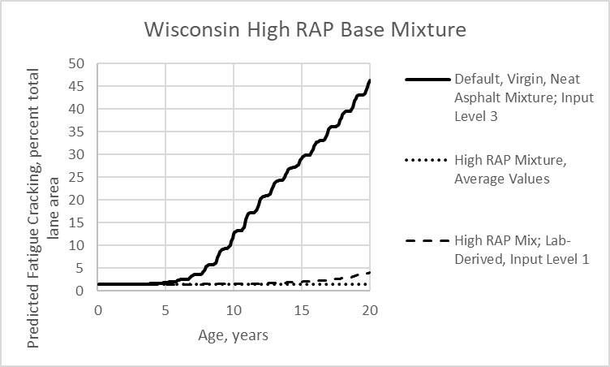
Figure 65. Graph. Predicted Area of Fatigue Cracking for R²AMs and Neat, Virgin Asphalt Mixtures, WI High RAP Base Mixture.

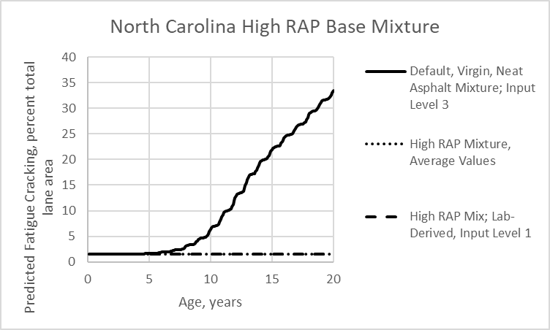
Figure 66. Graph. Predicted Area of Fatigue Cracking for R²AMs and Neat, Virgin Asphalt Mixtures; NC High RAP Base Mixture.

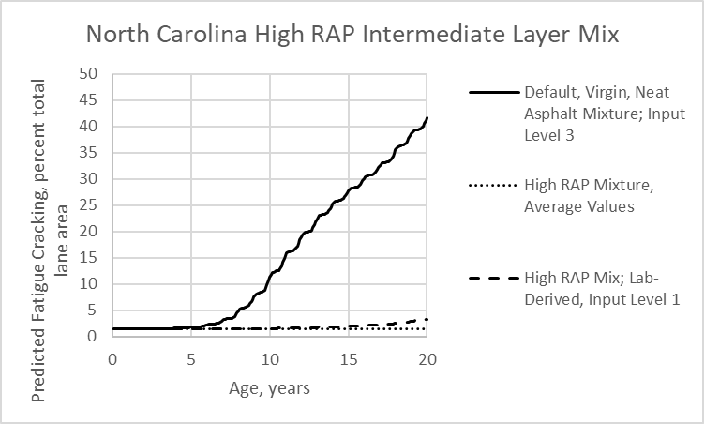
Figure 67. Graph. Predicted Area of Fatigue Cracking for R²AMs and Neat, Virgin Asphalt Mixtures; NC High RAP Intermediate Layer Mixture.

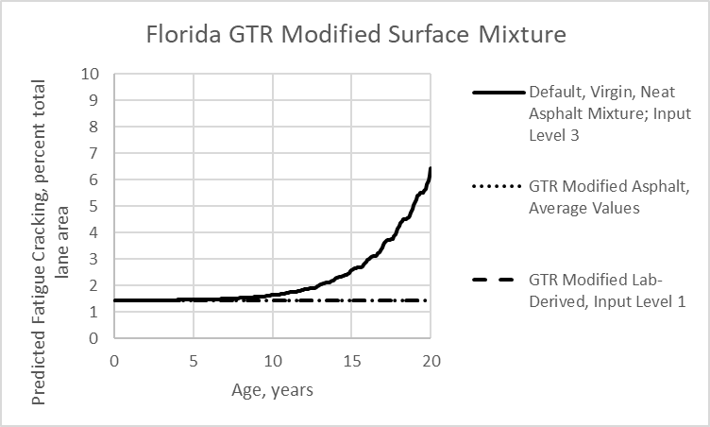
Figure 68. Graph. Predicted Area of Fatigue Cracking for R²AMs and Neat, Virgin Asphalt Mixtures; FL GTR Modified Surface Mixture.

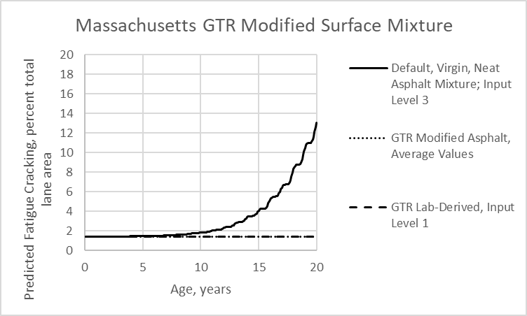
Figure 69. Graph. Predicted Area of Fatigue Cracking for R²AMs and Neat, Virgin Asphalt Mixtures; MA GTR Modified Surface Mixture.

4.5 Summary of Findings and Results
This section of chapter 4 provides a summary of the findings and results relative to using the “best-guessed” values or regression equations embedded in the Pavement ME Design software (input level 3) to calculate the mechanistic properties for R²AMs. Table 39 is a summary of the findings from the test program in terms of using the laboratory-derived mixture properties for use in the AASHTOWare Pavement ME Design software. It is important to note none of the regression equations embedded in the Pavement ME Design software to calculate the asphalt mixture properties are applicable to R²AMs included in this test program. Agencies should measure the properties listed in table 39 on their more standard R²AMs and include the average measured properties in their materials library for use in structural design.

Table 39. Applicability of Pavement ME Design, Version 2.5.5 Default Values Derived from Dense-Graded Virgin, Neat Asphalt Mixtures to R²AMs.
Asphalt Mix Property | Distresses Impacted | AASTHO Test Standard | Data Manipulation from Laboratory Test Data | Calculated Input Level 3 Properties Applicable to R²AMs | Notes and Observations
Dynamic Modulus; E* | - Rut depth in asphalt layers  - Bottom-up fatigue cracking  - Top-down fatigue cracking | T 342; Preferred | None Required | No | - E* values are measured on test specimens without confinement.  - High RAP mixtures consistently exhibited lower measured E* values compared to the calculated E* values for input level 3.  - GTR-modified mixtures exhibited higher temperature susceptibility for the measured E* values than the calculated E* values (see figure 21).  - All R²AMs exhibited lower E* values at the higher test temperatures compared to the calculated E* values (see figure 21).
Dynamic Modulus; E* |  | T 378 | Yes;  E* needs to be calculated for test temperatures: 14 and 130 ⁰F. | No
Dynamic Modulus; E* |  | TP 132  (small scale specimens, see Part 1 of the Guide) |  | No
Plastic Strain Coefficients; k_{1r}, k_{2r}, k_{3r} | - Rut depth in asphalt layers | Modified T 378;  [NCHRP 9-30A⁽⁷⁾] | Yes;  Section 2.2.2 includes the procedure to determine the values. | No | - The test is stopped at 10,000 load cycles or 5 percent axial strain.  - R²AMs using the lab-derived E* and plastic strain coefficients exhibited better resistance to rutting compared to the calculated (input level 3) E* and plastic strain coefficients (see figure 40).
IDT Creep Compliance; D(t) | - Transverse cracks | T 322 | None Required | No | - All of the R²AMs exhibited lower measured compliance values to the calculated (input level 3) compliance values.

IDT Strength; F_{T} | - Transverse cracks | T 322 | None Required | No | - 8 of the R²AMs exhibited higher IDT strengths than the calculated strengths, while 3 of the R²AMs exhibited slightly lower strengths (see figure 41).
Fatigue Strength Coefficients; k_{1f}, k_{2f}, k_{3f} | - Bottom-up alligator fatigue cracks | T 321 | Yes;  Section 2.4.2 includes the procedure to determine the values. | No | - The fatigue life for a test specimen is defined as the number of load cycles at 50 percent of the initial beam stiffness – the traditional definition for fatigue life.  - The GTR-modified mixtures consistently exhibited higher fatigue life than for the high RAP mixtures.
Fatigue Strength Coefficients; k_{1f}, k_{2f}, k_{3f} | - Top-down longitudinal fatigue cracks | T 321 |  | No
Endurance Limit, EL | - Bottom-up fatigue cracks | T 321 | Yes;  Section 2.4.2.4 includes the procedure to determine the values. | No | - The GTR-modified mixtures exhibited higher endurance limits in comparison to the high RAP mixtures (see table 33).  - The R2AMs exhibited higher endurance limits relative to the average values reported for virgin, neat dense-graded mixtures (see table 33).

Appendix A: Dynamic Modulus

The dynamic moduli measured on each R²AM are tabulated in chapter 3. Appendix A includes screen shots of the input level 1 dynamic moduli for the R²AMs included in the test program. The dynamic moduli measured in accordance with AASHTO T 342 can be directly entered into the software without any adjustments or manipulations of the data. Figures 70 to 77 include the screen shots for the laboratory measured dynamic moduli.
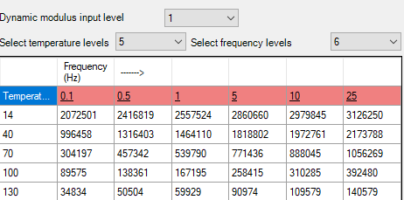
Figure 70. Illustration. Screen Shot for Entering Dynamic Modulus Values in the Pavement ME Design Software, WI High RAP+RAS Surface Layer Mixture.

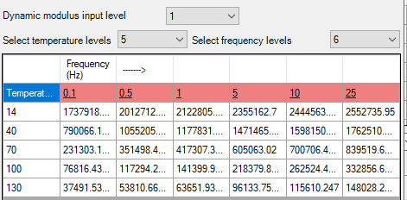
Figure 71. Illustration. Screen Shot for Entering Dynamic Modulus Values in the Pavement ME Design Software, WI High RAP+RAS Base Layer Mixture.

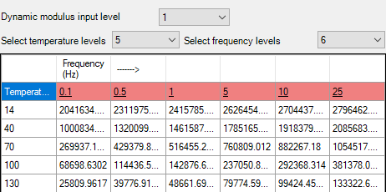
Figure 72. Illustration. Screen Shot for Entering Dynamic Modulus Values in the Pavement ME Design Software, NC High RAP+RAS Surface Layer Mixture.

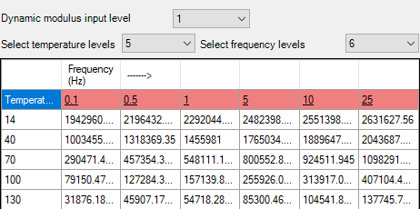
Figure 73. Illustration. Screen Shot for Entering Dynamic Modulus Values in the Pavement ME Design Software, NC High RAP+RAS Intermediate Layer Mixture.

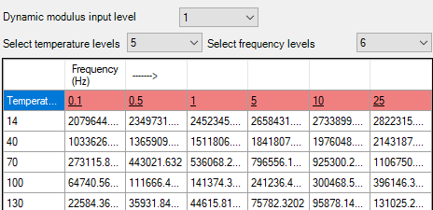
Figure 74. Illustration. Screen Shot for Entering Dynamic Modulus Values in the Pavement ME Design Software, NC High RAP Base Layer Mixture.

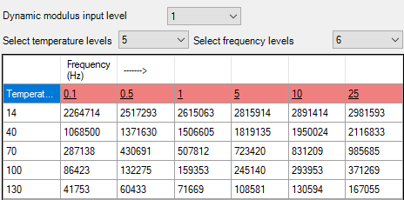
Figure 75. Illustration. Screen Shot for Entering Dynamic Modulus Values in the Pavement ME Design Software, FL RAP+GTR Modified Surface Layer Mixture.

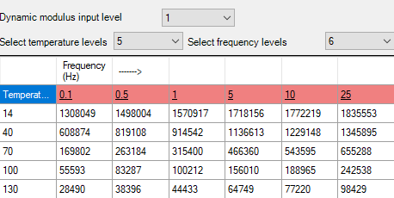
Figure 76. Illustration. Screen Shot for Entering Dynamic Modulus Values in the Pavement ME Design Software, MA RAP+GTR AGGR Surface Layer Mixture.

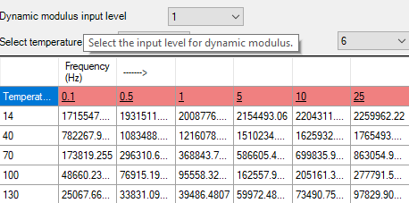
Figure 77. Illustration. Screen Shot for Entering Dynamic Modulus Values in the Pavement ME Design Software, PA GTR Plus PMA Surface Layer Mixture.

Appendix B. Plastic Strain Coefficients

Results from the repeated load plastic deformation tests are tabulated in chapter 3. Appendix B shows the coefficients derived from the test results following the procedure and steps outlined in section 2.2.2. Appendix B also includes screen shots of the input level 1 plastic strain coefficients derived for the R²AMs included in the test program.

WI High RAP Surface Mixture
- The test temperatures for the WI high RAP surface mixture were: 20, 33.8, and 47.6 ⁰C.
- Figure 78 shows the cumulative plastic strain versus number of load cycles for the 7 test specimens.
Figure 78. Graph. Results from the Repeated Load Plastic Deformation Test for the WI High RAP Surface Mixture.
- None of the test specimens exhibited tertiary flow, so coefficients “a” and “b” were determined using linear regression between 1,000 and 10,000 load cycles. However, the primary zone or stage extended to 2,000 load cycles for test specimen #6 (intermediate-test temperature) and 3,000 load cycles for test specimen #7 (high-test temperature).
- Coefficient “b” was dependent on test temperature: as temperature increased, coefficient b decreased. The average coefficient b was statistically different between the test temperatures. A linear regression of the test data resulted in the b-value being equal to 0.4751 minus the product of the temperature times 0.0068. As such, the load cycle exponent (k_{r3}) was determined to be 0.261 at the equivalent rut depth temperature (31.5 ⁰C) for the Wisconsin high RAP surface mixture.
- The intercept coefficient “a(T)” for each test specimen was calculated using the coefficient b-value derived for the equivalent rut depth temperature.
- A linear regression of the log test temperature (T) and log intercept term a(T) is used to determine the sensitivity of temperature on the intercept term. The slope or the temperature exponent, k_{r2}, was 2.1724 for this Wisconsin high RAP surface mixture.
- The resilient strain was calculated for each test temperature using the dynamic modulus measured at the test temperature for a loading frequency of 10 Hz. The dynamic moduli are included in Appendix A.
- The log intercept, k_{1r}, was calculated for each test specimen. Since the load cycle exponent, k_{r3}, was calculated at the equivalent rut depth temperature, the log intercept k_{r1} was determined at the equivalent rut depth temperature.
- Figure 79 summarizes the plastic strain coefficients entered into the PMED software for the Wisconsin high RAP surface mixture.
Figure 79. Illustration. Screen Shot for Deriving the Laboratory-Measured Plastic Strain Coefficients in the Pavement ME Design Software for the WI High RAP Surface Course Mixture.

WI High RAP Base Layer Mixture
- The test temperatures for the WI high RAP base mixture were: 20, 33.8, and 47.6 ⁰C.
- Figure 80 shows the cumulative plastic strain versus number of load cycles for the 9 test specimens.
Figure 80. Graph. Results from the Repeated Load Plastic Deformation Test for the WI High RAP Base Mixture.
- None of the specimens tested at the lower and intermediate test temperature exhibited tertiary flow, but all of the specimens tested at the higher test temperature exhibited tertiary flow or higher plastic deformations. The test was stopped before reaching 10,000 loading cycles for the high-test temperature. Coefficients “a” and “b” for the low-test temperature were determined between 90 and 10,000 loading cycles, because the primary stage or zone ended before 100 loading cycles. The coefficients “a” and “b” were determined between 1,000 and 10,00 loading cycles for the intermediate test temperatures, except for specimen #4. An anomaly occurred in the response of specimen #4 so the secondary zone ended around 3,000 loading cycles. The secondary zone or stage for all of the specimens tested at the higher temperature was between 30 and 300 loading cycles.
- Coefficient “b” was independent of test temperature, so the overall average value between all test specimens was used to determine the value of 0.326. The average coefficient “b” for the low and high-test temperatures were statistically the same and a lot of variation was exhibited at the intermediate test temperature. As such, all specimens were combined to determine the load cycle exponent, k_{r3}, of 0.326.
- The intercept coefficient “a(T)” for each test specimen was calculated using the average b-value for all test temperatures.
- A linear regression between the log test temperature (T) and log intercept term a(T) is used to determine the sensitivity of temperature on the intercept term a(T). The slope or the temperature exponent, k_{r2}, was 2.7906 for this Wisconsin high RAP base mixture.
- The resilient strain was calculated for each test temperature using the dynamic modulus measured at the test temperature for a loading frequency of 10 Hz. The dynamic moduli are included in Appendix A.
- The log intercept k_{1r} was calculated for each test specimen. Since coefficient b represents the average of all test specimens, the average log intercept k_{r1} was determined for all test specimens.
- .Figure 81 summarizes the plastic strain coefficients entered in the PMED software for the Wisconsin high RAP base mixture.
Figure 81. Illustration. Screen Shot for Deriving the Laboratory-Measured Plastic Strain Coefficients in the Pavement ME Design Software for the WI High RAP Base Course Mixture.

NC High RAP Surface Mixture
- The test temperatures for the NC high RAP surface mixture were: 20, 37.6, and 55.8 ⁰C.
- Figure 82 shows the cumulative plastic strain versus number of load cycles for the 8 test specimens.
Figure 82. Graph. Results from the Repeated Load Plastic Deformation Test for the NC High RAP Surface Mixture.
- None of the specimens exhibited tertiary flow, except for one at the intermediate test temperature around load cycle 7,000. Coefficients “a” and “b” were determined between 1,000 and 10,000 load cycles for the low and high test temperatures, while the coefficients for the intermediate test temperature were derived between 100 and 7,000 load cycles.
- Coefficient “b” was dependent on test temperature. As the test temperature increased, coefficient b decreased and all average values were statistically different. A linear regression of the test data resulted in the coefficient “b” being equal to 0.4529 minus the product of the temperature times 0.0037. As such, the load cycle exponent (k_{r3}) was determined to be 0.316 at the equivalent rut depth temperature (37 ⁰C) for the North Carolina high RAP surface mixture.
- The intercept coefficient “a(T)” for each test specimen was calculated using the average b-value for all test temperatures.
- A linear regression between the log test temperature (T) and log intercept term a(T) is used to determine the sensitivity of temperature on the intercept term a(T). The slope or temperature exponent, k_{r2}, was 2.8733 for this North Carolina high RAP surface mixture.
- The resilient strain was calculated for each test temperature using the dynamic modulus measured at the test temperature for a loading frequency of 10 Hz. The dynamic moduli are included in Appendix A.
- The log intercept k_{1r} was calculated for each test specimen. Since the load cycle exponent, k_{r3}, represents the average of all test specimens, the average log intercept k_{r1} was determined for all test specimens.
- Figure 83 summarizes the plastic strain coefficients entered in the PMED software for the North Carolina high RAP surface mixture.
Figure 83. Illustration. Screen Shot for Deriving the Laboratory-Measured Plastic Strain Coefficients in the Pavement ME Design Software for the NC High RAP Surface Course Mixture.

NC High RAP Intermediate Layer Mixture
- The test temperatures for the NC high RAP intermediate layer mixture were: 20, 37.6, and 55.8 ⁰C.
- Figure 84 shows the cumulative plastic strain versus number of load cycles for the 8 test specimens.
Figure 84. Graph. Results from the Repeated Load Plastic Deformation Test for the NC High RAP Intermediate Layer Mixture.
- None of the specimens at the high and low-test temperatures exhibited tertiary flow. The specimens for the intermediate-test temperatures, however, exhibited tertiary flow. Coefficients “a” and “b” were determined between 100 and 10,000 load cycles for the low and high test temperatures, while the coefficients for the intermediate-test temperature were derived between 100 and 3,000 load cycles.
- Coefficient “b” was independent of test temperature. The average coefficient “b” at the low and intermediate test temperatures were statistically the same, while coefficient “b” at the high-test temperature was significantly lower. As such, the load cycle exponent (k_{r3}) was determined as the average coefficient “b” for all test specimens. The load cycle exponent was 0.266.
- The intercept coefficient a(T) for each test specimen was calculated using the average b-value for all test temperatures.
- A linear regression between the log test temperature (T) and log intercept term a(T) is used to determine the sensitivity of temperature on the intercept term a(T). The slope or the temperature exponent, k_{r2}, was 2.1423 for this North Carolina high RAP intermediate layer mixture.
- The resilient strain was calculated for each test temperature using the dynamic modulus measured at the test temperature for a loading frequency of 10 Hz. The dynamic moduli are included in Appendix A.
- The log intercept k_{1r} was calculated for each test specimen. Since the load cycle exponent, k_{r3}, represents the average coefficient “b” for all test specimens, the average log intercept k_{r1} was determined for all test specimens, which was -2.9602.
- .Figure 85 summarizes the plastic strain coefficients entered in the PMED software for the North Carolina high RAP intermediate layer mixture.
Figure 85. Illustration. Screen Shot for Deriving the Laboratory-Measured Plastic Strain Coefficients in the Pavement ME Design Software for the NC High RAP Intermediate Course Mixture.

NC High RAP Base Layer Mixture
- The test temperatures for the NC high RAP base mixture were: 20, 37.6, and 55.8 ⁰C.
- Figure 86 shows the cumulative plastic strain versus number of load cycles for the 8 test specimens.
Figure 86. Graph. Results from the Repeated Load Plastic Deformation Test for the NC High RAP Base Mixture.
- None of the specimens exhibited tertiary flow. Coefficients “a” and “b” were determined between 1,000 and 10,000 load cycles.
- Coefficient “b” was independent of test temperature. The average coefficient “b” for the low and high-temperature were statistically the same, but coefficient “b” for the intermediate-temperature significantly lower than the other two values. As such, the load cycle exponent (k_{r3}) was determined as the average coefficient b for all test specimens. The load cycle exponent was 0.2419.
- The intercept coefficient a(T) for each test specimen was calculated using the average b-value for all test temperatures.
- A linear regression between the log test temperature (T) and log intercept term a(T) is used to determine the sensitivity of temperature on the intercept term a(T). The slope or the temperature exponent, k_{r2}, was 2.5100 for this North Carolina high RAP base mixture.
- The resilient strain was calculated for each test temperature using the dynamic modulus measured at the test temperature for a loading frequency of 10 Hz. The dynamic moduli are included in Appendix A.
- The log intercept k_{1r} was calculated for each test specimen. Since the load cycle exponent, k_{r3}, represents the average value for all test specimens, the average log intercept k_{r1} was calculated for all test specimens, and is -3.5549.
- .Figure 87 summarizes the plastic strain coefficients entered in the PMED software for the North Carolina high RAP base mixture.
Figure 87. Illustration. Screen Shot for Deriving the Laboratory-Measured Plastic Strain Coefficients in the Pavement ME Design Software for the NC High RAP Base Course Mixture.

FL RAP Plus GTR Modified Binder Surface Mixture
- The test temperatures for the FL RAP with GTR modified surface mixture were: 20, 38, and 58 ⁰C.
- Figure 88 shows the cumulative plastic strain versus number of load cycles for the 9 test specimens.
Figure 88. Graph. Results from the Repeated Load Plastic Deformation Test for the FL RAP plus GTR Modified Binder Surface Mixture.
- Two of the nine specimens exhibited tertiary flow: specimen #4 at the intermediate-test temperature and specimen #8 at the high-test temperature. Coefficients “a” and “b” were determined between 1,000 and 10,000 load cycles for the test specimens not exhibiting tertiary flow. Coefficients “a” and “b” were determined between 368 and 1,516 load cycles for specimen #4 exhibiting tertiary flow (intermediate test temperature), while coefficients “a” and “b” were determined between 492 and 1,992 load cycles for specimen #8 exhibiting tertiary flow (high-test temperature).
- Coefficient “b” was independent of test temperature. The average b-value for low and intermediate-test temperatures were statistically the same, while the average b-value for the high-test temperature was lower. The b-value for specimen #4 is significantly higher than for all other test specimens. Removing specimen #4, the average b-value for the intermediate and high-temperatures are statistically the same, while the average b-value for the low-temperature is slightly higher. As such, the load cycle exponent (k_{r3}) was determined as the average coefficient b for all test specimens, excluding specimen #4. The load cycle exponent was 0.1751.
- The intercept coefficient “a(T)” for each test specimen was calculated using the average b-value for all test temperatures.
- A linear regression between the log test temperature (T) and log intercept term a(T) is used to determine the sensitivity of temperature on the intercept term a(T). The slope or the temperature exponent, k_{r2}, was 1.5712 for this FL RAP with GTR modified surface mixture.
- The resilient strain was calculated for each test temperature using the dynamic modulus measured at the test temperature for a loading frequency of 10 Hz. The dynamic moduli are included in Appendix A.
- The log intercept k_{1r} was calculated for each test specimen. Since load cycle exponent, k_{r3}, represents the average value for all test specimens, the average log intercept k_{r1} was calculated for all test specimens, and is -1.7431.
- .Figure 89 summarizes the plastic strain coefficients entered in the PMED software for the FL RAP with GTR modified surface mixture.
Figure 89. Illustration. Screen Shot for Deriving the Laboratory-Measured Plastic Strain Coefficients in the Pavement ME Design Software for the FL GTR Modified Surface Course Mixture.

MA ARGG GTR Modified Binder Surface Mixture
- The test temperatures for the MA_ARGG GTR modified surface mixture were: 20, 31.5, and 43 ⁰C.
- Figure 90 shows the cumulative plastic strain versus number of load cycles for the 8 test specimens.
Figure 90. Graph. Results from the Repeated Load Plastic Deformation Test for the MA ARGG GTR Modified Binder Surface Mixture.
- Only one of the 8 specimens exhibited tertiary flow, which was specimen #9 at the high-test temperature. Coefficients “a” and “b” were determined between 1,000 and 10,000 load cycles for the test specimens not exhibiting tertiary flow. Coefficients “a” and “b” were determined between 401 and 4,001 load cycles for specimen #9 exhibiting tertiary flow at the high test temperature.
- Coefficient “b” was independent of test temperature. The average b-value at the intermediate and high-test temperature were statistically the same. The average b-value for the low temperature was statistically higher than for the other two test temperatures. As such, the load cycle exponent (k_{3r}) was determined as the average coefficient b for all of the intermediate and high temperature test specimens. The load cycle exponent was 0.141. Since, the b-value is less than 0.16, the k_{3r} coefficient was set as 0.160.
- The intercept coefficient “a(T)” for each test specimen was calculated using the average b-value for all test temperatures.
- A linear regression between the log test temperature (T) and log intercept term a(T) is used to determine the sensitivity of temperature on the intercept term a(T). The slope or the temperature exponent, k_{r2}, was 1.4851 for this MA_ARGG GTR modified surface mixture.
- The resilient strain was calculated for each test temperature using the dynamic modulus measured at the test temperature for a loading frequency of 10 Hz. The dynamic moduli are included in Appendix A.
- The log intercept k_{1r} was calculated for each test specimen. Since the load cycle exponent, k_{3r}, represents the average value for all test specimens, the average log intercept k_{1r} was calculated for the intermediate and high test temperature specimens, and is -1.483.
- .Figure 91 summarizes the plastic strain coefficients entered in the PMED software for the MA_ARGG GTR modified surface mixture.
Figure 91. Illustration. Screen Shot for Deriving the Laboratory-Measured Plastic Strain Coefficients in the Pavement ME Design Software for the MA AGGR GTR Modified Surface Course Mixture.

PA GTR Modified Binder Surface Mixture
- The test temperatures for the PA GTR plus PMA surface mixture were: 20, 33.3, and 46.6 ⁰C.
- Figure 92 shows the cumulative plastic strain versus number of load cycles for the 8 test specimens.
Figure 92. Graph. Results from the Repeated Load Plastic Deformation Test for the PA GTR Modified Binder Surface Mixture.
- Test specimen #5 at the low-test temperature exhibited tertiary flow around load cycle 500. However, the increase in plastic strain with a higher number of load cycles continued to increase but at a decreasing rate around load cycle 1,800. Test specimen #5 was considered an anomaly, and excluded from determining the average coefficients “a” and “b.” The primary zone (plastic strain increases but at a decreasing rate) goes well beyond 100 load cycles for the intermediate-test temperatures.
- Coefficients “a” and “b” are determined for each test specimen between 1,000 and 10,000 load cycles using linear regression analysis.
- Coefficient “b” was dependent on test temperature. However, the average b-values at the intermediate and high-test temperature were statistically the same but statistically different from the average b-value determined at the low-test temperature. As such, the load cycle exponent (k_{r3}) was determined as the average coefficient b for the intermediate and high-test temperatures. The load cycle exponent was 0.1289.
- The intercept coefficient “a(T)” for each test specimen was calculated using the average b-value for all test temperatures.
- A linear regression between the log test temperature (T) and log intercept term a(T) is used to determine the sensitivity of temperature on the intercept term a(T). The slope or temperature exponent, k_{r2}, was 1.4957 for this PA GTR modified surface mixture.
- The resilient strain was calculated for each test temperature using the dynamic modulus measured at the test temperature for a loading frequency of 10 Hz. The dynamic moduli are included in Appendix A.
- The log intercept k_{1r} was calculated for each test specimen. Since the load cycle exponent, k_{r3}, represents the average b-value for the intermediate and high-test temperatures, the average log intercept k_{r1} was calculated for specimens tested at the intermediate and high-test temperatures, and is -1.6578.
- .Figure 93 summarizes the plastic strain coefficients entered in the PMED software for the PA GTR modified surface mixture.
Figure 93. Illustration. Screen Shot for Deriving the Laboratory-Measured Plastic Strain Coefficients in the Pavement ME Design Software for the PA GTR Modified Surface Course Mixture.

Appendix C. IDT Creep Compliance and Strength

The IDT creep compliance and strength measured on each R²AM are tabulated in chapter 3. Appendix C includes screen shots of the input level 1 IDT creep compliance and input level 2 IDT strength for the R²AMs included in the test program. The creep compliance and strength measured in accordance with AASHTO T 322 can be directly entered into the software without any adjustments or manipulations of the data. Figures 94 to 101 include the screen shots for the laboratory measured IDT creep compliance and strength values.
The IDT creep compliance and strength values are material dependent. The eight mixtures tested is an insufficient number to determine the creep compliance and indirect tensile strengths for binders and aggregate gradations that deviate from the ones used in this study. Table 37 and table 38 summarized the IDT creep compliance and strengths that can be used with judgment by agencies that are planning to use the GTR and high RAP mixtures, but have yet to measure the properties. The WI mixtures can be used for binders in colder climates and the NC mixtures for mild to warmer climates for high RAP mixtures, while the FL mixture can be used for mild to warmer climates and the MA and PA mixtures for colder climates for GTR modified mixtures.

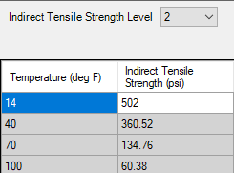
WI High RAP Surface Layer Mixture
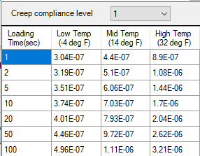
Figure 94. Illustration. Screen Shot for Entering the Laboratory-Measured IDT Creep Compliance and Strength in the Pavement ME Design Software for the WI High RAP Surface Course Mixture.

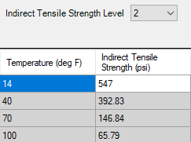
WI High RAP Base Layer Mixture
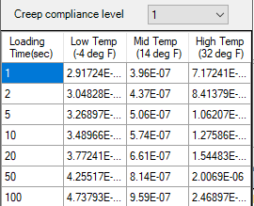
Figure 95. Illustration. Screen Shot for Entering the Laboratory-Measured IDT Creep Compliance and Strength in the Pavement ME Design Software for the WI High RAP Base Course Mixture.

NC High RAP Surface Layer Mixture
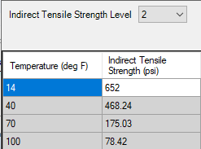
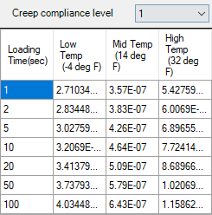

Figure 96. Illustration. Screen Shot for Entering the Laboratory-Measured IDT Creep Compliance and Strength in the Pavement ME Design Software for the NC High RAP Surface Course Mixture.

NC High RAP Intermediate Layer Mixture
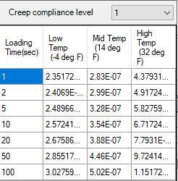
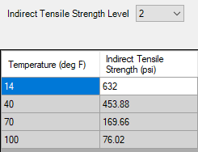

Figure 97. Illustration. Screen Shot for Entering the Laboratory-Measured IDT Creep Compliance and Strength in the Pavement ME Design Software for the NC High RAP Intermediate Course Mixture.

NC High RAP Base Layer Mixture
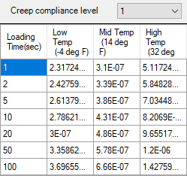

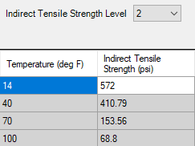
Figure 98. Illustration. Screen Shot for Entering the Laboratory-Measured IDT Creep Compliance and Strength in the Pavement ME Design Software for the NC High RAP Base Course Mixture.

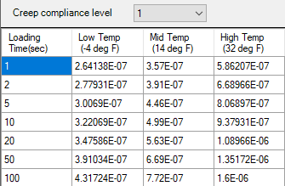
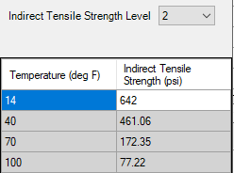
FL GTR Modified Surface Layer Mixture

Figure 99. Illustration. Screen Shot for Entering the Laboratory-Measured IDT Creep Compliance and Strength in the Pavement ME Design Software for the FL GTR Modified Surface Course Mixture.

MA AGGR GTR Modified Surface Layer Mixture
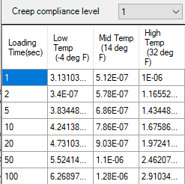
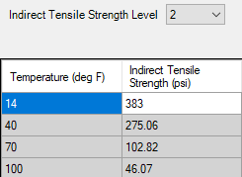

Figure 100. Illustration. Screen Shot for Entering the Laboratory-Measured IDT Creep Compliance and Strength in the Pavement ME Design Software for the MA AGGR GTR Modified Surface Course Mixture.

PA GTR Plus PMA Surface Mixture
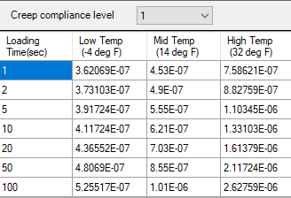
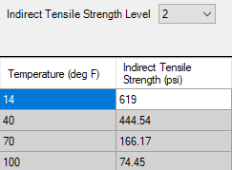

Figure 101. Illustration. Screen Shot for Entering the Laboratory-Measured IDT Creep Compliance and Strength in the Pavement ME Design Software for the PA GTR+PMA Surface Course Mixture.

Appendix D. Fatigue Strength Coefficients

Results from the bending beam fatigue tests are tabulated in chapter 3. Appendix D describes how the laboratory fatigue strength coefficients were derived from the test results. Appendix D also includes the screen shots of the excel solver spreadsheet for determining the input level 1 fatigue strength coefficients for the R²AMs included in the test program.

WI High RAP Surface Layer Mixture
Eleven specimens were tested at different conditions. Table 28 included a listing of the fatigue life for all test specimens based on the traditional definition for fatigue life – the number of load cycles for a 50 percent reduction is stiffness. Figure 102 graphically compares the measured fatigue life at different test temperatures. As shown, a decrease in fatigue life with increasing strain for 30 ⁰C is significantly different than for 10 ⁰C and 20 ⁰C. Specifically, the intercept and slope for 30 ⁰C are significantly different than for 10 ⁰C and 20 ⁰C.
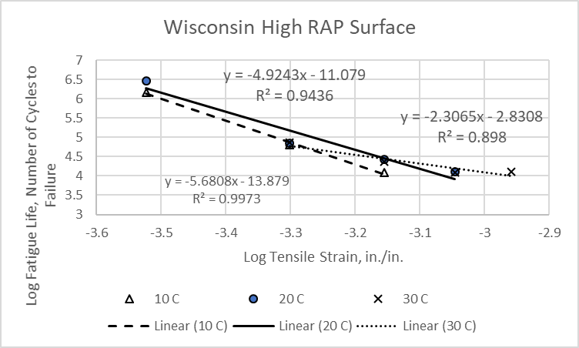
Figure 102. Graph. Fatigue Life Measured for the WI High RAP Surface Mixture.
Using all the fatigue data included in figure 106, the following summarizes the resulting laboratory-derived fatigue strength coefficients.
- K_{1f} = 3.56e-07
- K_{2f} = 4.498
- K_{3f} = 0.554
The modulus exponent term, K_{3f}, is extremely low because of the fatigue life measured at the lower two tensile strains at 30 ⁰C (see figure 102). Excluding the fatigue life for the lower two tensile strains at 30 ⁰C, the following summarizes the laboratory-derived fatigue strength coefficients, which are shown in figure 103 and are recommended for use in the PMED software.
- K_{1f} = 4.72e-03
- K_{2f} = 5.281
- K_{3f} = 1.656

Figure 103. Illustration. Screen Shot for Deriving the Laboratory-Measured Fatigue Strength Coefficients in the Pavement ME Design Software for the WI High RAP Surface Mixture.

WI High RAP Base Layer Mixture
Eleven specimens were tested at different conditions. Table 28 included a listing of the fatigue life for all test specimens based on the traditional definition for fatigue life – the number of load cycles for a 50 percent reduction is stiffness. Figure 104 graphically compares the measured fatigue life at different test temperatures.
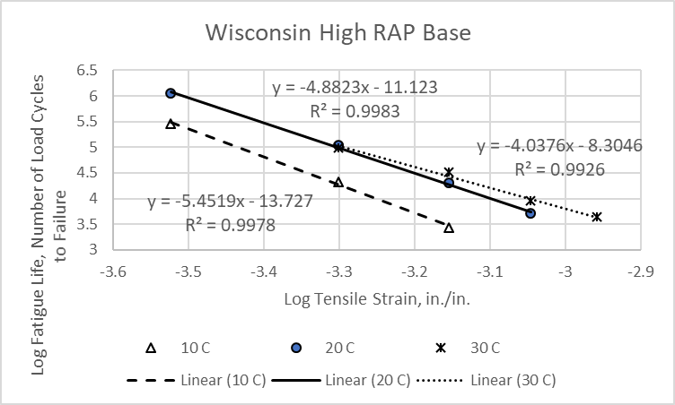
Figure 104. Graph. Fatigue Life Measured for the WI High RAP Base Mixture.
Using all the fatigue data included in figure 104, the following summarizes the laboratory-derived fatigue strength coefficients, which are shown in figure 105 and are recommended for use in the PMED software.
- K_{1f} = 1.810e-01
- K_{2f} = 4.897
- K_{3f} = 1.801

Figure 105. Illustration. Screen Shot for Deriving the Laboratory-Measured Fatigue Strength Coefficients in the Pavement ME Design Software for the WI High RAP Base Mixture.

NC High RAP Surface Layer Mixture
Twelve specimens were tested at different conditions. Table 28 included a listing of the fatigue life for all test specimens based on the traditional definition for fatigue life – the number of load cycles for a 50 percent reduction is stiffness. Figure 106 graphically compares the measured fatigue life at different test temperatures.
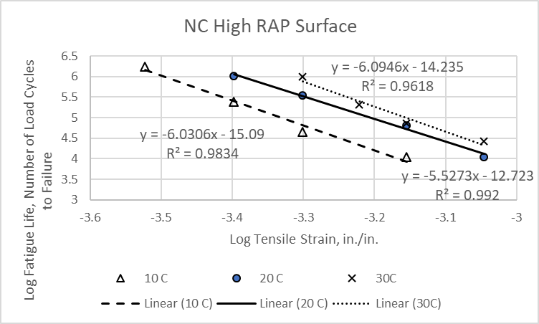
Figure 106. Graph. Fatigue Life Measured for the NC High RAP Surface Mixture.
Using all the fatigue data included in figure 106, the following summarizes the laboratory-derived fatigue strength coefficients, which are shown in figure 107 and are recommended for use in the PMED software.
- K_{1f} = 6.0421e-02
- K_{2f} = 5.644
- K_{3f} = 2.012

Figure 107. Illustration. Screen Shot for Deriving the Laboratory-Measured Fatigue Strength Coefficients in the Pavement ME Design Software for the NC High RAP Surface Mixture.

NC High RAP Intermediate Layer Mixture
Nine specimens were tested at different conditions: test temperature and flexural strain. Table 28 included a listing of the fatigue life for all test specimens based on the traditional definition for fatigue life – the number of load cycles for a 50 percent reduction is stiffness. Figure 108 graphically compares the measured fatigue life at different test temperatures.
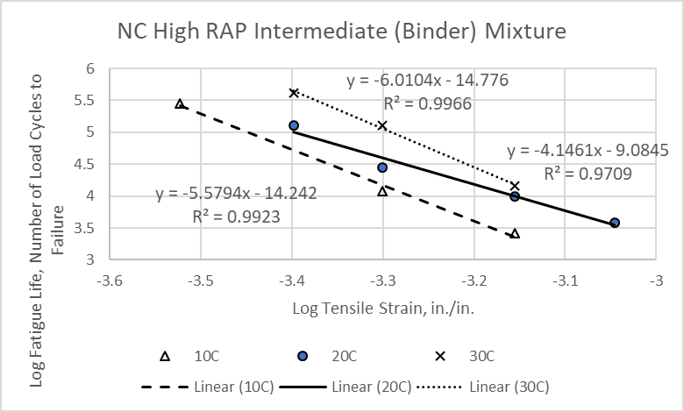
Figure 108. Graph. Fatigue Life Measured for the NC High RAP Intermediate Mixture.

Using all the fatigue data included in figure 108, the following summarizes the laboratory-derived fatigue strength coefficients.
- K_{1f} = 7.924e-02
- K_{2f} = 4.931
- K_{3f} = 1.764
The fatigue life for the lower tensile strain at 20 ⁰C is higher than for the other test temperatures. As such it was excluded from deriving the fatigue strength coefficients to be consistent with the MEPDG fatigue cracking methodology. Excluding the fatigue life for the lower tensile strain at 20 ⁰C, the following summarizes the laboratory-derived fatigue strength coefficients, which are shown in figure 109 and were used in the PMED software.
- K_{1f} = 4.316e-03
- K_{2f} = 5.400
- K_{3f} = 1.816

Figure 109. Illustration. Screen Shot for Deriving the Laboratory-Measured Fatigue Strength Coefficients in the Pavement ME Design Software for the NC High RAP Intermediate Layer Mixture.

NC High RAP Base Layer Mixture
Eleven specimens were tested at different conditions. Table 28 included a listing of the fatigue life for all test specimens based on the traditional definition for fatigue life – the number of load cycles for a 50 percent reduction is stiffness. Figure 110 graphically compares the measured fatigue life at different test temperatures. As shown, the fatigue life measured for the low tensile strain level at 30 ⁰C crosses over the fatigue life for the 20 ⁰C temperature. Thus, the fatigue life measured for the lower tensile strain at the 30 ⁰C test temperature was removed for deriving the fatigue strength coefficients.
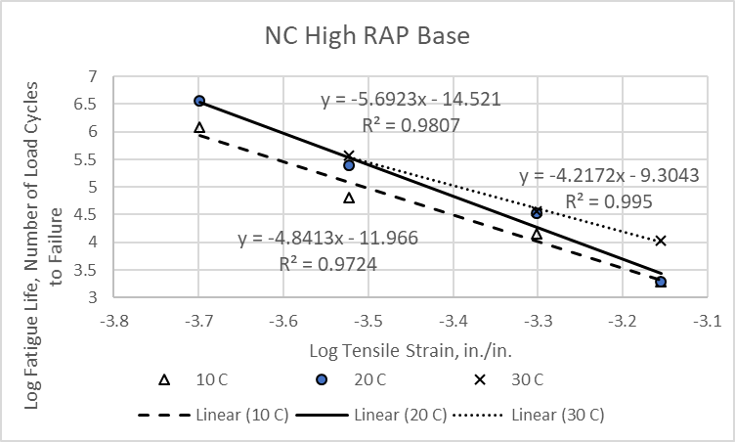
Figure 110. Graph. Fatigue Life Measured for the NC High RAP Base Mixture.
Using all the fatigue data included in figure 110, except for the lower tensile strain at 30 ⁰C, the following summarizes the laboratory-derived fatigue strength coefficients, which are shown in figure 111 and are recommended for use in the PMED software.
- K_{1f} = 1.448e-04
- K_{2f} = 5.070
- K_{3f} = 1.425

Figure 111. Illustration. Screen Shot for Deriving the Laboratory-Measured Fatigue Strength Coefficients in the Pavement ME Design Software for the NC High RAP Base Layer Mixture.

FL GTR Modified Surface Layer Mixture
Twelve specimens were tested at different conditions. Table 28 included a listing of the fatigue life for all specimens tested at different temperatures and tensile strain levels based on the traditional definition for fatigue life – the number of load cycles for a 50 percent reduction is stiffness. Figure 112 graphically compares the measured fatigue life at different test temperatures.
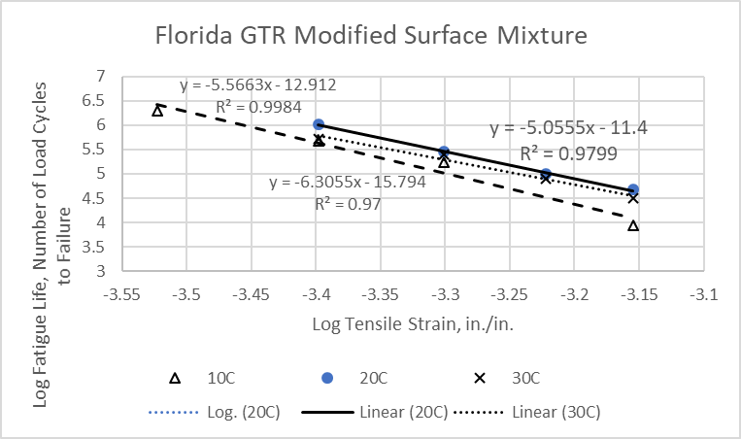
Figure 112. Graph. Fatigue Life Measured for the FL GTR Modified Surface Mixture.
Using all the fatigue data included in figure 112, the following summarizes the laboratory-derived fatigue strength coefficients, which are shown in figure 113.
- K_{1f} = 4.611e-11
- K_{2f} = 5.592
- K_{3f} = 0.477
The fatigue test results for the Florida GTR modified mixture is considered an anomaly, because the fatigue life or number of load cycles to failure for 20 ⁰C are greater than the fatigue life measured at 30 ⁰C (see figure 112). This result or observation was not the case for any of the other R²AMs. In addition, the intercept term, K_{1f}, and the modulus exponent term, K_{3f}, are significantly different than for the other R²AM and are representative of an asphalt mixture that has poor fatigue strength and is susceptible to fatigue cracking. Thus, the Florida GTR modified mixture is not recommended for use and was excluded from the recommended average fatigue strength coefficients of R²AMs or GTR modified mixtures.

Figure 113. Illustration. Screen Shot for Deriving the Laboratory-Measured Fatigue Strength Coefficients in the Pavement ME Design Software for the FL GTR Modified Surface Mixture.

MA AGGR Modified Surface Layer Mixture
Ten specimens were tested at different conditions. Table 28 included a listing of the fatigue life for all specimens tested at different temperatures and tensile strain levels based on the traditional definition for fatigue life – the number of load cycles for a 50 percent reduction is stiffness. Figure 114 graphically compares the measured fatigue life at different test temperatures.
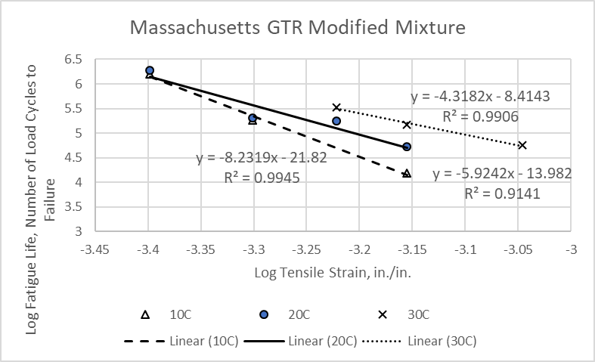
Figure 114. Graph. Fatigue Life Measured for the MA AGGR Modified Surface Base Mixture.
Using all the fatigue data included in figure 114, the following summarizes the laboratory-derived fatigue strength coefficients, which are shown in figure 115 and were used in the PMED software.
- K_{1f} = 1.846e-06
- K_{2f} = 6.295
- K_{3f} = 1.629
The fatigue life at the lower tensile strains for the 10 ⁰C and 10 ⁰C test temperatures were about the same value. Excluding the fatigue life for the two lower tensile strains for the 20 ⁰C test temperature resulted in similar fatigue strength coefficients, so all the data were used in determining the coefficients used in the PMED software.

Figure 115. Illustration. Screen Shot for Deriving the Laboratory-Measured Fatigue Strength Coefficients in the Pavement ME Design Software for the MA AGGR Modified Surface Mixture.

PA GTR Plus PMA Surface Mixture
Twelve specimens were tested at different conditions. Table 28 included a listing of the fatigue life for all test specimens tested at different temperatures and tensile strain levels based on the traditional definition for fatigue life – the number of load cycles for a 50 percent reduction is stiffness. Figure 116 graphically compares the measured fatigue life at different test temperatures.
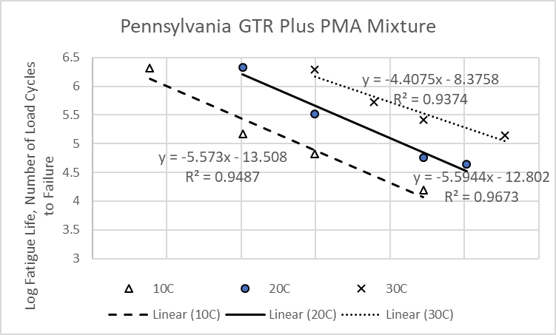
Figure 116. Graph. Fatigue Life Measured for the PA GTR Plus PMA Surface Mixture.
Using all the fatigue data included in figure 116, the following summarizes the laboratory-derived fatigue strength coefficients, which are shown in figure 117 and were used in the PMED software.
- K_{1f} = 3.415e+02
- K_{2f} = 5.259
- K_{3f} = 2.437
The intercept term, K_{1f}, and the modulus exponent term, K_{3f}, are significantly greater than for any of the other mixtures. Higher intercept and modulus exponent terms result in less fatigue damage or a higher number of load applications for fatigue cracking resistance. This observation is consistent with the fatigue test results for other PMA type mixtures.

Figure 117. Illustration. Screen Shot for Deriving the Laboratory-Measured Fatigue Strength Coefficients in the Pavement ME Design Software for the PA GTR+PMA Surface Mixture.

PA PMA Surface Mixture
Twelve specimens were tested at different conditions: test temperature and flexural strain. Table 28 included a listing of the fatigue life for all test specimens based on the traditional definition for fatigue life – the number of load cycles for a 50 percent reduction is stiffness. Figure 118 graphically compares the measured fatigue life at different test temperatures.
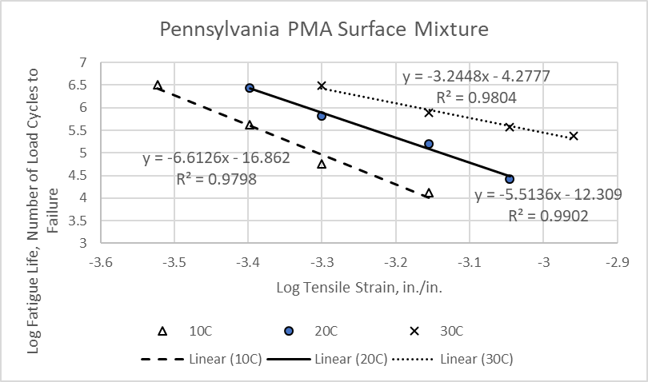
Figure 118. Graph. Fatigue Life Measured for the PA PMA Surface Mixture.
Using all the fatigue data included in figure 118, the following summarizes the laboratory-derived fatigue strength coefficients, which are shown in figure 119 and are recommended for use in the PMED software.
- K_{1f} = 3.422e+07
- K_{2f} = 5.175
- K_{3f} = 3.162
The intercept term, K_{1f}, and the modulus exponent term, K_{3f}, are significantly greater than for any of the other mixtures. Higher intercept and modulus exponent terms result in less fatigue damage or a higher number of load applications for fatigue cracking resistance. This observation is consistent with the fatigue test results for other PMA type mixtures.

Figure 119. Illustration. Screen Shot for Deriving the Laboratory-Measured Fatigue Strength Coefficients in the Pavement ME Design Software for the PA PMA Surface Mixture.

References
- Bonquist, Ramon, “Practitioner’s Guide: Part 1—Performance Testing of Resource Responsible Asphalt Mixtures to Support Mechanistic Empirical Pavement Design,” Draft Final Report, Federal Highway Administration, Washington, D.C., January 2019.

- American Association of State Highway and Transportation Officials (AASHTO), Mechanistic-Empirical Pavement Design Guide: A Manual of Practice, AASHTO, Washington, D.C., 2008.

- Applied Research Associates (ARA), “Guide for Mechanistic-Empirical Design of New and Rehabilitated Pavement Structures: Part 2. Design Inputs, Chapter 2. Material Characterization,” Final Report for the National Cooperative Highway Research Program, Transportation Research Board, Washington, D.C. 2004.

- Applied Pavement Technologies (APTech), “AASHTO Pavement ME National User Group Meetings—Technical Report: Second Annual Meeting, Denver, Colorado,” Federal Highway Administration, Office of Acquisition and Grants Management, Washington, D.C., February 2018.

- Williams, Brett, A., Audrey Copeland, and T. Carter Ross, “Asphalt Pavement Industry Survey on Recycled Materials and Warm-Mix Asphalt Usage: 2017,” Information Series 138 (8th Edition), National Asphalt Pavement Association, July 2018.

- Hansen, K.R., and Copeland, A., “Asphalt Pavement Industry Survey on Recycled Materials and Warm-Mix Asphalt Usage: 2014,” IS-138 (5th Edition), National Asphalt Pavement Association, Lanham, MD, November, 2015.

- Von Quintus, H., Mallela, J., Bonaquist, R., Schwartz, C., and Carvalo, R., “Calibration of Rutting Models for Structural and Mix Design,” NCHRP Report 719, National Cooperative Highway Research Program, Transportation Research Board, Washington, D.C., 2013.

- American Association of State Highway and Transportation Officials (ASHTO), Guide for the Local Calibration Guide of the Mechanistic Empirical Pavement Design Guide, AASHTO, Washington, D.C., 2010.

- Lytton, R. L. Uzan, J., Fernando, E.G., Roque, R., Hiltunen, D., and Stoffels, S.M., “Development and Validation of Performance Prediction Models and Specifications for Asphalt Binders and Paving Mixes,” Report No. SHRP-A-357. Strategic Highway Research Program, National Research Council, Washington, DC, 1993.

- Lytton, R.L., et al., “A Mechanistic Empirical Model for Top-Down Cracking of Asphalt Pavement Layers,” NCHRP Web-Only Document #257, National Cooperative Highway Research Program, National Research Council, Washington, D.C., November 1, 2018.

- Prowell, B.E., Brown, R.E., Anderson, R.M., Daniel, J.S., Swamy, A.K., Von Quintus, H., Shen, S., Captenter, S.H., Bhattacharjee, S., and Maghsoodloo, S., “Validating the Fatigue Endurance Limit for Hot Mix Asphalt,” NCHRP Report 646, Transportation Research Board, Washington, D.C., 2010.

- Bateman, Damien, “Laboratory Investigation of Fatigue Endurance Limits in Asphalt Concrete,” Dissertation, University of New Mexico, Albuquerque, New Mexico, May 2012 (http://digitalrepository.unm.edu/ce_etds).

- Witczak, Matthew, Mena Souliman, and Waled Zeiada, “Laboratory Validation of an Endurance Limit,” NCHRP Report 762, National Cooperative Highway Research Program, Transportation Research Board, Washington, D.C., 2013.

- American Association of State Highway and Transportation Officials (AASHTO), Mechanistic-Empirical Pavement Design Guide: A Manual of Practice, AASHTO, Washington, D.C., 2015.

