Practitioner’s Guide for Level 1 Material Characterization of Asphalt Mixtures to Support AASHTOWare Pavement ME Design With Examples for Resource Responsible Asphalt Mixtures

January, 2019
FOREWORD

Notice
This document is disseminated under the sponsorship of the U.S. Department of Transportation in the interest of information exchange. The U.S. Government assumes no liability for the use of the information contained in this document.
The U.S. Government does not endorse products or manufacturers. Trademarks or manufacturers’ names appear in this report only because they are considered essential to the objective of the document.
Quality Assurance Statement
The Federal Highway Administration (FHWA) provides high-quality information to serve Government, industry, and the public in a manner that promotes public understanding. Standards and policies are used to ensure and maximize the quality, objectivity, utility, and integrity of its information. FHWA periodically reviews quality issues and adjusts its programs and processes to ensure continuous quality improvement.
Technical Report Documentation Page
1. Report No. | 2. Government Accession No. |  |  | 3. Recipient’s Catalog No.
4. Title and Subtitle  Practitioner’s Guide for Level 1 Material Characterization of Asphalt Mixtures to Support AASHTOWare Pavement ME Design With Examples for Resource Responsible Asphalt Mixtures |  |  |  | 5. Report Date  January 29, 2019
 |  |  |  | 6. Performing Organization Code:
7. Author(s)  Ramon Bonaquist, Ph.D., P.E. |  |  |  | 8. Performing Organization Report No.
9. Performing Organization Name and Address  Advanced Asphalt Technologies, LLC  40 Commerce Circle  Kearneysville, WV 25430 |  |  |  | 10. Work Unit No.
 |  |  |  | 11. Contract or Grant No.
 |  |  |  | 13. Type of Report and Period Covered
 |  |  |  | 14. Sponsoring Agency Code
15. Supplementary Notes

16. Abstract
This guide presents detailed information on the equipment and procedures needed to perform material property characterization of asphalt mixtures to obtain Level 1 input properties for the AASHTOWare Pavement ME Design software. It was developed for engineers and technicians that are responsible for testing asphalt mixtures to support pavement design. This guide presents details concerning: (1) the equipment that is needed to fabricate and test asphalt mixture specimens, (2) the procedures for specimen fabrication and testing, (3) techniques for assessing the quality of the test data that are collected, and (4) methods to analyze the data and calculate material properties. The material properties covered by this guide include: (1) dynamic modulus, (2) repeated load permanent deformation coefficients, (3) low temperature creep compliance and tensile strength, and (4) fatigue coefficients. Detailed examples that include: (1) specimen fabrication, (2) material property testing, (3) data quality assessment, and (4) data analysis are presented using actual data collected on two types of Resource Responsible Asphalt Mixture (R²AMs), high recycled binder content mixtures and mixtures incorporating ground tire rubber modified binder. The separate companion to this guide, provides guidance on designing flexible pavements and overlays using R²AMs. It addresses the analysis required to transform the test data into the inputs required by Pavement ME Design and provides several examples of pavements incorporating R²AMs that were designed using Pavement ME Design. The companion guide is intended for engineers responsible for performing pavement design and analysis using AASHTOWare Pavement ME Design
17. Key Words  Mechanistic-empirical design, performance testing, dynamic modulus, repeated load permanent deformation, creep compliance and strength, flexural fatigue, Resource Responsible Asphalt Mixtures |  |  | 18. Distribution Statement  No restrictions. This document is available through the National Technical Information Service, Springfield, VA 22161.
19. Security Classif. (of this report)  Unclassified |  | 20. Security Classif. (of this page)  Unclassified |  |  | 21. No. of Pages  132 | 22. Price  N/A
Form DOT F 1700.7 (8-72) |  | Reproduction of completed page authorized

Table of Contents

Table of Contents i
List of Tables iv
List of Figures vi
Abbreviations, Acronyms, And Symbols ix
Chapter 1. Introduction 1
1.1 Background 1
1.2 Purpose of the Guide 2
1.3 Organization of the Guide 2
1.4 Source of Material Property Data 4
Chapter 2. Dynamic Modulus Testing and Analysis 8
2.1 Background 8
2.1.1 Introduction 8
2.1.2 Dynamic Modulus Master Curves 9
2.1.3 Dynamic Modulus Test Procedures 12
2.2 Equipment 13
2.2.1 Specimen Fabrication Equipment 13
2.2.2 Dynamic Modulus Testing Equipment 16
2.3 Procedures 20
2.3.1 Specimen Fabrication Procedure 20
2.3.2 Dynamic Modulus Testing Procedure 22
2.4 Data Analysis 25
2.5 Example 28
2.5.1 Step 1. Select Number of Specimens, Target Air Void Content, and Testing Temperatures 28
2.5.2 Step 2. Specimen Fabrication 29
2.5.3 Step3. Dynamic Modulus Testing 30
2.5.4 Step 4. Data Analysis 33
2.6 Summary of Recommended Dynamic Modulus Testing and Analysis Practices 35
2.6.1 Specimen Fabrication 35
2.6.2 Dynamic Modulus Testing 38
2.6.3 Data Analysis 38
2.7 Example Dynamic Modulus Values for R²AMs 38
Chapter 3. Repeated Load Permanent Deformation Testing and Analysis 44
3.1 Background 44
3.1.1 Rutting Model 44
3.1.2 Repeated Load Permanent Deformation Test for Pavement ME Design Analysis 45
3.2 Equipment 46
3.3 Procedures 47
3.3.1 Specimen Fabrication Procedure 47
3.3.2 Repeated Load Permanent Deformation Testing Procedure 47
3.4 Data Analysis 53
3.5 Example 54
3.5.1 Step 1. Select Number of Specimens, Target Air Void Content, and Testing Temperatures 54
3.5.2 Step 2. Specimen Fabrication 55
3.5.3 Step3. Repeated Load Permanent Deformation Testing 55
3.5.4 Step 4. Data Analysis 61
3.6 Summary of Recommended Repeated Load Permanent Deformation Testing and Analysis Practices 61
3.6.1 Specimen Fabrication 61
3.6.2 Repeated Load Permanent Deformation Testing 62
3.6.3 Data Analysis 63
3.7 Example Permanent Deformation Properties for Selected R²AMs 63
Chapter 4. Low Temperature Creep Compliance and Strength Testing 67
4.1 Background 67
4.1.1 Introduction 67
4.1.2 Creep Compliance 67
4.1.3. Tensile Strength 68
4.2 Equipment 68
4.2.1 Specimen Fabrication Equipment 68
4.2.2 Low Temperature Creep Compliance and Strength Testing Equipment 69
4.3 Procedures 72
4.3.1 Specimen Fabrication Procedure 72
4.3.2 Indirect Tension Creep Compliance Testing Procedure 74
4.3.3 Indirect Tension Strength Testing Procedure 77
4.4 Data Analysis 77
4.4.1 Tensile Strength 77
4.4.2 Creep Compliance 78
4.4.3 Poisson’s Ratio 79
4.5 Example 79
4.5.1 Step 1. Select Number of Specimens, Target Air Void Content, and Testing Temperatures 80
4.5.2 Step 2. Specimen Fabrication 80
4.5.3 Step 3. Creep Compliance Testing 80
4.5.4 Step 4. Strength Testing 81
4.5.5 Step 5. Data Analysis 83
4.6 Summary of Recommended Low Temperature Compliance and Strength Testing and Analysis Practices 85
4.6.1 Specimen Fabrication 85
4.6.2 Testing 86
4.6.3 Data Analysis 87
4.7 Example Low Temperature Compliance and Strength Properties for R²AMs 88
Chapter 5. Flexural Fatigue Testing 91
5.1 Background 91
5.1.1 Load Related Cracking Models 91
5.1.2 Flexural Fatigue Testing 91
5.2 Equipment 93
5.2.1 Specimen Fabrication Equipment 93
5.2.2 Flexural Fatigue Testing Equipment 99
5.3 Procedures 102
5.3.1 Specimen Fabrication Procedure 102
5.3.2 Flexural Fatigue Testing 105
5.4 Data Analysis 108
5.5 Example 109
5.5.1 Step 1. Select Number of Specimens, Target Air Void Content, and Testing Temperature 110
5.5.2 Step 2. Specimen Fabrication 110
5.5.3 Step 3. Flexural Fatigue Testing 110
5.5.4 Step 4. Data Analysis 114
5.6 Summary of Recommended Flexural Fatigue Testing and Analysis Practices 117
5.6.1 Specimen Fabrication 117
5.6.2 Testing 118
5.6.3 Data Analysis 119
5.7 Typical Flexural Fatigue Properties for R²AMs 120
Chapter 6. Summary 124
6.1 Equipment Requirements 124
6.2 Testing and Data Analysis 127
6.3 Special Considerations for R²AMs 127
References 131

List of Tables
Table 1. Properties of RAP mixtures. 5
Table 2. Properties of GTR and polymer modified mixtures. 6
Table 3. Summary of temperatures. 7
Table 4. Equipment for dynamic modulus specimen preparation. 15
Table 5. Equipment for dynamic modulus testing. 17
Table 6. Temperatures and loading frequencies for dynamic modulus master curve testing. 24
Table 7. Typical coefficient of variation of the mean of dynamic modulus tests on multiple specimens. 28
Table 8. Properties of the dynamic modulus test specimens for the North Carolina binder mixture. 30
Table 9. Recommended sequence of dynamic modulus testing. 32
Table 10. Data quality indicators for the North Carolina binder mixture, with limits shown in parentheses. 33
Table 11. Summary of average dynamic modulus data for mixtures with high recycled binder content. 40
Table 12. Volumetric and performance grade properties for mixtures with high recycled binder content. 40
Table 13. Summary of average dynamic modulus data for mixtures with GTR modified binder. 41
Table 14. Volumetric and performance grade properties for mixtures with GTR modified binder. 41
Table 15. Properties of the repeated load permanent deformation test specimens for the Pennsylvania surface mixture. 56
Table 16. Summary of laboratory permanent deformation coefficients for the Pennsylvania GTR modified surface course mixture. 61
Table 17. Summary of repeated load permanent deformation test. 62
Table 18. Summary of average repeated load permanent strain coefficients for mixtures with high recycled binder content and mixtures with GTR modified binder. 64
Table 19. Volumetric and performance grade properties for mixtures used in repeated load permanent deformation tests. 65
Table 20. Equipment for low temperature creep compliance and strength testing. 69
Table 21. Suggested creep loads for AASHTO T 322. 76
Table 22. Properties of AASHTO T 322 test specimens for the Wisconsin surface mixture. 80
Table 23. Tensile strength at -10 ⁰C for the Wisconsin surface mixture. 83
Table 24. Normalized displacements at 50 sec loading time for Wisconsin surface mixture 84
Table 25. Creep compliance and Poisson’s ratio calculations for the Wisconsin surface course mixture 85
Table 26. AASHTO T 322 tensile strength, volumetric properties, and low temperature Performance Grade properties for R²AMs. 88
Table 27. AASHTO T 322 creep compliance values for R²AMs. 90
Table 28. Equipment for flexural fatigue test specimen preparation. 94
Table 29. Air Voids and dimensions of North Carolina durface mixture fatigue specimens. 111
Table 30. Fatigue lives for the North Carolina surface mixture at 20 ºC. 115
Table 31. Data and regression input for determining laboratory fatigue coefficients. 115
Table 32. Summary R²AMs fatigue data for fitting laboratory fatigue relationships. 121
Table 33. Laboratory fatigue coefficients for selected R²AMs. 122
Table 34. Equipment for specimen fabrication for Level 1 material property characterization. 125
Table 35. Equipment for Level 1 material property characterization testing. 126
Table 36. Overview of the requited Level 1 material property characterization testing. 128
Table 37. Summary of data analysis for Level 1 material characterization tests. 129
Table 38. Summary of special considerations for testing R²AMs. 130

List of Figures
Figure 1. Graph. Schematic of dynamic modulus test data. 8
Figure 2. Equation. Calculation of dynamic modulus from test data. 9
Figure 3. Equation. Calculation of phase angle from test data. 9
Figure 4. Graph. Dynamic modulus master curve construction. 10
Figure 5. Graph. Temperature shift factors for dynamic modulus master curve. 10
Figure 6. Equation. Sigmoidal function for dynamic modulus. 11
Figure 7. Equation. Arrhenius function for shift factors. 11
Figure 8. Graph. Comparison of dynamic modulus master curves based on frequency and time. 12
Figure 9. Equation. Viscosity based shift factors used for dynamic modulus master curves in Pavement ME Design. 12
Figure 10. Photo. Commercial specimen coring system. 15
Figure 11. Photo. Commercial core clamp for trimming asphalt specimens. 16
Figure 12. Photo. Typical AMPT for dynamic modulus testing per AASHTO R 84 and AASHTO T 378. 17
Figure 13. Photo. Typical general-purpose servo-hydraulic testing machine for dynamic modulus testing per AASHTO T 342. 18
Figure 14. Photo. Example of AMPT magnetic mount for specimen deformation sensor. 19
Figure 15. Photo. Example of AMPT mechanical mount for specimen deformation sensor. 19
Figure 16. Photo. Example of AASHTO T 342 specimen deformation sensor. 20
Figure 17. Graph. Typical good quality dynamic modulus master curve. 27
Figure 18. Graph. Variation of phase angle with reduced frequency for good quality fitting of a dynamic modulus master curve. 27
Figure 19. Equation. Equation for estimating the mass of mixture for trial specimens to target a specified air void content. 29
Figure 20. Equation. Equation for adjusting the gyratory specimen mass when trial specimens are outside the air void tolerance. 30
Figure 21. Photo. Measurement of end flatness. 31
Figure 22. Photo. Measurement of end perpendicularity. 31
Figure 23. Screen Shot. MasterSolver “Data” spreadsheet with data for the North Carolina binder mixture. 34
Figure 24. Screen Shot. MasterSolver FIT spreadsheet for the North Carolina binder mixture. 35
Figure 25. Screen Shot. MasterSolver REPORT Spreadsheet for the North Carolina Binder Mixture. 36
Figure 26. Screen Shot. MasterSolver MEPDGINPUT spreadsheet for the North Carolina Binder mixture. 37
Figure 27. Graph. Comparison of dynamic modulus master curves for high recycled binder content mixtures. 42
Figure 28. Graph. Comparison of shift factors for high recycled binder content mixtures. 42
Figure 29. Graph. Comparison of dynamic modulus master curves for mixtures containing GTR modified binder. 43
Figure 30. Graph. Comparison of shift factors for mixtures containing GTR modified binder. 43
Figure 31. Equation. Pavement ME Design asphalt layer rutting model. 44
Figure 32. Graph. Typical laboratory repeated load permanent strain curve for an asphalt mixture. 45
Figure 33. Graph. AASHTO T 378 computation of the flow number. 45
Figure 34. Graph. Schematic of the stresses and deformations in the repeated load permanent deformation test. 46
Figure 35. Photo. Repeated load permanent deformation testing in an AMPT. 47
Figure 36. Photo. Examples of repeated load permanent deformation specimens with unacceptable air void gradient (left) and acceptable air void gradient (right). 50
Figure 37. Photo. Confined repeated load permanent deformation test specimen after confining pressure was applied. 51
Figure 38. Photo. Triaxial cell for repeated load permanent deformation testing in a general-purpose servo-hydraulic testing machine. 53
Figure 39. Equation. Lot-log form for fitting the secondary portion of laboratory permanent strain curve. 53
Figure 40. Screen Shot. LTPPBind 3.1 for Wilkes-Barre Scranton weather station showing determination of high pavement temperature. 55
Figure 41. Graph. Example repeated load permanent deformation curve where temperature is too high resulting in tertiary flow. 56
Figure 42. Graph. Example repeated load permanent deformation curve where loss of confinement occurred. 57
Figure 43. Graph. Example repeated deviatoric stress error during a repeated load permanent deformation test. 58
Figure 44. Graph. Example load standard error during a repeated load permanent deformation test. 59
Figure 45. Graph. Permanent deformation curves for the Pennsylvania GTR modified surface course mixture in arithmetic scale. 60
Figure 46. Graph. Permanent deformation curves for the Pennsylvania GTR modified surface course mixture in logarithmic scale. 60
Figure 47. Graph. Comparison of average permanent strain slope parameter, b. 65
Figure 48. Graph. Comparison of temperature exponent for the permanent strain intercept parameter, a. 66
Figure 49. Photo. Indirect tensile strength test. 68
Figure 50. Photo. Servo-hydraulic testing system for AASHTO T 322. 70
Figure 51. Photo. Miniature LVDT instrumentation system for AASHTO T 322. 70
Figure 52. Photo. Bi-axial strain gauge extensometer system for AASHTO T 322. 71
Figure 53. Photo. Indirect tensile gauge point template. 71
Figure 54. Photo. Indirect tensile loading fixture. 72
Figure 55. Graph. Typical load and deformation during an AASHTO T 322 creep test. 77
Figure 56. Equation. Calculation of indirect tensile strength. 78
Figure 57. Equation. Calculation of creep compliance. 78
Figure 58. Equation. Calculation of creep compliance factor. 79
Figure 59. Equation. Calculation of Poisson’s ratio. 79
Figure 60. Graph. Example plots of creep testing at -20 ⁰C for Wisconsin surface mixture. 82
Figure 61. Graph Example load-displacement curve at -10 ºC for Wisconsin surface mixture. 83
Figure 62. Graph. Comparison of AASHTO T 322 tensile strength at -10 ºC for R²AMs. 89
Figure 63. Graph. Comparison of AASHTO T 322 creep compliance for R²AMs. 89
Figure 64. Equation. Pavement ME Design fatigue equation. 91
Figure 65. Photo. Four-point flexural fatigue test in a stand-alone pneumatic flexural fatigue device. 92
Figure 66. Graph. Typical S-N diagram for asphalt mixtures 93
Figure 67. Equation. Laboratory fatigue equation for determining k_{1f}, k_{2f} and k_{3f}. 93
Figure 68. Photo. Linear kneading compactor. 96
Figure 69. Photo. Vibratory compactor. 96
Figure 70. Photo. Shear box compactor. 97
Figure 71. Photo. Segmented roller compactor. 97
Figure 72. Photo. Large laboratory mixer. 98
Figure 73. Photo. Double-bladed automatic feed control saw. 99
Figure 74. Photo. Four-point flexural fatigue device for a general-purpose servo-hydraulic testing machine. 100
Figure 75. Equation. Extreme fiber tensile strain in beam in four-point bending. 101
Figure 76. Equation. Maximum tensile stress in beam in four-point bending. 101
Figure 77. Equation. Flexural stiffness calculation. 101
Figure 78. Equation. Flexural stiffness calculation. 102
Figure 79. Equation. Equation for estimating the mass of mixture for trial specimens to target a specified air void content. 104
Figure 80. Equation. Equation for adjusting the specimen mass when trial specimens are outside the air void tolerance. 104
Figure 81. Graph. Test chamber temperature a during fatigue test. 107
Figure 82. Graph. Plots of change in initial stiffness and the product of stiffness and cycles during fatigue testing. 108
Figure 83. Equation. Equation for solving for the cycle where the peak of the stiffness times cycles occurs. 108
Figure 84. Graph. Polynomial fitting to determine AASHTO T 321 fatigue life. 109
Figure 85. Equation. Laboratory fatigue equation for determining k_{1f}, k_{2f} and k_{3f}. 110
Figure 86. Graph. Fatigue test results for North Carolina surface mixture tested at 20 ºC, 900 μstrain. 111
Figure 87. Graph. Fatigue test results for North Carolina surface mixture tested at 20 ºC, 700 μstrain. 112
Figure 88. Graph. Fatigue test results for North Carolina surface mixture tested at 20 ºC, 500 μstrain. 112
Figure 89. Graph. Fatigue test results for North Carolina surface mixture tested at 20 ºC, 400 μstrain. 113
Figure 90. Graph. Temperature control during 32 hour fatigue test. 113
Figure 91. Graph. Strain control during 1.2 million cycle fatigue tests. 114
Figure 92. Illustration. Excel regression output for fitting the laboratory fatigue coefficients for the North Carolina surface mixture. 116
Figure 93. Graph. Predicted versus measured cycles to failure for the North Carolina surface mixture. 116
Figure 94. Graph. Comparison of strain, k_{2f}, and modulus, k_{3f}, exponents for selected R²AMs. 122
Figure 95. Graph. Comparison of constant, k_{1f} in fatigue relationship for selected R²AMs. 123

Abbreviations, Acronyms, And Symbols
AASHTO | American Association of State Highway and Transportation Officials
AMPT | Asphalt Mixture Performance Tester
ARGG | Asphalt Rubber Gap Graded
ASTM | ASTM International
GTR | Ground Tire Rubber
LTPP | Long-Term Pavement Performance
LVDT | Linear variable differential transformer
MAAT | Mean Annual Air Temperature
MAPT | Mean Annual Pavement Temperature
MEPDG | Mechanistic-Empirical Pavement Design Guide: A Manual of Practice
NAPA | National Asphalt Pavement Association
NCHRP | National Cooperative Highway Research Program
PG | Performance Grade
PMA | Polymer Modified Asphalt
PTFE | Polytetrafluoroethylene
SBS | Styrene Butadiene Styrene
SHRP | Strategic Highway Research Program
SI | International System of Units
RAP | Reclaimed Asphalt Pavement
RAS | Reclaimed Asphalt Shingles
R²AM | Resource Responsible Asphalt Mixture
RTFOT | Rolling Thin Film Oven Test
RTD | Resistance Temperature Detector
Se | Standard Error
Sy | Standard Deviation
USCS | United States customary system
VMA | Voids in Mineral Aggregate
VBE | Effective Volume of Binder
VFA | Voids Filled with Asphalt
WMA | Warm Mix Asphalt

Chapter 1. Introduction

1.1 Background
Interest in using mechanistic-empirical pavement design as standard practice has increased sharply since the American Association of State Highway and Transportation Officials (AASHTO) published the Mechanistic-Empirical Pavement Design Guide: A Manual of Practice (MEPDG) (AASHTO, 2008) in 2008, and later released the accompanying software, AASHTOWare Pavement ME Design in 2011 (Pavement ME Design). Data compiled for the 2017 AASHTO Pavement ME National Users Group meeting showed 13 states have implemented Pavement ME Design for asphalt pavements and overlays, and 31 states and 4 Canadian provinces planned to implement it in the future (Applied Pavement Technology, 2018).

One of the advantages of using mechanistic-empirical pavement design is the ability to consider a variety of materials. This flexibility is important because, in addition to conventional asphalt mixtures, several resource responsible asphalt mixtures (R²AMs) are used extensively in the construction of flexible pavements and the rehabilitation of existing flexible and rigid pavements using asphalt mixtures. The R²AMs that are being used include: (1) mixtures with reclaimed asphalt pavement (RAP), (2) mixtures with reclaimed asphalt shingles (RAS), (3) mixtures containing asphalt binder modified with ground tire rubber (GTR), (4) mixtures produced as warm mix asphalt (WMA), and (5) mixtures produced using various combinations of RAP, RAS, GTR, and WMA. A 2017 survey of United States asphalt producers conducted by the National Asphalt Pavement Association (NAPA) documented the following usage levels for various R²AMs (Williams, et. al., 2018):

- WMA. An estimated 147.4 million tons of asphalt mixture were produced as WMA. This represents about 39 percent of the estimated 2017 production of 379.4 million tons of asphalt mixture. In 15 states WMA represented over 50 percent of the total asphalt mixture produced. WMA usage increased steadily from about 5 percent of total asphalt mixture produced in 2009 plateauing at about 30 percent from 2013 through 2016. The 2017 data show a substantial increase in the use of WMA.

- RAP. An estimated total of 76.2 million tons of RAP were used in asphalt mixtures. This represents a nationwide average RAP content of about 20 percent. At this level many produces reported still having excess RAP. The use of RAP in asphalt mixtures increased steadily from about 16 percent of total asphalt mix produced in 2009 plateauing at about 20 percent in 2014 through 2017.

- RAS. An estimated 0.94 million tons of RAS were used in asphalt mixtures. RAS usage in asphalt mixtures reached a peak in 2014 at about 2 million tons decreasing to about one half of this level in 2017.

- GTR. An estimated 0.97 million tons of asphalt mixture containing GTR were produced, using about 14,000 tons of GTR. GTR use in asphalt mixtures was relatively constant at about 1.2 million tons per year between 2013 and 2015. GTR usage peaked at about 1.5 million tons in 2016, then decreased in 2017.

1.2 Purpose of the Guide
As more states implement Pavement ME Design, questions arise concerning appropriate material properties for the various R²AMs that are used extensively in flexible pavements and asphalt overlays. Although the hierarchical approach included in the MEPDG and Pavement ME Design was structured to accommodate a variety of materials, only limited guidance is available for engineers designing flexible pavements with materials other than virgin asphalt mixtures. Pavement ME Design provides three hierarchical levels for design inputs. Level 1 is the most accurate and encompassing and for material properties, requires direct measurement of the engineering properties of the materials that will be used in the pavement. The AASHTO standard test procedures for measuring engineering properties of asphalt mixtures for Level 1 analysis were developed for asphalt mixtures produced with virgin materials. Although the test methods can be applied to R²AMs, no guidance is available on how specimen fabrication and testing may be different for R²AMs compared to virgin asphalt mixtures. Level 2 in Pavement ME Design is somewhat less accurate and uses correlations between the engineering properties required by Pavement ME Design and easily measured index or strength properties. Finally, Level 3 is the least accurate and uses default or recommended material properties. The engineering property correlations used for Level 2 analysis and the default values for Level 3 analysis for asphalt mixtures are based on historical data from studies for asphalt mixtures produced with virgin materials. There is no guidance available on whether these correlations and recommended values are appropriate for R²AMs. An added complication for states interested in using Level 1 is the MEPDG references the test procedures, but it provides little practical guidance on the equipment needed for specimen fabrication and testing, the techniques used to fabricate and test specimens, how to assess the quality of the resulting data, and the analysis required to derive inputs to Pavement ME Design. Typical laboratory technicians and many engineers are not familiar with the performance test procedures required to use Level 1 analyses.

This guide is part one of a two-part series intended to provide guidance to practicing pavement engineers on the design of pavements incorporating R²AMs. This guide addresses how to characterize the properties of asphalt mixtures for Level 1 analysis in Pavement ME Design using examples for selected R²AMs. It is intended for engineers and technicians responsible for testing asphalt mixtures to obtain data for Level 1 input properties for Pavement ME Design. This guide describes: (1) the equipment, testing, and data analysis required to obtain Level 1 input properties and (2) presents example properties for selected R²AMs. Part two, published as a separate guide, provides guidance on designing flexible pavements and overlays using R²AMs. It addresses the analysis required to transform the test data into the inputs required by the Pavement ME Design and provides several examples of pavements incorporating R²AMs that were designed using Pavement ME Design. Part two is intended for engineers responsible for performing pavement design and analysis using Pavement ME Design.

1.3 Organization of the Guide
This guide is intended for engineers and technicians responsible for testing asphalt mixtures to obtain data for Level 1 input properties for Pavement ME Design. It includes separate chapters covering the following properties of asphalt mixtures that are Level 1 inputs in Pavement ME Design:
- Dynamic modulus. The dynamic modulus is the material property used in Pavement ME Design to characterize the stiffness of asphalt layers. The structural response model in Pavement ME Design uses the dynamic modulus to calculate the stresses and strains induced in the pavement by traffic loads. The dynamic modulus of asphalt mixtures is measured using AASHTO T 342, Standard Method of Test for Determining Dynamic Modulus of Hot Mix Asphalt (HMA), or the dynamic modulus procedure in AASHTO T 378, Standard Method of Test for Determining the Dynamic Modulus and Flow Number for Asphalt Mixtures Using the Asphalt Mixture Performance Tester (AMPT).

- Repeated load permanent deformation coefficients. The rutting characteristics of asphalt mixtures are characterized in Pavement ME Design using two coefficients, intercept and slope, that are used to define repeated load permanent deformation curves in log-log space. The intercept defines the permanent deformation on the first load cycle, and the slope describes how the permanent deformation increases with increasing number of loading cycles. The permanent deformation intercept and slope are measured using a modified version of the confined flow number test from AASHTO T 378.

- Low temperature creep compliance and tensile strength. Creep compliance and tensile strength properties at low temperatures are used by Pavement ME Design to predict thermal cracking. Compliance is the inverse of stiffness. Mixtures that are more compliant have lower stiffness. The tensile stresses induced in the pavement during thermal contraction depend on the compliance of the asphalt mixture, while the resistance to cracking depends on the tensile strength. Both properties are measured using AASHTO T 322, Standard Method of Test for Determining the Creep Compliance and Strength of Hot-Mix Asphalt (HMA) Using the Indirect Tensile Test Device.

- Fatigue coefficients. Pavement ME Design uses a fatigue damage law with three material coefficients. This law expresses the allowable number of loads as a function of the strain induced by traffic loading at the bottom of the asphalt layer and the dynamic modulus of the asphalt mixture. The coefficients for this model are obtained from multiple laboratory fatigue tests conducted in accordance with AASHTO T 321, Standard Method of Test for Determining the Fatigue Life of Compacted Asphalt Mixtures Subjected to Repeated Flexural Bending.

Each chapter follows the outline presented below:

- Background. Describes the material property, how it is used in Pavement ME Design, and introduces the AASHTO Standard Method of Test for measuring the material property.

- Equipment Requirements. Describes the equipment required for specimen fabrication and testing.

- Procedures. Provides step by step guidance for specimen fabrication and testing. Methods for assessing data quality are discussed, and special techniques required for R²AMs are highlighted.
- Data Analysis. Describes the post test data processing required to use the measured test data with Pavement ME Design.

- Example. Presents a complete example of specimen fabrication, testing, and data analysis using test data collected on a specific R²AM.

- Summary. This section recaps the important points that were discussed in the chapter emphasizing aspects that are important when testing R²AMs.

- Example Properties. Presents a summary of properties measured on selected R²AMs.

The last chapter of this guide presents summary tables of: (1) the equipment needed to fabricate test specimens, the equipment needed to conduct Level 1 characterization tests, (2) test requirements and analysis for each of the Level 1 characterization tests, and (3) special considerations for testing R²AMs.

1.4 Source of Material Property Data
To provide realistic data for the examples included in this guide, material from 9 asphalt mixtures produced between 2014 and 2016 were sampled and tested using the procedures presented in this guide. Projects in warm and cool climates were included to provide a range of material properties. The asphalt mixtures included five with high recycled binder content, three containing a binder modified with GTR, and one containing a binder modified with styrene butadiene styrene (SBS) polymer. The last mixture was included to provide a comparison with the GTR modified binder mixtures. Characteristics of the high recycled binder mixtures are summarized in Table 1; similar data for the mixtures containing binder modified with GTR and SBS are summarized in Table 2.

The high recycled binder content mixtures were sampled from projects in Wisconsin and North Carolina. Except for the North Carolina base mixture, the mixtures were produced with a combination of RAP and RAS and used binder that was one grade softer than normally required. The North Carolina base mixture was produced with RAP and Performance Grade (PG) 64-22 binder, the binder normally specified for that environment.

The mixtures with GTR and polymer modified binders were sampled from projects in Massachusetts, Florida, and Pennsylvania. Two general types of GTR modified binders are used in the United States: (1) asphalt rubber, which is an on-site blended product using high GTR contents and relatively large GTR particles, and (2) terminal blended GTR which is produced at a terminal using finer GTR particles and typically formulated to meet standard performance grades. Asphalt rubber should only be used in gap-graded and open graded mixtures which provide space for the GTR particles. When asphalt rubber is used in dense-graded mixtures the mixture will dilate after compaction as the GTR particles rebound. Terminal blended GTR can be used in dense graded mixtures. The Massachusetts GTR mixture was a gap graded surface mixture produced with asphalt rubber binder meeting ASTM D 6114 (Type II). The Florida and Pennsylvania GTR mixtures were dense graded surface mixtures produced using proprietary terminal blended rubber modification processes. The Florida GTR binder met specification requirements for Florida designation PG 76-22 ARB, requiring a minimum of 7 percent rubber. The Pennsylvania GTR modified binder met the physical properties for PG 76-22. The Pennsylvania surface mixture produced with an SBS modified PG 76-22 binder was also sampled and tested. The Massachusetts and Florida mixtures contained RAP. The Pennsylvania mixtures were virgin mixtures.
Table 1. Properties of RAP mixtures.
Property |  | WI  Base | WI Surface | NC Base | NC  Binder | NC Surface
Gradation, % Passing | Sieve Size, mm
Gradation, % Passing | 37.5 | 100 | 100 | 100 | 100 | 100
Gradation, % Passing | 25 | 100 | 100 | 94 | 100 | 100
Gradation, % Passing | 19 | 99 | 100 | 92 | 100 | 100
Gradation, % Passing | 12.5 | 90 | 98 | 88 | 91 | 100
Gradation, % Passing | 9.5 | 77 | 86 | 83 | 82 | 96
Gradation, % Passing | 4.75 | 57 | 70 | 59 | 55 | 72
Gradation, % Passing | 2.36 | 46 | 54 | 45 | 43 | 58
Gradation, % Passing | 1.18 | 35 | 41 | 36 | 35 | 47
Gradation, % Passing | 0.6 | 25 | 30 | 27 | 25 | 33
Gradation, % Passing | 0.3 | 13 | 15 | 16 | 15 | 19
Gradation, % Passing | 0.15 | 7 | 8 | 10 | 9 | 11
Gradation, % Passing | 0.075 | 4.9 | 5.7 | 6.8 | 6.4 | 7.2
Reclaimed Binder Ratio |  | 0.50 | 0.50 | 0.33 | 0.40 | 0.33
Recycle Type |  | RAP+RAS | RAP+RAS | RAP | RAP+RAS | RAP+RAS
RAP Binder Ratio |  | 0.20 | 0.26 | 0.33 | 0.20 | 0.17
RAS Binder Ratio |  | 0.30 | 0.24 | 0.00 | 0.20 | 0.16
Virgin Binder PG Grade |  | 52-34 | 52-34 | 64-22 | 58-28 | 58-28
Asphalt Content |  | 4.53 | 4.51 | 4.38 | 4.20 | 5.72
VMA at 7 % Air Voids |  | 15.6 | 15.6 | 17.3 | 16.7 | 20.3
VBE |  | 8.6 | 8.6 | 10.3 | 9.7 | 13.3
VFA at 7% Air voids |  | 56.6 | 55.2 | 59.1 | 57.8 | 64.6
Recovered Binder Properties | High | 76.9 | 75.9 | 78.0 | 80.5 | 80.9
Recovered Binder Properties | Intermediate | 21.5 | 19.6 | 24.8 | 23.0 | 24.8
Recovered Binder Properties | Low S | -29.2 | -30.1 | -24.9 | -27.8 | -26.2
Recovered Binder Properties | Low m | -20.2 | -21.8 | -25.5 | -25.0 | -23.7
Recovered Binder Properties | Low Overall | -20.2 | -21.8 | -24.9 | -25.0 | -23.7
Recovered Binder Properties | Nearest PG grade | 76-22 | 76-22 | 76-22 | 82-22 | 82-22
Table 2. Properties of GTR and polymer modified mixtures.
Property |  | MA  ARGG | FL Dense Surface | PA Dense Surface | PA Dense Surface
Gradation, % Passing | Sieve Size, mm
Gradation, % Passing | 37.5 | 100 | 100 | 100 | 100
Gradation, % Passing | 25 | 100 | 100 | 100 | 100
Gradation, % Passing | 19 | 100 | 100 | 100 | 100
Gradation, % Passing | 12.5 | 93 | 99 | 100 | 100
Gradation, % Passing | 9.5 | 78 | 95 | 99 | 98
Gradation, % Passing | 4.75 | 33 | 68 | 66 | 56
Gradation, % Passing | 2.36 | 18 | 48 | 46 | 39
Gradation, % Passing | 1.18 | 14 | 35 | 33 | 29
Gradation, % Passing | 0.6 | 11 | 27 | 24 | 22
Gradation, % Passing | 0.3 | 8 | 17 | 15 | 14
Gradation, % Passing | 0.15 | 7 | 8 | 7 | 7
Gradation, % Passing | 0.075 | 5.2 | 4.4 | 3.1 | 3.5
Recycled Binder Ratio |  | 0.10 | 0.24 | 0 | 0
Recycle Type |  | RAP | RAP | NA | NA
GTR/Polymer Content |  | ≥ 15 % GTR* | ≥ 7 % *+ polymer | GTR* + polymer | SBS*
Asphalt Content |  | 6.54 | 4.68 | 5.90 | 5.90
VMA at 7 % Air Voids |  | 20.9 | 18.4 | 18.4 | 18.4
VBE |  | 13.9 | 11.4 | 11.4 | 11.4
VFA at 7% Air voids |  | 66.7 | 61.9 | 61.0 | 61.0
Virgin Binder Properties | High | 85.2 | 78.6 | 78.7 | 78.3
Virgin Binder Properties | Intermediate | 9.6 | 17.2 | 21.9 | 19.8
Virgin Binder Properties | Low S | -36.6 | -30.7 | -26.1 | -27.8
Virgin Binder Properties | Low m | -33.2 | -27.5 | -27.8 | -28.4
Virgin Binder Properties | Low Overall | -33.2 | -27.5 | -26.1 | -27.8
Virgin Binder Properties | Nearest PG grade | 82-34 | 76-28 | 76-28 | 76-28
* GTR/polymer contents not provided due to proprietary nature of the modified binders

The mixtures were produced for a range of environmental conditions. Table 3 presents a summary of temperatures near the mixture production locations. Table 3 includes: (1) the mean annual air temperature (MAAT), (2) the 50 percent reliability high pavement temperature from LTPPBind 3.1, and (3) the 50 percent reliability low pavement temperature at the surface from LTPPBind 3.1. The MAAT provides an overall indication of the climate where each mixture was used. The 50 percent reliability high pavement temperature from LTPPBind was used to select test temperatures for characterizing permanent deformation properties of the mixtures. The 50 percent low pavement temperatures characterize the winter environment where the mixtures were produced and used.
Table 3. Summary of temperatures.
Characteristic  Temperature | Wisconsin | North Carolina | Massachusetts | Florida | Pennsylvania
Mean Annual Air Temperature, °C | 8.6 | 16.7 | 9.4 | 20.3 | 9.7
LTPPBind 50 % High Pavement, °C | 52.6 | 60.8 | 48.0 | 65.3 | 51.6
LTPPBind 50 %  Low Pavement, °C | -20.7 | -6.4 | -16.6 | -1.6 | -14.7

Chapter 2. Dynamic Modulus Testing and Analysis

2.1 Background

2.1.1 Introduction
The dynamic modulus is the material property used in Pavement ME Design to characterize the stiffness of asphalt layers. The structural response model in Pavement ME Design uses the dynamic modulus to calculate the stresses and strains induced in the pavement by traffic loads. The dynamic modulus of asphalt mixtures changes with temperature and traffic speed. The dynamic modulus is also a parameter in the fatigue cracking law used by Pavement ME Design. Stiffer mixtures have poorer resistance to fatigue cracking at the same strain level; however, the strain induced by traffic loading at the bottom of the asphalt layer where fatigue damage occurs is less for stiffer mixtures. This is the reason a pavement structural model like Pavement ME Design is needed to estimate the fatigue performance of asphalt pavements.

In laboratory tests, dynamic modulus is measured by applying a controlled sinusoidal compressive stress to an asphalt mixture specimen and measuring the stress and resulting strain as a function of time, as shown schematically in Figure 1. The applied stresses are kept small to keep from inducing damage in the specimen. The dynamic modulus is defined as the peak stress divided by the peak strain as shown by the equation in Figure 2 and has the units stress, kPa in the International System of Units (SI) or psi in the United States customary system (USCS).

Figure 1. Graph. Schematic of dynamic modulus test data.

$$\left|E*\right|=\frac{σ_{o}}{ε_{o}}$$
where:
|E*| = dynamic modulus
σ_{o} = stress amplitude
ε_{o} = strain amplitued
Figure 2. Equation. Calculation of dynamic modulus from test data.
Dynamic modulus testing produces a second material property, phase angle, which indicates how much the strain lags the stress in the dynamic modulus test. Although mixture phase angle is not a material property input in Pavement ME Design, phase angles are helpful for assessing the quality of the dynamic modulus data. The equation in Figure 3 presents the calculation for the phase angle, ϕ. The phase angle is an indicator of the viscous properties of the asphalt mixture. For a purely elastic material, ϕ = 0º, and for a pure viscous material, ϕ = 90º.

$φ=\left(\frac{T_{l}}{T_{p}}\right)×360$
where:
$φ$= phase angle, degree
T_{l} = time lag between stress and strain
T_{p} = period of applied stress
Figure 3. Equation. Calculation of phase angle from test data.

2.1.2 Dynamic Modulus Master Curves
The dynamic modulus of asphalt mixtures varies with temperature and loading frequency. A master curve is used in the Pavement ME Design to characterize the dynamic modulus over a range of temperatures and loading frequencies. Master curves are formed by applying the time-temperature superposition principle to dynamic modulus data collected at different frequencies and temperatures. The application of this principle requires two steps. First, data for an arbitrary reference temperature are plotted. Then the dynamic modulus data at other temperatures are shifted horizontally until they align to form a continuous function. The master curve of dynamic modulus as a function of frequency at the reference temperature describes the frequency dependency of the dynamic modulus. The amount of shifting required to form the master curve describes the temperature dependency of the dynamic modulus. Both the master curve and the shift factors are needed for a complete description of the temperature and frequency effects. The application of time-temperature superposition to dynamic modulus data from an asphalt mixture is shown in Figure 4 and Figure 5, where 20 °C was selected as the reference temperature and the data at 4 and 45 °C were shifted horizontally to form the master curve. The master curve is shown in Figure 4, and the shift factors are shown in Figure 5. The shifted frequencies in Figure 4 are referred to as “reduced frequency” or frequency at the reference temperature.
Figure 4. Graph. Dynamic modulus master curve construction.
Figure 5. Graph. Temperature shift factors for dynamic modulus master curve.
Although dynamic modulus master curves can be constructed by graphically shifting data as shown in Figure 4, a master curve is most powerful when equations are used to describe the master curve and shift factors. The sigmoidal function given by the equation in Figure 6 and the Arrhenius function given by the equation in Figure 7 are often used with asphalt mixtures to describe the master curve and shift factors.

$$\log\left|E*\right|=δ+\left\{\frac{α}{\left[1+{2.718}^{\left(β+γ×ω×a\left(T\right)\right)}\right]}\right\}$$
where:
|E*| = dynamic modulus
ω = frequency, Hz
a(T) = shift factor
δ = minimum value of |E*|
δ+α = maximum value of |E*|
β and γ = describe the shape of the master curve
Figure 6. Equation. Sigmoidal function for dynamic modulus.
$\log{a}(T)=C\left(\frac{1}{T}-\frac{1}{T_{r}}\right)$
where:
a(T) = shift factor
T = test temperature, °K
T_{r} = reference temperature, °K
C = fitting parameter
Figure 7. Equation. Arrhenius function for shift factors.
The master curve and associated shift factors are constructed from laboratory test data by substituting the equation in Figure 7 into the equation in Figure 6, and then using numerical optimization to solve for the five unknown parameters: α, β, γ, δ, and C.

Pavement ME Design uses the same master curve function as given in the equation in Figure 6 except it is expressed as a function of loading time rather than loading frequency, where the loading time is the inverse of the frequency in Hz. As shown in Figure 8, this produces a master curve that is a mirror image of that shown in Figure 4. Additionally, in Pavement ME Design the shift factors are expressed as a function of binder viscosity using the equation in Figure 9. This allows the laboratory derived master curve for laboratory short-term oven aged conditions to be extended to field aged conditions using the Global Aging System Model (Applied Research Associates, 2004). The Global Aging System Model predicts binder viscosity as a function of pavement age, climate, depth in the pavement, and mixture air void content. Knowing the aged viscosity at the temperature of interest and the viscosity at the reference temperature for laboratory short-term oven aged conditions, a shift factor can be determined that accounts for aging as well as temperature effects.
Figure 8. Graph. Comparison of dynamic modulus master curves based on frequency and time.
$$\log\left(t_{r}\right)=\log{(}t)-c\left(\log{η}-\log{η_{r}}\right)$$
where
t_{r} = reduced loading time = loading time at the reference temperature and reference
age (short-term laboratory conditioned)
t = applied loading time
η = binder viscosity at the temperature and age of interest
η_{r} = binder viscosity at the reference temperature and reference age (short-term
laboratory conditioned)
Figure 9. Equation. Viscosity based shift factors used for dynamic modulus master curves in Pavement ME Design.

2.1.3 Dynamic Modulus Test Procedures
There are two AASHTO standard test procedures for dynamic modulus testing: (1) AASHTO T 342, Standard Method of Test for Determining Dynamic Modulus of Hot-Mix Asphalt Concrete Mixtures, and (2) AASHTO T 378 Standard Method of Test for Determining the Dynamic Modulus and Flow Number for Hot Mix Asphalt (HMA) Using the Asphalt Mixture Performance Tester (AMPT). The test procedures are very similar; the primary difference is the temperature range used in the testing.

AASHTO T 342 is the procedure referenced in the MEPDG. It was developed in National Cooperative Highway Research Program (NCHRP) Project 9-19, Superpave Support and Performance Models Management (Witczak, 2005). The range of temperatures used in this test procedure is from -10.0 to 54.4 °C, requiring a servo-hydraulic testing machine with a low temperature environmental chamber and load capacity of at least 25 kN. AASHTO T 378 is the procedure developed in NCHRP Project 9-29, Simple Performance Tester for Superpave Mix Design, (Bonaquist, et. al, 2003). A narrower temperature range of 4 to 45 °C is used in this procedure to reduce the size and cost of the equipment (smaller refrigeration and hydraulic loading systems are needed), and to eliminate testing problems that occur at low and high temperatures. At temperatures below 0 °C ice may form and bind the deformation measuring instrumentation. At high temperatures, the asphalt binder in the mixture softens resulting in movement of the glued gauge points causing errors in the measured strains during the test. A procedure for rapidly obtaining data for dynamic modulus master curves using the AMPT was also developed in NCHRP Project 9-29 and standardized as AASHTO R 84, Standard Practice for Developing Dynamic Modulus Master Curves for Hot Mix Asphalt (HMA) Using the Asphalt Mixture Performance Tester (AMPT) (Bonaquist, 2008a). This work included a comparison of master curves that showed when quality dynamic modulus data are obtained, the two test procedures yield similar master curves. A method for using the fitted AMPT master curves to provide input data for Pavement ME Design was also developed.

Since the AMPT is more popular in agency and consultant laboratories for routine characterization of asphalt mixtures for pavement design, the remainder of this chapter emphasizes using the AMPT, AASHTO T 378, and AASHTO R 84. The detailed AMPT descriptions are followed by shorter descriptions for using a general-purpose servo-hydraulic system to conduct AASHTO T 342.

2.2 Equipment
This section describes the equipment that is needed to perform dynamic modulus testing. As discussed in detail below, two categories of equipment are needed: (1) specimen fabrication equipment and (2) dynamic modulus testing equipment.

2.2.1 Specimen Fabrication Equipment
The standard test specimen for dynamic modulus testing is a cylindrical 100 mm diameter by 150 mm tall specimen that is cored and trimmed from the middle of a larger 150 mm diameter gyratory specimen that is at least 160 mm tall. Figure 9 is a photograph showing the dynamic modulus specimen and the larger gyratory specimen that it was cored and trimmed from. As discussed in greater detail in the section of this chapter describing the specimen fabrication procedure, the test specimen is cored and trimmed from the middle of a larger gyratory compacted specimen to minimize air void gradients within the test specimen.

To address dynamic modulus testing of constructed pavement layers, an Appendix was added to AASHTO T 378 to describe testing of 38 mm diameter by 110 mm tall specimens cored horizontally from pavement layers that are at least 50 mm thick (Li and Gibson, 2013). For thinner pavement layers, the Appendix recommends testing prismatic specimens 25 mm thick, 50 mm wide, and 100 mm long that are sawed from pavement layers.

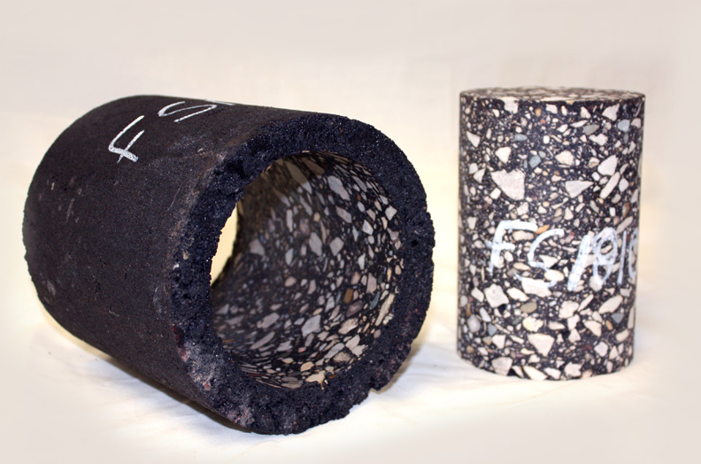
Figure 9. Photo. Dynamic modulus specimen cored and trimmed from a larger gyratory specimen.
Table 4 summarizes the major items of equipment needed to fabricate test specimens for dynamic modulus testing. Fabricating dynamic modulus specimens for R²AMs does not require special equipment. Most of the equipment in Table 4 is readily available in laboratories equipped for asphalt mixture design and acceptance testing. The primary difference between preparing standard gyratory specimens for mix design and quality control and preparing gyratory specimens for dynamic modulus test specimens is the height of the specimens for dynamic modulus testing. AASHTO R 83, Standard Practice for Preparation of Cylindrical Performance Test Specimens Using the Superpave Gyratory Compactor (SGC), specifies a minimum height of 160 mm for the gyratory specimens that dynamic modulus test specimens are prepared from. Not all gyratory compactors can compact 160 mm or taller specimens. The taller specimens require larger batches of mixture. The batch size for preparing dynamic modulus specimens is about 1.4 times that required for standard gyratory specimens; therefore, larger pans are needed for batching and short-term conditioning. The bucket mixers that are common in many asphalt mixture laboratories or 20 qt planetary mixers have enough capacity to mix the larger batches. Equipment suppliers have developed equipment for coring the dynamic modulus test specimen from the larger gyratory specimen; Figure 10 is an example from one manufacturer. Clamps for standard masonry saws are commercially available to hold the cored specimen when trimming the ends to provide flat, parallel ends. Figure 11 is an example from one manufacturer.

Table 4. Equipment for dynamic modulus specimen preparation.
Item | Details | Reference
Aggregate Preparation Equipment  (Lab Prepared Mixture) | Mechanical sieve shaker, sieves, and pans for separating aggregates into appropriate size fractions for batching. | Asphalt Institute MS-2
Mixture Preparation Equipment  (Lab Prepared Mixture) | Thermometers, balances, ovens, pans, 20 qt mechanical mixer, and miscellaneous hand tools for preparing asphalt mixtures. | Asphalt Institute MS-2
Splitting Equipment  (Plant Produced Mixture) | Mechanical splitter and associated equipment for reducing plant mix samples to the appropriate size. | AASHTO R 47
Superpave Gyratory Compactor | Superpave gyratory compactor and associated equipment for compacting specimens to a specified height. Make sure the gyratory compactor can prepare specimens to a height of 160 mm or greater. | AASHTO T 312
Conditioning Oven | Forced draft oven for short-term conditioning laboratory prepared asphalt mixtures. | AASHTO R 30
Core Drill | Air- or water-cooled diamond core drill with 100 mm diameter bit and 150 mm diameter gyratory specimen holder. | AASHTO R 83
Masonry Saw | Air- or water-cooled diamond saw with cutting depth of at least 100 mm. A 100 mm diameter specimen holder. | AASHTO R 83
Bulk Specific Gravity Equipment | Balances, water bath, suspension apparatus, oven and when testing specimens with interconnected voids or water absorption exceeding 2 percent a vacuum sealing device and accessories. | AASHTO T 166, AASHTO T 331
Maximum Specific Gravity Equipment | Balances, water bath, suspension apparatus, oven, vacuum system, mechanical shaker, vacuum bowl or pycnometer. | AASHTO T209
Specimen Dimension Measuring Equipment | Square, feeler gauges or wire, metal ruler, and calipers | AASHTO R 83

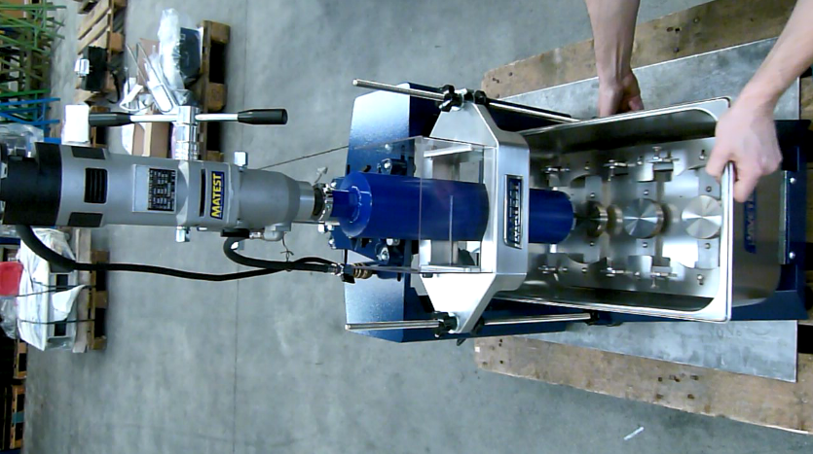
Figure 10. Photo. Commercial specimen coring system.
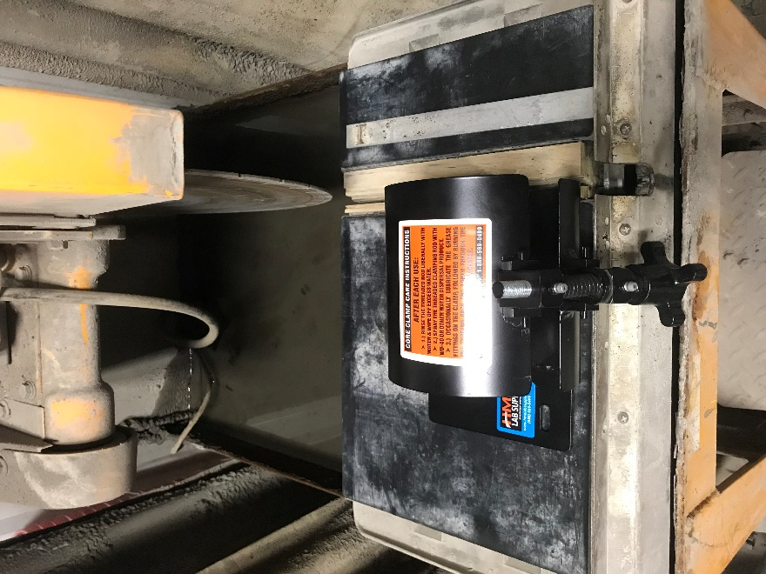
Figure 11. Photo. Commercial core clamp for trimming asphalt specimens.

2.2.2 Dynamic Modulus Testing Equipment
Table 5 summarizes the major items of equipment needed to perform dynamic modulus testing. Dynamic modulus testing requires a servo-hydraulic testing machine with a temperature control chamber, specimen mounted deformation sensors and appropriate loading platens and end friction reducers. The control and data acquisition software for the testing machine must have the ability to automatically adjust the load to achieve the target strain levels specified in the testing procedures.

The load capacity of the testing machine and the range of the temperature control chamber depends on which dynamic modulus test procedure is used. AASHTO R 84 / AASHTO T 378 specify using the AMPT shown in Figure 12, which was developed to perform dynamic modulus and permanent deformation testing to compliment volumetric mix design. The AMPT standards specify testing over the range from 4 to 45 °C. As shown in Table 5, the load capacity of the AMPT is less than that for the general-purpose servo-hydraulic machine required to perform AASHTO T 342 over the temperature range of -10 to 54.4 ⁰C. Figure 13 is a photograph of a general-purpose servo hydraulic machine capable of performing AASHTO T 342. The cost of the AMPT is lower than that for a general-purpose machine because the load capacity is lower and temperature range for the AMPT is more limited. Dynamic modulus testing throughput can be increased dramatically by having additional environmental chambers for conditioning test specimens to the testing temperatures. One or two hours may be required for the test specimen to equilibrate to the testing temperature depending on how much the specimen needs to be heated or cooled. With separate chambers for temperature conditioning, dynamic modulus testing on some specimens can proceed while others are conditioning to the next test temperature.
Table 5. Equipment for dynamic modulus testing.
Item | AASHTO R 84 / T 378 | AASHTO T 342
Closed-loop, Servo-hydraulic Testing Machine | 13.5 kN capacity.  Static and dynamic loading to 25 Hz. | 25 kN capacity.  Static and dynamic loading up to 25 Hz.
Temperature Control Chamber | Range from 4 to 70 °C with stability of ±0.5 °C. | Range from -10 to 60 °C with stability of ±0.5 °C
Specimen Mounted Deformation Sensors | Rapid mount system. Examples in Figure 14 and 915.  70 mm gauge length  Range of ±0.5 mm with 0.0002 mm resolution. | Guide rod system shown in Figure 16. 100 mm gauge length.  Range of ±0.5 mm with 0.0010 mm resolution.
Loading Platens | High strength aluminum 105 to 108 mm diameter.  Bottom platen fixed. Top platen able to rotate on spherical seat. | Hardened steel or anodized high strength aluminum 104.5 ± 0.5 mm diameter.
End Friction Reducers | One 0.25 mm thick PTFE (Polytetrafluoroethylene) sheet or two 0.3 mm thick latex membranes separated with silicone grease. | Two PTFE sheets or two 0.5 mm thick latex membranes separated with silicone grease.

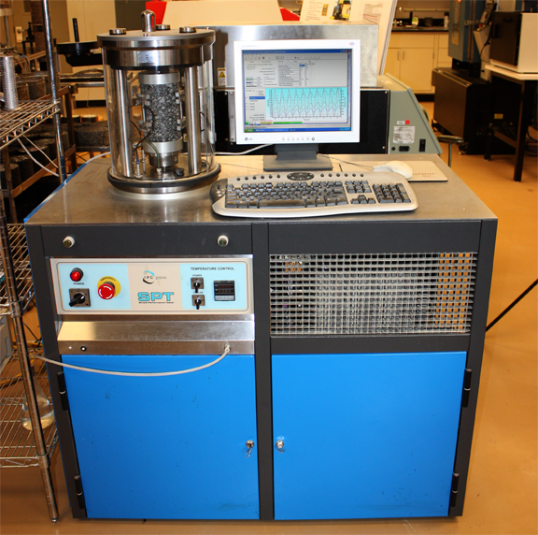
Figure 12. Photo. Typical AMPT for dynamic modulus testing per AASHTO R 84 and AASHTO T 378.
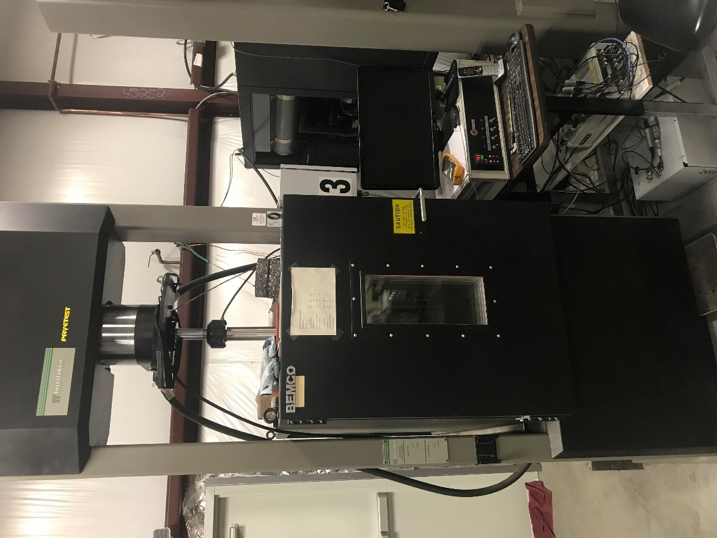
Figure 13. Photo. Typical general-purpose servo-hydraulic testing machine for dynamic modulus testing per AASHTO T 342.
AASHTO T 378 and AASHTO T 342 use different instrumentation to measure specimen deformations and calculate strains. Both procedures use instrumentation attached to gauge points that are glued to the specimen. In AASHTO T 378, the distance between gauge points is 70 mm. AMPT manufacturers have developed mechanical or magnetic mounting systems to rapidly attach either LVDTs or strain gauge extensometers to the gauge points. Figure 14 and Figure 15 show examples of specimen mounted instrumentation used in two AMPTs. In AASHTO T 342, the distance between gauge points is 100 mm, and a guide rod is used to maintain alignment of the upper- and lower-gauge points. The AASHTO T 342 instrumentation uses small screws to attach the linear variable differential transformers (LVDTs) to the gauge points. Figure 16 shows an example of specimen mounted instrumentation meeting the requirements for AASHTO T 342.
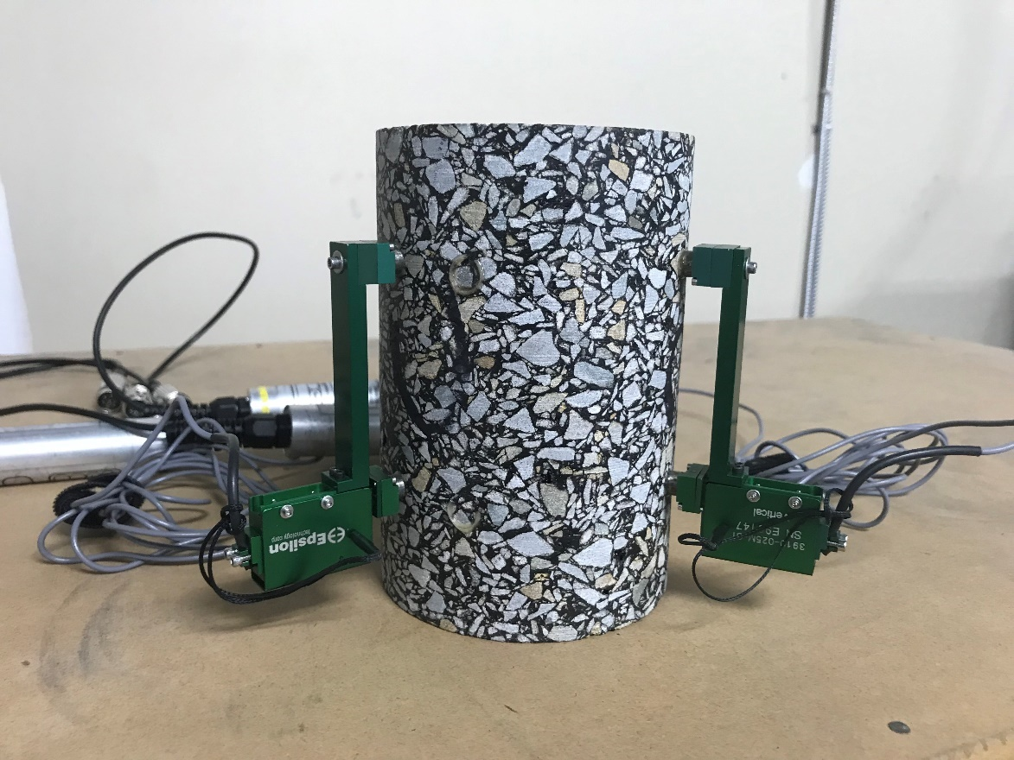
Figure 14. Photo. Example of AMPT magnetic mount for specimen deformation sensor.
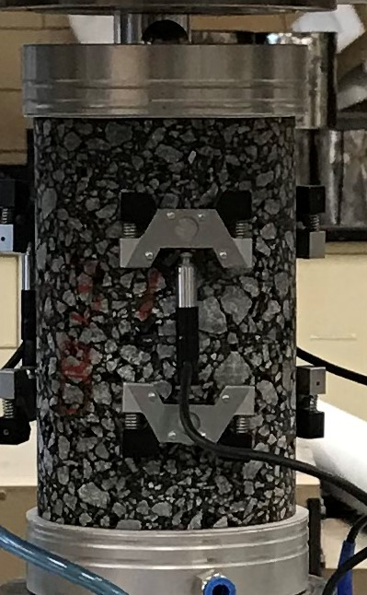
Figure 15. Photo. Example of AMPT mechanical mount for specimen deformation sensor.
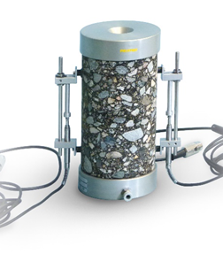
Figure 16. Photo. Example of AASHTO T 342 specimen deformation sensor.
Both AASHTO T 342 and AASHTO T 378 use loading platens that are a little larger than the test specimen. The upper loading platen should be free to rotate to accommodate slightly non-parallel specimens ends by loading through a ball in a spherical seat as shown in Figure 16. The dynamic modulus specimen height to diameter ratio of 1.5 requires the use of friction reducers between the specimens and the loading platens to minimize shear forces at the ends of the specimen. Both procedures permit the use of either Polytetrafluoroethylene (PTFE) sheets or two sheets of latex separated by silicone grease. Most dynamic modulus testing is conducted with the PTFE sheets because they are more convenient to use.

2.3 Procedures

2.3.1 Specimen Fabrication Procedure
Specimen fabrication is a critical part of dynamic modulus testing and the procedure has been standardized in AASHTO R 83. The objective when preparing specimens for dynamic modulus or other performance testing is to produce a specimen that is representative of the asphalt mixture in an actual pavement. This involves reproducing the composition, density and short-term aging of the compacted mixture, and fabricating a uniform specimen of appropriate size and shape to ensure uniform states of stress and strain during the testing. Specimen fabrication is the most time-consuming part of dynamic modulus testing and requires careful attention to detail. The sections below review the four critical aspects of specimen fabrication: (1) mixture preparation, (2) loose mix conditioning, (3) compaction, and (4) coring and sawing, emphasizing special considerations for R²AMs.

2.3.1.1 Mixture Preparation
The size of standard dynamic modulus specimens, 100 mm diameter by 150 mm tall, requires the specimens to be fabricated either from lab or plant produced loose mix rather than cored from a pavement layer. The specimen size was established in a comprehensive specimen size and geometry study (Witczak, et. al., 2000). Although smaller specimens can be used for dynamic modulus testing and an Appendix addressing small specimens is included in AASHTO T 378, the larger 100 mm diameter by 150 mm tall specimen is the standard to allow the same specimen to be used for dynamic modulus and flow number or repeated load permanent deformation testing. The test specimens are cored and trimmed from larger 150 mm diameter by at least 160 mm tall gyratory specimens; therefore, between 6,000 and 8,000 g of mixture per specimen will be needed depending on the specific gravity of the aggregate and the height of gyratory specimens used. As outlined in AASHTO R 83, the height of the gyratory specimens should be selected to minimize air void gradients in the test specimen.

For laboratory prepared mixtures, the batching and mixture preparation procedures outlined in MS-2 (Asphalt Institute, 2015) should be followed using the larger batch sizes discussed above. Appendix X2 of AASHTO R 35 provides recommended practices for laboratory preparation of WMA mixtures to reasonably replicate several WMA processes. The preparation of laboratory loose mix of R²AMs is generally the same as that for virgin mixtures with the following exceptions. First, for mixtures incorporating RAP or RAS, the RAP or RAS should not be heated with the virgin aggregates, which are often heated overnight. Instead, the RAP or RAS should be heated in an oven set to the mixing temperature for 1.5 to 3.0 hours, then combined with the virgin aggregates during the aggregate dry mixing step. This is done to avoid excessive heating of the RAP or RAS which may alter the properties of the recycled binder (West, et. al., 2013). A mechanical mixer should be used when preparing the larger batches needed for dynamic modulus testing. This is particularly important with RAP and RAS mixtures to ensure homogeneous mixing of the recycled materials in the mixture. For mixtures incorporating a binder with GTR, the binder must be stirred often during the mixture preparation process because these binders are not storage stable and rubber particles will tend to separate and sink to the bottom when the binder is in a fluid state.

No special handling is needed for the preparation of specimens from plant mix samples of R²AMs. Like other mixtures, these should be reheated to the compaction temperature in an oven set at the compaction temperature.

2.3.1.2 Loose Mix Conditioning
The MEPDG specifies that laboratory prepared loose mix should be short-term conditioned in accordance with AASHTO R 30, Standard Practice for Mixture Conditioning of Hot-Mix Asphalt (HMA), for 4 hours at 135 °C to “To account for short-term aging that occurs during mixing and compaction…” (Applied Research Associates, 2004). Additionally, the binder viscosity-temperature relationship used for the shift factors for the master curve should be obtained from test data for binder short-term conditioned in the Rolling Thin Film Oven Test (RTFOT) in accordance with AASHTO T 240, Standard Method of Test for Effect of Heat and Air on a Moving Film of Asphalt (Rolling Thin-Film Oven Test) (Applied Research Associates, 2004). RTFOT conditioning of asphalt rubber binders produced to meet ASTM D6114, Standard Specification for Asphalt-Rubber Binder may not be possible because these binders do not form a film during RTFOT conditioning and often crawl out of the bottles during conditioning. For these binders short-term aging should be done using the Thin Film Oven Test, AASHTO T 179, Standard Method of Test for Effect of Heat and Air on Asphalt Materials (Thin-Film Oven Test). For mixtures incorporating RAP, the binder properties should be measured on binder recovered from the mixture after short-term oven conditioning. The extraction and recovery should be performed in accordance with AASHTO R 59, Standard Practice for Recovery of Asphalt Binder from Solution by Abson Method.

Plant produced mix samples should not receive any additional conditioning; they should be reheated to the compaction temperature in an oven set at the compaction temperature. For plant produced mix samples incorporating RAP, binder properties should be measured on binder recovered from the mixture after heating to the compaction temperature.

2.3.1.3 Compaction
Specimens for dynamic modulus testing are prepared by compacting a 150 mm diameter gyratory specimen to a target height between 160 and 180 mm then the 100 mm diameter test specimens is cored from the middle of the larger gyratory specimens and the ends of the core are trimmed to produce the 150 mm tall test specimen. The target gyratory specimen height for a laboratory’s compaction equipment is determined experimentally to minimize air void gradients in the final test specimen. The target air void content for the larger gyratory specimens to produce final test specimens meeting the air void tolerance is determined by trial and error. It is typically 1.0 to 1.5 percent higher than the target air void content for the test specimens because the sides and ends of the gyratory specimen have higher air voids compared to the middle. The air void content of the gyratory specimen and the test specimens is controlled by compacting the appropriate mass of mixture to a target height. For a typical test specimen air void content of 7 percent, the number of gyrations to reach the target height will vary from about 10 to 50 depending on the properties of the mixture. No special procedures are needed when compacting R²AMs.

2.3.1.4 Coring and Sawing
To prepare the test specimens, a 100 mm diameter core is drilled from the middle of the 150 mm diameter gyratory specimen, then the ends of the core are trimmed to produce a 150 mm tall test specimen. Mixture with GTR modified binder, mixtures with polymer modified binder, and high binder content mixtures require special attention during coring because the binder tends to smear and bind the core drill. This can be reduced by: (1) increasing the flow of water to improve cooling at the cutting surface and more rapidly flush cuttings as the bit advances, (2) reducing the force being applied to advance the bit, and (3) periodically backing the bit out to allow the water to better remove cuttings from the cylinder being formed by the bit.

Test specimens should be measured for compliance with the tolerances for diameter, height, end flatness, and end perpendicularity listed in AASHTO R 83. Laboratory procedures that yield acceptable dynamic modulus specimens for virgin mixtures will also produce acceptable specimens for R²AM.

2.3.2 Dynamic Modulus Testing Procedure
Modern computer-controlled, servo-hydraulic testing equipment makes dynamic modulus testing relatively easy to perform. Testing equipment suppliers have developed control and data acquisition software to perform testing in accordance with the two dynamic modulus testing procedures: AASHTO T 378 and AASHTO T 342. Once the sample is instrumented and placed in the testing equipment, the software performs the testing per the applicable standard, collects the resulting load and displacement data, and calculates and reports the dynamic modulus and phase angle per the algorithm that is the same in the two procedures. The software also calculates and reports six data quality indicators that technicians and engineers conducting dynamic modulus testing or using the dynamic modulus data should review to ensure that quality dynamic modulus data have been collected and reported. Additionally, equipment suppliers have developed devices to quickly and accurately mount the gauge points. For AASHTO T 378, equipment suppliers have designed deformation sensors that are easy to install. The sections below review the four critical aspects of dynamic modulus testing: (1) instrumentation, (2) temperature selection and control, (3) proper use of end friction reducers, and (4) review of data quality indicators, pointing out special considerations for R²AMs.

2.3.2.1 Instrumentation
Dynamic modulus testing requires deformation sensors to be mounted on the test specimens. For both AASHTO T 378 and AASHTO T 342, the sensors are mounted to gauge points that are glued to the test specimen. As discussed above, gauge point mounting devices are available for accurately locating the gauge points. The technician that instruments the specimen should make sure that the gauge points are being attached at representative locations on the specimen. Additionally, if the coring smeared binder on the surface of the specimen, the excess binder should be scraped off at the locations where the gauge points will be mounted. This is most likely to be an issue for mixtures with GTR or polymer modified binder, or mixtures with high binder content.

2.3.2.2 Temperature Selection and Control
AASHTO R 84 and AASHTO T 342 specify the temperatures and loading frequencies to be used for dynamic modulus testing. These testing conditions are summarized in Table 6. The primary concern with AASHTO T 342 testing is movement of the gauge points when testing at 54.4 °C under the weight and force of the deformation sensors which produces erroneous results. This is particularly problematic for mixtures with softer binder grades. The temperatures in AASHTO R 84 were selected to minimize this problem by linking the highest test temperature to the binder grade: (1) 35 °C for PG 58-XX and softer binders, (2) 40 °C for PG 64-XX and PG 70-XX binders, and (3) 45 °C for PG 76-XX and stiffer binders. When testing R²AMs using AASHTO R 84, the upper testing temperature should be selected based on the expected stiffness of the binder in the mixture. The high-test temperature for mixtures with GTR modified binders produced to meet ASTM D 6114 should be 45 °C. Mixtures with GTR modified binders formulated to meet performance grading requirements should be tested at the high-test temperature from Table 6 for the performance grade of the binder. For mixtures incorporating RAP, the high temperature performance grade increases about 6 °C for each 15 percent of the binder in the mixture replaced with RAP binder. The increase for RAS is approximately 6 °C for each 7 percent of the binder replaced with RAS binder.

Temperature control is critical in dynamic modulus testing. A monitoring specimen with a thermocouple or resistance temperature detector (RTD) mounted at the center should be used to determine the temperature of the specimens. The test specimens and the monitoring specimen must be subjected to the same thermal history during conditioning and testing.

Table 6. Temperatures and loading frequencies for dynamic modulus master curve testing.
Condition | AASHTO R 84 | AASHTO T 342
Temperature, °C | 4, 20, and 35, 40, or 45 depending on binder grade | -10, 4.4, 21.1, 37.8, and 54.4
Loading Frequency, Hz | 10, 1, and 0.1; additionally, 0.01 at the high temperature only | 25, 10, 5, 1.0, 0.5, and 0.1

2.3.2.3 End Friction Reducers
End friction reducers are required during dynamic modulus testing to reduce friction and shear forces at the loading platens that result in non-uniform stresses in the specimen. Either a PTFE sheet or two latex membranes separated by silicone grease should be used as friction reducers at each end of the specimen. There are no special considerations for end friction reducers for R²AM specimens.

2.3.2.4 Data Quality Indicators
The data quality indicators should be reviewed after each dynamic modulus test to ensure quality measurements have been made. This is good laboratory practice and not a special requirement for R²AMs. Reviewing the data quality indicators after each test allows tests to be repeated while the sample is still at the test temperature. A brief review of the data quality indicators is presented below:

- Deformation Drift. During dynamic modulus testing, a compressive load is applied to the specimen; therefore, some permanent compressive deformation occurs in the specimen. This deformation, called deformation drift, is removed as part of the algorithm for calculating the dynamic modulus and phase angle. If the deformation drift is not in the compression direction, it indicates the gauge points are moving apart under the weight of the deformation measuring equipment or the spring forces in the deformation measuring equipment. The resulting deformations and strains calculated from those deformations are in error. When reverse deformation drift occurs, the test temperature should be reduced to minimize the drift.

- Peak to Peak Strain. The target strain for the dynamic modulus test is 100 µstrain. The dynamic modulus test procedures provide ranges for the applied strains to minimize within and between laboratory variations. AASHTO T 378 specifies strains between 75 and 125 µstrain, while AASHTO T 342 specifies strains between 50 and 150 µstrain. The larger range in AASHTO T 342 is due to the wider temperature range used. At -10 °C it may not be possible to apply enough load to reach the target of 100 µstrain. Conversely at 54.4 °C, the applied load needed to produce 100 µstrain in the specimen may be less than the control capabilities of the equipment. The loads should be increased or decreased to maintain strains within the specified tolerances.

- Standard Error of the Load. The standard error of the load measures how well the load approximates sinusoidal loading. Load standard errors greater than 10 percent indicate the tuning of the servo-hydraulic control is not appropriate for the specimen being tested. Since dynamic modulus tests are conducted in load control, the specimen becomes part of the control loop. Stiffer specimens require less proportional gain, softer specimens require greater proportional gain.

- Deformation Standard Error. The deformation standard error measures how well the strain response approximates sinusoidal loading. The maximum recommended deformation standard error is 10 percent. If the load standard error is high the deformation standard error will also be high, and the adjustments made to correct the load standard error will also reduce the deformation standard error. There are, however, reasons that the deformation standard error may be high when the load standard error is low. The most likely reasons are loose gauge points, and damaged deformation sensors or cabling.

- Deformation Uniformity. The deformation uniformity indicates whether deformations measured at different locations around the specimen are the same. The deformation uniformity should be less that 30 percent. Deformations may vary greatly due to specimen effects like segregation, difference in air voids across the specimen, or non-parallel specimens ends; or instrumentation effects like loose gauge points or damaged deformation sensors or cabling.

- Phase Uniformity. The phase uniformity indicates whether phase angles measured at different locations around the specimen are the same. The phase uniformity should be less than 3 degrees. The measured phase angle may vary due to specimen effects like segregation, difference in air voids across the specimen, or non-parallel specimens ends; or instrumentation effects like loose gauge points or damaged deformation sensors or cabling.

2.4 Data Analysis
For pavement design, constructing a master curve is the primary analysis performed on dynamic modulus data. The widespread availability of nonlinear optimization software like the Solver function in Microsoft Excel has made dynamic modulus master curve construction routine. Dynamic modulus master curve construction is performed within Pavement ME Design software using data collected in accordance with AASHTO T 342. This section discusses using the MasterSolver workbook developed in NCHRP Project 9-29 and referenced in AASHTO R 84 to construct a dynamic modulus master curve from data collected with an AMPT. Since Pavement ME Design software requires data at temperatures and loading frequencies not usually collected during AMPT testing, a master curve is constructed from the AMPT data and used to calculate dynamic modulus values at the temperatures and loading frequencies required by Pavement ME Design.

Data collected with the AMPT in accordance with AASHTO R 84 includes measurements of dynamic modulus and phase angle for the 10 combinations of temperature and loading frequency given previously in Table 6 for multiple test specimens. These data along with the corresponding test temperatures, loading frequencies, and voids in the mineral aggregate (VMA) and voids filled with asphalt (VFA) of the specimens tested are inputs to the MasterSolver workbook. Using these data, MasterSolver first estimates the limiting maximum dynamic modulus for the mixture using the Hirsch model (Christensen, et. al., 2003) with a binder shear modulus of 1 GPa. MasterSolver then uses the Solver function in Microsoft Excel to simultaneously optimize the fitting parameters of the dynamic modulus master curve equation (see Figure 6), and the Arrhenius shift factor equation, (see Figure 7). Finally, MasterSolver uses the fitted dynamic modulus master curve and shift factors to calculate the dynamic modulus at the temperatures and loading frequencies required by Pavement ME Design.
MasterSolver is an Excel workbook that includes five spreadsheets with the names given in parentheses below:
- Data entry spreadsheet (DATA).
- Spreadsheet to perform the master curve fitting (FIT).
- Summary report spreadsheet (REPORT).
- Spreadsheet with moduli for the temperatures and frequencies required by the Pavement ME Design (MEPDGINPUT).
- Instructions spreadsheet (README).

The units in MasterSolver are: (1) temperature in °C, (2) frequency in Hz, (3) dynamic modulus in ksi, and (4) phase angle in degrees. The five spreadsheets are in the order that they are used in a typical analysis. A brief description of each of the spreadsheets is given below. Screen shots of the spreadsheets are provided in the example in Section 2.5.4.

DATA Spreadsheet
All data needed to develop a master curve are input in the blue highlighted cells in the DATA spreadsheet. The data spreadsheet includes cells for entering descriptive data and test data. The descriptive data include: (1) project, (2) mix identification, (3) date, (4) technician, (5) sample description, and (6) notes. These descriptive data are used in the various reports generated by MasterSolver. The test data include: (1) sample VMA and VFA for computing the limiting maximum modulus, (2) the reference temperature to be used for constructing the dynamic modulus master curve (usually 20 °C), (3) test temperatures in °C, (4) loading frequencies in Hz, (5) measured dynamic modulus data in ksi, and (6) measured phase angle data in degrees. MasterSolver allows data for up to three test specimens to be entered. If only 1 or 2 specimens are tested, leave the cells for the specimens not tested blank.

FIT Spreadsheet
This spreadsheet includes: (1) the computation of the limiting maximum modulus using the Hirsch model and the average VMA and VFA of the specimens tested, and (2) fitting the dynamic modulus master curve and shift factors. A button is provided to execute the Solver function tool to minimize the sum of the squared errors between the measured dynamic modulus values and the dynamic modulus values calculated using the master curve and shift factor equations. The initial estimates of the master curve and shift factor parameters provided in the FIT spreadsheet will provide convergence for a wide range of mixtures. After Solver performs the optimization, the final values of the master curve and shift factor parameters are returned. The quality of the fitting is best evaluated using the next spreadsheet, REPORT.

REPORT Spreadsheet
This spreadsheet provides the output of the optimized master curve and shift factors from the FIT spreadsheet. It includes the measured data, the optimized master curve and shift factor parameters, plots of the dynamic modulus master curve, the shift factors, and the phase angle master curve. The report spreadsheet also provides two measures of the quality of the fitting. The first is the R² value which is the explained variance and the second is the ratio of the standard error of estimate to the standard deviation of the measured data, Se/Sy. Good quality master curves will have R² greater than 0.99 and Se/Sy less than 0.05. Additionally, the dynamic modulus and phase angle master curves should be inspected. The measured dynamic modulus data should plot closely around the fitted master curve and exhibit a leveling off at high and low reduced frequencies. Figure 17 shows a typical high-quality dynamic modulus master curve fitted using MasterSolver. The measured phase angles should form a continuous function which exhibits a peak as shown in Figure 18.

Figure 17. Graph. Typical good quality dynamic modulus master curve.
Figure 18. Graph. Variation of phase angle with reduced frequency for good quality fitting of a dynamic modulus master curve.

MEPDGINPUT Spreadsheet
This spreadsheet uses the fitted master curve to compute and report dynamic modulus values at the temperatures and frequencies required by Pavement ME Design. Dynamic modulus values are computed for 30 combinations of temperature and frequency. The temperatures range from -10 to 54.4 °C and the frequencies range from 0.1 to 25 Hz.

2.5 Example
This section presents a complete example of dynamic modulus specimen fabrication, testing, and analysis using data from the North Carolina high recycled binder content mixture. This was a mixture sampled at the asphalt plant and was produced with a combination of RAP and RAS. It has 40 percent of the binder replaced with recycled binder. The RAP contributed approximately one-half of the recycled binder and the RAS contributed the other half. The virgin binder was a PG 58-28.

2.5.1 Step 1. Select Number of Specimens, Target Air Void Content, and Testing Temperatures
The number of specimens tested depends on the desired accuracy for the analysis. The standard deviation (or coefficient of variation) of the mean of multiple measurements is equal to the standard deviation (or coefficient of variation) of the measurements divided by the square root of number of samples tested. The coefficient of variation for dynamic modulus measurements varies from about 5 to 25 percent depending primarily on the stiffness of the specimen. It is higher for lower dynamic modulus values and larger nominal maximum aggregate size mixtures. A good typical value for selecting the number of specimens to test is 15 percent. Table 7 summarizes the coefficient of variation of the mean as a function of the number of samples tested using a typical value of 15 percent for the coefficient of variation of dynamic modulus tests. Testing as few as two specimens reduces the coefficient of variation of the mean to about 10 percent. For this example, two specimens were selected.
Table 7. Typical coefficient of variation of the mean of dynamic modulus tests on multiple specimens.
Specimens | Coefficient of Variation of the Mean, %
1 | 15.0
2 | 10.6
3 | 8.7
4 | 7.5
5 | 6.7

Dynamic modulus specimens for pavement design should be compacted to an air void content representative of in-service pavements. A target air void content of 7 percent is usually used for dynamic modulus testing based on typical specifications for in-place compaction.

AASHTO R 84 recommends testing at three temperature: 4 °C, 20 °C, and a high temperature based on the high temperature grade of the binder in the mixture. For mixtures incorporating RAP, the high temperature performance grade increases about 6 °C for each 15 percent of the binder in the mixture replaced with RAP binder. The increase for RAS is approximately 6 °C for each 7 percent of the binder replaced with RAS binder. The North Carolina binder mixture has about 20 percent of the binder replaced with RAP and about 20 percent of the binder replaced with RAS. This increases the high temperature grade of the virgin binder in the mixture by about 25 °C (20/15*6 + 20/7*6= 25.1). Adding 25 to the high temperature grade of the virgin PG 58 binder yields PG 83; therefore, the high temperature for testing was 45 °C.

2.5.2 Step 2. Specimen Fabrication
Specimen fabrication involves several steps: (1) trial specimen air void analysis, (2) final specimen compaction, (3) sawing and coring, and (4) dimensional analysis. The mixture conditioning used in specimen preparation depends on how the mixture was produced. For laboratory prepared mixtures, the lab mix is prepared in accordance with AASHTO T 312 and conditioned for 4 hours at 135 °C in accordance with AASHTO R 30. For plant mixtures, the plant mix is reheated to the compaction temperature in an oven set at the compaction temperature.

The first step in specimen fabrication is to prepare a trial test specimen and measure the air void content of the trial test specimen. The gyratory specimen from which the test specimen is cored and sawed should be prepared to the height determined from an air void uniformity analysis performed in accordance with the Appendix X2 of AASHTO R 83. For the equipment used in this example, the air void uniformity analysis yielded a height of 175 mm. The gyratory specimens should be prepared to an air void content that is 1.0 (fine mixtures) to 1.5 (coarse mixtures) percent higher than the target air void content for the test specimens. Knowing the gyratory specimen height, the target air void content, and the maximum specific gravity of the mixture, the estimated mass of mixture for the trial gyratory specimen can be computed using the equation in Figure 19.

$$GSM_{Trial}=\frac{\left(100-Air Voids\right)}{100}×Gmm×176.71×h$$
where:
GSM_{Trial} = trial gyratory specimen mass, g
Air Voids = target gyratory specimen air voids, %
Gmm = mixture maximum specific gravity
h = gyratory specimen height determined from an air void uniformity analysis, cm
Figure 19. Equation. Equation for estimating the mass of mixture for trial specimens to target a specified air void content.
The maximum specific gravity of the North Carolina binder mixture used in this example was 2.526. For a target gyratory specimen air void content of 8 percent and a gyratory specimen height of 17.5 cm, the resulting trial gyratory specimen mass was 7,186.5 g. A trial gyratory specimen was prepared using this mass and compacted to a height of 175 mm. Since plant mix was used, the plant mix was reheated to 135 °C for compaction. The 100 mm diameter by 150 mm tall test specimen that was sawed and cored from the middle of the trial gyratory specimen yielded an air void content of 6.3 percent, which is outside of the test specimen air void tolerance of 6.5 to 7.5 percent. A second trial gyratory specimen was prepared to a height of 175 mm using a linearly adjusted mass from the Equation in Figure 20.

$$GSM_{Adjusted}=\left[\frac{\left(100-T\arg{e}t Air Voids\right)}{\left(100-Measured Air Voids\right)}\right]×GSM_{Trial}$$
where:
GSM_{Adjusted} = adjusted gyratory specimen mass, g
GSM_{Trial} = trial gyratory specimen mass, g
Target Air Voids = target test specimen air voids, %
Measured Air Voids = measure air voids of the trial test specimen %
Figure 20. Equation. Equation for adjusting the gyratory specimen mass when trial specimens are outside the air void tolerance.
The adjusted mass was 7,079.5 g resulting a test specimen with an air void content of 7.2 percent. A third specimen was prepared using 7,079.5 g yielding an air void content of 6.9 percent.

Table 8 summarizes the properties of the test specimens and compares them to the tolerances in AASHTO R 83. The end flatness and end perpendicularity measurements are go-no-go measurements that are made using a square and appropriate diameter wire as shown in Figure 21 and Figure 22. The test specimens used in this example were fabricated using a double-bladed saw. Acceptable test specimens can also be produced using a single bladed saw and an appropriate clamping system.
Table 8. Properties of the dynamic modulus test specimens for the North Carolina binder mixture.
Item | Specimen 1 | Specimen 2 | AASHTO R 83 Tolerance
Air Void Content | 7.2 | 6.9 | *
Average Diameter, mm | 100.1 | 100.1 | 98 to 104
Standard Deviation of Diameter, mm | 0.2 | 0.2 | <0.5
Height, mm | 150.0 | 150.0 | 147.5 to 152.5
End Flatness, mm | Ok | Ok | <0.5
End Perpendicularity, mm | Ok | Ok | <1.0
* AASHTO R 83 does not specify an air void tolerance. Target ±0.5 % is typically used

2.5.3 Step3. Dynamic Modulus Testing
Using the AMPT, dynamic modulus testing is relatively easy to perform. The software guides the user through the specimen set-up and testing, and automatically adjusts the load applied to the specimen to achieve strains between 75 and 125 micro strain as specified in AASHTO T 378. The sections below address important aspects of testing that are not controlled by the software.

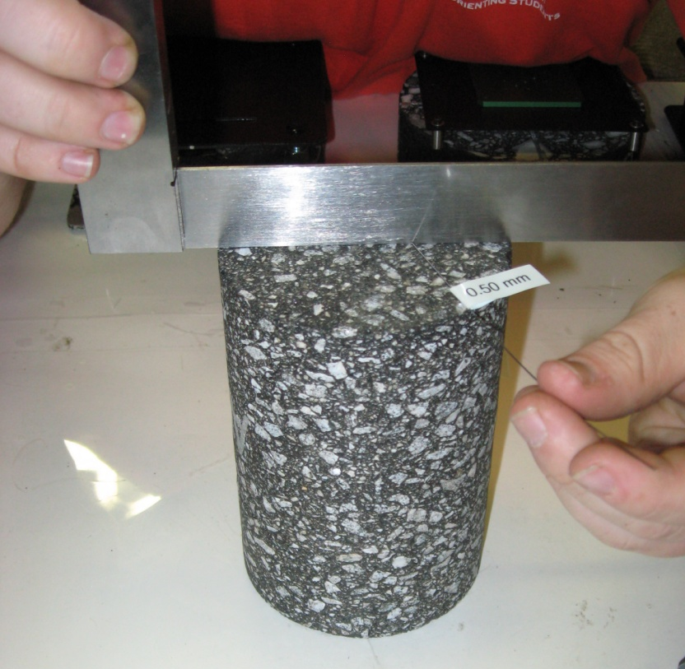
Figure 21. Photo. Measurement of end flatness.

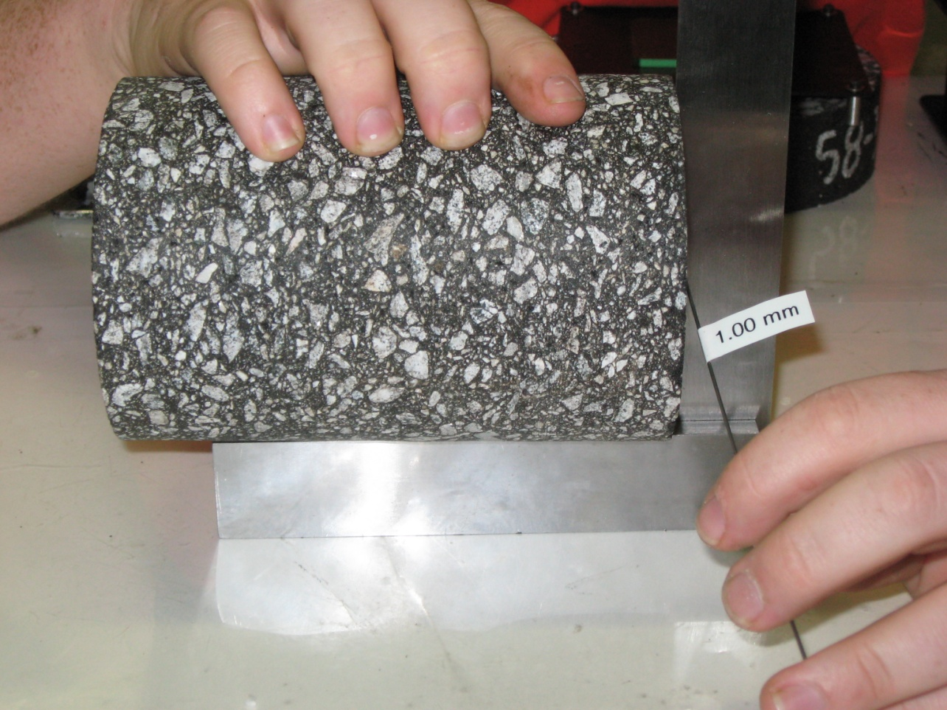
Figure 22. Photo. Measurement of end perpendicularity.

- Sequence of Testing. The recommended sequence of testing is to start testing at the lowest temperature and proceed to the highest temperature. At each temperature, the frequencies should be applied starting from the highest frequency and proceeding to the lowest. Table 9 gives the recommended sequence of testing for the temperatures and frequencies for dynamic modulus testing in accordance with AASHTO R 84.
Table 9. Recommended sequence of dynamic modulus testing.
Number | Temperature, °C | Frequency, Hz | Initial Dynamic Modulus, ksi | Initial Dynamic Modulus, MPa
1 | 4 | 10 | 1600 | 11000
2 | 4 | 1 | 1200 | 8300
3 | 4 | 0.1 | 800 | 5500
4 | 20 | 10 | 700 | 4800
5 | 20 | 1 | 400 | 2800
6 | 20 | 0.1 | 200 | 1400
7 | 35, 40, or 45¹ | 10 | 150 | 1000
8 | 35, 40, or 45¹ | 1 | 80 | 550
9 | 35, 40, or 45¹ | 0.1 | 40 | 280
10 | 35, 40, or 45¹ | 0.01 | 30 | 210
¹ High temperature depends on binder grade

- Initial Modulus Values. The AMPT software requires the user to input an initial estimate of the dynamic modulus for each of the testing conditions. This initial modulus value is used by the software to start the trial and error process for finding the load that results in strains between 75 and 125 micro strain. Table 9 presents recommended initial modulus values for the temperatures and loading frequencies specified in AASHTO R 84.

- Temperature Control. Proper control of temperature is critical when testing asphalt mixtures. The AMPT software controls the temperature in the testing chamber; however, the testing chamber is only large enough to accommodate the specimen being tested. A separate environmental chamber is often used to condition the test specimens to the testing temperature. A monitoring specimen with a temperature probe mounted at the middle of the specimen is monitored to determine when the test specimens have reached the testing temperature. The test specimen is then transferred to the testing chamber. The specimen transfer, instrumentation, and rebound of the test chamber temperature must be completed within 5 minutes to minimize the changes in the test specimen temperature. If the 5-minute tolerance is exceeded, the specimen should be equilibrated again at the testing temperature before testing.

- Data Quality Indicators. Upon completion of testing at each temperature, the data quality indicators should be reviewed and compared to the tolerances given in AASHTO T 378. Review of the data quality indicators before removing the test specimen allows the specimen or equipment to be adjusted, and the test repeated before removing the specimen from the testing chamber. If the testing chamber is opened to make adjustments, the time to open the chamber, make adjustments, close the chamber, and rebound of the chamber to the test temperature should not exceed 5 minutes. If the 5-minute tolerance is exceeded, the specimen should be equilibrated again at the testing temperature before proceeding. Table 10 summarizes the data quality indicators for the two specimens of the North Carolina Binder mixture tested in this example and compares them to allowable tolerances. The tolerances are shown in parentheses in the headers. All data quality indicators meet the recommended tolerances although some approach the recommended limits.
Table 10. Data quality indicators for the North Carolina binder mixture, with limits shown in parentheses.
ID | Temp.,  °C | Freq.,  Hz | Deformation Drift  (Compression) | Strain,  µm/m  (75 -125) | Load Standard Error,  %  (<10) | Deformation Standard Error,  %  (<10) | Deformation Uniformity,  %  (<30) | Phase Uniformity,  Degree  (<3)
S1 | 4 | 10 | Compression | 98.6 | 4.81 | 5.44 | 8.01 | 1.72
S1 | 4 | 1 | Compression | 94.3 | 3.87 | 4.49 | 4.45 | 1.95
S1 | 4 | 0.1 | Compression | 98.6 | 1.42 | 2.30 | 0.15 | 1.82
S1 | 20 | 10 | Compression | 104.3 | 6.15 | 6.37 | 19.42 | 2.5
S1 | 20 | 1 | Compression | 112.9 | 4.47 | 5.40 | 19.92 | 1.82
S1 | 20 | 0.1 | Compression | 91.4 | 1.49 | 4.52 | 25.25 | 0.78
S1 | 45 | 10 | Compression | 85.7 | 6.79 | 6.83 | 18.16 | 1.56
S1 | 45 | 1 | Compression | 111.4 | 4.81 | 7.67 | 21.86 | 0.66
S1 | 45 | 0.1 | Compression | 82.9 | 2.61 | 5.56 | 22.23 | 0.75
S1 | 45 | 0.01 | Compression | 81.4 | 3.64 | 8.50 | 17.17 | 0.73
S2 | 4 | 10 | Compression | 100.0 | 4.51 | 5.18 | 6.07 | 1.37
S2 | 4 | 1 | Compression | 94.3 | 4.63 | 5.42 | 4.05 | 1.41
S2 | 4 | 0.1 | Compression | 95.7 | 1.40 | 2.95 | 4.19 | 1.19
S2 | 20 | 10 | Compression | 112.9 | 6.34 | 5.87 | 11.74 | 1.09
S2 | 20 | 1 | Compression | 122.9 | 4.17 | 5.02 | 10.54 | 0.58
S2 | 20 | 0.1 | Compression | 91.4 | 1.45 | 3.13 | 12.29 | 0.41
S2 | 45 | 10 | Compression | 94.3 | 6.88 | 7.18 | 10.21 | 0.96
S2 | 45 | 1 | Compression | 111.4 | 4.49 | 7.45 | 16.86 | 2.43
S2 | 45 | 0.1 | Compression | 84.3 | 2.86 | 7.93 | 18.63 | 2.7
S2 | 45 | 0.01 | Compression | 115.7 | 2.69 | 6.20 | 20.99 | 1.51

2.5.4 Step 4. Data Analysis
The final step in dynamic modulus testing is to use the MasterSolver workbook to generate a dynamic modulus master curve for input in Pavement ME Design. The first step in the data analysis is to input the data for the specimens that were tested. Figure 23 shows the data input for the two specimens in the blue shaded cells. This includes the header information, VMA and VFA of the specimens, reference temperature of 20 °C for master curve, the test temperatures and frequencies, and the measured dynamic modulus and phase angle values.
Figure 23. Screen Shot. MasterSolver “Data” spreadsheet with data for the North Carolina binder mixture.
The second step is to execute the Solver function to fit the master curve. This is done by selecting the “Goto FIT” button on the DATA spreadsheet, and then selecting the “Solver Operation” button on the FIT spreadsheet. Figure 24 shows the FIT spreadsheet after the numerical optimization using Solver. The FIT spreadsheet shows the limiting maximum modulus that was calculated for the average VMA and VFA of the specimens, the fitted master curve parameters, several goodness of fit statistics, the measured data, and the fitted dynamic modulus values.

Although the FIT spreadsheet provides goodness of fit statistics, the quality of the fitted master is best reviewed using the REPORT spreadsheet. Figure 25 shows the REPORT spreadsheet for the North Carolina binder mixture. The REPORT spreadsheet repeats the data that was input to the DATA spreadsheet including: (1) the header data, (2) the reference temperature, (3) the average VMA and VFA of the test specimens, (4) the test temperatures and frequencies, and (5) the measured dynamic modulus and phase angle data. Below this information are the fitted master curve parameters, and goodness of fit statistics. Note the quality of the fitting for the North Carolina binder mixture. The R² is 0.998 and the ratio of the standard error to the standard deviation of the measured data (Se/Sy) is only 0.03. The last part of the REPORT spreadsheet are graphs showing: (1) the measured dynamic modulus data and the fitted master curve, (2) the shift factors as a function of temperature, and (3) the phase angle master curve. These are used to visualize how well the master curve fits the measured data. The examples in Figure 25 are typical of the fitting that can be expected for good quality data.

Figure 24. Screen Shot. MasterSolver FIT spreadsheet for the North Carolina binder mixture.
The last spreadsheet, MEPDGINPUT, provides the dynamic modulus data at the temperatures and frequencies specified in AASHTO T 342. These are calculated using the fitted master curve and shift factors and can be input directly into Pavement ME Design. Figure 26 is a screen shot of the MEPDGINPUT spreadsheet.

2.6 Summary of Recommended Dynamic Modulus Testing and Analysis Practices
The preceding sections of this chapter presented detailed descriptions of the state of the practice for dynamic modulus testing and analysis. The sections below summarize important points presented in this chapter emphasizing aspects that are important when testing R²AMs.

2.6.1 Specimen Fabrication
The objective when preparing specimens for dynamic modulus or other performance testing is to produce a specimen that is representative of the asphalt mixture in an actual pavement. This involves reproducing the composition, density and short-term aging of the compacted mixture, and fabricating a uniform specimen of appropriate size and shape to ensure uniform states of stress and strain during the testing. Specimen fabrication is the most time-consuming part of dynamic modulus testing and requires careful attention to detail. AASHTO R 83 includes detailed procedures for preparing dynamic modulus specimens. Specimen fabrication for R²AMs is generally the same as that for virgin mixtures with the following exceptions.

- For mixtures incorporating RAP or RAS, the RAP or RAS should be heated in an oven set to the mixing temperature for 1.5 to 3.0 hours, then combined with the virgin aggregate during the aggregate dry mixing step. This is done to avoid excessive heating of the recycled material which may alter the properties of the recycled binder.

Figure 25. Screen Shot. MasterSolver REPORT Spreadsheet for the North Carolina Binder Mixture.
Figure 26. Screen Shot. MasterSolver MEPDGINPUT spreadsheet for the North Carolina Binder mixture.
- A mechanical mixer should be used when preparing the larger batches needed for dynamic modulus testing. This is particularly important with RAP and RAS mixtures to ensure homogeneous mixing of the recycled materials in the mixture.

- For mixtures incorporating a binder modified with GTR, the binder must be stirred often during the mixture preparation process because these binders are not storage stable and rubber particles will tend to separate and sink to the bottom when the binder is in a fluid state.

- Mixtures with GTR modified binder, mixtures with polymer modified binder, and high binder content mixtures require special attention during coring because the binder tends to smear and bind the core drill. This can be reduced by: (1) increasing the flow of water to improve cooling at the cutting surface and more rapidly flush cuttings as the bit advances, (2) reducing the force being applied to advance the bit, and (3) periodically backing the bit out to allow the water to better remove cuttings from the cylinder being formed by the bit.

2.6.2 Dynamic Modulus Testing
Modern computer-controlled, servo-hydraulic testing equipment makes dynamic modulus testing relatively easy to perform. Once the sample is instrumented and placed in the testing equipment, the software performs the testing, collects the resulting load and displacement data, and calculates and reports the dynamic modulus and phase angle. The software also calculates and reports six data quality indicators that technicians and engineers conducting dynamic modulus testing or using the dynamic modulus data should review and compare to the tolerances given in AASHTO T 378 to ensure that quality dynamic modulus data have been collected and reported.

Perhaps the most important part of dynamic modulus testing that must be carefully controlled by technicians performing the test is ensuring the test specimen is equilibrated at the target test temperature. A monitoring specimen with an embedded temperature sensor that is handled in the same manner as the test specimen is the recommended method for ensuring the test specimen is at the target testing temperature.

AASHTO R 84 was developed to quickly collect and analyze dynamic modulus master curve data for pavement structural design. The temperatures and loading frequencies in this standard practice were selected to cover the range of modulus values needed for structural design while avoiding problems associated with tests conducted at low and high temperature.

Dynamic modulus master curve testing for R²AMs is the same as that for virgin mixtures. When testing R²AMs, the upper testing temperature should be selected based on the expected stiffness of the binder in the mixture. The high-test temperature for mixtures with GTR modified binders produced to meet ASTM D6114 should be 45 °C. Mixtures with GTR modified binders formulated to meet performance grading requirements should be tested at the high-test temperature recommended in AASHTO R 84 for the performance grade of the binder. For mixtures incorporating RAP, the high temperature performance grade increases about 6 °C for each 15 percent of the binder in the mixture replaced with RAP binder. The increase for RAS is approximately 6 °C for each 7 percent of the binder replaced with RAS binder.

2.6.3 Data Analysis
Pavement structural design using the Pavement ME Design requires the construction of a dynamic modulus master curve. For data collected in accordance with AASHTO R 84, the MasterSolver workbook is a public domain tool for analyzing dynamic modulus data and constructing master curves. Dynamic modulus data analysis is the same for R²AMs and virgin mixtures.

2.7 Example Dynamic Modulus Values for R²AMs
Dynamic modulus master curve data were collected in accordance with AASHTO R 84 for eight of the nine mixtures sampled during this project. Table 11 presents average dynamic moduli and phase angles measured on five mixtures with high recycled binder content. Pertinent volumetric properties of the mixtures and continuous AASHTO M 320 performance grade properties for binder recovered from the mixtures are presented in Table 12. Average dynamic moduli for the three mixtures containing GTR modified binder are presented in Table 13. Volumetric properties and binder data for these mixtures are presented in Table 14.

Figure 27 and Figure 28 show dynamic modulus master curves and shift factors for the high recycle mixtures. Figure 27 shows the intermediate and low temperature modulus (reduced frequency greater than 0.1 Hz) to be similar for all mixtures except for the Wisconsin base which has lower stiffness. At high temperatures, the Wisconsin base, the Wisconsin surface, and the North Carolina binder mixtures have higher stiffness compared to the North Carolina surface and base. The shift factors in Figure 28 are very similar for the five mixtures.

Figure 29 and Figure 30 show dynamic modulus master curves and shift factors for the mixtures containing GTR modified binder. The Massachusetts gap graded mixture has lower intermediate and low temperature stiffness compared to the other mixtures. The Florida mixture containing a GTR modified PG 76-22 and RAP is the stiffest mixture over all reduced frequencies. The shift factors in Figure 30 are similar for the three mixtures.

Table 11. Summary of average dynamic modulus data for mixtures with high recycled binder content.
Temperature, ℃ | Frequency, Hz | WI  Base  Modulus, ksi | WI  Base  Phase Angle, degree | WI Surface  Modulus, ksi | WI Surface  Phase Angle, degree | NC  Base  Modulus, ksi | NC  Base  Phase Angle, degree | NC Binder  Modulus, ksi | NC Binder  Phase Angle, degree | NC Surface  Modulus, ksi | NC Surface  Phase Angle, degree
4 | 10 | 1638 | 12.9 | 2012 | 12.0 | 2020 | 11.2 | 1935 | 11.6 | 1960 | 11.3
4 | 1 | 1191 | 16.4 | 1474 | 15.7 | 1533 | 14.9 | 1466 | 14.7 | 1484 | 14.5
4 | 0.1 | 818 | 20.1 | 1035 | 18.9 | 1064 | 19.1 | 1034 | 18.3 | 1031 | 18.0
20 | 10 | 744 | 22.8 | 963 | 21.2 | 981 | 21.7 | 978 | 20.6 | 939 | 20.7
20 | 1 | 450 | 26.7 | 572 | 25.0 | 576 | 27.2 | 585 | 25.8 | 554 | 25.7
20 | 0.1 | 252 | 29.0 | 333 | 27.3 | 305 | 31.4 | 322 | 29.7 | 301 | 29.8
45 | 10 | 180 | 31.5 | 194 | 29.8 | 183 | 35.9 | 195 | 36.1 | 183 | 34.9
45 | 1 | 94 | 29.9 | 105 | 26.6 | 79 | 32.0 | 91 | 33.9 | 83 | 33.2
45 | 0.1 | 54 | 25.8 | 57 | 23.0 | 39 | 24.8 | 51 | 27.4 | 43 | 27.2
45 | 0.01 | 37 | 22.0 | 40 | 17.6 | 28 | 18.3 | 36 | 22.3 | 29 | 22.6

Table 12. Volumetric and performance grade properties for mixtures with high recycled binder content.
Property | WI  Base | WI  Surface | NC  Base | NC  Binder | NC  Surface
Asphalt Content, wt % | 4.53 | 4.51 | 4.38 | 4.20 | 5.72
VMA at 7% Air Voids, vol % | 15.6 | 15.6 | 17.3 | 16.7 | 20.3
VBE, vol % | 8.6 | 8.6 | 10.3 | 9.7 | 13.3
VFA at 7% Air Voids, % | 56.6 | 55.2 | 59.1 | 57.8 | 64.6
Continuous High Temperature Grade | 76.9 | 75.9 | 78.0 | 80.5 | 80.9
Continuous Intermediate Temperature Grade | 21.5 | 19.6 | 24.8 | 23.0 | 24.8
Continuous Low Temperature Grade | -20.2 | -21.8 | -24.9 | -25.0 | -23.7
Table 13. Summary of average dynamic modulus data for mixtures with GTR modified binder.
Temperature, ℃ | Frequency, Hz | MA ARRG  Modulus, ksi | MA ARRG  Phase Angle, degree | FL Surface  Modulus, ksi | FL Surface  Phase Angle, degree | PA  Surface  Modulus, ksi | PA  Surface  Phase Angle, degree
4 | 10 | 1256 | 13.0 | 1991 | 12.8 | 1671 | 12.0
4 | 1 | 928 | 16.6 | 1534 | 16.3 | 1228 | 16.2
4 | 0.1 | 629 | 19.8 | 1103 | 19.4 | 812 | 20.9
20 | 10 | 579 | 23.8 | 891 | 21.4 | 746 | 25.9
20 | 1 | 338 | 28.0 | 543 | 25.2 | 404 | 32.2
20 | 0.1 | 187 | 30.5 | 318 | 27.9 | 195 | 35.6
40 | 10 | 168 | 30.4
40 | 1 | 85 | 28.7
40 | 0.1 | 50 | 24.8
40 | 0.01 | 36 | 20.5
45 | 10 |  |  | 201 | 31.6 | 129 | 35.9
45 | 1 |  |  | 104 | 29.7 | 58 | 31.7
45 | 0.1 |  |  | 60 | 26.4 | 35 | 24.7
45 | 0.01 |  |  | 43 | 23.0 | 25 | 19.8

Table 14. Volumetric and performance grade properties for mixtures with GTR modified binder.
Property | MA ARGG | FL Surface | PA Surface
Asphalt Content, wt % | 6.54 | 4.68 | 5.90
VMA at 7% Air Voids, vol % | 20.9 | 18.4 | 18.4
VBE, vol % | 13.9 | 11.4 | 11.4
VFA at 7% Air Voids, % | 66.7 | 61.9 | 61
Continuous High Temperature Grade | 85.2 | 78.6 | 78.7
Continuous Intermediate Temperature Grade | 9.6 | 17.2 | 21.9
Continuous Low Temperature Grade | -33.2 | -27.5 | -26.1

Figure 27. Graph. Comparison of dynamic modulus master curves for high recycled binder content mixtures.
Figure 28. Graph. Comparison of shift factors for high recycled binder content mixtures.
Figure 29. Graph. Comparison of dynamic modulus master curves for mixtures containing GTR modified binder.
Figure 30. Graph. Comparison of shift factors for mixtures containing GTR modified binder.

Chapter 3. Repeated Load Permanent Deformation Testing and Analysis

3.1 Background

3.1.1 Rutting Model
Rutting in flexible pavements is caused by the permanent deformation that accumulates under traffic loading in the asphalt layers, unbound base and subbase layers, and subgrade soil. Pavement ME Design divides each layer of the pavement into sublayers and sums the permanent deformation in each sublayer to determine the total rutting in the pavement structure. The equation in Figure 31 is the model used in Pavement ME Design to predict the rutting that occurs in asphalt sublayers.

$∆_{p(HMA)}=β_{1r}k_{z}ε_{r(HMA)}{10}^{k_{1r}}n^{k_{2r}β_{2r}}T^{k_{3r}β_{3r}}$
where:
Δ_{p(HMA)} = permanent vertical deformation in the asphalt sublayer, in
ε_{r(HMA)} = resilient strain in the asphalt sublayer from the structural response model, in/in
n = number of axle load repetitions
T = temperature in the asphalt sublayer, ºF
k_{z} = depth correction factor
k_{1r}, k_{2r}, k_{3r} = laboratory determined permanent deformation coefficients
β_{1r}, β_{2r}, β_{3r}, = local calibration coefficients
Figure 31. Equation. Pavement ME Design asphalt layer rutting model.
The laboratory determined permanent deformation coefficients are determined from the slope and intercept of the secondary portion of repeated load permanent deformation curves plotted as the logarithm of the accumulated permanent strain versus the logarithm of the number of loading cycles. Figure 32 shows a typical log-log plot from a laboratory repeated load permanent deformation test and the slope and intercept used to calculate permanent deformation coefficients for Pavement ME Design. The repeated load permanent deformation curve has three zones. The primary zone where the slope of the permanent strain curve decreases with increasing load cycles. The secondary zone where the slope of the permanent strain curve is nearly constant. The tertiary zone, where the slope of the permanent strain curve increases with increasing load cycles. The rutting model in Pavement ME Design uses the slope and intercept from the secondary portion of the permanent strain curve as shown in Figure 32.

The permanent deformation coefficients used in Pavement ME Design are not the same as the flow number. The flow number is a measure of the resistance of an asphalt mixture to permanent deformation. It is defined as the load cycle corresponding to the minimum slope of the permanent strain curve when plotted on an arithmetic scale. The flow number identifies the end of the secondary portion of the permanent strain curve. In AASHTO T 378, the flow number is determined by fitting the permanent strain curve with a specific non-linear equation and then taking the second derivative of the fitted equation to determine the minimum slope. Figure 33 illustrates the calculation of the flow number for the repeated load permanent deformation curve shown in Figure 32.

Figure 32. Graph. Typical laboratory repeated load permanent strain curve for an asphalt mixture.

Figure 33. Graph. AASHTO T 378 computation of the flow number.

3.1.2 Repeated Load Permanent Deformation Test for Pavement ME Design Analysis
A modified version of the flow number test from AASHTO T 378 is used to determine the permanent deformation characteristics of asphalt mixtures (Von Quintus, et. al., 2012). Figure 34 is a schematic of the loading that is used and the deformations that are measured during the test. The test uses a haversine load pulse of 0.1 sec repeated every 1.0 sec. Air is used to supply the confining pressure and it is constant throughout the test at 68.9 kPa. The repeated deviator stress is 482.6 kPa, and the contact deviator stress is 24 kPa. The accumulated permanent deformation is recorded from the actuator displacement at the end of each loading cycle. The percent permanent stain is calculated as the accumulated permanent deformation divided by the original length of the specimen. The repeated load permanent deformation test is carried out to the lesser of 10,000 load cycles or the number of load cycles corresponding to 5 percent permanent strain. Prior to testing, the specimen is conditioned with 100 load cycles using a repeated deviator stress of 48.3 kPa and a contact deviator stress of 2.4 kPa to seat the load and deformation measuring equipment. A detailed description of the test procedure is presented in Section 3.3.2.

Figure 34. Graph. Schematic of the stresses and deformations in the repeated load permanent deformation test.

3.2 Equipment
The specimen fabrication and testing equipment for repeated load permanent deformation testing is the same as that described in Section 2.1 of this guide for dynamic modulus testing. Test specimens for repeated load permanent deformation testing are 100 mm diameter by 150 mm tall and are cut and cored from larger gyratory specimens. Refer to Section 2.2.1 of this guide for details on the equipment needed for specimen fabrication. The repeated load permanent deformation test may be performed in an AMPT meeting the requirements of AASHTO T 378 or a general-purpose servo-hydraulic testing machine with appropriate temperature control and a triaxial cell to apply the confining pressure. Figure 35 is a photograph of repeated load permanent deformation tests being conducted in an AMPT. Repeated load permanent deformation tests are conducted at temperatures ranging from 20 to 65 ºC.
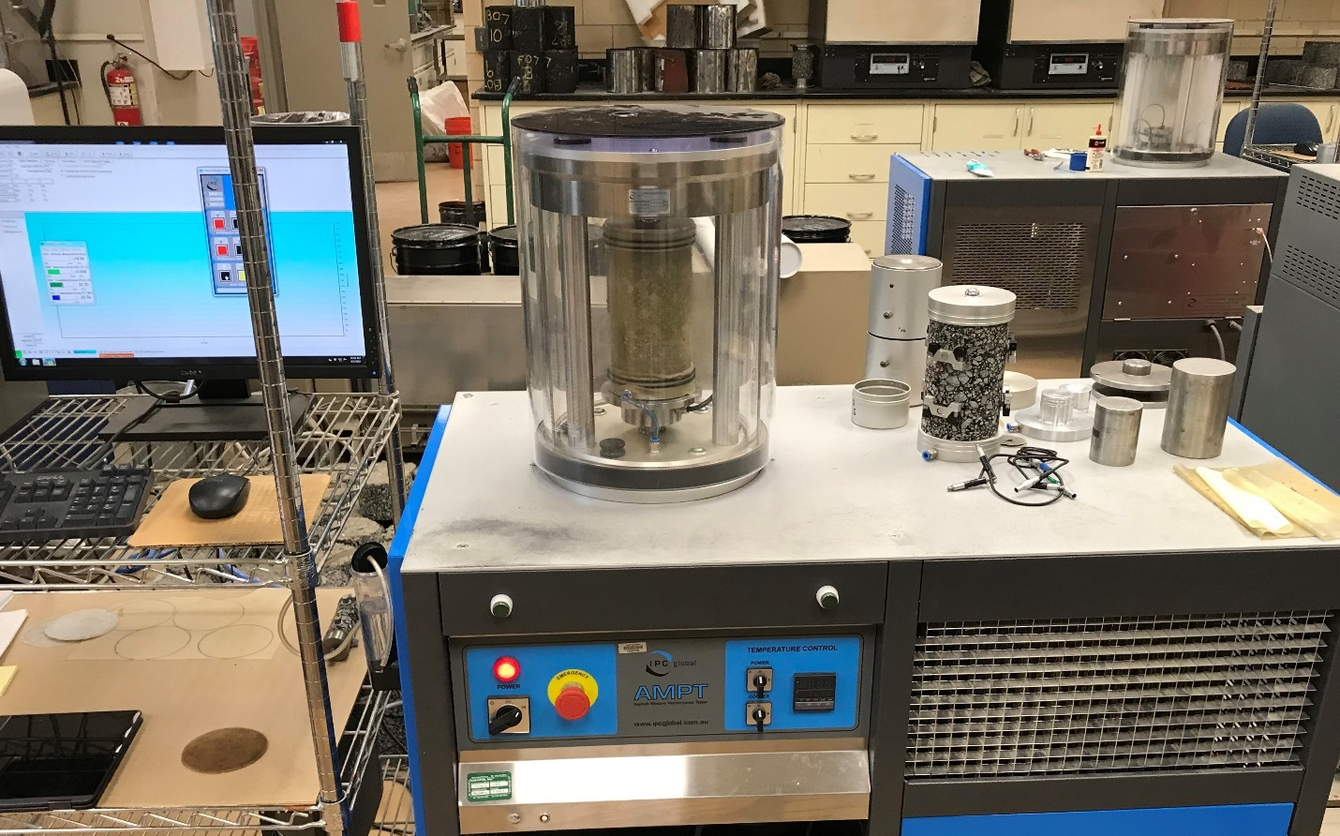
Figure 35. Photo. Repeated load permanent deformation testing in an AMPT.

3.3 Procedures

3.3.1 Specimen Fabrication Procedure
Repeated load permanent deformation tests are conducted on 100 mm diameter by 150 mm tall specimens that are sawed and cored from larger gyratory specimens. AASHTO R 83 is the standard practice for fabricating specimens for dynamic modulus and repeated load permanent deformation testing. Refer to Section 2.3.1 of this guide for review of the four critical aspects of specimen fabrication: (1) mixture preparation, (2) loose mix conditioning, (3) compaction, and (4) coring and sawing. Section 2.3.1 of this guide also includes special considerations for fabricating specimens for R²AMs.

3.3.2 Repeated Load Permanent Deformation Testing Procedure
Up to the date of publication of this guide, AASHTO T 378 had not been revised to include the recommendations from NCHRP 9-30A for testing and analysis to determine the log-log slope and intercept of the permanent strain curve for asphalt mixtures that are needed for the Pavement ME Design rutting analysis. The sections below present details of the testing.

3.3.2.1 Test Specimens
Test specimens for repeated load permanent deformation testing are 100 mm in diameter by 150 mm tall, fabricated in accordance with AASHTO R 83. The test specimens should be fabricated to an air void content that is representative of the construction specifications for the pavement being designed, typically around 7 percent. Laboratory prepared loose mix should be short-term conditioned in accordance with AASHTO R 30. Plant produced mix samples should not receive any additional conditioning; they should be reheated to the compaction temperature in an oven set at the compaction temperature.

3.3.2.2 Test Temperatures
Characterization of the permanent deformation characteristics of asphalt mixtures requires testing a total of nine specimens. Three specimens should be tested at three temperatures. The temperatures are: (1) 20 ºC, (2) 5 ºC below the 50 percent reliability high pavement temperature from LTPPBind, and (3) midway between these two temperatures. For example, the LTPPBind 50 percent high pavement temperature for the Florida project location was 63 ºC. Specimens for this project were tested at: 20, 58, and 39 ºC.

3.3.2.3 Loading Platens and End Friction Reducer
Like the flow number tests in AASHTO T 378, the repeated load permanent deformation test uses loading platens that are fixed parallel to each other and not free to rotate. This differs from the dynamic modulus test where the top loading platen is free to rotate. The repeated load permanent deformation test uses the greased latex end friction reducers specified for flow number testing in AASHTO T 378. These friction reducers are fabricating by placing a small amount of silicone grease between two circular sheets cut from the latex membranes used to confine the specimen. Refer to AASHTO T 378 for details on fabricating greased latex friction reducers.

3.3.2.4 Loading and Specimen Conditioning
Figure 34 showed a schematic of the loading applied during the repeated load permanent deformation test. This loading is the same as an AASHTO T 378 confined flow number test with the following conditions:
- Confining pressure: 68.9 kPa.
- Repeated deviator stress: 482.6 kPa.
- Contact deviator stress: 24 kPa.

The same software that is used to perform confined flow number tests in the AMPT or a general-purpose servo-hydraulic testing machine can be used to conduct the repeated load permanent deformation test.

The primary difference between the repeated load permanent deformation test and an AASHTO T 378 confined flow number test is the repeated load permanent deformation test includes a specimen load conditioning sequence before collecting the data for the permanent strain curve. The conditioning is 100 load cycles using: confining pressure of 68.9 kPa, repeated deviator stress of 48.3 kPa, and contact deviator stress of 2.4 kPa. The purpose of this conditioning sequence is to seat the load and deformation measuring equipment.

3.3.2.5 Data Acquisition
The actuator displacement is used to determine the accumulated permanent deformation; this means specimen-mounted LVDTs are not used. The accumulated permanent deformation is measured at the end of each loading cycle as shown in Figure 34. The accumulated permanent strain for each cycle is calculated as the accumulated permanent deformation divided by the original height of the test specimen. The accumulated percent permanent strain is recorded for each load cycle. The repeated load permanent deformation test is carried out to the lesser of the number of load cycles to reach an accumulated percent permanent strain of 5 percent or 10,000 load cycles. A test carried out to 10,000 load cycles requires approximately 2.8 hours to complete. This data acquisition is consistent with that required in AASHTO T 378 for flow number testing.

3.3.2.6 Data Quality
The quality of the data collected during a repeated load permanent deformation test depends on several factors as described below.

- Specimen Quality. One of the most important, and often overlooked, factors affecting the quality of repeated load permanent deformation test data is the quality of the specimens used in the testing. Important specimen characteristics related to data quality include: (1) air void content, (2) air void gradients, (3) segregation, and (4) specimen end conditions. Producing quality specimens for R²AMs is not more difficult than producing quality specimens for virgin mixtures. Attention to detail is the most important factor.

A typically used tolerance for specimen fabrication is ± 0.5 percent of the target air void content. It is challenging to achieve this tolerance for coarse graded mixtures with nominal maximum aggregate sizes of 19 mm or greater. The range of specimen air voids affects the variability of the permanent deformation properties between specimens. After fabricating the nine specimens needed for permanent deformation testing, the specimens for the three testing temperatures should be grouped to achieve approximately the same average air void content and range of air void contents for the three temperature groups.

Air void gradients in the specimen have a major effect on the permanent deformation properties measured in a repeated load permanent deformation test. Gyratory compacted specimens have higher air voids near the top and bottom of the specimen and at the circumference of the specimens. The purpose of using smaller test specimens that are cored and sawed from the middle of larger gyratory specimens is to minimize air void gradients. For specimens used in repeated load permanent deformation testing minimizing air void gradients is extremely important. If higher than average air voids occur near the top or bottom of the specimen, the specimen will deform more or fail prematurely at that location. Specimens that do not have significant air void gradients will bulge nearly uniformly from top to bottom when proper friction reducers are used. Specimens with significant air void gradients will bulge only at the location of the high air voids. Figure 36 shows examples of specimens with unacceptable and acceptable air void gradients. The specimen on the left in Figure 36 failed prematurely near the top of the specimen because of the high air voids present at that location. The specimen on the right bulged nearly uniformly from top to bottom. Air void gradients are more important in repeated load permanent deformation testing than in dynamic modulus testing because the strains are much higher in permanent deformation tests, and the deformations are measured over the entire specimen rather than the 70 mm gauge length at the middle of the specimen that is used in dynamic modulus testing.

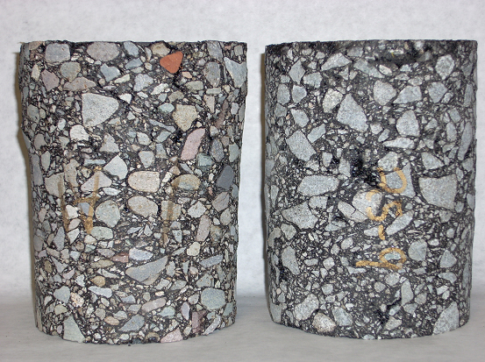
Figure 36. Photo. Examples of repeated load permanent deformation specimens with unacceptable air void gradient (left) and acceptable air void gradient (right).
Segregation in the test specimen can have a similar effect as air void gradients on permanent deformation properties. Increased permanent deformation and premature failure will occur in segregated areas due to the higher air voids in the segregated areas. Exercise care when charging the mold for compaction to minimize the potential for segregation.

Finally, the flatness and parallelism of the specimen ends will affect the permanent deformation properties. If the specimen ends are not flat and parallel, greater permanent deformation will be measured by the actuator displacement measurement as these local imperfections flatten out. In extreme cases, ends that are not parallel will result in specimen bending and premature failure because one side of the specimen receives greater loading.

- Confining Pressure Control. It is critical that the appropriate confining pressure be applied to the test specimen throughout the test. Modern computer-controlled equipment can easily maintain the pressure in the triaxial cell within the ± 2 percent shown in Figure 34 and specified in AASHTO T 378 for confined flow number tests. The confining pressure should be recorded for each load cycle. However, the confining pressure is the same as the cell pressure only if the specimen inside the membrane is properly vented and leakage through membrane seals and holes in the membrane is minimal. When a triaxial cell is used, the platens must be vented, and holes are required in the friction reducers at the platen vent hole to ensure the specimen is properly vented. A bubble chamber should be included in the vent lines to detect leakage. When confining pressure is first applied to the specimen rapid bubbling should occur in the bubble chamber as air is vented from the membrane. The bubbles should stop within 30 seconds after applying the confining pressure. If bubbling continues this is an indication of a hole in the membrane or a leak in the seal. Once loading starts, one or two bubbles per load pulse is common as air is forced from the specimen. Figure 37 shows a confined repeated load test specimen after confining pressure has been applied.

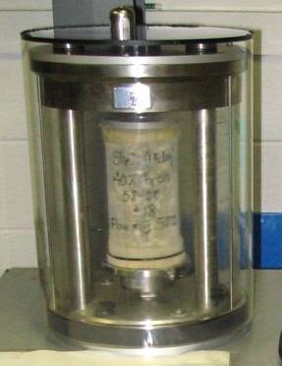
Figure 37. Photo. Confined repeated load permanent deformation test specimen after confining pressure was applied.

An innovative approach to providing the 68.9 kPa confinement needed for the repeated load permanent deformation test is to pull a partial vacuum on the specimen vent lines allowing atmospheric pressure to provide the confining pressure. This approach can be used for confining pressures that are less than atmospheric pressure, approximately 100 kPa. Using a vacuum to apply confinement has several advantages. First safety issues associated with using a triaxial cell with air as the confining pressure are eliminated. Properly designed triaxial cells have pressure relief valves so that the cell cannot be pressurized above its rated pressure. However, most triaxial cells are fabricated from plastic that can be scratched or damaged by improper handling compromising the integrity of the cell. Second, positive control of the confining pressure is provided. Since transducers for vacuum measure gauge pressure (the difference between atmospheric pressure and the partial vacuum) they provide a direct measure of the confinement applied to the specimen. If some minor membrane leakage occurs, it is removed by the vacuum system. Third, a triaxial cell is not needed. Installing the test specimen in a membrane inside a triaxial adds a level of complication to testing. Unless the triaxial cell is automated like the cell in the AMPT, the triaxial cell must be either partially disassembled, or lifted to allow the specimen to be installed. Then the membrane must be sealed against the loading platens and the triaxial cell lowered or reassembled before confining pressure is applied. These operations take time resulting in the potential for the temperature of the test specimen to change. The last major advantage of using a vacuum system to apply confinement is air at an incorrect temperature is not introduced around the specimen. When using a traditional triaxial cell, room temperature air is introduced into the triaxial cell. Because air and plastic are insulators, it will take several minutes for the air in the triaxial cell to equilibrate to the test temperature changing the temperature of the test specimen. In the AMPT, the temperature in the cell is controlled directly rather than indirectly as it is in a standard triaxial cell.

- Temperature Control. Like dynamic modulus testing, it is critical that the test specimen for repeated load permanent deformation testing be equilibrated at the test temperature and that the temperature be maintained throughout the testing. A monitoring specimen with a thermocouple or RTD mounted at the center should be used to determine when the test specimens have equilibrated to the test temperature. The specimen installation guidelines in AASHTO T 378 that were established through ruggedness testing allow five minutes for installing the specimen and returning the air around the specimen to test temperature (Bonaquist, 2008). It may not be possible to meet this criterion when using a standard triaxial cell where unconditioned air is used to apply confinement. If the AASHTO T 378 specimen installation guidelines cannot be met, then tests using a monitoring specimen should be conducted to establish a dwell time between pressurization and the start of testing to ensure that the specimen is at the proper temperature. The temperature control system in the AMPT and the temperature chambers supplied with general purpose servo-hydraulic testing machines can control temperature within about ±0.5 ºC of the target temperature. When using a general-purpose machine with a triaxial cell, the transducer monitoring and recording the temperature should be located inside the triaxial cell close to the test specimen. Temperature should be recorded for each load cycle. Figure 38 shows a triaxial cell for a general-purpose servo-hydraulic testing machine configured for repeated load permanent deformation testing.

- Deviator Stress Control. Modern computer-controlled servo-hydraulic testing equipment can easily control the contact deviator stress and the repeated deviator stress within ±2 percent as shown in Figure 34 and specified in AASHTO T 378 for confined flow number testing. AASHTO T 378 also specifies that the standard error of the repeated deviator stress pulse be less than 5 percent to control the shape of the pulse. Adaptive level control and real time tuning that is available on some AMPTs and general- purpose servo-hydraulic testing machines can be used to adjust the tuning as the test progresses to maintain proper control of the haversine load pulse.
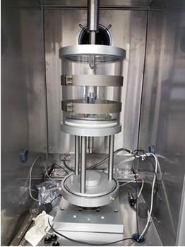

Figure 38. Photo. Triaxial cell for repeated load permanent deformation testing in a general-purpose servo-hydraulic testing machine.

3.4 Data Analysis
The primary analysis of repeated load permanent deformation test data for pavement design is the determination of the log-log slope and intercept of the secondary portion of the permanent strain curve. Figure 32 illustrated the slope and intercept used to characterize the permanent deformation characteristics of asphalt mixtures for input into Pavement ME Design. These are obtained by fitting the equation in Figure 39 to the secondary portion of the permanent strain curve.

$$log\left(ε_{p}\right)=log\left(a\right)+b*\log\left(N\right)$$
where:
ε_{p} = permanent strain
N = number of load cycles
a = intercept
b = slope
Figure 39. Equation. Lot-log form for fitting the secondary portion of laboratory permanent strain curve.
When tested at the temperatures and stress levels recommended for the repeated load permanent deformation testing for Pavement ME Design rutting analyses, mixtures should not exhibit tertiary flow. When tertiary flow does occur using the recommended stress levels, it is likely caused by the loss of confining stress due to holes or leaks in the membrane confining the specimen. The recommended method for determining the slope and intercept of the secondary portion of the permanent deformation curve is as follows:

- Check to determine if tertiary flow occurred during the test. This can be done using the flow number algorithm from AASHTO T 378. If tertiary flow occurred, the data should not be used for Pavement ME Design rutting analyses. Inspect the testing equipment to ensure that the membrane is sealing properly, there are no leaks in the membrane and the specimen is properly vented. If tertiary flow occurs on additional specimens after ensuring there are no membrane leaks and the specimen is properly vented, then decrease the testing temperature by 5 ºC.

- For tests that do not exhibit tertiary flow, fit the data from 1,000 to 10,000 cycles to the equation in Figure 39 using linear regression. First take the base 10 logarithm of the number of cycles and the base 10 logarithm of the permanent strain. Then use linear regression to determine the slope and intercept of the secondary portion of permanent deformation curve.

- Determine the average of the slope and intercept for the specimens tested at each temperature.

3.5 Example
This section presents an example of permanent deformation specimen fabrication, testing, and analysis using data from the Pennsylvania GTR modified surface mixture. This was a mixture sampled at the asphalt plant and was produced using a GTR modified binder meeting the requirements for PG 76-22.

3.5.1 Step 1. Select Number of Specimens, Target Air Void Content, and Testing Temperatures
For Level 1 Pavement ME Design rutting analysis, the slope and intercept for each asphalt mixture in the pavement should be determined from the average of three specimens tested at three temperatures. Since repeated load permanent deformation testing is destructive, a separate specimen is needed for each test, resulting in a total of nine specimens. Three specimens are tested at 20 ºC, three specimens are tested at 5 ºC below the 50 percent reliability high pavement temperature from LTPPBind, and three specimens are tested the midpoint between the first two temperatures. Repeated load permanent deformation test specimens should be compacted to an air void content representative of in-service pavements. A target air void content of 7 percent is usually used based on typical specifications for in-place compaction.

The 50 percent reliability high pavement temperature where the Pennsylvania surface mixture is used is 51.6 ºC. Figure 40 is a screen shot from LTPPBind 3.1 showing how this temperature was determined. The depth was selected as zero since the mixtures is a surface course mixture. For this mixture three specimens were prepared for testing at 20 ºC, three specimens were prepared for testing at 46.6 ºC, which is 5 ºC below the high pavement temperature and three specimens were prepared for testing at 33.3 ºC, which is the midpoint between 20 and 51.6 ºC. The specimens were prepared to a target air void content of 7.0 percent.
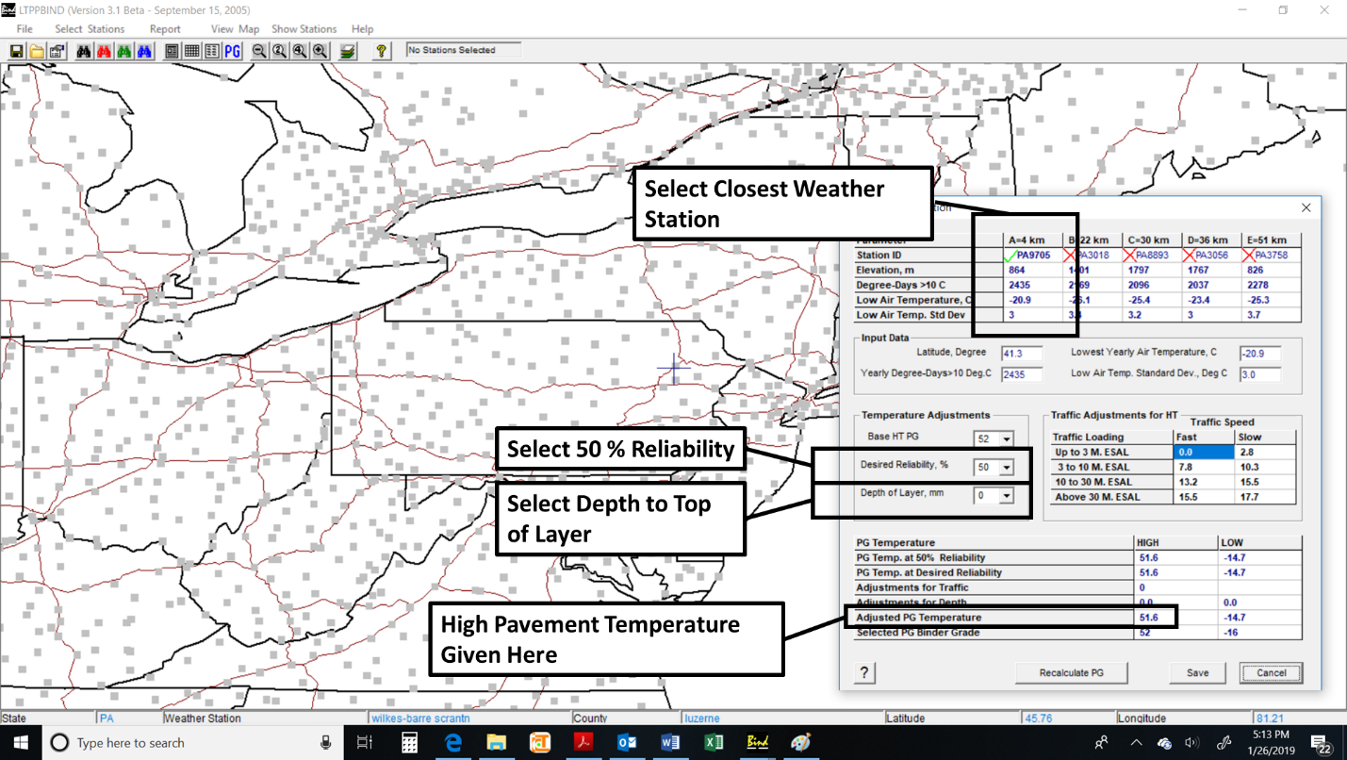
Figure 40. Screen Shot. LTPPBind 3.1 for Wilkes-Barre Scranton weather station showing determination of high pavement temperature.

3.5.2 Step 2. Specimen Fabrication
Test specimens for repeated load permanent deformation testing are the same as those used for dynamic modulus testing. The test specimens are 100 mm in diameter by 150 mm tall and fabricated from larger gyratory specimens as described AASHTO R 83. Section 2.5.2 of this guide illustrates by example using the North Carolina binder mixture the critical specimen fabrication steps: (1) trial specimen air void analysis, (2) final specimen compaction, (3) sawing and coring, and (4) dimensional analysis.

Table 15 summarizes the properties of the nine repeated load permanent deformation test specimens prepared for the Pennsylvania surface mixture and compares them to the tolerances in AASHTO R 83. The test specimens used in this example were fabricated using a double-bladed saw. Acceptable test specimens can also be produced using a single bladed saw and an appropriate clamping system.

3.5.3 Step3. Repeated Load Permanent Deformation Testing
With the AMPT, repeated load testing is relatively easy to perform using the flow number test procedure with confinement. The software guides the user through the specimen set-up and testing. For each specimen, the repeated load test is performed twice. First for the conditioning sequence then for the testing sequence. The sections below address important aspects of testing that are not controlled by the software.

Table 15. Properties of the repeated load permanent deformation test specimens for the Pennsylvania surface mixture.
Item | 1 | 2 | 3 | 4 | 5 | 6 | 7 | 8 | 9 | AASHTO R 83 Tolerance
Air Void Content | 6.6 | 6.8 | 7.0 | 7.4 | 7.5 | 6.8 | 6.6 | 7.4 | 7.5 | *
Average Diameter, mm | 100.1 | 100.1 | 100.1 | 100.1 | 100.1 | 100.1 | 100.1 | 100.1 | 100.1 | 98 to 104
Standard Deviation of Diameter, mm | 0.2 | 0.2 | 0.2 | 0.2 | 0.2 | 0.2 | 0.2 | 0.2 | 0.2 | <0.5
Height, mm | 150.0 | 150.0 | 150.0 | 150.0 | 150.0 | 150.0 | 150.0 | 150.0 | 150.0 | 147.5 to 152.5
End Flatness, mm | Ok | Ok | Ok | Ok | Ok | Ok | Ok | Ok | Ok | <0.5
End Perpendicularity, mm | Ok | Ok | Ok | Ok | Ok | Ok | Ok | Ok | Ok | <1.0
* AASHTO R 83 does not specify an air void tolerance. Target ±0.5 % is typically used
- Sequence of Testing. The recommended sequence of testing is to start by testing specimens at the highest temperature and proceed to the lowest temperature. If tertiary flow is going to occur, it will occur at the highest test temperature. If tertiary flow occurs at the highest temperature and it is not due to the loss of confinement, decrease the highest test temperature by 5 ºC. Adjust the middle test temperature based on the new adjusted high-test temperature. Figure 41 is an example permanent deformation curve where the test temperature was too high resulting in flow tertiary flow after about 1,000 load cycles.
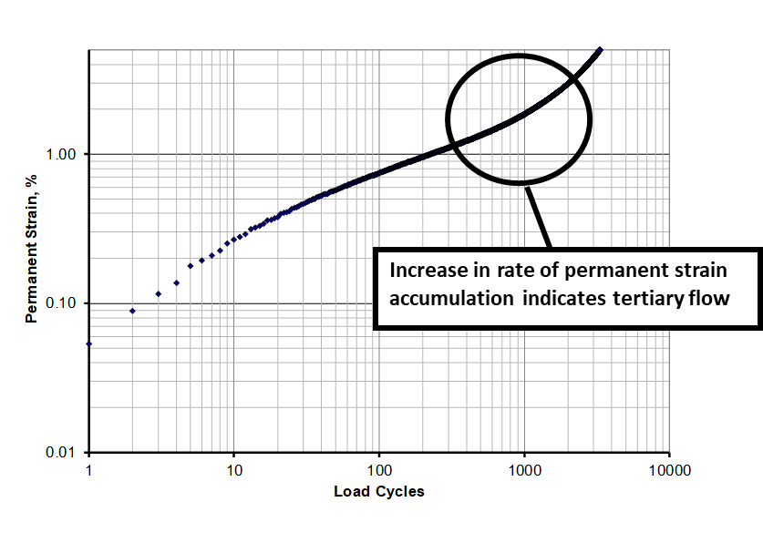
Figure 41. Graph. Example repeated load permanent deformation curve where temperature is too high resulting in tertiary flow.
- Confining Pressure Control. Proper control of the confining pressure is critical when conducting repeated load permanent deformation tests. The testing software provides accurate control of the pressure in the cell, but the confining pressure can be different than the cell pressure if there are leaks in the specimen membrane or if the specimen is not properly vented. Figure 42 is an example permanent deformation curve where confining pressure was lost after approximately 7,000 load cycles. Note the abrupt change in the slope of the permanent deformation curve at approximately 7,000 load cycles.
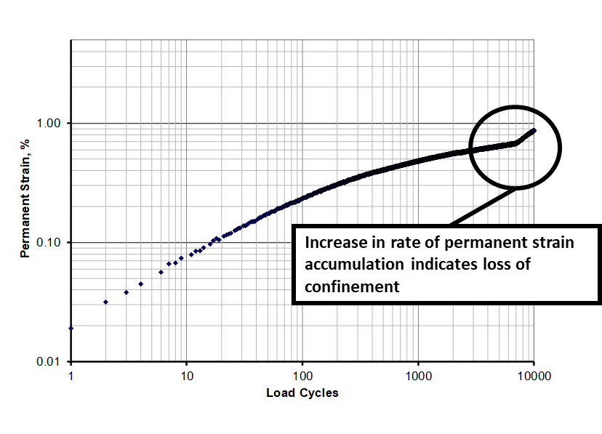
Figure 42. Graph. Example repeated load permanent deformation curve where loss of confinement occurred.
- Temperature Control. Proper control of temperature is critical when testing asphalt mixtures. The AMPT software controls the temperature in the testing chamber; however, the testing chamber is only large enough to accommodate the specimen being tested. A separate environmental chamber should be used to condition the test specimens to the testing temperature to increase productivity in the laboratory. A monitoring specimen with a temperature probe mounted at the middle of the specimen is monitored to determine when the test specimens have reached the testing temperature. The test specimen is then transferred to the testing chamber. The specimen transfer, instrumentation, and rebound of the test chamber temperature must be completed within 5 minutes to minimize the changes in the test specimen temperature. If the 5-minute tolerance is exceeded, the specimen should be equilibrated again at the testing temperature.

When using a general-purpose testing machine with a traditional triaxial cell, the transducer for monitoring and recording temperature should be located inside the triaxial cell close to the specimen. When confinement is applied, room temperature air is introduced into the triaxial cell. Because air and plastic are insulators, it may take more than 5 minutes for the temperature in the triaxial cell to return to the test temperature. If the AASHTO T 378 specimen installation guidelines cannot be met, then tests using a monitoring specimen should be conducted to establish a dwell time between pressurization and the start of testing to ensure that the specimen is at the proper temperature.

- Deviator Stress Control. The AMPT and general-purpose servo-hydraulic testing machines can control the repeated deviator stress and the contact deviator stress within ± 2.0 percent. The repeated and contact deviator stresses should be recorded and reviewed to ensure that this level of control was maintained. Figure 43 shows a typical plot of the repeated deviator stress error during a test on the Pennsylvania GTR modified surface course mixture.

Figure 43. Graph. Example repeated deviatoric stress error during a repeated load permanent deformation test.

Additionally, the load pulse should be haversine in shape. The load standard error should be recorded and reviewed. The load standard error should be less than 5 percent. Figure 44 shows a typical plot of the load standard error during a test on the Pennsylvania GTR modified surface course mixture. Adaptive level control and real time tuning that is available on some AMPTs and general-purpose servo-hydraulic testing machines can be used to adjust the tuning as the test progresses to maintain proper control of the haversine load pulse.

Figure 44. Graph. Example load standard error during a repeated load permanent deformation test.

The repeated load permanent deformation curves for the Pennsylvania GTR modified surface course mixture tested at 20, 33.3, and 46.6 ºC are shown in arithmetic scale in Figure 45 and logarithmic scale in Figure 46. As expected, the permanent strains increase with increasing temperature. Even at the highest temperature, the permanent strains are quite low for this mixture. The high temperature grade of the binder in this mixture is two grades above the 98 percent reliability performance grade of PG 64 that is normally used in the region of Pennsylvania where the mixture is produced.

Figure 45. Graph. Permanent deformation curves for the Pennsylvania GTR modified surface course mixture in arithmetic scale.
Figure 46. Graph. Permanent deformation curves for the Pennsylvania GTR modified surface course mixture in logarithmic scale.

3.5.4 Step 4. Data Analysis
The equation in Figure 39 was fit to each of the repeated load permanent deformation curves shown in Figure 46 over the range of 1,000 to 10,000 load cycles. The resulting slopes, intercepts and explained variances are summarized in Table 16.
Table 16. Summary of laboratory permanent deformation coefficients for the Pennsylvania GTR modified surface course mixture.
Specimen | Temperature, ºC | b | a, % | Explained Variance
5 | 20.0 | 0.3337 | 0.0135 | 0.994
9 | 20.0 | 0.2235 | 0.0365 | 0.987
12 | 20.0 | 0.2061 | 0.0393 | 0.990
Average | 20.0 | 0.2544 | 0.0298 | NA
3 | 33.3 | 0.1349 | 0.1572 | 0.993
7 | 33.3 | 0.1152 | 0.2137 | 0.993
10 | 33.3 | 0.1244 | 0.1886 | 0.994
Average | 33.3 | 0.1249 | 0.1865 | NA
2 | 46.6 | 0.1276 | 0.3098 | 0.996
8 | 46.6 | 0.1442 | 0.2429 | 0.997
11 | 46.6 | 0.1224 | 0.3252 | 0.997
Average | 46.6 | 0.1314 | 0.2927 | NA

3.6 Summary of Recommended Repeated Load Permanent Deformation Testing and Analysis Practices
The preceding sections of this chapter presented detailed descriptions of the state of the practice for repeated load permanent deformation testing and analysis. The sections below summarize important points presented in this chapter.

3.6.1 Specimen Fabrication
Level 1 rutting analysis using Pavement ME Design requires fabrication and testing of nine specimens; three specimens tested at three temperatures. Test specimens for repeated load permanent deformation testing are the same as those for dynamic modulus testing. AASHTO R 83 includes detailed procedures for preparing test specimens for dynamic modulus and repeated load permanent deformation testing. Refer to Section 2.2.1, Section 2.3.1, and Section 2.6.1 of this guide for information on specimen fabrication.

It is critical that air void gradients be minimized in specimens used for repeated load permanent deformation tests. The high strains used in repeated load permanent deformation testing will cause excessive deformation if areas of high air voids are present in the test specimen. Air void gradients are more important in repeated load permanent deformation testing than in dynamic modulus testing because the strains are much higher, and the deformations are measured over the entire specimen rather than the 70 mm gauge length at the middle of the specimen that is used in dynamic modulus testing.

3.6.2 Repeated Load Permanent Deformation Testing
Since repeated load permanent deformation testing uses confinement, it is somewhat more complicated compared to dynamic modulus testing. AASHTO T 378 has not been revised to include the test procedure used to determine the permanent deformation characteristics of asphalt mixtures needed for Pavement ME Design rutting analyses. Table 17 presents a summary of the repeated load permanent deformation procedure. This procedure is similar to the confined flow number test in AASHTO T 378 except a conditioning sequence is applied before the testing sequence. The flow number control and data acquisition software for the AMPT can be used to conduct the repeated load permanent deformation test using the confining and deviatoric stresses listed in Table 17.
Table 17. Summary of repeated load permanent deformation test.
Item | Details
Specimens | Number: Nine. Three tested at three temperatures  Size: 100 mm dia. by 150 mm high  Tolerances: AASHTO R 83
Temperature | Number: Three (20 ºC, 50 percent reliability high pavement temperature from LTPPBind, midway between the first two).
Loading | Confining pressure: static  Confining pressure tolerance: ± 2% per AASHTO T 378  Deviatoric stress: haversine pulse of 0.1 sec repeated every 1.0 seconds per AASHTO T 378  Deviatoric stress tolerance: ± 2% per AASHTO T 378  Load standard error: ≤ 5% per AASHTO T 378
Conditioning Sequence | Confining pressure: 68.9 kPa  Repeated deviatoric stress: 48.3 kPa  Contact deviatoric stress: 2.4 kPa  Number of cycles: 100
Testing Sequence | Confining pressure: 68.9 kPa  Repeated deviatoric stress: 482.6 kPa  Contact deviatoric stress: 24.1 kPa  Number of cycles: 10,000
Friction Reducer | Greased latex membrane per Appendix to AASHTO T 378
Measurements for Load Each Cycle | Permanent axial strain: actuator displacement divided by specimen height  Contact deviatoric stress  Repeated deviatoric stress  Confining pressure  Temperature

The repeated load permanent deformation test is relatively easy to conduct with an AMPT because the testing chamber provides the confining pressure using air at the test temperature. The primary concern is ensuring that the specimen is properly vented and that there are no major leaks in the membrane so that the cell pressure equals the confining pressure. When using a triaxial cell with a general-purpose servo-hydraulic testing machine, proper temperature control is an additional concern because room temperature air is used to pressurize the triaxial cell and it has the potential to change the temperature of the specimen. For this configuration it is critical that the temperature sensor be mounted inside the triaxial cell near the specimen and that appropriate dwell times be established between pressurization and the start of testing if the AASHTO T 378 specimen installation guidelines cannot be met.

The temperatures and stress levels used in the repeated load permanent deformation testing for Pavement ME Design rutting analyses were selected so that tertiary flow will not occur during the test. When tertiary flow does occur, it is likely caused by the loss of confining stress due to holes or leaks in the membrane confining the specimen. The recommended sequence of testing is to start by testing specimens at the highest temperature and proceed to the lowest temperature. If tertiary flow is going to occur, it will occur at the highest test temperature. If tertiary flow occurs at the highest temperature and it is not due to the loss of confinement, decrease the highest test temperature by 5 ºC. Adjust the middle test temperature based on the new adjusted high-test temperature.

3.6.3 Data Analysis
Data analysis for repeated load permanent deformation tests consists of determining the log-log slope and intercept for the secondary portion of the permanent deformation curve. Only permanent deformation curves that do not exhibit tertiary flow should be used. Fit the data from 1,000 to 10,000 cycles to the equation in Figure 39 using linear regression. First take the base 10 logarithm of the number of cycles and the base 10 logarithm of the permanent strain. Then use linear regression to determine the slope and intercept of the secondary portion of permanent deformation curve. Average the slope and intercept for the specimens tested at each temperature.

3.7 Example Permanent Deformation Properties for Selected R²AMs
Repeated load permanent deformation data were collected for eight of the nine mixtures sampled during this project. Table 18 presents average intercepts and slopes at the temperatures used in the testing. Pertinent volumetric properties of the mixtures and continuous AASHTO M 320 performance grade properties for binder recovered from the mixtures are presented in Table 19.

The rutting model in Pavement ME Design uses a constant value for the slope parameter, b for all temperatures. Figure 34 compares the average slope parameters from Table 17. This figure shows that the FL, MA, and PA GTR modified binder mixtures have lower slope parameters indicating the permanent deformation in these mixtures is less sensitive to the number of load cycles.

The rutting model in Pavement ME Design uses a power model to describe the effect of temperature on the intercept parameter, a. Figure 47 compares the temperature exponent of the intercept parameter for the mixtures tested. There is no clear effect of mix type, continuous high temperature grade, or volumetric properties on the temperature exponent.

Table 18. Summary of average repeated load permanent strain coefficients for mixtures with high recycled binder content and mixtures with GTR modified binder.
Mix | Mix Type | Temperature, ºC | a (intercept),  % | b (slope)
WI Base | High Recycle | 20.0 | 0.014 | 0.325
WI Base | High Recycle | 33.8 | 0.061 | 0.316
WI Base | High Recycle | 47.6 | 0.109 | 0.389
WI Surface | High Recycle | 20.0 | 0.014 | 0.325
WI Surface | High Recycle | 33.8 | 0.108 | 0.264
WI Surface | High Recycle | 47.6 | 0.282 | 0.190
NC Base | High Recycle | 20.0 | 0.021 | 0.277
NC Base | High Recycle | 37.6 | 0.180 | 0.167
NC Base | High Recycle | 55.8 | 0.227 | 0.294
NC Intermediate | High Recycle | 20.0 | 0.018 | 0.299
NC Intermediate | High Recycle | 37.6 | 0.090 | 0.287
NC Intermediate | High Recycle | 55.8 | 0.251 | 0.224
NC Surface | High Recycle | 20.0 | 0.006 | 0.369
NC Surface | High Recycle | 37.6 | 0.066 | 0.320
NC Surface | High Recycle | 55.8 | 0.291 | 0.226
FL Surface | GTR Modified | 20.0 | 0.039 | 0.208
FL Surface | GTR Modified | 39.0 | 0.161 | 0.151
FL Surface | GTR Modified | 58.0 | 0.337 | 0.173
MA ARGG | GTR Modified | 20.0 | 0.061 | 0.237
MA ARGG | GTR Modified | 31.5 | 0.287 | 0.128
MA ARGG | GTR Modified | 43.0 | 0.430 | 0.153
PA Surface | GTR Modified | 20.0 | 0.030 | 0.254
PA Surface | GTR Modified | 33.3 | 0.186 | 0.125
PA Surface | GTR Modified | 46.6 | 0.293 | 0.131

Table 19. Volumetric and performance grade properties for mixtures used in repeated load permanent deformation tests.
Property | WI  Base | WI  Surface | NC  Base | NC  Binder | NC  Surface | FL Surface | MA ARGG | PA Surface
Asphalt Content, wt % | 4.53 | 4.51 | 4.38 | 4.20 | 5.72 | 4.68 | 6.54 | 5.90
VMA at 7% Air Voids, vol % | 15.6 | 15.6 | 17.3 | 16.7 | 20.3 | 18.4 | 20.9 | 18.4
VBE, vol % | 8.6 | 8.6 | 10.3 | 9.7 | 13.3 | 11.4 | 13.9 | 11.4
VFA at 7% Air Voids, % | 56.6 | 55.2 | 59.1 | 57.8 | 64.6 | 61.9 | 66.7 | 61
Continuous High Temperature Grade | 76.9 | 75.9 | 78.0 | 80.5 | 80.9 | 78.6 | 85.2 | 78.7
Continuous Intermediate Temperature Grade | 21.5 | 19.6 | 24.8 | 23.0 | 24.8 | 17.2 | 9.6 | 21.9
Continuous Low Temperature Grade | -20.2 | -21.8 | -24.9 | -25.0 | -23.7 | -27.5 | -33.2 | -26.1

Figure 47. Graph. Comparison of average permanent strain slope parameter, b.
Figure 48. Graph. Comparison of temperature exponent for the permanent strain intercept parameter, a.

Chapter 4. Low Temperature Creep Compliance and Strength Testing

4.1 Background

4.1.1 Introduction
The thermal cracking model in Pavement ME Design is an enhanced version of the model originally developed during the Strategic Highway Research Program (SHRP) (Lytton, et al., 1993). This model performs a thermo-viscoelastic analysis of a constrained layer to the estimate tensile stresses as a function of depth that are caused by contraction as the pavement cools. These stresses are used to estimate the depth that a crack has propagated into the asphalt layer. The extent of cracking in the pavement is related to how far the crack has propagated through the idealized asphalt layer by a transfer function.

The asphalt mixture properties needed for the thermal cracking model are: (1) the coefficient of thermal contraction, (2) a creep compliance master curve, and (3) the tensile strength at -10 ºC. The coefficient of thermal contraction is estimated from the volumetric composition of the asphalt mixture. For Level 1 analysis, the creep compliance master curve and the tensile strength are measured using indirect tension tests in accordance with AASHTO T 322. This chapter provides guidance for testing asphalt mixtures in accordance with AASHTO T 322 and highlights special considerations for testing R²AMs.

4.1.2 Creep Compliance
AASHTO T 322 is a product of the SHRP asphalt research. It includes separate procedures for measuring the creep compliance and tensile strength of asphalt mixtures at low temperatures. In the indirect tensile test, a disc-shaped specimen is loaded in compression across its diameter as shown in Figure 49. This loading induces a relatively uniform horizontal tensile stress at the center of the specimen. Because the geometry of the test specimen is well suited for testing relatively thin pavement layers, the indirect tensile test became popular for testing asphalt mixtures starting in the mid-1960s. Most asphalt technicians are familiar with using indirect tensile testing in AASHTO T 283, Standard Method of Test for Resistance of Compacted Asphalt Mixtures to Moisture-Induced Damage.

Although indirect tensile testing was used for many years, AASHTO T 322 introduced the use of specimen mounted deformation measuring instrumentation to indirect tensile testing. In the AASHTO T 322 creep compliance test, horizontal and vertical deformations are measured over the middle portion of the specimen where the stresses are relatively constant using gauge points that are glued to the specimen. The specimen mounted instrumentation eliminates errors caused by small movements of the specimen during the test and allows Poisson’s ratio to be calculated more accurately.

For thermal cracking analysis, creep compliance tests are conducted at three temperatures and time-temperature superposition is used to construct a creep compliance master curve. The master curve construction is similar to that outlined in Chapter 2 of this guide for dynamic modulus master curves. The construction of the creep compliance master curve is done within Pavement ME Design using creep compliance data measured in accordance with AASHTO T 322 at 0, -10, and -20 ⁰C.

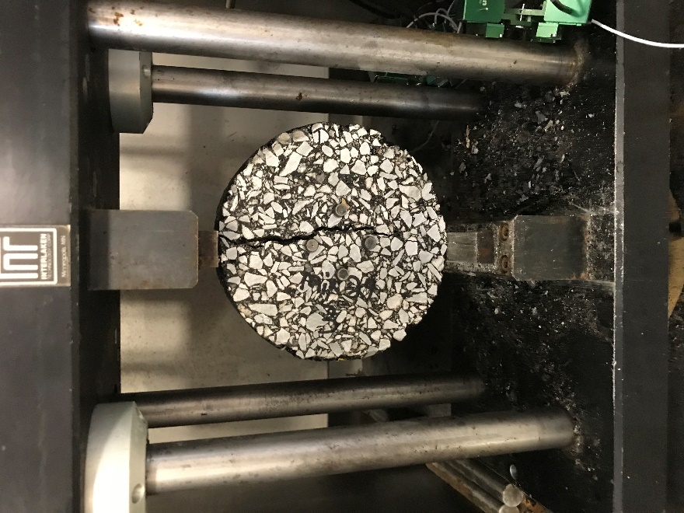
Figure 49. Photo. Indirect tensile strength test.

4.1.3. Tensile Strength
The tensile strength test procedure in AASHTO T 322 is a standard indirect tensile strength test using an actuator displacement rate of 12.5 mm per minute. For thermal cracking analysis using Pavement ME Design, the tensile strength should be measured at -10 ⁰C.

4.2 Equipment
This section describes the equipment that is needed to perform creep compliance and strength testing at low temperature. As discussed in detail below, two categories of equipment are needed: (1) specimen fabrication and (2) creep compliance/strength testing.

4.2.1 Specimen Fabrication Equipment
The test specimens for AASHTO T 322 are 150 mm in diameter by 38 to 50 mm thick. The specimens must have sawed, parallel faces for attaching the gauge points for the specimen mounted instrumentation. The test specimens can be prepared from laboratory compacted loose mix or field cores. When preparing indirect tensile test specimens from laboratory compacted loose mix, the same equipment described in Section 2.2.1 of Chapter 2 of this guide for preparing dynamic modulus specimens can be used. Note that a core drill is not needed because indirect tensile test specimens are 150 mm in diameter. Fabricating indirect tensile test specimens for R²AMs does not require special equipment.

4.2.2 Low Temperature Creep Compliance and Strength Testing Equipment
Table 20 summarizes the major items of equipment needed to perform creep compliance and strength testing in accordance with AASHTO T 322. A 100 kN (22,500 lb) testing machine is needed due to the high stiffness and strength of asphalt mixtures at low temperatures. Closed-loop control is needed to rapidly apply the creep load and maintain the loading during the test. The response of the machine must be rapid enough to apply the 12.5 mm/min actuator displacement needed for the strength test. Although closed-loop electro-mechanical systems should meet these requirements, most of the systems that have been supplied are servo-hydraulic. A high-quality temperature control chamber is required to reach -30 ⁰C and maintain the temperature within ± 0.5 ⁰C as required by AASHTO T 322. The temperature control chamber should be large enough to accommodate the indirect tensile test fixture, several test specimens, and a temperature monitoring specimen. The temperature sensor used to control the test chamber should be mounted near the test fixture as environmental chambers typically have thermal gradients from top to bottom. Figure 50 shows a servo-hydraulic testing machine with temperature control chamber configured for conducting AASHTO T 322 testing.
Table 20. Equipment for low temperature creep compliance and strength testing.
Item | AASHTO T 322 Requirement
Closed-loop, Servo-hydraulic or Electro-mechanical Testing Machine | 100 kN capacity.  Actuator displacement rate greater than 12.5 mm/min.
Temperature Control Chamber | Range from -30 to 10 °C with stability of ±0.5 °C.
Specimen Mounted Deformation Sensors | Gauge points 8 mm diameter by 3.2 mm tall  Deformation transducers with range of 2.5 mm with 0.00010 mm resolution. See Figure 51 and Figure 52.
Gauge Point Template | Template to accurately locate the gauge points. See Figure 53.
Indirect Tensile Test Load Frame | Load frame with vertical guide rods and 19 mm wide loading strips having a radius of 150 mm. See Figure 54.

Figure 51 and Figure 52 show the two types of deformation measuring sensors that have been developed by equipment suppliers. Figure 51 shows a system based on miniature linear variable differential transformers (LVDTs), which is the type of system used in the original SHRP research. Small set screws are used to attach the core and body of the LVDT to the gauge points making alignment and adjustment of the LVDT cumbersome. Figure 52 shows a system based on biaxial strain gauge extensometers. This system uses magnets to attach the transducer to the gauge point system and has a small dowel to keep the transducer within its measuring range during installation making it easy to install this system on the specimen. The miniature LVDT system is less expensive but requires greater time to properly install compared to the magnetic strain gauge system. Figure 53 shows a template for gluing the gauge points to the specimen. Note the slotted alignment tab that helps align the gauge points on the two faces of the specimen. Finally, Figure 54 shows an indirect tensile test load frame.

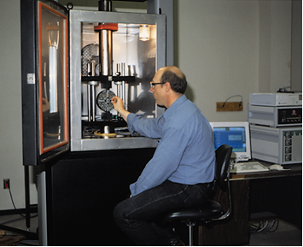
Figure 50. Photo. Servo-hydraulic testing system for AASHTO T 322.
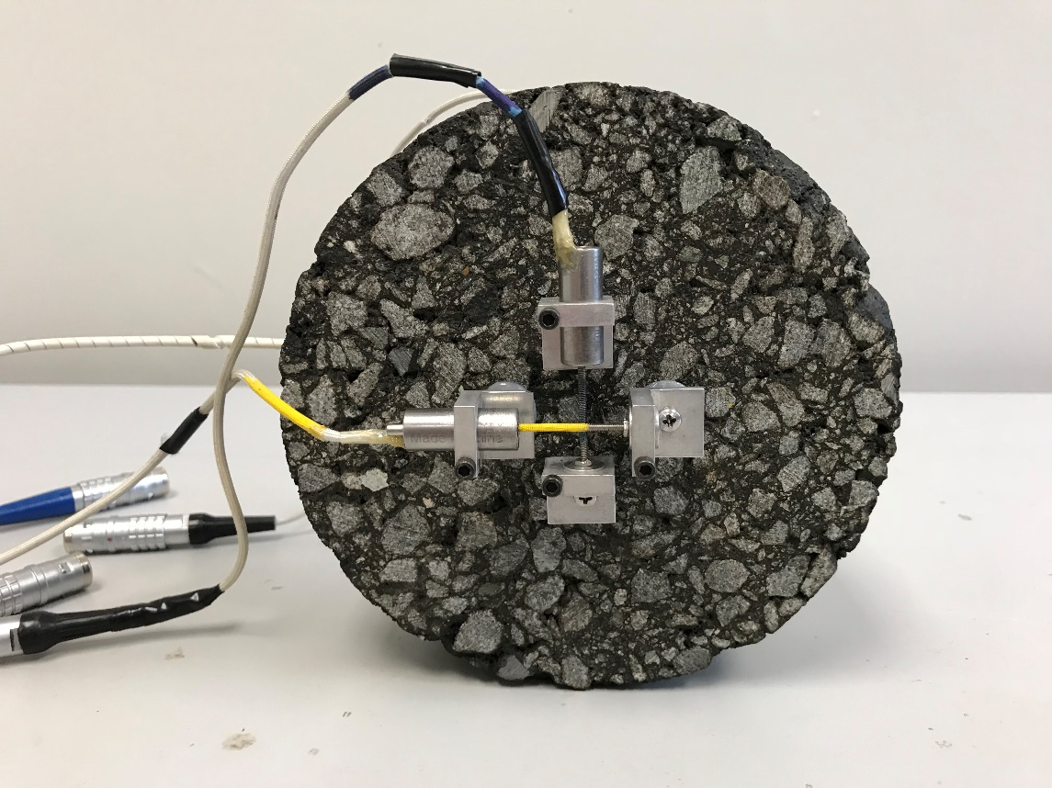
Figure 51. Photo. Miniature LVDT instrumentation system for AASHTO T 322.
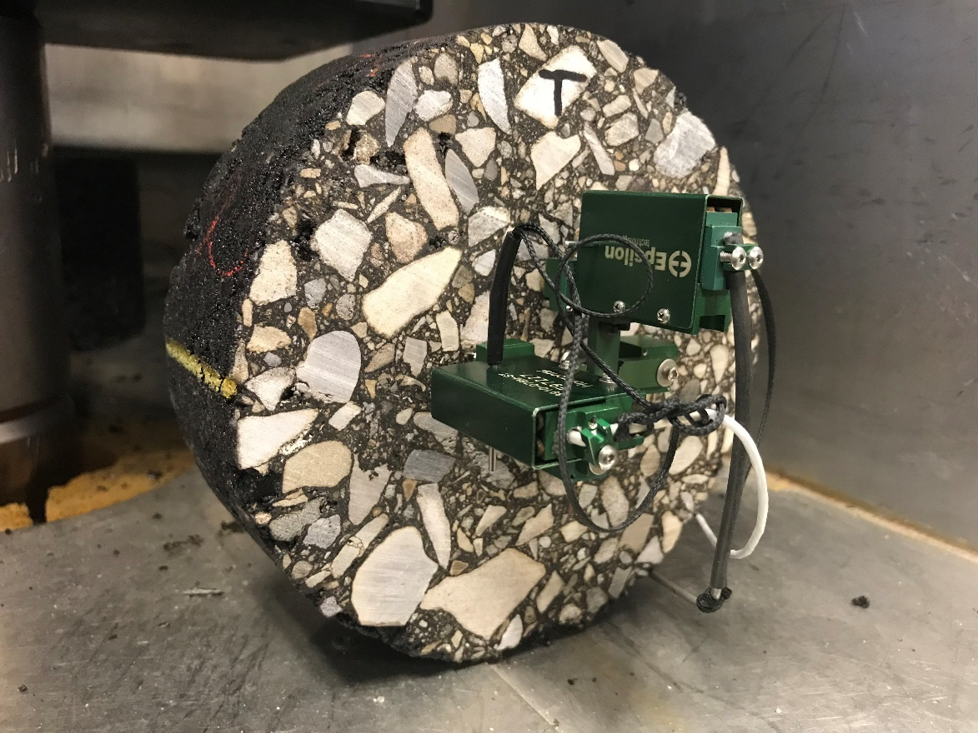
Figure 52. Photo. Bi-axial strain gauge extensometer system for AASHTO T 322.
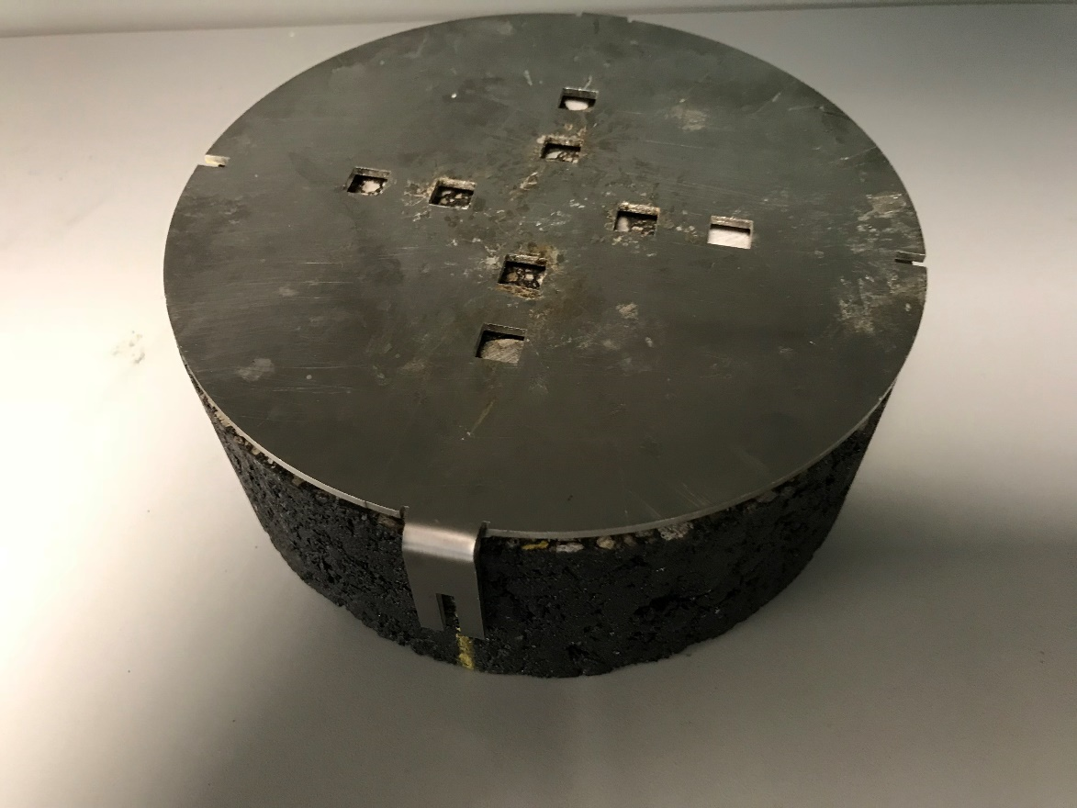
Figure 53. Photo. Indirect tensile gauge point template.

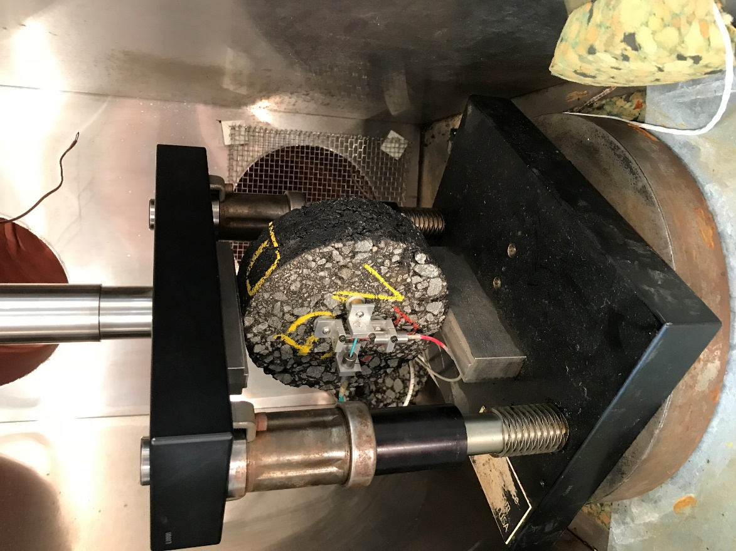

Figure 54. Photo. Indirect tensile loading fixture.

4.3 Procedures

4.3.1 Specimen Fabrication Procedure
AASHTO T 322 can be conducted on test specimens that are cut from field cores or from laboratory compacted gyratory specimens. In AASHTO T 322, three specimens are prepared. For Level 1 thermal cracking analysis with Pavement ME Design, each specimen is tested for creep compliance at 0, -10, and -20 ⁰C. After compliance testing, the tensile strength of each specimen is measured at -10 ⁰C.

The low temperature properties for the thermal cracking analysis for Pavement ME Design analyses should be measured using laboratory prepared specimens that have been short-term conditioned in accordance with AASHTO R 30. Specimen preparation for AASHTO T 322 testing generally follows the standard practice for preparing dynamic modulus specimens, AASHTO R 83, except the gyratory specimens should be prepared to a height of at least 100 mm and coring is not required. The sections below review the four critical aspects of specimen fabrication: (1) mixture preparation, (2) loose mix conditioning, (3) compaction, and (4) sawing, emphasizing special considerations for R²AMs.

4.3.1.1 Mixture Preparation
The size of standard indirect tensile test specimens for AASHTO T 322 is 150 mm diameter by 50 mm thick. The test specimens are trimmed from larger 150 mm diameter by at least 100 mm tall gyratory specimens; therefore, between 4,000 and 5,000 g of mixture per specimen will be needed depending on the specific gravity of the aggregates and the height of gyratory specimens used. Due to air void gradients within gyratory compacted specimens, a single indirect tensile test specimen should be trimmed from the middle of the gyratory specimen.

For laboratory prepared mixtures, the batching and mixture preparation procedures outlined in MS-2 (Asphalt Institute, 2015) should be followed using batch sizes discussed above. Appendix X2 of AASHTO R 35 provides recommended practices for laboratory preparation of WMA mixtures to reasonably replicate several WMA processes. The preparation of laboratory loose mix of R²AMs is generally the same as that for virgin mixtures with the following exceptions. First, for mixtures incorporating RAP or RAS, the RAP and RAS should not be heated with the virgin aggregate, which are often heated overnight. Instead, the RAP and RAS should be heated in an oven set to the mixing temperature for 1.5 to 3.0 hours, then combined with the virgin aggregate during the aggregate dry mixing step. This is done to avoid excessive heating of the RAP and RAS which may alter the properties of the recycled binder (West, et. al., 2013). A mechanical mixer should be used when preparing specimens for AASHTO T 322. This is particularly important with RAP and RAS mixtures to ensure homogeneous mixing of the recycled materials in the mixture. For mixtures incorporating a binder with GTR, the binder must be stirred often during the mixture preparation process because these binders are not storage stable and rubber particles will tend to separate and sink to the bottom when the binder is in a fluid state.

No special handling is needed for the preparation of specimens from plant mix samples of R²AMs. Like other mixtures, these should be reheated to the compaction temperature in an oven set at the compaction temperature.

4.3.1.2 Loose Mix Conditioning
The MEPDG specifies that laboratory prepared loose mix should be short-term conditioned in accordance with AASHTO R 30, for 4 hours at 135 °C to “To account for short-term aging that occurs during mixing and compaction…” (Applied Research Associates, 2004). Plant produced mix samples should not receive any additional conditioning; they should be reheated to the compaction temperature in an oven set at the compaction temperature.

4.3.1.3 Compaction
Specimens for AASHTO T 322 testing are prepared by compacting a 150 mm diameter gyratory specimen to a target height of at least 100 mm, then the 50 mm thick test specimen is trimmed from the middle of the larger gyratory specimen. Air void gradients are not a concern in the thin indirect tensile test specimen. The target air void content for the larger gyratory specimens to produce final test specimens meeting the air void tolerance is determined by trial and error. It is typically 1.0 to 1.5 percent higher than the target air void content for the test specimens because the ends of the gyratory specimen have higher air voids compared to the middle. The air void content of the gyratory specimen and the test specimens is controlled by compacting the appropriate mass of mixture to a target height. For a typical test specimen air void content of 7 percent, the number of gyrations to reach the target height will vary from about 10 to 50 depending on the properties of the mixture. No special procedures are needed when compacting R²AMs.

4.3.1.4 Sawing
To prepare the indirect test specimen, a 50 mm thick disc is sawcut from the middle of the taller 150 mm diameter gyratory specimen. The primary concern with test specimen sawing is to achieve a consistent thickness and smooth parallel faces for the specimen mounted instrumentation. Acceptable specimens for AASHTO T 322 testing can be prepared with a single bladed saw equipped with an appropriate clamp (See Figure 11 in Chapter 2 of this guide) or a double-bladed saw.

The thickness and diameter of the test specimens should be measured with calipers to the nearest 1 mm. These dimensions are used in the compliance calculations. AASHTO T 322 provides a range of 38 to 50 mm for the specimen thickness. AASHTO T 322 specifies the test specimen diameter should be 150 ± 9 mm.

4.3.2 Indirect Tension Creep Compliance Testing Procedure
Testing equipment suppliers have developed control and data acquisition software to perform creep compliance testing in accordance with AASHTO T 322. Once the sample is instrumented and placed in the testing equipment, the software performs the testing per the applicable standard, and collects the resulting load and displacement data. The sections below review the three critical aspects of creep compliance testing: (1) instrumentation, (2) temperature selection and control, (3) loading, and (4) review of data quality, pointing out special considerations for R²AMs.

4.3.2.1 Instrumentation
The AASHTO T 322 creep compliance test requires deformation sensors to be mounted on the test specimens. Since the equations for calculating the creep compliance and Poisson’s ratio include factors for correcting the strain over the gauge length to the point strain at the center of the specimen, it is critical that the gauge points be mounted with the correct gauge length, 38 ± 3.2 mm. Additionally, the instrumentation on the two faces of the specimen must be parallel to each other. A gauge point template similar to that shown earlier in Figure 53 facilitates locating the gauge points. The two slotted brackets on the gauge point gluing template permit alignment marks to be made to ensure that the instruments on both faces are parallel to each other. The technician that instruments the specimen should make sure that the gauge points are being attached at representative locations on the specimen. Additionally, if the sawing smeared binder on the surface of the specimen, the excess binder should be scraped off at the locations where the gauge points will be mounted. This is most likely to be an issue for mixtures with GTR or polymer modified binder, or mixtures with high binder content.

Attaching the instrumentation to the gauge points depends on the type of instrumentation being used. The miniature LVDT systems shown earlier in Figure 51 typically have holders that are attached to the gauge points with screws. With these systems screws are also used to clamp the LVDT body and core in the holders. These systems typically have alignment rods to make sure the LVDT core and body are correctly aligned. After mounting the instrumentation, each LVDT must be positioned close to its zero position. For the system shown in Figure 51, the screw that clamps the body of the LVDT in place is loosened and the LVDT body moved to adjust the instrumentation to the zero position.

Attaching the strain gauge extensometers is generally much easier than the miniature LVDT system. As shown earlier in Figure 52, the strain gauge extensometers have magnets that hold the instrumentation on the gauge points. Additionally, they have small dowel that keeps the instrumentation in range during installation. Once the instrumentation is attached to the specimen, the dowel is removed, and the specimen is ready for testing.

4.3.2.2 Temperature Control
Temperature control is critically important for all performance testing of asphalt mixtures. The creep compliance testing in AASHTO T 322 is performed at 0, -10, and -20 ⁰C. Although AASHTO T 322 specifies allowing the specimens to equilibrate at the test temperature for 3 ± 1 hour before testing, this guide recommends using a monitoring specimen that is the same size as the test specimen with a temperature probe at the middle to determine when the test specimen has reached the test temperature. This is particularly important when using the miniature LVDT deformation systems because it can take several minutes to attach these systems to the specimen and zero them. During this time the temperature control chamber is usually open resulting in an in increase the chamber temperature and the temperature of the test specimen. Once the instrumentation is attached and zeroed and the temperature chamber closed, the monitoring specimen can be used to determine when the test specimen has returned to the test temperature so that testing can begin.

4.3.2.3 Loading and Data Acquisition
Once the specimen returns to the test temperature after installing and zeroing the deformation sensors, a constant load is applied for 100 s and the horizontal and vertical deformations on each face are recorded. At the end of the creep loading, the horizontal deformations should be between 0.00125 and 0.0190 mm. The upper limit guards against damage to the specimen, while the lower limit provides data that are not significantly affected by signal noise. The operator should carefully monitor the horizontal deformation during the test. If it appears that the 0.0190 mm limit is going to be exceeded, stop the test and repeat the test using a lower load after a 5-minute rest period. If the deformation is less than 0.00125 mm at the end of the test, repeat the test using a higher load level after a 5-minute rest period. Data acquisition during the test is a 0.1 samples per second for the first 10 seconds and 1 sample per second for the next 90 seconds.

Table 21 presents suggested creep loads for 150 mm diameter by 50 mm thick specimens. These loads are based on testing of specimens made with binders having low temperature grades of -22 and -28. For mixtures having binders with lower low temperature grades and GTR modified binders, the loads may have to be reduced while the loads may have to be increased for mixtures containing recycled binder. These suggested loads provide a reasonable starting point for technicians who are not familiar with AASHTO T 322 testing. It is important to monitor the horizontal deformation during the test and adjust the loading as described above to have horizontal deformation at the end of the creep loading between 0.00125 and 0.0190 mm.
Table 21. Suggested creep loads for AASHTO T 322.
Temperature, ⁰C | Suggested Creep Load, kN (lb)
0 | 4.5 to 9.0 (1000 to 2000)
-10 | 11.1 to 20.0 (2500 to 4500)
-20 | 24.4 to 33.4 (-5500 to 7500)

4.3.2.4 Data Quality
Although AASHTO T 322 does not provide guidance concerning the quality of the creep data, the creep data should be reviewed before conducting the strength test. If the upper horizontal deformation limit is not exceeded during the creep test, the test can be repeated if the data appear suspect.

The best way to review the quality of the creep data is to prepare plots of the load and each deformation measurement as a function of time. Usually, the data acquisition system for the testing machine will provide these plots and they can be reviewed on the computer screen at the end of the test. These plots should be reviewed at the end of each test before the instrumentation is removed or the test temperature changed. Figure 55 shows a typical plot of the load and deformations from the creep test. Review this plot checking the following:

- The creep load should remain constant during the test. A reasonable tolerance for the creep load is ± 2 percent.

- All four deformation measuring sensors are recording and the deformation responses are continuous without excessive noise.

- The deformations have the correct polarity. The horizontal deformations should be positive (tension) and the vertical deformations should be negative (compression).

- The horizontal deformation at the end of the 100 sec creep loading should be between 0.0012 and 0.0190 mm.

- The vertical deformations are larger in magnitude than the horizontal deformations.

- The horizontal and vertical deformations on the two faces of the specimen are similar in shape and magnitude.

Figure 55. Graph. Typical load and deformation during an AASHTO T 322 creep test.

4.3.3 Indirect Tension Strength Testing Procedure
Once quality creep data have been collected on each of the three test specimens at each temperature (a total of nine creep tests), the tensile strength of the specimens can be measured. The strength test is conducted at -10 ⁰C using a actuator displacement rate of 12.5 mm per minute. Although AASHTO T 322 specifies recording the vertical and horizontal displacements during the strength test, the data are not used in the strength determination which is defined in AASHTO T 322 as the maximum load for the specimen. To avoid damage to the deformation measuring instrumentation during the strength test, this guide recommends removing this instrumentation before conducting the strength test.

4.4 Data Analysis
Three properties are calculated from the data collected during AASHTO T 322: (1) tensile strength, (2) creep compliance, and (3) Poisson’s ratio. A spreadsheet that performs these calculations, LTSTRESS, was developed by the Northeast Center for Excellence in Pavement Technology (Christensen, 1998). Although Poisson’s ratio from AASHTO T 322 is not used in Pavement ME Design, the calculation of Poisson’s ratio using AASHTO T 322 data is discussed in this guide because it serves as a check on the quality of the test data. Reasonable Poisson’s ratio values for low temperature creep tests are from 0.05 to 0.50. Values outside of this range indicate issues with the test data, most likely the instrumentation.

4.4.1 Tensile Strength
The tensile strength of each of the three specimens is calculated using the Equation in Figure 56. The average of the tensile strength of the three specimens is reported as the mixture tensile strength.

$$S_{t}=\frac{(2P_{f})}{(πbD)}$$
where:
S_{t} = tensile strength, kPa
P_{f} = maximum load, kN
b = specimen thickness, m
D = specimen diameter, m
Figure 56. Equation. Calculation of indirect tensile strength.

4.4.2 Creep Compliance
Creep compliance curves at 0, -10, and -20 ⁰C are calculated at each sampling interval from average data for the three specimens using the Equation in Figure 57. This equation uses the average diameter and thickness of the three specimens and the average applied load for the three specimens. The horizontal displacement used in the equation in Figure 57 is a trimmed average of the horizontal displacements from the three specimens. During the creep test, displacements are collected on two faces of each specimen resulting in six horizontal and six vertical displacement measurements at each time interval. A trimmed mean approach is used with the horizontal and vertical displacement measurements when calculating the creep compliance. First, the six horizontal and vertical displacements at 50 sec are normalized for differences in thickness, diameter, and applied load. The horizontal displacement data for the specimen and face with the largest and smallest normalized horizontal displacement are eliminated and the remaining horizontal displacement data at each sampling interval are averaged to obtain the trimmed mean horizontal displacement. Similarly, the trimmed mean vertical displacement is obtained by eliminating the vertical displacement data for the specimen and face with the largest and smallest normalized vertical displacement then averaging the remaining vertical displacement data. The creep compliance factor in the equation in Figure 57 converts average strains from the measured displacements and gauge length to strains at the middle of the specimen and corrects for errors resulting from specimen bulging and the use of stresses from a two-dimensional analysis. The creep compliance factor is given by the equation in Figure 58. The creep compliance factor has minimum and maximum limits that depend on the average thickness to diameter ratio of the specimens tested.

$D\left(t\right)=\left[\frac{(Δ{X\left(t\right)}_{tm}×D_{avg}×b_{avg})}{{(P}_{avg}×GL)}\right]×C_{cmpl}$
where:
D(t) = creep compliance at sample time t, 1/kPa
D_{avg} = average diameter of the three specimens, m
b_{avg} = average thickness of the three specimens, m
P_{avg} = average applied creep load for the three specimens, kN
GL = gauge length for the specimen mounted displacement sensors, m
ΔX(t)_{tm} = trimmed mean of the measured horizontal displacements at time t, m
C_{cmpl} = creep compliance factor at time t rom the equation in Figure 58.
Figure 57. Equation. Calculation of creep compliance.

$C_{cmpl}=0.6354×\left(\frac{{-ΔY\left(t\right)}_{tm}}{{ΔX\left(t\right)}_{tm}}\right)-0.332$
$${Min C}_{cmpl}=0.704-0.213×\left(\frac{b_{avg}}{D_{avg}}\right)$$
${Max C}_{cmpl}=1.566-0.195×\left(\frac{b_{avg}}{D_{avg}}\right)$
where:
C_{cmpl} = creep compliance factor at time t
ΔX(t)_{tm} = trimmed mean of the measured horizontal displacements at time t, m
ΔY(t)_{tm} = trimmed mean of the measured vertical displacements at time t, m
b_{avg} = average thickness of the three specimens, m
D_{avg} = average diameter of the three specimens, m
Figure 58. Equation. Calculation of creep compliance factor.

4.4.3 Poisson’s Ratio
Poisson’s ratio as a function of time for tests at 0, -10, and -20 ⁰C is calculated at each sampling interval from average data for the three specimens using the equation in Figure 59. Like the equation for creep compliance, this equation uses average specimen dimensions and the trimmed mean of the horizontal and vertical displacements. The range for Poisson’s ratio from properly conducted tests is between 0.05 and 0.50.

$$ν\left(t\right)=-0.10+1.480×{\left(\frac{{ΔX\left(t\right)}_{tm}}{{ΔY\left(t\right)}_{tm}}\right)}^{2}-0.778×{\left(\frac{b_{avg}}{D_{avg}}\right)}^{2}×{\left(\frac{{ΔX\left(t\right)}_{tm}}{{ΔY\left(t\right)}_{tm}}\right)}^{2}$$
Where:
ν(t) = Poisson’s ratio at time t
b_{avg} = average thickness of the three specimens, m
D_{avg} = average diameter of the three specimens, m
ΔX(t)_{tm} = trimmed mean of the measured horizontal displacements at time t, m
ΔY(t)_{tm} = trimmed mean of the measured vertical displacements at time t, m
Figure 59. Equation. Calculation of Poisson’s ratio.

4.5 Example
This section presents an example of AASHTO T 322 specimen fabrication, testing, and analysis using data from the Wisconsin high recycle content surface mixture. This was a mixture sampled at the asphalt plant and was produced using PG 52-34 binder, 5 percent RAS by weight of aggregate, and 32 percent RAP by weight of aggregate. The recycled binder ratio for this mixture was 0.50. The continuous grade of the binder recovered from the mixture was PG 75.9 (19.6) -21.8. The low temperature grade normally specified in the location the mixture was placed is -28.

4.5.1 Step 1. Select Number of Specimens, Target Air Void Content, and Testing Temperatures
AASHTO T 322 specifies testing three specimens. The specimens were prepared to a target air void content of 7.0 percent based on typical specifications for in-place compaction. Level 1 Pavement ME Design thermal cracking analysis requires creep compliance to be measured at 0, -10, and -20 ⁰C, and tensile strength to be measured at -10 ⁰C.

4.5.2 Step 2. Specimen Fabrication
Test specimens for AASHTO T 322 testing are 150 mm diameter by 50 mm thick. The test specimens were sawed from 150 mm diameter by 100 mm tall gyratory specimens using a double-bladed saw. The 100 mm tall gyratory specimens were fabricated following the procedure described in AASHTO R 83. First, a 100 mm trial specimen was prepared using a target air void content of 8.0 percent. The equation in Figure 19 Section 2.5.2 of this guide was used to estimate the mass of mixture needed to produce a 100 mm tall gyratory specimen with 8 percent air voids. The maximum specific gravity of the Wisconsin surface mixture used in this example was 2.518. For a target gyratory specimen air void content of 8 percent and a gyratory specimen height of 10.0 cm, the resulting trial gyratory specimen mass was 4,093.6 g. A trial gyratory specimen was prepared using this mass and compacted to a height of 100 mm. Since plant mix was used, the plant mix was reheated to 135 °C for compaction. The 50 mm thick test specimen that was sawed from the middle of the trial gyratory specimen yielded an air void content of 6.7 percent, which is within the test specimen air void tolerance of 6.5 to 7.5 percent. Two additional test specimens were prepared using a gyratory specimen mass of 4093.6 g compacted to a height of 100 mm. Table 22 summarizes properties of the test specimens that were prepared and compares them to the tolerances in AASHTO T 322. The test specimens used in this example were fabricated using a double-bladed saw. Acceptable test specimens can also be produced using a single bladed saw and an appropriate clamping system.
Table 22. Properties of AASHTO T 322 test specimens for the Wisconsin surface mixture.
Item | 1 | 2 | 3 | Tolerance
Air Void Content | 6.7 | 7.1 | 7.0 | *
Diameter, mm | 150 | 150 | 150 | 141 to 159
Thickness, mm | 50 | 50 | 50 | 38 to 50
* AASHTO R T322 does not specify an air void tolerance. Target ±0.5 % is typically used

4.5.3 Step 3. Creep Compliance Testing
Gauge points were glued to each face of each specimen using the template shown in Figure 53. The biaxial strain gauge extensometers shown in Figure 52 were attached to the gauge points to measure vertical and horizontal deformations during creep testing. The creep tests were conducted using a 250 kN (56,000 lb) computer controlled, servo-hydraulic testing machine. The sections below address important aspects of testing that are not specified by AASHTO T 322.

- Sequence of Testing. AASHTO T 322 does not specify a sequence for the creep testing. It is most efficient to conduct the -10 ⁰C creep test last because the strength test is conducted at this temperature. The creep testing sequence used with the Wisconsin surface mixture in this example was 0, -20, and then -10 ⁰C.
- Creep Loads. AASHTO T 322 does not provide guidance on the range of creep loads to be used. Table 21 provided a suggested range for the creep loading as a function of temperature. The creep loads used with this mixture were 5.3 kN at 0 ⁰C, 26.6 kN at -20 ⁰C, and 13.3 kN at -10 ⁰C.

- Temperature Control. Proper control of temperature is critical when testing asphalt mixtures. The environmental chamber used in this example was large enough to hold the three specimens and a monitoring specimen. Although AASHTO T 322 specifies equilibrating the specimens for 2 to 4 hours at the test temperature, the monitoring specimen was used in this example to ensure that the specimens were at the test temperature. The magnetic biaxial axial strain gauge deformation measuring system makes AASHTO T 322 testing very efficient because the instrumentation can be quickly moved from one sample to the next. As a result, changes in test chamber temperature are smaller and specimen temperature recovery times are shorter.

- Data Quality. Although AASHTO T 322 does not provide guidance on data quality, other than limits for the horizonal deformations, technicians conducting creep compliance tests should review plots of the data from each creep test. This review should be conducted before the instrumentation is removed from the specimen so that issues can be corrected and the test repeated while the specimen is at the test temperature. Figure 60 shows plots of creep compliance data for the three specimens of the Wisconsin surface mixture tested at -20 ⁰C. Inspection of these plots reveals the following which indicate quality creep data:

- The creep load is constant during each test.
- All four deformation sensors are recording during each test and the deformation responses are continuous without excessive noise.
- The deformations have the correct polarity. The horizontal deformations are positive (tension) and the vertical deformations are negative (compression).
- The horizontal deformations at the end of the test range from 0.00032 in (0.0081 mm) to 0.00070 in (0.0178 mm), which is within the range of 0.0012 mm to 0.0190 mm specified in AASHTO T 322.
- The magnitude of the vertical deformation for each specimen is larger than the magnitude of the horizontal deformations.
- The horizontal and vertical deformations on the two faces of each specimen are similar in shape and magnitude.

4.5.4 Step 4. Strength Testing
After the nine creep tests were completed and the data were reviewed to ensure quality creep data were collected, the indirect tensile strength of each specimen was measured using a actuator displacement rate of 12.5 mm/min. Note that this loading rate is slower than the 50 mm/min used in the indirect tensile strength testing for AASHTO T 283. Figure 61 is the load displacement curve from the strength test for specimen 2 of the Wisconsin surface mix. Note the brittle failure which is typical for tensile strength tests at low temperatures. Since specimen mounted deformation data are not needed for the strength calculation and the instrumentation can be damaged by the brittle failure, the biaxial strain gauge extensometers were removed before conducting the strength tests.
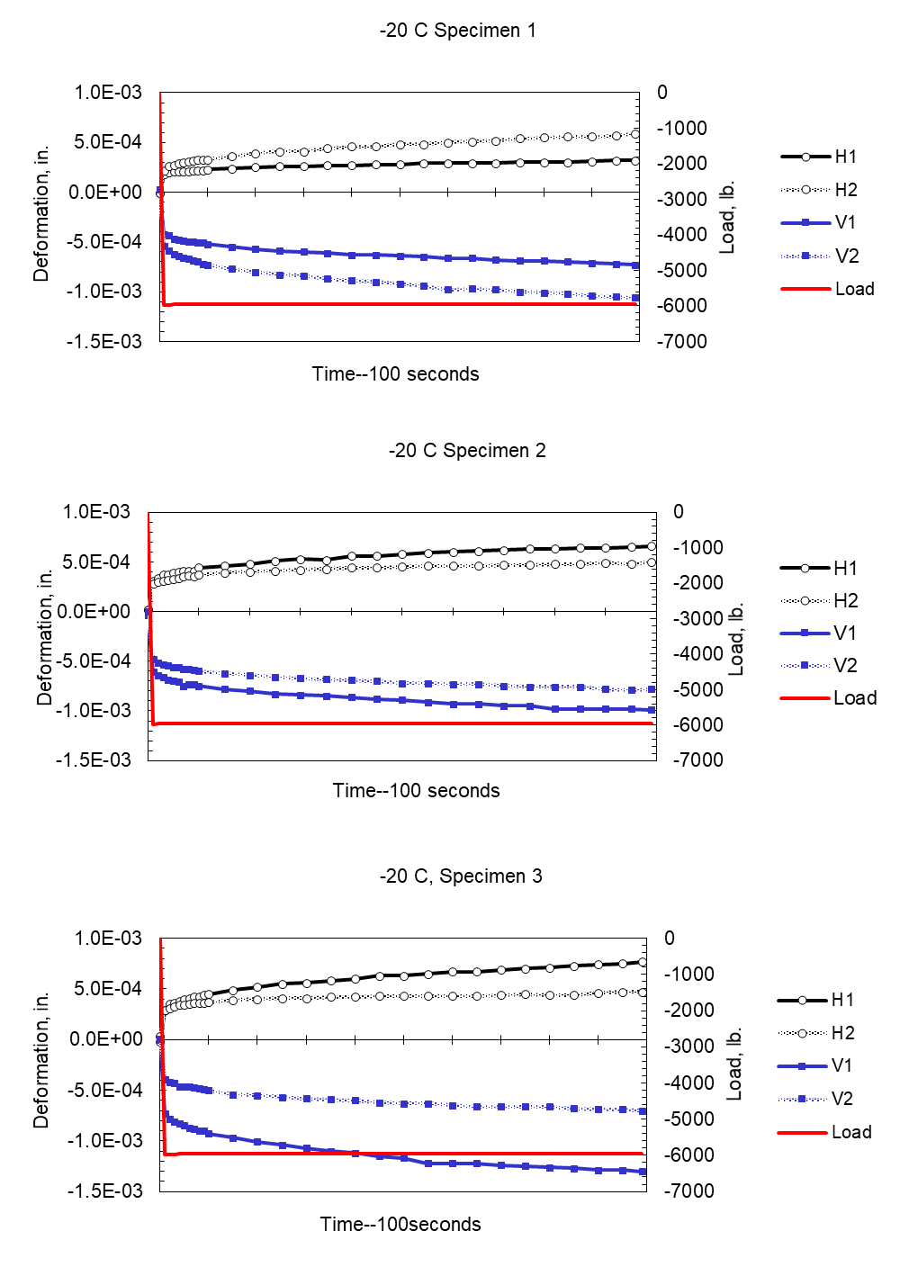
Figure 60. Graph. Example plots of creep testing at -20 ⁰C for Wisconsin surface mixture.
Figure 61. Graph Example load-displacement curve at -10 ºC for Wisconsin surface mixture.

4.5.5 Step 5. Data Analysis
Analysis of the AASHTO T 322 strength test data is straightforward. The tensile strength of each specimen was calculated using equation in Figure 56, which requires the maximum load for each specimen and the specimen dimensions. Table 23 summarizes the results for the Wisconsin surface mixture used in this example.
Table 23. Tensile strength at -10 ⁰C for the Wisconsin surface mixture.
Item | 1 | 2 | 3
Maximum Load, kN | 38.59 | 42.41 | 41.43
Diameter, mm | 150 | 150 | 150
Thickness, mm | 50 | 50 | 50
Tensile Strength, kPa | 3,274 | 3,598 | 3,515

Analysis of the AASHTO T 322 creep compliance data is somewhat more complicated and is best accomplished with a spreadsheet like LTSTRESS (Christensen, 1998). The creep data from the three specimens tested at each temperature are used to generate a compliance curve for each of the three test temperatures using the equations in Figure 57 and Figure 58. These equations use the trimmed mean of the horizontal and vertical deformations. The data for the specimens and faces used in the trimmed mean are determined based on the normalized deformation at 50 sec loading time. Table 24 summarizes the normalized displacements at 50 sec load time and shows the data from the specimen faces that were included in the trimmed mean calculations. Note that the normalized displacement calculations resulted in different faces being used for the horizontal and vertical trimmed mean calculations and different faces being used in the calculations at different temperatures.
Table 24. Normalized displacements at 50 sec loading time for Wisconsin surface mixture
Temp,  ⁰C | Specimen | Face | Normalized Horizontal Displacement, m | Normalized Vertical Displacement, m | Included in Horizonal Trimmed Mean | Included in Vertical Trimmed Mean
-20 | 1 | 1 | 7.11E-06 | -1.63E-05 | Min | Include
-20 | 1 | 2 | 1.19E-05 | -2.26E-05 | Include | Include
-20 | 2 | 1 | 1.46E-05 | -2.26E-05 | Include | Include
-20 | 2 | 2 | 1.13E-05 | -1.75E-05 | Include | Include
-20 | 3 | 1 | 1.61E-05 | -2.96E-05 | Max | Min
-20 | 3 | 2 | 1.09E-05 | -1.53E-05 | Include | Max
-10 | 1 | 1 | 1.57E-05 | -2.37E-05 | Max | Include
-10 | 1 | 2 | 1.11E-05 | -1.63E-05 | Include | Include
-10 | 2 | 1 | 1.03E-05 | -1.67E-05 | Include | Include
-10 | 2 | 2 | 9.99E-06 | -1.69E-05 | Include | Include
-10 | 3 | 1 | 8.01E-06 | -2.60E-05 | Min | Min
-10 | 3 | 2 | 1.45E-05 | -1.21E-05 | Include | Max
0 | 1 | 1 | 1.50E-05 | -2.34E-05 | Max | Include
0 | 1 | 2 | 1.13E-05 | -2.48E-05 | Include | Min
0 | 2 | 1 | 1.36E-05 | -2.40E-05 | Include | Include
0 | 2 | 2 | 9.33E-06 | -1.34E-05 | Include | Include
0 | 3 | 1 | 8.00E-06 | -1.27E-05 | Min | Max
0 | 3 | 2 | 1.29E-05 | -2.27E-05 | Include | Include

Table 25 summarizes the calculations for creep compliance and Poisson’s ratio. The times in Table 25 are the times that creep compliance data are required by Pavement ME Design for Level 1 thermal cracking analysis. If desired, creep compliance values can be calculated for all 190 data points used in the AASHTO T 322 data collection. When performing the creep compliance calculations, it is important to check the minimum and maximum limits for the creep compliance factor, C_{cmpl}, which is a function of the average thickness and diameter. For the specimens used in this example the limits of the creep compliance factor were 0.6330 to 1.4947. The C_{cmpl} values calculated for the trimmed average displacements were within these limits in all cases.

Table 25. Creep compliance and Poisson’s ratio calculations for the Wisconsin surface course mixture
Temp ⁰C | Time sec | Load  kN | Horizontal Displacementm | Vertical Displacementm | C_{cmpl}  Figure 58 | Creep Compliance Figure 57 1/kPa | Poisson’s Ratio  Figure 59
-20 | 1 | 26.58 | 6.99E-06 | -1.30E-05 | 0.8505 | 4.410E-08 | 0.30
-20 | 2 | 26.54 | 7.68E-06 | -1.38E-05 | 0.8111 | 4.634E-08 | 0.33
-20 | 5 | 26.52 | 8.64E-06 | -1.53E-05 | 0.7924 | 5.093E-08 | 0.34
-20 | 10 | 26.52 | 9.59E-06 | -1.65E-05 | 0.7605 | 5.427E-08 | 0.37
-20 | 20 | 26.52 | 1.06E-05 | -1.78E-05 | 0.7356 | 5.806E-08 | 0.39
-20 | 50 | 26.52 | 1.23E-05 | -2.01E-05 | 0.7048 | 6.461E-08 | 0.42
-20 | 100 | 26.52 | 1.41E-05 | -2.26E-05 | 0.6855 | 7.191E-08 | 0.44
-10 | 1 | 11.83 | 4.25E-06 | -8.26E-06 | 0.8991 | 6.384E-08 | 0.27
-10 | 2 | 11.80 | 5.02E-06 | -9.59E-06 | 0.8808 | 7.388E-08 | 0.28
-10 | 5 | 11.79 | 6.16E-06 | -1.15E-05 | 0.8520 | 8.781E-08 | 0.30
-10 | 10 | 11.79 | 7.37E-06 | -1.35E-05 | 0.8276 | 1.021E-07 | 0.32
-10 | 20 | 11.79 | 8.89E-06 | -1.55E-05 | 0.7738 | 1.151E-07 | 0.36
-10 | 50 | 11.78 | 1.17E-05 | -1.94E-05 | 0.7141 | 1.406E-07 | 0.41
-10 | 100 | 11.79 | 1.49E-05 | -2.29E-05 | 0.6469 | 1.609E-07 | 0.49
0 | 1 | 5.18 | 3.05E-06 | -6.92E-06 | 1.1088 | 1.287E-07 | 0.17
0 | 2 | 5.18 | 4.06E-06 | -8.57E-06 | 1.0064 | 1.559E-07 | 0.21
0 | 5 | 5.15 | 5.52E-06 | -1.15E-05 | 0.9881 | 2.091E-07 | 0.22
0 | 10 | 5.16 | 7.11E-06 | -1.38E-05 | 0.9030 | 2.456E-07 | 0.27
0 | 20 | 5.16 | 8.83E-06 | -1.68E-05 | 0.8777 | 2.963E-07 | 0.28
0 | 50 | 5.15 | 1.20E-05 | -2.19E-05 | 0.8262 | 3.798E-07 | 0.32
0 | 100 | 5.15 | 1.57E-05 | -2.74E-05 | 0.7752 | 4.657E-07 | 0.36

4.6 Summary of Recommended Low Temperature Compliance and Strength Testing and Analysis Practices
For Level 1 thermal cracking analysis, Pavement ME Design uses creep compliance and strength data collected in accordance with AASHTO T 322. The preceding sections of this chapter presented detailed descriptions of the state of the practice for low temperature creep compliance and strength testing to support Level 1 thermal cracking analyses using Pavement ME Design. There were no difficulties fabricating and testing specimens of the high recycled binder content and GTR modified binder mixtures. The sections below summarize important points presented in this chapter.

4.6.1 Specimen Fabrication
AASHTO T 322 does not include detailed instructions for specimen fabrication. The low temperature properties for the thermal cracking analysis using the Pavement ME Design should be measured using laboratory prepared specimens that have been short-term conditioned in accordance with AASHTO R 30. Preparation of 150 mm in diameter by 50 mm thick test specimens generally follows the standard practice for preparing dynamic modulus specimens, AASHTO R 83, except the gyratory specimens should be prepared to a height of at least 100 mm and coring is not required. One 50 mm thick test specimen should be sawed from the center of the taller gyratory specimen. The sawed faces of the test specimens should be smooth and parallel for proper mounting of the deformation sensors needed for the creep compliance testing. Refer to Section 2.2.1, Section 2.3.1, and Section 2.6.1 of this guide for detailed information on specimen fabrication. Test specimens should be compacted to the expected in-place air void content based on the compaction specification used. A total of three specimens are required. Creep compliance measurements are made on each specimen at temperatures of 0, -10, and -20 ºC. Once the compliance data have been reviewed and found acceptable, the tensile strength is measured at -10 ºC.

4.6.2 Testing
A 100 kN testing machine is needed to conduct AASHTO T 322 due to the high stiffness and strength of asphalt mixtures at low temperatures. Closed-loop control is needed to rapidly apply the creep load and maintain the loading during the test. The response of the machine must be rapid enough to apply the 12.5 mm/min actuator displacement needed for the strength test. A high-quality temperature control chamber is required to reach -30 ⁰C and maintain the temperature within ± 0.5 ⁰C as required by AASHTO T 322. For testing efficiency, the temperature control chamber should be large enough to accommodate the specimen being tested as well as several others.

Creep compliance testing requires measurement of horizontal and vertical deformations on both faces of the disk shaped indirect tensile test specimen. Equipment manufacturers have developed two types of deformation measuring systems: (1) miniature LVDTs and (2) biaxial strain gauge extensometers. Although more expensive, the biaxial strain gauge extensometer deformation measuring system is easier to install and because less temperature change occurs during instrumentation, significantly reduces the time required for specimens to return to the test temperature.

Proper control of temperature is critical when testing asphalt mixtures. Although AASHTO T 322 specifies equilibrating the specimens for 2 to 4 hours at the test temperature, this guide recommends using a monitoring specimen with a temperature sensor at the middle to determine when the test specimen reaches the testing temperature. The testing sequence is not specified in AASHTO T 322. Since the strength testing is done on the same test specimens after creep testing at three temperatures, this guide recommends conducting the -10 ºC creep test last.

Carefully monitor the horizonal deformations when conducting the creep testing to ensure that the data at the end of the 100 sec creep test are within the horizontal deformation limits of 0.0012 mm to 0.0190 mm specified in AASHTO T 322. If it appears that the 0.0190 mm limit is going to be exceeded, stop the test and repeat the test using a lower load after a 5-minute rest period. If the horizontal deformation is less than 0.00125 mm at the end of the test, repeat the test using a higher load level after a 5-minute rest period. Data acquisition during the test is a 0.1 samples per second for the first 10 seconds and 1 sample per second for the next 90 seconds.

Although AASHTO T 322 does not provide guidance concerning the quality of the creep data, the creep data should be reviewed before conducting the strength test. If the upper horizontal deformation limit is not exceeded during the creep test, the test can be repeated if the data appear suspect. The best way to review the quality of the creep data is to prepare plots of the load and each deformation measurement as a function of time. These plots should be reviewed at the end of each test before the instrumentation is removed or the test temperature change. Review the data plots checking the following:

- The creep load should remain constant during the test. A reasonable tolerance for the creep load is ± 2 percent.
- All four deformation measuring sensors are recording and the deformation responses are continuous without excessive noise.
- The deformations have the correct polarity. The horizontal deformations should be positive (tension) and the vertical deformations should be negative (compression).
- The horizontal deformation at the end of the 100 sec creep loading should be between 0.0012 and 0.0190 mm.
- The vertical deformations are larger in magnitude than the horizontal deformations.
- The horizontal and vertical deformations on the two faces of the specimen are similar in shape and magnitude.

After the nine creep tests have been completed and the data have been reviewed to ensure quality creep data were collected, the indirect tensile strength of each specimen is measured using an actuator displacement rate of 12.5 mm/min. Note that this loading rate is slower than the 50 mm/min used in the indirect tensile strength testing for AASHTO T 283. At -10 ºC, most mixtures exhibit brittle failure that can damage the specimen mounted instrumentation. Although AASHTO T 322 specifies leaving the deformation measuring sensors on the specimen during the strength testing, data from these sensors are not used in the strength calculation. This guide, therefore, recommends removing the specimen mounted deformation measuring sensors before strength testing to avoid damaging the instrumentation.

4.6.3 Data Analysis
Data analysis involves calculating: (1) tensile strength, (2) creep compliance, and (3) Poisson’s ratio. Tensile strength and creep compliance data are needed by Pavement ME Design. Poisson’s ratio is calculated to ensure quality data re being collected. Poisson’s ratio for properly conducted tests should be between 0.05 and 0.5.

The tensile strength of each specimen is calculated using the standard equation for indirect tensile strength. The individual tensile strengths are averaged to determine the tensile strength of the mixture. Mixture creep compliance and Poisson’s ratio are calculated as a function of time at 0, -10, and -20 ºC using the average load, average specimen dimensions, and trimmed mean of the measured horizontal and vertical displacements. Creep testing of three specimens at each temperature yields six horizontal and six vertical displacements. The horizonal and vertical displacements at 50 sec loading are normalized for differences in load and specimen dimensions. The data from the specimen face yielding the maximum and minimum horizontal and vertical displacement are eliminated. The trimmed mean of the horizontal and vertical displacements as a function of time are used to calculate creep compliance and Poisson’s ratio using the equations in AASHTO T 322. This analysis is best done using a spreadsheet.
Level 1 thermal cracking analysis using the Pavement ME Design requires the average tensile strength of the mixture at -10 ºC and mixture creep compliance values for 21 combinations of temperature and loading time. The temperatures are 0, -10, and -20 ºC. At each temperature creep compliance values are required for loading times of 1, 2, 5, 10, 20, 50, and 100 sec.

4.7 Example Low Temperature Compliance and Strength Properties for R²AMs
Low temperature creep compliance and strength data were collected in accordance with AASHTO T 322 for eight of the nine mixtures sampled during this project. AASHTO T 322 data was not collected on the Pennsylvania surface course mixture produced with SBS modified binder. Table 26 presents the average tensile strengths at -10 ºC, pertinent volumetric properties, and the low temperature continuous grade of binder recovered from the mixtures. The tensile strength data are compared graphically in Figure 62. The Massachusetts gap graded GTR modified binder mixture has lower tensile strength compared to the other mixtures. The best correlation between tensile strength and volumetric and recovered binder properties is for the low temperature continuous grade based on creep stiffness. This correlation is moderate having a correlation coefficient of 0.77.

Table 27 summarizes the creep compliances for the eight mixtures at the conditions required for Level 1 thermal cracking analysis using Pavement ME Design. Figure 63 compares the compliance data for the eight mixtures for 3 conditions: (1) -20 ºC, 1 sec loading, (2) -10 ºC, 10 sec loading, and (3) 0 ºC, 100 sec loading. This figure shows that the three high recycled content North Carolina mixtures have the lowest compliance while the Massachusetts GTR modified binder mixture and the Wisconsin high recycle base mixture have the highest compliance. Like the tensile strength data, the best correlation with volumetric or binder properties was for the low temperature continuous grade based on creep stiffness, having a moderate correlation coefficient of 0.74

Table 26. AASHTO T 322 tensile strength, volumetric properties, and low temperature Performance Grade properties for R²AMs.
Property | WI  Base | WI  Surface | NC  Base | NC  Binder | NC  Surface | FL Surface | MA ARGG | PA Surface
Tensile Strength at -10 ºC, kPa | 3772 | 3461 | 3944 | 4358 | 4496 | 4427 | 2648 | 4268
Asphalt Content, wt % | 4.53 | 4.51 | 4.38 | 4.20 | 5.72 | 4.68 | 6.54 | 5.90
VMA at 7% Air Voids, vol % | 15.6 | 15.6 | 17.3 | 16.7 | 20.3 | 18.4 | 20.9 | 18.4
Continuous Low Temperature Grade Based on Stiffness | -29.2 | -30.1 | -24.9 | -27.8 | -26.2 | -30.7 | -36.6 | -26.1
Continuous Low Temperature Grade Based on m-value | -20.2 | -21.8 | -25.5 | -25.0 | -23.7 | -27.5 | -33.2 | -27.8

Figure 62. Graph. Comparison of AASHTO T 322 tensile strength at -10 ºC for R²AMs.
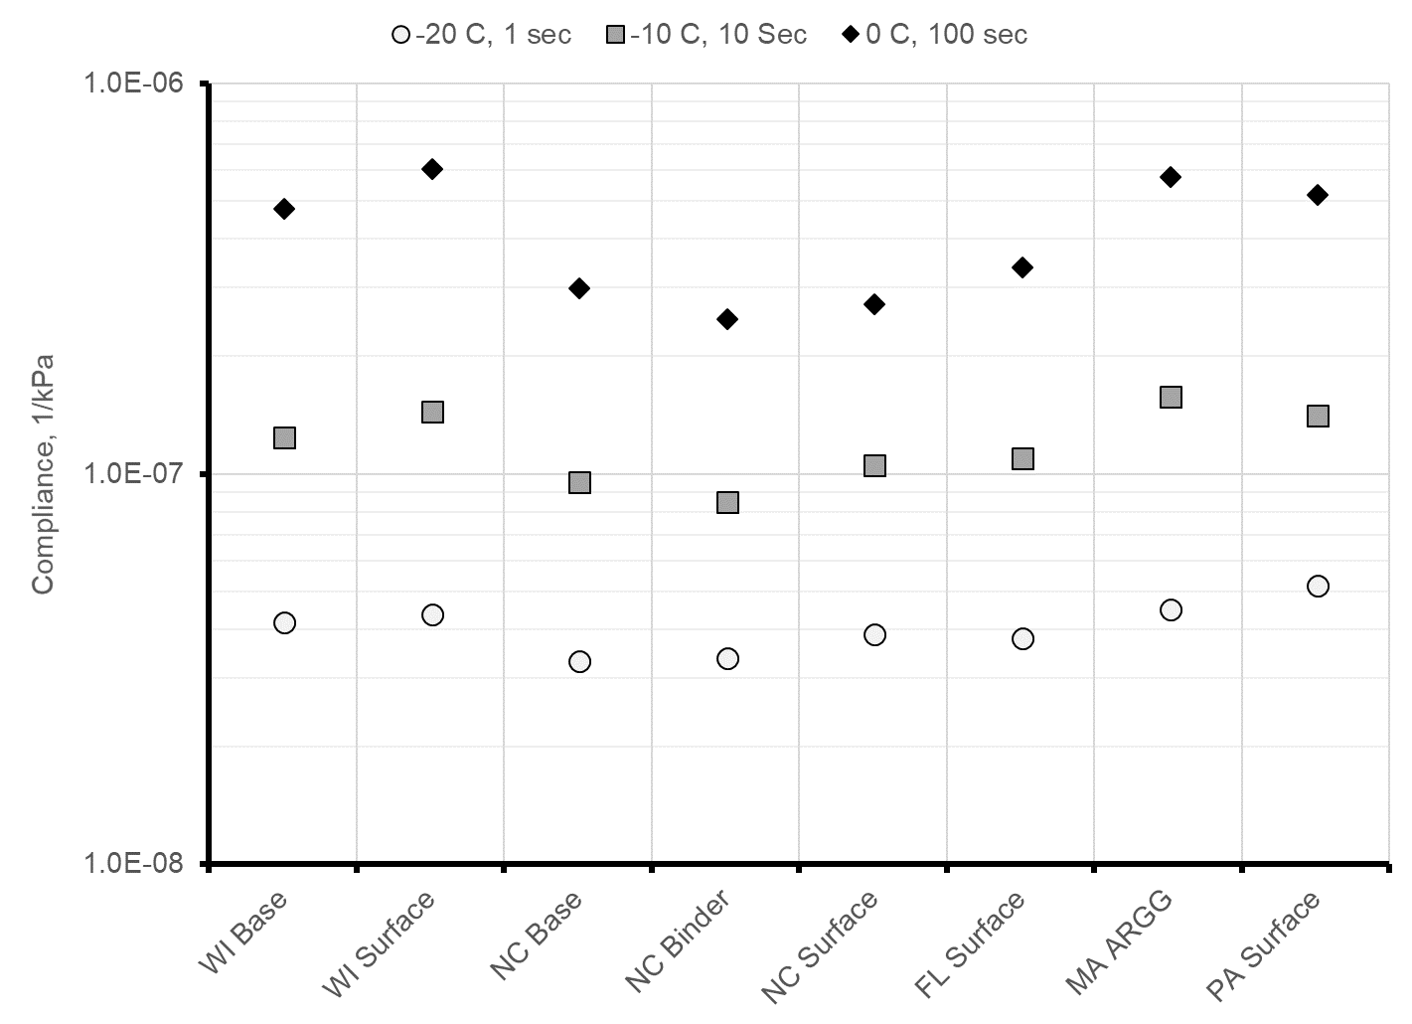
Figure 63. Graph. Comparison of AASHTO T 322 creep compliance for R²AMs.

Table 27. AASHTO T 322 creep compliance values for R²AMs.
Temp, C | Time, sec | WI  Base,  1/kPa | WI  Surface,  1/kPa | NC  Base, 1/kPa | NC  Binder, 1/kPa | NC  Surface, 1/kPa | FL Surface, 1/kPa | MA ARGG, 1/kPa | PA Surface, 1/kPa
-20 | 1 | 4.23E-08 | 4.41E-08 | 3.36E-08 | 3.41E-08 | 3.93E-08 | 3.83E-08 | 4.54E-08 | 5.25E-08
-20 | 2 | 4.42E-08 | 4.63E-08 | 3.52E-08 | 3.49E-08 | 4.11E-08 | 4.03E-08 | 4.93E-08 | 5.41E-08
-20 | 5 | 4.74E-08 | 5.09E-08 | 3.79E-08 | 3.61E-08 | 4.39E-08 | 4.36E-08 | 5.56E-08 | 5.68E-08
-20 | 10 | 5.06E-08 | 5.43E-08 | 4.04E-08 | 3.73E-08 | 4.65E-08 | 4.67E-08 | 6.15E-08 | 5.97E-08
-20 | 20 | 5.47E-08 | 5.81E-08 | 4.35E-08 | 3.88E-08 | 4.95E-08 | 5.04E-08 | 6.86E-08 | 6.33E-08
-20 | 50 | 6.17E-08 | 6.46E-08 | 4.87E-08 | 4.14E-08 | 5.42E-08 | 5.67E-08 | 8.01E-08 | 6.97E-08
-20 | 100 | 6.87E-08 | 7.19E-08 | 5.36E-08 | 4.39E-08 | 5.85E-08 | 6.26E-08 | 9.09E-08 | 7.62E-08
-10 | 1 | 5.74E-08 | 6.38E-08 | 4.50E-08 | 4.10E-08 | 5.17E-08 | 5.18E-08 | 7.42E-08 | 6.57E-08
-10 | 2 | 6.33E-08 | 7.39E-08 | 4.91E-08 | 4.34E-08 | 5.56E-08 | 5.67E-08 | 8.38E-08 | 7.10E-08
-10 | 5 | 7.34E-08 | 8.78E-08 | 5.60E-08 | 4.75E-08 | 6.18E-08 | 6.47E-08 | 9.94E-08 | 8.05E-08
-10 | 10 | 8.33E-08 | 1.02E-07 | 6.25E-08 | 5.14E-08 | 6.73E-08 | 7.24E-08 | 1.14E-07 | 9.00E-08
-10 | 20 | 9.59E-08 | 1.15E-07 | 7.05E-08 | 5.63E-08 | 7.38E-08 | 8.16E-08 | 1.31E-07 | 1.02E-07
-10 | 50 | 1.18E-07 | 1.41E-07 | 8.38E-08 | 6.47E-08 | 8.40E-08 | 9.70E-08 | 1.60E-07 | 1.24E-07
-10 | 100 | 1.39E-07 | 1.61E-07 | 9.65E-08 | 7.28E-08 | 9.33E-08 | 1.12E-07 | 1.86E-07 | 1.46E-07
0 | 1 | 1.04E-07 | 1.29E-07 | 7.42E-08 | 6.35E-08 | 7.87E-08 | 8.50E-08 | 1.45E-07 | 1.10E-07
0 | 2 | 1.22E-07 | 1.56E-07 | 8.48E-08 | 7.13E-08 | 8.71E-08 | 9.70E-08 | 1.69E-07 | 1.28E-07
0 | 5 | 1.54E-07 | 2.09E-07 | 1.02E-07 | 8.45E-08 | 1.00E-07 | 1.17E-07 | 2.08E-07 | 1.60E-07
0 | 10 | 1.85E-07 | 2.46E-07 | 1.19E-07 | 9.74E-08 | 1.12E-07 | 1.36E-07 | 2.43E-07 | 1.93E-07
0 | 20 | 2.24E-07 | 2.96E-07 | 1.40E-07 | 1.13E-07 | 1.26E-07 | 1.58E-07 | 2.86E-07 | 2.34E-07
0 | 50 | 2.91E-07 | 3.80E-07 | 1.74E-07 | 1.41E-07 | 1.48E-07 | 1.96E-07 | 3.57E-07 | 3.07E-07
0 | 100 | 3.58E-07 | 4.66E-07 | 2.07E-07 | 1.67E-07 | 1.68E-07 | 2.32E-07 | 4.22E-07 | 3.81E-07

Chapter 5. Flexural Fatigue Testing

5.1 Background

5.1.1 Load Related Cracking Models
Pavement ME Design predicts two types of load related cracks: (1) alligator cracks which are assumed to initiate at the bottom of the asphalt layer and (2) longitudinal cracks which are assumed to initiate at the surface. For both types of cracking, the allowable number of load applications used in the incremental damage analysis is given by the equation in Figure 64. This equation is an adjusted version of the Asphalt Institute fatigue equation (Applied Research Associates 2004). The general form of this equation was established through analysis of flexural fatigue test results published by various researchers.

$$N_{f}=k_{f1}CC_{H}β_{f1}{\left(\frac{1}{ε_{t}}\right)}^{\left(k_{f2}β_{f2}\right)}{\left(\frac{1}{\left|E^{*}\right|}\right)}^{\left(k_{f3}β_{f3}\right)}$$
where:
N_{f} = allowable number of load applications
ε_{t} = tensile strain from the pavement response model at critical locations, in/in
|E*| = dynamic modulus, psi
$C= {10}^{\left(VFA-0.69\right)}$
VFA = voids filled with asphalt expressed as a decimal
C_{H} = thickness correction factor
k_{1f}, k_{2f}, k_{3f} = laboratory fatigue coefficients
β_{1f}, β_{2f}, β_{3f} = local calibration factors
Figure 64. Equation. Pavement ME Design fatigue equation.

5.1.2 Flexural Fatigue Testing
AASHTO T 321, Standard Method of Test for Determining the Fatigue Life of Compacted Asphalt Mixtures Subjected to Repeated Flexural Bending, is the standard test for determining fatigue properties of asphalt mixtures. In this test a beam sample, 380 mm long by 63 mm wide by 50 mm thick is subjected to strain controlled repeated four-point bending. Figure 64 is a photograph of a beam being tested in accordance with AASHTO T 321. During a flexural fatigue test, the beam is damaged by the repeated flexing resulting in a decrease in the stiffness of the beam. The traditional definition of failure for a strain controlled flexural fatigue test on asphalt mixtures is the number of cycles required for the beam stiffness to decrease to 50 percent of its initial value. In recent changes to AASHTO T 321, the definition of failure has been changed to the number of cycles where the product of the flexural stiffness and load cycles is a maximum. The number of loading cycles applied to the beam can range from 1,000 to 10,000,000 or more.
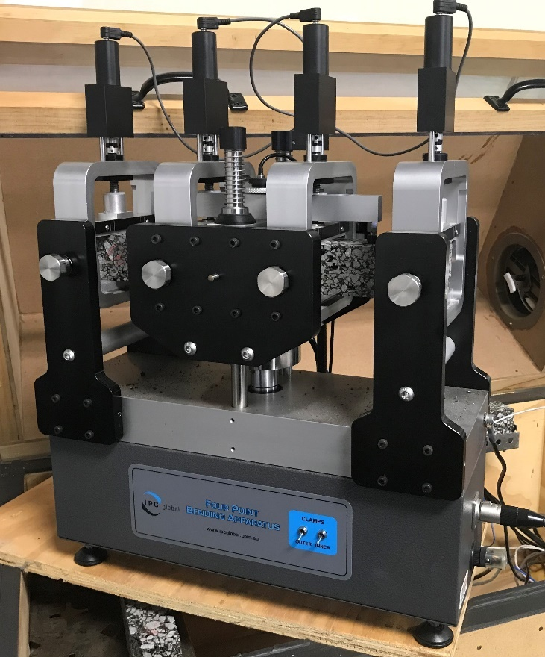
Figure 65. Photo. Four-point flexural fatigue test in a stand-alone pneumatic flexural fatigue device.
The results of fatigue tests are presented in the form of S-N diagrams, which are simply plots of the applied strain and the corresponding number of cycles to failure. Figure 66 presents a typical S-N diagram for asphalt mixtures generated from laboratory test data. The strain where the fatigue life becomes infinite (vertical) is called the endurance limit. A practical limit of 500,000,000 load cycles has be suggested for the endurance limit of asphalt mixtures (Prowell, et. al., 2010). Generating an S-N curve for an asphalt mixture at a specific temperature requires testing several beams at different strain levels. A family of S-N curves can be generated by testing at multiple temperatures. An estimate of the endurance limit may be obtained by extrapolation of the S-N curves to 500,000,000 load cycles.

To determine the laboratory fatigue coefficients for the equation in Figure 64 requires a dynamic modulus master curve and data for S-N curves at different temperatures. The data are then fit to the Equation in Figure 67 using linear regression after log transformation of the data. The term, (VFA-0.69) is needed to account for the voids filled with asphalt effect that is included in the fatigue cracking model in Pavement ME Design.

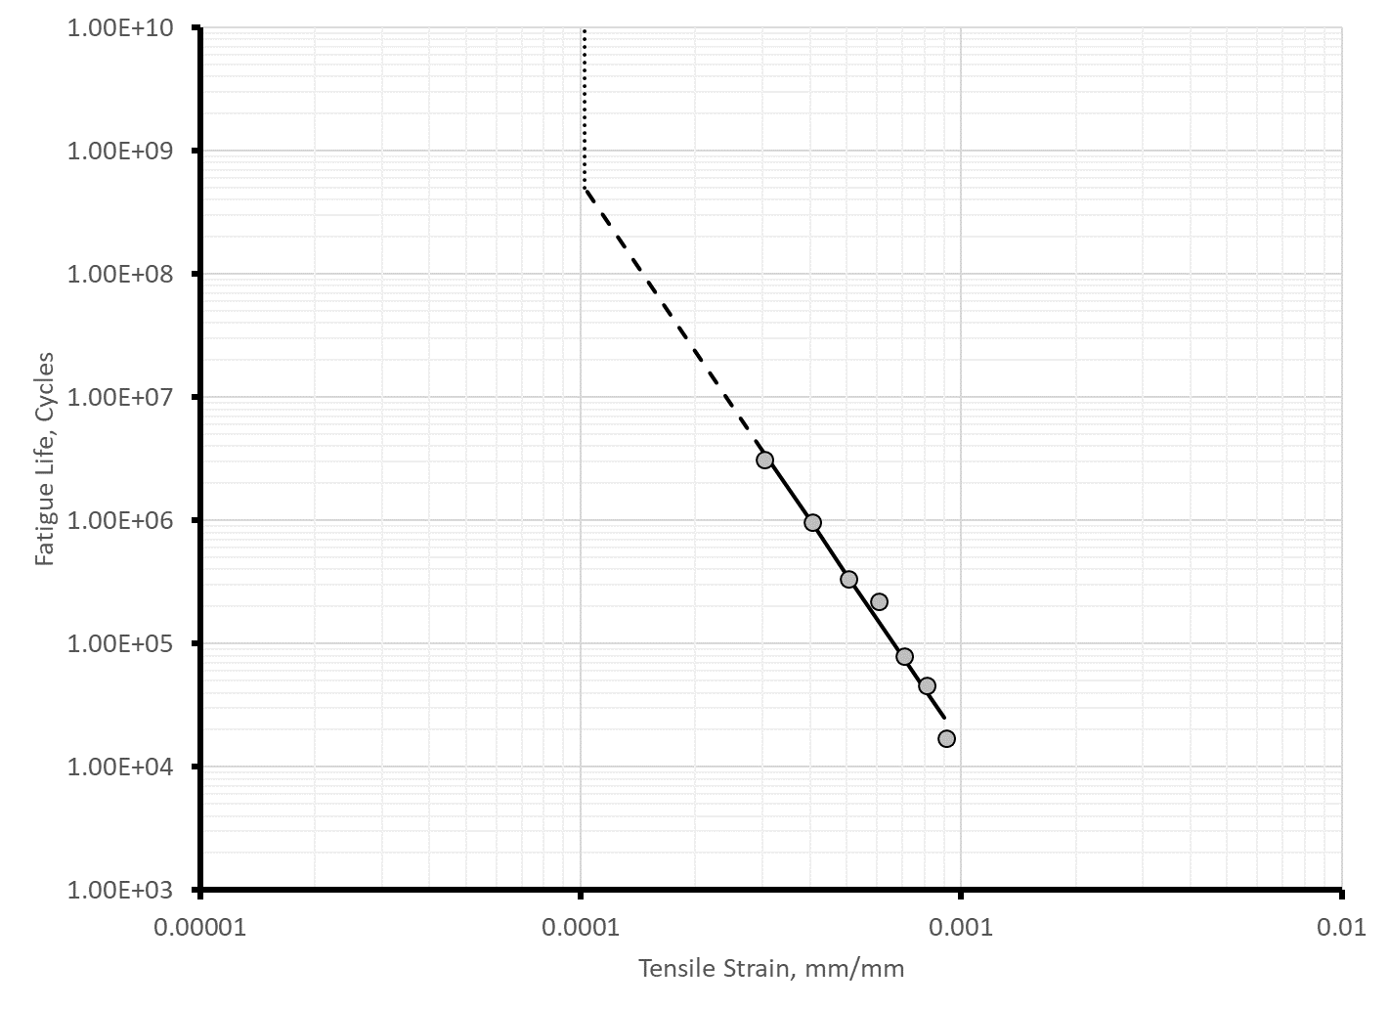
Figure 66. Graph. Typical S-N diagram for asphalt mixtures.
$$\log{N_{f}}-\left(VFA-0.69\right)={\log{k_{1f}-k_{2f}}\log{ε_{t}-}k}_{3f}\log\left|E^{*}\right|$$
where:
N_{f} = number of load cycles to failure
ε_{t} = tensile strain used in the fatigue test, in/in
|E*| = dynamic modulus at the frequency and temperature used in the fatigue test, psi
VFA = voids filled with asphalt expressed as a decimal
k_{1f}, k_{2f}, k_{3f} = laboratory fatigue coefficients
Figure 67. Equation. Laboratory fatigue equation for determining k_{1f}, k_{2f} and k_{3f}.

5.2 Equipment
This section describes the equipment that is needed to perform flexural fatigue testing. As discussed in detail below, two categories of equipment are needed: (1) specimen fabrication and (2) flexural fatigue testing.

5.2.1 Specimen Fabrication Equipment
The standard test specimen for flexural fatigue testing is a beam, 380 mm long by 63 mm wide by 50 mm thick. The beam specimens must be sawed from larger laboratory compacted slabs or blocks, or from slabs that have been removed from roadways. Table 28 summarizes the major items of equipment needed to fabricate beam specimens for flexural fatigue testing from laboratory prepared mixtures. The same equipment is used to fabricate beam specimens for virgin mixtures and R²AMs.
Table 28. Equipment for flexural fatigue test specimen preparation.
Item | Details | Reference
Aggregate Preparation Equipment  (Lab Prepared Mixture) | Mechanical sieve shaker, sieves, and pans for separating aggregates into appropriate size fractions for batching. | Asphalt Institute MS-2
Mixture Preparation Equipment  (Lab Prepared Mixture) | Thermometers, balances, ovens, pans, 20 qt mechanical mixer, and miscellaneous hand tools for preparing asphalt mixtures. | Asphalt Institute MS-2
Splitting Equipment  (Plant Produced Mixture) | Mechanical splitter and associated equipment for reducing plant mix samples to the appropriate size. | AASHTO R 47
Conditioning Oven | Forced draft oven for short-term conditioning laboratory prepared asphalt mixtures. | AASHTO R 30
Compactor | A compactor capable of preparing beam, block, or slab specimens. | See text
Masonry Saw | Air- or water-cooled diamond saw. Match depth of cut for saw with thickness of compacted block or slab specimen. | AASHTO R 83
Bulk Specific Gravity Equipment | Balances, water bath, suspension apparatus, oven and when testing specimens with interconnected voids or water absorption exceeding 2 percent a vacuum sealing device and accessories. | AASHTO T 166, AASHTO T 331
Maximum Specific Gravity Equipment | Balances, water bath, suspension apparatus, oven, vacuum system, mechanical shaker, vacuum bowl or pycnometer. | AASHTO T209
Specimen Dimension Measuring Equipment | Square, metal ruler, and calipers | AASHTO R 83

Most of the equipment in Table 28 is the same equipment required for producing dynamic modulus, repeated load permanent deformation, and indirect tensile test specimens. The primary difference is the type of compactor needed to fabricate beam specimens. For specimen preparation, AASHTO T 321 references AASHTO PP 3, Standard Practice for Preparing Hot Mix Asphalt (HMA) Specimens by Means of the Rolling Wheel Compactor, and AASHTO T 247, Standard Method of Test for Preparation of Test Specimens of Hot Mix Asphalt (HMA) by Means of California Kneading Compactor. These two specimen compaction procedures, however, are rarely used in practice. Most laboratories that perform flexural fatigue testing use compactors that can prepare slab or block specimens. Figures 68 through 71 are photographs of four different compactors that have been used to prepare beam specimens for flexural fatigue testing. Standard compaction procedures are available for two of the devices: (1) ASTM D7981, Standard Practice for Compaction of Prismatic Asphalt Specimens by Means of the Shear Box Compactor; and (2) ASTM D8079, Standard Practice for Preparation of Compacted Slab Asphalt Mix Samples Using a Segmented Rolling Compactor. In addition to standardization, the following are important considerations when selecting a compactor for preparation of beam specimens.

- Reasonable simulation of field compaction. As discussed earlier in Section 2.3.1 of this guide, the objective when preparing specimens for performance testing is to produce a specimen that is representative of the asphalt mixture in an actual pavement. Most asphalt technologists agree that in addition to composition, gradation, density and binder properties, the structure of the aggregate skeleton significantly affects performance test properties for asphalt mixtures. Unfortunately, guidance is lacking on how to best reproduce, in the laboratory, the aggregate structure produced by field compaction. The devices shown in Figure 68 through Figure 71 attempt to reproduce field compaction using: (1) shearing, (linear kneading compactor and shear box compactor), (2) vibration (vibratory compactor), or (3) combination of shearing and vibration (segmented roller compactor).

- Ability to compact to a specified height. Flexural fatigue specimens are compacted to a target air void content. The fabrication procedure is similar to that described in Section 2.3.1 of this guide for preparing dynamic modulus specimens. First a larger block or slab is prepared to a target air void content that is 1.0 to 1.5 percent higher than the target air void content of the test beam. Then the test beam is sawed from the larger block or slab. Using test beams that are sawcut from larger specimens removes areas of high air voids that occur near the walls of the compaction mold and produces specimens with consistent dimensions. Compactors that automatically compact to a specified height greatly simplify the process of compacting the block or slab to a target air void content.

- Uniformity of density. The compactor should be capable of producing uniform density within the beam specimen. Often multiple beams are sawed from a single compacted block or slab. The region of uniformity density should be determined experimentally by sawing small 50 mm by 50 mm density specimens from the slab or block and measuring the density in accordance with AASHTO T 166 or AASHTO T 331.

- Size of the block or slab and useable number of specimens. The size of the block or slab determines the mass of mixture that must be prepared. For example, a common block size for the shear box compactor is 150 mm wide by 450 mm long by 150 mm tall. This size block requires 22 to 25 kg of mix depending on the maximum specific gravity of the mixture. From this block, four 380 mm long by 63 mm wide by 50 mm thick beam specimens of approximately equal density can be sawcut.

Testing equipment suppliers market large laboratory mixers to prepare the volume of mix needed for large slab or block specimens. An example is shown in Figure 72. Unfortunately, these mixers do not have weight measurement capabilities making them somewhat cumbersome to use. Additionally, short-term conditioning in accordance with AASHTO R 30 requires the mix to be spread out to a thickness of 25 to 50 mm while conditioning. Short-term conditioning of mixture for large slab or block samples requires 0.25 to 0.50 m² of surface area. It is easier to condition the mixture in several moderate sized pans rather than a single very large pan. It is also more efficient to prepare the mixture in multiple smaller batches. The mix for the 22 to 25 kg shear box compactor blocks discussed above can be prepared in three 7.5 to 8.5 kg batches. This size batch can be easily mixed in a bucket mixer or a 20 qt planetary mixer, the same equipment used for preparing dynamic modulus and repeated load permanent deformation test specimens.

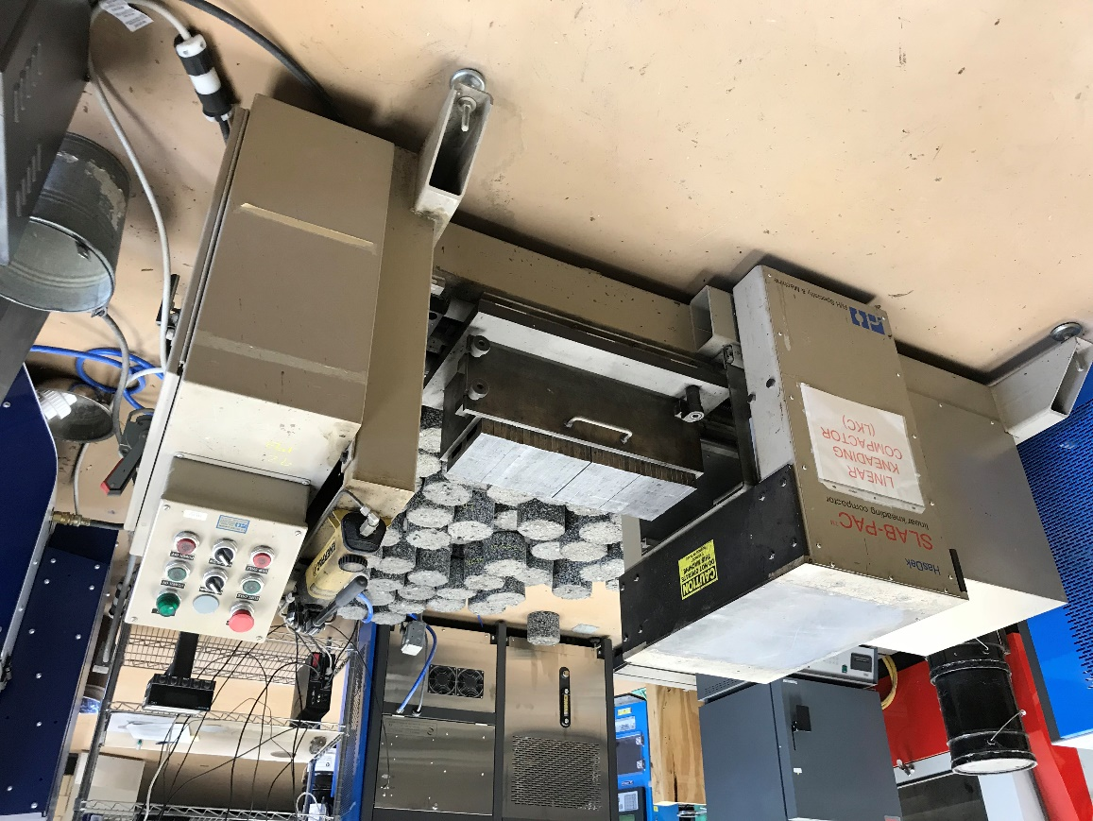
Figure 68. Photo. Linear kneading compactor.
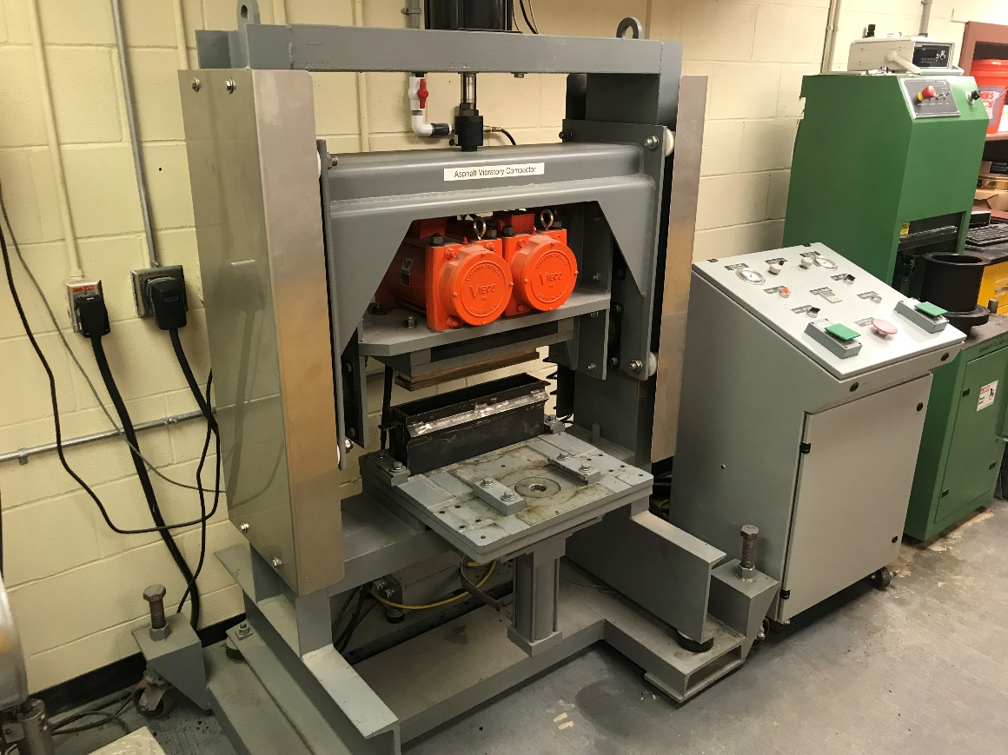
Figure 69. Photo. Vibratory compactor.
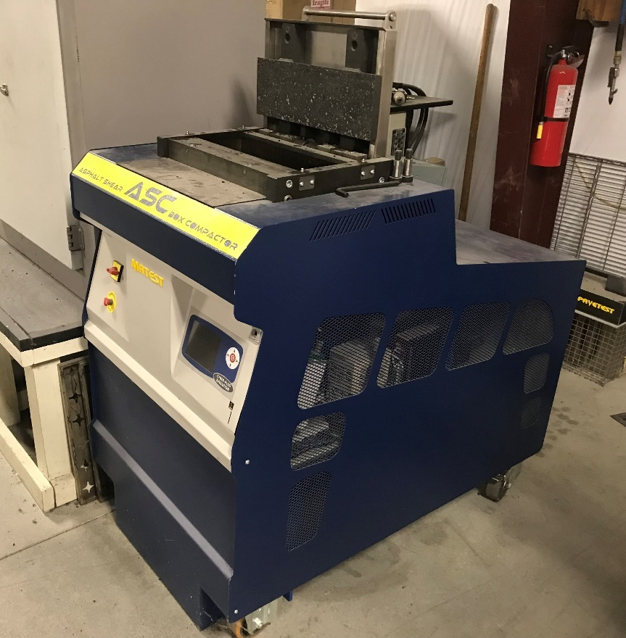
Figure 70. Photo. Shear box compactor.
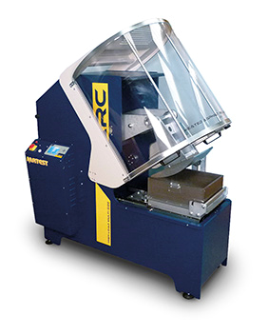
Figure 71. Photo. Segmented roller compactor.

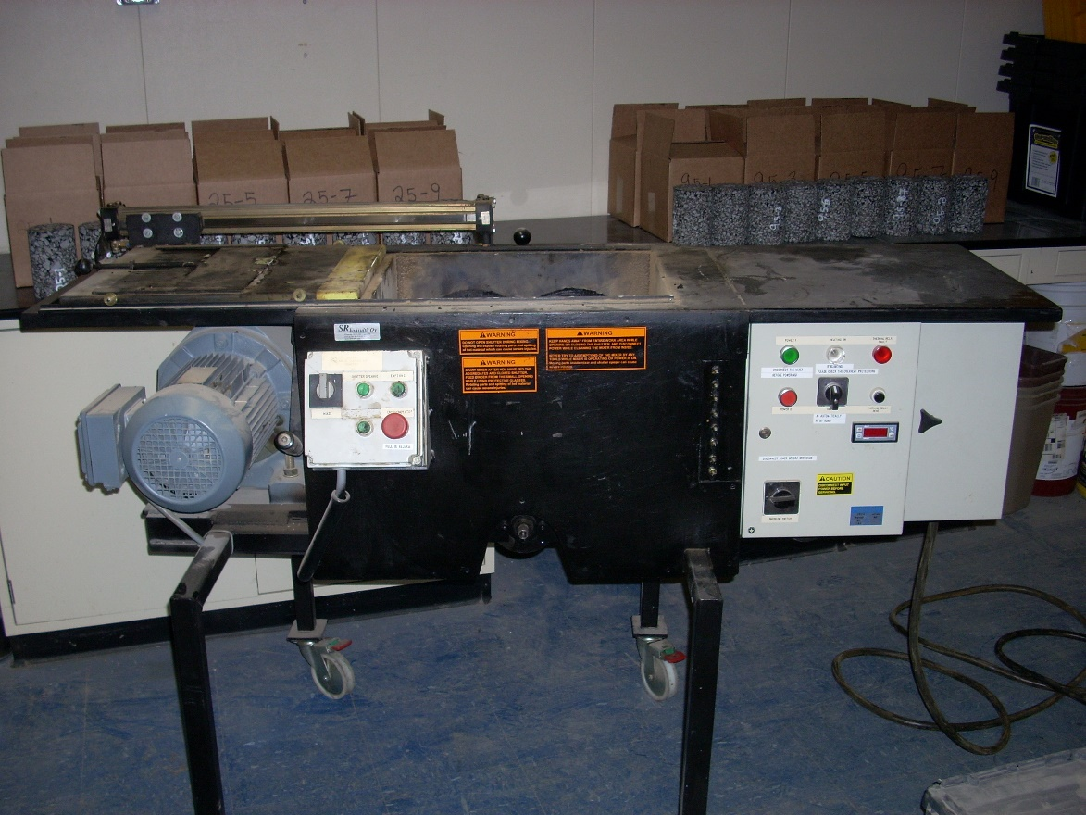
Figure 72. Photo. Large laboratory mixer.

A major consideration in the selection of equipment for beam specimen fabrication is the type of saw. Although acceptable beam specimens can be prepared using either a single- or double- bladed saw, a double-bladed saw with automatic feed control is much more efficient when many beam specimens must be prepared. With this type of saw, specimen preparation time is significantly reduced, and the final test beams will have more parallel sides and more consistent dimensions. If a single-bladed saw is used, the clamps for holding the specimen should be designed so that the specimen does not have to be removed from the clamping system to make parallel sides of the beam specimen. Once an appropriate feed rate is determined, a saw with automatic feed control will produce much more uniform specimens with less tearing of aggregates from the specimen surface. Another consideration in the selection of a saw, is the cut depth. Blocks prepared with a segmented roller or shear box compactor can be over 150 mm deep requiring a saw with cutting depth greater than 150 mm. Figure 73 is a photograph of a double-bladed saw with automatic feed control having a cutting depth of 200 mm.

Figure 73. Photo. Double-bladed automatic feed control saw.

5.2.2 Flexural Fatigue Testing Equipment
There are two options for performing flexural fatigue tests: (1) an appropriate four-point flexural fatigue fixture mounted in a general-purpose servo-hydraulic machine or (2) a small stand-alone pneumatic device designed specifically for four-point flexural fatigue testing. Figure 74 is a photograph of a four-point flexural fatigue fixture in a general-purpose servo-hydraulic testing machine. A small stand-alone pneumatic flexural fatigue device was shown earlier in Figure 65. Flexural fatigue testing requires loads less than 5 kN; making small stand-alone pneumatic devices attractive. The stand-alone pneumatic devices are bottom loading. The four-point flexural fatigue fixtures for general purpose servo-hydraulic machines may be top or bottom loading. Figure 74 shows a bottom loading four-point flexural fatigue fixture in a servo-hydraulic machine. The major requirements for devices for flexural fatigue testing are:

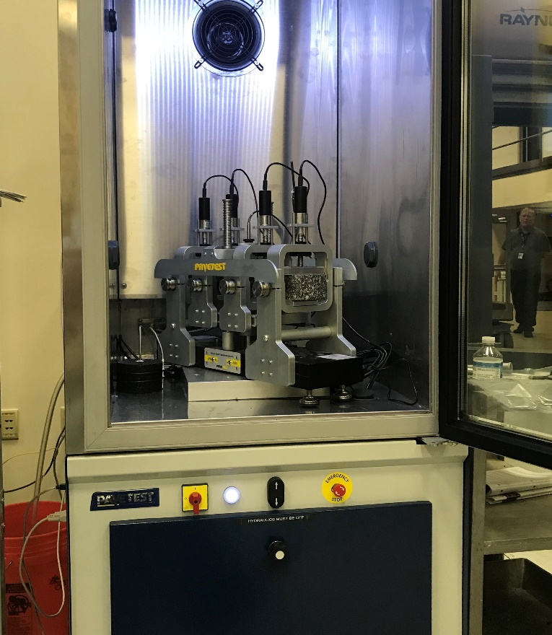
Figure 74. Photo. Four-point flexural fatigue device for a general-purpose servo-hydraulic testing machine.
- Four-Point Bending. The device must load the specimen through two loading points that are equally spaced on either side of the middle of the beam. The distance between the reaction supports and the loading points must be the same as the distance between the two loading points. Four-point bending produces a constant moment over the middle portion of the beam.

- Automated Clamps. The beam is clamped in the four-point bending device to allow the beam to be loaded in both directions without backlash. The clamps must be automated to apply a constant clamping force throughout the test. The clamps must be designed to allow free translation and rotation. A system of aligning the clamps at the proper spacing when inserting the beam into the testing machine greatly simplifies the testing.

- Closed-Loop Loading. Closed-loop computer control is needed to apply sinusoidal loading to the beam at frequencies from 5 to 10 Hz. A 10 Hz loading is usually used to reduce the overall testing time. The test is conducted by controlling the displacement of the beam using an LVDT at the center of the beam that measures the displacement of the mid-point of the beam relative to the reaction supports. The deflection required to produce a target extreme fiber strain is computed using beam theory. See the equation in Figure 75 below.

- Data Acquisition. During each loading cycle, the data acquisition system must record the load and beam deflection as a function of time. The amplitude of the load and displacement are used to calculate: (1) the maximum tensile strain, (2) the maximum tensile stress, and (3) the flexural stiffness using the equations in Figure 75, Figure 76, and Figure 77, respectively. The phase angle is calculated from the time lag between the peak load and the peak displacement using the equation in Figure 78.

- Environmental Chamber. Temperature control is critical for all tests on asphalt materials. Since moderate to low strain flexural fatigue tests may last several hours or even days, the flexural fatigue device must be inside an environmental chamber. The environmental chamber should control the temperature with ±0.5 ºC of the target test temperature.

$$ε_{t}=\frac{\left(12×δ×h\right)}{\left[\left(3×L^{2}\right)-\left(4×a^{2}\right)\right]}$$
where:
ε_{t}= maximum extreme fiber tensile strain, mm/mm (in/in)
δ = peak displacement of the center of the beam, mm (in)
h = average height of the beam, mm (in)
a = center to center spacing of the clamps, mm (in)
L = center to center distance between outside clamps, mm (in)
Figure 75. Equation. Extreme fiber tensile strain in beam in four-point bending.

$$σ_{t}=\frac{\left(3×a×P\right)}{\left(b×h^{2}\right)}$$
where:
σ_{t}= maximum tensile stress, MPa, (psi)
a = center to center spacing of the clamps, mm (in)
P = peak load, N (lb)
b = average width of the beam, mm (in)
h = average height of the beam, mm (in)
Figure 76. Equation. Maximum tensile stress in beam in four-point bending.

$$S=\frac{σ_{t}}{ε_{t}}$$where:
S = flexural stiffness, MPa, (psi)
σ_{t}= maximum tensile stress, MPa, (psi)
ε_{t}= maximum extreme fiber tensile strain, mm/mm (in/in)
Figure 77. Equation. Flexural stiffness calculation.

$ϕ=360×f×s$
where:
ϕ = phase angle, degrees
f = loading frequency, Hz
s = time lag between peak load and peak displacement, s
Figure 78. Equation. Flexural stiffness calculation.

5.3 Procedures

5.3.1 Specimen Fabrication Procedure
AASHTO T 321 is conducted on beam specimens that are 380 mm long by 63 mm wide by 50 mm thick. Laboratory fatigue relationships for Level 1 analysis using Pavement ME Design should be determined from fatigue tests performed on laboratory prepared mixtures that have been short-term conditioned in accordance with AASHTO R 30. At least 12 beams should be prepared and tested specimens (4 strain levels at 3 temperatures) to fit the laboratory fatigue relationship given by the equation in Figure 67.

The preparation of beam specimens for AASHTO T 321 testing is similar to the fabrication procedure described in Section 2.3.1 of this guide for preparing dynamic modulus specimens. First a larger block or slab is prepared to a target air void content that is 1.0 to 1.5 percent higher than the target air void content of the test beam. Then the test beam is sawed from the larger block or slab. The sections below review the four critical aspects of specimen fabrication: (1) mixture preparation, (2) loose mix conditioning, (3) compaction, and (4) sawing, emphasizing special considerations for R²AMs.

5.3.1.1 Mixture Preparation
Beams for flexural fatigue testing are usually prepared from larger slab or block specimens that are compacted in one of the compactors shown earlier in Figures 68 through 71. The batch size required for specimen preparation depends on the size of the slab or block that will be compacted. It ranges from 3 to 4 kg for a single beam specimen compacted in the vibratory compactor to over 30 kg for multiple beams cut from a slab or block prepared in a linear kneading, segmented roller, or shear box compactor. Large batches of asphalt mixture can be prepared as a single batch in a large laboratory mixer similar to that shown in Figure 72 or by combining several smaller batches mixed in a bucket mixer or a 20 qt planetary mixer. Batching and mixture preparation outlined in MS-2 (Asphalt Institute, 2015) should be followed using the appropriate batch size. Appendix X2 of AASHTO R 35 provides recommended practices for laboratory preparation of WMA mixtures to reasonably replicate several WMA processes.

The preparation of laboratory loose mix of R²AMs is generally the same as that for virgin mixtures with the following exceptions. First, for mixtures incorporating RAP or RAS, the RAP and RAS should not be heated with the virgin aggregate, which are often heated overnight. Instead, the RAP and RAS should be heated in an oven set to the mixing temperature for 1.5 to 3.0 hours, then combined with the virgin aggregate during the aggregate dry mixing step. This is done to avoid excessive heating of the RAP and RAS which may alter the properties of the recycled binder (West, et. al., 2013). For mixtures incorporating a GTR modified binder, the binder must be stirred often during the mixture preparation process because these binders are not storage stable and rubber particles will tend to separate and sink to the bottom when the binder is in a fluid state.

No special handling is needed for the preparation of specimens from plant mix samples of R²AMs. Like other mixtures, these should be reheated to the compaction temperature in an oven set at the compaction temperature.

5.3.1.2 Loose Mix Conditioning
Laboratory prepared loose mix should be short-term conditioned in accordance with AASHTO R 30, for 4 hours at 135 °C to “To account for short-term aging that occurs during mixing and compaction…” (Applied Research Associates, 2004). Short-term conditioning of large batches of loose mix requires a large surface area. Conditioning loose mix per AASHTO R 30 requires about 100 to 200 cm² of pan area per kg of loose mix. Conditioning 4 kg of loose mix requires 400 to 800 cm² of pan area, while conditioning 30 kg of loose mix require 0.3 to 0.6 m² of pan area. It is easier to short-term condition large batches in several smaller pans and combine them when charging the compaction mold. Plant produced mix samples should not receive any additional conditioning; they should be reheated to the compaction temperature in an oven set at the compaction temperature.

5.3.1.3 Compaction
Although AAHTO T 321 specifically references AASHTO PP 3, rolling wheel compaction, or AASHTO T 247, California kneading compaction, these two methods are rarely used in practice. Most laboratories that perform flexural fatigue testing use compactors that can prepare slab or block specimens. Four different compactors that have been used for preparing flexural fatigue specimens where shown previously in Figures 68 through 71. Although ASTM standards are available for preparing specimens using a segmented rolling compactor, ASTM D 8079, or a shear box compactor, ASTM D 7981, the best source of information for compaction using a specific device is the manufacturer’s instructions.

AASHTO T 321 requires that at least 6 mm be sawed from all faces of flexural beam specimens. This trimming removes regions of higher air voids that occur at the top and bottom of the block or slab specimens and along the walls of the compaction mold. Therefore, to prepare beam specimens to a target air void content, the larger block or slab should be compacted to a higher air void content, typically 1.0 to 1.5 percent, higher than the target air void content for the sawed beam specimens. The air void content of the block or slab is controlled by controlling the mass of mixture and the compacted height. The number of beams with uniform density and the compacted height that should be used to produce beam specimens with uniform density must be determined by trial and error for the specific compaction equipment being used. For the shear box compactor used in this project, a few trial compactions were conducted to establish that four beams of uniform density could be obtained by sawing the beams from the middle of a 450 mm long, by 150 mm wide, by 150 mm high block. Once the height that produces specimens of uniform density is determined for the compaction equipment, the mass of mixture needed to produce slabs or blocks with a target air void content for each mixture is determined using the equation in Figure 79 below. If beams sawed from the block or slab do not meet the air void tolerance for the beam specimens, then a linear adjustment to the mixture mass should be made using the Equation in Figure 80. This is the same approach outlined in AASHTO R 83 for preparing dynamic modulus specimens. No special procedures are needed when compacting R²AMs.

$${BM}_{Trial}=\frac{\left(100-Air Voids\right)}{100}×\frac{Gmm}{1000}×l×w×h$$
where:
BM_{Trial} = trial block or slab mass, kg
Air Voids = target air voids for the block or slab, %
Gmm = mixture maximum specific gravity
h = block or slab height previous uniformity analysis, cm
l = block or slab length cm
w = block or slab width cm
Figure 79. Equation. Equation for estimating the mass of mixture for trial specimens to target a specified air void content.
$$BM_{Adjusted}=\left[\frac{\left(100-T\arg{e}t Air Voids\right)}{\left(100-Measured Air Voids\right)}\right]×BM_{Trial}$$
where:
BM_{Adjusted} = adjusted block or slab mass, kg
BM_{Trial} = trial block or slab mass, kg
Target Air Voids = target test specimen air voids, %
Measured Air Voids = measure air voids of the trial test specimen %
Figure 80. Equation. Equation for adjusting the specimen mass when trial specimens are outside the air void tolerance.

5.3.1.4 Sawing
The last step in the preparation of flexural fatigue beam specimens is to sawcut the beams to the final dimensions of 380 mm long by 63 mm wide by 50 mm. The tolerance in AASHTO T 321 for all dimensions is ± 6 mm. It is important that the beams are rectangular with parallel sides and that the width and thickness be uniform over the length of the beam. As discussed earlier, a double-bladed saw with automatic feed control greatly simplifies the cutting of beam specimens. With this type of saw, specimen preparation time is significantly reduced, and the final test beams will have more parallel sides and more consistent dimensions. If a single-bladed saw is used, the clamps for holding the specimen should be designed so that the specimen does not have to be removed from the clamping system to cut the parallel sides of the specimen. Laboratory procedures that yield acceptable beam specimens for virgin mixtures will also produce acceptable specimens for R²AM.

The thickness and width of the test beams should be measured with calipers at three locations along the length of the beam to the nearest 0.1 mm. The average width and thickness are used in the stress, strain, and stiffness calculations. The length of the beam can be measured with a ruler. The beam length is not used in the calculations. The length in the calculations is the center to center distance between the outside clamps.

5.3.2 Flexural Fatigue Testing
Modern computer testing equipment makes flexural fatigue testing relatively easy to perform. Testing equipment suppliers have developed control and data acquisition software to perform testing in accordance with AASHTO T 321. Once the beam specimen is clamped in the testing equipment, the software performs the testing per AASHTO T 321, collects the resulting load and displacement data, and calculates and reports the maximum tensile stress, maximum tensile strain, flexural stiffness, phase angle, and the product of the flexural stiffness and load cycles. The traditional definition of failure for a strain controlled flexural fatigue test on asphalt mixtures is the number of cycles required for the flexural stiffness to decrease to 50 percent of its initial value. In recent changes to AASHTO T 321, the definition of failure has been changed to the number of cycles where the product of the specimen stiffness and load cycles is a maximum. The sections below review important aspects of flexural fatigue testing.

5.3.2.1 Specimen and Loading Fixture Dimensions
When developing an S-N curve for an asphalt mixture, it is important that the specimen dimensions be carefully controlled and that the correct dimensions for the specimen and loading fixture be used when calculating the extreme fiber tensile strain. Most flexural fatigue devices have a system for aligning the clamps at the proper spacing. The testing machine controls the midpoint displacement of the beam, which is related to the extreme fiber tensile strain and the specimen and loading fixture dimensions in accordance with equation in Figure 75. The strain, stress, and stiffness calculations are based on classical beam theory, which includes several simplifying assumptions that are not entirely met by asphalt mixture beams. Therefore, it is important to use the same size beams for tests at different strain levels when developing an S-N curve.

5.3.2.2 Temperature Selection and Control
Fatigue tests at multiple temperatures are required to develop laboratory fatigue coefficients used in Pavement ME Design. Test temperatures of 10, 20, and 30 ºC are recommended. Like all tests on asphalt mixtures, temperature control during flexural fatigue testing is critical. AASHTO T 321 specifies a tolerance of ±0.5 ⁰C. A monitoring beam with a thermocouple or RTD mounted at the center should be used to determine the temperature of the test beams. The test specimens and the monitoring specimen must be subjected to the same thermal history during conditioning and testing.

5.3.2.3 Selection of Strain Levels
At each temperature, flexural fatigue tests should be conducted over a range of strain levels to provide fatigue lives between 10,000 and 1,000,000 cycles. At 10 Hz loading, a 10,000-cycle test takes 17 minutes, while a 1,000,000-cycle test takes 27.8 hours. Tests at four strain levels for each temperature are recommended. For typical dense graded asphalt mixtures start testing with a strain of 500 μstrain at each temperature. Based on the results of the 500 μstrain test, increase or decrease the strain level in increments of 100 to 200 μstrain to obtain data within the range of 10,000 to 1,000,000 cycles. As test temperatures increases, higher strains will be required for the same target cycles to failure.

5.3.2.3 Beam Alignment and Clamping
The beam is inserted through the open end of the flexural fatigue device. Most fatigue devices have alignment marks to facilitate proper alignment of the beam in the testing fixture. The aligning gauge for the clamps is used to properly position the four clamps. Once the beam and the clamps are positioned, the outside clamps are tightened first, followed by the inside clamps. The clamps on most flexural fatigue devices have small motors that maintain the clamping force throughout the test.

5.3.2.4 Testing and Data Acquisition
Once the beam is properly aligned and clamped, and it is confirmed that the testing chamber and the monitoring specimen are at the planned testing temperature, the control software is used to start the fatigue test. The testing technician should monitor the following periodically during fatigue testing:

- Tensile Strain. The control software provides a screen report of the maximum tensile strain for each cycle of the fatigue test. The maximum tensile strain should be controlled within a few micro strain of the target value. Fatigue test equipment that has adaptive level control greatly simplifies maintaining a constant tensile strain during the test. The adaptive level control varies the proportional gain of the system as required to consistently reach the target strain level.

- Shape of the Loading. The flexural fatigue equipment controls the loading by controlling the amplitude and shape of the midpoint deflection of the beam. The shape of the loading should be sinusoidal. Since the test is conducted in displacement control, once the system is properly tuned for displacement control, adjustment of the tuning during the test is not necessary. The shape of the loading should be monitored periodically checking to see that the displacement trace is a smooth curve without steps. Steps in the displacement curve are an indication of movement at the beam support clamps, the loading clamps, the loading actuator, or the beam displacement sensor.

- Temperature. Temperature control is critical during fatigue testing. Since fatigue tests may last several hours or days, the temperature of the test chamber should be carefully monitored during test. This is best done using the screen graphing in the control software. A typical plot is shown in Figure 81. The target temperature was 20 ºC. In addition to the measured temperatures, ± 0.5 ºC tolerances are shown. This particular test was carried out to 1,130,660 cycles, which is a duration of 31.4 hours at 10 Hz loading. Proper temperature control is particularly important in long duration tests.
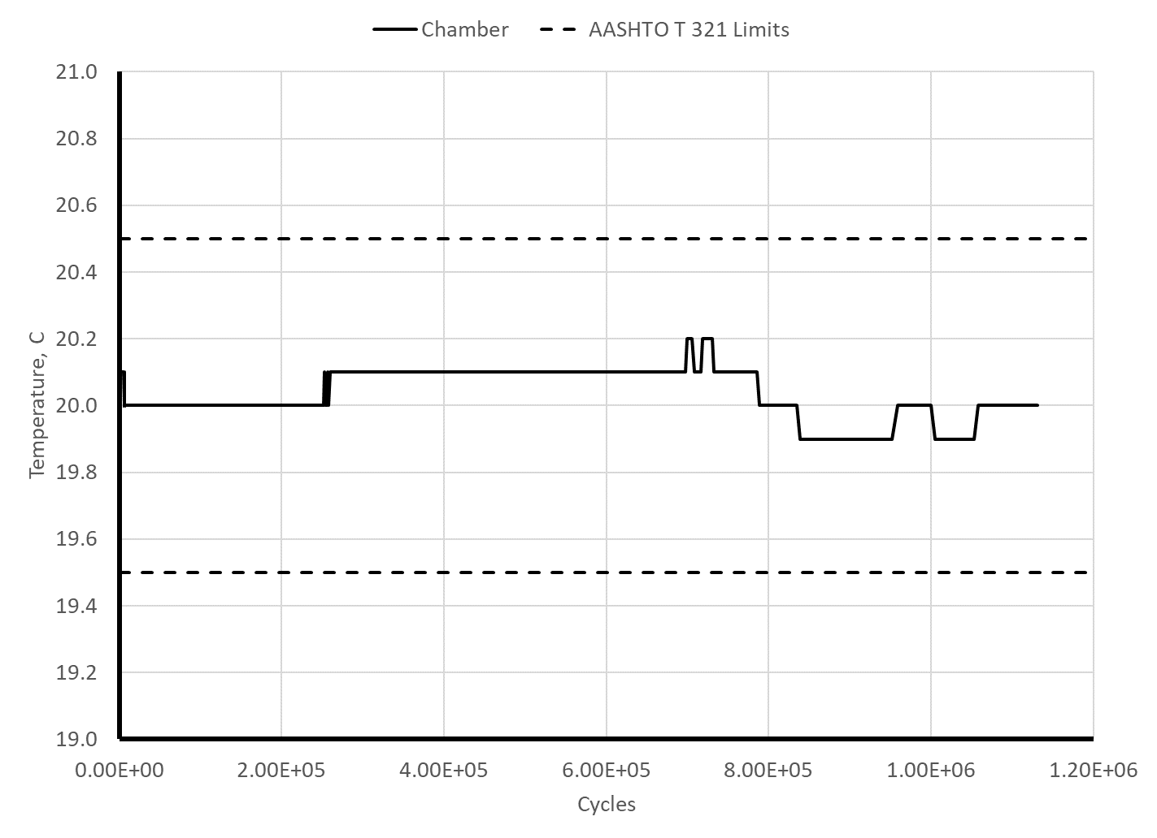
Figure 81. Graph. Test chamber temperature a during fatigue test.
- Flexural Stiffness and Product of Cycles and Flexural Stiffness. Controlled strain flexural fatigue tests result in a gradual reduction of the flexural stiffness of the beam with increasing load cycles. The traditional definition of failure in flexural fatigue testing is the number of cycles required to reduce the flexural stiffness to 50 percent of its initial value. AASHTO T 321 defines the initial stiffness as the stiffness at 50 cycles of loading. The gradual reduction in stiffness and typical cycle to cycle variation in stiffness make it difficult to detect when 50 percent reduction has occurred; therefore, fatigue tests are typically continued until to 60 percent or greater reduction with the number of cycles to 50 percent reduction determined by curve fitting. A plot of the product of flexural stiffness and cycles, on the other hand, exhibits a distinct peak. Figure 82 shows a plot comparing the flexural stiffness and the product of flexural stiffness and cycles as a function of the loading cycles. The two definitions of failure are also shown on this plot. By inspection of the raw data, the fatigue life based on the traditional 50 percent stiffness reduction is 933,250 while the fatigue life using the peak of the product of stiffness and cycles is 1,020,670. The difference between the two values is approximately 10 percent of the mean. Usually the peak of the product of stiffness and cycles occurs after 50 percent modulus reduction; therefore, monitoring a screen plot of this parameter during testing provides the information needed for proper termination of the fatigue test. Continuing the test to approximately 10 percent reduction in the peak of the product of flexural stiffness and cycles provides sufficient information to determine the peak using the polynomial curve fitting described in the next section
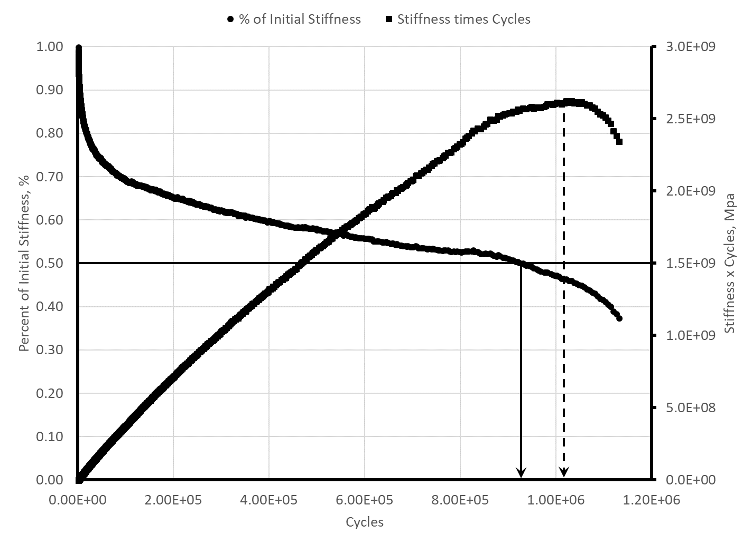
Figure 82. Graph. Plots of change in initial stiffness and the product of stiffness and cycles during fatigue testing.

5.4 Data Analysis
Analysis of the flexural fatigue data collected using AASHTO T 321 to determine the fatigue life of the beam is straightforward. Per the current version of the test method, the fatigue life is defined as the number of load cycles where the peak occurs in the stiffness times cycles versus cycles curve. The peak is determined by fitting a 6th order polynomial to the data collected from cycle 50 where the initial stiffness is determined to the point where the curve has decreased to 90 percent of the apparent peak value. The apparent peak value is the maximum value obtained from the raw data. The polynomial is then differentiated, and the derivative is set to zero to determine the peak. The resulting equation is given in Figure 83. The fitting is easily accomplished using the trendline function in Excel, and the equation in Figure 83 is easily solved using the goal seek function in Excel. Figure 84 shows the polynomial fit and the coefficients for the data in Figure 82. Substituting the coefficients into the equation inf Figure 83 and solving with the goal seek command in Excel yields a fatigue life of 1,005,763 for this beam.

$$0=a_{1}+2a_{2}x+3a_{3}x^{2}+4a_{4}x^{3}+5a_{5}x^{4}+6a_{6}x^{5}$$
where:
a₁, a₂, a₃, a₄, a₅, a₆ = polynomial coefficients for x, x², x³, x⁴, x⁵, x⁶
Figure 83. Equation. Equation for solving for the cycle where the peak of the stiffness times cycles occurs.
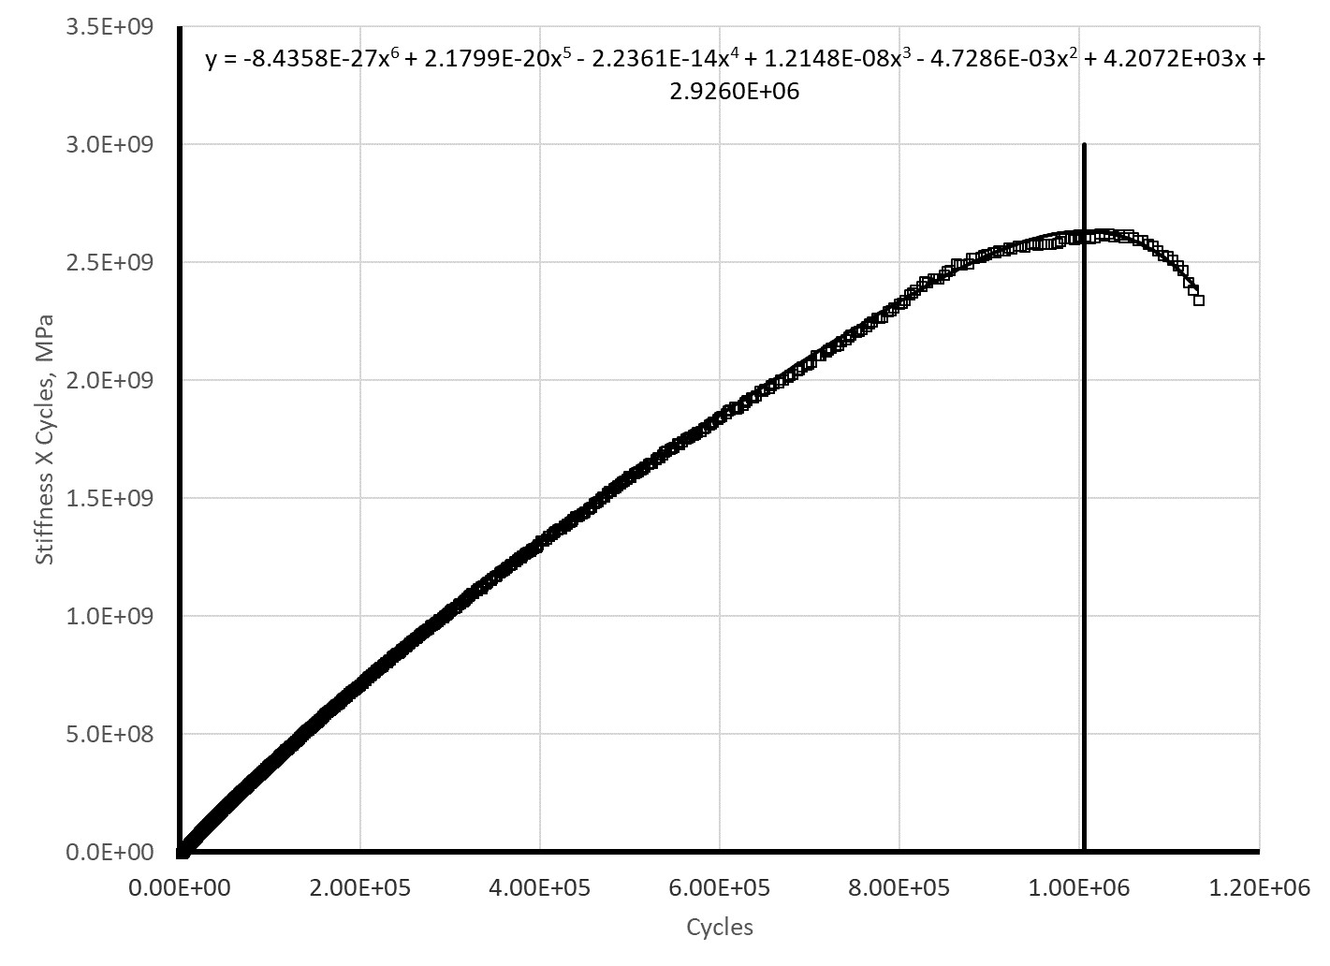
Figure 84. Graph. Polynomial fitting to determine AASHTO T 321 fatigue life.
The laboratory fatigue relationship is reproduced in Figure 85. The coefficients k_{1f}, k_{2f}, and k_{3f} for the pavement fatigue model in Pavement ME Design are determined by fitting the equation in Figure 85 to the laboratory fatigue lives of beams tested at 12 combination of temperature and frequency (3 temperatures and 4 frequencies). In addition to the fatigue lives, the average VFA of the specimens tested and the dynamic modulus at the temperatures and frequency used in the fatigue testing are needed. The dynamic modulus is best obtained from a dynamic modulus master curve determined as outlined in Chapter 2 of this guide. The fitting can be performed using the regression function in Excel. For each beam tested, first take the base 10 logarithm of the average tensile strain during the test, the base 10 logarithm of the dynamic modulus and the base 10 logarithm of the fatigue life. Subtract (VMA-0.69) from the logarithm of the fatigue life and then use the linear regression function in Excel to determine the coefficients k_{1f}, k_{2f}, and k_{3f}.

5.5 Example
This section presents an example of AASHTO T 321 specimen fabrication, testing, and analysis using data from the North Carolina high recycle content surface mixture. This was a mixture sampled at the asphalt plant. It was produced using a PG 58-28 binder with 5 percent manufacturer RAS and 20 percent RAP. Approximately 33 percent of the binder in this mixture was recycled binder with approximately equal amounts coming for the RAP and the RAS.

$$\log{N_{f}}-\left(VFA-0.69\right)={\log{k_{1f}-k_{2f}}\log{ε_{t}-}k}_{3f}\log\left|E^{*}\right|$$
where:
N_{f} = number of load cycles to failure
ε_{t} = tensile strain used in the fatigue test, in/in
|E*| = dynamic modulus at the frequency and temperature used in the fatigue test, psi
VFA = voids filled with asphalt expressed as a decimal
k_{1f}, k_{2f}, k_{3f} = laboratory fatigue coefficients
Figure 85. Equation. Laboratory fatigue equation for determining k_{1f}, k_{2f} and k_{3f}.

5.5.1 Step 1. Select Number of Specimens, Target Air Void Content, and Testing Temperature
Data for 12 beams are needed to determine the laboratory fatigue coefficients for fatigue analysis using Pavement ME Design. Fatigue tests are conducted at 10, 20, and 30 ºC. At each temperature fatigue tests are conducted using 4 strain levels. The beams were compacted to a target air void content of 7.0 percent based on typical specifications for in-place compaction.

5.5.2 Step 2. Specimen Fabrication
The beam specimens were fabricated using a shear box compactor shown earlier in Figure 70. Preliminary work with this compactor established that four beams of uniform density could be cut from a block 450 mm long, by 150 mm wide, by 150 mm high. The target air void content of the beams was 7.0 percent; therefore, the target air voids for an initial trial block was 8.0 percent. The North Carolina surface mixture had a maximum specific gravity of 2.437 yielding a trial block mass of 24.67 kg using the equation in Figure 79. The mixture was prepared in three 8.22 kg batches using a 20 qt planetary mixer and short-term conditioned for 4 hours at 135 ⁰C in 480 mm by 280 mm pans. The air void content of the four beams cut from the trial block ranged from 6.0 to 6.4 percent with an average of 6.2 percent. Using the equation in Figure 80, the block mass was adjusted to 24.46 kg. Four beams from this block had air void contents ranging from 7.1 to 7.3 percent with an average of 7.2 percent. Two additional blocks were compacted using the mass of 24.46kg. Table 29 summarizes the air void content and dimensions of the 12 beam specimens.

5.5.3 Step 3. Flexural Fatigue Testing
The flexural fatigue tests were conducted in the stand-alone pneumatic device shown earlier in Figure 65. The center to center spacing of the loading clamps on this device is 118.5 mm and the center to center spacing of the support clamps is 237 mm. The dimensions and the average width and thickness of each specimen listed in Table 29 were used to calculate the maximum strain, the maximum stress, and the flexural stiffness using the equations in Figure 75, Figure 76, and Figure 77, respectively.

The data from flexural fatigue tests conducted at 20 ºC using 10 Hz loading are shown in Figure 85 for testing at 900 μstrain, Figure 86 for testing at 700 μstrain, Figure 87 for testing at 500 μstrain, and Figure 88 for testing at 400 μstrain. The duration of these tests ranged from about 30 minutes for the 900 μstrain test to about 32 hours of the 400 μstrain test. Figure 89 and Figure 90 show the level of strain and temperature control during the 400 μstrain test. During this 32-hour test, the chamber temperature varied ±0.2 ºC and the strain varied ±2 μstrain.
Table 29. Air voids and dimensions of North Carolina surface mixture fatigue specimens.
ID | Air Voids % | Left Width, mm | Center Width, mm | Right Width, mm | Average Width, mm | Left Thickness, mm | Center Thickness, mm | Right Thickness, mm | Average Thickness, mm | Length, mm
1 | 7.3 | 61.1 | 60.5 | 60.6 | 60.7 | 52.2 | 51.9 | 51.9 | 52.0 | 380
2 | 7.2 | 61.1 | 60.6 | 61.4 | 61.0 | 52.3 | 52.4 | 51.9 | 52.2 | 380
3 | 7.2` | 61.2 | 61.3 | 61.0 | 61.2 | 51.7 | 52.0 | 52.3 | 52.0 | 380
4 | 7.1 | 60.7 | 60.9 | 60.5 | 60.7 | 52.2 | 52.3 | 52.5 | 52.3 | 380
5 | 6.9 | 60.8 | 61.2 | 60.9 | 61.0 | 51.8 | 51.8 | 52.1 | 51.9 | 380
6 | 6.7 | 60.6 | 61.4 | 61.2 | 61.1 | 52.5 | 51.7 | 51.8 | 52.0 | 380
7 | 6.9 | 61.4 | 61.5 | 60.5 | 61.1 | 52.4 | 52.2 | 52.5 | 52.4 | 380
8 | 6.7 | 60.8 | 60.6 | 61.3 | 60.9 | 52.3 | 52.5 | 51.8 | 52.2 | 380
9 | 6.7 | 61.1 | 61.2 | 60.5 | 60.9 | 52.3 | 51.5 | 52.0 | 51.9 | 380
10 | 6.7 | 60.9 | 61.0 | 61.2 | 61.0 | 52.5 | 52.2 | 52.3 | 52.3 | 380
11 | 6.7 | 61.4 | 60.7 | 61.2 | 61.1 | 52.1 | 52.3 | 51.7 | 52.0 | 380
12 | 6.8 | 61.4 | 60.5 | 61.2 | 61.0 | 51.5 | 51.7 | 52.3 | 51.8 | 380

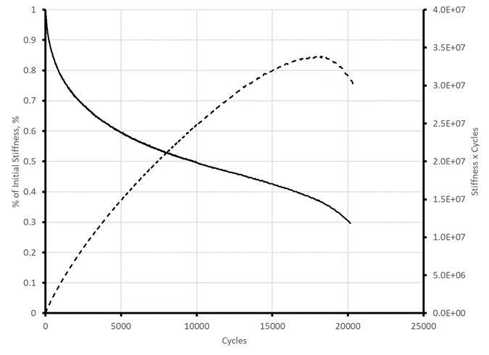
Figure 86. Graph. Fatigue test results for North Carolina surface mixture tested at 20 ºC, 900 μstrain.

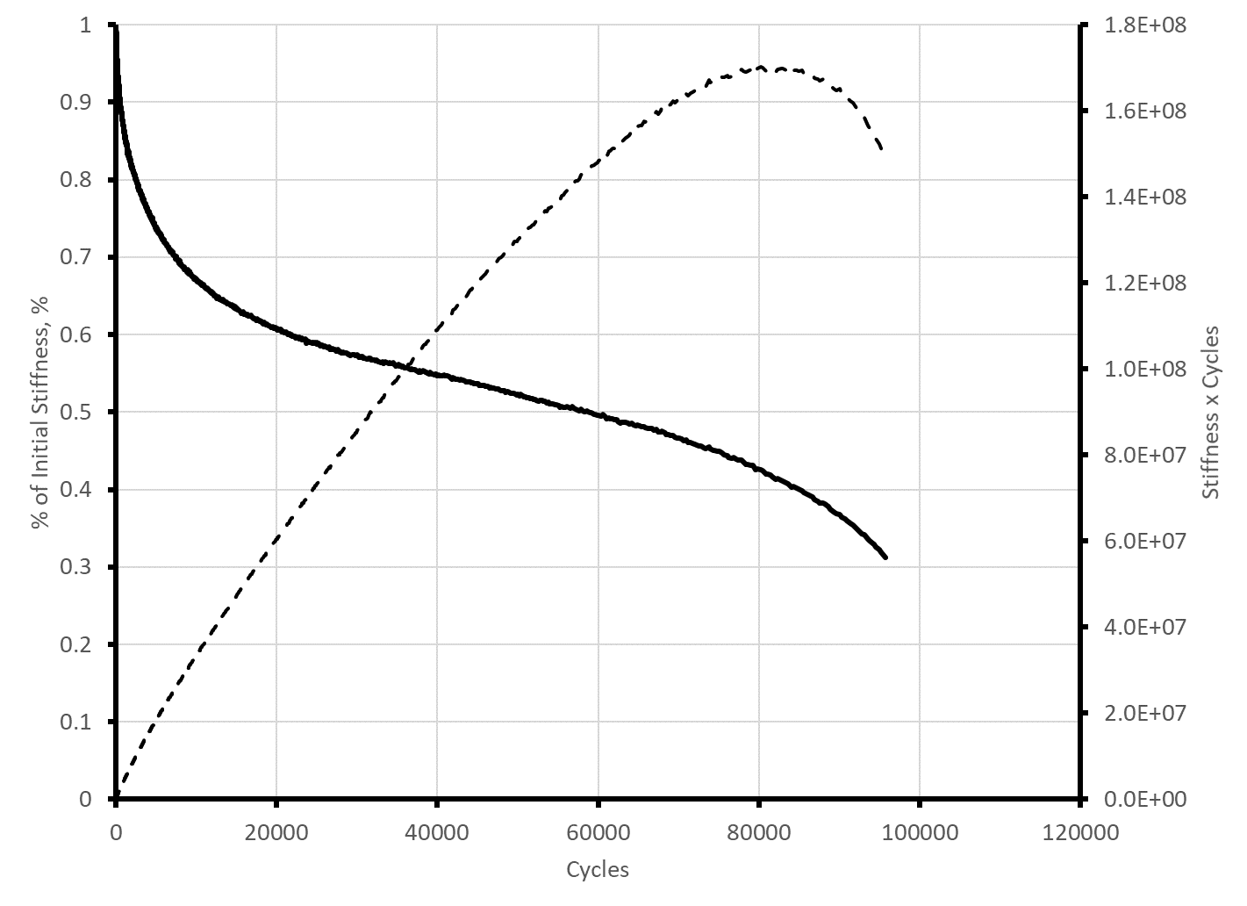
Figure 87. Graph. Fatigue test results for North Carolina surface mixture tested at 20 ºC, 700 μstrain.
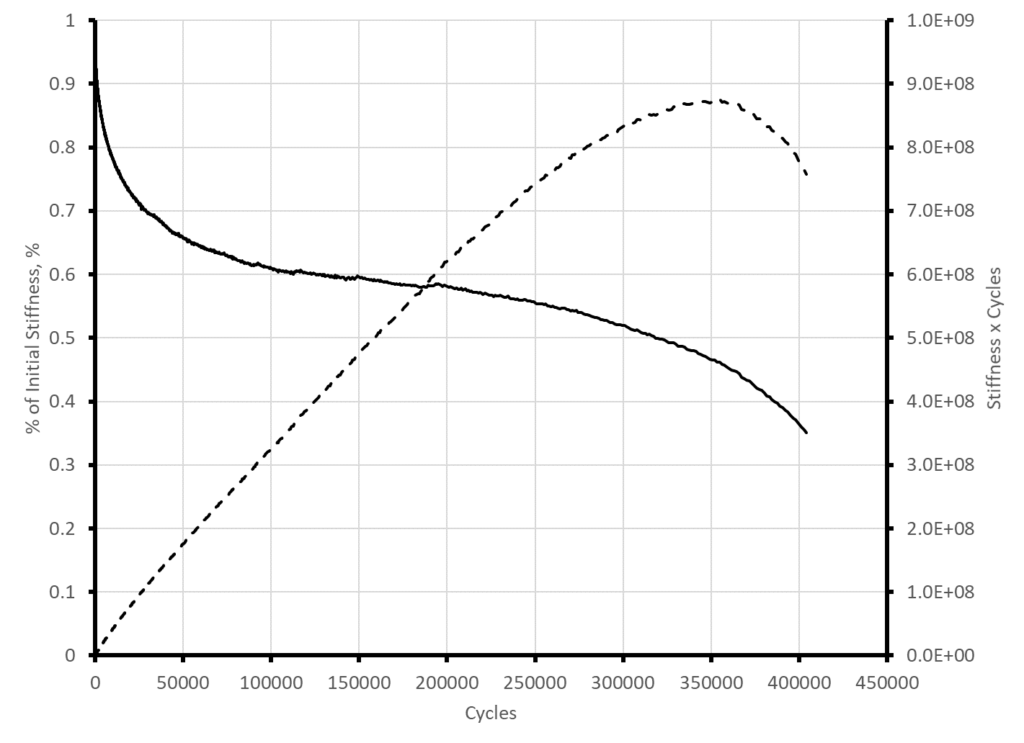
Figure 88. Graph. Fatigue test results for North Carolina surface mixture tested at 20 ºC, 500 μstrain.
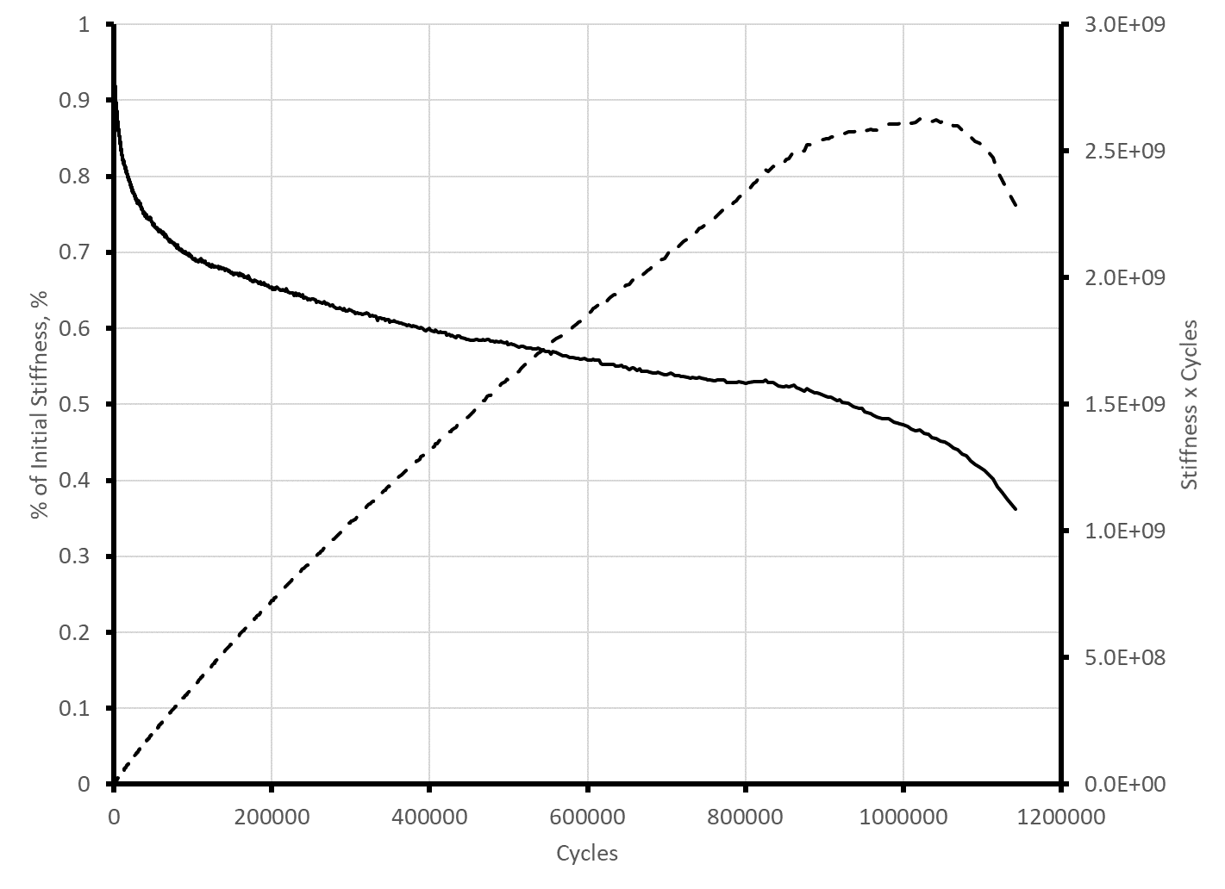
Figure 89. Graph. Fatigue test results for North Carolina surface mixture tested at 20 ºC, 400 μstrain.
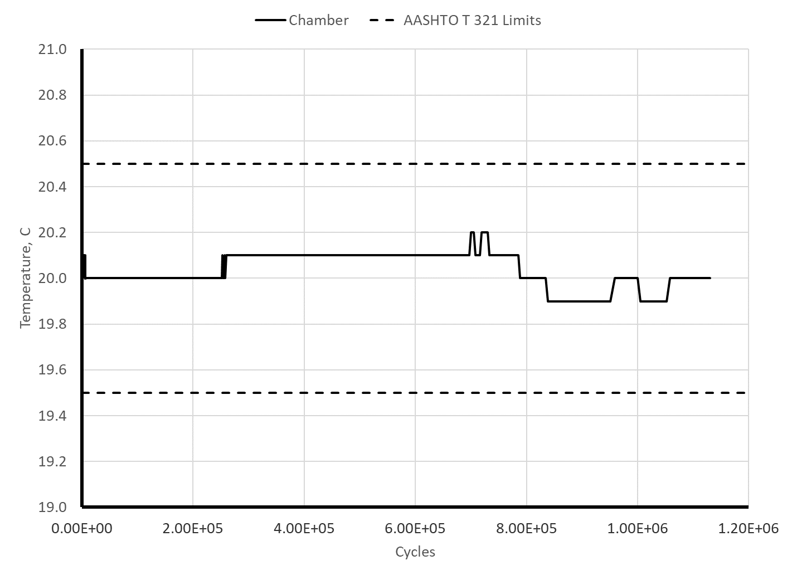
Figure 90. Graph. Temperature control during 32-hour fatigue test.
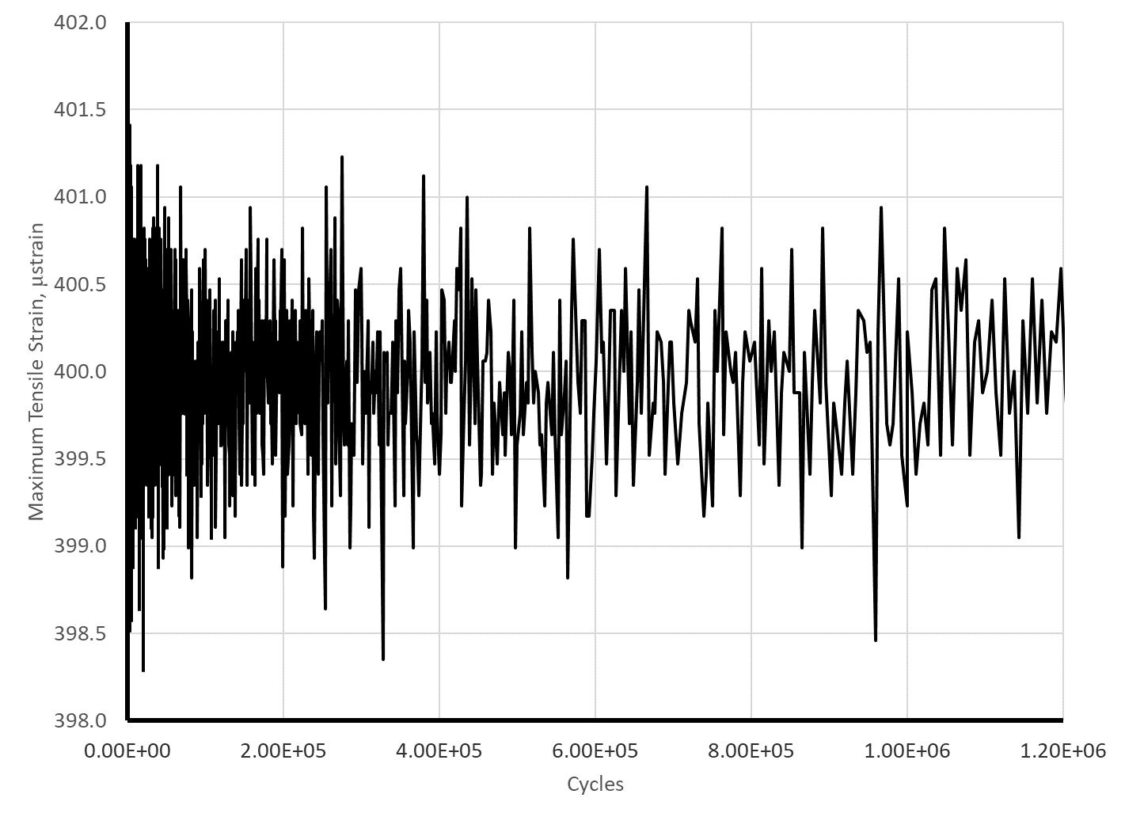
Figure 91. Graph. Strain control during 1.2 million cycle fatigue tests.

5.5.4 Step 4. Data Analysis
Each test is analyzed to determine the fatigue life of the specimen tested. The traditional definition of fatigue life is the number of cycles required to reduce the flexural stiffness of the specimen to 50 percent of the initial flexural stiffness. The initial flexural stiffness is defined as the flexural stiffness at 50 cycles. The definition of the fatigue life was recently changed to the peak of the flexural stiffness times cycles versus cycles curve. The peak is determined by fitting a sixth order polynomial to the data and setting the equation for the derivative to zero.

Table 30 summarizes the calculation of the fatigue life of the four specimens of the North Carolina surface mixture tested at 20 ºC using the peak of the stiffness times cycles per the current version of AASHTO T 321. Table 30 also includes the fatigue life determined using the traditional definition of 50 percent flexural stiffness reduction. The fatigue life using the current definition is consistently longer than the traditional definition. At higher strain levels, the fatigue life using the current definition is about 1.8 times that from the traditional definition, while at low strain levels the current definition produces about 10 percent longer fatigue lives.

Table 30. Fatigue lives for the North Carolina surface mixture at 20 ºC.
Item | 900 μstrain | 700 μstrain | 500 μstrain | 400 μstrain
Coefficient a₆ | -3.6882E-18 | -1.9844E-21 | -1.9381E-24 | -9.3524E-27
Coefficient a₅ | 2.0397E-13 | 5.2871E-16 | 2.2066E-18 | 2.4443E-20
Coefficient a₄ | -4.6890E-09 | -5.6761E-11 | -1.0078E-12 | -2.5153E-14
Coefficient a₃ | 5.7467E-05 | 2.9911E-06 | 2.1989E-07 | 1.3461E-08
Coefficient a₂ | -4.4892E-01 | -8.8240E-02 | -2.4118E-02 | -4.9936E-03
Coefficient a₁ | 4.2332E+03 | 3.9425E+03 | 4.2653E+03 | 4.2249E+03
Fatigue Life (Peak of stiffness times cycles), cycles | 17,699 | 82,009 | 346,723 | 1,004,762
Fatigue Life (50 percent stiffness reduction, cycles | 9,850 | 58,730 | 317,440 | 926,679

The final step in analysis of flexural fatigue data is to determine the laboratory fatigue coefficients k_{1f}, k_{2f}, and k_{3f} by fitting the Equation in Figure 85 to the fatigue life data for the 12 beams that were tested. Table 31 presents the data from the fatigue tests on the North Carolina surface mixture using the peak of the stiffness times cycles as the failure criterion. The dynamic modulus data were determined from the dynamic modulus master curve developed for this mixture following the procedures in Chapter 2 of this guide. Dynamic modulus values were calculated using the master curve equation for a frequency of 10 Hz and the temperatures of 10, 20, and 30 ºC used in the testing. The VFA at 7 percent air voids for this mixture was reported in Table 1 as 0.646 Table 31 also presents the transformed data that used as input to the linear regression function in Excel.
Table 31. Data and regression input for determining laboratory fatigue coefficients.
Data |  |  |  |  | Regression Input
Temp, C | Strain, in/in | |E*|,  Psi | N_{f},  cycles | VFA | Log (1/strain) | Log (1/|E*|) | Log N_{f} -(VFA-0.69)
10 | 0.0003 | 1580000 | 1416150 | 0.646 | 3.52288 | -6.19866 | 6.19511
10 | 0.0004 | 1580000 | 255070 | 0.646 | 3.39794 | -6.19866 | 5.45066
10 | 0.0005 | 1580000 | 37430 | 0.646 | 3.30103 | -6.19866 | 4.61722
10 | 0.0007 | 1580000 | 18660 | 0.646 | 3.15490 | -6.19866 | 4.31491
20 | 0.0004 | 984000 | 1004762 | 0.646 | 3.39794 | -5.99300 | 6.04606
20 | 0.0005 | 984000 | 346723 | 0.646 | 3.30103 | -5.99300 | 5.58398
20 | 0.0007 | 984000 | 82009 | 0.646 | 3.15490 | -5.99300 | 4.95786
20 | 0.0009 | 984000 | 17699 | 0.646 | 3.04576 | -5.99300 | 4.29195
30 | 0.0005 | 521000 | 1107750 | 0.646 | 3.30103 | -5.71684 | 6.08844
30 | 0.0006 | 521000 | 279680 | 0.646 | 3.22185 | -5.71684 | 5.49066
30 | 0.0007 | 521000 | 264030 | 0.646 | 3.15490 | -5.71684 | 5.46565
30 | 0.0009 | 521000 | 53740 | 0.646 | 3.04576 | -5.71684 | 4.77430

Figure 92 shows the Excel regression output. The equation provides a good fit to the data with an adjust R² of 0.93. The intercept coefficient of 2.8785 is log(k_{1f}); therefore, k_{1f} for this mixture is 10^{2.8785} or 756. The coefficient for log (1/strain) is k_{2f} and the coefficient for log(1/|E*|) is k_{3f}. Figure 93 shows a plot of the estimated versus measured cycles to failure.
Figure 92. Illustration. Excel regression output for fitting the laboratory fatigue coefficients for the North Carolina surface mixture.
Figure 93. Graph. Predicted versus measured cycles to failure for the North Carolina surface mixture.

5.6 Summary of Recommended Flexural Fatigue Testing and Analysis Practices
Pavement ME Design uses an adjusted version of the Asphalt Institute fatigue equation to model top down and bottom up fatigue cracking. The general form of this equation was established through analysis of flexural fatigue test results published by various researchers. The mixture specific fatigue coefficients are obtained from flexural fatigue tests conducted at 12 combinations of temperature and strain level using AASHTO M 321. The preceding sections of this chapter presented detailed descriptions of the state of the practice for fatigue testing. The sections below summarize important points presented in this chapter.

5.6.1 Specimen Fabrication
AASHTO T 321 does not include detailed instructions for fabricating the 380 mm long by 63 mm wide by 50 mm thick beam specimens needed for flexural fatigue testing. Mixture fatigue properties to support mechanistic-empirical pavement design should be measured using laboratory prepared specimens that have been short-term conditioned in accordance with AASHTO R 30 and compacted to the typical in-place air void content of pavements produced using the agency’s compaction specification, usually around 7.0 percent.

The procedure for fabricating beam specimens is similar to that described in AASHTO R 83 for preparing dynamic modulus specimens. First a larger block or slab specimen is compacted to an air void content that is 1.0 to 1.5 percent higher than the target air void content for the beam specimens. Then, the beam specimens are sawcut from the larger block or slab. The primary differences are: (1) the type of compactor, (2) the size of the batch of mixture that must be prepared if multiple beams will be sawcut from the block or slab, and (3) a saw with capability to cut rectangular specimens with parallel sides.

Although AASHTO T 321 references kneading or rolling wheel compaction for laboratory prepared specimen compaction, these two methods are rarely used in practice. Most laboratories performing flexural fatigue testing use either a linear kneading compactor, a vibratory compactor, a segmented roller compactor, or a shear box compactor. ASTM has published standard compaction procedures for segmented roller and shear box compactors.

The batch size required for specimen preparation depends on the size of the slab or block that will be compacted. It ranges from 3 to 4 kg for a single beam specimen compacted in the vibratory compactor to over 30 kg for multiple beams cut from a slab or block prepared in a linear kneading, segmented roller, or shear box compactor. Large batches of asphalt mixture can be prepared as a single batch in a large laboratory mixer or by combining several smaller batches mixed in a bucket mixer or a 20 qt planetary mixer. When large batches are needed, it is generally easier to batch, mix, and condition several smaller batches and then combine the batches when charging the compaction mold. Conditioning loose mix per AASHTO R 30 requires about 100 to 200 cm² of pan area per kg of loose mix. Conditioning 4 kg of loose mix requires 400 to 800 cm² of pan area, while conditioning 30 kg of loose mix require 0.3 to 0.6 m² of pan area.

Beam specimens with parallel sides can be sawcut using a single or double-bladed saw with appropriate clamping fixtures. A double-bladed saw with automatic feed control greatly improves specimen preparation efficiency when many specimens are required. Double-bladed saws produce specimens with more consistent dimensions and more parallel sides. Automatic feed control reduces the amount of aggregate that tears from the surface of the specimen during cutting. If a single bladed saw is used, the clamping fixture should allow parallel faces of the specimen to be sawcut without removing the specimen from the clamping fixture. This will provide specimens with more parallel sides and more consistent dimensions. Finally, the maximum depth of cut for the saw should exceed the maximum height for specimens produced by the compactor. For example, segmented roller and shear box compactors can compact blocks that are over 150 mm deep requiring a saw having a depth of cut greater than 150 mm.

5.6.2 Testing
Flexural fatigue testing in accordance with AASHTO T 321 may be conducted with: (1) a four- point bending fixture in a general-purpose servo-hydraulic testing machine or (2) a stand-alone pneumatic four-point bending device. The stand-alone pneumatic devices are useful when many flexural fatigue tests will be conducted. The following are critical equipment requirements:

- Four-Point Bending. The device must provide four-point loading. The distance between the reaction supports and the loading points must be the same as the distance between the two loading points.

- Automated Clamps. The clamps holding the beam must be automated to apply a constant clamping force throughout the test. The clamps must be designed to allow free translation and rotation. A system of aligning the clamps at the proper spacing when loading the beam greatly simplifies the testing.

- Closed-Loop Loading. Closed-loop, computer control is needed to apply sinusoidal loading to the beam at frequencies from 5 to 10 Hz. A 10 Hz loading is usually used to reduce the overall testing time. The test is conducted by controlling the displacement of the beam using an LVDT at the center of the beam that measures the displacement of the mid-point of the beam relative to the reaction supports. Beam theory is used to relate the mid-point deflection to the extreme fiber tensile strain.

- Data Acquisition. During each loading cycle, the data acquisition system must record the load and beam deflection as a function of time. The amplitude of the load and displacement are used to calculate: (1) the maximum tensile strain, (2) the maximum tensile stress, and (3) the flexural stiffness.

- Environmental Chamber. Temperature control is critical for all tests on asphalt materials. Since moderate to low strain flexural fatigue tests may last several hours or even days, the flexural fatigue device must be inside an environmental chamber. The environmental chamber should control the temperature with ±0.5 ºC of the target test temperature.

Modern computer testing equipment makes flexural fatigue testing relatively easy to perform. Testing equipment suppliers have developed control and data acquisition software to perform testing in accordance with AASHTO T 321. Once the beam specimen is clamped in the testing equipment, the software performs the testing per AASHTO T 321, collects the resulting load and displacement data, and calculates and reports the maximum tensile stress, maximum tensile strain, flexural stiffness, phase angle, and the product of the flexural stiffness and load cycles. Although flexural fatigue testing is highly automated, attention to detail is needed in the following areas:

- Specimen and Loading Fixture Dimensions. Specimen dimensions should be carefully controlled and the correct dimensions for the specimen and loading fixture must be used when calculating the extreme fiber tensile strain. The strain, stress, and stiffness calculations are based on classical beam theory, which includes several simplifying assumptions. Therefore, it is important to use the same size beams for tests at different strain levels when developing a laboratory fatigue relationship.

- Temperature Selection and Control. The recommended temperatures for fatigue testing to develop a laboratory fatigue relationship is 10, 20, and 30 ⁰C. Like all tests on asphalt mixtures, temperature control during flexural fatigue testing is critical. AASHTO T 321 specifies a tolerance of ±0.5 ⁰C. A monitoring beam with a thermocouple or RTD mounted at the center should be used to determine the temperature of the test beams. The test specimens and the monitoring specimen must be subjected to the same thermal history during conditioning and testing.

- Selection of Strain Levels. When developing a laboratory fatigue relationship for an asphalt mixture, flexural fatigue tests should be conducted over a range of strain levels to provide fatigue lives between 10,000 and 1,000,000 cycles. At 10 Hz loading, a 10,000-cycle test takes 17 minutes, while a 1,000,000-cycle test takes 27.8 hours. Tests at four strain levels for each temperature are recommended. For typical dense graded asphalt mixtures start testing with a strain of 500 μstrain at each temperature. Based on the results of the 500 μstrain test, increase or decrease the strain level by 100 to 200 μstrain to obtain data within the range of 10,000 to 1,000,000 cycles. As test temperatures increases, higher strains will be required for the same target cycles to failure.

- Beam Alignment and Clamping. Ensure that the beam is properly aligned in the flexural fatigue fixture and use the aligning gauge to properly position the clamps. Once the beam and the clamps are positioned, Tighten the outside clamps first, followed by the inside clamps.

- Periodic Monitoring. During testing use the plotting capabilities of the control software to monitor the: (1) tensile strain, (2) temperature, (3) flexural stiffness, and (4) product of the flexural stiffness and load cycles. The test should be stopped after the curve of flexural stiffness times load cycles versus load cycles drops to about 90 percent of the peak value. The shape of the loading should be monitored periodically checking to see that the displacement trace is a smooth sinusoidal curve without steps. Steps in the displacement curve are an indication of movement at the beam support clamps, the loading clamps, the loading actuator, or the beam displacement sensor. Since the test is conducted in displacement control, once the system is properly tuned for displacement control, adjustment of the tuning during the test is not necessary.

5.6.3 Data Analysis
Analysis of flexural fatigue data includes: (1) determining the fatigue life of each specimen tested, and (2) developing a laboratory fatigue relationship for the mixture. The traditional definition of the fatigue life for a strain controlled flexural fatigue test on asphalt mixtures is the number of cycles required for the flexural stiffness to decrease to 50 percent of its initial value. In recent changes to AASHTO T 321, the definition of fatigue life has been changed to the number of cycles where the product of the specimen stiffness and load cycles is a maximum. The fatigue life using the current definition is determined by fitting a 6th order polynomial to the curve of flexural stiffness times load cycles versus load cycles and finding the number of cycles where the derivative of the fitted equation is zero. Fatigue lives using the current definition are somewhat longer than those determined using the traditional definition.

The data required to develop a laboratory fatigue relationship are: (1) the fatigue life for the 12 combinations of test temperature and strain level, (2) the dynamic modulus at 10 Hz for the temperatures used in the testing, and (3) the average VFA for the beam specimens tested. Linear regression is used to fit the coefficients of the laboratory fatigue relationship after base 10 logarithmic transformation of the strain, dynamic modulus, and fatigue life data. This is easily accomplished using the regression function in Excel.

5.7 Typical Flexural Fatigue Properties for R²AMs
Flexural fatigue data were collected in accordance with AASHTO T 321 for the nine mixtures sampled during this project. For each mixture fatigue tests were conducted for multiple strain levels at 10, 20, and 30 ºC using 10 Hz loading. The testing was conducted before the recent change to the failure definition in AASHTO T 321; therefore, the reported fatigue lives and the laboratory fatigue relationships presented below are based on 50 percent stiffness reduction.

The fatigue life data are combined with 10 Ha dynamic modulus values in Table 32. Except for the Pennsylvania polymer modified surface mixture, the dynamic modulus values are from the master curves presented in section 2.6 of this guide. The dynamic modulus values for the Pennsylvania polymer modified surface mixtures were estimated from the master curve for the Pennsylvania GTR modified surface mixture by multiplying by the ratio of the flexural stiffnesses measured during the fatigue testing. The VFA of the mixtures at 7 percent air voids were reported earlier in Table 1 and Table 2.

Coefficients for the laboratory fatigue relationship given in Figure 85 were determined for each of the mixtures using the linear regression function in Excel after logarithmic transformation of the data. Table 33 summarizes the coefficients and the explained variance. The general form of the fatigue relationship reasonably fits the measured data with explained variance ranging from 87 to 96 percent. Figure 95 and Figure 96 compare the fitting coefficients for the various mixtures. These figures reveal no clear trends in the coefficients for the fatigue relationships.

Table 32. Summary R²AMs fatigue data for fitting laboratory fatigue relationships.
Mixture and Property | 10 ºC | 10 ºC | 10 ºC | 10 ºC | 20 ºC | 20 ºC | 20 ºC | 20 ºC | 30 ºC | 30 ºC | 30 ºC | 30 ºC
WI High RAP Base Strain, in/in | 0.0003 | 0.0005 | 0.0007 |  | 0.0003 | 0.0005 | 0.0007 | 0.0009 | 0.0005 | 0.0007 | 0.0009 | 0.0011
WI High RAP Base Modulus, psi | 1287000 | 1287000 | 1287000 |  | 784000 | 784000 | 784000 | 784000 | 434000 | 434000 | 434000 | 434000
WI High RAP Base Cycles to Failure | 215440 | 15840 | 2070 |  | 838170 | 81690 | 15250 | 3820 | 73370 | 24230 | 6840 | 3240
WI High RAP Surface Strain, in/in | 0.0003 | 0.0005 | 0.0007 |  | 0.0003 | 0.0005 | 0.0007 | 0.0009 | 0.0005 | 0.0007 | 0.0009 | 0.0011
WI High RAP Surface Modulus, psi | 1580000 | 1580000 | 1580000 |  | 979000 | 979000 | 979000 | 979000 | 530000 | 530000 | 530000 | 530000
WI High RAP Surface Cycles to Failure | 1047120 | 47010 | 8760 |  | 2089290 | 49860 | 19540 | 9160 | 52610 | 16800 | 8780 | 9430
NC High RAP Base Strain, in/in | 0.0002 | 0.0003 | 0.0005 | 0.0007 | 0.0002 | 0.0003 | 0.0005 | 0.0007 | 0.0003 | 0.0005 | 0.0007
NC High RAP Base Modulus, psi | 1658000 | 1658000 | 1658000 | 1658000 | 1025000 | 1025000 | 1025000 | 1025000 | 534000 | 534000 | 534000
NC High RAP Base Cycles to Failure | 973490 | 52340 | 11420 | 1560 | 2915610 | 193490 | 26910 | 1570 | 300830 | 28470 | 8700
NC High RAP Binder Strain, in/in | 0.0003 | 0.0005 | 0.0007 |  | 0.0004 | 0.0005 | 0.0007 | 0.0009 | 0.0004 | 0.0005 | 0.0007
NC High RAP Binder Modulus, psi | 1595000 | 1595000 | 1595000 |  | 990000 | 990000 | 990000 | 990000 | 530000 | 530000 | 530000
NC High RAP Binder Cycles to Failure | 220460 | 9110 | 2050 |  | 100380 | 21650 | 7760 | 2950 | 319880 | 100380 | 11330
NC High RAP Surface Strain, in/in | 0.0003 | 0.0004 | 0.0005 | 0.0007 | 0.0004 | 0.0005 | 0.0007 | 0.0009 | 0.0005 | 0.0006 | 0.0007 | 0.0009
NC High RAP Surface Modulus, psi | 1580000 | 1580000 | 1580000 | 1580000 | 984000 | 984000 | 984000 | 984000 | 521000 | 521000 | 521000 | 521000
NC High RAP Base Cycles to Failure | 1544850 | 217930 | 40630 | 9940 | 926679 | 317440 | 58730 | 9850 | 908510 | 185490 | 64890 | 24480
MA ARGG Strain, in/in | 0.0004 | 0.0005 | 0.0007 |  | 0.0004 | 0.0005 | 0.0006 | 0.0007 | 0.0006 | 0.0007 | 0.0009
MA ARGG Modulus, psi | 1003800 | 1003800 | 1003800 |  | 577200 | 577200 | 577200 | 577200 | 305000 | 305000 | 305000
MA ARGG Cycles to Failure | 1513560 | 175790 | 14520 |  | 1782830 | 189810 | 164680 | 49600 | 317440 | 139100 | 53830
FL GTR Surface Strain, in/in | 0.0003 | 0.0004 | 0.0005 | 0.0007 | 0.0004 | 0.0005 | 0.0006 | 0.0007 | 0.0004 | 0.0005 | 0.0006 | 0.0007
FL GTR Surface Modulus, psi | 1570000 | 1570000 | 1570000 | 1570000 | 970000 | 970000 | 970000 | 970000 | 521000 | 520000 | 520000 | 520000
FL GTR Surface Cycles to Failure | 1693900 | 404260 | 149040 | 7540 | 867620 | 248310 | 82750 | 39910 | 439870 | 210530 | 66230 | 27190
PA GTR Surface Strain, in/in | 0.0003 | 0.0004 | 0.0005 | 0.0007 | 0.0004 | 0.0005 | 0.0007 | 0.0008 | 0.0005 | 0.0006 | 0.0007 | 0.0009
PA GTR Surface Modulus, psi | 1351400 | 1351400 | 1351400 | 1351400 | 764000 | 764000 | 764000 | 764000 | 372400 | 372400 | 372400 | 372400
PA GTR Surface Cycles to Failure | 1728930 | 123490 | 56230 | 13080 | 1764680 | 272260 | 47610 | 36680 | 1617660 | 446680 | 214610 | 116140
PA PMA Surface Strain, in/in | 0.0003 | 0.0004 | 0.0005 | 0.0007 | 0.0004 | 0.0005 | 0.0007 | 0.0009 | 0.0005 | 0.0007 | 0.0009 | 0.0011
PA PMA Surface Modulus, psi | 1542600 | 1542600 | 1542600 | 1542600 | 878600 | 878600 | 878600 | 878600 | 428200 | 428200 | 428200 | 428200
PA PMA Surface Cycles to Failure | 2670950 | 349400 | 47250 | 11020 | 2279170 | 555900 | 132330 | 21980 | 2550740 | 635810 | 306660 | 201060

Table 33. Laboratory fatigue coefficients for selected R²AMs.
Parameter | WI High RAP Base | WI High RAP Surface | NC High RAP Base | NC High RAP Binder | NC High RAP  Surface | MA ARGG | FL GTR Surface | PA GTR Surface | PA PMA Surface
k_{1f} | 1.78E-01 | 3.57E-07 | 7.06E-06 | 7.84E-02 | 5.93E-02 | 1.85E-06 | 4.75E-11 | 3.37E+02 | 3.36E+07
k_{2f} | 4.895 | 4.496 | 5.116 | 4.931 | 5.642 | 6.287 | 5.588 | 5.257 | 5.172
k_{3f} | 1.799 | 0.553 | 1.241 | 1.763 | 2.010 | 1.625 | 0.477 | 2.435 | 3.159
R² | 0.94 | 0.87 | 0.96 | 0.96 | 0.94 | 0.88 | 0.90 | 0.93 | 0.91

Figure 94. Graph. Comparison of strain, k_{2f}, and modulus, k_{3f}, exponents for selected R²AMs.
Figure 95. Graph. Comparison of constant, k_{1f} in fatigue relationship for selected R²AMs.

Chapter 6. Summary

This guide presented detailed information on the equipment and procedures needed to perform material property characterization of asphalt mixtures to obtain Level 1 input properties for Pavement ME Design. It was developed for the engineers and technicians that are responsible for testing asphalt mixtures to support pavement designs Pavement ME Design. This guide presented details concerning: (1) the equipment that is needed to fabricate and test asphalt mixture specimens, (2) the procedures for specimen fabrication and testing, (3) techniques for assessing the quality of the test data that are collected, and (4) methods to analyze the data and calculate material properties. The material properties covered by this guide include: (1) dynamic modulus, (2) repeated load permanent deformation coefficients, (3) low temperature creep compliance and tensile strength, and (4) fatigue coefficients. Detailed examples that include: (1) specimen fabrication, (2) material property testing, (3) data quality assessment, and (4) data analysis were presented using actual data collected on two types of R²AM, high recycled binder content mixtures and mixtures incorporating GTR modified binder. The companion to this guide, published as a separate document, provides guidance on designing flexible pavements and overlays using R²AMs. It addresses the analysis required to transform the test data into the inputs required by Pavement ME Design and provides several examples of pavements incorporating R²AMs that were designed using Pavement ME Design. Part two is intended for engineers responsible for performing pavement design and analysis using Pavement ME Design.

In the sections that follow, a series of tables that summarize equipment requirements, test procedures, and data analysis methods are presented and discussed. These are followed by summary tables presenting special considerations for R²AMs.

6.1 Equipment Requirements
Table 34 summarizes the equipment required for specimen fabrication for Pavement ME Design Level 1 material property characterization. Much of the same equipment can be used to fabricate specimens for dynamic modulus, permanent deformation, low temperature creep and strength, and flexural fatigue testing. The differences in equipment requirements are highlighted below:

- Compactor. Two types of compactors are required. Specimens for dynamic modulus, permanent deformation, and creep compliance and strength are compacted using a gyratory compactor. The same gyratory compactor can be used provided the compactor can prepare specimens that are 160 mm or taller. Flexural fatigue specimens may be compacted using a linear kneading, vibratory, shear box, or segmented roller compactor.

- Core drill. A core drill with 100 mm inside diameter bit is required to core dynamic modulus and permanent deformation specimens from larger the gyratory specimens.

- Masonry Saw. Specimen fabrication for all Level 1 tests require a masonry saw to trim the test specimens to the appropriate dimensions. Dynamic modulus and permanent deformation specimens require a cutting depth greater than 100 mm. Creep compliance and strength specimens require a cutting depth greater than 150 mm. The cutting depth for flexural fatigue specimens can be greater than 150 mm if for the shear box and segmented roller compactors.
Table 34. Equipment for specimen fabrication for Level 1 material property characterization.
Item | Details | Reference | Dynamic Modulus | Permanent Deformation | Creep Compliance and Strength | Flexural Fatigue
Aggregate Preparation Equipment | Mechanical sieve shaker, sieves, and pans for separating aggregates into appropriate size fractions for batching. | AI MS-2
Mixture Preparation Equipment | Thermometers, balances, ovens, pans, 20 qt mechanical mixer, and miscellaneous hand tools for preparing asphalt mixtures. | AI MS-2
Splitting Equipment | Mechanical splitter and associated equipment for reducing plant mix samples to the appropriate size. | AASHTO R 47
Superpave Gyratory Compactor | Superpave gyratory compactor and associated equipment for compacting specimens to a specified height. | AASHTO T 312 | Specimens >160 | Specimens >160 mm
Beam or Slab Compactor | Vibratory, linear kneading, shear box, or Segmented roller compactor | ASTM D7981  ASTM D8079  Manufacturer’s literature
Conditioning Oven | Forced draft oven for short-term conditioning laboratory prepared asphalt mixtures. | AASHTO R 30
Core Drill | Air- or water-cooled diamond core drill with 100 mm diameter bit and 150 mm diameter gyratory specimen holder. | AASHTO R 83
Masonry Saw | Air- or water-cooled diamond saw with appropriate clamps. | AASHTO R 83 | > 100 mm cutting depth | > 100 mm cutting depth | > 150 mm cutting depth | >Beam or slab thickness
Bulk Specific Gravity Equipment | Balances, water bath, suspension apparatus, oven and vacuum sealing device and accessories if needed | AASHTO T 166, AASHTO T 331
Maximum Specific Gravity Equipment | Balances, water bath, suspension apparatus, oven, vacuum system, mechanical shaker, vacuum bowl or pycnometer. | AASHTO T209
Specimen Dimension Measuring Equipment | Square, feeler gauges or wire, metal ruler, and calipers | AASHTO R 83

Although testing equipment suppliers market large laboratory mixers to prepare the volume of mix needed for large slab or block specimens, these are not recommended for two reasons. First, these mixers do not have weight measurement capabilities making them cumbersome to use. Second, short-term conditioning in accordance with AASHTO R 30 requires the mix to be spread out to a thickness of 25 to 50 mm while conditioning. It is easier to handle and condition the mixture in several moderate batches and recombine the batches when charging the compaction mold.

Table 35 summarizes the equipment needed to perform the Level 1 material property tests. All Level 1 tests cannot be performed in a single general-purpose servo-hydraulic machine. A 100 kN machine for low temperature creep compliance and strength testing will not provide acceptable haversine loading at the low load levels needed for dynamic modulus testing at 35, 40, or 45 ºC. Additionally, permanent deformation and flexural fatigue tests are long duration tests. A 10,000-cycle permanent deformation test requires 2.8 hours to complete per specimen. A 1,000,000-cycle flexural fatigue test at 10 Hz requires 27.8 hours to complete. Agencies that want to conduct Level 1 material property tests should plan on acquiring multiple testing machines. The best equipment for flexural fatigue testing is the stand-alone pneumatic 4-point bending device. The best equipment for dynamic modulus and permanent deformation testing is the AMTP. Low temperature creep compliance and strength testing requires a 100 kN, general-purpose servo-hydraulic machine. In addition to the testing machines, separate environmental chambers to condition test specimens at the testing temperatures are recommended to improve laboratory productivity.
Table 35. Equipment for Level 1 material property characterization testing.
Item | Dynamic Modulus | Permanent Deformation | Creep Compliance and Strength | Flexural Fatigue
Machine Type | AMPT or general-purpose servo-hydraulic | AMPT or general-purpose servo-hydraulic | General-purpose servo-hydraulic | Stand-alone pneumatic or general-purpose servo-hydraulic
Load Capacity | >= 13.5 kN | >= 13.5 kN | >= 100 kN | >=5 kN
Max Frequency | 25 Hz | 25 Hz | 5 Hz | 25 Hz
Confinement | NA | air >= 10 psi | NA | NA
Platens/Fixture | Top platen free to rotate | Fixed Platens | Indirect Tensile Fixture | 4-point flexure
Friction Reducers | PTFE | Greased latex | NA | NA
Temperature Control Chamber | 4 to 50 ºC  ±0.5 ºC | 4 to 70 ºC  ±0.5 ºC | -30 to 10 ºC  ±0.5 ºC | 5 to 35 ºC  ±0.5 ºC
Instrumentation | Load and 3 specimens mounted deformation sensors | Load and actuator displacement | Load and vertical and horizontal displacement on two faces | Load and mid-point beam displacement
Accessories | Gauge point mounting jig | NA | Gauge point template | NA

6.2 Testing and Data Analysis
Table 36 provides an overview of the Level 1 material characterization tests. Characterization of all properties requires fabrication and testing of 27 test specimens: 3 for dynamic modulus, 9 for permanent deformation, 3 for low temperature compliance and strength and 12 for flexural fatigue. Equipment manufacturers have developed software to conduct the tests per the standard test methods listed in Table 36. This allows the technicians conducting the tests to concentrate their efforts on the quality of the test data. Perhaps the most important of these is ensuring that the test specimen has equilibrated at the desired testing temperature. This guide emphasized the use of a monitoring specimen with a thermocouple or resistance temperature RTD mounted at the center to ensure the test specimen is at the desired testing temperature. The dynamic modulus test method reports six data quality indicators that should be reviewed to ensure quality data are collected. Since the other test methods do not report specific data quality indicators, this guide included specific items that testing technicians should monitor or review to ensure quality data are collected. These items are summarized in Table 36.

Table 37 summarizes the data analysis required for each of the tests. All the data analysis can be done using spreadsheet software like Excel. For dynamic modulus master curves, the MasterSolver Excel Workbook developed in NCHRP Project 9-29 is available. For the low temperature compliance and strength, the LTSTRESS Excel Workbook developed at the Northeast Center of Excellence for Pavement Technology is also available. Engineers responsible for Level 1 characterization for Pavement ME Design should develop their own spreadsheets for determining permanent deformation coefficients and fatigue coefficients. The example data in the guide should be used to verify the spreadsheets.

6.3 Special Considerations for R²AMs
Several R²AMs were tested during the development of this guide. Table 38 summarizes special considerations for specimen fabrication and testing for two categories of R²AMs: high recycle content asphalt mixtures and asphalt mixtures with GTR modified binder. The recommendations for GTR modified binders assume that an appropriate type of GTR modified binder is being used in the mixture. Asphalt rubber, which is an on-site blended product using high GTR contents and relatively large GTR particles should only be used in gap-graded and open-graded mixtures which provide space for the GTR particles. If asphalt rubber is used in dense-graded mixtures the mixture will dilate after compaction as the GTR particles rebound. Terminal blended GTR which is produced at a terminal using smaller GTR particles and typically formulated to meet standard performance grades can be used in dense-grades as well as gap- and open graded mixtures. The specimen fabrication and testing procedures established for virgin mixtures can be applied to high recycled binder content mixtures and GTR modified binder mixtures with minimal change. The special considerations listed in Table 38 are associated with specimen fabrication and selection of the proper upper temperature for dynamic modulus testing.

Table 36. Overview of the requited Level 1 material property characterization testing.
Item | Dynamic Modulus | Permanent Deformation | Creep Compliance and Strength | Flexural Fatigue
Test Method | AASHTO R 84 / T 378 | Modified AASHTO T 378 | AASHTO T 322 | AASHTO T 321
Specimen Size | 100 mm dia by 150 mm tall | 100 mm dia by 150 mm tall | 150 mm dia by 50 mm tall | 380 mm long by 63 mm wide by 50 mm thick
Number of Specimens | 3 | 9 | 3 | 12
Test Temperatures | 4, 20, and 35, 40, or 45 depending on binder grade | 20 ºC, 50 percent reliability high pavement temperature from LTPPBind, midway between the first two | Compliance: 0, -10, and -20 ºC  Strength: -10 ºC | 10, 20, and 30 ºC
Frequencies/Stresses/Strains | 3 frequencies at 4 and 20 ºC; 4 frequencies at high test temperature | 3 specimens at each temperature tested at same confinement and deviatoric stress | Each specimen tested for compliance at each temperature. Each specimen tested for strength at -10 ºC | 4 strain levels at each temperature. One strain level per specimen
Loading Type | Load controlled axial haversine within target strain level. Frequency from 0.01 to 10 Hz | Static confining pressure.  Load controlled haversine deviatoric pulse of 0.1 sec repeated every 1.0 sec | Compliance: 100 sec constant load  Strength: 12.5 mm/min controlled actuator displacement | Displacement controlled 10 Hz sinusoidal
Conditioning sequence | 10 cycles at each frequency | 100 cycles  Confinement: 68.9 kPa  Repeated deviatoric: 48.3 kPa  Contact deviatoric: 2.4 kPa | None | None
Testing sequence | 75-125 μstrain  10 cycles at each frequency  Frequencies applied from high to low | 100 cycles  Confinement: 68.9 kPa  Repeated deviatoric: 482.6 kPa  Contact deviatoric: 24.1 kPa | Creep test at each temperature followed by strength at -10 ºC | Continuous at target extreme fiber strain
Report | Each frequency:  Dynamic Modulus  Phase Angle  Temperature  Data quality indicators | Each cycle:  Permanent axial strain  Contact deviatoric stress  Repeated deviatoric stress  Confining pressure  Temperature | Specified times:  Load  Horizontal displacement each face  Vertical displacement each face  Temperature | Each cycle:  Stress  Strain  Flexural stiffness  Stiffness times cycles  Temperature
Data Quality | Six data quality indicators  Temperature | Load standard error  Confining stress  Maximum load  Shape of permanent deformation curve  Temperature | Shape and magnitude of the load and each deformation  Temperature | Shape of load and  deformation signals  Applied strain  Temperature

Table 37. Summary of data analysis for Level 1 material characterization tests.
Property | Analysis | Software/Approach
Dynamic Modulus | Construct Master Curve using average of measured dynamic moduli at each temperature and frequency. | MasterSolver Excel Workbook
Repeated Load Permanent Deformation Coefficients | Determine intercept and slope of permanent strain curve for each specimen tested. | Linear regression function in Excel after base 10 logarithmic transformation of the measured permanent strains and the load cycles
Low Temperature Creep Compliance | Determine compliance and Poisson’s ratio as a function of time | LTSTRESS Excel Workbook
Low Temperature Tensile Strength | Indirect tensile strength equation using peak load from strength test | LTSTRESS Excel Workbook; spreadsheet, or calculator
Fatigue Coefficients | Determine fatigue life of each specimen using the peak of the stiffness times cycles curve | 6th order polynomial fit using trendline function in Excel to determine polynomial coefficients. Goal Seek function in Excel to solve derivative equation.
Fatigue Coefficients | Fit laboratory fatigue relationship to determine k_{1f}, k_{2f}, and k_{3f} using fatigue lives from all specimens, dynamic modulus from the dynamic modulus master curve, and the average VFA of the specimens. | Linear regression function in Excel after base 10 logarithmic transformation of the fatigue life, strain, and dynamic modulus data.

Table 38. Summary of special considerations for testing R²AMs.
Type of R²AM | Specimen Fabrication | Testing
WMA | - Follow procedures in Appendix X2 of AASHTO R 35.
High Recycled Binder Content Mixtures | - Heat RAP and RAS in an oven set to the mixing temperature for 1.5 to 3.0 hours, then combined with the virgin aggregate during the aggregate dry mixing step to avoid excessive heating of the recycled material which may alter the properties of the recycled binder.  - Use a bucket mixer or 20 qt planetary mixer to ensure homogeneous mixing of the recycled materials in the mixture. | - Select the upper dynamic modulus testing temperature based on the expected grade of the blended virgin and recycled binder. For RAP the high temperature performance grade increases about 6 °C for each 15 percent of the binder in the mixture replaced with RAP binder. The increase for RAS is approximately 6 °C for each 7 percent of the binder replaced with RAS binder.
GTR Modified Mixtures | - Stir GTR modified binders often during mixture preparation to keep the rubber particles suspended  - The following will reduce smearing and binding of core drills and saw blades:  - increase the flow of water to improve cooling at the cutting surface and more rapidly flush cuttings  - reduce the force being applied to advance the core bit or saw  - periodically back the core bit out to allow the water to better remove cuttings | - Use 45 ºC as the upper dynamic modulus testing temperature for mixtures with GTR modified binders produced to meet ASTM D6114.  - Test mixtures with GTR modified binders formulated to meet performance grading requirements at the high-test temperature recommended in AASHTO R 84 for the performance grade of the binder.  - Condition GTR modified binders that do not roll properly in AASHTO 240 using AASHTO T 179 for binder testing.

References

Applied Pavement Technologies, “AASHTO Pavement ME National Users Group Meetings,
Technical Report: Second Annual Meeting—Denver, CO October 11-12, 2017,” Prepared for the Federal Highway Administration, Washington, D.C., February 15, 2018, available from https://www.pooledfund.org/Document/Download/7682

Applied Research Associates, “Guide for Mechanistic-Empirical Design of New and Rehabilitated Pavement Structures: Part 2. Design Inputs, Chapter 2. Material Characterization,” Final Report for the National Cooperative Highway Research Program, Transportation Research Board, Washington, D.C. 2004.

American Association of State Highway and Transportation Officials (AASHTO), Mechanistic-Empirical Pavement Design Guide: A Manual of Practice, AASHTO, Washington, D.C., 2008.

Asphalt Institute, “Asphalt Mix Design Methods,” MS-2, 7th Edition, Asphalt Institute, Lexington, KY, 2015.

Bonaquist, R.F., Christensen, D.W., and Stump, W., “Simple Performance Tester for Superpave Mix Design: First-Article Development and Evaluation,” NCHRP Report 513, Transportation Research Board, 2003.

Bonaquist, R. “Refining the Simple Performance Tester for Use in Routine Practice,” NCHRP Report 614, Transportation Research Board, Washington, D.C., 2008a.

Bonaquist, R., “Ruggedness Testing of the Dynamic Modulus and Flow Number
Tests with the Simple Performance Tester,” NCHRP Report 629, Transportation Research Board, 2008b.

Christensen, D.W., “Analysis of Creep Data from Indirect Tension Test on Asphalt Concrete,” Journal of the Association of Asphalt Paving Technologists, Vol. 67, 1998.

Christensen, D. W., Pellinen, T., and Bonaquist, R. F., “Hirsch Model for Estimating the Modulus of Asphalt Concrete,” Journal of the Association of Asphalt Paving Technologists, Vol. 72, 2003.

Li, X. and Gibson, N., “Using Small Specimens for AMPT Dynamic Modulus and Fatigue Tests,” Journal of the Association of Asphalt Paving Technologists, Vol. 82, 2013.

Lytton, R. L. Uzan, J., Fernando, E.G., Roque, R., Hiltunen, D., and Stoffels, S.M., “Development and Validation of Performance Prediction Models and Specifications for Asphalt Binders and Paving Mixes,” Report No. SHRP-A-357. Strategic Highway Research Program, National Research Council, Washington, DC, 1993.

Prowell, B.E., Brown, R.E., Anderson, R.M., Daniel, J.S., Swamy, A.K., Von Quintus, H., Shen, S., Captenter, S.H., Bhattacharjee, S., and Maghsoodloo, S., “Validating the Fatigue Endurance Limit for Hot Mix Asphalt,” NCHRP Report 646, Transportation Research Board, Washington, D.C., 2010.

Von Quintus, H., Mallela, J., Bonaquist, R., Schwartz, C., and Carvalo, R., “Calibration of Rutting Models for Structural and Mix Design,” NCHRP Report 719, Transportation Research Board, Washington, D.C., 2013.

West, R., Willis, J.R., and Marasteanu, M., “Improved Mix Design, Evaluation, and Materials Management Practices for Hot Mix Asphalt with High Reclaimed Asphalt Pavement Content,” NCHRP Report 752, Transportation Research Board, Washington, D.C., 2013.
Williams, B.A., Copeland, A., and Ross, T.C. “Asphalt Pavement Industry Survey on Recycled Materials and Warm-Mix Asphalt Usage: 2017,” IS-138 (8th Edition), National Asphalt Pavement Association, Lanham, MD, July, 2018, available from http://www.asphaltpavement.org/PDFs/IS138/IS138-2017_RAP-RAS-WMA_Survey_Final.pdf

Witczak, M., “Simple Performance Tests: Summary of Recommended Methods and Database,” NCHRP Report 457, Transportation Research Board, Washington, D.C., 2005.

Witczak, M., Bonaquist, R., Von Quintus, H., and Kaloush, “Specimen Geometry and Aggregate Size Effects in Uniaxial Compression and Constant Height Shear Tests,” Journal of the Association of Asphalt Paving Technologists, Vol. 69, 2000.

