Assessment and Repair of Prestressed Bridge Girders Subjected to Over-Height Truck Impacts (OHTI)

PI: Mohamed ElGawady
Professor and Benavides Faculty Scholar
Civil Engineering Department
Missouri University of Science and Technology
Co-PI: Ahmed Ibrahim
Associate Professor
Civil Engineering Department
University of Idaho

Based on bridge failure incidents that occurred between 1967 and 2006, vessel and vehicle impacts are the second highest cause of bridge failure (Agrawal et al. 2018). This proposal will include a comprehensive experimental and analytical project to assess the damage to bridge girders due to over-height truck impacts. The remaining carrying capacity of the damaged bridge girders will be determined, which will allow stakeholders (e.g., DOT engineers) to prioritize girder repair needs. Then, different repair measures will be investigated. The carrying capacity of the repaired girders will be determined as well. The remaining carrying capacities of the damaged and repaired girders will be determined using analytical and finite element models. The anticipated testing includes testing fourteen full-scale prestressed girders under impact load; then, four of those tested girders will be used to determine their residual load carrying capacities while the remaining ten will be repaired and their load carrying capacities will be determined under static and fatigue loads. The main tasks to be completed in this project are as follows:
- Conduct an extensive literature review on bridge girders subjected to over-height truck impacts (OHTI), including the current carrying-capacity assessment and repair procedures.
- Carry out experimental testing of approximately fourteen 50 ft long full-scale bridge girders subjected to OHTI. Fig. 1 shows the anticipated impact system. The full-scale girders will be subjected to different impact speeds and/or weights. The final spans and cross-sections will be determined considering the inputs from the participating DOTs to include the most common bridge girders in the participant states. The impact will be designed to cause the following damage in the investigated girders:
- Severe damage of the bottom flanges associated with rupture of different numbers of the prestressing tendons at the moment-critical sections, i.e., mid-spans of the girders.
- Severe damage of the girder and rupture of different numbers of the prestressing tendons at the shear-critical sections.
- Four of the impact-tested girders, i.e., four girders will be experimentally tested to determine their residual load carrying capacities under static load. The remaining eight girders will be reserved to apply the different repair options.
- Develop high-fidelity finite element models to determine the extent of damage and predict the remaining load-carrying capacity of the damaged girders. The models will be calibrated versus experimental testing. The models will be used to determine the most influential parameters on the response of the girders. The PI recently published a practice-ready paper in the Transportation Research Record (TRR) that uses high-fidelity finite element models to determine the vehicle-impact force on a bridge column.
- Conduct an extensive literature review and survey of the different repair options used by the different DOTs for girders subjected to OHTI. The review and survey will conclude with a summary of the standard details and best practice for the repair of damaged girders used by the different DOTs. For example, Fig. 2 shows the details of the repair of a bridge girder used by Idaho DOT.
- Repair ten of the impact-tested girders using alternative repair options, including those currently in use by the participant DOTs such as carbon fiber reinforced polymer (e.g., Fig. 1) as well as other innovative solutions including re-prestressing the cables. The final details of the repair will be submitted to the participant DOTs for their approval before executing them to ensure their practicality.
- Testing eight of the repaired girders to determine their load carrying capacities under static loads.
- The remaining two repaired girders will be used to determine their load carrying capacities under fatigue loads.
- Different material characterization and bond testing will be carried out while optimizing the repair. This task will be finalized based on the selected repair options. For example, for the CFRP repair option, pullout tests using ASTM D7522 will be carried out.
- Develop high-fidelity finite element models to predict the performance of the repaired girders. The models will be calibrated versus experimental testing. The models will be used to optimize the different repair options.
- Propose standard detailing and design provisions for the proposed repair technique.

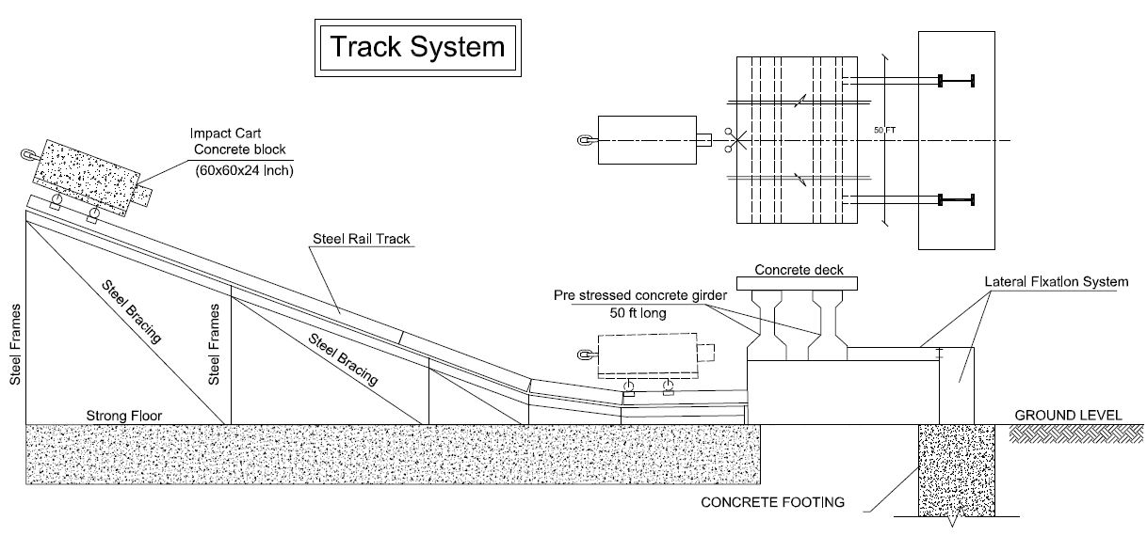
Fig. 1 – Impact testing system

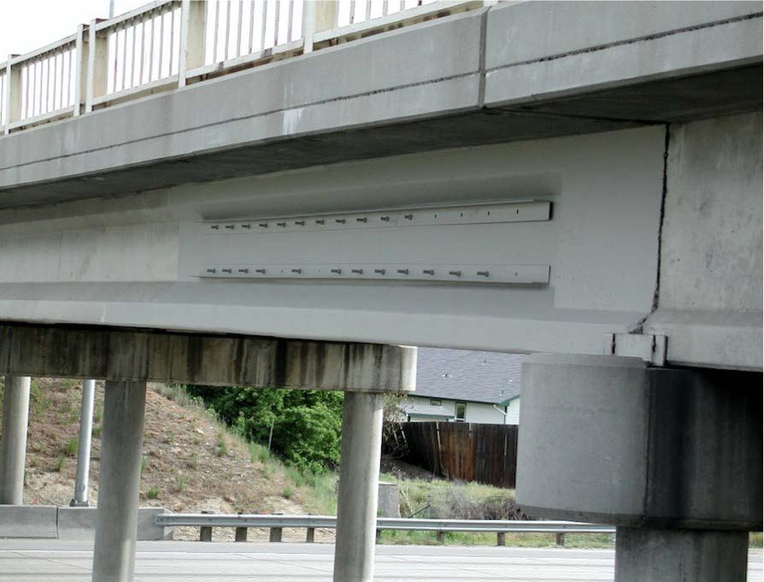
Fig. 2 – Repair of bridge girders using CFRP (Courtesy of Idaho DOT)

