TRANSPORTATION POOLED FUND PROGRAM
QUARTERLY PROGRESS REPORT

Lead Agency (FHWA or State DOT): _FHWA______________________________________

INSTRUCTIONS:
Project Managers and/or research project investigators should complete a quarterly progress report for each calendar quarter during which the projects are active. Please provide a project schedule status of the research activities tied to each task that is defined in the proposal; a percentage completion of each task; a concise discussion (2 or 3 sentences) of the current status, including accomplishments and problems encountered, if any. List all tasks, even if no work was done during this period.

Transportation Pooled Fund Program Project #  (i.e, SPR-2(XXX), SPR-3(XXX) or TPF-5(XXX)  TPF-5(279) |  | Transportation Pooled Fund Program - Report Period:  □Quarter 1 (January 1 – March 31)  □Quarter 2 (April 1 – June 30)  □Quarter 3 (July 1 – September 30)  Quarter 4 (October 1 – December 31)
Project Title:
High Performance Computational Fluid Dynamics (CFD) Modeling Services for Highway Hydraulics

Name of Project Manager(s):  Kornel Kerenyi | Phone Number:  (202) 493-3142 |  | E-Mail  kornel.kerenyi@fhwa.dot.gov
Lead Agency Project ID: | Other Project ID (i.e., contract #): |  | Project Start Date:
Original Project End Date: | Current Project End Date: |  | Number of Extensions:

Project schedule status:
On schedule □ On revised schedule □ Ahead of schedule □ Behind schedule

Overall Project Statistics:
Total Project Budget | Total Cost to Date for Project | Percentage of Work  Completed to Date

Quarterly Project Statistics:
Total Project Expenses  and Percentage This Quarter | Total Amount of Funds  Expended This Quarter | Total Percentage of  Time Used to Date

Project Description:

The Federal Highway Administration established an Inter-Agency Agreement (IAA) with the Department of Energy’s (DOE) Argonne National Laboratory (ANL) Transportation Analysis Research Computing Center (TRACC) to get access and support for High Performance Computational Fluid Dynamics (CFD) modeling for highway hydraulics research conducted at the Turner-Fairbank Highway Research Center (TFHRC) Hydraulics Laboratory. TRACC was established in October 2006 to serve as a high-performance computing center for use by U.S. Department of Transportation (USDOT) research teams, including those from Argonne and their university partners. The objective of this cooperative project is to:

- Provide research and analysis for a variety of highway hydraulics projects managed or coordinated by State DOTs.
- Provide and maintain a high performance Computational Fluid Dynamics (CFD) computing environment for application to highway hydraulics infrastructure and related projects
- Support and seek to broaden the use of CFD among State Department of Transportation employees.

The work includes:

- Computational Mechanics Research on a Variety of Projects: The TRACC scientific staff in the computational mechanics focus area will perform research, analysis, and parametric computations as required for projects managed or coordinated by State DOTs.
- Computational Mechanics Research Support: The TRACC support team consisting of highly qualified engineers in the CFD focus areas will provide guidance to users of CFD software on an as needed or periodic basis determined by the State DOTs.
- Computing Support: The TRACC team will use the TRACC clusters for work done on projects; The TRACC system administrator will maintain the clusters and work closely with the Argonne system administrator’s community; The TRACC system administrator will also install the latest versions of the STAR-CCM+ CFD software and other software that may be required for accomplishing projects.

Progress this Quarter (includes meetings, work plan status, contract status, significant progress, etc.):

1: Computational Mechanics Research on a Variety of Projects
1.1: Three Dimensional Flow Analysis Methodology for Assessing Stream Stability and Channel Migration
The objectives of this project are to investigate the use of three dimensional computational fluid dynamics to obtain a detailed distribution of shear stress on stream banks, to use it to calculate the erosion rates, and finally to develop a methodology that allows to evaluate the potential future increase in the instability of streams. The impact of increasing intensity and frequency of extreme rain events over different periods of time was explored by analyzing four “what if” scenarios with variations of future ten-year daily hydrographs, including variations in the overall volume and standard deviation of discharge that passes through the channel.

The proposed methodology for assessing bank erosion rates and distances that combines the use of: hydrographs, historical scans of the river topology, and geotechnical surveys with computational modeling consists of the following steps:
- Obtain at least one scan of the river bathymetry with the geometry as detailed as possible. Use the bathymetry data to build a 3D geometry model of the river reach that serves as a basis for a series of CFD simulations of the river flow under varying flow rates. Shear stresses on the river banks and bankfull fractions are derived from the computations.
- Obtain a daily hydrograph from a measurement station that is as close as possible to the river reach being analyzed and provides a good measure of the flow in the reach.
- Obtain the soil conditions in the area of interest, including material properties that are needed in the bank erosion rate formula. If the material characteristics are not available, then other methods should be considered. An alternative methodology proposed and demonstrated in this work requires a set of historic images of the river bends of interest (source: google maps or USGS). The more images of the changing topology are available, the more detailed the forecast of the stream migration will be. The historic migration obtained from these images is then used to fit bank soil erosion rate material property parameters in a bank erosion rate function of shear stress.
- Perform an interpolation procedure that yields daily average eroding bank shear stress and bank full fraction on a section of the bank subject to rapid erosion from the daily discharge and the shear stress computed in CFD simulations of bounding discharges. Velocity and wall shear stress contour plots for two example flow rates are showed in Figure 1.
- Calculate the daily erosion rates to get the daily erosion distance and sum them up to get total erosion distance for sections of river bank for a chosen time period.
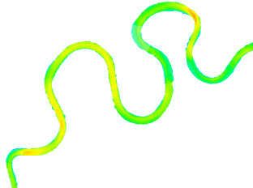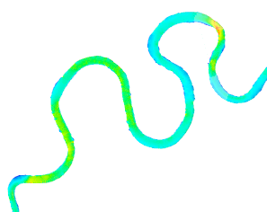
(a)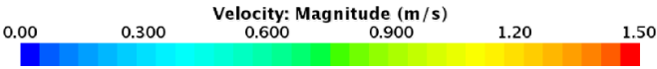 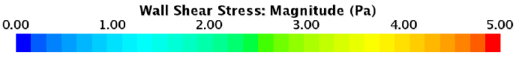
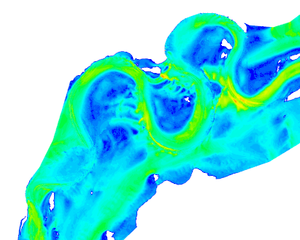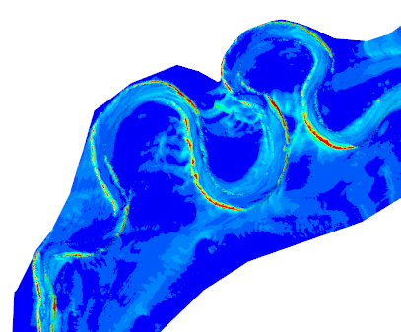
(b) 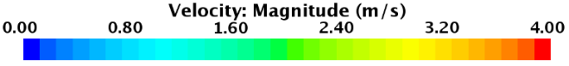 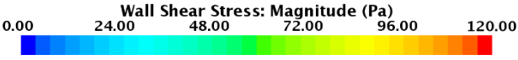
Figure 1. Surface velocity distribution and wall shear stress for discharges (a) 1,000 and (b) 20,000 cfs

The described methodology was used to predict stream migration during the period from 2016-2026 under a set of four hypothetical rainfall conditions, characterized by four different hydrographs. The hypothetical hydrographs were based on the 2006-2016 hydrograph for the Maple River at the studied location and assumed that: (1) the discharge pattern was the same as the one observed in years 2006-2016, (2) the daily discharge was increased by 75 cfs for all days, (3) the standard deviation of the daily discharges was doubled with no change to the mean of the daily discharges, and (4) an additional large peak flow of 10,000 cfs was added each year around the first week of May, the time of spring rains, including a ramp up and ramp down over a several day period.

As an example, Figure 2 shows the bank migration as predicted by the first scenario, in which the hydrograph for the period 2016-2026 is assumed to be the same as for the period 2006-2016. When this hydrograph is used to estimate bank migration for the next ten years, it yields the same lateral erosion distance as for the previous ten years. If the most conservative estimate is considered, the migration of the river bend over the next ten years would be 119 ft, which would place it within 21 ft of Highway 175, and possibly require action over the following several years to avoid incursion from the river.

The neck between the bends at bend number 3 is predicted to have a major change in morphology based on the current migration rates. As shown in Figure 6-1, the right side of bank 5 intersects with the left side of bank 3 within 10 years. The banks moved by 176 ft relative to each other (~88 ft each side) in the last 10 years. Figure 6-2 shows trendlines for the migration of bend 3 and 5 extending to 2023. A migration of 60 ft on each side would cause the bends to merge and cutoff the horseshoe in between 6 and 7 years. The merging of the banks at bend 3 will have a complex effect on the flow in the other bends. The geometry of the model would need to be modified to follow the new path of the channel to assess the effect that the cutoff of one of horseshoe bends will have on the migration of the other bends.
3
2
1
4
Figure 2. Lateral migration distances predicted for the bends in Scenario 1. Yellow line is estimated bank location based on current migration rate

The results from tests of different weather trends illustrate that the method can be used as a learning and exploratory tool to see how a stream prone to migration responds to different types of changes in weather patterns, and to help identify which changes carry more risk of impacting transportation and other infrastructure. Although many more tests would need to be carried out to be conclusive, the model indicates that bank migration may be primarily a function of the total volume of flow that is at erosive levels and not a function of how extreme the weather events are with respect the mean flow over time.

1.2: Computational Analysis of Water Film Thickness on Modern Road Geometry During Rain Events for Assessing Hydroplaning Risk
The methodology to model roughness of the pavement, proposed earlier, assumes that the pavement surface is approximated with a bed of spherical particles with diameter equal to the average aggregate size. The thickness of the porous region is equal to the mean texture depth, which is equal to the mean depth of the pavement macrotexture. The bottom surface of the domain is a no-slip wall boundary.

Gallaway et al. in their 1971 experimental study [1] analyzed water flow on roadway surface under various conditions. Their model was a 4-foot-wide strip of a 24 ft wide road with cross-slope ranging from 0.5% to 8%. The longitudinal slope was not included in the considerations. Nine test surfaces of various types were prepared and the average texture depths ranged from 0.003 in to 0.07 in. The results collected from 240 test cases was used to find a correlation between the water depth and: the distance from the road crown, texture depth, rain intensity and surface slope. The best fit function, obtained by minimization of the error of prediction, is as following:
$$f=0.00338 {TXD}^{0.11}L^{0.43}{RI}^{0.59}{SL}^{(-0.42)}-TXD$$
where $TXD$ is texture depth, $L$ is the drainage distance, $RI$ is rain intensity and $SL$ is slope.
First, it was shown that the proposed CFD method agrees well with the Gallaway et al. experimental measurements for roads with a unidirectional slope. In the next phase of the study, an analysis of water film thickness distribution was performed for more complex cases where surfaces are sloped in two directions and the cross slope varies (like a transition section to a superelevation). Superelevation transitions change cross-slopes from a normal crown section to a full superelevation and have a non-zero longitudinal slope.
Figure 3 shows a drawing of a scaled down section of a road that was modeled in the CFD simulations and presents water depth distribution and velocity streamlines for a smooth pavement (left) and rough pavement with texture depth 0.9 mm (right).
(a)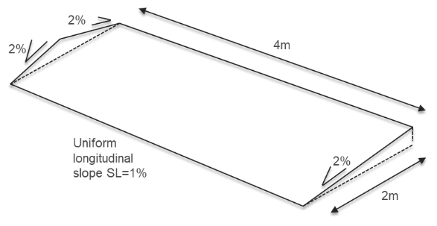
(b) 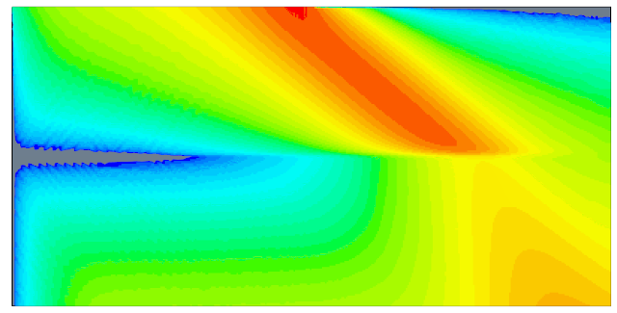 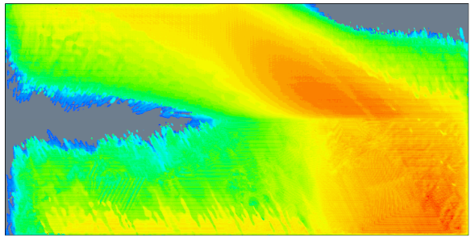
Water depth [mm]
0.0 0.28 0.56 0.84 1.12 1.41 -0.9 -0.6 0.0 0.43 0.94 1.64
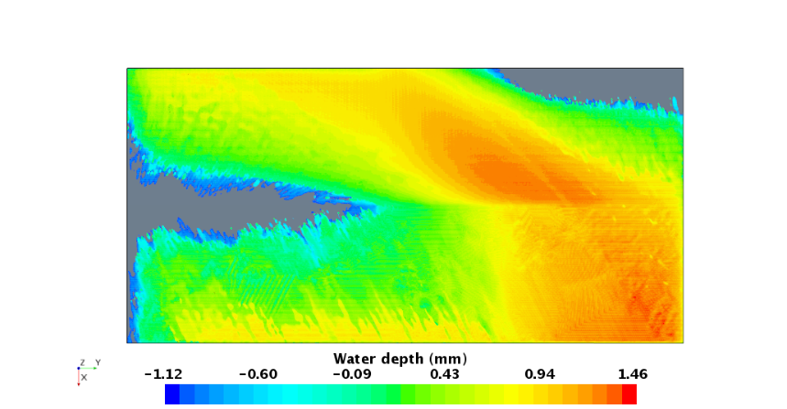
(c) 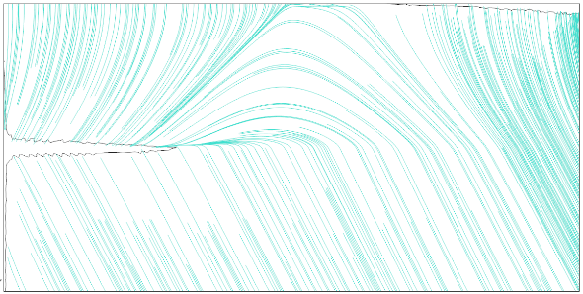 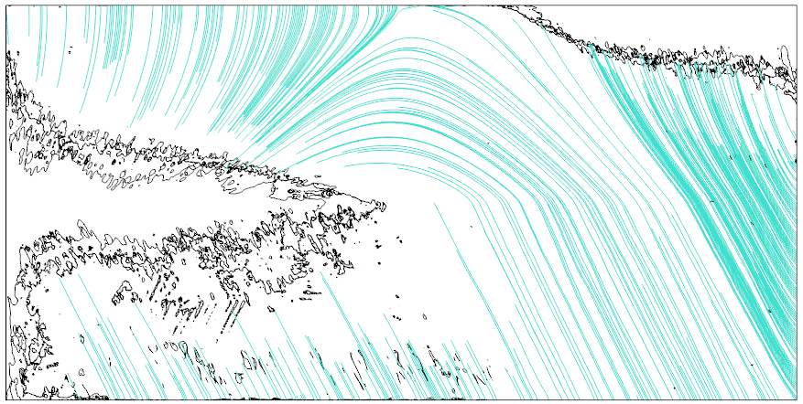
Figure 3. Geometry of the road (a), (b) flow patterns and (c) streamlines of velocity for varying pavement texture depth: smooth (left), 0.9 mm (right)

The results obtained in the CFD simulations are compared with calculations based on the assumption that the flow direction follows the hydraulic gradient path and therefore the velocity streamlines, when there is no local influence of a curb, that would cause pooling of water along the curb, or drainage, that would lower the water depth and change the flow direction in its vicinity.This assumption makes it possible to find the flow streamlines and calculate the water film thickness from Gallaway at el. formula. A grid of points with known coordinates needs to be established on the surface. Each point in the grid is a starting point for a search through the neighboring points for the one that gives the biggest slope. The search continues point by point until it reaches the edge of the domain. The result is a series of flow lines as shown in Figure 4 for a coarse grid of points. The longest line out of those crossing through a selected point is a streamline along which the water film thickness can be calculated. This approach gives a rough approximation of the shape of the streamlines and respective water film thickness. There is a good comparison of results for the majority of the drainage distance. Only in the section of the road where the slope is close to zero, the predictions differ, as Gallaway et al. formula overpredicts the value of water depth.
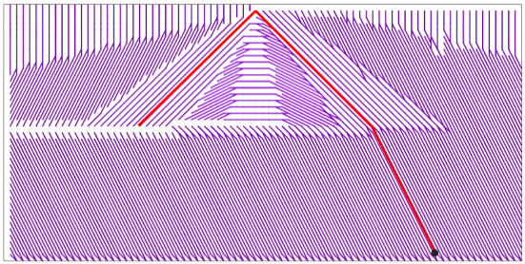

Figure 4. Flow lines (purple) and a streamline (red) going through a selected point (marked in black) and plots of water film thickness along the streamline obtained in CFD and from Gallaway et al. equation.

2: Computational Mechanics Research Support

Argonne Transportation Research and Analysis Computing Center (TRACC) computational mechanics staff ran nationwide videoconferences every other Thursday that were open to state Department of Transportation staff and university researchers supported by the Federal Highway Administration or state DOTs. The videoconferences provide a venue to discuss approaches and issues related to hydraulics modeling projects. Topics during this reporting period included, but were not limited to:
- new methodologies of scour modeling
- approaches to modeling and mitigating hydroplaning risk
- hydraulic analysis of catch basins

3: Computing Support

Routine cluster maintenance including software and hardware upgrades, security patching against cyber threats, and development of custom tools to increase users' productivity. Currently working on upgrading the TRACC clusters to support the latest scientific and engineering software utilizing industry's best practice guidelines in Open Source software and virtualization.
Anticipated work next quarter:

1: Computational Mechanics Research on a Variety of Projects

- hydraulic analysis of a catch basin
- analysis of water film thickness on pavements

2: Computational Mechanics Research Support

This work will continue.

Task 3: Computing Support

This work will continue.

Circumstance affecting project or budget. (Please describe any challenges encountered or anticipated that
might affect the completion of the project within the time, scope and fiscal constraints set forth in the
agreement, along with recommended solutions to those problems).

None.

