TRANSPORTATION POOLED FUND PROGRAM
QUARTERLY PROGRESS REPORT

Lead Agency (FHWA or State DOT): _FHWA______________________________________

INSTRUCTIONS:
Project Managers and/or research project investigators should complete a quarterly progress report for each calendar quarter during which the projects are active. Please provide a project schedule status of the research activities tied to each task that is defined in the proposal; a percentage completion of each task; a concise discussion (2 or 3 sentences) of the current status, including accomplishments and problems encountered, if any. List all tasks, even if no work was done during this period.

Transportation Pooled Fund Program Project #  (i.e, SPR-2(XXX), SPR-3(XXX) or TPF-5(XXX)  TPF-5(279) |  | Transportation Pooled Fund Program - Report Period:  □Quarter 1 (January 1 – March 31)  □Quarter 2 (April 1 – June 30)  Quarter 3 (July 1 – September 30)  □Quarter 4 (October 1 – December 31)
Project Title:
High Performance Computational Fluid Dynamics (CFD) Modeling Services for Highway Hydraulics

Name of Project Manager(s):  Kornel Kerenyi | Phone Number:  (202) 493-3142 |  | E-Mail  kornel.kerenyi@fhwa.dot.gov
Lead Agency Project ID: | Other Project ID (i.e., contract #): |  | Project Start Date:
Original Project End Date: | Current Project End Date: |  | Number of Extensions:

Project schedule status:
On schedule □ On revised schedule □ Ahead of schedule □ Behind schedule

Overall Project Statistics:
Total Project Budget | Total Cost to Date for Project | Percentage of Work  Completed to Date

Quarterly Project Statistics:
Total Project Expenses  and Percentage This Quarter | Total Amount of Funds  Expended This Quarter | Total Percentage of  Time Used to Date

Project Description:

The Federal Highway Administration established an Inter-Agency Agreement (IAA) with the Department of Energy’s (DOE) Argonne National Laboratory (ANL) Transportation Analysis Research Computing Center (TRACC) to get access and support for High Performance Computational Fluid Dynamics (CFD) modeling for highway hydraulics research conducted at the Turner-Fairbank Highway Research Center (TFHRC) Hydraulics Laboratory. TRACC was established in October 2006 to serve as a high-performance computing center for use by U.S. Department of Transportation (USDOT) research teams, including those from Argonne and their university partners. The objective of this cooperative project is to:

- Provide research and analysis for a variety of highway hydraulics projects managed or coordinated by State DOTs.
- Provide and maintain a high-performance Computational Fluid Dynamics (CFD) computing environment for application to highway hydraulics infrastructure and related projects
- Support and seek to broaden the use of CFD among State Department of Transportation employees.

The work includes:

- Computational Mechanics Research on a Variety of Projects: The TRACC scientific staff in the computational mechanics focus area will perform research, analysis, and parametric computations as required for projects managed or coordinated by State DOTs.
- Computational Mechanics Research Support: The TRACC support team consisting of highly qualified engineers in the CFD focus areas will provide guidance to users of CFD software on an as needed or periodic basis determined by the State DOTs.
- Computing Support: The TRACC team will use the TRACC clusters for work done on projects; The TRACC system administrator will maintain the clusters and work closely with the Argonne system administrator’s community; The TRACC system administrator will also install the latest versions of the STAR-CCM+ CFD software and other software that may be required for accomplishing projects.

Progress this Quarter (includes meetings, work plan status, contract status, significant progress, etc.):

1: Computational Mechanics Research on a Variety of Projects
1.1: Hydraulic Study of a SCDOT Catch Basin CB16, CB17, and Type 1
Proper design of surface drainage of roadways is essential to minimize flooding and provide traffic safety. Inlets collect the excess storm water from drainage area and discharge it to storm drains. Knowing the hydraulic efficiency of inlets, defined as the percentage of intercepted flow to the total street flow, is necessary in drainage design. With this knowledge, the inlet spacing can be determined such that the system can transport all or majority of the road surface flow during rain events. Catch basins Type 16 and 17 have the same cross-section showed on the left in Figure 1. They differ with the length of the opening, which is 4 feet for Type 16, and 8 feet for Type 17. Catch basin Type 1 characterizes with a grate covering part of the inlet and a fully open portion on the curb edge, protected with a hood. A cross-section through the inlet is shown on the right in Figure 1.

The main goal of the study is to perform a hydraulic efficiency analysis of the three types of catch basins with the use of Computational Fluid Dynamics. CFD analysis will yield the following results: efficiency curves as function of the spread or volume flow rate, the longitudinal slope, and the shoulder width, and the flow spread along the roadway in the vicinity the catch basin inlet.

Figure 1. Cross section through the inlets Type 16 (17), and Type 1

The results of the analysis will be combined in a spreadsheet with programmed calculations that will allow the engineers to design drainage on South Carolina roads. Additionally, a manual will be provided to SCDOT, which will include information about the methods of development of the efficiency curves and drainage calculations, and also instructions on how to use them in the design process. This will allow SCDOT to modify and create new design information due to changes in roadway and hydraulic design requirements. Also, a description of the analysis case runs will be included, covering all data from the simulations and programing explanations.

The computational model used in the study resembles the one used in the previous research of catch basin CB25 [1]. It is a full-scale model of a section of a road with an inlet. The width of the section is limited by a road crown on one side, and a curb on the other side.

[1] Sitek M.A., Lottes S.A., Sinha N., Hydraulic Study of the South Carolina DOT Catch Basin Type 25, technical report ANL-19/20, 2019

1.2: Three-Dimensional CFD Analysis of Construction Design Alternatives for an ERDC Coastal and Hydraulics Laboratory Flow Accelerator
Three-dimensional Computational Fluid Dynamics (CFD) analysis was used for design of an Engineer Research and Development Center (ERDC) Coastal and Hydraulics Laboratory flow accelerator for a flume with a 10 ft wide channel. The design is based on the plans of the existing Turner-Fairbank Highway Research Center (TFHRC) J. Sterling Jones Hydraulics Research Laboratory fiberglass flume inlet, and it was scaled up to meet the ERDC experimental requirements.
The flow enters the TFHRC hydraulic flume through a PVC pipe into a perforated distribution pipe in the reservoir that spans the inlet region from the bottom to the top of the accelerator and is capped on the top to eliminate spillage of water. The distribution pipe is perforated with one inch diameter circular holes. The shape of the back wall of the accelerator is defined by two symmetric spiral functions that is followed by a straight section, which ends with three frames, where honeycombs can be installed. Currently, one honeycomb is installed in the downstream frame and it efficiently reduces the lateral turbulence. The frames also allow for installation of mesh screens whose goal is to additionally straighten the flow by reducing the axial turbulence. The honeycomb and screens straighten the flow before it gets into the converging part of the accelerator where the walls converge laterally and vertically. The discharge in the TFHRC flume is usually about 30 cfs.

The researchers at the ERDC are in need of a 10 foot wide flume channel to perform experiments in a wide variety of flow conditions with a discharge into the flume of about 60 cfs. The new design of the flume inlet needs to accommodate the higher flow rates and retain the uniformity of the flow in the channel, i.e. the velocity of the flow in the test section should have very low components in the two directions perpendicular to the main flow direction.
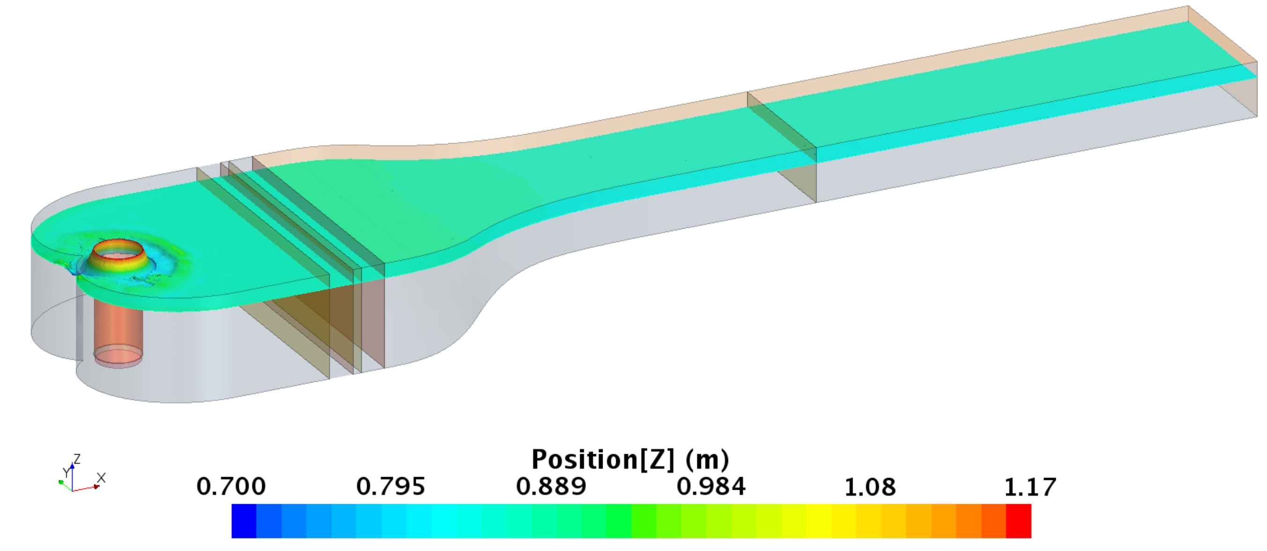
Figure 2. CFD model of one of the proposed designs of the ERDC flow accelerator

Three flow conditions were identified by the ERDC researchers as relevant in the experimental setup and therefore they were chosen as input values to the CFD model. They span from shallow to deeper flows at different slopes and will allow comprehensive analysis of the effectiveness of the proposed design. As the first design candidate, a scaled-up TFHRC flume geometry was considered. The scaling factor was equal 10/6 all three dimensions. Additionally, the flume height was increased to 1.2 m, The resistance characteristics of the inner parts of the TFHRC flume, i.e. the honeycomb and screens, were kept unchanged, only the diameter of the inlet pipe was modified to 36 inches, as per ERDC requirements.

Secondly, several modifications are applied to the flow straighteners: the shape and size of the perforations in the distribution pipe, and its position in relation to the flow, the number of wire screens, the number of honeycombs, as well as the diameter and length of the tubes that form them. The results are analyzed to assess which combination gives the most uniform flow pattern in the testing zone of the flume. Next, the model was simplified to include only the converging part of the accelerator and the straight rectangular channel. The downstream surface of the honeycomb was transformed into an inlet surface with assigned uniform velocity. Two cases were compared: with the geometry of the converging part unchanged, and stretched three times in the main flow direction. This modification makes it possible to assess if under the assumption of a ‘perfect’ flow coming from the honeycomb + screen combination (1) flow separation points occur in the original geometry, and if so, (2) will they disappear if the slopes of the wall curvatures are reduced to minimum under the existing size restrictions (the flume length will be limited by the size of the building).

An analysis of the influence of the distribution pipe and the shape of the contraction on the water flow in the flume showed that a more porous distribution pipe with circular perforations works best out of the tested options, moreover, and that the shape of the scaled up contraction of the TFHRC flume is sufficient. Three honeycombs with different porosity and inertial resistance were studied and it was established that a honeycomb made of Ø 2”, 20-inch long pipes gives the best results out of the tested cases.

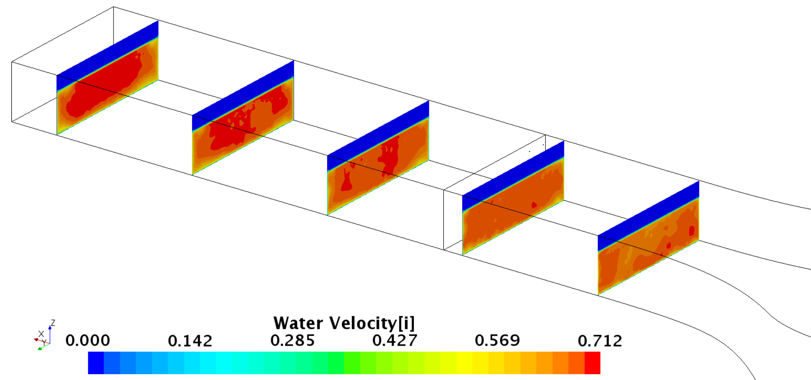
Figure 3. Contour plots of velocity component Vx (along the channel) in the ERDC flume model with two honeycombs (Ø 2”, 20-inch long) and two wire screens

2: Computational Mechanics Research Support

Argonne Transportation Research and Analysis Computing Center (TRACC) computational mechanics staff ran nationwide videoconferences every other Thursday that were open to state Department of Transportation staff and university researchers supported by the Federal Highway Administration or state DOTs. The videoconferences provide a venue to discuss approaches and issues related to hydraulics modeling projects. Topics during this reporting period included, but were not limited to:
- new methodologies of scour modeling
- river bank erosion rate prediction
- approaches to modeling and mitigating hydroplaning risk

3: Computing Support

Routine cluster maintenance including software and hardware upgrades, security patching against cyber threats, and development of custom tools to increase users' productivity. Currently working on upgrading the TRACC clusters to support the latest scientific and engineering software utilizing industry's best practice guidelines in Open Source software and virtualization.
Anticipated work next quarter:

1: Computational Mechanics Research on a Variety of Projects

- analysis of water film thickness on pavements
- stream stability and channel migration

2: Computational Mechanics Research Support

This work will continue.

Task 3: Computing Support

This work will continue.

Circumstance affecting project or budget. (Please describe any challenges encountered or anticipated that
might affect the completion of the project within the time, scope and fiscal constraints set forth in the
agreement, along with recommended solutions to those problems).

None.

