TRANSPORTATION POOLED FUND PROGRAM
QUARTERLY PROGRESS REPORT

Lead Agency (FHWA or State DOT): _FHWA______________________________________

INSTRUCTIONS:
Project Managers and/or research project investigators should complete a quarterly progress report for each calendar quarter during which the projects are active. Please provide a project schedule status of the research activities tied to each task that is defined in the proposal; a percentage completion of each task; a concise discussion (2 or 3 sentences) of the current status, including accomplishments and problems encountered, if any. List all tasks, even if no work was done during this period.

Transportation Pooled Fund Program Project #  (i.e, SPR-2(XXX), SPR-3(XXX) or TPF-5(XXX)  TPF-5(279) |  | Transportation Pooled Fund Program - Report Period:  Quarter 1 (January 1 – March 31)  □Quarter 2 (April 1 – June 30)  □Quarter 3 (July 1 – September 30)  □Quarter 4 (October 1 – December 31)
Project Title:
High Performance Computational Fluid Dynamics (CFD) Modeling Services for Highway Hydraulics

Name of Project Manager(s):  Kornel Kerenyi | Phone Number:  (202) 493-3142 |  | E-Mail  kornel.kerenyi@fhwa.dot.gov
Lead Agency Project ID: | Other Project ID (i.e., contract #): |  | Project Start Date:
Original Project End Date: | Current Project End Date: |  | Number of Extensions:

Project schedule status:
On schedule □ On revised schedule □ Ahead of schedule □ Behind schedule

Overall Project Statistics:
Total Project Budget | Total Cost to Date for Project | Percentage of Work  Completed to Date

Quarterly Project Statistics:
Total Project Expenses  and Percentage This Quarter | Total Amount of Funds  Expended This Quarter | Total Percentage of  Time Used to Date

Project Description:

The Federal Highway Administration established an Inter-Agency Agreement (IAA) with the Department of Energy’s (DOE) Argonne National Laboratory (ANL) Transportation Analysis Research Computing Center (TRACC) to get access and support for High Performance Computational Fluid Dynamics (CFD) modeling for highway hydraulics research conducted at the Turner-Fairbank Highway Research Center (TFHRC) Hydraulics Laboratory. TRACC was established in October 2006 to serve as a high-performance computing center for use by U.S. Department of Transportation (USDOT) research teams, including those from Argonne and their university partners. The objective of this cooperative project is to:

- Provide research and analysis for a variety of highway hydraulics projects managed or coordinated by State DOTs.
- Provide and maintain a high performance Computational Fluid Dynamics (CFD) computing environment for application to highway hydraulics infrastructure and related projects
- Support and seek to broaden the use of CFD among State Department of Transportation employees.

The work includes:

- Computational Mechanics Research on a Variety of Projects: The TRACC scientific staff in the computational mechanics focus area will perform research, analysis, and parametric computations as required for projects managed or coordinated by State DOTs.
- Computational Mechanics Research Support: The TRACC support team consisting of highly qualified engineers in the CFD focus areas will provide guidance to users of CFD software on an as needed or periodic basis determined by the State DOTs.
- Computing Support: The TRACC team will use the TRACC clusters for work done on projects; The TRACC system administrator will maintain the clusters and work closely with the Argonne system administrator’s community; The TRACC system administrator will also install the latest versions of the STAR-CCM+ CFD software and other software that may be required for accomplishing projects.

Progress this Quarter (includes meetings, work plan status, contract status, significant progress, etc.):

1: Computational Mechanics Research on a Variety of Projects
1.1: Computational Analysis of Water Film Thickness on Modern Road Geometry During Rain Events for Assessing Hydroplaning Risk
The influence of the pavement roughness was analyzed with regards to the water flow patterns on multilane roads and the thickness of water film forming during rain events. Roughness of a pavement surface can be represented in three ways: roughness coefficient or roughness height, porous region, meshed out geometry of the surface.

In this part of the study, Argonne researchers obtained a point cloud from a laser scan of a pavement sample from Turner-Fairbank Highway Research Center. The data was transformed into a stereolithographic file and a square piece was cut out from the circular surface and stitched together to create a long strip. This strip was used as a pavement surface in the geometry of a CFD model and a wall boundary condition was assigned to it. The meshed out rough surface model makes it possible to observe and analyze the flow in great detail. Figure 1 shows a contour plot of water depth on two ends of the strip: at the median and at the shoulder. The road surface was plotted in grey in the figures. Close to the median, there are patches with no water or the water is contained in small depressions, with surface level lower than the asperities. Far from the median, the water depth is higher, and covers almost all asperities. Water surface is not flat, as ripples form due to the roughness of the pavement.

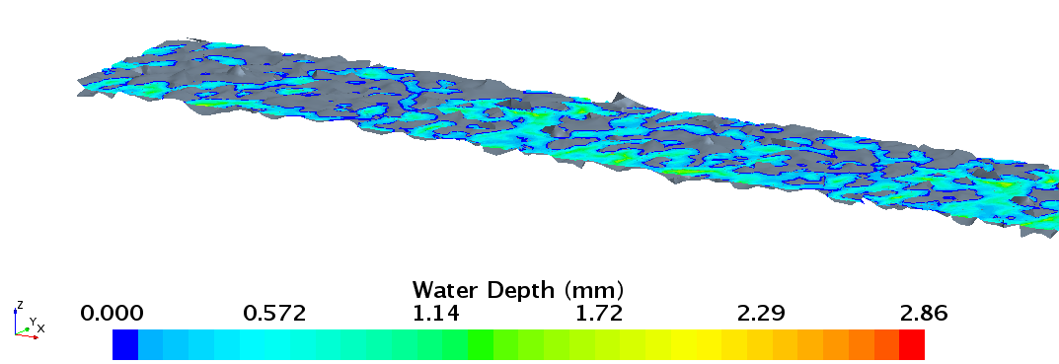
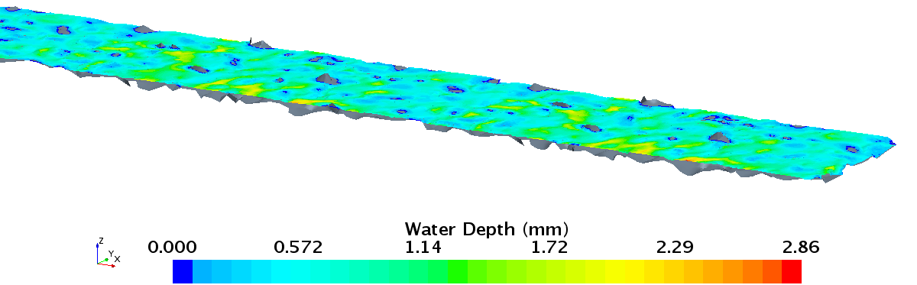

Figure 1. Water depth on a rough pavement, (a) close to the median, (b) close to the shoulder. Rainfall intensity 2 in/hr, slope 2%.

Gallaway et al [1] proposed an empirical formula to calculate the water film thickness on pavements with roughness. The water film thickness obtained from the calculations is positive when the film thickness is greater than the average height of the asperities and negative when water level is lower. To calculate the water film thickness and validate the CFD model in this study, water film thickness prediction by various models was compared: a rough surface model, smooth surface models, and the Gallaway equation [1]. An example result is shown in Figure 2. Close to the median, the smooth surface solution gives a nonzero water depth, whereas the rough surface solution has patches of zero water depth. Far from the median, the smooth surface solution again gives values higher than the average rough surface solution. Gallaway’s equation gave negative water film thickness up to 6.5 ft away from the median. Far away from the median the thickness is in good agreement with the rough surface solution.
Figure 2: A comparison of the water film thickness prediction by the rough surface model, smooth surface models: without and with curb, and Gallaway equation [2] for a 2 in/hr rain

[1] Gallaway, B. M. et al., Pavement and Geometric Design Criteria for Minimizing Hydroplaning, FHWA RD-79-31, 1979

1.2: Hydraulic study of a SCDOT catch basin CB25
A new type of a catch basin with an inlet grate, Type 25 (CB25), to use as drainage on South Carolina’s freeways was designed by the South Carolina Department of Transportation engineers. Computational fluid dynamics (CFD) modeling was chosen to establish the hydraulic capacity of the grate. Three-dimensional computational fluid dynamic simulations were developed by scientists at Argonne’s Transportation Research and Analysis Computing Center with the use of high performance cluster computing.

In the majority of the cases of roadway geometry and flow rate considered in the study, only part of the flow is captured by the grate. In the worst scenario, the resulting bypass flow makes up for 67% of the total inflowing water. This bypassing flow could be intercepted in full, or partially, by a double grate, with the second inlet located downstream of the first one. Usually double grates are designed to be installed one next to the other. In some cases, it is more beneficial to build the second grate away from the first one, because there is a length of road just beyond the grate where the spread is contracting as water falls back to the curb, filling space created by water diverted into the grate. The distance over which this occurs is called the ‘reattachment length’, or ‘fallback distance’. Figure 3 shows streamlines of water velocity downstream from the grate, for a set of simulations using a 6-foot flow spread on a roadway with 4-foot shoulder, and longitudinal slope (a) 0.3%, (b) 1%, (c) 3%, (d) 5%, (e) 7%. The fallback distance, d1, was marked in the figure, along with distance d2, which is the distance from the grate to a point where the spread is the narrowest, and starts to stabilize. For the two smallest longitudinal slopes the fallback of the bypass flow occurs directly behind the grate, therefore installing the second grate next to the first one will assure its full interception. When the slope is bigger, both distances, d1, and d2, are larger than one grate width. In this case it would be more beneficial to install the second grate further away, in the area just beyond where the bypassing flow falls back to, and follows, the curb.
Figure 3. Streamlines showing the fallback distances d1 and d2

2: Computational Mechanics Research Support

Argonne Transportation Research and Analysis Computing Center (TRACC) computational mechanics staff ran nationwide videoconferences every other Thursday that were open to state Department of Transportation staff and university researchers supported by the Federal Highway Administration or state DOTs. The videoconferences provide a venue to discuss approaches and issues related to hydraulics modeling projects. Topics during this reporting period included, but were not limited to:
- river bank erosion rate prediction
- approaches to modeling and mitigating hydroplaning risk

3: Computing Support

Routine cluster maintenance including software and hardware upgrades, security patching against cyber threats, and development of custom tools to increase users' productivity. Currently working on upgrading the TRACC clusters to support the latest scientific and engineering software utilizing industry's best practice guidelines in Open Source software and virtualization.
Anticipated work next quarter:

1: Computational Mechanics Research on a Variety of Projects

- hydraulic analysis of a catch basin
- analysis of water film thickness on pavements

2: Computational Mechanics Research Support

This work will continue.

Task 3: Computing Support

This work will continue.

Circumstance affecting project or budget. (Please describe any challenges encountered or anticipated that
might affect the completion of the project within the time, scope and fiscal constraints set forth in the
agreement, along with recommended solutions to those problems).

None.

