TRANSPORTATION POOLED FUND PROGRAM
QUARTERLY PROGRESS REPORT

Lead Agency (FHWA or State DOT): _FHWA______________________________________

INSTRUCTIONS:
Project Managers and/or research project investigators should complete a quarterly progress report for each calendar quarter during which the projects are active. Please provide a project schedule status of the research activities tied to each task that is defined in the proposal; a percentage completion of each task; a concise discussion (2 or 3 sentences) of the current status, including accomplishments and problems encountered, if any. List all tasks, even if no work was done during this period.

Transportation Pooled Fund Program Project #  (i.e, SPR-2(XXX), SPR-3(XXX) or TPF-5(XXX)  TPF-5(279) |  | Transportation Pooled Fund Program - Report Period:  □Quarter 1 (January 1 – March 31)  □Quarter 2 (April 1 – June 30)  □Quarter 3 (July 1 – September 30)  Quarter 4 (October 1 – December 31)
Project Title:
High Performance Computational Fluid Dynamics (CFD) Modeling Services for Highway Hydraulics

Name of Project Manager(s):  Kornel Kerenyi | Phone Number:  (202) 493-3142 |  | E-Mail  kornel.kerenyi@fhwa.dot.gov
Lead Agency Project ID: | Other Project ID (i.e., contract #): |  | Project Start Date:
Original Project End Date: | Current Project End Date: |  | Number of Extensions:

Project schedule status:
On schedule □ On revised schedule □ Ahead of schedule □ Behind schedule

Overall Project Statistics:
Total Project Budget | Total Cost to Date for Project | Percentage of Work  Completed to Date

Quarterly Project Statistics:
Total Project Expenses  and Percentage This Quarter | Total Amount of Funds  Expended This Quarter | Total Percentage of  Time Used to Date

Project Description:

The Federal Highway Administration established an Inter-Agency Agreement (IAA) with the Department of Energy’s (DOE) Argonne National Laboratory (ANL) Transportation Analysis Research Computing Center (TRACC) to get access and support for High Performance Computational Fluid Dynamics (CFD) modeling for highway hydraulics research conducted at the Turner-Fairbank Highway Research Center (TFHRC) Hydraulics Laboratory. TRACC was established in October 2006 to serve as a high-performance computing center for use by U.S. Department of Transportation (USDOT) research teams, including those from Argonne and their university partners. The objective of this cooperative project is to:

- Provide research and analysis for a variety of highway hydraulics projects managed or coordinated by State DOTs.
- Provide and maintain a high performance Computational Fluid Dynamics (CFD) computing environment for application to highway hydraulics infrastructure and related projects
- Support and seek to broaden the use of CFD among State Department of Transportation employees.

The work includes:

- Computational Mechanics Research on a Variety of Projects: The TRACC scientific staff in the computational mechanics focus area will perform research, analysis, and parametric computations as required for projects managed or coordinated by State DOTs.
- Computational Mechanics Research Support: The TRACC support team consisting of highly qualified engineers in the CFD focus areas will provide guidance to users of CFD software on an as needed or periodic basis determined by the State DOTs.
- Computing Support: The TRACC team will use the TRACC clusters for work done on projects; The TRACC system administrator will maintain the clusters and work closely with the Argonne system administrator’s community; The TRACC system administrator will also install the latest versions of the STAR-CCM+ CFD software and other software that may be required for accomplishing projects.

Progress this Quarter (includes meetings, work plan status, contract status, significant progress, etc.):

1: Computational Mechanics Research on a Variety of Projects
1.1: Computational Analysis of Water Film Thickness on Modern Road Geometry During Rain Events for Assessing Hydroplaning Risk
Permeable pavement is a type of pavement that allows for infiltration of fluids. Top surface of a permeable pavement can be either: porous, to allow the fluids to flow through it, or built of nonporous elements with gaps in between them. The examples of porous paving materials are: porous asphalt, pervious concrete, open graded friction courses, etc. There are many advantages of using porous paving materials. They can manage runoff of water from paved surfaces, as the water can reach underlying soils in the case of a fully porous pavement, or drain water to the sides in the case of an Open Graded Friction Course (OGFC). They reduce the downstream flooding that is present in impervious pavements and therefore reduce splash and spray during rain events, as well as improve hydroplaning resistance. They also reduce the road shoulder erosion. While OGFC have many benefits, they also have certain limitations. The evaluation of the existing pavements revealed that their durability is lower, as compared to the dense graded asphalt pavements. They are prone to icing in winter, as the water and air can permeate to the inside of the layer. Raveling is common, which can lead to the the dislodgement of aggregate particles. Additional research is still needed to study the performance and properties of porous pavements during rain events to develop guidelines for expanded use. CFD can be used to analyze behavior of porous pavements under a variety of flow conditions.

There are a number of approaches to model porous phases, from very simple to more complex ones. The top surface of the OGFC can be modeled as a permeable wall surface, which approximates the permeable layer with a wall boundary condition with assigned porosity characteristics. This approach is the simplest, but also gives the least information about the flow. As the volume of the layer is not a part of the domain, no information is obtained about the flow through the layer.
The permeable layer can also be represented by a volume with assigned porosity characteristics, i.e. a porous region. In this case, the porosity of the layer is represented with: porosity, porous inertial and viscous resistance, that depend on a mean diameter of the grains. The properties of the volume are uniform, or can vary only in distinct regions. Also, the geometry of separate grains forming the porous layer can be meshed out. The last approach is the most complex, but also the most accurate. It resolves the flow around particles and therefore it has the least reliance on physics models. Modeling pavement at the scale of the aggregate size makes it possible to analyze the partial and full infiltration through porous layers. Moreover, the porous region can consist of grains of different sizes and shapes. The shortcoming of this method is that it is computationally demanding and the simulations can take up to a few weeks to converge.

An example of the use of the porous region to model a permeable pavement was analyzed. An infiltration test on a cylindrical sample of a permeable pavement was modeled in a multiphase (water and air) Eulerian simulation with Volume of Fluid model to compute the water surface. The boundary conditions on the cylinder sides were assumed to be symmetry, on the top and bottom of the domain the boundary condition was pressure outlet. One inch thick layer of water on top of the porous region, with zero velocity, was used as initial condition. Gravitational acceleration was included in the computations. Figure 1 shows the CFD model used for the analysis and the progress of the infiltration at: 10, 50, 100, and 150 seconds. The top water surface gradually drops, as the the water permeates the porous region.
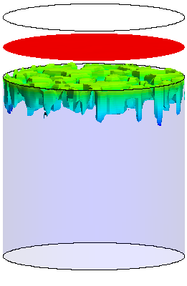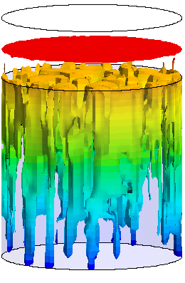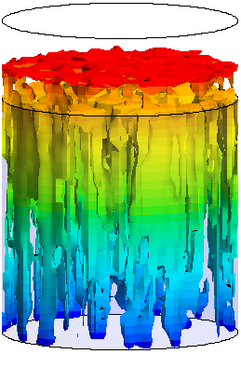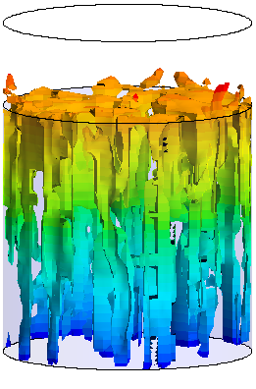
10 sec 50 sec 100 sec 150 sec
Figure 1. Progress of the infiltration through the sample: water surface at 10, 50, 100, and 150 seconds of simulated time

1.2: Hydraulic study of a SCDOT catch basin CB25
A new type of a catch basin with an inlet grate, Type 25 (CB25), to use as drainage on South Carolina’s freeways was designed by the South Carolina Department of Transportation engineers. Computational fluid dynamics (CFD) modeling was chosen to establish the hydraulic capacity of the grate. Three-dimensional computational fluid dynamic simulations were developed by scientists at Argonne’s Transportation Research and Analysis Computing Center with the use of high-performance cluster computing.

A typical cross-section through an interstate highway is shown in Figure 2. It was assumed in this study that the roadway and shoulder cross-slopes are equal to the typically used values: 2% for the roadway and 4% for the shoulder. The cross-slopes were not parameters of the study and were assumed constant. The travel lane is 12 feet wide. Four widths of the shoulder were tested: 4, 4.75, 7.5, 10 ft. The longitudinal slope of the roadway may vary. Longitudinal slopes of 0.3%, 1%, 3%, 5%, and 7% were tested in this study for shoulder widths up to 7.5 ft. In some cases, an additional 4% slope was considered. When shoulder width was 10 ft, the tested longitudinal slopes were: 0.3%, 1%, 2%, 3%, 4%. It was assumed that the roadway surface Manning number equals 0.011.
4%
shoulder
crown
travel lanes
2%
median
shoulder
2%
4%
4%
4%
2%
2%
Figure 2. A cross-section of a typical rural/urban six-lane divided freeway
Computational fluid dynamics simulations make it possible to observe in detail various flow patterns that depend on geometry of the roadway and hydraulic conditions. Figure 3 shows three cases of flow patterns: fully captured flow, broken water surface with bypass flow, and overtopped grate. When the flow velocity is low and the spread doesn’t exceed the width of the grate, then all or majority of the flow is intercepted by the grate. In this case all of the flow enters over the grate through the upstream end, there is no splash over, and the efficiency of the grate is 100%. When the spread is wider than the grate and the flow velocity is higher, part of the flow bypasses the grate due to inertia force. The surface of the water over the grate breaks and enters the catch basin, but not over the entire grate width, so some water entering over the grate near the curb is not intercepted by the grate. The flow through the upstream end of the grate exceeds the side inflow. The grate does not capture all of the water flowing over it, and there is a significant amount of bypass flow that does not cross over the grate. When the spread is wider than the grate there is a possibility of splash-over occurrence. In this case, if the grate is long enough, the splashed water can be still intercepted by the grate, otherwise, the hydraulic efficiency of the grate decreases. In the situation of extreme values of the flow rate, the grate can be overtopped by the water.
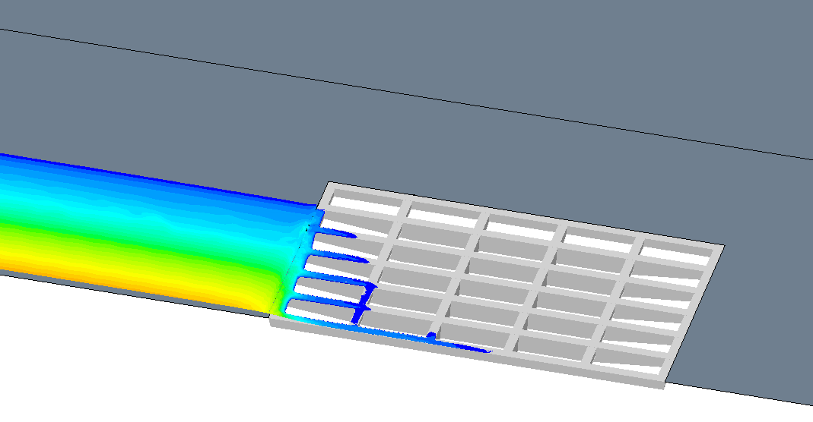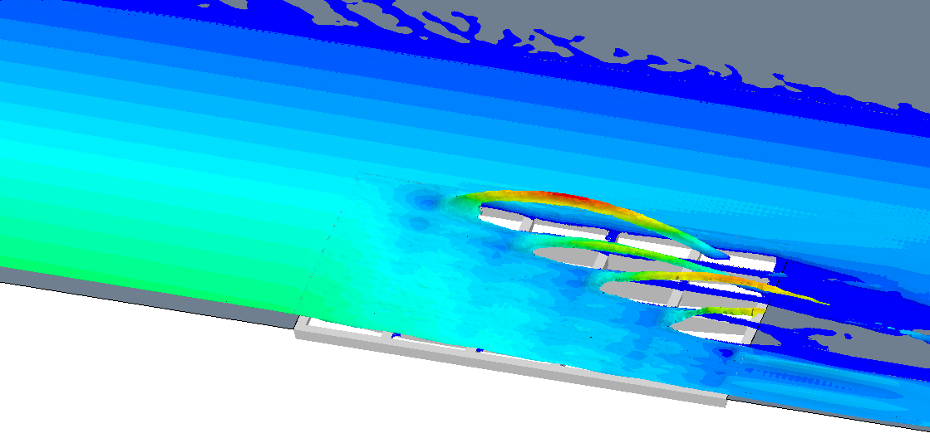
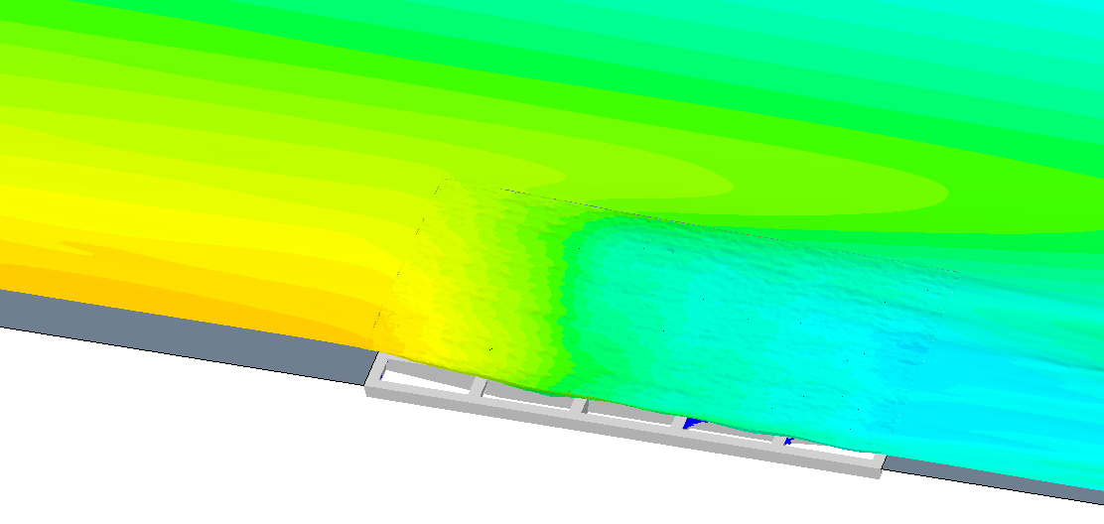
Figure 3. Flow patterns in the vicinity of the grate

2: Computational Mechanics Research Support

Argonne Transportation Research and Analysis Computing Center (TRACC) computational mechanics staff ran nationwide videoconferences every other Thursday that were open to state Department of Transportation staff and university researchers supported by the Federal Highway Administration or state DOTs. The videoconferences provide a venue to discuss approaches and issues related to hydraulics modeling projects. Topics during this reporting period included, but were not limited to:
- new methodologies of scour modeling
- river bank erosion rate prediction
- approaches to modeling and mitigating hydroplaning risk

3: Computing Support

Routine cluster maintenance including software and hardware upgrades, security patching against cyber threats, and development of custom tools to increase users' productivity. Currently working on upgrading the TRACC clusters to support the latest scientific and engineering software utilizing industry's best practice guidelines in Open Source software and virtualization.
Anticipated work next quarter:

1: Computational Mechanics Research on a Variety of Projects

- hydraulic analysis of a catch basin
- analysis of water film thickness on pavements

2: Computational Mechanics Research Support

This work will continue.

Task 3: Computing Support

This work will continue.

Circumstance affecting project or budget. (Please describe any challenges encountered or anticipated that
might affect the completion of the project within the time, scope and fiscal constraints set forth in the
agreement, along with recommended solutions to those problems).

None.

