TRANSPORTATION POOLED FUND PROGRAM
QUARTERLY PROGRESS REPORT

Lead Agency: Utah Department of Transportation

INSTRUCTIONS:
Project Managers and/or research project investigators should complete a quarterly progress report for each calendar quarter during which the projects are active. Please provide a project schedule status of the research activities tied to each task that is defined in the proposal; a percentage completion of each task; a concise discussion (2 or 3 sentences) of the current status, including accomplishments and problems encountered, if any. List all tasks, even if no work was done during this period.

Transportation Pooled Fund Program Project #  TPF-5(381) |  | Transportation Pooled Fund Program - Report Period:  _ Quarter 1 (January 1 – March 31, 2019)  _ Quarter 2 (April 1 – June 30, 2019)  x Quarter 3 (July 1 – September 30, 2019)  _ Quarter 4 (October 1 – December 31, 2019)
Project Title:
Evaluation of Lateral Pile Resistance Near MSE Walls at a Dedicated Wall Site – Phase 2

Name of Project Manager(s):  David Stevens | Phone Number:  801-589-8340 |  | E-Mail  davidstevens@utah.gov
Lead Agency Project ID:  FINET 42085, ePM PIN 16761  UDOT PIC No. UT17.404 | Other Project ID (i.e., contract #):  UDOT Contract No. 19-8182 |  | Project Start Date:  August 20, 2018
Original Project End Date:  September 30, 2020 | Current Project End Date:  September 30, 2020 |  | Number of Extensions:  1

Project schedule status:

X On schedule _ On revised schedule _ Ahead of schedule _ Behind schedule

Overall Project Statistics:
Total Project Budget | Total Cost to Date for Project | Percentage of Work  Completed to Date
$220,000.00 (current contract)  $240,000.00 (total commitments) | $60,000.00 | 35%

Quarterly Project Statistics:
Total Project Expenses  and Percentage This Quarter | Total Amount of Funds  Expended This Quarter | Total Percentage of  Time Used to Date
0% | $0.00 | 54%

Project Description:

Bridge abutment piles are frequently surrounded by mechanically stabilized earth (MSE) walls rather than a soil slope. Piles near MSE walls must be designed for lateral loads from earthquakes and thermal expansion/contraction. In the TPF-5(272) Phase 1 study involving several state DOTs, a series of 31 tests on free-head piles provided p-multipliers as a function of pile spacing which can be used to account for reduced lateral soil resistance due to the presence of an MSE wall. Equations were also developed to compute the induced force developed in the reinforcements by the lateral pile loading. However, a number of questions came up when the results of the Phase 1 study were presented to engineers and those responsible for code changes. These issues involve (a) the effect of cyclic loading when previous testing was monotonic, (b) the effect of pile head fixity because previous tests were on free-head piles while most abutment piles are “fixed-head”, (c) the effect of pile group loading when previous tests were for single piles, and (d) the effect of pile diameter on the p-multiplier and induced force equations because previous tests were all for piles about 12 inches in diameter.

Objective: To provide closure relative to the outstanding issues described above, a series of additional tests will be conducted as a Phase 2 follow-up to the original test series.
The Phase 1 study included construction of a dedicated MSE wall site in Utah with instrumented piles behind the 20-ft high wall.

Tasks for this Phase 2 study include:

1. Excavate the top 6 ft of the soil backfill behind the existing MSE wall.
2. Instrument MSE reinforcements and piles with strain gauges.
3. Re-compact the top 6 ft of the soil backfill behind the existing MSE wall.
4. Conduct cyclic lateral pile load testing.
5. Conduct fixed-head lateral pile load testing.
6. Conduct lateral pile load testing of larger-diameter piles (24-inch diameter), to be newly placed between cut-off existing piles.
7. Conduct lateral pile load testing of a pile group.
8. Develop p-multipliers for Phase 2 lateral pile load testing results, compare these with the Phase 1 results, and update the overall p-multiplier equation as necessary.
9. Develop tensile force equations for Phase 2 lateral pile load testing results, compare these with the Phase 1 results, and update the overall tensile force equations as necessary.
10. Submit a final report that documents the Phase 2 research effort.
11. Report results to TAC committee members in video conferences.
12. Make presentations at AASHTO bridge engineers’ committee meetings and TRB events to aid in national efforts to implement the study results.

Dr. Kyle Rollins of BYU is the Principal Investigator for this research project. The technical advisory committee (TAC) for the study currently includes representatives from UT, CA, FL, KS, MN, NY, and WI state DOTs.

Progress this Quarter (includes meetings, work plan status, contract status, significant progress, etc.):

Task 1 – Completed.
Task 2 – Completed.
Task 3 – Completed.
Task 4 – Submitted memo reporting on this completed testing.
Task 5 – Submitted memo reporting on this completed testing.
Task 6 – Submitted memo reporting on this completed testing.
Task 7 – Worked on memo reporting on this completed testing.
Task 8 – Continued this task.
Task 9 – Not started.
Task 10 – Not started.
Task 11 – Not started.
Task 12 – Not started.

Contract – No changes this quarter.

Anticipated work next quarter:

Task 1 – Completed.
Task 2 – Completed.
Task 3 – Completed.
Task 4 – Completed.
Task 5 – Completed.
Task 6 – Completed.
Task 7 – Submit the task completion memo with test layout, procedure, basic results, and load-deflection curves.
Task 8 – Develop p-multipliers for Phase 2 lateral pile load testing results, and submit the task completion memo.
Task 9 – Start developing reinforcement tensile force equations.
Task 10 – None planned.
Task 11 – Hold a TAC web conference to provide updates and discuss progress.
Task 12 – None planned.

Contract – Consider adding the remaining pooled fund commitment amount to the contract for face-to-face TAC meetings or additional numerical analysis and pressure cell analysis.

Significant Results:

This quarter the research team has been analyzing the cyclic lateral pile load test results. The cyclic lateral load tests were performed on the 12.75 OD steel pipe piles located within the section of the MSE wall reinforced by welded wire reinforcements. The test piles in this location were actually located at distances of 1.5, 3.1 and 4.2 and 5.3 pile diameters (D) where distance is measured from the back face of the MSE wall to the center of the test pile. The cyclic loads were applied using an MTS hydraulic actuator bolted to the test pile and the reaction beam. Each connection was attached to a 3D swivel head to provide a “pinned” connection representing a “free-head” loading condition. Cyclic loading was applied to define the load-deflection curve with target deflection levels of approximately 0.25, 0.5, 0.75 and 1.5 inches. Cyclic loading was bi-directional (i.e. load in one direction to the target displacement followed by load in the opposite direction) for each cycle and 15 cycles of loading were applied at each target displacement. A typical pile head lateral load vs. displacement curve for the test pile at 1.5D is provided in Fig. 1. Because displacement was controlled at the actuator, some variations in the test pile displacement occurred when the test pile began to experience significant displacements owing to significant movement of the MSE reinforcements. At this point, the test pile displacement increased while the test pile load decreased as shown in Fig. 1.

Pile head load vs. deflection curves for the first cycle of loading towards the wall are shown in Fig. 2 and away from the wall in Fig. 3 for the four test piles at the four different locations behind the MSE wall. For loading towards the wall, the load-deflection curves are generally quite similar for all piles for the initial loading. However, the lateral resistance for the test piles at 3.1D and 1.5D show progressively greater reduction in lateral resistance relative to the test piles at 5.3D and 4.2D from the wall. Of course, this is consistent with previous findings from monotonic loading tests that showed relatively little decrease in lateral resistance for piles located more than four pile diameters from the back of the MSE wall.

For loading away from the wall, the load-deflection curves are generally quite similar for test piles at all spacings behind the wall. This finding is consistent with the fact that all the test piles are loading towards a level compacted fill zone that extends a significant distance beyond all of the piles. Without the presence of a vertical wall, the lateral resistance remains relatively consist for each pile. In addition, a comparison of the load-deflection curves from Fig. 2 and Fig. 3 indicates the curves for loading towards the wall for piles located at 5.3D and 4.2D are quite similar to those for the test piles loaded away from the wall. This result indicates that the reinforcement behind the MSE wall is providing enough lateral resistance to lateral pile displacement that the resistance is the same as if no wall were present, at least for the piles located further than about four pile diameters behind the wall. This result also confirms findings from the original monotonic load tests which identified 4D as the distance beyond which a p-multiplier of 1.0 could be used to analyze the lateral resistance of piles located behind MSE walls.

Fig. 1 Typical cyclic lateral load vs. deflection curve for single 12.75 inch OD pipe pile with welded-wire reinforcement. These curves are for the test pile located 1.5 pile diameters from the back of the MSE wall to the center of the test pile.

Fig. 2 Pile head load vs. deflection curves for first cycle peak loads in the direction of the wall for the four test piles located at distances of 5.3, 4.2, 3.1 and 1.5D behind the back of the MSE wall panel.

Fig. 3 Pile head load vs. deflection curves for first cycle peak loads in the direction away from the wall for the four test piles located at distances of 5.3, 4.2, 3.1 and 1.5D behind the back of the MSE wall panel.

Figs 4 and 5 provide plots showing the reduction in the peak lateral pile resistance relative to the first cycle of loading for tests away from the MSE wall and towards the wall, respectively. For this test at 1.5D behind the wall, there is somewhat greater reduction in lateral resistance towards the wall than away from the wall and the decrease in resistance is somewhat more rapid for the loading towards the wall. However, after about 15 cycles of loading the reduction in resistance is between 90 and 93% in both cases. The reduction in resistance does appear to increase as the pile head load increases and will be investigated further in the next quarter.

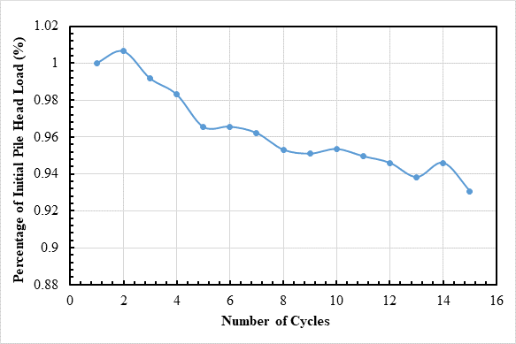

Fig. 4 Reduction in peak load with number of load cycles for lateral loading in the direction away from the wall for the pile located at 1.5D behind the MSE wall.

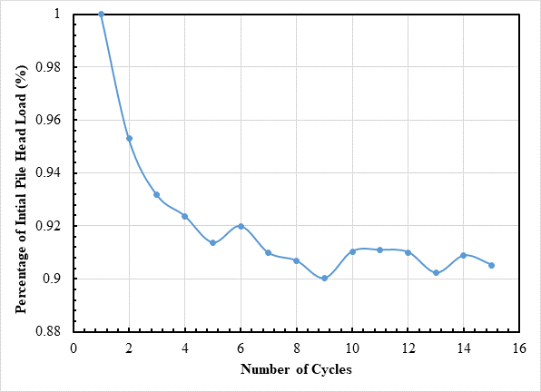

Fig. 5 Reduction in peak load with number of load cycles for lateral loading in the direction of the wall for the pile located at 1.5D behind the MSE wall.

Circumstance affecting project or budget. (Please describe any challenges encountered or anticipated that
might affect the completion of the project within the time, scope and fiscal constraints set forth in the
agreement, along with recommended solutions to those problems).

None.

Potential Implementation:

