TRANSPORTATION POOLED FUND PROGRAM
QUARTERLY PROGRESS REPORT

Lead Agency: Utah Department of Transportation

INSTRUCTIONS:
Project Managers and/or research project investigators should complete a quarterly progress report for each calendar quarter during which the projects are active. Please provide a project schedule status of the research activities tied to each task that is defined in the proposal; a percentage completion of each task; a concise discussion (2 or 3 sentences) of the current status, including accomplishments and problems encountered, if any. List all tasks, even if no work was done during this period.

Transportation Pooled Fund Program Project #  TPF-5(244) |  | Transportation Pooled Fund Program - Report Period:  _ Quarter 1 (January 1 – March 31, 2017)  _ Quarter 2 (April 1 – June 30, 2017)  x Quarter 3 (July 1 – September 30, 2017)  _ Quarter 4 (October 1 – December 31, 2017)
Project Title:
Shaking Table Testing to Evaluate Effectiveness of Vertical Drains for Liquefaction Mitigation

Name of Project Manager(s):  David Stevens | Phone Number:  801-589-8340 |  | E-Mail  davidstevens@utah.gov
Lead Agency Project ID:  FINET 42046, ePM PIN 9933  UDOT PIC No. UT07.708 | Other Project ID (i.e., contract #):  UDOT Contract No. 138731 |  | Project Start Date:  May 1, 2013
Original Project End Date:  March 31, 2016 | Current Project End Date:  December 31, 2017 |  | Number of Extensions:  3

Project schedule status:

_ On schedule X On revised schedule _ Ahead of schedule _ Behind schedule

Overall Project Statistics:
Total Project Budget | Total Cost to Date for Project | Percentage of Work  Completed to Date
$115,000.00 | $71,500.00 | 80%

Quarterly Project Statistics:
Total Project Expenses  and Percentage This Quarter | Total Amount of Funds  Expended This Quarter | Total Percentage of  Time Used to Date
0% | $0 | 94%

Project Description:

The vision for this study is to determine the viability of large diameter (100 mm) prefabricated vertical drains for preventing liquefaction and associated settlements or lateral spreading under full-scale conditions. If viable, drainage alternatives offer substantial advantages in comparison to conventional densification approaches. In production, drains can often be installed at 25% to 40% of the cost of stone columns. In addition, the drains can be installed in about one-third to one-half of the time required for stone columns. Finally, the time and cost associated with post-treatment in-situ testing to evaluate improvement produced by densification may not be required with drains. In an era when construction budgets are becoming increasingly tight and projects are increasingly placed on fast-track schedules, innovative alternative solutions are required to deal with liquefaction hazards.

Although limited blast liquefaction testing (Rollins et al. 2003, Rollins et al. 2004), vibration testing (Chang et al. 2004) and centrifuge testing (Yang et al. 2004 ) suggest that vertical drains can be effective, no full-scale drain installation has been subjected to earthquake induced ground motions. This lack of performance data under full-scale conditions has been a major impediment to expanding the use of this technique. To remedy this problem we will conduct full-scale tests with vertical drains in liquefiable sand using the laminar shear box and high speed actuator system at NEES-Univ. at Buffalo. Tests will involve level ground conditions with two drain spacings and will be integrated with a previously funded NEESR study currently underway so that the control tests without drains will already be available. We will use the same sand installation techniques, as well as the same instrumentation plan and shaking protocols which have already been developed and proven successful. This collaborative approach will significantly reduce the cost of the study in comparison to a completely independent study. In addition, it will provide a comparison between the performance of the soil profile with drains relative to subsequent tests where piles will be involved. If full-scale tests prove the effectiveness of the drainage technique, significant time and costs savings can be achieved for both new construction and for retrofit situations.

Three objectives are outlined for this study:
1. Evaluate the ability of earthquake drains to reduce excess pore pressure and settlement for level ground conditions at progressively higher acceleration levels.
2. Define the influence of drain spacing on the effectiveness of the drains for mitigating liquefaction hazard.
3. Provide well-documented case histories which can be used to calibrate/validate numerical models for predicting the performance of vertical drains.

The scope of work consists of eight specific tasks:
1. Perform a literature review to summarize the state of the art in the area of liquefaction mitigation through drainage.
2. Conduct level ground shaking table tests with drains at 4 ft spacing.
3. Conduct level ground shaking table tests with drains at 3 ft spacing.
4. Reduce the test data, analyze, and compare with previous test on untreated sand.
5. Evaluate predictive methods by comparing measured behavior with behavior computed using computer models and simplified models.
6. Prepare a final report on effectiveness of the drain technique.
7. Disseminate the research results.
8. Hold technical advisory committee meetings.

Dr. Kyle Rollins of BYU is the Principal Investigator for this research project. The TPF-5(244) testing was performed at the SUNY-Buffalo shaking table testing facility in the summer of 2014. BYU was approved for shared-use status on the NEES-Buffalo shake table. Individual task reports will be prepared for Tasks 1 through 5 when these are completed. Up to two in-person meetings with the multi-state technical advisory committee (TAC) are planned to be held in Salt Lake City, Utah during the project. Other TAC meetings will be tele-conference or web meetings.

Progress this Quarter (includes meetings, work plan status, contract status, significant progress, etc.):

Task 1 – 100% complete.
Task 2 – 100% complete.
Task 3 – 100% complete.
Task 4 – 90% complete. BYU prepared a data reduction report.
Task 5 – 70% complete. BYU prepared an analysis progress report.
Task 6 – 70% complete. BYU prepared portions of the final report.
Task 7 –20% complete. Dr. Rollins published paper and presented results of laminar shear box testing at Intl. Conf. on Soil Mechanics and Geotechnical Engineering in Seoul, South Korea.
Task 8 – 40% complete.
Contract – No changes.

Anticipated work next quarter:

Task 1 – None.
Task 2 – None.
Task 3 – None.
Task 4 – Post the revised task report on the TPF website. Provide a data reduction report for TAC review.
Task 5 – Continue with evaluating predictive methods. Provide a predictive methods report for TAC review.
Task 6 – Complete the draft final report for TAC review.
Task 7 – No plans
Task 8 – Plan to hold another TAC web-conference to review and discuss final results from the study. Consider travel and implementation support needs of the TAC members.
Contract – No changes planned.

Significant Results:

During the past quarter Dr. Rollins and Caleb Oakes published and presented a paper entitled “Effectiveness of Vertical Drains for Liquefaction Mitigation Based on Large-Scale Laminar Shear Box Testing” at the International Conference on Soil Mechanics and Geotechnical Engineering held in Seoul, South Korea. The paper was well received by the attendees.

During this quarter, a parametric study was performed to determine the effect of changing certain model parameters that are related to soil properties, drain properties, and seismic loading. For this investigation, the calibrated model for the 4ft drain spacing during Round 1 testing with amax=0.1g was used as the example. This changing of parameters was done systematically, with all other parameters kept equal despite the fact that some parameters might be cross-correlated. The resulting excess pore pressure vs. time curves were plotted together on one plot for each depth where a pore pressure transducer was located for comparison. It is assumed that the behavior observed when varying each parameter in this example will have the same or very similar effects on all other models.

It was found that for the initial slope of R_{u} rise (generation curve) and the peak R_{u} value attained, the number of cycles to liquefaction and the hydraulic conductivity have the greatest effect. However, the downward slope (dissipation curve) is most influenced by hydraulic conductivity (k) and coefficient of compressibility (mv), with the latter having particular effect on the initial angle of the dissipation slope.

In the subsequent sections, the effect of variations in hydraulic conductivity, relative density, modulus of soil compressibility, and earthquake magnitude will all be examined.

Effect of Variation in Hydraulic Conductivity

The hydraulic conductivity of the soil has the strongest effect on the dissipation of pore pressures to drains and the resulting R_{u} values. It is also the most sensitive property as shown by parametric study. However, conductivity was relatively simple to measure in-situ for these tests, thus reducing the variability in modeling. Intuitively, a higher conductivity value leads to a lower R_{u} value since water can escape more easily; this is confirmed by the parametric study. In real field applications, the determination of an accurate hydraulic conductivity in the horizontal direction becomes of paramount importance. It should also be noted that the computer model assumes that the hydraulic conductivity remains constant regardless of R_{u} even after liquefaction which may differ from reality.

Results of the parametric study for hydraulic conductivity are shown in Figure 1 and hydraulic conductivity values used in this analysis are summarized in Table 1. The dashed black curve is the model prediction of Ru made using the measured hydraulic conductivity while the measured R_{u} time history is shown in dark blue. Increasing or decreasing the hydraulic conductivity by about 25% (kmodel x 1.25 and kmodel x 0.75) typically changed the computed peak R_{u} values 10 to 25 percentage points. The highest and lowest R_{u} vs time curves use the overall maximum and minimum k values (upper bound k, and lower bound k) measured in the laminar shear box, and use the same k at all depths. Peak R_{u} values change somewhat than for the 25% variation case particularly at shallow depth and dissipation times increased markedly for the lowest k values.

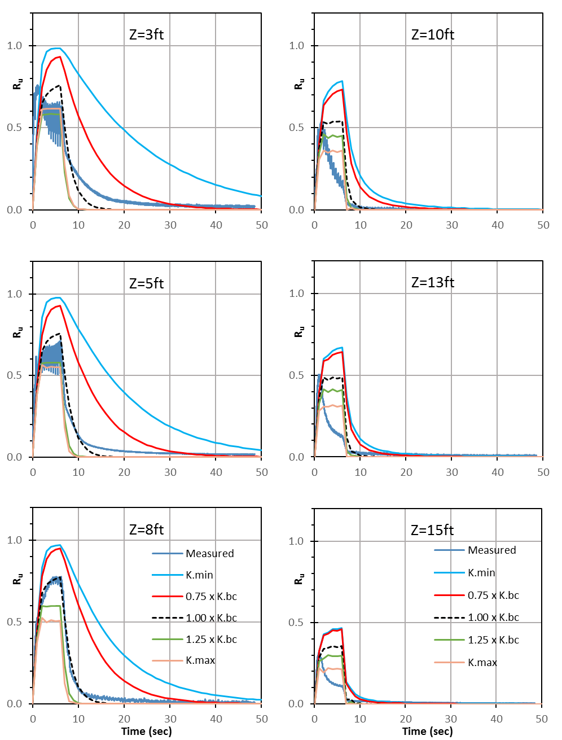
Figure 1. Effect of Varying Hydraulic Conductivity (k) at Each Piezometer Level.

Table 1. Summary of range hydraulic conductivity values used in parametric analyses.

Effect of Variations in Modulus of Soil Compressibility, (m_{v})
As previously stated, soil compressibility has a strong effect on the peak R_{u} value and dissipation rate of the computed R_{u} curves. The back calculated m_{v} values for the experimental soil was much higher than those suggested in the FEQDrain manual for natural soils. Most of the back-calculated m_{v} values were close to 8x10⁻⁶ ft²/lbs. but the suggested values were around 2x10⁻⁶ ft²/lbs. This is likely because the sand in the laminar box was very uniform, newly deposited, and did not have any significant structure or bonding between the particles.
A summary of the m_{v} values used in the parametric analysis is provided in Table 2. Results of the parametric study of the modulus of soil compressibility are shown in Figure 2 for each level where pore pressure transducers are located. Comparisons are provided with measured and back-calculated models as was done previously. The results of modeling show that a higher coefficient of compressibility produces higher R_{u} peak values, and slower dissipation. Lower compressibility produces lower pore pressures and faster dissipation. This effect is clearly illustrated in Figure 2, which shows several curves produced by increasing or decreasing the m_{v} by multiplying the back-calculated compressibility for each layer by a factor. The values in the legend and table indicate what factor was applied for each curve. Changing the m_{v} values by factors of 1.25 and 0.75 changed the peak R_{u} values by 10 to 25 percentage points which is very similar to the sensitivity observed with the hydraulic conductivity. R_{u} vs time curves computed using the maximum and minimum range of m_{v} values measured in the experiment show a variation in peak R_{u} values of plus 25% to 50% and minus 20 to 50%.
Table 2. Summary of modulus of soil compressibility values used in the parametric sensitive analysis.

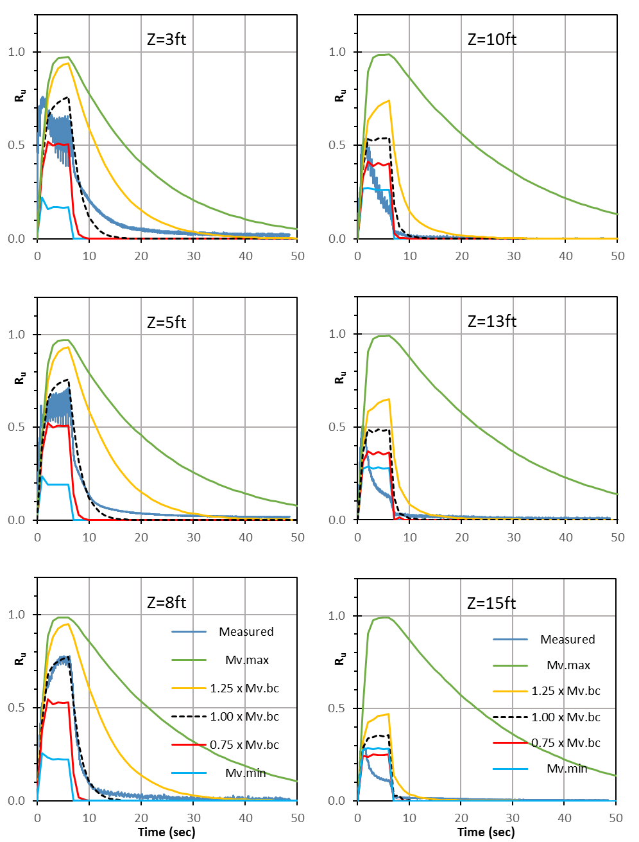
Figure 2. Effect of Varying Coefficient of Volumetric Compressibility (m_{v}) at Each Piezometer Level.

Effect of Variation in Earthquake Magnitude, M_{w}
The FEQDrain program uses the number of equivalent cycles and shaking duration to define the magnitude of a seismic event. Having a longer duration of shaking (t_{d}) with a greater number of equivalent cycles (N_{eq}) describes a higher magnitude earthquake which would last longer or have higher accelerations. The user’s manual provides recommendations for the number of equivalent cycles (Seed & Idriss, 1982), and duration of shaking (Seed et al., 1975b) to correspond to different moment magnitudes (M_{w}), shown below in Table 3. The basis for the cycles and time combination is provided by research with undrained cyclic shear tests which showed that it does not matter whether the shear cycles were applied at 1 Hz or 10 Hz. Because the frequency of loading had no effect, it follows that only the number of cycles really matters. This is probably why Pestana et al. (1998) recommended the combination of number of cycles and duration to account for increasing magnitude.

Table 3. Variation of duration and number of cycles of loading as a function of earthquake magnitude.
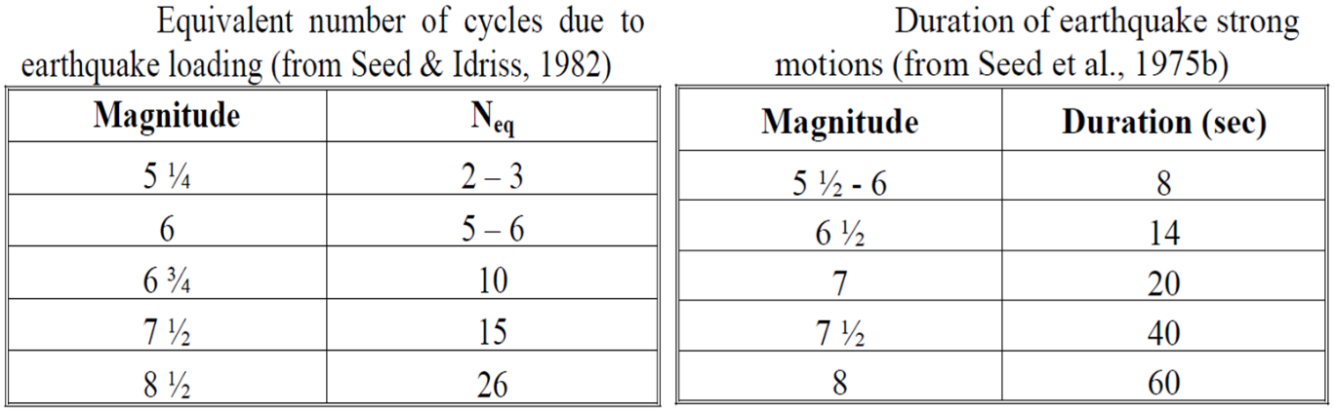
However, for the situation involving PV drains, the frequency and duration of loading is relevant. For example, an intense, short duration earthquake would likely overwhelm the drains and liquefy the soil. But a similar number of cycles applied over a longer time period might suggest that the drains would be sufficient to prevent liquefaction. In fact, the application of 15 cycles of loading, typical of a 7.5 M_{w} earthquake, in 7.5 seconds during the laminar shear box testing, could represent a relatively severe loading for the drains in comparison with a 40 second duration that would be typical of a 7.5 M_{w} earthquake.
To investigate the effect of earthquake duration and number of cycles on pore pressure response, the computer program FEQDrain was used to analyze the soil profile for various magnitudes of earthquakes. Results of the parametric study for the effect of earthquake magnitude are shown in Figure 3 for each level where pore pressure transducers are located. Comparisons are provided with measured and back-calculated models as has been done previously.
As shown in Figure 3, the peak R_{u} values computed for all the different earthquake magnitude events are substantially lower in almost all cases than that observed with 15 uniform load cycles over a 7.5 second duration in the experimental testing. The primary pore pressure response includes an initial pore pressure rise, a plateau, and dissipation when the shaking stops. There is a noticeable difference in the plateau length of each curve, but none has a very high maximum value. Surprisingly, there is no progressive increase in peak pore pressure for higher magnitude events. Higher magnitude seismic events have more cycles (N_{eq}) and a longer duration (t_{d}) which results in a longer plateau, but with nearly the same pore pressure rise as for smaller quakes. This response occurs because the longer duration “dilutes” the energy of the shear cycles by allowing time for drainage and dissipation to occur while shaking continues, without overwhelming the drains.
Similar pore pressure response among models for increasing earthquake magnitude agrees with the similarity in the ratio of shaking duration to equivalent uniform cycles (seconds/cycle) for each magnitude. Based on the recommendations in the FEQDrain User’s manual (Pestana et al, 1998), typical seconds/cycle values range from about 2 to 2.67 seconds/cycle for Mw values ranging from 5.5 to 8.5. Of course, this loading rate is much slower than the 0.5 seconds/cycle loading rate actually used in the experimental testing. Therefore, the results from the laminar shear box testing likely represent a conservative estimate of the response that might be observed in a real earthquake. However, it should be recognized that earthquakes do not typically apply cycles at a uniform rate over the entire duration of shaking. Therefore, higher frequency shaking over a short portion of the total duration could still reduce the effectiveness of PV drains relative to the predictions in Figure 3.

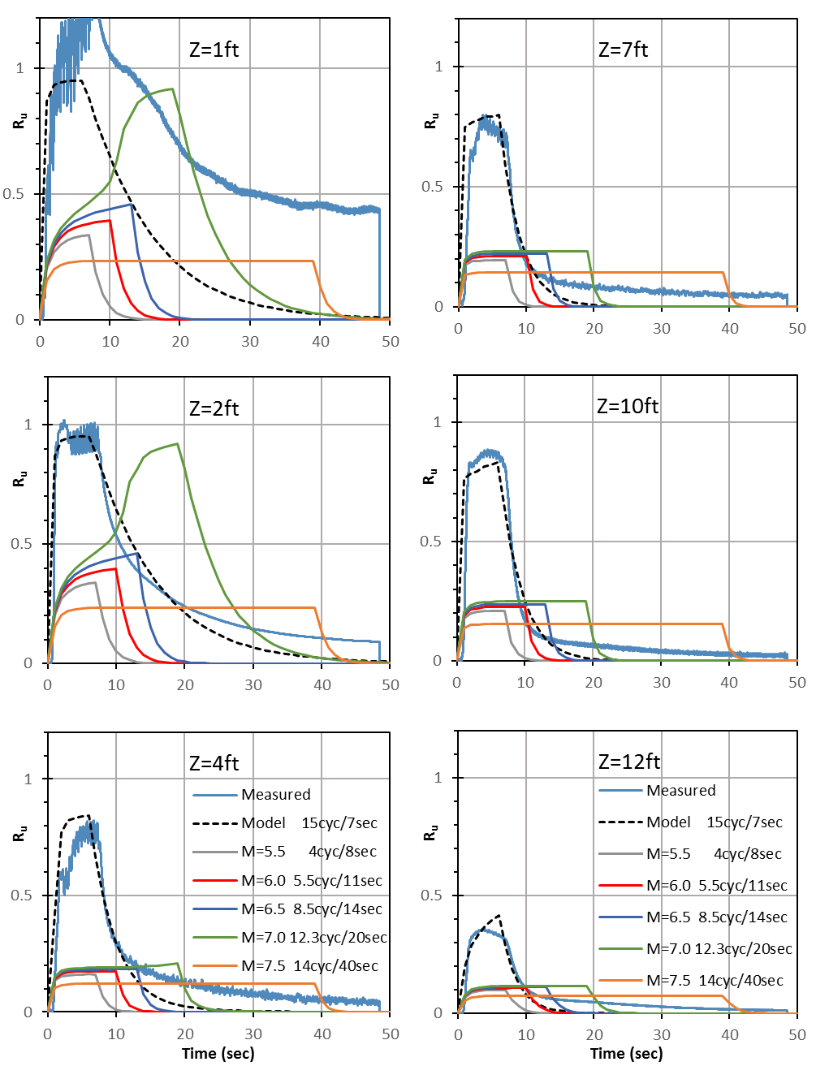
Figure 3 Effect of Number of Cycles and Shake Duration with Variations in Earthquake Magnitude Suggested by FEQDrain User Manual (Pestana et al. 1998).

Circumstance affecting project or budget. (Please describe any challenges encountered or anticipated that
might affect the completion of the project within the time, scope and fiscal constraints set forth in the
agreement, along with recommended solutions to those problems).

Additional time was needed to complete reports and reviews by the TAC. Therefore the contract was amended to reflect the project ending in December 2017 instead of the original plan.

Potential Implementation:

