TRANSPORTATION POOLED FUND PROGRAM
QUARTERLY PROGRESS REPORT

Lead Agency (FHWA or State DOT): Oklahoma Department of Transportation

INSTRUCTIONS:
Project Managers and/or research project investigators should complete a quarterly progress report for each calendar quarter during which the projects are active. Please provide a project schedule status of the research activities tied to each task that is defined in the proposal; a percentage completion of each task; a concise discussion (2 or 3 sentences) of the current status, including accomplishments and problems encountered, if any. List all tasks, even if no work was done during this period.

Transportation Pooled Fund Program Project #  TPF-5(297) |  | Transportation Pooled Fund Program - Report Period:  O Quarter 1 (January 1 – March 31)  X Quarter 2 (April 1 – June 30)  O Quarter 3 (July 1 – September 30)  O Quarter 4 (October 1 – December 31)
Project Title:
Improving Specifications to Resist Frost Damage in Modern Concrete Mixtures

Name of Project Manager(s):  Tyler Ley | Phone Number:  405-744-5257 |  | E-Mail  Tyler.ley@okstate.edu
Lead Agency Project ID:  TPF-TPF5(297)RS / JOB PIECE 30802(04) | Other Project ID (i.e., contract #):  AA-5-52974 |  | Project Start Date:  March 10, 2014
Original Project End Date:  February 28, 2017 | Current Project End Date:  February 28, 2019 |  | Number of Extensions:  1

Project schedule status:
On schedule X On revised schedule □ Ahead of schedule □ Behind schedule

Overall Project Statistics:
Total Project Budget | Total Cost to Date for Project | Percentage of Work  Completed to Date
$440,000 | $20,500 | 12%

Quarterly Project Statistics:
Total Project Expenses  and Percentage This Quarter | Total Amount of Funds  Expended This Quarter | Total Percentage of  Time Used to Date
$20,500 | $20,500 | 12%

Project Description:

Concrete can be damaged when it is 1) sufficiently wet (has a high degree of saturation) and 2) is exposed to temperature cycles that enable freezing and thawing. The damage that occurs due to freezing and thawing can lead to premature deterioration, costly repairs, and premature replacement of concrete infrastructure elements. Current specifications for frost durability are largely based on work completed in the 1950s, and while this work included many landmark discoveries (Kleiger 1952, 1954). This work from the 1950s may not be representative of materials used in modern concrete mixtures. Results from recent studies suggest that there are several ways in which frost damage can be reduced through new tests and improve specifications that can lead to extended service life of concrete infrastructure.

This report focuses on the work completed in Phase II of the project.

The goal of the research is to produce improved specifications, and test methods; while, improving the understanding of the underlying mechanisms of frost damage. Specifically, this work will seek to develop new test procedures that may be faster and/or more reliable than the existing methods. The objectives of Phase II are:

- Continued Development of the SAM and Investigation of Field Construction Practices
- Validate and standardize the Bucket Test
- Measuring and Modeling different freeze thaw exposure conditions
- Confirm the freeze thaw results with X-ray and neutron imaging

Progress this Quarter (includes meetings, work plan status, contract status, significant progress, etc.):

Phase II

Task 1 – Continued Development of the SAM (Oklahoma State)

This task will aim to improve the usability and performance of the SAM. A device that is easier to use will be one that is easier to adopt, more accurate readings, and happier users.

First, a new o-ring has been developed and produced on a large scale. The new o-ring has a lower durometer or stiffness. The softer o-ring is able to bridge over sand grains and better seal the lid of the meter.

A new gauge has been developed that is reinforced. This makes it more resilient against damage. There are also several program changes to the gauge that allow the meter to use the softer o-ring.

A new device has been developed that makes it easier to add water to the bottom chamber without adding bubbles.

One other issue was correctly adding water to the bottom chamber without adding bubbles. This device is a funnel that screws into one of the petcocks. The petcock is closed and the funnel is filled. The petcock is then opened and a continuous stream of water is added to the bottom chamber. The meter can then be adjusted to remove the air and then the petcock can be closed again. The funnel decreases the time, it makes it easier for the user, and it reduces human error of inadvertently adding bubbles.

All of these new additions will be sent to the states for them to use in the field and provide feedback.

The research team is working on new ways to clean the rim of the bottom bucket after striking the sample. The team is also working on an external pump to be used with the test.

A preliminary precision and bias statement has been developed by using two different SAM testers. Details can be seen in the attached paper. Work is underway to develop data for multiple users. To do this the research team is using four or five operators on the same concrete mixtures.

Work is also being done to update the AASHTO TP 118 test method for the SAM. The major change is to remove the use of a vibrator in consolidating the concrete. Ongoing research shows that this is not a good practice.

Task 2 – Investigate field construction practices and aid SAM adoption (Oklahoma State)

In this task the research team will continue to work with different DOTs to investigate their interest in field usage of the SAM. The field data from the SAM has also been compiled from Phase I of the project. Results from laboratory testing is included in Fig. 1. This data is included so that a comparison can be made to the field data. The field data from 13 states and over 250 concrete mixtures is included in Fig. 2. There is similar agreement between the lab and field data for a spacing factor of 0.008”and a SAM Number of 0.20. This data is being prepared for publication.

A tremendous amount of work has been done on pumping concrete. A report has been included with additional details. The research has completed work in both the lab and the field. Both tests show that the air void system coarsens in every pumped concrete mixture. This coarsening is caused by the dissolution of the fine bubbles in the concrete. Sometimes this dissolution causes the air content of the concrete to decrease and sometimes is does not. In only a few cases was it found that the air content increased. This usually happened when the concrete was exposed to some kind of free fall.

Despite every mixture showing a coarsening of the air void system and typically a loss in air, these concrete mixtures did not show poor freeze thaw behavior. Air contents were found to be as low as 2% after the concrete pump and yet these mixtures passed the freeze thaw testing. This suggests that the air that dissolves during pumping will return to the concrete. This is now being confirmed with hardened air void analysis. This is a significant finding, and it suggests that concrete must be checked before it goes into a concrete pump and should not be investigated after pumping the concrete. Important graphs are shown in Figs. 3 and 4. This graph compares both air content and SAM Number for concrete that has been pumped and concrete that has not. The data shows that air contents can be as low as 2% and SAM numbers much greater than 0.30 and there is still satisfactory performance in freeze thaw testing. As stated previously, we think this is possible because the air void system that is measured is not the air void system that will be in the final concrete mixture. It appears that the air void system comes back over time, and this is why the freeze thaw performance is satisfactory. This is being investigated further by examining the hardened air void results for these samples. These findings will be reported in future reports.

Testing has also been done to investigate drop height of the concrete and the impact of vibration on the air void system. Work is also being done with combinations of aggregates to determine the impact on the air void system.

Testing has also been done on how drop height impacts the air void system in concrete. These tests provide insight into many parts of construction. Some examples include: dumping concrete out of a truck in front of a paver, dropping concrete from a bucket to a point of placement, and the free fall of concrete through a pipe or tremie before hitting the ground. Testing has been completed on a few different concrete mixtures and results will be presented in the future.

The team also has plans to investigate how vibration and mixing impacts the air void system in concrete. These will be exciting additions to the understanding of how concrete is created and constructed.

Task 3 – Standardizing a new rapid freeze thaw test (Oregon State and Oklahoma State)

As part of the previous research on the pooled fund it was realized that critical degree of saturation has a significant impact on the freeze thaw resistance of concrete. This means that as the concrete becomes increasingly saturated that there will be a point when the concrete becomes critically saturated after which time a freezing cycle results in damage. While the current test method is based on placing samples in water and subjecting them to freezing cycles, it appears that it may be possible to extend this very economical and simple test to a more rapid test method. The proposed test method (the bucket test) is simple as the concrete mass is measured after demolding and then over time while the sample is in lime water or perhaps a simulated pore solution. While this test seems simple it shows great agreement with the ASTM C 666 data as shown in Fig. 4.

Work at Oregon State has shown that it may be possible to extend this approach to an even faster test method that could be used as an input into the service life prediction model. If successful this would imply that data from the SAM test and bucket test could be used to provide an indication for the service life of a concrete element exposed to freezing and thawing.

A number of concrete mixtures have been created at Oklahoma State with different w/cm and air void contents and qualities. These samples have been sent to Oregon for testing. In addition the samples have been investigated for hardened air void analysis and for ASTM C 666 testing. The conditioning and testing of the samples at Oregon State have begun and updates will be reported in the future.

Task 4 – Measuring different FT exposure conditions (Oklahoma State and Oregon State)

It is widely realized that different freeze thaw environments are different across the US. However, all of the freeze thaw specifications treat each environment the same. The research team aims to better describe these different regions by quantifying how the different environments impacts the moisture content and temperature of concrete. Because these are the two primary inputs to freeze thaw durability, this will be very valuable data.

This is being done by making concrete samples at Oklahoma State with a known concrete mixture and embedding stainless steel rods in them at different depths and also using thermocouples or temperature sensors at these same depths. The samples will be forced to gain and lose water from only their finished surface. This is much like a concrete pavement. By gathering this information from all of these locations then it will allow the weather conditions and their impact on the concrete to be compared.

The data loggers to measure this have been constructed and we are finalizing the measurement in concrete. We hope to get a data logger out in the field in August in Oklahoma to make sure the system is running smoothly.

Task 5 – Modeling different FT exposure conditions (Oregon State)

The data from the field monitoring (Task 4) will be essential in establishing models to simulate how different exposure conditions impact FT prediction. These models will aim to incorporate drying, wetting, salts, temperature ranges, etc. in making the ultimate prediction of FT field performance of concrete. The previous work on this pooled fund has used well known exposure conditions to better understand the freeze thaw performance of concrete. This has allowed us to build a new level of understanding of FT performance. In this task we aim to extend this knowledge to much more variable exposure conditions of the concrete. This may require some additional laboratory testing to look at how wetting and drying cycles impact the moisture penetration. It also may require completing some previous testing under the influence of salt solution. The ultimate goal of this work is to build a numerical model that will help DOTs design their concrete based on their local conditions and exposure levels. This tool could also be used to forecast the life of concrete of different qualities into the future. This would aid in the design, repair, and service life prediction of existing structures to predict differences in designed and provided life expectancy of structures.

Work will be completed on this as the field data is generated. Once the field system is deployed then a lot of data will be generated simultaneously. This will help this task tremendously.

Task 6 - Confirmation of FT results with X-ray and neutron imaging (Oregon State and Oklahoma State)

Both research groups on this project have been studying the movement of water with both X-ray and neutron tomography and radiography. These techniques lend themselves well to the study of freeze thaw damage within concrete as they can be used to evaluate structure, fluid movement, and damage. These methods will be a useful tool to validate the findings from this work and provide deeper insights to critical questions. These tools will not be extensively used in the research; however, they will be able to provide measurements that are not possible with any other method. It is anticipated that a freezing stage will be constructed for usage for neutron and X-ray imaging. This will allow in-situ imaging to be complete of materials as they are freezing.

Preliminary work is being completed at both Universities on this task. Progress will be presented in the future.

Figure 1 – A combination of OSU lab data, Oklahoma field data, and FHWA lab data that compares the SAM to the spacing factor. There is a 90% agreement between the data sets when evaluating a spacing factor of 200 μm or 0.008”.

Figure 2 – A comparison of the SAM Number versus the Spacing Factor for over 250 field concrete mixtures from 13 different state DOTs. For the mixtures investigated 81% of them fall within the upper right or lower left quadrant when a SAM Number of 0.20 is used. Also, 20% of the data falls within the upper right quadrant. This is the region that is not recommended for freeze thaw durability.

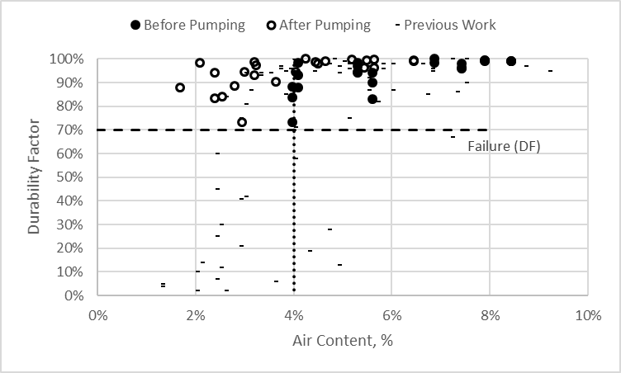
Figure 3 – The durability factor plotted against the air content for mixtures that were pumped and those what were not. This shows that mixtures with very low air contents after pumping show satisfactory durability performance in the ASTM C 666. This is likely caused by a temporary loss of air caused by pumping. This air bubbles appear to return to the concrete over time and still provide freeze thaw protection to the concrete.
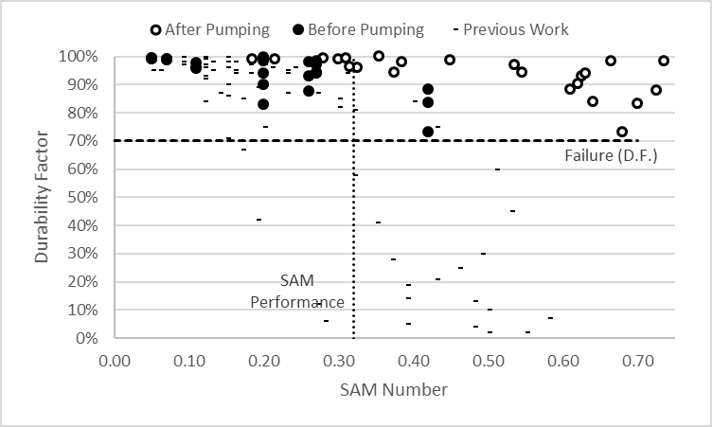
Figure 4 – The durability factor plotted against the SAM Number for mixtures that were pumped and those what were not. This shows that mixtures with poor SAM Numbers after pumping show satisfactory durability performance in the ASTM C 666. This is likely caused by a temporary loss of air caused by pumping. This air bubbles appear to return to the concrete over time and still provide freeze thaw protection to the concrete.

Figure 5 – Time to critical saturation as determined by the bucket test is shown versus the ASTM C 666 durability factor. Good agreement is shown between the two methods.

Anticipated work next quarter:

The team is continuing to evaluate methods to improve the SAM.

Using the SAM to investigate field concrete through pumping, vibration, drop height, and mixing.

The Bucket Test is being evaluated and improved.

Deploy field samples in Oklahoma.

Significant Results:

The data from over 300 different laboratory and field mixtures completed by two different labs suggest that a SAM
number of 0.20 can correctly determine if the spacing factor is above or below 0.008” about 93% of the time. There is
also over 80% agreement between the SAM results and the ASTM C666 results. Validation data has been gathered by FHWA Turner Fairbanks laboratory and the Pennsylvania DOT.

Over 20 different presentations and webinars have been given over the research. Over 10 papers have been authored based on the work from this research. The SAM is now being used in 37 states, and five foreign countries. Specification language is being investigated in Idaho, Michigan, Kansas, Oklahoma, and New York.

The publication and revision of the AASHTO TP118 test method is also an important result.

Circumstance affecting project or budget. (Please describe any challenges encountered or anticipated that
might affect the completion of the project within the time, scope and fiscal constraints set forth in the
agreement, along with recommended solutions to those problems).

Potential Implementation:

The Provisional AASHTO test method for the Super Air Meter is in press. Work will continue on the project to develop the precision and bias statement.

The results from this study have been used to help guide the new AASHTO durability specification for concrete pavements. This would be an outstanding implementation of this work.

