

Simplified CPT Performance-Based Assessment of Liquefaction and Effects:

TASK 4

Prepared For:

Utah Department of Transportation
Research Division

Submitted By:

Brigham Young University
Department of Civil and Environmental Engineering

Authored By:

Kevin W. Franke
Tyler B. Coutu
Mikayla S. Hatch
Alex M. Arndt

Year 1, Quarter 2 Update Report for the
TPF-5(338) Technical Advisory Committee
December 2016

DISCLAIMER
The authors alone are responsible for the preparation and accuracy of the information, data, analysis, discussions, recommendations, and conclusions presented herein. The contents do not necessarily reflect the views, opinions, endorsements, or policies of the Utah Department of Transportation or the U.S. Department of Transportation. The Utah Department of Transportation makes no representation or warranty of any kind, and assumes no liability therefore.

ACKNOWLEDGMENTS
The authors acknowledge the Utah, Oregon, South Carolina, and Connecticut Departments of Transportation for funding this research for pooled fund study TPF-5(338). The views and opinions presented in this report represent those of its authors, and may not represent those of the state agencies funding this research.

TECHNICAL REPORT ABSTRACT
1. Report No.  NA |  | 2. Government Accession No.  NA |  |  | 3. Recipient's Catalog No.  NA
4. Title and Subtitle  Simplified CPT Performance-Based Assessment of Liquefaction and Effects: Task 4 |  |  |  |  | 5. Report Date  December 2016
6. Performing Organization Code
NA
7. Author(s)  Kevin W. Franke, Tyler B. Coutu, Mikayla S. Hatch, Alex M. Arndt |  |  |  |  | 8. Performing Organization Report No.  NA
9. Performing Organization Name and Address  Brigham Young University  Department of Civil and Environmental Engineering  368 Clyde Building  Provo-UT 84602-4009 |  |  |  |  | 10. Work Unit No.  4207415D
11. Contract or Grant No.
169826
12. Sponsoring Agency Name and Address  Utah Department of Transportation  4501 South 2700 West  P.O. Box 148410  Salt Lake City, UT 84114-8410 |  |  |  |  | 13. Type of Report & Period Covered  Year 1, Quarter 2 TAC Update September-November 2016
14. Sponsoring Agency Code
PIC No. UT15.402
15. Supplementary Notes
Prepared in cooperation with the Utah Department of Transportation and the U.S. Department of Transportation, Federal Highway Administration
16. Abstract
The purpose of the research being performed is to provide the benefit of the full performance-based probabilistic earthquake hazard analysis, without requiring special software, training, and experience. To do this, simplified models of liquefaction triggering and lateral spread displacements that approximate the results of the full probabilistic analysis will be developed. The full projects scope of work will be completed in two-year segments. This report provides the year 1, quarter 2 progress update by addressing the completion of the Numerical tool for task 4 of the TPF-5(338) research contract.
Year1, quarter 2 progress consists mainly of the development of a research tool to run the full performance-based probabilistic calculation of liquefaction triggering, liquefaction-induced settlement, and liquefaction-induced lateral displacement. This program, CPTLiquefY, currently has the capabilities of reading in a CPT file, running soil parameter calculations, pseudo-probabilistic liquefaction analyses, and deterministic liquefaction analyses. Full performance-based probabilistic methods are now operational, along with a connection to a new off-line USGS deaggregation tool that gives access to the 2014 USGS deaggregation models.
17. Key Words  Liquefaction Triggering, Performance-based Engineering, Seismic Hazards, Cone Penetration Test, USGS 2014 Deaggregation |  |  | 18. Distribution Statement  Not restricted. Available through:  UDOT Research Division  4501 South 2700 West  P.O. Box 148410  Salt Lake City, UT 84114-8410  www.udot.utah.gov/go/research |  |  | 23. Registrant's Seal  NA
19. Security Classification  (of this report)  Unclassified | 20. Security Classification  (of this page)  Unclassified |  | 21. No. of Pages  27 | 22. Price  NA |  | 23. Registrant's Seal  NA
TABLE OF CONTENTS
LIST OF FIGURES 5
UNIT CONVERSION FACTORS 6
LIST OF ACRONYMS 7
EXECUTIVE SUMMARY 9
1.0 INTRODUCTION 10
1.1 Problem Statement 10
1.2 Objectives 10
1.3 Scope 10
2.0 CPTLiquefY DEVELOPMENT UPDATE 11
2.1 Overview 11
2.2 Recent Progress in CPTLiquefY 11
2.2.1 Full Performance-Based Analysis of Liquefaction Triggering 11
2.2.2 Liquefaction Triggering Results Tab 12
2.2.3 Settlement Results Tab 14
2.2.4 Lateral Spread Results Tab 17
2.3 Inclusion of new USGS deaggregation tool 18
2.3.1 USGS Offline Deaggregation tool (NSHMP-haz) 18
2.3.2 USGS Deaggregation Model 2008 23
2.3.3 USGS Deaggregation Model 2014 24
2.4 Future work on CPTLiquefY 24
3.0 CONCLUSIONS 25
3.1 Summary 25
3.2 Progress and Challenges 25
3.3 Future Work 25
REFERENCES 26

LIST OF FIGURES
Figure 2.1 View of CPTLiquefY, showing the completed analysis process on the “Full Probabilistic User Inputs” tab. 12
Figure 2.2 View of “Liquefaction Triggering Results” tab after analysis 13
Figure 2.3 Example plot from “Liquefaction Triggering Results” tab 13
Figure 2.4 Maximum vertical strain levels inferred by deterministic vertical strain models, and weighted average used to define mean value (after Huang 2008) 15
Figure 2.5 View of “Settlement Results” tab after analysis is complete 16
Figure 2.6 View of hazard curves for total ground surface settlement 17
Figure 2.7 View of “Lateral Spread Results” tab after analysis 18
Figure 2.8 USGS NSHMP-haz code repository on GitHub.com 19
Figure 2.9 Image of the old USGS online deaggregation tool 21
Figure 2.10 Input options for new USGS tool on the “Pseudo Probabilistic” tab 22
Figure 2.11 View of the window launched by NSHMP-haz 22
Figure 2.12 Map west United States, showing the division in USGS between western, central, and eastern states 23
Figure 2.13 Display of USGS deaggregation year selection 24

UNIT CONVERSION FACTORS
Units used in this report and not conforming to the UDOT standard unit of measurement (U.S. Customary system) are given below with their U.S. Customary equivalents:
LIST OF ACRONYMS
AASHTO American Association of State Highway and Transportation Officials
ASCE American Society of Civil Engineers
CPT Cone Penetration Test
FHWA Federal Highway Administration
GUI Graphical User Interface
NSHMP National Seismic Hazard Model Project
SPT Standard Penetration Test
UDOT Utah Department of Transportation
USGS United States Geological Survey

LIST OF TERMS

CRR cyclic resistance ratio
CSR cyclic stress ratio
FS_{L} factor of safety against liquefaction triggering
H the free face height H
LD lateral displacement
LDI lateral displacement index
L and the distance from toe of the free face
P_{L} probability of liquefaction
ε_{v} volumetric strain
Q_{tn} cone tip resistance corrected for overburden stress
Q_{tncs} clean-sand equivalent normalized CPT tip resistance Robertson (2009)
r_{d} shear stress reduction coefficient
S the ground slope in percentage
ε_{v,max} maximum vertical strain
Pa atmospheric pressure
Ic soil behavior type index
(N₁)_{60,cs} corrected SPT blow count

EXECUTIVE SUMMARY
The purpose of this research is to provide the benefit of the full performance-based probabilistic earthquake hazard analysis, without requiring special software, training, and experience. To do this, full performance-based methods will be created to calculate liquefaction triggering, liquefaction-induced settlements, and liquefaction-induced lateral spread based on cone penetration test (CPT) data. Currently, a computer tool, CPTLiquefY, created to perform the full performance-based hazard calculations is nearly complete. Once complete this program will be used for a multi-site analysis. The analysis will compare the full performance-based approach to deterministic, pseudo-probabilistic, and semi-probabilistic calculations. This report provides an update of the Quarter 2 Year 1 progress of development of the computer tool, addressing Tasks 1, 2 3 and 4 of the TPF-5(338) research contract.
The main focus of Quarter 2 has been the completion of the tool to run site-specific performance-based liquefaction analysis, CPTLiquefY. The new deaggregation tool from United States Geological Survey (USGS) has been integrated into CPTLiquefY to run deaggregations from the 2008 and 2014 deaggregation models. This new tool allows the program to run deaggregations from the desktop without the need to go online to the USGS website. The full performance-based probabilistic calculations have been completed in CPTLiquefY for liquefaction triggering, liquefaction-induced free-field settlements, and will be completed soon for lateral spread calculations. For the liquefaction-induced settlement calculations, an adjustment was made to account for unrealistic vertical strain values.
CPTLiquefY is expected to be complete within a few weeks, and at that point analysis will begin. Analysis will consist of comparing results from the full performance-based methods to the deterministic, pseudo-probabilistic, and semi-probabilistic methods. Data will be collected for 10 different sites with varying CPT soil profiles.

INTRODUCTION

Problem Statement
The purpose of this current research is to develop software that calculates a full performance-based engineering analysis to predict liquefaction triggering, lateral spread displacement, and post-liquefaction free-field settlement. To accomplish this purpose, empirical and/or semi-empirical models are used to estimate soil parameters from a cone penetration test, CPT, as well as determine the behavior of the given soil during and after a seismic event. This is all accomplished using code written in Visual C++ to automate these procedures.

Objectives
The objective of this report is to report on the progress made in the development of the software CPTLiquefY, addressing Task 4 of the TPF-5(338) research contract.

Scope
The primary task of this phase of research is the development of software that calculates soil characteristics from a CPT and automates the full performance-based model for liquefaction triggering, lateral spread displacement, post-liquefaction settlement.
The research conducted for this report will contain the following:
- Introduction
- Progress in Development of Performance-Based Liquefaction Hazard Tool
- Integration of New USGS Deaggregation tool
- Conclusions
- Appendices

CPTLiquefY DEVELOPMENT UPDATE

Overview
As previously mentioned, in the Quarter 1, Year 1 report, a computer program is in development named CPTLiquefY. This program is used to calculate the full performance-based response of liquefaction triggering and its effects of lateral spread displacement and post-liquefaction free-field settlement using CPT sounding input to characterize the soil. Microsoft Visual Studio C++ (i.e., Visual C++) was selected to code CPTLiquefY because of its processing speed, flexibility, rigor, and useful graphical user interface (GUI).

Recent Progress in CPTLiquefY

Full Performance-Based Analysis of Liquefaction Triggering
CPTLiquefY now contains the ability to perform full performance-based analysis of liquefaction triggering. This allows the user to do a performance-based liquefaction hazard analysis while considering data from a CPT. To perform this analysis the user simply uploads a CPT file and selects “Calculate”. The user can then go to the “Full Probabilistic User Inputs” tab and select “Load Seismic Data”. This will load information from the new beta USGS uniform hazard deaggregation tool that will allow the user to perform a full performance-based analysis. Once the green bar above the “Load Seismic Data” button is full, then the user can press the “Run Analysis” to begin this process. Once the lower green loading bar is full, the analysis is complete and the results are plotted in the “Liquefaction Triggering Results” tab. Details on the models and mathematical calculations that comprise the full performance-based analysis method are discussed in the Quarter 1, Year 1 report.
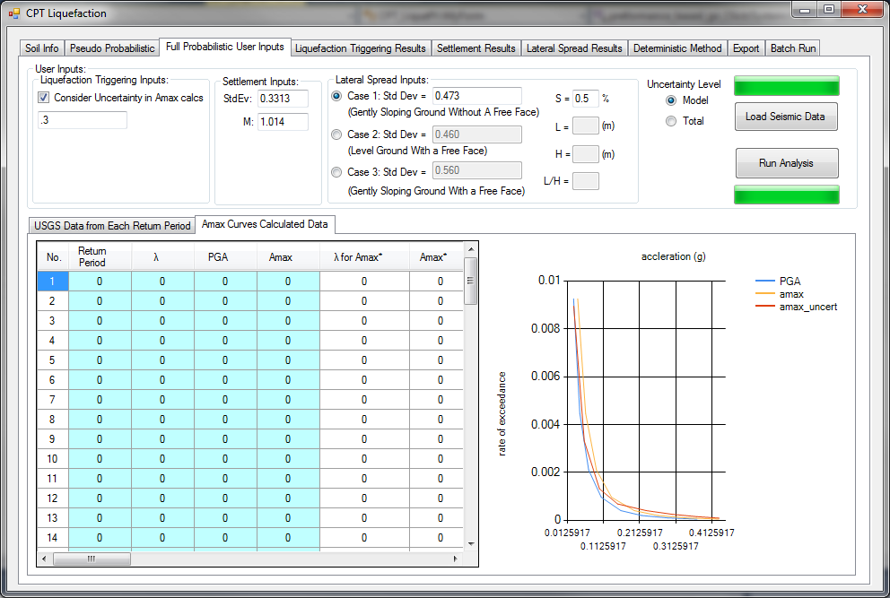
Figure 2.1 View of CPTLiquefY, showing the completed analysis process on the “Full Probabilistic User Inputs” tab.

Liquefaction Triggering Results Tab
At the completion of the analysis, the user may navigate to the “Liquefaction Triggering Results” tab, as shown in Figure 2.1. Each layer of the CPT profile that has been analyzed will have a distinct liquefaction triggering hazard curve calculated using both Boulanger and Idriss (2014) and Ku et al. (2012) (i.e., Robertson and Wride, 1998) methods. The user may enter in a specific layer into the “Enter Layer Number” textbox to launch a data grid with the information for that layer’s hazard curve, as seen in Figure 2.2. All data is easily copied and pasted into Microsoft Excel for additional plotting options. The “Export” tab also contains options for easily saving all calculated data into a tabulated format. An example of a completed liquefaction triggering hazard curve for a single soil layer is shown in Figure 2.3. For any return period of interest, the user can use this plot to estimate the performance-based factor of safety against liquefaction of the specific layer analyzed.

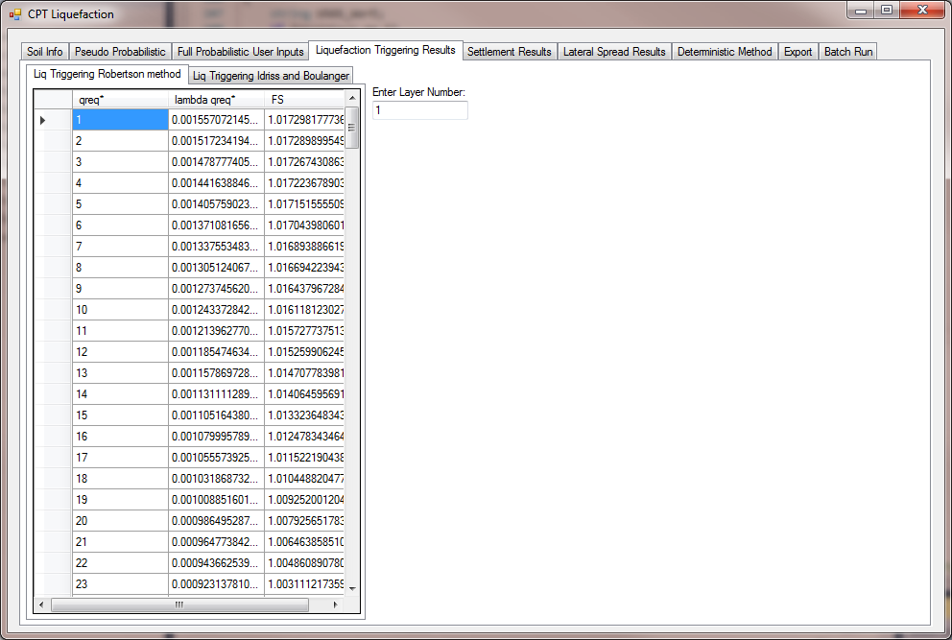
Figure 2.2 View of “Liquefaction Triggering Results” tab after analysis

Figure 2.3 Example plot from “Liquefaction Triggering Results” tab

Settlement Results Tab
After running the performance-based liquefaction triggering analysis, the user may navigate to the “Settlement Results” tab to see free-field settlement results. To calculate total settlement, using a full probabilistic performance-based approach, CPTLiquefY calculates a strain hazard curve using a full probabilistic approach as presented in Kramer et al. (2014), for every soil layer, which is about every 5-cm of soil depth depending on the CPT input file. Next, CPTLiquefY develops a liquefaction-induced settlement hazard curve for the site. The settlement hazard curve is developed following the process described in the Quarter 1, Year 1 report. It is important to note the multiplicative model bias value (M) has been re-regressed using empirical field observed data, as planned in the Year 1, Quarter 1 report, and implemented in CPTLiquefY.
In addition to all background given in the Year 1, Quarter 1 report, a method to limit unrealistic strain values has been implemented into the strain calculation. Kramer et al. (2008) found that specific soils have certain maximum volumetric strains that are even physically possible to achieve. Huang (2008) performed a study to find the maximum limited strain for different types of soil. Huang (2008) used the deterministic models of Tokimatsu and Seed (1987), Ishihara and Yoshimine (1992), Shamoto et al. (1998), and Wu and Seed (2004) to create a weighted average of maximum volumetric strain based on relative density (as correlated with SPT resistance) as shown in Figure 2.4.
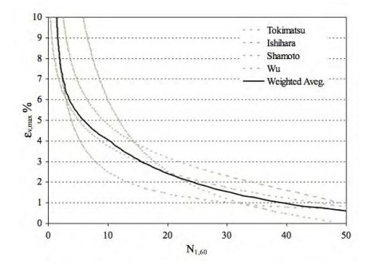
Figure 2.4 Maximum vertical strain levels inferred by deterministic vertical strain models, and weighted average used to define mean value (after Huang 2008)

Kramer et al. (2014) approximated the weighted average relationship by using the following equation.
$ε_{v,max}(\%) = 9.765-2.427ln[ ({N_{1})}_{60,cs}]$ (Eq. 1)

Equation 1 was used to develop a limiting volumetric strain. Huang (2008) suggests using an ε_{v,max} range of 0.5*ε_{v,max} to 1.5*ε_{v,max} with a uniform probability distribution to account for scatter in the data. Finally, to apply Equation 1 to CPT data, Jefferies and Davies (1993) was used to convert between CPT tip resistance and SPT blow count values. Jefferies and Davies (1993) developed this CPT-SPT relationship as:

$\frac{(qt/p_{a})}{ {{(N}_{1})}_{60,cs}}$=$8.5(1-\frac{I_{c}}{4.6})$ (Eq. 2)

where is atmospheric pressure, is the Soil Behavior Type Index, and is the normalized CPT tip resistance. This approach has been implemented into CPTLiquefY to account for unrealistic strain values. Substituting Equation 2 into Equation 1, a CPT-based equation for the maximum volumetric strain is given as:
(Eq. 3)

After all these calculations are completed, the user may view the settlement results under the “Settlement Results” tab, as shown in Figure 2.5. On the left, the user will view all the data values for the total ground settlement hazard curves. This data can be copied and pasted into a spreadsheet for plotting. An example of ground surface settlement hazard curves developed by CPTLiquefY is shown in Figure 2.6. It is important to note that the finished version of CPTLiquefY will have the capability to export all the settlement and/or strain data directly into a spreadsheet.

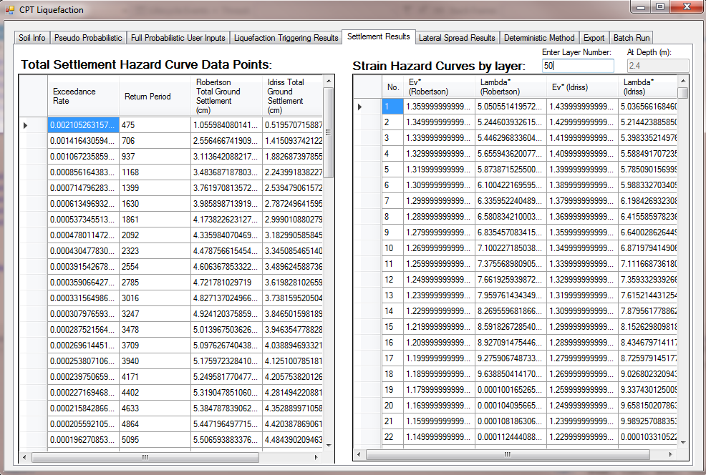
Figure 2.5 View of “Settlement Results” tab after analysis is complete
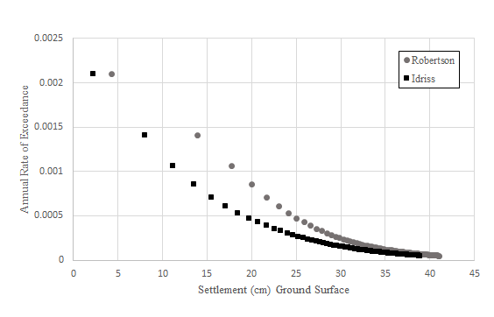
Figure 2.6 View of hazard curves for total ground surface settlement

Lateral Spread Results Tab
Following the analysis method set forth by Zhang et al. (1998), three cases are defined for lateral spread: Case 1, gently sloping ground without a free face; Case 2, level ground with a free face; and Case 3, gently sloping ground with a free face. The selection of Case 1, 2, or 3 is made prior to running the performance-based liquefaction triggering analysis, on the “Full Probabilistic User Inputs” tab (seen in Figure 2.1). On that tab, the case is selected based on the site geometry. Corresponding geometry values can be entered as: S (ground slope as a percentage), L (horizontal distance from the toe of a free face), and H (elevation difference between the level ground surface and the toe of the free face).
Similar to the “Settlement Results” tab, once the full performance-based liquefaction triggering analysis is complete, the user may navigate to the “Lateral Spread Results” tab to see performance-based results of lateral spread displacement. This tab is shown in Figure 2.7. Similar to the “Settlement Results” tab, the user can enter a specific layer number, and the corresponding relationship between maximum cyclic shear strain (i.e., ) and annual rate of exceedance is displayed. Any of these values can be easily copied into another program and plotted to display the horizontal strain hazard curve.

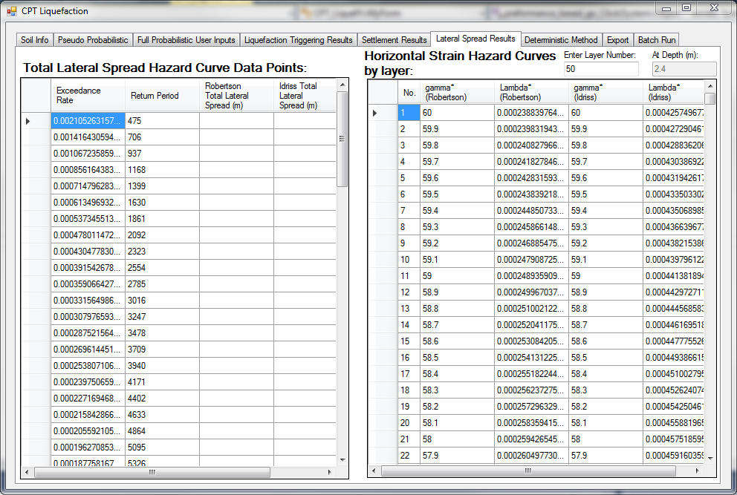
Figure 2.7 View of “Lateral Spread Results” tab after analysis

Current progress is being made to develop a hazard curve for total lateral spread across multiple return periods. It is expected that this will be completed by the end of January 2017.

Inclusion of new USGS deaggregation tool
Coinciding with the release of the 2014 deaggregation model, USGS has decided to transition from an online interactive deaggregation to a local deaggregation software tool called “NSHMP-haz”. After the date of March 1, 2017 the online deaggregation tool will no longer be available, necessitating the use of this new tool. A beta version of this new tool has already been integrated into CPTLiquefY. However, a few programming errors within the new tool are being addressed by the USGS before complete functionality will be available.

USGS Offline Deaggregation tool (NSHMP-haz)
NSHMP-haz is currently in beta mode, but will be available to the public soon. In cooperation with the USGS programmers, we have obtained access to the source code of NSHMP-haz through the website GitHub.com. An image of the NSHMP-haz code repository is shown in Figure 2.8. From GitHub, a download is available of the tool to a compatible system. Once downloaded, the computer can run ground motion deaggregations without accessing the USGS servers through the Internet. This is a major step forward for performance-based earthquake engineering research because a major obstacle to the development of earlier research tools has been the instability caused by performing and downloading thousands of USGS ground motion deaggregation files. This should no longer be a problem in the future, as a single system will be capable of developing all ground motion deaggregations and performing all performance-based calculations.

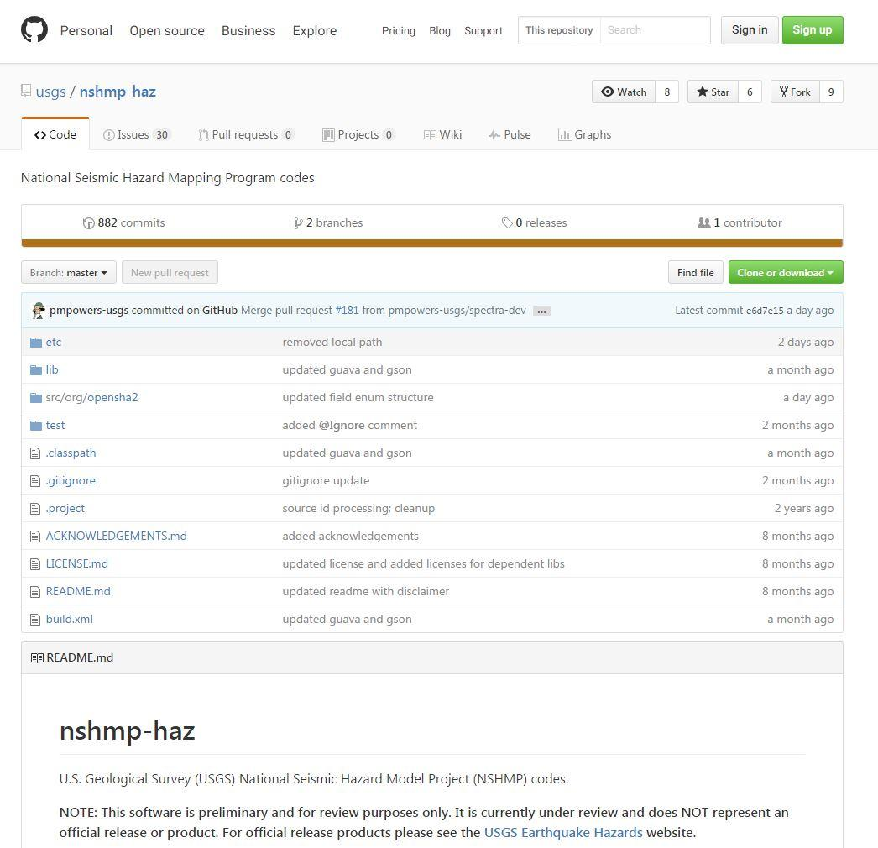
Figure 2.8 USGS NSHMP-haz code repository on GitHub.com
The NSHMP-haz code uses the Java programming language, so installation of Java is required before running the tool. Setup of Java is a simple process and clear instructions have been developed by the USGS to guide users. As stated previously, the online deaggregations will no longer be available after March 1, 2017, so access to this new tool is crucial for the success of our liquefaction hazard analysis tool CPTLiquefY.
At this point, CPTLiquefY successfully runs and collects deaggregation data from the new tool for the 2008 and 2014 deaggregations for the western half of the United States. Some minor errors have been detected in the new tool while calculating deaggregations for eastern states. USGS is working to fix these errors as they prepare for the final release of the tool around March 1, 2017.
This NSHMP-haz code runs in a similar fashion to the old interactive deaggregation available online. The user chooses four parameters before running the analysis. These are a latitude, longitude, exceedance probability and a number of years to consider in the analysis. An image of the old online interactive deaggregation is shown with major parameters highlighted in Figure 2.9.

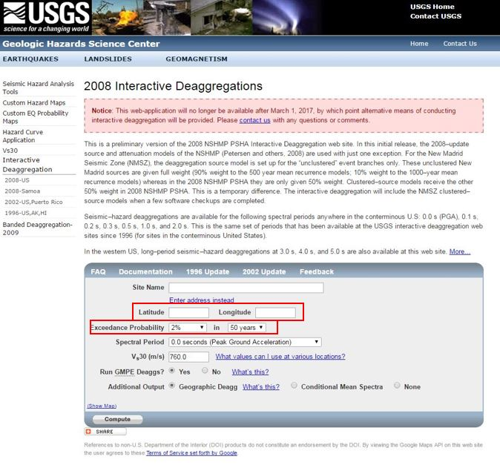
Figure 2.9 Image of the old USGS online deaggregation tool

These options remain the same with the new NSHMP-haz tool. The user simply selects the same four parameters in the “Pseudo Probabilistic” tab in the program CPTLiquefY as highlighted in Figure 2.10. CPTLiquefY will then pass the parameters on to the USGS tool and display the results after completion of the deaggregation run. The new tool runs on the system command prompt so when the tool is activated a command line window will briefly open as the tool runs. Figure 2.11 shows an example of the window launched by the application.
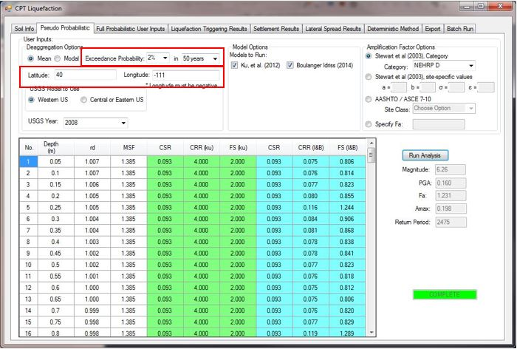
Figure 2.10 Input options for new USGS tool on the “Pseudo Probabilistic” tab

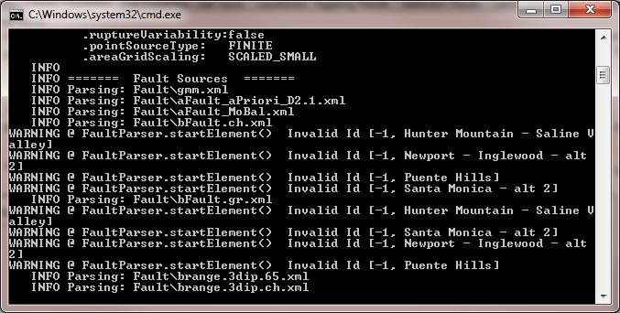
Figure 2.11 View of the window launched by NSHMP-haz
There is one slight difference in the new USGS tool. Users are now required to select which region of the United States the location of interest is found. There are currently two options, option 1 is for the western US, and option 2 is for the central and eastern US. The division between western, central, and eastern states can be seen in Figure 2.12. If the wrong region is selected an error will occur and the user will be notified to use the other model. Other models are currently available for locations in Hawaii and Alaska but have not yet been integrated with CPTLiquefY. Other models may become available in the near future. Continued work may include the addition of these models.

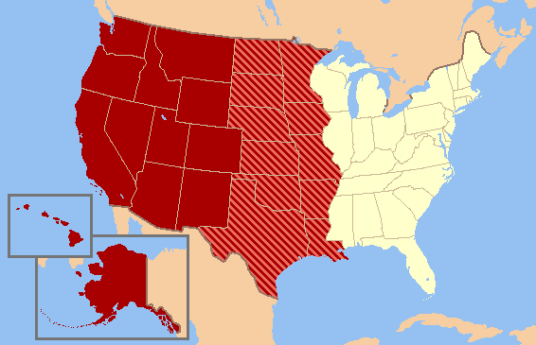
Figure 2.12 Map west United States, showing the division in USGS between western, central, and eastern states

USGS Deaggregation Model 2008
Along with the new tool, USGS has now made available an updated version of the 2008 Deaggregation model that was available previously. This model includes bug fixes and increased accuracy. The user can choose to use the 2008 model in the new tool by selecting the USGS year in the “Pseudo Probabilistic” tab, as seen in Figure 2.13.
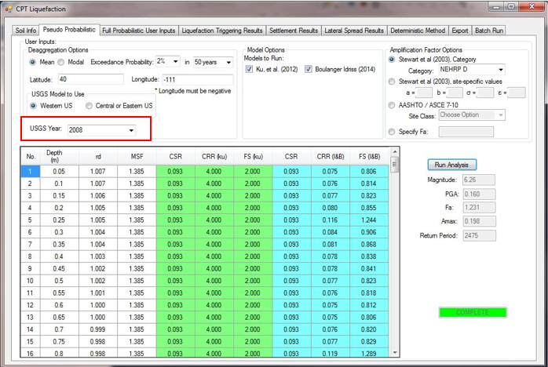
Figure 2.13 Display of USGS deaggregation year selection

USGS Deaggregation Model 2014
With the release of NSHMP-haz, USGS is releasing the USGS 2014 Deaggregation Model for the first time. This model contains all the most recent data, and provides an update from the previous 2008 Deaggregations that we previously available online. This model is now available by selecting “2014” from the USGS Year dropdown box as seen in Figure 2.13.

Future work on CPTLiquefY
Current effort is being made to complete and verify the results from Settlement and Lateral Spread tabs. Settlement tab is complete and is in its final stages of verifying the analysis is running correctly. Lateral Spread tab will be complete within the week and, following which, the results will be verified.
Once CPTLiquefY is complete, a multi-site analysis will be run to compare performance-based results to results from more common analyses such as the deterministic, pseudo-probabilistic, and semi-probabilistic approaches. This analysis will cover 10 sites and will cover a range soil profile environments.

CONCLUSIONS

Summary
The purpose of this phase of research is to develop a full performance-based liquefaction hazard analysis tool that performs its computations using CPT data. To accomplish this goal, the performance-based framework from a similar project based on the SPT was followed, but modified to incorporate the CPT. The objective of this report was to discuss progress that has been made in the research of liquefaction procedures with the CPT being used, and the development of the full performance-based tool, CPTLiquefY.

Progress and Challenges
Procedures from Kramer and Mayfield (2007), Robertson and Wride (1998), Robertson (2009), as well as others were followed to begin the performance-based calculations using the CPT. CPTLiquefY currently has the ability to run pseudo-probabilistic, deterministic, performance-based liquefaction triggering, and performance-based liquefaction-induced settlement analyses. The program will soon have the capability of running a performance-based lateral spread displacement analysis. The tool is in its final stages of validations and debugging and will soon be ready for analyses.
Integration of the new USGS NSHMP-haz deaggregation tool is complete. There are a few errors within the tool itself that are being addressed by programmers from USGS. However, all issues should be addressed and fixed within the next few weeks.

Future Work
Once CPTLiquefY is complete analyses will be performed comparing the full probabilistic performance-based approach to the pseudo-probabilistic, deterministic, and semi-probabilistic approaches. Analyses will be performed at 10 different locations and with a variety of CPT data representing different soil profiles.

REFERENCES
Boulanger, R., and Idriss, I. (2014). "CPT and SPT based liquefaction triggering procedures." Center for Geotechnical Modeling, Department of Civil and Environmental Engineering, University of California, Davis, CA. Report No. UCD/CGM-14/01.
Huang, Y.M. (2008) “Performance-based design and evaluation for liquefaction-related seismic hazards.” Ph.D. Dissertation, University of Washington, Seattle, WA.
Ishihara, K., and Yoshimine, M. (1992). "Evaluation of settlements in sand deposits following liquefaction during earthquakes." SOILS AND FOUNDATIONS, 32(1), 173-188.
Jefferies, M.G., and Davies, M.P., 1993. Use of CPTU to estimate equivalent SPT N60. Geotechnical Testing Journal, ASTM, 16(4): 458-468.
Kramer, S. L., and Mayfield, R. T. (2007). "Return period of soil liquefaction." Journal of Geotechnical and Geoenvironmental Engineering, 133(7), 802-813.
Kramer, S.L., (2008). “Evaluation of liquefaction hazards in Washington State.” WSDOT Report WA-RD 668.1, 152 pp.
Kramer, S.L., Huang, Y.M., and Greenfield, M.W. (2014). Performance-based assessment of liquefaction hazards. Geotechnics for Catastrophic Flooding Events, Iai ed., ISBN 978-1-138-02709-1, Taylor and Francis Group, London, 17-26.
Ku, C.-S., Juang, C. H., Chang, C.-W., and Ching, J. (2011). "Probabilistic version of the Robertson and Wride method for liquefaction evaluation: development and application." Canadian Geotechnical Journal, 49(1), 27-44.
Robertson, P. (2009) "Performance based earthquake design using the CPT." Proc., Proceedings of IS-Tokyo 2009: international conference on performance-based design in earthquake geotechnical engineering—from case history to practice, Tokyo, Japan, 15-18.
Robertson, P., and Wride, C. (1998). "Evaluating cyclic liquefaction potential using the cone penetration test." Canadian Geotechnical Journal, 35(3), 442-459.
Shamoto, Y., Zhang, J.-M., and Tokimatsu, K. (1998). “Methods for evaluating residual post-liquefaction ground settlement and horizontal displacement,” Soils and Foundations, Special Issue No. 2, 69-83.
Tokimatsu, K. and Seed, H.B. (1987). "Evaluation of settlements in sand due to earthquake shaking," Journal of Geotechnical Engineering, ASCE, Vol. 113, No. 8, pp. 861-878.
Wu, J. and Seed, R.B. (2004). “Estimation of liquefaction-induced ground settlement (case studies),” Proceedings, Fifth International Conference on Case Histories in Geotechnical Engineering, New York, pp. 1-8.
Zhang, G., Robertson, P. K., and Brachman, R. (2004). "Estimating liquefaction-induced lateral displacements using the standard penetration test or cone penetration test." Journal of Geotechnical and Geoenvironmental Engineering, 130(8), 861-871.

