TRANSPORTATION POOLED FUND PROGRAM
QUARTERLY PROGRESS REPORT

Lead Agency (FHWA or State DOT): Oklahoma Department of Transportation

INSTRUCTIONS:
Project Managers and/or research project investigators should complete a quarterly progress report for each calendar quarter during which the projects are active. Please provide a project schedule status of the research activities tied to each task that is defined in the proposal; a percentage completion of each task; a concise discussion (2 or 3 sentences) of the current status, including accomplishments and problems encountered, if any. List all tasks, even if no work was done during this period.

Transportation Pooled Fund Program Project #  TPF-5(297) |  | Transportation Pooled Fund Program - Report Period:  O Quarter 1 (January 1 – March 31)  O Quarter 2 (April 1 – June 30)  O Quarter 3 (July 1 – September 30)  X Quarter 4 (October 1 – December 31)
Project Title:
Improving Specifications to Resist Frost Damage in Modern Concrete Mixtures

Name of Project Manager(s):  Tyler Ley | Phone Number:  405-744-5257 |  | E-Mail  Tyler.ley@okstate.edu
Lead Agency Project ID:  TPF-TPF5(297)RS / JOB PIECE 30802(04) | Other Project ID (i.e., contract #):  AA-5-52974 |  | Project Start Date:  March 10, 2014
Original Project End Date:  February 28, 2017 | Current Project End Date:  February 28, 2019 |  | Number of Extensions:  1

Project schedule status:
On schedule □ On revised schedule □ Ahead of schedule X Behind schedule

Overall Project Statistics:
Total Project Budget | Total Cost to Date for Project | Percentage of Work  Completed to Date
$572,500 | $558,000 | 90%

Quarterly Project Statistics:
Total Project Expenses  and Percentage This Quarter | Total Amount of Funds  Expended This Quarter | Total Percentage of  Time Used to Date
$80,000 | $80,000 | 97%

Project Description:

Concrete can be damaged when it is 1) sufficiently wet (has a high degree of saturation) and 2) is exposed to temperature cycles that enable freezing and thawing. The damage that occurs due to freezing and thawing can lead to premature deterioration, costly repairs, and premature replacement of concrete infrastructure elements. Current specifications for frost durability are largely based on work completed in the 1950s, and while this work included many landmark discoveries (Kleiger 1952, 1954). This work from the 1950s may not be representative of materials used in modern concrete mixtures. Results from recent studies suggest that there are several ways in which frost damage can be reduced through new tests and improve specifications that can lead to extended service life of concrete infrastructure.

The goal of the research is to produce improved specifications, and test methods; while, improving the understanding of the underlying mechanisms of frost damage. Specifically, this work will seek to develop new test procedures that may be faster and/or more reliable than the existing methods. The objectives of this project are:

• Determine the necessary properties of the air-void system to provide satisfactory frost durability in testing of laboratory and field concretes with different combinations of admixtures, cements, and mixing temperatures
• Determine the accuracy of a simple field test method that measures air void system quality with field and laboratory concrete
• Determine the critical combinations of absorption and the critical degree of saturation on the frost durability in accelerated laboratory testing
• Establish new test methods and specifications for fresh and hardened concrete to determine frost durability and field performance

In addition, a series of trainings have been held in different regions and online content will be generated as part of this work.

Progress this Quarter (includes meetings, work plan status, contract status, significant progress, etc.):

Task 1: Literature Review and Development of the Testing Matrix (OSU and Oregon State)

In this task the research teams will review the existing literature and determine a testing matrix to cover the necessary variables. Work is needed to understand how different mixture components impact the air entrainment system and subsequently the frost durability of concrete. These variables can lead to changes in AEA effectiveness and their impact needs to be quantified with ASTM C 666 testing. As part of this task we will work with our project oversight committee to establish a set of materials and a testing matrix that can be used for the entire study. The decisions used in developing this test matrix will be made based on literature review, previous research by the PIs and the needs identified by the study advisory discussions.

The testing matrix was discussed with the research oversight committee. The team first looked at mixtures for bridge decks and then moved to mixtures for pavements. Here is an overview of the mixtures:

Limestone aggregate and natural sand from Oklahoma will be used for these mixtures. Both aggregates have been shown great freeze thaw field performance in the laboratory and the field. A mixture with 20% class C fly ash will be investigated with 6.5 sacks of total cementitious content and a w/cm of 0.45. A wood rosin AEA will be the primary admixture investigated as it is the most widely used AEA. However, select mixtures will be investigated with synthetic AEA. These AEAs will be used to produce mixtures with different spacing factors and air content. These samples will be investigated in a number of the freeze thaw tests in the project. Next, a mixture with 0.40 w/cm will be investigated with the same AEA. After that mixtures with high range water reducers will be investigated with 0.40 and 0.35 w/cm. A few mixtures with different high range water reducer dosages will also be investigated. Further testing is under completion with w/cm up to 0.50 to investigate the impact of the mass transport of the binder on freeze thaw durability.

On this project over 150 concrete mixtures have been investigated in the laboratory. The work has been completed for the hardened air void analysis and the rapid freeze thaw testing. In addition, two SAMs were completed on each mixture.

Repeatability testing is being completed on mixtures at OSU with four expert SAM operators. This testing has gone well and 9 mixtures have been completed. The team also did some round robin testing at the SAM training Workshop that was held in Chicago. Results are included in this document.

The research team also looked at concrete before and after a concrete pump with the SAM. This data is still being analyzed and will be presented in future reports.

In addition, the SAM has been used to investigate repair concretes that use calcium sulfoaluminate, calcium aluminate, and alkali activated binders. The results show that the SAM measurement seems to work well with these materials except for the alkali activated binders and shows good correlation with the durability factor from the ASTM C 666 test. The hardened air void analysis is still ongoing. The SAM has also been used to investigate grouts. It appears as that the early age pore solution chemistry does have an impact on the desired SAM number that correlates to 0.008”. Also if the paste content is very high (around 50%) then this also requires a tweak to the SAM number. However, it should be states that there is no recommended spacing factor for these materials. This is an area of future research.

Work has also been done to investigate a wider range of concrete mixtures with different w/cm. These samples have been prepared and have been sent to Oregon State for testing. These mixtures will also be used to investigate the synergistic effects between calcium oxychloride formation and freeze-thaw damage.

95% complete (This task will not reach 100% until the end of the project as changes are continually made to the testing matrix.)

Task 2: Sample Preparation (OSU and Oregon State)

All of the mixtures that represent bridge decks and pavements have been completed at OSU and then shipped to Purdue/Oregon State for testing. Mixtures with different amounts of superplasticizers and air entraining agents have been investigated. Over 100 mixtures have been investigated. Currently around 50 more mixes are being completed to look at the impact of w/cm on the freeze thaw performance. These samples should be finished in about a month and then sent to Oregon State.

Concrete repair materials have been investigated with the SAM. The SAM number shows good correlation with the ASTM C 666 durability factor for all materials tested except for alkali activated cements. These materials use very little water and instead use a chemical activator. The chemical activator likely changes the solubility of the air in the solution. This probably explains why the SAM test does not work with these materials. A large portion of the samples have been investigated with hardened air void analysis and the data analysis has begun.

The SAM test has also been used to look at some repair grouts and concrete with microspheres. The preliminary results did not show a good correlation between SAM number and microspheres but only two tests were completed. More work is needed on this topic and so it has been put on hold.

The research team has also started using four users to investigate concrete mixtures with the SAM. This is done to examine the repeatability of the test method. So far nine mixtures have been completed and the data is given at the end of this document. Also, at the latest SAM workshop round robin testing was completed. The workshop had users of a variety of experience levels and all of them were allowed to participate in the testing. The coefficient of variation (a measurement of the variability of the mixtures) was found to be very similar between the lab testing done at OSU and the round robin testing done at the workshop. Furthermore, this coefficient of variation is very close to the values obtained by hardened air void analysis (ASTM C 457) and for rapid freeze thaw testing (ASTM C 666).

Mixtures have also been completed before and after a concrete pump. These results have been analyzed and show good promise. The preliminary data suggests that sampling concrete after the concrete pump is not representative of the air void volume or air void spacing in the hardened concrete. These findings need to be confirmed on a higher number of mixtures. Because of this we have replicated some of the mixtures and are focusing on completing the hardened air void analysis and freeze thaw testing.

A number of additional samples were produced with different w/cm and without fly ash for investigation by Oregon State. On these samples the SAM, hardened air void analysis, and freeze thaw durability was also investigated. These tests have been completed and have been sent to Oregon State for testing.

95% complete

Task 3: Validation of the Super Air Meter (OSU)

In this task the Super Air Meter (SAM) will be evaluated in laboratory and field mixtures. The laboratory mixtures to be investigated include: aggregate with high aggregate correction factor, light weight aggregate, hot weather concrete, cold weather concrete, and any other items that the research oversight committee feels is important. In addition a number of mixtures will be investigated in the field. This will be done by visiting local ready mix and central mix batch plants to take samples.

The results of over 174 laboratory mixtures, 50 field mixtures, and over 49 mixtures by FHWA Turner Fairbanks Laboratory are shown in Fig. 1. The data shows that the SAM does a good job of predicting the spacing factor for the majority of the mixtures investigated. The SAM limit of 0.20 has shown a correlation to a spacing factor of 0.008” 90% of the time. Figure 2 shows the correlation between the SAM Number and different spacing factors.

Data has also been included for the correlation between the SAM number and the durability factor. This data is included in Fig. 3. There is also a plot of the percentage agreement of the SAM number and a Durability Factor of 60, 70, and 80. For all three of these limits a SAM number of 0.32 showed greater than 88% correlation in Fig. 4. This is an important finding as this confirms that the SAM number correlates well with the freeze thaw durability of the concrete. For comparison, the results of the ASTM C 666 durability factor are compared to the ASTM C 457 spacing factor in Fig. 5. The correlation between these two test methods is 69%.

This probably occurs because there is a safety factor placed on the spacing factor. Based on a 95% confidence interval for the SAM Number (two standard deviations = 0.10 for 172 replicate tests) this would mean that there should be a target value of 0.22 for the SAM Number to ensure that 95% of the samples have a value above 0.32. If this number is rounded down to 0.20 then this matches the same correlation to a spacing factor of 0.008”. This will be discussed in much more detail in the interim final report in February.

For all of these mixtures at least two different SAMs are being investigated in order to collect the precision and bias information needed for the AASHTO test method. To further investigate the variability of the test method research team is using four local SAM users to simultaneously investigate the same concrete mixtures. These results so far for nine concrete mixtures is shown in Table 1. The testing shows that the method has an average coefficient of variation of 17.9%. There was a SAM workshop held in Chicago in June, 2016. At the workshop there was also a round robin on three different concrete mixtures. The results are shown in Table 2. The average coefficient of variation was found to be 18.1% for all of the users at the workshop. There were several users that had identified themselves as new SAM users. The coefficient of variation for two users on 172 replicate tests was 15.1%. With improvements to the method the research team hopes that this value can be reduced.

A comparison between the measured coefficient of variations from the SAM round robin testing and the spacing factor from ASTM C 457 and the durability factor from ASTM C 666 are compared in Table 3. In all three of the tests the coefficient of variation was found to be very close to one another (between 17.1% and 22.7%). In the same table a comparison between the test method and the ASTM C 666 test, as well as the length of time needed to complete the test. This table shows that the SAM test shows a slightly lower variability then the ASTM C 457 and ASTM C 666 test while providing data within 10 min and allowing changes to be made to the mixture.

It is interesting that all of these tests are measuring a similar parameter and all three of them have a similar coefficient of variation. This suggests that the air void spacing within concrete may be variable over the volume of the samples used in the tests (about 0.25 ft³). This may mean that while the total air volume is very consistent; however, the air void spacing may be variable. To test this the SAM test was completed 19 times by two operators with just water and a calibration vessel in the bottom chamber. This allowed the test to be completed without including the variability caused by concrete. When only using water in the test the standard deviation was found to drop by 50%. This shows that the variability of concrete plays a significant role in the test. This finding will also be discussed in more detail in the interim report in February.

Furthermore, the SAM has been used successfully on mortars, different repair materials that are made of binders vastly different than portland cement, in different temperatures, with over 30 different aggregate types, and in mixtures with varying slumps (0.5” to 10” and also in SCC). With all of these materials the SAM has performed well.

In addition, the SAM has been provided to the following partners for their use: Oregon State, Iowa State, Purdue, Iowa, Nebraska, Kansas, North Dakota, Illinois, Oklahoma, Pennsylvania, Minnesota, Idaho, New Jersey, and Wisconsin. In addition, the FHWA mobile concrete lab has supplied samples from a number of different states. The research team has completed almost all of the hardened air-void analysis. Results have been included in this report.

Individual results from field concrete cast and then the hardened air void analysis was independently completed by Pennsylvania DOT is shown in Figs. 6 and 7. This means that Penn DOT sampled and tested the field concrete with the SAM, collected hardened concrete, and then analyzed the concrete with a hardened air-void analysis. All of this testing was done without involvement from PI Ley or Weiss. Figure 6 shows the spacing factor versus the air content. Again, this graph shows that only using air volume is not enough to ensure that you have a quality air void system. However, fig. 7 shows that when you compare the SAM number and spacing factor then there is an 83% agreement. This matches the correlation shown in Fig. 1 and is a validation of the test method. A similar plot for other state DOTs is shown in Fig. 8. This data shows a 74% agreement between the SAM number and the spacing factor. This figure further shows agreement between the different states.

New supplemental equipment has been developed to speed the test from 8-10 minutes to 5-6 minutes called the CAPE (Controlled Air Pressure Extender). Pooled Fund members that promise to send data have been given a CAPE as part of the project. Also, there is a new air pressure adjustment valve that has been added to the SAM. This was added to all of the SAMs at the workshop in Chicago. These were also sent with the CAPEs. This new valve makes it easier for users to get the exact pressure in the test and they will no longer have to use the Schrader valve to adjust the pressures. This will speed the test up and make it easier to run.

Based on feedback from users and from additional findings a programming upgrade is being made to the gauge. This change will only report SAM numbers between 0.03 and 0.82. The reason for this is that based on a large amount of testing this is the expected range within the test. This will help people learn when they are making mistakes while running the test. Furthermore, a new o-ring is being developed that will improve the testing and new method to clean the rim of the meter was also learned while completing the round robin testing. All of these changes will be made to future version of the meter and were possible because of this pooled funding.

Finally, a new method has been developed to investigate the data from the SAM and determine the average size of the bubbles in the air void system. This is found by plotting the air content on the X-axis versus the SAM number on the Y-axis. This graph is shown in Fig. 9. Typical curves for poor void size and spacing is shown as the upper curve. The lower curve shows a good void size and spacing. This means that if you plot the SAM number and air content on the graph and the point falls near the lower curve then you have a good void size and spacing and you will need a minimum air content to provide freeze thaw durability. If your data point plots near the top line then you have a coarse air void system. This means that you can take the data from the SAM and instantly determine the characteristic of your air void system. Changes can then be made in the design of the concrete mixture to change the location of the mixture on this curve. This is an important tool for our industry to help troubleshoot problems in the field, and help guide practitioners on how to design their concrete mixtures.

85% complete

Task 4: Creation of an AASHTO Test Method and Specification for the SAM (OSU)
The SAM test method has been published as AASHTO TP 118. This is a great accomplishment.

The research team is making great progress to update the variance of the test method. Also, some text needs to be added that limits the amount of time the test takes to be completed. It is proposed that a time limit of 12 minutes be added to the test method. Also, the reported limits on the SAM number will be between 0.03 and 0.82. As mentioned earlier, this recommendation is based on hundreds of laboratory and field mixtures that have all shown that correctly run tests are between these two values. By adding this to the test specification it will let the user know that they are running the test incorrectly if their values are outside of these bounds.

90% complete

Task 5: Use of X-Ray Tomography of Air Voids and Frost Damage (OSU)

Researchers at OSU have developed nondestructive techniques to examine microscopic air voids in fresh and hardened concrete by using a X-ray micro computed tomography (mCT) scanner. This is a powerful technique that allows measurements to be made not previously possible. The research team has developed techniques to image water movements and have access to a freezing stage. By combining this information about the void distribution, the moisture content and distribution, and then being able to image the damage that occurs from freezing is a powerful tool. These observations can lead to ground breaking insights into the mechanisms of frost damage and how it can be avoided.

The experimental methods are largely finished and a paper is being authored over the work. A rough draft of the paper has been developed and is being reviewed. Work has also been completed over using mCT to image samples both before and after freezing. We have successfully aligned the data sets and we can clearly show where there were existing cracks in the sample and how these cracks extend after a single freezing cycle. Some results have been included in the attached figures. Samples have been investigated with a poor air void system and a high degree of saturation. This is the worst case and it has caused damage.

Work has also been done to investigate the mechanisms of salt scaling. Samples were imaged with the mCT scanner before and after during freezing events. These results show that damage can be observed with this method and provide quantitative mapping of the location of crack propagation. A student has completed his thesis on this topic, a journal paper is under preparation, and a poster was presented at the American Ceramics Society – Cements Division meeting. This poster was given an award for meritorious achievement. The poster was included in a previous quarterly report.

A paper is being prepared over this topic and the goal is to include it in the interim report.

Progress 70%

Task 6: ASTM C 666 (OSU and Oregon State)

The primary test method used to investigate the durability of concrete exposed to freezing is ASTM C 666. To date mixtures have been investigated with a w/c of 0.4 with two different air void structures as well as two different water to cement ratios. Additional samples are being prepared to extend the work to a wider range of water to cement ratios however it should be noted that this is additional effort not covered in the existing work.

As part of this task the specimen absorption and desorption of the samples will be investigated using a modified form of ASTM C 1585, referred to as the bucket test. While the team realizes that the ASTM C 666 is a well-respected test, they feel that the three months required to complete the test is too long. A significant amount of C 666 testing has been completed. A summary of the test results are shown in Fig. 2. The durability factor determined from ASTM C 666 will also be compared with the approach discussed in Task 7 using absorption and critical saturation to predict long term performance. A paper has been written up and submitted to TRB that outlines the ASTM C666 work as well as the predictions from Task 7. The paper has been included in the appendix.

Progress 95%

Task 7: Absorption and Desorption (Oregon State)

During this task the research team will perform desorption/sorption analysis on selected mixtures prepared in Task 2. For the sorption tests full size cylinders were used (100 mm x 200 mm) in the bucket test. In addition, the complete degree of saturation will be determined using vacuum saturation.

It should be noted that the initial saturation (S_{Matrix}) can be determined quite accurately simply from mixture design for mixtures with OPC. A paper was recently submitted (Azid et al.) outlining the extension of this work to ‘a much wider range of cementitious materials which will include fly ash, slag, ground lightweight aggregate, limestone, and other materials. This model is based on first principles of thermodynamics.

On going work is being conducted to relate the rate of secondary sorption (S2) to the mixture proportions. It appears that this value does not depend on the air content however the value has a greater extent of variability than originally anticipated. Additional research is also needed to better relate this to a wide range of environmental conditions. This work has been proposed to continue in the research extension.

The time that it takes to reach the critical degree of saturation as shown in Equation 1, where S_{critical} is a function of the SAM number S_{matrix} and S₂ are measured from the bucket test and t_{o} is small it is taken as zero.
$t_{Saturation}={\left(\frac{S_{Critical}-S_{Matrix}}{{\dot{S}}_{2}}\right)}^{2}+t_{0}$ Equation 1
The time of saturation value from Equation 1 would be the expected time for a sample to reach failure due solely to water absorption. This work would correlate with concrete in continual contact with water and requires a modification to consider additional/alternative environmental exposure conditions.

Figure 19 illustrates the relationship between the time to reach critical saturation and the durability factor obtained from ASTM C666. Figure 20 shows similar data however it also identifies values of air quality and SAM number. It can be noticed that there is a strong correlation between samples with a relatively low prediction in time to reach critical saturation and poor air volume and poor SAM numbers. Figure 21 Illustrates the time to reach critical saturation as a function of air content and SAM number.

Figure 25 and 26 illustrate potential false positive and false negative numbers when using the time to reach critical saturation as a predictor of ASTM C 666.
- 19 of the 33 mixtures tested passed ASTM C 666 (when the durability factor is greater than 80%)
- 21 of the 33 mixtures tested passed ASTM C 666 (when the durability factor is greater than 60%)
- For the samples that passed the ASTM C 666 (with a durability factor of 80%):
  - 32% of the samples indicated insufficient air (less than 4.5%),
  - 26% of the samples indicated insufficient SAM numbers (greater than 0.20)
  - both the air and SAM were sufficient for 64% of the samples which resulted in a durability factor above 80%.
  - 17% of the samples (2 samples) passed the air volume and SAM air test and failed the ASTM C666 with a durability factor of 80%.
- When time to reach saturation was compared with the durability factor:
  - 1 sample had a predicted life of more than a 10 years when a failing durability factor of 60% was and 3 samples had a predicted service life of more than 10 years when a failing durability factor of 80% was used.
  - The time of saturation was useful in predicting 88% of the sample behavior when a durability factor of 60% was used with only 3 false negatives (a time of saturation that predicts failure while the durability index provides better performance) and only 1 false positive where a life of 10 years is predicted for a sample that does not perform as expected.
This indicates that the time of saturation test provides results that are similar to that of the ASTM C666 test. The volumetric mixture proportioning approach can be used to predict the degree of saturation when the matrix is filled and the bucket test has the capability of measuring both the matrix degree of saturation and the secondary sorption rate in a simple approach that can be used in a service life modeling approach. The results also indicate good correlation between the SAM number, volume of air, time to reach critical saturation, and ASTM C666.

It is also suggested that the mixture qualification could be used to establish a relationship between the SAM number and the air content for a given mixture.

Progress 80%

Task 8: Degree of Saturation and Damage Development (Oregon State)

Samples prepared in Task 2 will be saturated to different degrees of saturation and the freeze-thaw tests will be performed with the samples in a sealed condition. Freeze-thaw tests have been performed on 11 samples with 50 mm thickness and 68 mm diameter using a new Longitudinal Gaurded Comparitive Calorimeter (LGCC) setup with acoustic emission sensing to detect damage (Figure 13). This test setup is capable of measuring temperature throughout the setup height to determine heat flow through the sample during each freeze-thaw cycle. Additionally, the setup is equipped with 2 acoustic emission sensors which can passively detect acoustic events as well as actively measure pulse velocity across the sample. The changes in pulse velocity throughout the freeze-thaw process can then be directly correlated to damage development in the concrete. Results from this test will be used to identify the critical degree of saturation with the express purpose of relating the critical degree of saturation to the quality of the entrained air system (for example the air void spacing). Information from this test will be used in conjunction with the results from Task 7 to determine if the air void system alters the time required to reach a critical degree of saturation (which is hypothesized with a higher SAM number corresponding to a lower S _{CRIT}). Additionally, a series of 3 cylinders will be used to determine the resistivity and degree of saturation over time of samples submerged in pore solution (to prevent alkali leaching). Additional resistivity tests will be performed at various ages and degrees of saturation on samples from a variety of tests in order to determine if a relationship exists to correlate resistivity and sorption.

The testing protocols have been developed (Figure 11). DOS cylinders from all 34 total mixtures have been tested and the results have been used to determine the degree of saturation for cylinders in the corresponding resistivity tests. Both short and long term resistivity tests have concluded for all samples. The degree of saturation and resistivity were monitored over time and are displayed in Figure 14 and Figure 15 respectively. Experimental nick point values have been compared to theoretical values and have been related to both air volume and SAM numbers. This was discussed in the conference paper included in a previous quarterly report. Further work is underway to investigate the relationship between formation factor at various degrees of saturation and air parameters in order to more easily assess durability.

All Freeze-Thaw samples have been cut, cored, and conditioned for testing in the LGCC (Figure 13). This includes additional samples outside of the testing scope that will be available for future testing if necessary. The additional samples have been sent to Oregon State University where the work will continue. Mixture with different air contents and varying SAM numbers have been tested at approximately 100%, 95%, and 90% degrees of saturation. Each sample was exposed to three freeze-thaw cycles over the course of five days, with pulse velocity measurements taken hourly. Results from these tests have been analyzed. An example of the acoustic emission data output is shown in Figure 17, which shows the acoustic emissions recorded by two opposing sensors on three specimens within the same mixture, conditioned to all three saturation levels. It is clear that for this fully saturated sample, cracks are emitting due to freeze-thaw damage over the course of 3 thermal cycles. This activity is reduced with lower levels of saturation. Figure 18 shows the acousto-ultrasonic testing results for the same three specimens. Damage in the concrete matrix (a reduction in the elastic modulus) can be correlated to the reduction in pulse velocity after each freezing cycle. It is evident that highly saturated samples show a drastic reduction in pulse velocity (large amounts of damage) while the sample closer to the critical degree of saturation shows little reduction in pulse velocity (low levels of damage). This method of calculating damage index was used to ultimately determine whether a relationship exists between the critical degree of saturation and properties of the air void system quality (SAM number). Ultimately, it was determined that specimens with higher quality air void systems (lower SAM numbers) are associated with higher thresholds for the degree of saturation necessary for freeze-thaw damage development (the critical degree of saturation). This finding can be used to create performance-based specifications for concrete durability, considering the critical degree of saturation as a limit state for service life. This result is shown in Figure 19 and will be explained further in a journal paper which is currently in progress.

Progress 90%

While the additional work has been completed the team would like to discuss additional research directions that should be pursued for the development of this model and use in practice.

Task 9: Rate of Damage Analysis (Oregon State)

This task will combine acoustic emission data and X-ray mCT and neutron tomography to detect cracking and also image the location. This will be done in samples with different quality of air void systems and with different paste quality and saturation level. Preliminary work has been performed to use fracture concepts to relate a pressure to damage: however this work has been put on hold while the research team begins to investigate the driving force of the pressure and the development of a new model. Toward this end the OSU team has begun to perform some fundamental measurements that will be needed to not only consider damage due to freezing but will also be able to consider the influence of salt on damage. This will build on work recent work by Segadi et al. (2016) shown in Figure 27 that enables the pores to be divided into two different classifications and a phase diagram can be used to determine the amount of ice formation which is believed will be able to be related to fundamental pressures that can generate damage due to ice and salt damage. The model is further along than the PIs originally thought it would be; however, they have decided to ‘dig deeper’ into the source of the damage. This will need to be completed on the future research efforts.

Oregon State provided 12 samples that the team at OSU scanned at several micron resolution and then sent back to Oregon State so that they could investigate them in the neutron beamline at NIST. In the beamline the samples were exposed to water and then freezing cycles were used to try and create damage in the samples. The samples have been sent back to OSU and scanned again to investigate the amount of cracking. This technique can show the extensive damage in the samples with high levels of DOS. The analysis can separate the air voids, aggregates, cracks, and paste. It can clearly show where the cracks are located before and after the freezing events. This should begin to provide useful observations for the project and provide a more basic understanding of freeze thaw damage.

Progress 80%

Task 10: Technology Transfer (OSU and Oregon State)

A portion of this project will be dedicated to development of a strong educational technology transfer program. As part of this program several presentations have been given at conferences, webinars, and a workshop was held in Chicago in June, 2016, in New York in July, 2016, and in Oklahoma in September, 2016. This helped train over 50 SAM users and provided important feedback to the presenters on how they can improve the workshops. An online video has been created over the SAM results from the testing and uploaded to YouTube. The video is just over an hour but it has been indexed so that the viewer can choose the section that they are interested in. Training for the SAM has also been created and will be shared with the Pooled Fund members. This is a presentation, hand-outs, activities, written evaluation tests, and performance standards to grade the technicians while completing the test. This curriculum is being tested in Oklahoma and will be adjusted before the submission in February.

Progress 85%

Task 11: Final Report (OSU and Oregon State)

Preparation on the final report will begin. The creation of the quarterly reports has been a nice preparation for the final document. The research team plans on providing a short summary document (~ 30 pages) and then attach journal papers and other publications to give more details.

Below is a list of papers that have been generated through this work.

Submitted and Accepted Papers
Weiss, W.J., Barrett, T.J., Qiao, C., and Todak, H., (2016) “Toward A Specification for Transport Properties of Concrete Based on the Formation Factor of A Sealed Specimen,” Advances in Civil Engineering Materials,
Todak, H., Tsui-Chang, M., Ley, M.T., and Weiss, W. J., (2015) “Freeze-thaw resistance of concrete: the influence of air entrainment, water to cement ratio and saturation,” Brittle Matrix Composites, September 28-30th, Warsaw 2015
Todak, H., Tsui-Chang, M., Ley, M.T., and Weiss, W. J., (2015) “Evaluating Freeze-Thaw Damage in Concrete with Acoustic Emissions and Ultrasonics,” Proceedings of the World Congress on Acoustic Emission, November 10-13, 2015 Waikiki Oahu Hawaii
Weiss, W. J., Tsui-Chang, M., and Todak, H., (2016) “Is the Concrete Profession Ready for Performance Specifications that Provide an Alternative to Prescriptive W/C and Air Content Requirements, National Ready Mixed Concrete Association Annual Meeting, Washington DC
Qiao, C., Suraneni, P., Weiss, W.J., (accepted) Measuring volume change due to calcium oxychloride phase transformation in a Ca(OH)2 -CaCl2-H2O system” ASTM Advances in Civil Engineering Materials
Yu, T., Bognacki, C., Obla, K., Hicks, J., D’Ambrosia, M., Weiss, W. J., Fu, T., and Giannini, E., (2017) “Can We Implement Performance Based Specifications for Durability and Longevity of Concrete? Will They Work?” Concrete International
Azad, V. J., Suraneni, P., Isgor, O. B., and Weiss, W. J., (2016) “Interpreting the pore structure of hydrating cement phases through a synergistic use of the Powers-Brownyard model and thermodynamic calculations”, Advanced Civil Engineering Materials, ASTM International
Weiss, W. J., Ley, M.T., Isgor, O. B., and Van Dam (2017) “Toward Performance Specifications for Concrete Durability: Using the Formation Factor for Corrosion and Critical Saturation for Freeze-Thaw,” Transportation Research Board
Papers of interest though not funded through this study
Esmaeeli, H. S., Farnam, Y., Bentz, D. P., Zavattieri, P.D. and Weiss, W. J., (2016) “Numerical Simulation of the Freeze-Thaw Behavior of Mortar Containing Deicing Salt Solution” RILEM Materials and Structures - Funded by the Federal Aviation Administration
Farnam, Y., Esmaeeli, H.S., Zavattieri, P. D., Haddock, J., and Weiss, W. J., (submitted) “Incorporating Phase Change Materials in Concrete to Melt Snow and Ice,” – Funded by the Federal Aviation Administration
Cavalline, T., Ley, M.T., Sutter, L., Weiss, W. J., and Van Dam, T., (2016) “A Road Map for Research and Implementation of Freeze-Thaw Resistant Highway Concrete,” international Society of Concrete Pavements, August 28th to September 1st, 2015
Suraneni, P., Monical, J., Unal, E., Farnam, Y., and Weiss, W.J., (2017) “Calcium Oxychloride Formation Potential in Cementitious Pastes Exposed to Blends of Deicing Salts,” American Concrete Institute Materials Journal – Funded by the Indiana Department of Transportation
Suraneni, P., Azad, V. J., Isgor, O. B., and Weiss, W. J., (2017) “Concrete Paving Mixture Compositions that Minimize Deicing Salt Damage,” Transportation Research Record
Wei, J., Tao, B., and Weiss, W. J., (Submitted) “Water Absorption in Cementitious Materials at Different Temperatures,” ASTM Advances in Civil Engineering Materials – Funded by the Indiana Soy Alliance
Li, W., Pour-Ghaz, M., Trtik, M., Wyrzykowski, M., Munch, B., Lura, P. Vontobel, P., Lehman, E., and Weiss, W. J., (2016) “Using Neutron Radiography to Assess Water Absorption in Air Entrained Mortar,”
Lucero, C., Spragg, R., Bentz, D. P., Hussey, D. S., Jacobsen, D. L., and Weiss, W. J., (accepted) Using Neutron Radiography to Measure the Absorption of Calcium Chloride Solution in Mortar, American Concrete Institute Materials Journal

Progress 25%

Figure 1 – A combination of OSU lab data, Oklahoma field data, and FHWA lab data that compares the SAM to the spacing factor. There is a 90% agreement between the data sets when evaluating a spacing factor of 200 μm or 0.008”.

Figure 2 - The percent agreement between the Sam Number and different spacing factors. (200 μm = 0.008”, 250 μm = 0.010”, 300 μm = 0.012”)

Figure 3 – SAM Number versus Durability Factor for 68 mixtures. A SAM Number of 0.32 identified if the concrete would have a Durability Factor above 70% for 90% of the mixtures investigated.

Figure 4 – The percent agreement between the SAM Number and different durability factors.

Figure 5 – The Spacing Factor versus the Durability Factor for 68 concrete mixtures. A Spacing Factor of 200 μm identified if the concrete would have a Durability Factor above 70% for 69% of the mixtures investigated.

Table 1 – The air content and SAM number for nine different mixtures for multiple operators completed at Oklahoma State University.

Table 2 – The results from the round robin testing from three different concrete mixtures at the SAM Workshop in Chicago, Illinois in June 2016. Values in blue show values for new users.

Table 3 – The average coefficient of variation for the SAMs as measured by laboratory testing for 10 mixtures, and from three mixtures at the SAM workshop in Chicago. The coefficient of variation is also given for the spacing factor as determined by ASTM C 457 and the durability factor as determined by ASTM C 666. Notice that all values are very close to one another. The agreement between the methods and ASTM C 666 is also reported along with the length of time it takes to complete the testing.

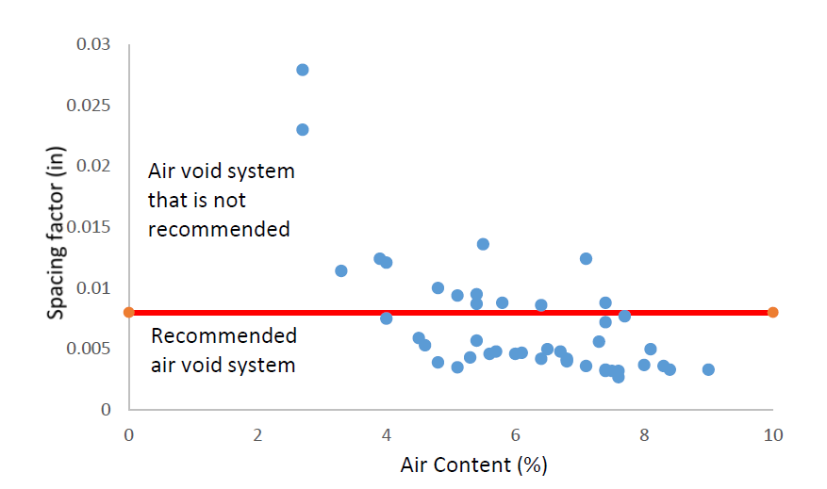
Figure 6 – A comparison of the air content versus the spacing factor for the field data from Pennsylvania.

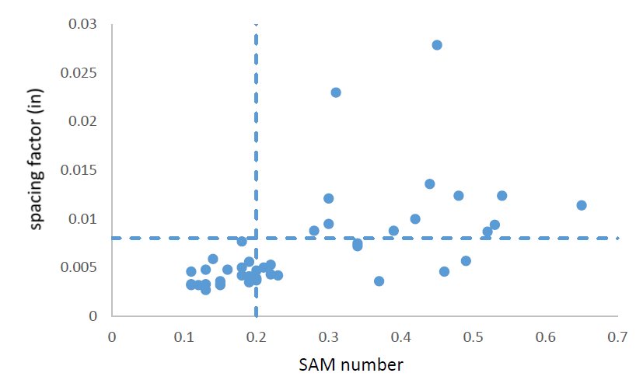
83% agreement
Figure 7 – Comparison of the SAM number and spacing factor for 47 field samples from Pennsylvania DOT field mixtures. A SAM limit of 0.20 and a spacing factor limit of 0.008” is shown. The results show an 83% agreement between the two methods.

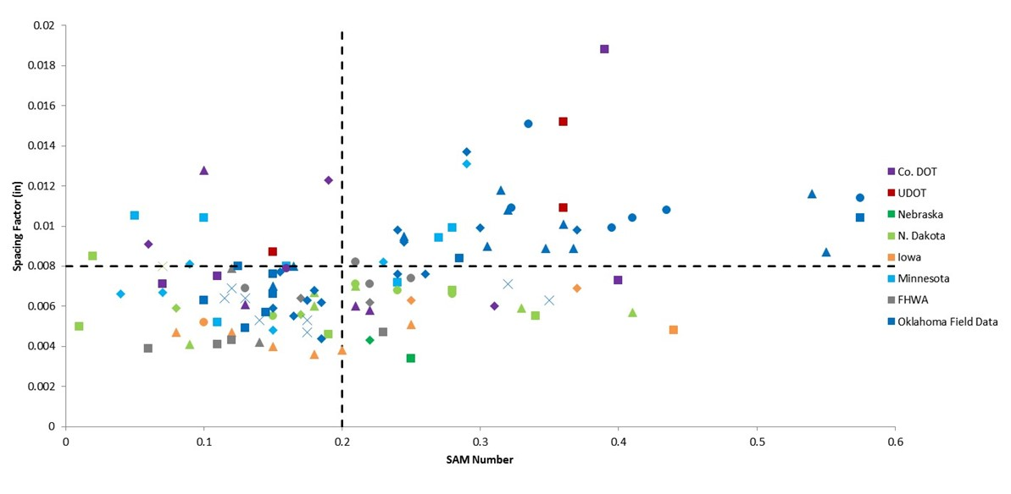
72% agreement
Figure 8 – Field testing data comparing the SAM number to the spacing factor for field mixtures from a number of different states with the spacing factor and SAM number compared. All mixtures were field data and they show a 72% agreement between the two methods.

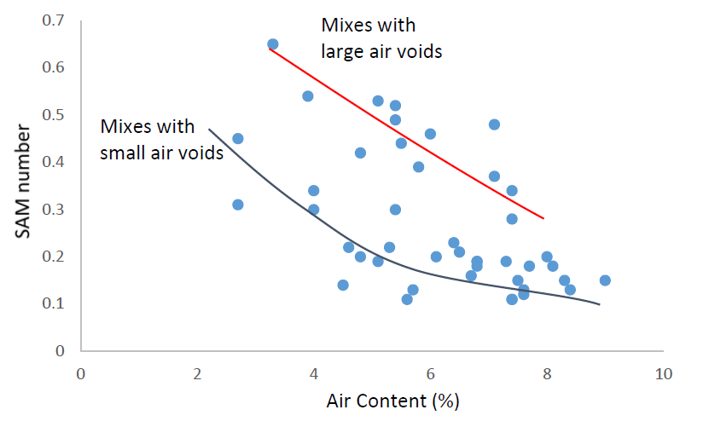
Figure 9 – A comparison of the air content and SAM number. The top line shows mixtures with coarse air voids and the bottom line shows mixtures with fine air voids. By plotting the data in this way it can tell the operator quickly what the overall size distribution of the void system is.

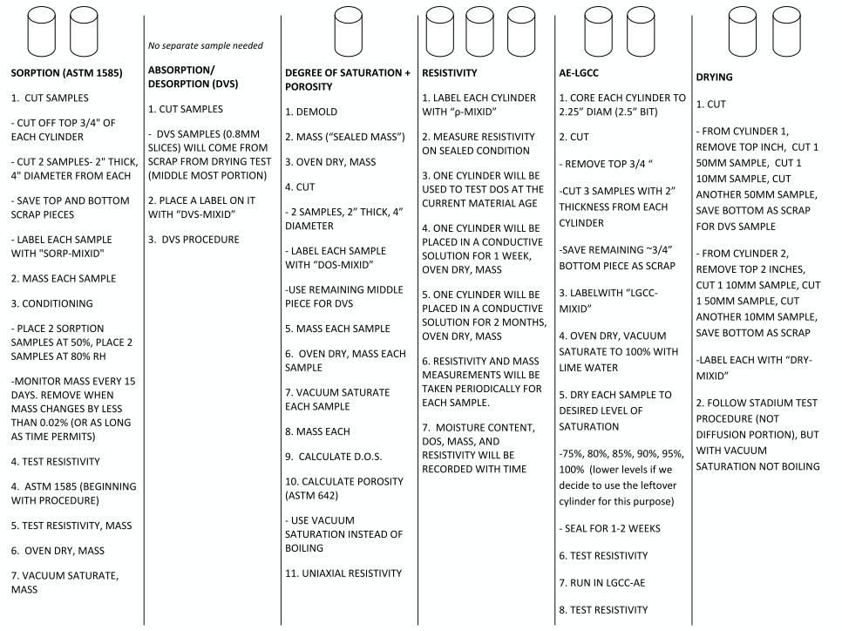
Figure 10 - Sample cutting, conditioning, and testing plan for each series of mixtures

(a)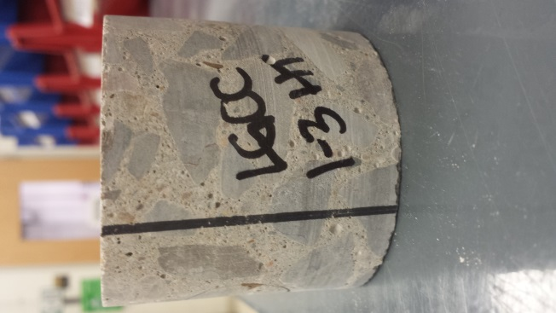 | (b)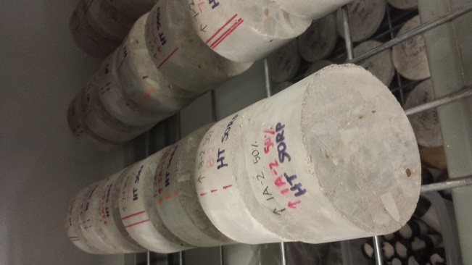 | (c)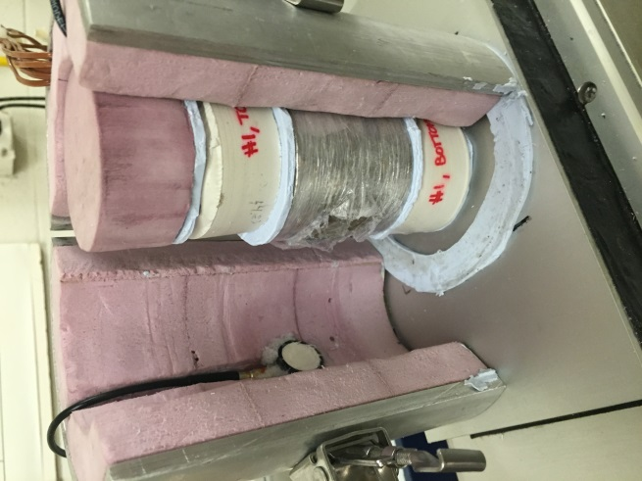

Figure 11 - Current Testing States (a) Sorption samples conditioning at 50% relative humidity (b) Sample labeling convention on a cut and cored LGCC sample (c) LGCC Test Setup.

Figure 12 Degree of Saturation over Time for (a) Group 1, (b) Group 2, (c) Group 3 and (d) Group 4 Cylinders Submerged in Pore Solution

Figure 13 Sealed Resistivity and Submerged Resistivity for all 4 mixture groups

Figure 14 The Impact of Total Air Volume on (a-d) Sealed Degree of Saturation and (e-h) Nick Point Degree of Saturation Shown with Experimental Data and Theoretical Prediction

Figure 15 Acoustic Emission Hits and Cumulative Signal Strength (1eu=1nV·s) for (a) Fully Saturated (b) 94% Saturated and (c) 89% Saturated Concrete Undergoing Three Freeze-Thaw Cycles Compared to (D) an Aluminum Sample with No Freeze-Thaw Related Damage
Figure 16 Wave Velocity Throughout Three Thermal Cycles for (a-c) Concrete Saturated to Three Different Degrees of Saturation Compared to (d) Control Aluminum Sample.

Figure 17 Projected Critical Degree of Saturation for Concrete Mixtures with a) Total Air Content and b) Air Quality (SAM Number) Using the Damage Index Following Three Freeze-Thaw Cycles

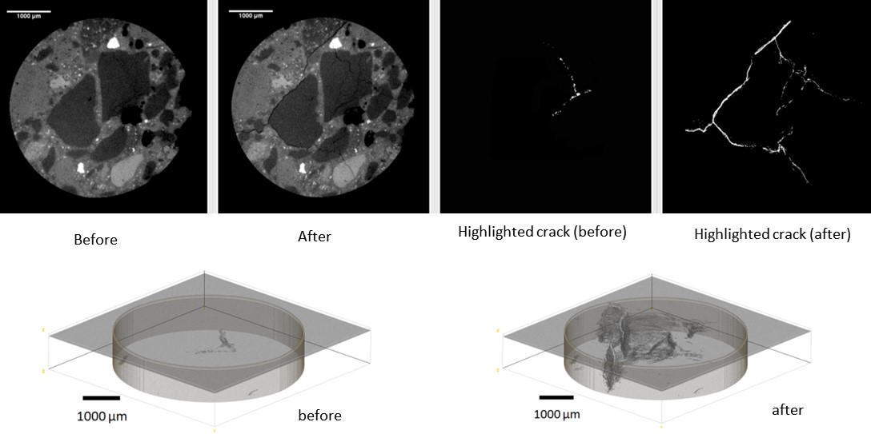
Figure 18 – An air entrained mortar sample shown both before and after a freeze thaw cycle. The highlighted cracks are shown from the cross sections. In addition, 3D data sets are shown of the crack distribution both before and after the freeze thaw cycle. The data was obtained with X-ray mCT.

Figure 19 – Comparison of the time to reach critical saturation (as determined from measured absorption and
measured secondary sorptivity as a function of measured durability factor.

a b

c d

Figure 20 – Comparison of the time to reach critical saturation (as determined from measured absorption and measured
secondary sorptivity) versus durability factor with various test limits: a) no limits, b) SAM Air > 0.20, c) air < 4.5%, and
d) either air > 0.20 or Air < 4.5%.

Figure 21 – Time to Saturation As A Function of Air Cotent and SAM Number

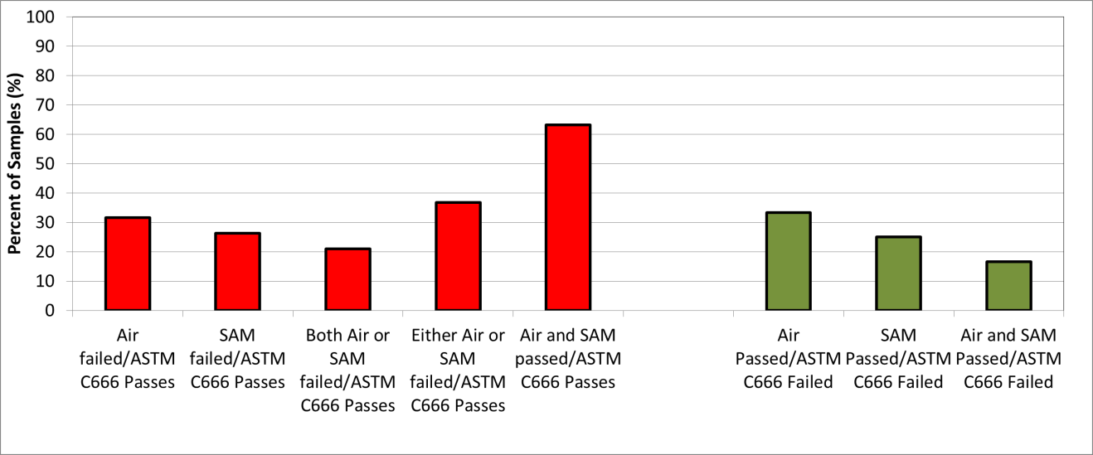

Figure 22 – Proportion of Samples Failing SAM and Air Criteria as Compared to Durability Factor Testing

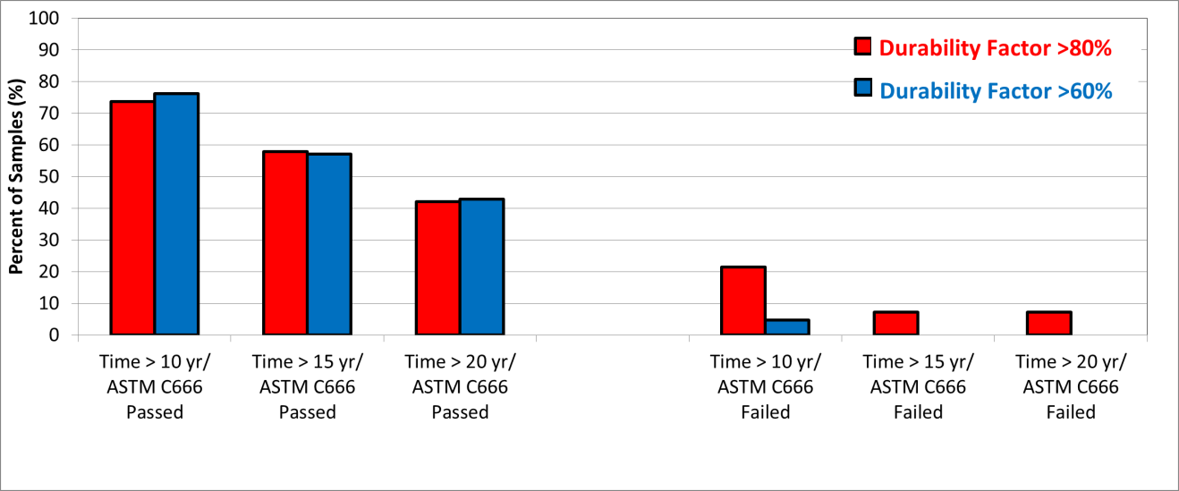

Figure 23 – Proportion of Samples Failing Time of Saturation Criteria as Compared to Durability Factor Testing

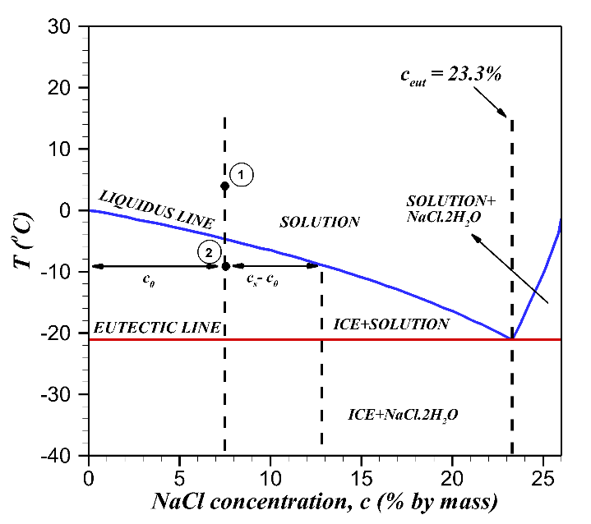  (a) | 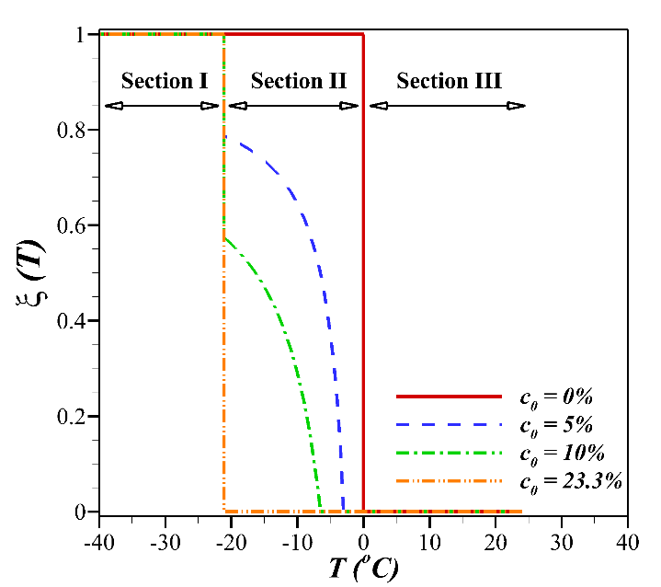  (b)

Figure 24 Phase diagram for aqueous NaCl solution; (b) the fraction of produced ice as a function of temperature within the freezing region for bulk NaCl solution.

Anticipated work next quarter:

The teams will continue preparing concrete mixtures to be investigated with the SAM and processing the materials
produced previously.

The team also plans to begin examining the rate of the absorption and desorption, rate of damage, and degree of saturation level on the damage with the concrete produced.

Work will continue with the mCT and neutron work.

Significant Results:

The data from over 300 different laboratory and field mixtures completed by two different labs suggest that a SAM
number of 0.20 can correctly determine if the spacing factor is above or below 0.008” about 93% of the time. There is
also over 80% agreement between the SAM results and the ASTM C666 results. Validation data has been gathered by FHWA Turner Fairbanks laboratory and the Pennsylvania DOT.

A presentation on the progress of the project was given at the NCC meeting in Omaha, NE and Miwaukee, WI. In addition
the research team has shared information in two conference calls with the research oversight committee.

In addition, webinars and in person presentations have been given by Dr. Ley to the ACPA and their members,
Missouri Science and Technology, North Dakota ACPA, Kansas KAPA, Utah ACPA, Iowa Paving conference,
Colorado ACPA, Wisconsin ACPA, New Mexico Concrete School, Minnesota Concrete Association, Michigan DOT,
The National ACPA Meeting, AASHTO SOM, and two National ACI conferences. The FHWA Mobile Concrete Lab
visited the OSU campus for several days to discuss about our progress with the SAM and other testing methods.

The SAM is now being used in 37 states, two Canadian provinces, and in England. It has also been specified in two states.
Kansas DOT has developed a specification that they are starting to implement this summer.

The publication of the AASHTO TP118 test method is also an important result.

Circumstance affecting project or budget. (Please describe any challenges encountered or anticipated that
might affect the completion of the project within the time, scope and fiscal constraints set forth in the
agreement, along with recommended solutions to those problems).

There was some delay getting the contracts signed. This has delayed the start of the project some but the research team is doing their best to make up for this. The project is about four months behind schedule. A contract extension will likely be necessary.

Other than this issue the project is on time and on scope.

Potential Implementation:

The Provisional AASHTO test method for the Super Air Meter is in press. Changes to other test methods are also being
discussed. Work will continue on the project to develop the precision and bias statement.

The results from this study have been used to help guide the new AASHTO durability specification for concrete pavements. This would be an outstanding implementation of this work.

