TRANSPORTATION POOLED FUND PROGRAM
QUARTERLY PROGRESS REPORT

Lead Agency: Utah Department of Transportation

INSTRUCTIONS:
Project Managers and/or research project investigators should complete a quarterly progress report for each calendar quarter during which the projects are active. Please provide a project schedule status of the research activities tied to each task that is defined in the proposal; a percentage completion of each task; a concise discussion (2 or 3 sentences) of the current status, including accomplishments and problems encountered, if any. List all tasks, even if no work was done during this period.

Transportation Pooled Fund Program Project #  TPF-5(244) |  | Transportation Pooled Fund Program - Report Period:  _ Quarter 1 (January 1 – March 31, 2016)  _ Quarter 2 (April 1 – June 30, 2016)  x Quarter 3 (July 1 – September 30, 2016)  _ Quarter 4 (October 1 – December 31, 2016)
Project Title:
Shaking Table Testing to Evaluate Effectiveness of Vertical Drains for Liquefaction Mitigation

Name of Project Manager(s):  David Stevens | Phone Number:  801-589-8340 |  | E-Mail  davidstevens@utah.gov
Lead Agency Project ID:  FINET 42046, ePM PIN 9933  UDOT PIC No. UT07.708 | Other Project ID (i.e., contract #):  UDOT Contract No. 138731 |  | Project Start Date:  May 1, 2013
Original Project End Date:  March 31, 2016 | Current Project End Date:  December 30, 2016 |  | Number of Extensions:  1

Project schedule status:

_ On schedule X On revised schedule _ Ahead of schedule _ Behind schedule

Overall Project Statistics:
Total Project Budget | Total Cost to Date for Project | Percentage of Work  Completed to Date
$115,000.00 | $61,500.00 | 60%

Quarterly Project Statistics:
Total Project Expenses  and Percentage This Quarter | Total Amount of Funds  Expended This Quarter | Total Percentage of  Time Used to Date
0% | $0 | 95%

Project Description:

The vision for this study is to determine the viability of large diameter (100 mm) prefabricated vertical drains for preventing liquefaction and associated settlements or lateral spreading under full-scale conditions. If viable, drainage alternatives offer substantial advantages in comparison to conventional densification approaches. In production, drains can often be installed at 25% to 40% of the cost of stone columns. In addition, the drains can be installed in about one-third to one-half of the time required for stone columns. Finally, the time and cost associated with post-treatment in-situ testing to evaluate improvement produced by densification may not be required with drains. In an era when construction budgets are becoming increasingly tight and projects are increasingly placed on fast-track schedules, innovative alternative solutions are required to deal with liquefaction hazards.

Although limited blast liquefaction testing (Rollins et al. 2003, Rollins et al. 2004), vibration testing (Chang et al. 2004) and centrifuge testing (Yang et al. 2004 ) suggest that vertical drains can be effective, no full-scale drain installation has been subjected to earthquake induced ground motions. This lack of performance data under full-scale conditions has been a major impediment to expanding the use of this technique. To remedy this problem we will conduct full-scale tests with vertical drains in liquefiable sand using the laminar shear box and high speed actuator system at NEES-Univ. at Buffalo. Tests will involve level ground conditions with two drain spacings and will be integrated with a previously funded NEESR study currently underway so that the control tests without drains will already be available. We will use the same sand installation techniques, as well as the same instrumentation plan and shaking protocols which have already been developed and proven successful. This collaborative approach will significantly reduce the cost of the study in comparison to a completely independent study. In addition, it will provide a comparison between the performance of the soil profile with drains relative to subsequent tests where piles will be involved. If full-scale tests prove the effectiveness of the drainage technique, significant time and costs savings can be achieved for both new construction and for retrofit situations.

Three objectives are outlined for this study:
1. Evaluate the ability of earthquake drains to reduce excess pore pressure and settlement for level ground conditions at progressively higher acceleration levels.
2. Define the influence of drain spacing on the effectiveness of the drains for mitigating liquefaction hazard.
3. Provide well-documented case histories which can be used to calibrate/validate numerical models for predicting the performance of vertical drains.

The scope of work consists of eight specific tasks:
1. Perform a literature review to summarize the state of the art in the area of liquefaction mitigation through drainage.
2. Conduct level ground shaking table tests with drains at 4 ft spacing.
3. Conduct level ground shaking table tests with drains at 3 ft spacing.
4. Reduce the test data, analyze, and compare with previous test on untreated sand.
5. Evaluate predictive methods by comparing measured behavior with behavior computed using computer models and simplified models.
6. Prepare a final report on effectiveness of the drain technique.
7. Disseminate the research results.
8. Hold technical advisory committee meetings.

Dr. Kyle Rollins of BYU is the Principal Investigator for this research project. The TPF-5(244) testing was performed at the SUNY-Buffalo shaking table testing facility in the summer of 2014. BYU was approved for shared-use status on the NEES-Buffalo shake table. Individual task reports will be prepared for Tasks 1 through 5 when these are completed. Up to two in-person meetings with the multi-state technical advisory committee (TAC) are planned to be held in Salt Lake City, Utah during the project. Other TAC meetings will be tele-conference or web meetings.

Progress this Quarter (includes meetings, work plan status, contract status, significant progress, etc.):

Task 1 – 100% complete.
Task 2 – 100% complete.
Task 3 – 100% complete.
Task 4 – 100% complete. Summary report was reviewed by the TAC and revised by BYU.
Task 5 – 50% complete. BYU continued evaluating predictive methods.
Task 6 – 20% complete. BYU prepared portions of the final report.
Task 7 – No work yet.
Task 8 – 40% complete.
Contract – No adjustment.

Anticipated work next quarter:

Task 1 – None.
Task 2 – None.
Task 3 – None.
Task 4 – None.
Task 5 – Continue with evaluating predictive methods.
Task 6 – Continue preparing portions of the final report.
Task 7 – None.
Task 8 – Plan to hold another TAC web-conference to review and discuss additional results from the study. Consider having Dr. Rollins travel to each participating state to present final results as states consider how best to implement the research results.
Contract – Consider extending the contract end date to allow for report completion and reviews.

Significant Results:

Using displacement and acceleration data measured at each ring of the laminar shear box, the cyclic shear strain and cyclic shear stress were computed for each cycle of loading at the elevation of the pore pressure transducers for nine of the shaking tests performed. Cyclic shear stress vs. shear strain curves were then used to compute the shear modulus for each cycle and the shear modulus was normalized by the shear modulus at a strain of 0.0001 strain based on shear wave velocity tests. Fig. 1 provides a plot of the G/Go vs. cyclic shear strain data points obtained from the laminar shear box tests where the excess pore pressure ratio, R_{u}, was less than 60%. These data points are shown in comparison with the typical range of data for sands with an Ru=0 developed from triaxial shear tests by Seed et al (1986) in Fig.1.

Range of Data for Sands No Liquefaction
Seed et al. (1986)

Fig. 1. G/G_{o} vs cyclic shear strain data points from laminar shear box tests with R_{u}<60% in comparison with curves developed from cyclic triaxial shear tests with R_{u} = 0% (Seed et al 1986)
The agreement between the data points and the curves developed by Seed et al (1986) is generally quite good and confirms the general validity of the approach taken.

A similar set of G/G_{o} vs cyclic shear strain data points was also obtained for cases where R_{u} was greater than 60% or liquefied (R_{u}=100%) in most cases. These data points are plotted in comparison with the G/Go vs cyclic shear strain curves developed by Seed et al (1986). In contrast with the results in Fig. 1, the data points all fall below the G/Go range for non-liquefied sand as would be expected. The data points extend to greater strain levels than are reasonable to obtain with a cyclic triaxial test. The G/Go data points typically lie within the range of 10% to 1%. To provide additional data points for liquefied G/Go data points at smaller strain levels, shear wave velocity measurements after a number of blast induced liquefaction tests are plotted at a strain level of 0.0001%. Once again the G/Go data points are considerably lower than the curve for non-liquefied sand and have an average value of 16%. Likewise velocity data with an Ru of 60% have a G/Go value of about 40%. These curves provide guidance on the effect of pore pressure ratio on the G/Go curves.

R_{u} = 100%
Range of Data for Sands No Liquefaction
Seed et al. (1986)
Fig. 2. G/G_{o} vs cyclic shear strain data points from laminar shear box tests with R_{u}>60% in comparison with curves developed from cyclic triaxial shear tests with R_{u} = 0% (Seed et al 1986). Data points for G/Go from shear wave velocity testing in blast liquefaction tests are also shown.

The measured cyclic shear strain and excess pore pressure data from the laminar shear box tests was also used to evaluate the development of excess pore pressure with shear strain during the various tests with PVD Drains. Fig. 3 provides a plot showing the typical range of data defining the development of R_{u} as a function of cyclic shear strain amplitude, γ, after 10 cycles as determined by Dobry (1984) from triaxial cyclic strain tests. The range of data encompasses sands with relative densities from 20 to 80% with an average of about 60%. These results suggest that the range of data is relatively unaffected by relative density. This is likely due to the fact that the relationships are based on strain rather than stress. Although a denser sand may require a higher shear stress than a loose sand to induce liquefaction, a denser sand will also require a greater stress to develop the same shear strain that a loose sand would develop at lower stress. Dobry (1984) contends that the relationship between Ru and γ is a fundamental relationship governing the development of excess pore pressure during liquefaction. Ru vs γ data from the three rounds of tests with the PV drains are also plotted in Fig. 3. The γ value is the average shear strain at a given depth for 10 cycles and Ru is the peak excess pore pressure developed in those 10 cycles from the pore pressure transducer at that depth. Each round of tests involved three separate shaking tests with peak accelerations of 0.05, 0.10 and 0.20g. For the first round of tests the data points generally fall within the range of data for sands without drains, although there are some data points which pull the average best-fit power curve down near the bottom of the range of data. These results suggest that the drains were having a minor effect on pore pressure response for the very loose, compressible soil structure that existed in the freshly placed soil. Perhaps the sand was too loose for drain to provide any meaningful benefit. In contrast, the data points for the second and third rounds of tests are significantly lower than the typical range for sand without drains. The data points and the best-fit power curves in each case also show that the reduction in excess pore pressure generation for a given shear strain becomes more significant with each round of testing. These results suggest that as the sand became somewhat denser and less compressible, that the drains were more effective in retarding the development of excess pore pressure for a given shear strain level. These results provide data on a fundamental level indicating that the drains are reducing the potential for excess pore pressure development relative to sand without drains.

Fig. 3. Relationship between excess pore pressure ratio, Ru, vs cyclic shear strain, γ, measured in three rounds of testing with drains in the laminar shear box. The range of data for tests on sands without drains (Dobry, 1984) is also shown for comparison.

Some researchers have speculated that even if drains could prevent the development of excess pore pressures, that the resulting settlement would still be the same. To investigate this contention, volumetric strain from the tests was plotted against pore pressure. Volumetric strain was measured as a function of depth for each of the tests, and volumetric strain was plotted as a function of excess pore pressure ratio measured near each pore pressure transducer in the profile in Fig. 4. The volumetric strain produced by a given excess pore pressure ratio for each round of tests falls within a band with increasing pore pressure. Regardless of round number, a given excess pore pressure produced roughly the same range of volumetric shear strain. It is clear; however, that less volumetric strain occurs for round 3 than for round 2 and less for round 2 than for round 1 because lower excess pore pressure ratios developed. These results indicate that the reduction in settlement observed in the tests is primarily due to the reduction in excess pore pressure produced by the drains.

During the past quarter, significant progress has been achieved in modeling the measured buildup and dissipation of excess pore pressures observed in the laminar box testing. Previous difficulties with the computer program FEQDrain were associated with improper selection of time step and duration values. Once these problems were discovered, reasonable agreement with the measured excess pore pressure time histories was obtained. For example, measured and computed excess pore pressure ratio time histories are plotted for a number of depths in Fig. 5. These curves are for the first round of tests with a peak acceleration level of 0.10g. Although there are clearly differences between the measured and computed curves, the model is general capturing the observed behavior. Reasonable agreement with the results from the tests for other rounds and other acceleration levels has been obtained by adjusting three parameters, the hydraulic conductivity, the modulus of compressibility, and the number of cycles to liquefaction. The hydraulic conductivity and modulus of compressibility that could be used in the model were fairly well constrained by the measured values from the physical tests. The number of cycles to liquefaction had to be estimated based on the results of similar tests without drains along with some judgment. Good agreement could generally be obtained using parameters within the range of measured values versus depth. The simplified pore pressure generation model in FEQDrain was not capable of capturing the dilation spikes in the pore pressure time histories for the tests at higher relative density for round 3.

Fig. 4. Relationship between measured volumetric strain and peak excess pore pressure ratio for round 1, 2 and 3 tests with prefabricated vertical drains in the laminar shear box testing.

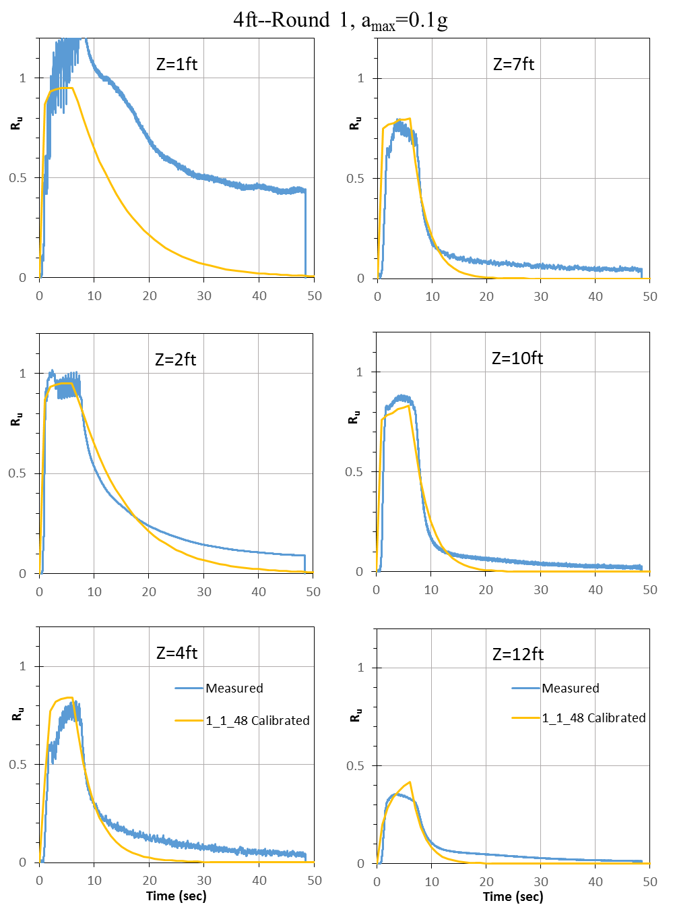
Fig. 5. Comparison of measured excess pore pressure ratio, Ru, time histories from laminar shear box tests with time histories computed using the computer program FEQDrain using input parameters within the range of measured values from the tests.
Circumstance affecting project or budget. (Please describe any challenges encountered or anticipated that
might affect the completion of the project within the time, scope and fiscal constraints set forth in the
agreement, along with recommended solutions to those problems).

Additional time was needed to complete reports and reviews by the TAC. Therefore the contract was amended to reflect the project ending in December 2016 instead of the original plan.

Potential Implementation:

