TRANSPORTATION POOLED FUND PROGRAM
QUARTERLY PROGRESS REPORT

Lead Agency: Utah Department of Transportation

INSTRUCTIONS:
Project Managers and/or research project investigators should complete a quarterly progress report for each calendar quarter during which the projects are active. Please provide a project schedule status of the research activities tied to each task that is defined in the proposal; a percentage completion of each task; a concise discussion (2 or 3 sentences) of the current status, including accomplishments and problems encountered, if any. List all tasks, even if no work was done during this period.

Transportation Pooled Fund Program Project #  TPF-5(264) |  | Transportation Pooled Fund Program - Report Period:  x Quarter 1 (January 1 – March 31, 2016)  _ Quarter 2 (April 1 – June 30, 2016)  _ Quarter 3 (July 1 – September 30, 2016)  _ Quarter 4 (October 1 – December 31, 2016)
Project Title:
Passive Force-Displacement Relationships for Skewed Abutments

Name of Project Manager(s):  David Stevens | Phone Number:  801-589-8340 |  | E-Mail  davidstevens@utah.gov
Lead Agency Project ID:  FINET 42051, ePM PIN 10903  UDOT PIC No. UT11.406 | Other Project ID (i.e., contract #):  UDOT Contract No. 138123 |  | Project Start Date:  August 13, 2012
Original Project End Date:  September 30, 2014 | Current Project End Date:  December 15, 2016 |  | Number of Extensions:  3

Project schedule status:

_ On schedule X On revised schedule _ Ahead of schedule _ Behind schedule

Overall Project Statistics:
Total Project Budget | Total Cost to Date for Project | Percentage of Work  Completed to Date
$270,000.00 (current contract)  $400,000.00 (total committed) | $172,300.00 | 75%

Quarterly Project Statistics:
Total Project Expenses  and Percentage This Quarter | Total Amount of Funds  Expended This Quarter | Total Percentage of  Time Used to Date
4% | $11,500.00 | 85%

Project Description:

At present, about 40% of the 600,000 bridges in the FHWA database are constructed at a skew angle (Silas Nichols, Personal Communication). There is considerable uncertainty about the passive force on skewed abutments where the passive force develops at an angle relative to the longitudinal axis of the bridge structure. Although current design codes (AASHTO 2011) consider that the ultimate passive force will be the same for a skewed abutment as for a non-skewed abutment, numerical analyses performed by Shamsabadi et al. (2006) indicate that the passive force will decrease substantially as the skew angle increases. Reduced passive force on skewed abutments would be particularly important for bridges subject to seismic forces or integral abutments subject to thermal expansion. Unfortunately, there have not been any physical test results for skewed abutments reported in the literature which could guide engineers in making appropriate adjustments for skewed conditions. Nevertheless, some field evidence has clearly shown poorer performance of skewed abutments during seismic events and distress to skewed abutments due to thermal expansion (Shamsabadi et al. 2006, Steinberg and Sargand 2010).

This study builds on previous pooled fund testing conducted by Rollins and his students at BYU to evaluate passive force-deflection relationships for non-skewed abutments (TPF-5(122), Dynamic Passive Pressure on Abutments and Pile Caps, Rollins et al, 2010). The test facilities can readily be modified to allow for the test program with relatively small additional costs because of the test fixtures (reaction shafts, reaction walls, and pile supported cap) which are already constructed at the site. Results from this study can be compared with previous testing to assess overall performance.

Four objectives are outlined for this new study:
- Determine static passive force-displacement curves for skewed abutments with and without wingwalls from large scale tests.
- Provide comparisons of behavior of skewed abutments with that of normal abutments.
- Evaluate the effect of wingwalls on skewed abutment response.
- Develop design procedures for calculating passive force-displacement curves for skewed abutments.

The scope of work consists of twelve specific tasks, including new tasks 7 through 12:
- Literature Review and Collection of Existing Test Data
- Perform Laboratory Passive Force-Deflection Tests on 2 ft High Wall with Skew Angles of 0º, 15º, 30º, and 45º
- Perform Field Passive Force-Deflection Tests on 5.5 ft High Wall with Skew Angles of 0º, 15º, and 30º and Transverse Wingwalls
- Perform Field Passive Force-Deflection Tests on 5.5 ft High Abutment with Skew angles of 0º, 15º, 30º and MSE Wingwalls
- Calibrate Computer Model and Conduct Parametric Studies
- Preparation of Final Report
- Perform Additional Field Passive Force-Deflection Tests on 5.5 ft High Abutment with a Skew Angle of 45º with and without MSE Wingwalls
- Perform Field Passive Force-Deflection Tests on 3.0 ft High Unconfined Backfill with Skew Angles of 0º and 30º
- Perform Field Passive Force-Deflection Tests on 5.5 ft High Pile Cap with Concrete Wingwalls and Skew Angles of 0º and 45º
- Perform Field Passive Force-Deflection Tests on 3.5 ft High Unconfined Gravel Backfill with Skew Angles of 0º and 30º
- Perform Field Passive Force-Deflection Tests on 3.5 ft High GRS Gravel Backfill with Skew Angles of 0º and 30º
- Present the Results of the Study at TRB and AASHTO Meetings

Dr. Kyle Rollins of BYU is the Principal Investigator for this research project. Individual task reports will be prepared for Tasks 1 through 5 and 7 through 11 when these are completed. Up to two in-person meetings with the multi-state technical advisory committee (TAC) are planned to be held in Salt Lake City, Utah during the project. Other TAC meetings will be tele-conference or web meetings.

Progress this Quarter (includes meetings, work plan status, contract status, significant progress, etc.):

Task 1 – 100% complete.
Task 2 – 100% complete.
Task 3 – 100% complete.
Task 4 – 100% complete.
Task 5 – 80% complete. Completed draft final report on no wingwall case. Continued work on RC Wingwall case.

Task 6 – 50% complete. Finalized the planned list of final task reports (and project summary report) to be published. Progress was made on multiple draft final reports to be published. Planned list of final reports is as follows:

- Passive force-deflection behavior of 5.5 ft skewed abutments with transverse wingwalls (45 degree skew tests added)
- Passive force-deflection behavior of 5.5 ft skewed abutments with longitudinal MSE wingwalls (45 degree skew tests added)
- Passive force-deflection behavior of 3 ft skewed abutments with transverse wingwalls (larger width-to-height ratio tests)
- Passive force-deflection behavior of 5.5 ft abutments with longitudinal reinforced concrete wingwalls
- Passive force-deflection behavior of 3.5 ft gravel and Geosynthetic Reinforced Soil (GRS) backfill with transverse wingwalls
- Computer model calibration and parametric studies, Part 1 – Passive force-deflection modeling with no wingwall
- Computer model calibration and parametric studies, Part 2 – Additional modeling with longitudinal reinforced concrete wingwalls, 45 degree skew, two-lane highway
- Summary report on passive force-deflection behavior of skewed abutments (short report up to 20 pages)

Task 7 – 80% complete. Continued data analysis and worked on task report.
Task 8 – 90% complete. Completed draft final report for this task.
Task 9 – 90% complete. TAC reviewed the draft final report for this task.
Task 10 – 90% complete. Completed combined draft final report for Tasks 10 and 11.
Task 11 – 90% complete. Completed combined draft final report for Tasks 10 and 11.
Task 12 – 60% complete.

TAC Meetings – A TAC meeting was held in Salt Lake City, Utah, on March 23. A few TAC members attended in person and others participated via web conference. The meeting summary was sent via email to the TAC. Prior to the meeting, three new draft final reports for different tasks were distributed to the TAC for review. In the meeting Dr. Rollins presented on the latest results from the study and discussed these with the TAC. The TAC also discussed potential code changes, implementation, and plans for additional field testing with Dr. Rollins.

Contract – The TAC reviewed a draft work plan developed by Dr. Rollins and Caltrans for a new field testing task involving passive force/skewed abutments using controlled low-strength material (CLSM) as backfill.

Anticipated work next quarter:

Task 1 – None.
Task 2 – None.
Task 3 – None.
Task 4 – None.
Task 5 – Continue work on RC Wingwall case.
Task 6 – Continue work on multiple draft final reports to be published. Combine portions of other task reports for the Final Summary Report.
Task 7 – Complete the draft final report for this task.
Task 8 – Revise the draft final report for this task based on TAC feedback.
Task 9 – Revise the draft final report for this task based on TAC feedback.
Task 10 – Revise the draft final report for this task based on TAC feedback.
Task 11 – Revise the draft final report for this task based on TAC feedback.
Task 12 – Dr. Rollins, with support from study TAC members, will present the updated research results and proposed code changes to technical committees at the 2016 AASHTO SCOBS annual meeting in Minneapolis, Minnesota, in June.

TAC Meetings – No TAC meetings are planned this quarter.

Contract – Add some baseline push-and-rotate tests on the test abutment/pile cap into the CLSM proposed additional work plan. Obtain TAC feedback on this updated plan. Identify additional funding needs and sources. The contract will be amended for the new tasks, schedule, and budget. Work will begin on the new field testing.

Significant Results:

Field testing with an RC wingwall at a skew angle of 45 degrees suggested that a pocket of soil located near the acute angle formed by the back of the abutment and the wingwall could cause a pocket of soil to essentially move with the abutment and reduce the effective skew angle. This led to a skew reduction factor R_{skew} considerably higher than observed in the other tests as shown in Fig. 1. We speculated that this phenomenon might be associated with the relatively narrow width of the test wall and that the R_{skew} value might be closer to the predicted value as the width of the abutment increased. To investigate this possibility, 3D finite element analyses were conducted using the computer program PLAXIS for an abutment with a width of 11 ft, as in the case of the field test, and with a width of 38 ft which might be more typical of an abutment for a two lane wall.

Fig. 1. Skew reduction factor, R_{skew}, plotted versus skew angle for all tests along with curve predicted by Rollins and Jessee (2013). The R_{skew}, value for the RC wingwall is considerably higher than the predicted curve which provides a reasonable fit to all the other data points.

Results of the two Plaxis analyses are shown in Fig. 2. In both cases, a pocket of soil about 6 ft wide moves largely in unison with the back of the abutment wall. Interface friction on the wingwall appears to be sufficient to hold this pocket of soil in place. For the 11 ft wide abutment, the width of this 6 ft pocket represents about half the width of the soil backfill. As this pocket moves with the abutment, it reduces the effective skew angle to about 35 degrees so that the R_{skew} is more consistent with this skew angle and is higher than expected. However, for the 38 ft wide abutment, the width of the 6 ft pocket is only about 16% of the width of the abutment, and the effect on the overall behavior of the wall is considerably reduced.

(b)
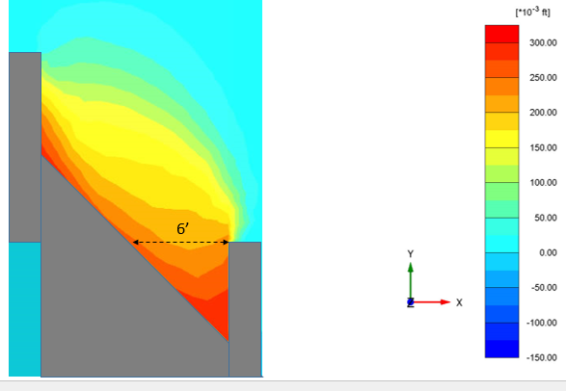
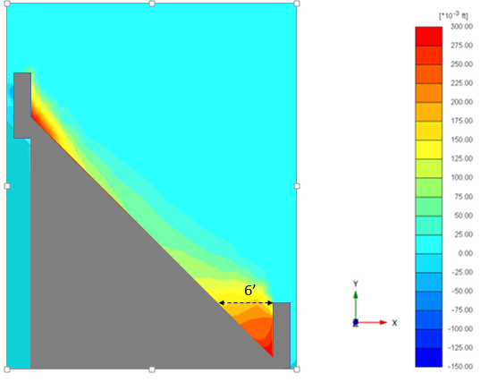
(a)
Fig. 2. Longitudinal displacement contours of the backfill with (a) 38 ft wide abutment and (b) 11 ft wide abutment similar to the field test (plan view).

Plaxis analyses were also performed for walls with zero skew, and the computed passive forces were used to computed R_{skew} for both wall widths. Based on the results of the finite element analyses for both walls, the computed R_{skew} values are plotted in Fig. 3 relative to the best-fit curve for all test results. As the width of the abutment increases, the back-calculated R_{skew} values gets closer to the best-fit curve. Additional analyses will be performed with wider abutments to investigate the effect of the abutment width on R_{skew}. We anticipate that these results will show that the effect of the wingwall becomes significantly reduced as the width of the abutment increases.

Based on our review of all the test results, we have found that a simpler equation can be used to compute the variation of R_{skew} versus skew angle. The equation is
R_{skew} = e^{(-ϴ/45)}

where ϴ is the skew angle in degrees, and e is base e or 2.718.

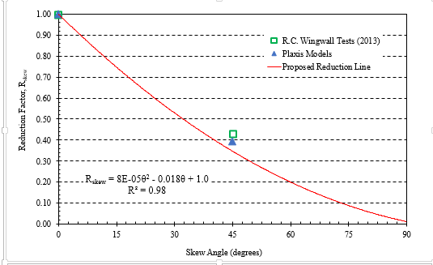
Fig. 3 Plot of back-calculated R_{skew} values from 3D PLAXIS wingwall model of a 38 ft wide abutment relative to the value obtained from field testing of an 11 ft wide abutment. It appears tha the R_{skew} value becomes closer to the value predicted by the best-fit equation as the width of the abutment becomes larger.

Circumstance affecting project or budget. (Please describe any challenges encountered or anticipated that
might affect the completion of the project within the time, scope and fiscal constraints set forth in the
agreement, along with recommended solutions to those problems).

Reports are being completed relative to first 12 work tasks. Additional work tasks related to CLSM backfill tests are being added at the request of Caltrans and Utah DOT. Once the work plan for additional field testing with CLSM backfill and push-and-rotate tests is prepared, this will be incorporated into a new contract amendment which will also extend the contract end date.

Potential Implementation:

UDOT is considering early adoption of the skew reduction factor for passive force based on the laboratory and field test results. In June 2013 and June 2014, Dr. Rollins presented the results of the research to date to technical committees at the AASHTO Subcommittee on Bridges and Structures Annual Meetings in Oregon and Ohio on behalf of the project TAC. This interaction is intended by the TAC and Dr. Rollins to prepare the way for design code revisions once the research is completed. Caltrans is also promoting use of the research results in their design methods. Dr. Rollins is proposing changes to the AASHTO code that will be presented at the AASHTO meeting in Minnesota this June.

