TRANSPORTATION POOLED FUND PROGRAM
QUARTERLY PROGRESS REPORT

Lead Agency (FHWA or State DOT): Oklahoma Department of Transportation

INSTRUCTIONS:
Project Managers and/or research project investigators should complete a quarterly progress report for each calendar quarter during which the projects are active. Please provide a project schedule status of the research activities tied to each task that is defined in the proposal; a percentage completion of each task; a concise discussion (2 or 3 sentences) of the current status, including accomplishments and problems encountered, if any. List all tasks, even if no work was done during this period.

Transportation Pooled Fund Program Project #  TPF-5(297) |  | Transportation Pooled Fund Program - Report Period:  O Quarter 1 (January 1 – March 31)  O Quarter 2 (April 1 – June 30)  O Quarter 3 (July 1 – September 30)  X Quarter 4 (October 1 – December 31)
Project Title:
Improving Specifications to Resist Frost Damage in Modern Concrete Mixtures

Name of Project Manager(s):  Tyler Ley | Phone Number:  405-744-5257 |  | E-Mail  Tyler.ley@okstate.edu
Lead Agency Project ID:  TPF-TPF5(297)RS / JOB PIECE 30802(04) | Other Project ID (i.e., contract #):  AA-5-52974 |  | Project Start Date:  March 10, 2014
Original Project End Date:  February 28, 2017 | Current Project End Date: |  | Number of Extensions:

Project schedule status:
On schedule □ On revised schedule □ Ahead of schedule X Behind schedule

Overall Project Statistics:
Total Project Budget | Total Cost to Date for Project | Percentage of Work  Completed to Date
$572,500 | $110,000 | 19%

Quarterly Project Statistics:
Total Project Expenses  and Percentage This Quarter | Total Amount of Funds  Expended This Quarter | Total Percentage of  Time Used to Date
$40,000 | $40,000 | 28%

Project Description:

Concrete can be damaged when it is 1) sufficiently wet (has a high degree of saturation) and 2) exposed temperature cycles that enable freezing and thawing. The damage that occurs due to freezing and thawing can lead to premature deterioration, costly repairs, and premature replacement of concrete infrastructure elements. Current specifications for frost durability are largely based on work completed in the 1950s, and while this work included many landmark discoveries (Kleiger 1952, 1954) it may not be completely representative of materials used in modern concrete mixtures. Further, the majority of current frost damage studies investigate freezing and thawing in water. While it is known that the presence of salts alters the freezing behavior, little research on frost damage is performed on air entrained concrete in salt water other than scaling studies. While the use of water greatly simplifies the system, it is not the most representative of what occurs on America’s bridges and highways. Results from recent studies suggest that there are several ways in which frost damage can be reduced through new tests and improve specifications that can lead to extended service life of concrete infrastructure.

The goal of the research is to produce improved specifications, and test methods; while, improving the understanding of the underlying mechanisms of frost damage. Specifically, this work will seek to develop new test procedures that may be faster and/or more reliable than the existing methods. The objectives of this project are:

• Determine the necessary properties of the air-void system to provide satisfactory frost durability in laboratory testing of laboratory and field concretes with different combinations of admixtures, cements, and mixing temperatures in salt environments
• Determine the accuracy of a simple field test method that measures air void system quality with field and laboratory concrete
• Determine the critical combinations of absorption and the critical degree of saturation on the frost durability in accelerated laboratory testing in the presence of deicer salts
• Establish new test methods and specifications for fresh and hardened concrete to determine frost durability and field performance

In addition a streaming lecture series over freeze that durability will be generated as part of this work.

Progress this Quarter (includes meetings, work plan status, contract status, significant progress, etc.):

Task 1: Literature Review and Development of the Testing Matrix (OSU and Purdue)

In this task the research teams will review the existing literature and determine a testing matrix to cover the necessary variables. Work is needed to understand how cements of different alkali content, different mixing temperatures, and types of mixing impact the air entrainment system and subsequently the frost durability of concrete. These variables can lead to changes in AEA effectiveness and their impact needs to be quantified with ASTM C 666 testing. As part of this task we will work with our project oversight committee to establish a set of materials and a testing matrix that can be used for the entire study. The decisions used in developing this test matrix will be made based on literature review, previous research by the PIs and the needs identified by the study advisory discussions.

The initial testing matrix will focus on understanding the impact of different air void systems on the freeze thaw durability of concrete. The matrix has been developed and was shared with the research oversight committee in the first conference call. The team will first look at mixtures for bridge decks and then work towards mixtures that are more appropriate for pavements. Here is an overview of the mixtures:

Limestone aggregate and natural sand from Oklahoma will be used for these mixtures. Both aggregates have been shown great freeze thaw field performance in the laboratory and the field. A mixture with 20% class C fly ash will be investigated with 6.5 sacks of total cementitious content and a w/cm of 0.45. A wood rosin AEA will be the primary admixture investigated as it is the most widely used AEA. However, select mixtures will be investigated with synthetic AEA. These AEAs will be used to produce mixtures with different spacing factors and air content. These samples will be investigated in a number of the freeze thaw tests in the project. Next, a mixture with 0.40 w/cm will be investigated with the same AEA. After that mixtures with high range water reducers will be investigated with 0.40 and 0.35 w/cm. A few mixtures will different high range water reducer dosages will be investigated. After this point the team will start to think about investigating a subset of pavement mixtures.

Review of the literature is still ongoing to help guide the research. The bridge deck mixtures are close to being complete and some pavement mixtures have been completed.

60% complete

Task 2: Sample Preparation (OSU and Purdue)

A number of the mixtures suggested in task 1 have been completed at OSU and have been shipped to Purdue for testing. This is a great accomplishment for the first quarter of the project. Mixtures with different amounts of superplasticizers have been investigated. Mixtures are also being complete to look at different dosages of superplasticizer and also some mid-range water reducers. A few mixtures have been investigate that are appropriate for pavements. These will be the next focus of the research.

30% complete

Task 3: Validation of the Super Air Meter (OSU)

In this task the Super Air Meter (SAM) will be evaluated in laboratory and field mixtures. The laboratory mixtures to be investigated include: aggregate with high aggregate correction factor, light weight aggregate, hot weather concrete, cold weather concrete, and any other items that the research oversight committee feels is important. In addition a number of mixtures will be investigated in the field. This will be done by visiting local ready mix and central mix batch plants to take samples.

A number of laboratory mixtures have been completed and the results are being complied. The data shows that the SAM does a good job of predicting the spacing factor for the majority of the mixtures investigated. The SAM limit of 0.20 psi has shown a conservative correlation to a spacing factor of 0.008” over 90% of the time. For all of these mixtures at least two different SAMs are being investigated in order to collect the precision and bias information needed for the AASHTO test method. Work will be done to look at different dosages of high range water reducer and the impact on the air content, SAM number, and spacing factor relationship. Work is continuing to be completed to investigate the variability in the test method. The current results are shown in Fig. 1.

In addition, the research team has evaluated over 70 different field concrete mixtures. For all of these mixtures we have used two SAMs to evaluate each mixture. We plan to continue to add measurements. These results are shown in Fig. 2.

The Turner Fairbanks Lab at FHWA has also completed a 3rd party evaluation of the SAM and they have provided their data for comparison. The results are shown in Fig. 3.

The results from the lab, field, and 3rd party evaluations are included in Figure 4. In this report. The data continues to be very consistent and show that there is about a 93% agreement between spacing factor recommendation of 0.008” and a SAM number of 0.20.

In addition commercial versions of the SAM have been provided to the following partners for their usage: Purdue, Iowa, Nebraska, Kansas, North Dakota, Illinois, Oklahoma, Pennsylvania, Minnesota, and Wisconsin. The meter is now being used in 20 different states and one Canadian province. Samples for from the field for comparison of SAM to hardened air-void analysis have been submitted by Colorado, Utah, Minnesota, Pennsylvania, Tennessee, North Dakota, and Iowa. These samples are being prepared and polished for hardened air-void analysis. This data will contribute to the vast data set that is being compiled.

35% complete

Task 4: Creation of an AASHTO Test Method and Specification for the SAM (OSU)
A presentation was made to the AASHTO Materials subcommittee. The presentation was well received and we have been invited to submit a draft of the test for the summer meeting. The draft test method has been prepared with the help of Larry Sutter and has been submitted. PI Ley traveled to the SOM meeting and gave an update on the pooled fund. The SOM reported that the test method will be evaluated in the SOM meeting in February.

45% complete

Task 5: Use of X-Ray Tomography of Air Voids and Frost Damage (OSU)

Researchers at OSU have developed nondestructive techniques to examine microscopic air voids in fresh and hardened concrete by using a X-ray micro computed tomography (mCT) scanner. This is a powerful technique that allows measurements to be made not previously possible. The research team has developed techniques to image water movements and have access to a freezing stage. By combining this information about the void distribution, the moisture content and distribution, and then being able to image the damage that occurs from freezing is a powerful tool. These observations can lead to ground breaking insights into the mechanisms of frost damage and how it can be avoided.

The experimental methods are largely finished. Experimental work to examine freezing should start in the next quarter.

Progress 10%

Task 6: ASTM C 666 (OSU)

The primary test method used to investigate the frost durability of the concrete will be the ASTM C666 test. This test is the most widely recognized test to investigate the rapid deterioration from freezing and thawing. As many mixtures will be investigated with this test as possible. For some mixtures a modified version will be used where the samples are soaked in salt solutions during freezing and thawing. As part of this task the specimen absorption and desorption of the samples will be investigated using a modified form of ASTM C1585. The impact of wetting and drying will also be investigated. While the team realizes that the ASTM C666 is a well-respected test they feel that the three months required to complete the test is too long. The research team plans on using this information to help find a shorter test with the same rigor.

A new chamber has been purchased and a significant amount of C666 testing has been completed. A summary of the test results are shown in Fig. 5. These results show a good correlation between C666 and the SAM number. The results suggest that it might be possible to use a slightly higher SAM number than 0.20. This will be discussed in the next conference call with the research team.

Progress 20%

Task 7: Absorption and Desorption (Purdue)

During this task the research team will perform desorption/sorption analysis on selected mixtures prepared in Task 2. For the sorption tests 100 mm diameter samples will be used that are 50 mm in thickness. The samples will then be placed in fluid according to a modified version of ASTM C 1585 to determine the degree of saturation over time. In addition, the complete degree of saturation will be determined using vacuum saturation.

The sampling and testing protocols have been developed (as illustrated in Fig. 6). The sorption samples have been cut from the first batch of cylinders sent to Purdue and are in week 5 of conditioning at 50% and 80% relative humidity (Figure 7a). It is essential that the conditioning of the sample starts early due to the time required for the samples condition to come to equilibrium. This information will be extremely useful to determine the S_{n} value of sorption and the slope of the secondary sorption curve which is essential for prediction of long term performance.

The samples from different batch for the sorption test are cut and conditioned in 50% and 75% RH environment. It was decided to use 75% instead of 80% RH environment to more easily facilitate specification. The samples are weighted every 15 days. The samples still need time to come to equilibrium. The drying tests are started and being processed. The data for the drying tests are collecting and some of the results are ready for analysis. Testing the different absorption and desorption abilities of samples with 50%, 75%, 93%, and 100% (saturation) will be done instead of the dynamic vapor sorption test.

Progress 20%

Task 8: Degree of Saturation and Damage Development (Purdue)

Samples prepared in Task 2 will be saturated to different degrees of saturation and the freeze-thaw tests will be performed with the samples in a sealed condition. Freeze-thaw tests will be performed on samples with 50 mm thickness and 68 mm diameter using a new Longitudinal Gaurded Comparitive Calorimeter (LGCC) setup with acoustic emissions sensing to detect damage. Results from this test will be used to identify the critical degree of saturation with the express purpose of relating the critical degree of saturation to the quality of the entrained air system (for example the air void spacing). Information from this test will be used in conjunction with the results from Task 7 to determine if the air void system alters the time required to reach a critical degree of saturation (which is hypothesized with a higher SAM number corresponding to a lower S _{CRIT}). A series of 3 cylinders will be used to determine the resistivity over time of samples submerged in pore solution to prevent leaching. Additional resistivity tests will be performed at various ages and degrees of saturation on samples from a variety of tests.

The testing protocols have been developed (See Figure 6). DOS cylinders from batch 1 have been tested and the results have been used to determine the degree of saturation for cylinders in the resistivity tests. Both short and long term resistivity tests have concluded for the first batch of cylinders. These results are being analyzed to study the resistivity, formation factor, and degree of saturation over time. Experimental nick point values are being compared to theoretical values and are being related to both air volume and SAM numbers. Freeze-Thaw samples have been cut and cored and are in the final stages of preparation for the LGCC (Figure 7b). Two LGCC setups with acoustic emissions capabilities for freeze-thaw testing of these samples are completed and testing has begun on samples from batch 1. A preliminary testing schedule has been created to capture samples different air contents (Figure 8). DOS and resistivity measurements will be repeated on batches 2 and 3.

Progress 20%

Task 9: Rate of Damage Analysis (Purdue)

This task will combine acoustic emission data and X-ray mCT to detect cracking and also image the location. This will be done in samples with different quality of air void systems and with different paste quality and saturation level.

No progress has been made to date as research has focused on launching Tasks 7 and 8 however as those tasks are progressing; however this will become a primary focus during the next quarter.

Progress 0%

Task 10: Technology Transfer (OSU and Purdue)

A portion of this project will be dedicated to development of a strong educational technology transfer program. The PI’s propose the development of a short course that utilizes streaming video (and could be placed on a DVD for widespread dissemination). No progress has been made on this task. This will be completed late in the project so that the latest findings can be shared with the audience.

Progress 0%

Task 11: Final Report (OSU and Purdue)

This task will be completed in the final quarter of the project.

Progress 0%

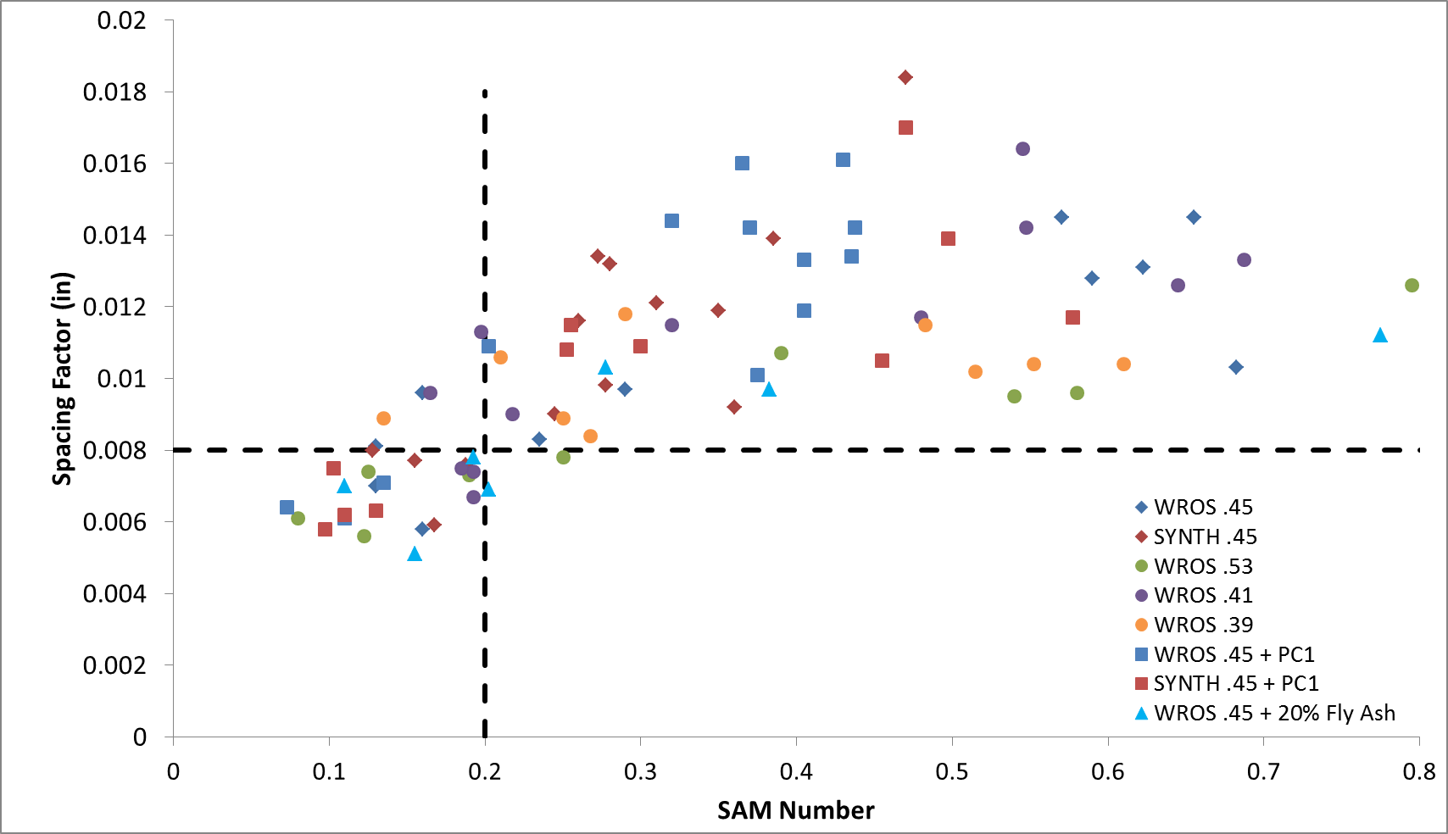

Figure 1 – Laboratory study results comparing the SAM number to the spacing factor for mixtures completed at OSU.

Figure 2 – Field testing data comparing the SAM number to the spacing factor for mixtures completed at OSU.

Figure 3 – Results from FHWA Turner Fairbanks Laboratory.

Figure 4 – A combination of the Figures 1, 2, and 3. This shows a comparison of the lab field, and 3rd party lab data.

Figure 5 – The SAM number versus the Durability Factor from the C666 testing.

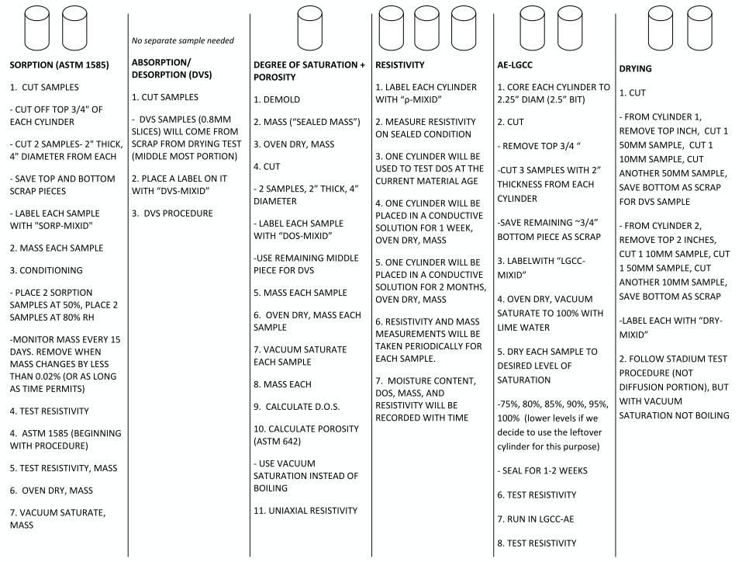
Figure 6 - Sample cutting, conditioning, and testing plan for each series of mixtures

(a)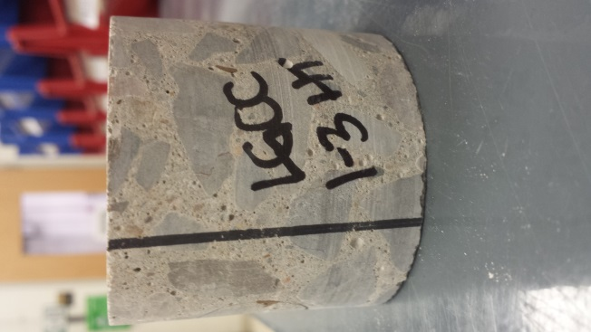 | (b)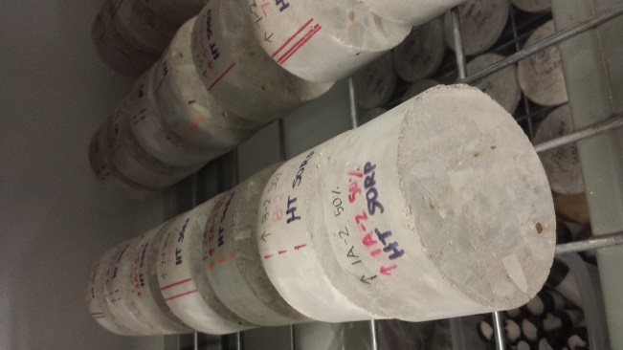 | (c)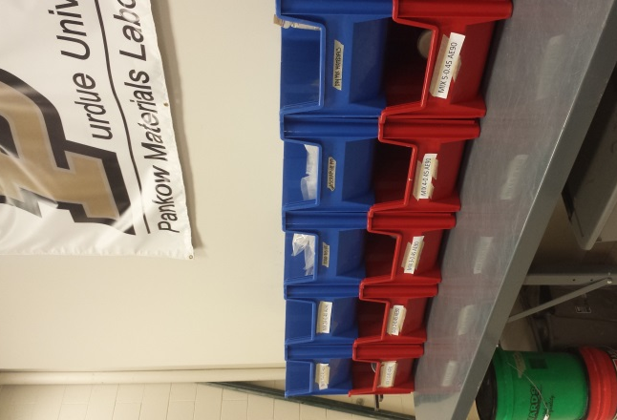

Figure 7 - Current Testing States (a) Sorption samples conditioning at 50% relative humidity (b) Sample labeling convention on a cut and cored LGCC sample (c) Sample organization in preparation for testing

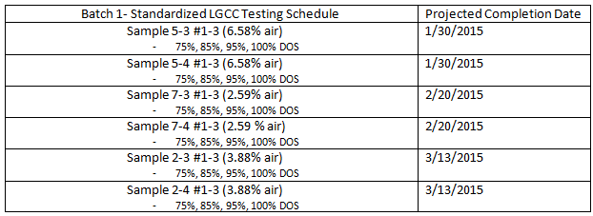
Figure 8 - LGCC Freeze- Thaw Testing Schedule for Batch 1 Samples

Anticipated work next quarter:

The teams will continue preparing concrete mixtures to be investigated with the SAM and processing the materials
produced previously. The ASTM C666 testing will continue as well as the ASTM C457 sample preparation for the samples provided by other states.

The team also plans to begin examining the rate of looking the absorption and desorption, rate of damage, and degree of saturation level on the damage with the concrete provided by OSU.

Significant Results:

The data from over 300 different laboratory and field mixtures completed by two different labs suggest that a SAM
number of 0.20 can correctly determine if the spacing factor is above or below 0.008” about 93% of the time. There is
also good agreement between the SAM results and the ASTM C666 results.

A presentation on the progress of the project was given at the NCC meeting in Omaha, NE. Many of the sponsoring
states were at the meeting and were able to be updated on the progress. In addition, webinars were given by Dr. Ley to
the ACPA and their members, Missouri Science and Technology, North Dakota ACPA, Kansas KAPA, and Utah ACPA.

In the next quarter presentations will be made at NCC in Reno, NV, Colorado ACPA, Wisconsin ACPA, and the National
ACI Convention.

Circumstance affecting project or budget. (Please describe any challenges encountered or anticipated that
might affect the completion of the project within the time, scope and fiscal constraints set forth in the
agreement, along with recommended solutions to those problems).

There was some delay getting the contracts signed. This has delayed the start of the project some but the research team is doing their best to make up for this. A contract extension will likely be necessary.

Other than this issue the project is on time and on scope.

Potential Implementation:

A preliminary test method for the Super Air Meter has been presented to the AASHTO SOM. There was discussions at the AASHTO SOM meeting in Minneapolis and it appears that the test method will be approved in the fall and become available. This is a great accomplishment. Work will continue on the project to develop the precision and bias statement.

Several papers are being authored over the work and will be submitted for publication soon.

