TRANSPORTATION POOLED FUND PROGRAM
QUARTERLY PROGRESS REPORT

Lead Agency: Utah Department of Transportation

INSTRUCTIONS:
Project Managers and/or research project investigators should complete a quarterly progress report for each calendar quarter during which the projects are active. Please provide a project schedule status of the research activities tied to each task that is defined in the proposal; a percentage completion of each task; a concise discussion (2 or 3 sentences) of the current status, including accomplishments and problems encountered, if any. List all tasks, even if no work was done during this period.

Transportation Pooled Fund Program Project #  TPF-5(244) |  | Transportation Pooled Fund Program - Report Period:  x Quarter 1 (January 1 – March 31, 2015)  _ Quarter 2 (April 1 – June 30, 2015)  _ Quarter 3 (July 1 – September 30, 2015)  _ Quarter 4 (October 1 – December 31, 2015)
Project Title:
Shaking Table Testing to Evaluate Effectiveness of Vertical Drains for Liquefaction Mitigation

Name of Project Manager(s):  David Stevens | Phone Number:  801-589-8340 |  | E-Mail  davidstevens@utah.gov
Lead Agency Project ID:  FINET 42046, ePM PIN 9933  UDOT PIC No. UT07.708 | Other Project ID (i.e., contract #):  UDOT Contract No. 138731 |  | Project Start Date:  May 1, 2013
Original Project End Date:  March 31, 2016 | Current Project End Date:  March 31, 2016 |  | Number of Extensions:

Project schedule status:

_ On schedule X On revised schedule _ Ahead of schedule _ Behind schedule

Overall Project Statistics:
Total Project Budget | Total Cost to Date for Project | Percentage of Work  Completed to Date
$115,000.00 | $23,250.00 | 40%

Quarterly Project Statistics:
Total Project Expenses  and Percentage This Quarter | Total Amount of Funds  Expended This Quarter | Total Percentage of  Time Used to Date
15% | $16,750.00 | 65%

Project Description:

The vision for this study is to determine the viability of large diameter (100 mm) prefabricated vertical drains for preventing liquefaction and associated settlements or lateral spreading under full-scale conditions. If viable, drainage alternatives offer substantial advantages in comparison to conventional densification approaches. In production, drains can often be installed at 25% to 40% of the cost of stone columns. In addition, the drains can be installed in about one-third to one-half of the time required for stone columns. Finally, the time and cost associated with post-treatment in-situ testing to evaluate improvement produced by densification may not be required with drains. In an era when construction budgets are becoming increasingly tight and projects are increasingly placed on fast-track schedules, innovative alternative solutions are required to deal with liquefaction hazards.

Although limited blast liquefaction testing (Rollins et al. 2003, Rollins et al. 2004), vibration testing (Chang et al. 2004) and centrifuge testing (Yang et al. 2004 ) suggest that vertical drains can be effective, no full-scale drain installation has been subjected to earthquake induced ground motions. This lack of performance data under full-scale conditions has been a major impediment to expanding the use of this technique. To remedy this problem we will conduct full-scale tests with vertical drains in liquefiable sand using the laminar shear box and high speed actuator system at NEES-Univ. at Buffalo. Tests will involve level ground conditions with two drain spacings and will be integrated with a previously funded NEESR study currently underway so that the control tests without drains will already be available. We will use the same sand installation techniques, as well as the same instrumentation plan and shaking protocols which have already been developed and proven successful. This collaborative approach will significantly reduce the cost of the study in comparison to a completely independent study. In addition, it will provide a comparison between the performance of the soil profile with drains relative to subsequent tests where piles will be involved. If full-scale tests prove the effectiveness of the drainage technique, significant time and costs savings can be achieved for both new construction and for retrofit situations.

Three objectives are outlined for this study:
1. Evaluate the ability of earthquake drains to reduce excess pore pressure and settlement for level ground conditions at progressively higher acceleration levels.
2. Define the influence of drain spacing on the effectiveness of the drains for mitigating liquefaction hazard.
3. Provide well-documented case histories which can be used to calibrate/validate numerical models for predicting the performance of vertical drains.

The scope of work consists of eight specific tasks:
1. Perform a literature review to summarize the state of the art in the area of liquefaction mitigation through drainage.
2. Conduct level ground shaking table tests with drains at 4 ft spacing.
3. Conduct level ground shaking table tests with drains at 3 ft spacing.
4. Reduce the test data, analyze, and compare with previous test on untreated sand.
5. Evaluate predictive methods by comparing measured behavior with behavior computed using computer models and simplified models.
6. Prepare a final report on effectiveness of the drain technique.
7. Disseminate the research results.
8. Hold technical advisory committee meetings.

Dr. Kyle Rollins of BYU is the Principal Investigator for this research project. The TPF-5(244) testing was performed at the SUNY-Buffalo shaking table testing facility in the summer of 2014. BYU was approved for shared-use status on the NEES-Buffalo shake table. Individual task reports will be prepared for Tasks 1 through 5 when these are completed. Up to two in-person meetings with the multi-state technical advisory committee (TAC) are planned to be held in Salt Lake City, Utah during the project. Other TAC meetings will be tele-conference or web meetings.

Progress this Quarter (includes meetings, work plan status, contract status, significant progress, etc.):

Task 1 – 100% complete.
Task 2 – 100% complete. BYU provided the summary report for the task testing, and this was shared with the TAC.
Task 3 – 90% complete. BYU prepared the summary report for the task testing.
Task 4 – 50% complete. BYU continued the test data reduction and analysis.
Task 5 – 10% complete. BYU began evaluating predictive methods.
Task 6 – No work yet.
Task 7 – No work yet.
Task 8 – 15% complete. No TAC meetings were held this quarter.

Anticipated work next quarter:

Task 1 – None.
Task 2 – None.
Task 3 – Submit the Test 2 summary report for TAC review.
Task 4 – Continue with test data reduction and analysis.
Task 5 – Continue with evaluating predictive methods.
Task 6 – None.
Task 7 – None.
Task 8 – Plan to hold another TAC web-conference to review and discuss preliminary results from the testing.

Significant Results:

During the past quarter we have worked to reduce test data and produce basic plots showing settlement vs. depth, peak excess pore pressure ratio versus depth, acceleration time histories at each accelerometer, pore pressure ratio time histories at each piezometer location, and total settlement versus number of tests. These plots have now been prepared for the tests involving drains spaced at both 3 ft and 4 ft on centers. Typical companion plots showing settlement versus depth along with peak excess pore pressure ratio versus depth plots for the last round of tests with 0.20g base input motion for the 4 ft and 3 ft drain spacing are shown in Figures 1 and 2, respectively. A comparison of the two plots indicates that the closer drains spacing (3 ft vs 4 ft) was generally successful in reducing the excess pore pressure ratios and preventing liquefaction, particularly for the upper portion of the profile. However, the measured settlement associated with the test for the drains at 3 ft spacing is actually a little higher than for the drains at 4 ft spacing. But after correcting for the different initial sand heights for the two tests (14.5 ft for the 4 ft spacing and 16.5 ft for the 3 ft spacing) the total settlements are nearly identical. Nevertheless, the settlement distribution throughout the profile is somewhat different for each test.

Plots showing time histories of acceleration and time histories of excess pore pressure ratio at various depths within the profile are provided in Figures 3 and 4 for the tests with drain spacings of 4 ft and 3 ft, respectively. In both cases, the peak accelerations are closer to 0.3g through most of the profile although the peak base acceleration level was 0.2g. The time histories of excess pore pressure ratio for both the 4 ft and 3 ft drain spacings show significant oscillations near the ground surface. This appears to be a result of dilation at high strain levels at low confining pressures. Nevertheless, the excess pore pressure ratios near the surface were limited to about 0.6 to 0.7 for the 3 ft spacing whereas liquefaction developed (excess pore pressure ratio of 1.0) for the 4 ft spacing. Although the pore pressure ratios are clearly lower, the ratios may still have reached high enough levels to produce settlement.

In order to evaluate the performance of the sand for the two drain spacings, we anticipate that it will be necessary to perform a more sophisticated statistical analysis. Comparisons can be made on a layer by layer basis where settlement can be related to factors such as excess pore pressure ratio, shear strain, peak acceleration, duration of excess pore pressure, etc. Although settlement is similar for both drain spacings, the settlement may be associated with layers that are not strongly affected by drainage near the surface or may be associated with higher levels of acceleration or shear strain in the PVD2 tests. Peak acceleration levels for the tests with drains at 3 ft spacing were higher in some cases than for the tests with drains at 4 ft spacings. Therefore, final conclusions regarding the performance of the drains must await additional study on a layer by layer basis.

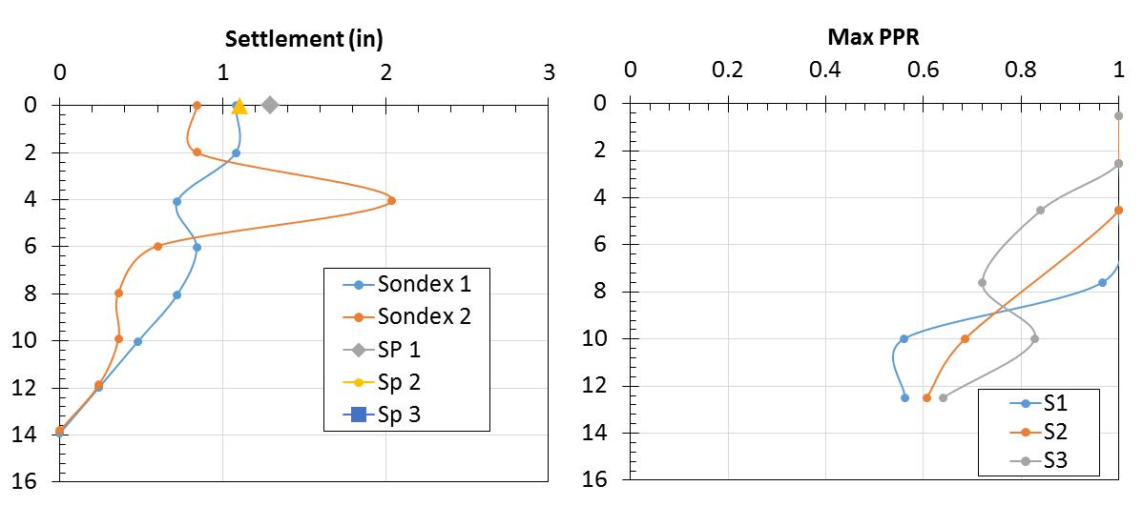
Fig. 1 Profiles of liquefaction induced settlement and maximum excess pore pressure ratio (PPR) with depth (ft) for third round test with a_{max}=0.20 g for drains at 4-ft spacing.

Fig. 2 Profiles of liquefaction induced settlement and maximum excess pore pressure ratio (PPR) with depth (ft) for third round test with a_{max}=0.20 g for drains at 3-ft spacing.

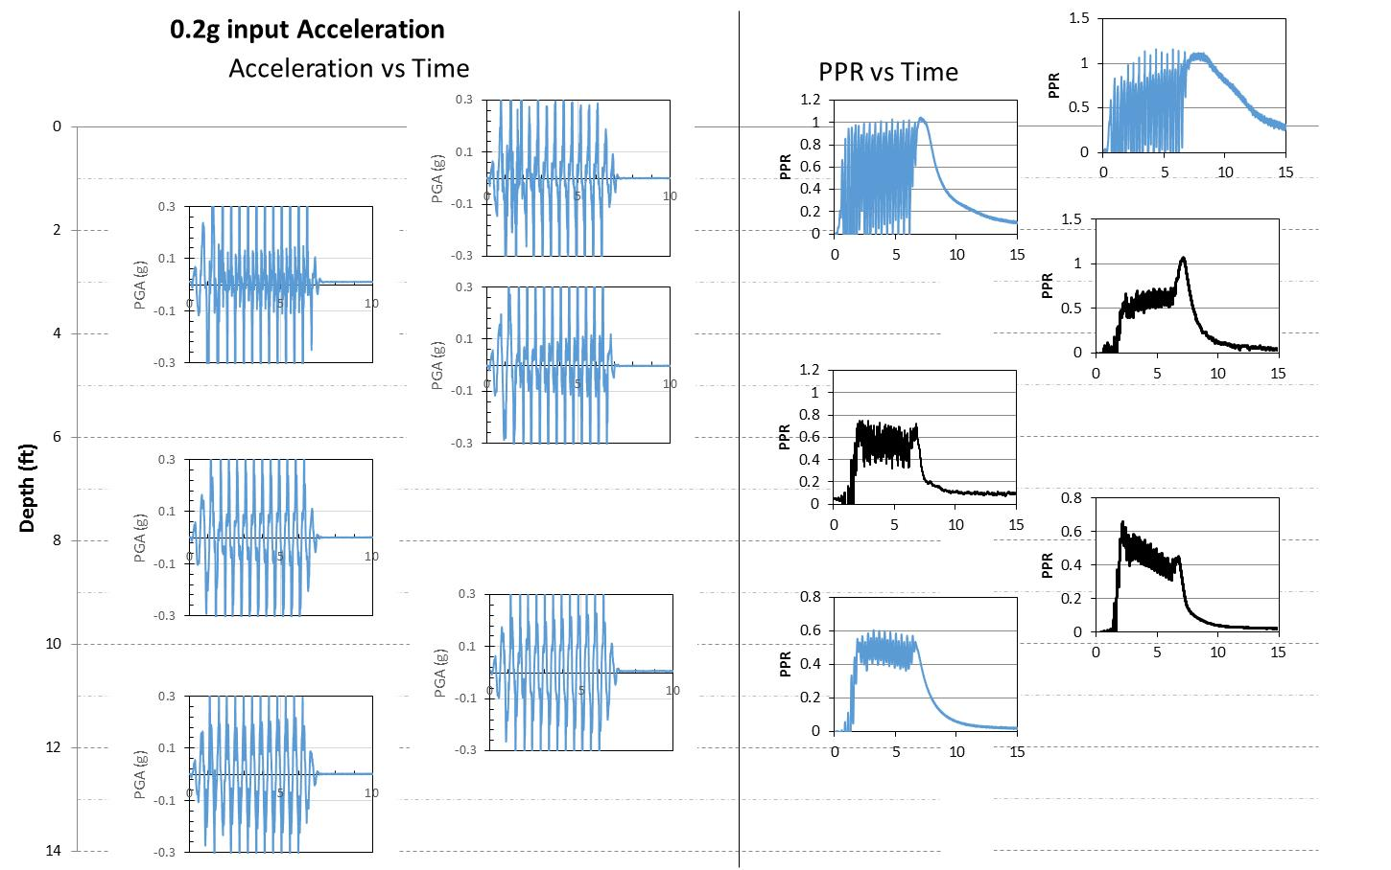

Fig. 3 Acceleration and excess pore pressure ratio vs time plots at several depths for the third round of tests
with a_{max}=0.20g for drains at 4-ft spacing.
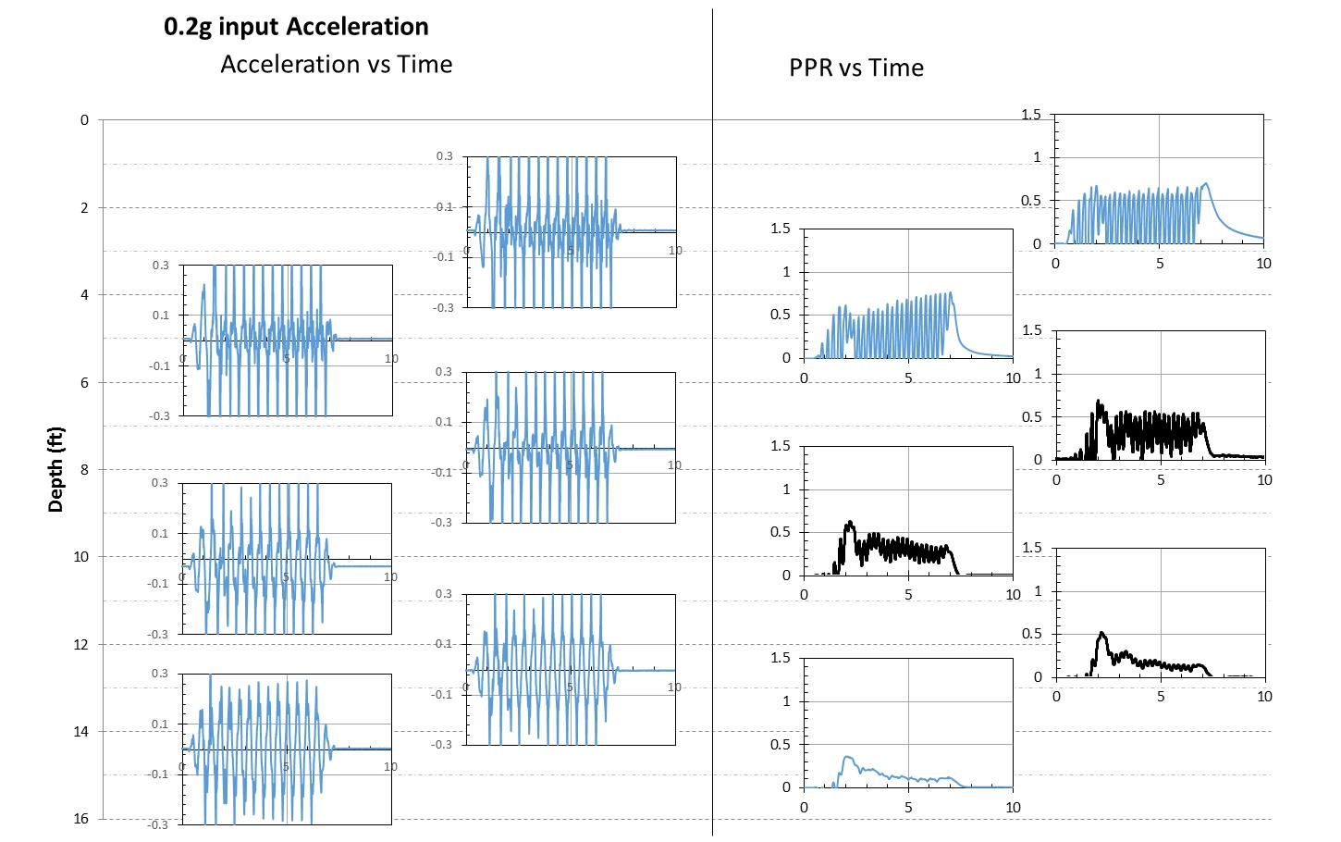

Fig. 4 Acceleration and excess pore pressure ratio vs time plots at several depths for the third round of tests
with a_{max}=0.20g for the drains at 3-ft spacing.

Circumstance affecting project or budget. (Please describe any challenges encountered or anticipated that
might affect the completion of the project within the time, scope and fiscal constraints set forth in the
agreement, along with recommended solutions to those problems).

Some testing tasks and associated analysis have taken longer to complete than originally planned. However, it is anticipated that the project tasks and deliverables will be completed within the original contract period.

Potential Implementation:

